Magnetic field-induced plasmonic enhancement of near infrared fluorescence from a magnetoplasmonic nanoplatform for bioimaging applications
Siqi Gao, Jiantao Liu, Iuliia Golovynska, Zhenlong Huang, Yiqiang Wang, Hao Xie, Rana Zaki Abdul Bari, Hao Xu, Junle Qu, Tymish Y. Ohulchanskyy
*Corresponding author. Email: tyo@szu.edu.cn
†Contributed equally to this work.
Key Laboratory of Optoelectronic Devices and Systems of Ministry of Education and Guangdong Province, College of Physics and Optoelectronic Engineering, Shenzhen University, Shenzhen 518060, China

Materials and methods
Materials
1-octadecene (ODE), dibenzyl ether, 1-tetradecene, iron (III) acetylacetonate (Fe(acac)₃), oleic acid (OA), anhydrous ethanol, hexane, chloroform, cetyltrimethylammonium bromide (CTAB), triethanolamine (TEA), tetraethyl orthosilicate (TEOS), (3-mercaptopropyl) trimethoxysilane (MPTES), ammonium nitrate, dimethylformamide (DMF), 2-[2-[2-chloro-3-[2-(1,3,3-trimethylindol-1-ium-2-yl)ethenyl]cyclohex-2-en-1-ylidene]ethylidene]-1,3,3-trimethylindole chloride (IR775), chloroauric acid (HAuCl₄), sodium citrate, and sodium borohydride (NaBH₄) were purchased from Sinopharm Chemical Reagent Co (China). All reagents were directly used without purification. A rectangular (20 × 10 × 4mm) and a round (5 mm diameter, 1 mm thick) NdFeB magnets were purchased from Taobao and used for in vitro and in vivo experiments, respectively.

Synthesis of Fe₃O₄
Fe₃O₄ nanoparticles were synthesized according to previously reported method [1, 2]. In brief, a mixture of ODE (50 mL), dibenzyl ether (50 mL), and 1-tetradecene (15 mL) was used as a high-boiling solvent. Then, Fe(acac)₃ (5 mmol), and OA (20 mmol) were added in the mixed solvent. This resulting mixture was heated to 70℃ under a vacuum and kept at this temperature for 1h with vigorous magnetic stirring. Subsequently, the temperature of the mixture was increased to 290°C under a constant flow of argon gas and kept at this temperature for another 1 h. Finally, the mixture was cooled to room temperature under a constant flow of argon gas. The purification of the iron oxide was performed by adding anhydrous ethanol, the black mixture was centrifugation at 12000 rpm for 20 min, and then the product was washed several times with a mixture of anhydrous ethanol and hexane to remove the residual reactants. Finally, iron oxide was dissolved in chloroform and stored in a refrigerator at 4°C.

Preparation of Fe₃O₄@mSiO₂
Fe₃O₄@mSiO₂ nanoparticles were synthesized according to previously reported method [3]. Firstly, CTAB (0.4 g) and TEA (0.06 g) were dissolved in deionized water (20 mL) under magnetic stirring, and then iron oxide (2 mg, in 1 mL chloroform) was added to the above solution, the mixed solution was continuously sonicated for 30 min. The chloroform in the system was removed by a rotary evaporator (80 °C). After these injections, the resulting solution was kept at 80 °C for 1 h under magnetic stirring, and the TEOS (100 µL) was added dropwise into the above solution. The reaction system was stirred for 4 h in the thermostatic water bath at 80 °C. The product was collected by centrifugation (12000 rpm, 10 min) and washed several times with ethanol. To remove the surfactants (CTAB), the Fe₃O₄@mSiO₂ solution was obtained by stirring in a solution of ammonium nitrate in ethanol (1 wt%, 3 h) for two rounds.
Preparation of MPTES-Modified Fe₃O₄@mSiO₂
Fe₃O₄@mSiO₂-SH nanoparticles were synthesized according to previously reported method [4, 5]. Fe₃O₄@mSiO₂ nanoparticles (1 mg) were dispersed in ethanol by ultrasonication for 30 min. Next, MPTES (100 µL, 10% in ethanol) was added to the Fe₃O₄@mSiO₂ solution and sonication continued for another 20 min. The resulting solution was placed in the shaker at room temperature for two days. Then, the obtained Fe₃O₄@mSiO₂-SH nanoparticles were washed three times with ethanol to remove the unbound organosilane reagents and redispersed into 10 mL ethanol.

Preparation of IR775-silane
To prepare IR775-conjugated silane precursor (MPTES), as depicted in Figure S1. IR775-silane were synthesized according to previously reported method [6, 7]. In a typical procedure, NIR fluorescent dye IR775 (30 mg, 0.059 mmol) was dissolved in anhydrous DMF (1 mL). To this, TEA (45 µL, 0.3 mmol) and MPTES (60 µL, 0.3 mmol) was added, and the resultant mixture was stirred for 12 h at 55℃ under N₂ atmosphere to evaporate the organic solvent. The final obtained product was directly used to load into the mesoporous silica shell.

Preparation of Fe₃O₄@mSiO₂@Au-IR775
A small size of Au NPs was prepared by following the steps [8], 20 mL solution of HAuCl₄ (0.25 mM) and sodium citrate (0.25 mM) were mixed under vigorous magnetic stirring. Then, 0.6 mL of freshly prepared 100 mM NaBH₄ solution was added to the above solution. The formation of Au NPs was confirmed by observing the change in its color from pink to light red. Finally, the resulting mixture was continuously stirred for 30 min at room temperature. 2 mL of the prepared Fe₃O₄@mSiO₂-SH solution was mixed with IR775-silane methanol solution at different concentrations (5 µg/mL, 9 µg/mL, and 12.5 µg/mL) for two days. Then, the resulting solution was added dropwise into 4 mL of fresh Au nanoparticle solution, and the mixed solution was continuously sonicated for 30 min. Then, the reaction was carried out with vortex stirring for another one day. Finally, the obtained product was washed with water three times and redispersed in the deionized water.

Characterization
The absorption spectra were measured with a UV-Vis spectrophotometer LAMBDA 750 (PerkinElmer, USA). Emission spectra were recorded using a Fluorolog-3 spectrofluorometer (Horiba, Japan). DLS and Zeta potential were performed using a Nano-ZS90 Zetasizer (Malvern Panalytical, United Kingdom). Transmission electron microscopy (TEM) was performed using a JEM2100PLUS TEM instrument (JEOL, Japan). Elemental mapping analyses was performed using a JEM-F200 (HRP) instrument. Magnetization measurements were performed using a LakeShore7404 instrument. A commercial fluorescence lifetime imaging system (DCS-120, Becker & Hickl, GmbH, Germany) equipped with a confocal microscope was utilized to perform fluorescence lifetime imaging analysis. The NIR fluorescence imaging was performed using a homemade NIR imaging system with 850 nm long-pass (LP) filter at 808 nm laser irradiation.

FDTD simulation
The FDTD simulations were conducted using Lumerical FDTD solutions 2020 software, simulation mode of Fe₃O₄@mSiO₂@Au nanostructures was built with 3D MAX, and the results analyses were processing with Matlab 2022. In FDTD simulation, Palik was chosen as SiO₂ and Au materials, simulation time was setting as 1000 fs, simulation temperature was 300K, boundary condition was perfectly matched layer (PML). Override mesh was added on Fe₃O₄@mSiO₂@Au nanostructures, maximum mesh step and minimum mesh step of X and Y were setting as 5 nm and 0.25 nm, respectively. The wavelength of incident source is 808 nm. Frequency-domain field profile monitor was added to visualize electric field information. After simulation, data were export into Matlab via FDTD scripts, and further analyses were processed in MATLAB 2022.

Fluorescence lifetime imaging microscopy (FLIM)
To employ fluorescence lifetime imaging microscopy for characterization of NIR fluorescence from Fe₃O₄@mSiO₂@Au-IR775 NPs with and without applied MF, NPs aqueous dispersion was placed in Petri dishes. To introduce a magnetic field, a rectangular NdFeB magnet (20 × 10 × 4mm) was placed under the dish bottom. For in vivo FLIM of Fe₃O₄@mSiO₂@Au-IR775 NPs with and without applied MF, a small round NdFeB magnet (5 mm diameter, 1 mm thick) was placed the one injection region on the back of a mouse, another injection region was left without any treatment. A 2.5× objective lens was used to focus the excitation light onto the sample and collect signal. During imaging, a wavelength of 808 nm was chosen to excite the fluorescence from IR775 in Fe₃O₄@mSiO₂@Au-IR775 NPs with and without applied MF, and an 830 LP filter was used to block the scattered laser excitation. The fluorescence lifetime images were acquired and stored by the controlling software SPCM64 (version 9.76, Becker & Hickl, GmbH, Germany). The software used for FLIM analysis was SPCImage 8.4. The pixel dwell time was set to 3.2 μs, and the acquisition time for a lifetime image consisting of 512 × 512 pixels in a single frame was approximately 40 s.

NIR fluorescence imaging
To perform a NIR fluorescence imaging of Fe₃O₄@mSiO₂@Au-IR775 NPs with and without applied MF, Fe₃O₄@mSiO₂@Au-IR775 aqueous dispersion (500 µL, 1 mg/mL, IR775 concentration=9 µg/mL) was placed in Petri dishes. To introduce a magnetic field, a rectangular NdFeB magnet (20 × 10 × 4mm) was placed the dishes bottom. The NIR fluorescence images of Fe₃O₄@mSiO₂@Au-IR775 NPs before and after applied MF were captured using a homemade NIR imaging system based on InGaAs SWIR imaging camera and 808 nm laser excitation (power density=20 mW/cm², exposure time=20 ms-200 ms).
All animal studies were performed with the requirement of the Animal Ethical and Welfare Committee of Shenzhen University (Approval No. SZUHSC-01). Female nude mice (4-6 weeks old) were used for in vivo studies. For in vivo imaging, Fe₃O₄@mSiO₂@Au-IR775 nanoformulation (200 µL, 1mg/ mL, IR775 concentration=9 µg/mL) was subcutaneously injected into the different regions on the back of the mouse. Then, the corresponding NIR fluorescence images of different injection regions from mouse were immediately obtained at 0 hour. To introduce a magnetic field, a small round NdFeB magnet (5 mm diameter, 1 mm thick) was placed the one injection region on the back of mouse, and without any treatment for another injection region. At 6 h, 24 h, 36 h, 48 h, 72 h, and 96 h post-injection, the NIR fluorescence images of the mice were captured using a homemade NIR imaging system based on InGaAs SWIR imaging camera and 808 nm laser excitation (power density=160 mW/cm², exposure time=200 ms). After imaging, the mice were sacrificed and major organs (heart, liver, spleen, lungs, and kidneys) and skin were harvested for ex vivo NIR fluorescence imaging.

Histopathological analysis
For histological examination of lungs, liver, spleen, kidneys, and heart a standard formalin-fixed paraffin-embedding method was used. Serial slices (4 μm thickness, 10 slices per organ) were obtained and stained with hematoxylin and eosin (H&E) according to the standard method. Representative histological images were obtained using an inverted Nikon fluorescence microscope and analyzed with ImageJ software. The severity of lungs, liver, spleen, kidneys, and heart injury was determined using a histological index of quantitative assessment (IQA). Briefly, 6 slices were randomly selected from each group of mice, and 3 fields of each section were reviewed under a microscope. The scoring was determined by scale from 0 to 3 based on the degree of pathological changes for each organ: absence of pathology (0) presence of mild pathological changes (1), moderate pathological changes (2), or severe pathological changes (3).

Statistical analysis
All data were presented as the mean standard deviation (SD) from at least three independent experiments (n ≥ 3). The statistical differences in the data were determined using a One-Sample t-Test analysis within Origin 9_64 software. *p <0.05, **p < 0.01, and ***p < 0.001 were considered statistically significant.

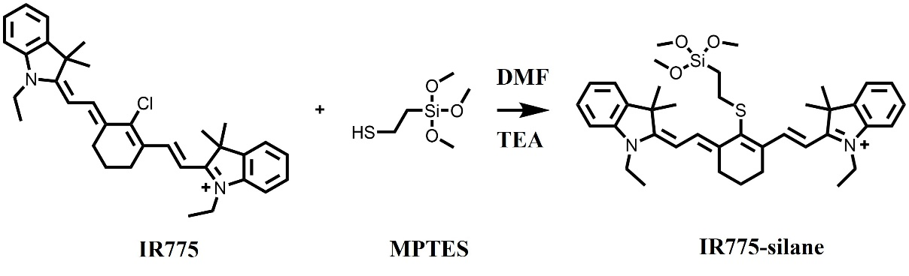
Figure S1 Synthesis of MPTES-conjugated IR775.

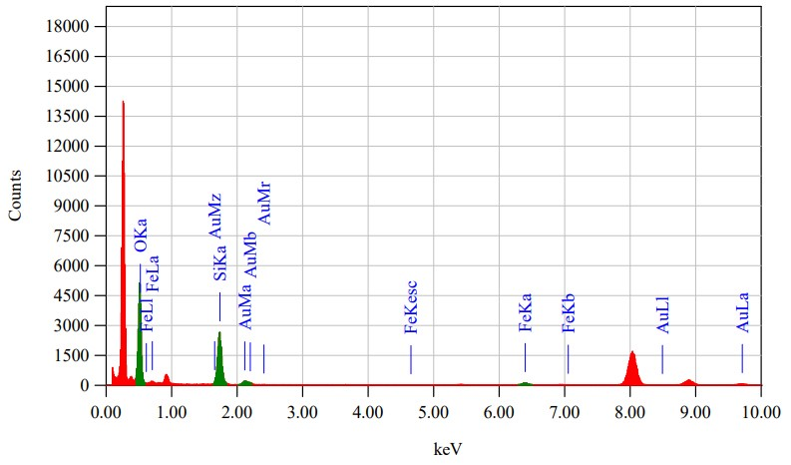
Figure S2 Energy-dispersive X-ray (EDX) spectrum of Fe₃O₄@mSiO₂@Au-IR775 NPs.

Table S1 Quantitative Analysis
Element | (kev) | Mass%
O K | 0.525 | 53.29
Si K | 1.739 | 36.61
Fe K | 6.398 | 2.38
Au M | 2.120 | 7.71
Total | / | 100

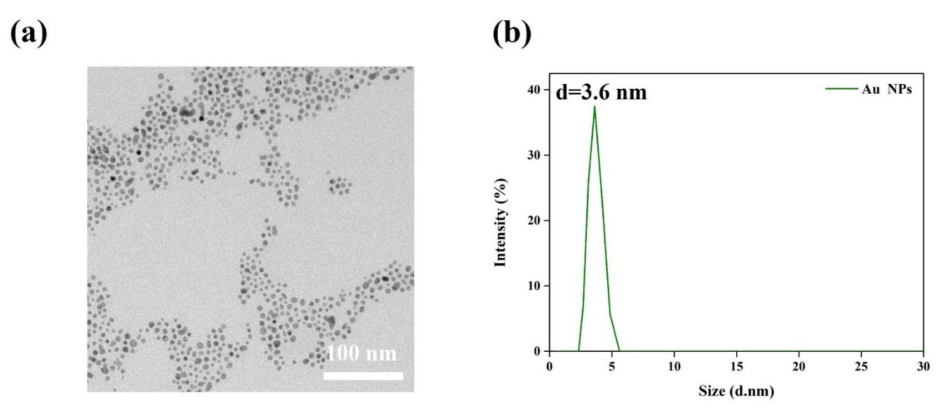
Figure S3 TEM image of Au NPs (a), and their size distribution in water dispersion (DLS data) (b).

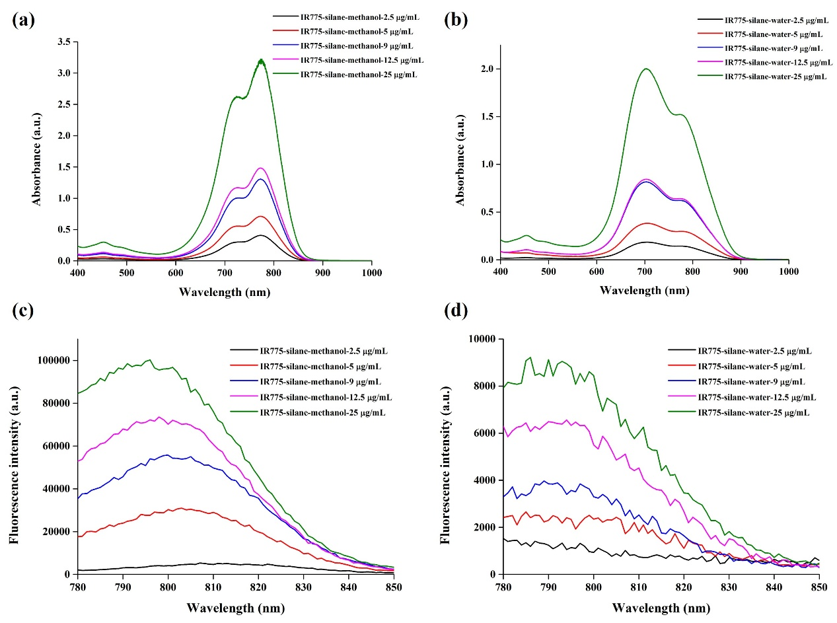
Figure S4 Absorption (a, b) and fluorescence (c, d) spectra of IR775-silane in methanol and water.
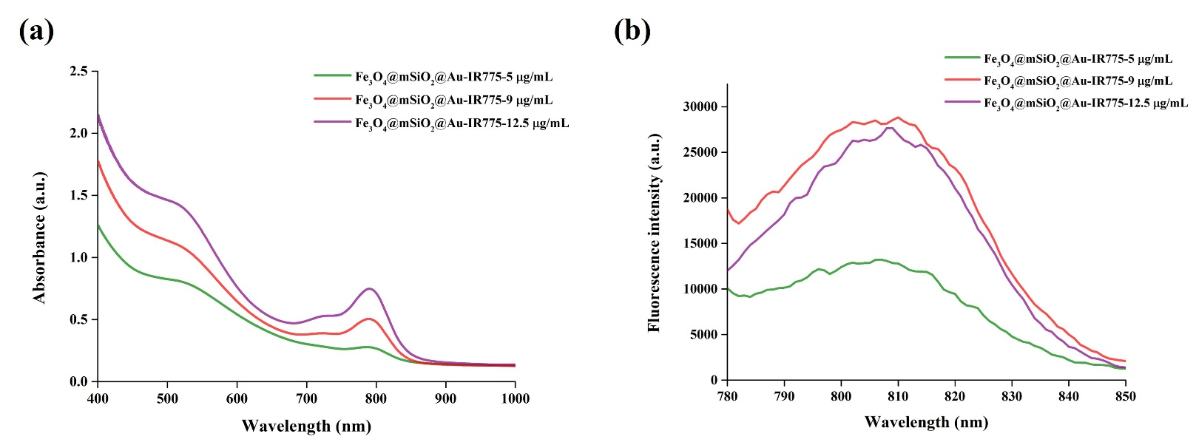
Figure S5 Absorption (a) and fluorescence (b) spectra of Fe₃O₄@mSiO₂@Au-IR775 with IR775-silane added at different concentrations.

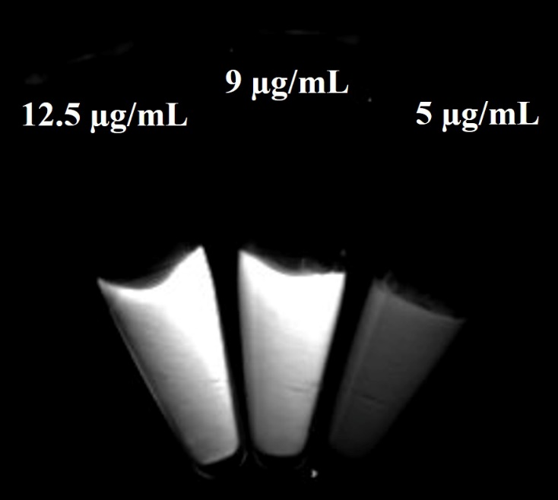
Figure S6 NIR fluorescence image of Eppendorf tubes with Fe₃O₄@mSiO₂@Au-IR775 dispersion with IR775-silane added at different concentrations. The image was acquired using an NIR camera, an 850 nm long-pass filter and 808 nm laser excitation (power density=20 mW/cm², exposure time=200 ms).

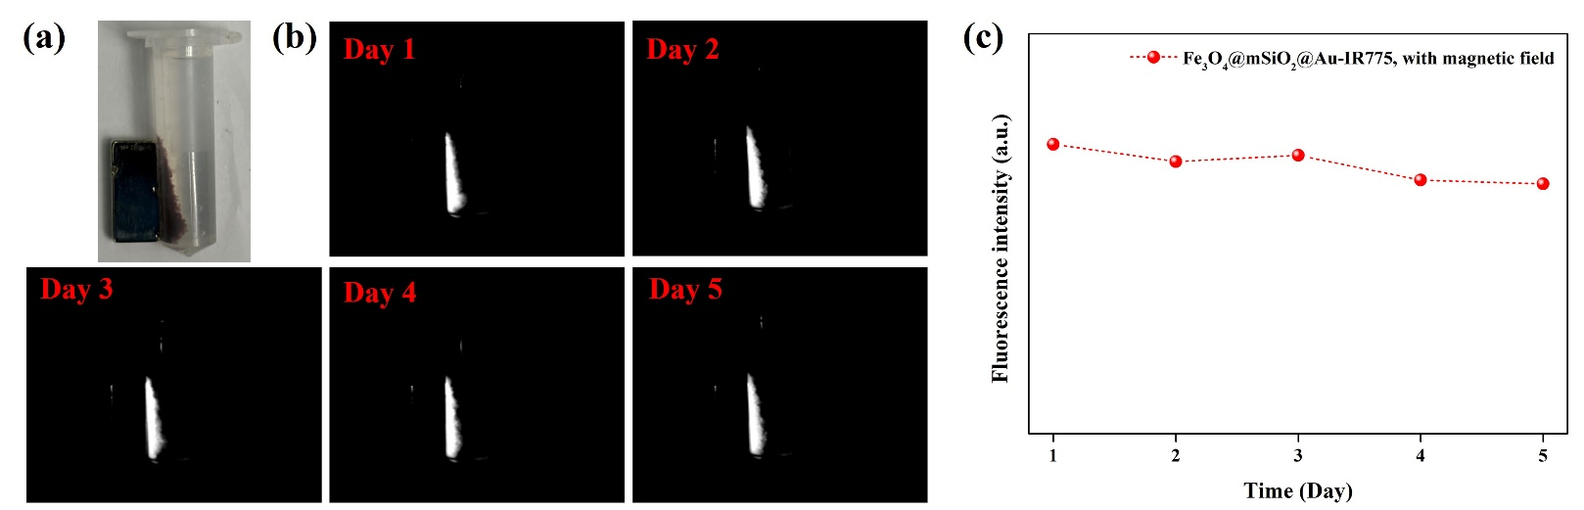
Figure S7 (a) Photograph of Fe₃O₄@mSiO₂@Au-IR775 (IR775 concentration=9 µg/mL, 2 mL) with the application of magnet, and (b) corresponding NIR fluorescence images at different time points (day1, day 2, day 3, day 4, and day 5) acquired using an NIR camera, an 850 nm long-pass filter and 808 nm laser excitation (power density=20 mW/cm², exposure time=200 ms). (c) Dependence of fluorescence intensity of Fe₃O₄@mSiO₂@Au-IR775 under applied MF on storage time..

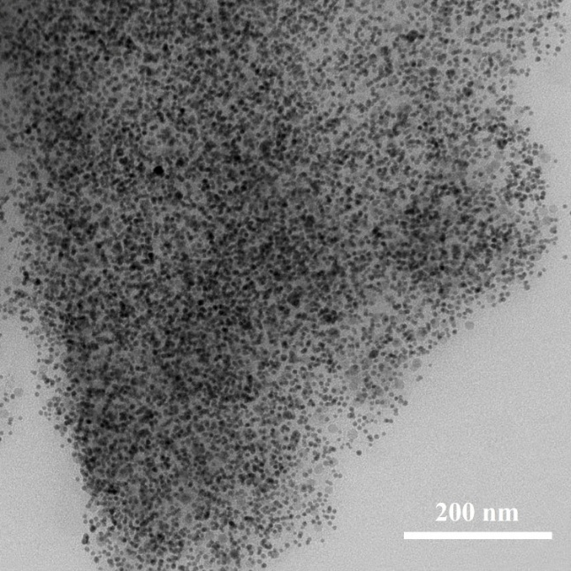
Figure S8 TEM image of Fe₃O₄@mSiO₂@Au-IR775 NPs aggregated after MF application.

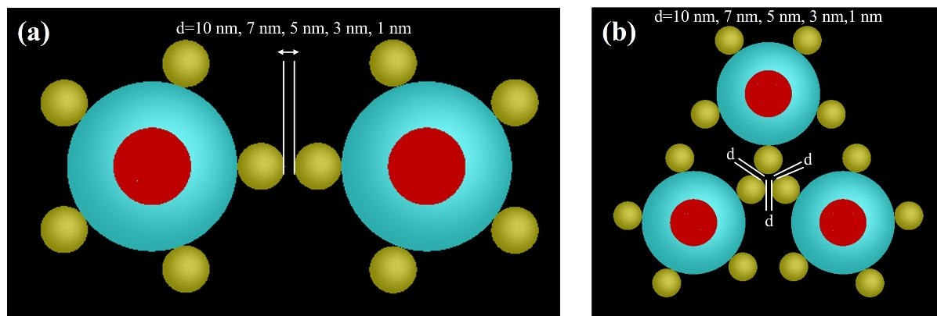
Figure S9 Schematics of possible dimer (a) and trimer (b) structures of Fe₃O₄@mSiO₂@Au NPs.
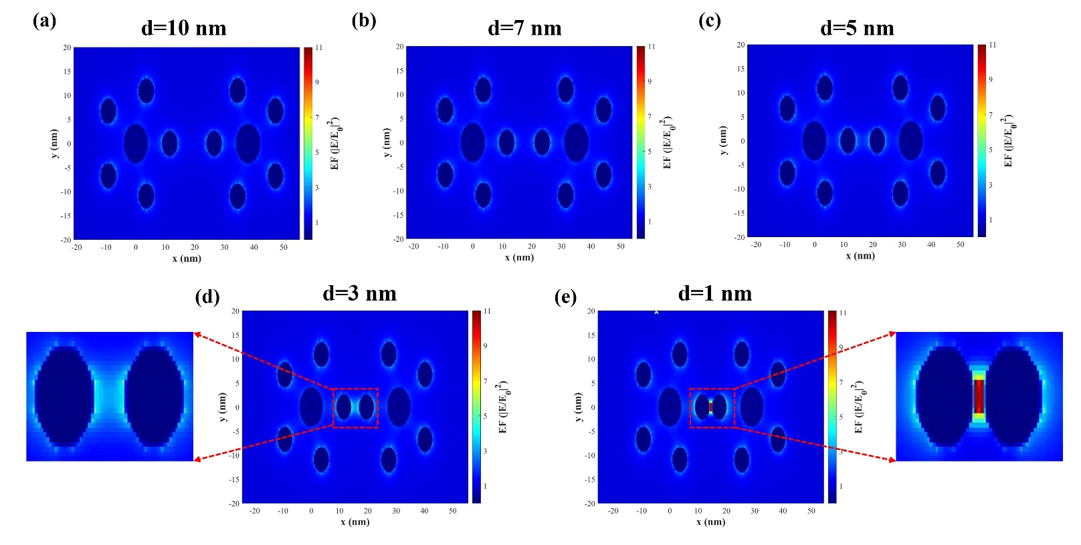
Figure S10 FDTD simulated the electric field enhancement (|E/E₀|²) distribution images for dimer structures of laser irradiated Fe₃O₄@mSiO₂@Au NPs with shortening of distance between Au satellites.
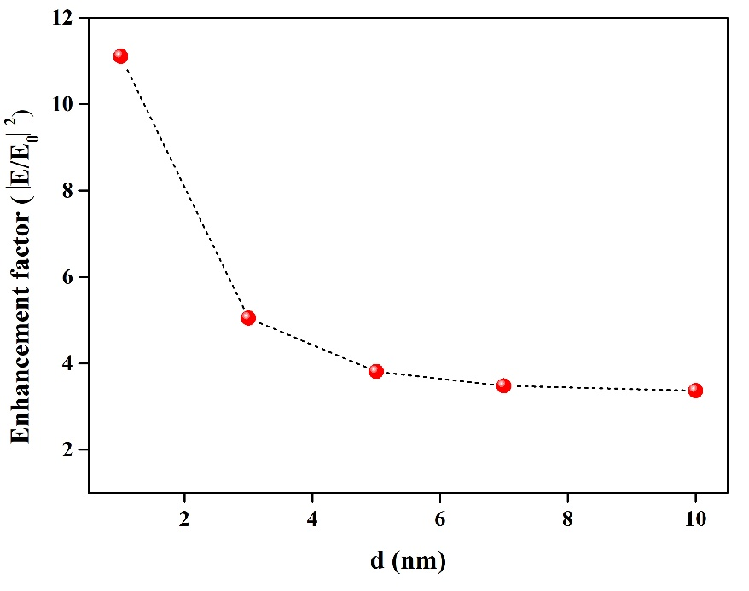
Figure S11 Dependence of electric field enhancement factor (|E/E₀|²) on distance between Au satellites in dimer of Fe₃O₄@mSiO₂@Au NPs.

Figure S12 FDTD simulated the electric field enhancement (|E/E₀|²) distribution images for trimer structures of laser irradiated Fe₃O₄@mSiO₂@Au NPs with shortening of distance between Au satellites.
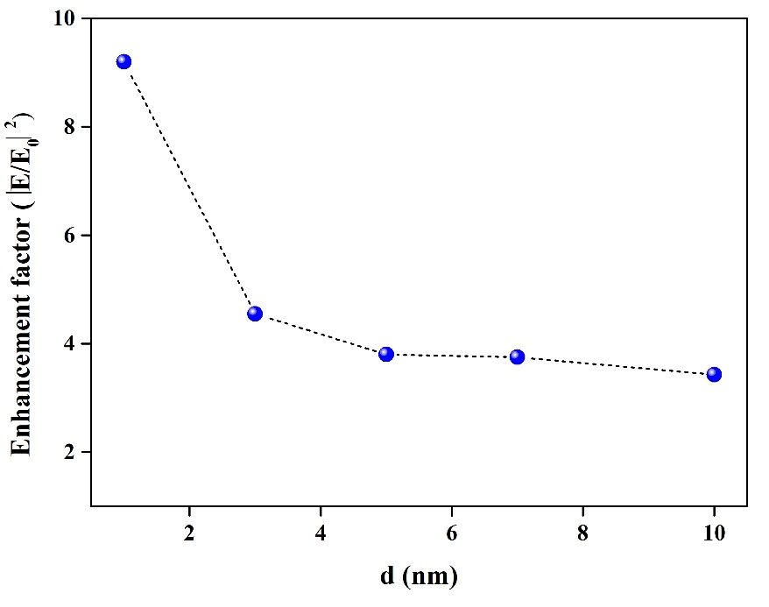
Figure S13 Dependence of electric field enhancement factor (|E/E₀|²) on distance between Au NPs for trimer structures of Fe₃O₄@mSiO₂@Au NPs.

References
- Liu YL, et al. Multifunctional superparticles for magnetically targeted NIR-II imaging and photodynamic therapy. Adv Sci. 2023; 10(2): e2203669.
- Kim J, et al. Multifunctional uniform nanoparticles composed of a magnetite nanocrystal core and a mesoporous silica shell for magnetic resonance and fluorescence imaging and for drug delivery. Angew Chem Int Ed. 2008; 47(44): 8438-8441.
- Yu L, et al. Ultrasmall mesoporous organosilica nanoparticles: Morphology modulations and redox-responsive biodegradability for tumor-specific drug delivery. Biomaterials. 2018; 161: 292-305.
- Westcott SL, et al. Formation and adsorption of clusters of gold nanoparticles onto functionalized silica nanoparticle surfaces. Langmuir. 1998; 14(19): 5396-5401.
- Yang F, et al. Magnetic photoluminescent nanoplatform built from large-pore mesoporous silica. Chem Mater. 2019; 31(9): 3201-3210.
- Tang L, et al. Synthesis and biological response of size-specific, monodisperse drug-silica nanoconjugates. ACS Nano. 2012; 6(5): 3954-3966.
- Kumar R, et al. Covalently dye-linked, surface-controlled, and bioconjugated organically modified silica nanoparticles as targeted probes for optical imaging. ACS Nano. 2008; 2(3): 449-456.
- Cui L, et al. Synthesis of multifunctional Fe₃O₄@mSiO₂@Au core-shell nanocomposites for pH-responsive drug delivery. Eur J Inorg Chem. 2014; 36: 6156-6164.

