Supplementary Table 3. Comparison of indicators without significantly statistical differences in functions of heart, thyroid and blood clotting between the EBV group and Non-EBV group.
Indexes | EBV group (Var./Po./%) | Non-EBV group (Var./Po./%) | p1 | p2
Heart function | N=50 | N=55
LDH (Higher) | 521.20(454.50-587.80/49/98) | 448.60(391.60-505.50/53/96) | 1 | 0.10
CK (Higher) | 442.90(396.30-489.60/15/30) | 547.30(395.00-699.60/22/40) | 0.31 | 0.17
CK-Isoenzymes (Higher) | 42.89(35.70-50.08/35/70) | 41.75(35.33-38.17/30/55) | 0.11 | 0.79
AMY (Higher) | 231.30(197.80-264.80/16/32) | 250.90(202.00-299.00/15/27) | 0.67 | 0.49
α-HBDH (Higher) | 386.60(336.50-4436.60/49/98) | 336.90(299.20-374.50/52/95) | 0.62 | 0.10
Lipoprotein a (Higher) | 416.40(3314.80-518.10/11/22) | 485.40(386.20-584.60/9/16) | 0.62 | 0.30
Apo-A1 (Lower) | 0.90(0.83-0.96/16/32) | 0.84(0.75-0.92/22/40) | 0.42 | 0.24
Apo-B (Higher) | 1.38(1.29-1.46/6/12) | 1.50(1.22-1.79/5/9) | 0.75 | 0.32
Thyroid function | N=60 | N=64
PCT (Higher) | 3.33(1.37-5.30/34/57) | 3.97(0.77(7.17/35/55) | 0.86 | 0.71
Thyroxine (Lower) | 35.38(20.53-50.24/12/20) | 47.10(6.67-87.54/9/14) | 0.47 | 0.35
TSH (Higher) | 5.75(4.73-6.76/8/13) | 7.94(0.72-15.17/4/6) | 0.23 | 0.33
Blood clotting | N=62 | N=64
PT (Higher) | 14.15(13.08-15.23/10/16) | 15.31(11.51-19.11/9/14) | 0.81 | 0.50
PTA (Higher) | 65.90(58.89-72.90/8/13) | 59.25(34.35-84.15/4/6) | 0.24 | 0.35
FDP (Higher) | 21.40(15.40-27.40/44/71) | 20.46(14.40-26.52/47/73) | 0.84 | 0.84
D-Dimer (Lower) | 3.14(2.87-3.99/52/84) | 2.44(1.98-2.91/45/70) | 1 | 0.14
Fibrinogen (Lower) | 1.71(1.52-1.90/10/16) | 1.83(1.64-2.01/5/8) | 0.18 | 0.41
Prothrombin Ratio (Higher) | 1.34(1.22-1.47/8/13) | 1.46(1.04-1.87/7/11) | 0.79 | 0.41
APTT (Higher) | 62.94(33.60-92.28/16/26) | 59.59(42.79-76.39/15/23) | 0.84 | 0.80
INR (Higher) | 1.35(1.23-1.47/8/13) | 1.46(1.04-1.87/6/9) | 0.58 | 0.54
Note: LDH, CK, CK-Isoenzymes, AMY,α-HBDH, Apo-A1, Apo-B, TSH, PT, PTA, FDP, APTT and INR were short for Lactic Dehydrogenase, Creatine Kinase, Creatine Kinase Isoenzymes, Amylase, α-Hydroxybutyrate dehydrogenase, Apolipoprotein A1, Apolipoprotein B, PCT, Procalcitonin, Thyroid-Stimulating Hormone, Prothrombin Time, Prothrombin Activity, Fibrinogen Degradation Products, Activated Partial Prothrombin Time, International Normalized Ratio, respectively; ‘Var.’, ‘Po.’ and ‘%’ were the same as annotation in Table 1.

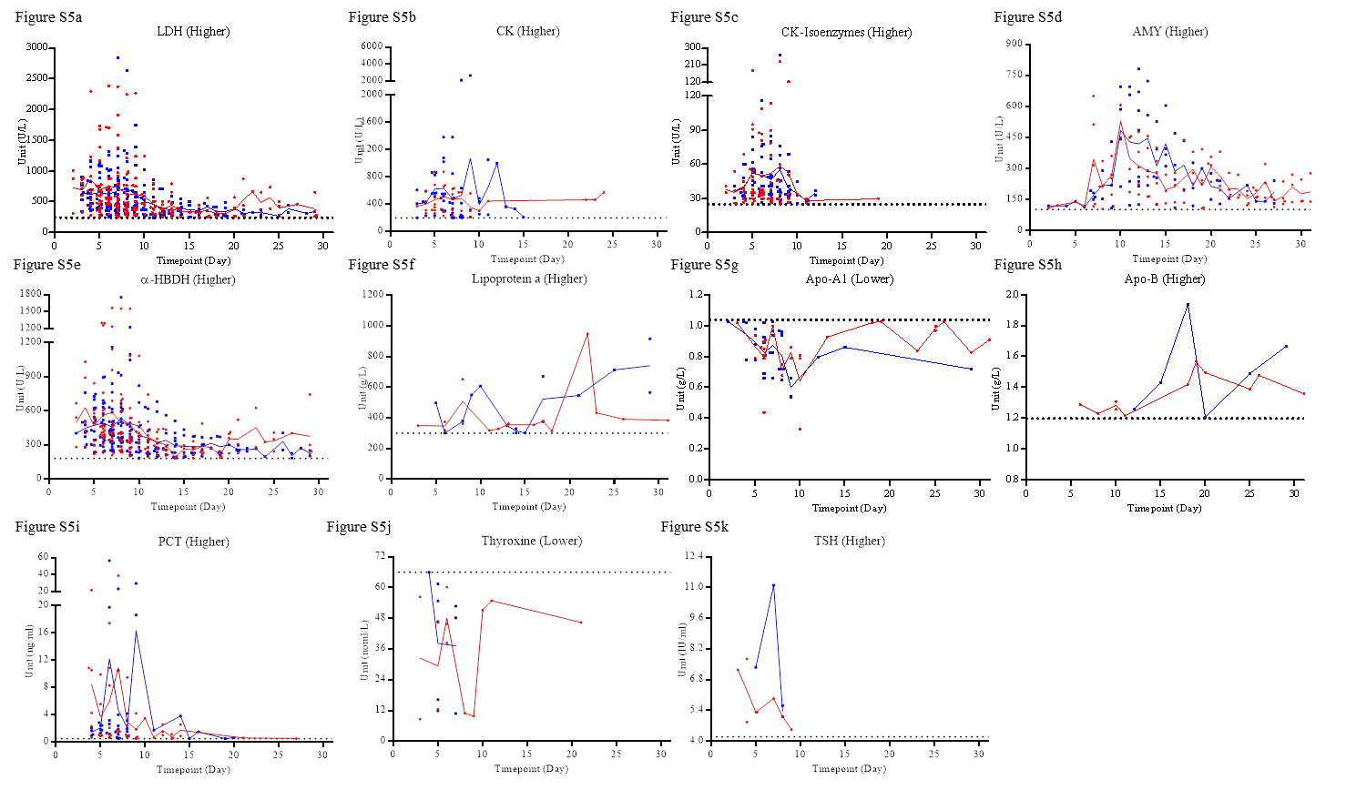
Figure S5. The outliers of the indicators without significantly statistical differences in the lab findings of heart and thyroid from disease onset to 31st day. Figure 5a to Figure 5i and Figure 5j to Figure 5k belonged to the function test of heart and thyroid, respectively. ‘Higher’ or ‘Lower’ indicate the outliers were higher or lower than the upper or lower limit of normal critical value, respectively. The red dots and lines or the blue squares and lines indicate the data from the EBV group or the Non-EBV group, respectively.

