Supplementary Table 1. Comparison of indicators without significantly statistical differences in liver function between the EBV group and Non-EBV group.
Indexes | EBV Group(Var./Po./%) | Non-EBVGroup(Var./Po./%) | p1 | p2
ALT (Higher) | 104.00(84.10-123.80/28/64) | 107.50(90.28-124.70/35/80) | 0.16 | 0.78
AST (Higher) | 114.50(77.35-151.60/39/89) | 98.14(77.40-118.90/41/93) | 0.71 | 0.43
AST/ALT (Lower) | 0.58(0.54-0.62/22/50) | 0.57(0.53-0.62/29/66) | 0.20 | 0.90
AST/ALT (Higher) | 2.35(1.90-2.80/17/39) | 3.00(2.19-3.81/22/50) | 0.39 | 0.16
AKP (Lower) | 37.28(35.06-39.05/10/23) | 36.85(35.40-38.30/17/39) | 0.17 | 0.71
AKP (Higher) | 166.40(124.20-208.50/3/7) | 150.70(103.80-197.60/3/7) | 1 | 0.55
Tbil (Higher) | 35.63(20.57-50.69/4/9) | 29.60(24.99-34.20/6/14) | 0.74 | 0.38
DBLL (Higher) | 12.06(7.57-16.55/7/16) | 10.20(7.93-12.47/8/18) | 1 | 0.44
IBIL (Higher) | 22.40(19.30-25.40/3/7) | 26.90(22.29-31.51/3/7) | 0.74 | 0.06*
TP (Lower) | 54.04(52.84-55.24/36/82) | 54.89(53.75-56.03/40/91) | 0.35 | 0.29
Albumin (Lower) | 31.63(30.90-32.36/40/91) | 31.26(30.15-32.37/40/91) | 1 | 0.57
Albumin/Globulin (Lower) | 1.01(0.98-1.04/25/57) | 1.00(0.07-1.03/28/64) | 0.66 | 0.75
Globulin (Lower) | 17.45(16.24-18.66/10/23) | 16.77(14.13-19.41/11/25) | 1 | 0.60
Cholinesterase (Lower) | 3398(3263-3532/11/25) | 3280(2886-3674/8/18) | 0.61 | 0.54
TC (Lower) | 2.52(2.41-2.63/11/25) | 2.49(2.33-2.64/11/25) | 0.35 | 0.73
Triglyceride (Higher) | 2.85(2.57-3.12/29/66) | 2.83(2.50-3.17/29/66) | 1 | 0.96
HDL (Lower) | 0.66(0.59-0.73/28/64) | 0.65(0.61-0.70/31/70) | 0.65 | 0.81
LDL (Higher) | 3.95(3.52-4.37/8/18) | 3.79(3.30-4.29/7/16) | 1 | 0.97
LDL (Lower) | 1.46(1.33-1.59/23/37) | 1.59(1.49-1.70/30/47) | 0.28 | 0.10
Serum Ferritin (Higher) | 1485(1112-1858/28/64) | 1706(1327-2085/26/59) | 0.83 | 0.36
α-L-Fucosidase (Lower) | 9.17(8.66-9.67/12/27) | 8.61(7.90-9.32/12/27) | 1 | 0.20
Note: ALT, AST, AKP, Tbil, TP, TC, HDL and LDL were short for Alanine Aminotransferase, Aspartate Aminotransferase, Alkaline Phosphatase, Total Bilirubin, Total Protein, Total Cholesterol, High-Density Lipoprotein, Low-Density Lipoprotein, respectively; there were 44 or 44 patients in EBV group or Non-EBV group, respectively; ‘Var.’, ‘Po.’ and ‘%’ were the same as annotation in Table 1.

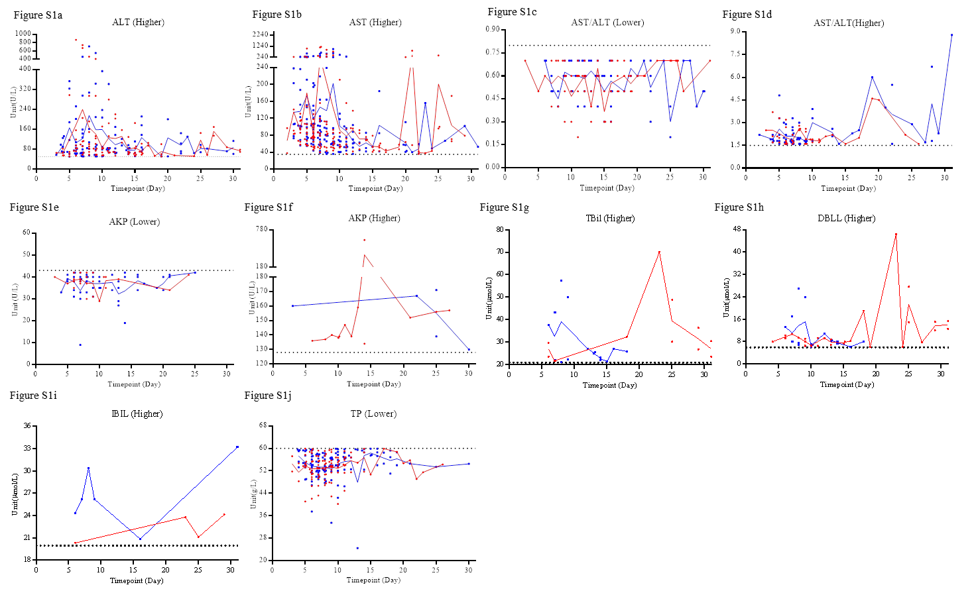
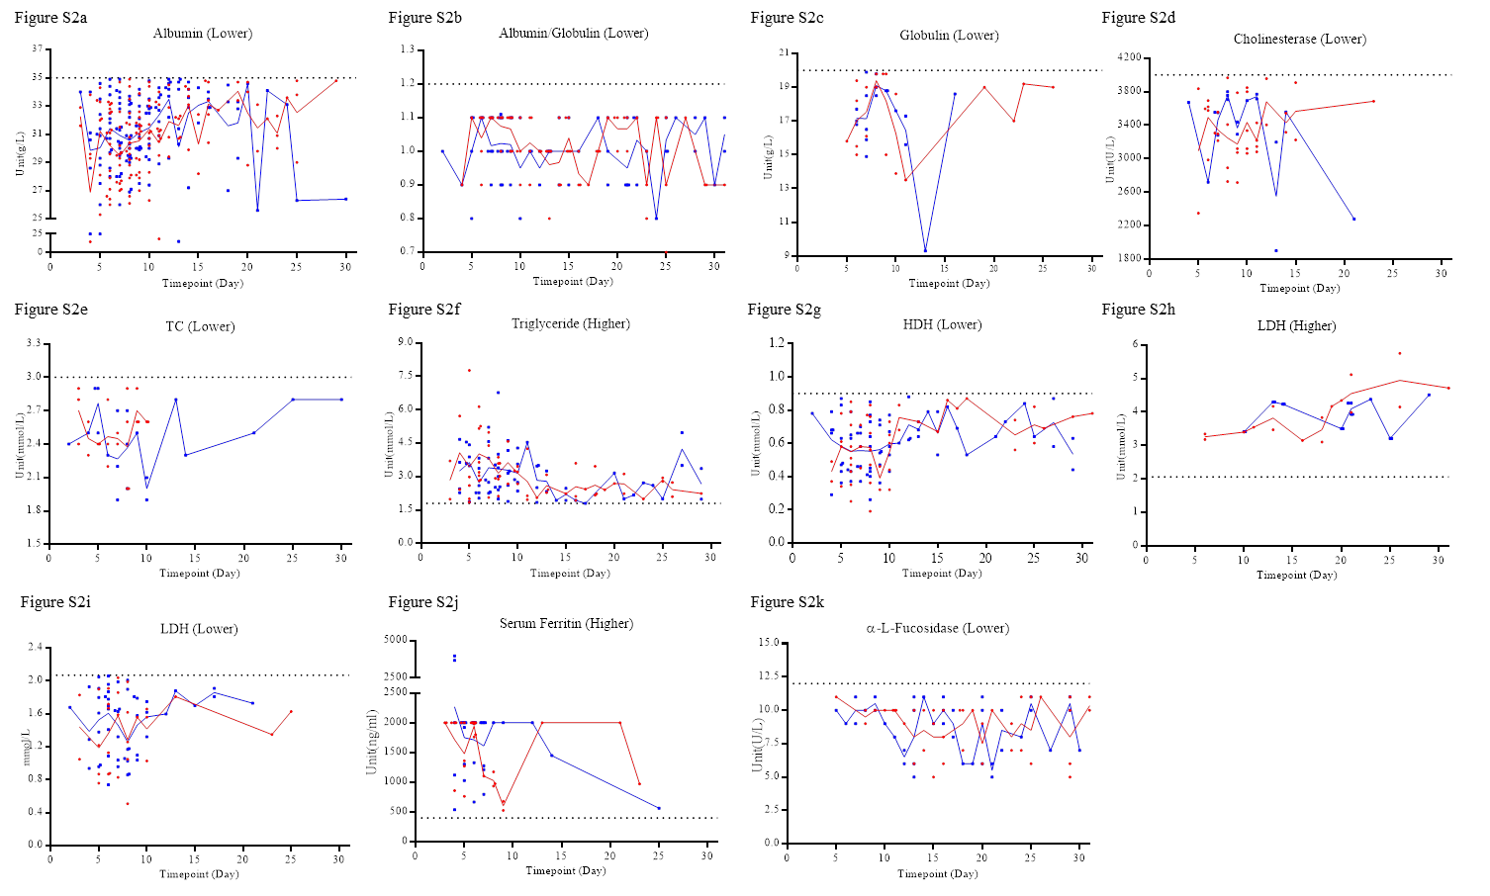
Supplementary Figure 1 and 2. The outliers of the indicators without significantly statistical differences in the lab findings of liver from disease onset to 31st day. ‘Higher’ or ‘Lower’ indicate the outliers were higher or lower than the upper or lower limit of normal critical value, respectively. The red dots and lines or the blue squares and lines indicate the data from the EBV group or the Non-EBV group, respectively.

