Supplementary Table 5. Comparison of indicators without significantly statistical differences in immune function between the EBV group and Non-EBV group.
Indexes | EBV group (Var./Po./%) | Non-EBV group (Var./Po./%) | p1 | p2
CRP (Higher) | 39.16(29.24-49.08/52/84) | 46.32(35.38-57.27/53/83) | 1 | 0.32
IL-6 (Higher) | 35.33(20.05-50.61/36/58) | 44.61(21.73-67.49/29/45) | 0.16 | 0.44
IL-10 (Higher) | 22.73(11.57-33.88/13/21) | 26.44(15.58-37.29/15/23) | 0.83 | 0.57
IL-12 (Higher) | 6.55(-1.75-14.85/7/11) | 5.58(3.81-7.35/15/23) | 1 | 0.09*
IL-17 (Higher) | 112.10(-55.09-279.30/6/10) | 47.05(7.48-86.62/9/14) | 0.58 | 0.31
IL-1β(Higher) | 47.14(-0.38-94.67/9/15) | 33.97(23.81-44.13/13/20) | 0.48 | 0.52
IFN-γ(Higher) | 47.65(29.69-65.62/11/18) | 109.00(6.83-211.20/11/17) | 1 | 0.19
C3 (Lower) | 0.68(0.36-0.99/4/6) | 0.71(0.64-0.78/7/11) | 0.53 | 0.57
C4 (Lower) | 0.16(0.12-0.20/9/15) | 0.14(0.11-0.18/10/16) | 1 | 0.50
C1q (Higher) | 316.60(268.80-364.30/25/40) | 283.30(272.80-293.80/19/30) | 0.26 | 0.16
IgG (Lower) | 0.78(6.21-7.35/13/21) | 6.50(5.22-7.89/13/20) | 1 | 0.60
IgM (Higher) | 2.83(1.94-3.72/6/10) | 3.07(2.11-4.03/7/11) | 1 | 0.63
IgA (Higher) | 3.08(2.31-3.85/10/16) | 3.57(1.65-5.49/7/11) | 0.44 | 0.45
CD8⁺ T cells | 2502.00(1329.00-3674.00/18/29) | 2888.00(2157.00-3619.00/23/36) | 0.45 | 0.54
Th/Ts | 0.37(0.32-0.43/33/53) | 0.38(0.32-0.43/35/55) | 1 | 0.84
Note: CRP, IL, IFN, C3, C4, C1q and Th/Ts were short for C-reactive protein, Interleukin, Interferon,Complement 3, Complement 4, Complement 1q, ratio of T helper cells and supressor T cells, respectively; there were 62 or 64 patients in EBV group or Non-EBV group, respectively; ‘Var.’, ‘Po.’ and ‘%’ were the same as annotation in Table 1.

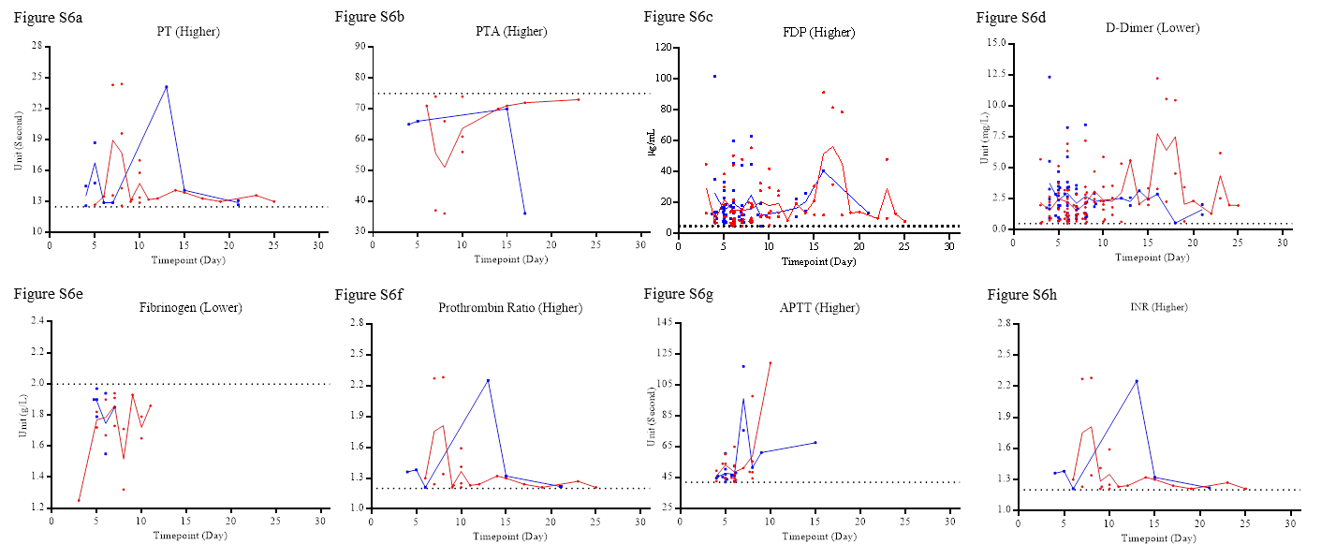
Figure S6. The outliers of the indicators without significantly statistical differences in the lab findings of blood clotting from disease onset to 31st day. ‘Higher’ or ‘Lower’ indicate the outliers were higher or lower than the upper or lower limit of normal critical value, respectively. The red dots and lines or the blue squares and lines indicate the data from the EBV group or the Non-EBV group, respectively.
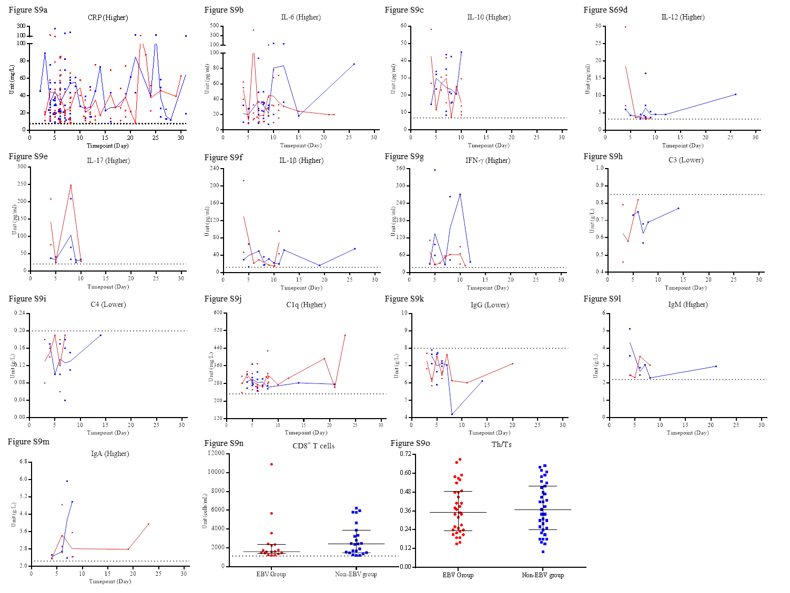
Figure S9. The outliers of the indicators without significantly statistical differences in the lab findings of immune function from disease onset to 31st day. ‘Higher’ or ‘Lower’ indicate the outliers were higher or lower than the upper or lower limit of normal critical value, respectively. The red dots and lines or the blue squares and lines indicate the data from the EBV group or the Non-EBV group, respectively.

