Supplementary Table 2. Comparison of indicators without significantly statistical differences in kidney function between the EBV group and Non-EBV group.
Indexes | EBV group (Var./Po./%) | Non-EBV group (Var./Po./%) | p1 | p2
BUN (Higher) | 18.47(17.37-19.656/49/88) | 16.93(15.31-18.55/46/82) | 0.60 | 0.11
Cr (Higher) | 294.30(268.10-320.60/50/89) | 282.70(256.20-309.20/49/88) | 1 | 0.53
Hypokalemia | 3.17(3.13-3.21/39/70) | 3.21(3.18-3.25/41/73) | 0.84 | 0.10
Hyperkalemia | 5.75(5.46-5.83/7/13) | 6.18(5.17-7.19/8/14) | 1 | 0.27
Hyponatremia | 130.10(128.50-131.70/45/80) | 130.70(129.30-132.00/38/68) | 0.20 | 0.55
Hypernatremia | 148.70(147.90-149.50/34/61) | 148.20(147.60-148.80/35/63) | 1 | 0.29
Hypochloraemia | 91.97(90.56-93.37/25/45) | 91.46(90.01-92.91/21/38) | 0.57 | 0.61
Hyperchloraemia | 111.70(110.90-112.50/38/68) | 111.20(110.50-111.90/38/68) | 1 | 0.31
Hypomagnesemia | 0.58(0.53-0.63/4/7) | 0.59(0.55-0.62/4/7) | 1 | 0.79
Hypermagnesemia | 1.25(0.88-1.61/6/11) | 1.18(1.09-1.27/5/9) | 1 | 0.66
Hyperphosphatemia | 1.85(1.59-2.10/10/18) | 1.96(1.82-2.10/8/14) | 0.80 | 0.09*
Hypophosphatemia | 0.67(0.64-0.70/3/5) | 0.68(0.56-0.80/3/5) | 1 | 0.87
CO2CP (Lower) | 19.22(18.72-19.71/49/88) | 19.39(18.80-19.98/47/84) | 0.79 | 0.64
CO2CP (Higher) | 32.76(32.18-33.33/10/18) | 32.14(31.23-33.05/13/23) | 0.64 | 0.30
AG (Higher) | 19.31(18.59-20.03/31/55) | 19.79(19.10-20.48/29/52) | 0.85 | 0.33
AG (Lower) | 6.10(5.74-6.47/25/45) | 5.94(5.50-6.37/23/41) | 0.85 | 0.85
RBP (Higher) | 89.29(85.78-92.80/22/39) | 88.34(83.92-92.76/21/38) | 1 | 0.73
RBP (Lower) | 17.80(14.89-20.71/22/39) | 16.73(15.72-17.73/30/54) | 0.19 | 0.47
TRF (Lower) | 1.54(1.45-1.63/11/20) | 1.48(1.38-1.58/11/20) | 1 | 0.40
BLD (Higher) | 1.93(1.64-2.21/13/23) | 2.14(1.84-2.44/15/27) | 0.83 | 0.29
White blood cell in Urine (Higher) | 26.03(15.52-36.54/31/55) | 48.13(20.69-75.57/22/39) | 0.13 | 0.13
Urothelial Cell (Higher) | 19.93(12.14-27.72/8/14) | 19.90(-0.06-39.86/12/21) | 0.46 | 1
Proteinuria (Higher) | 2.76(2.46-3.06/18/32) | 2.59(2.32-2.85/17/30) | 1 | 0.35
Urine casts (Higher) | 5.29(2.74-7.83/8/14) | 12.79(1.46-24.12/7/13) | 1 | 0.15
Cystatin C (Higher) | 3.00(2.65-3.35/12/21) | 2.89(2.57-3.22/11/20) | 1 | 0.65
Note: BUN, Cr, CO2CP, AG, RBP, TRF and BLD were short for Blood Urea Nitrogen, Creatinine, Carbon Dioxide Combining Power, Anion Gap, Retinol-binding Protein, Transferrin, Blood in Urine, respectively; there were 56 or 56 patients in EBV group or Non-EBV group, respectively; ‘Var.’, ‘Po.’ and ‘%’ were the same as annotation in Table 1.

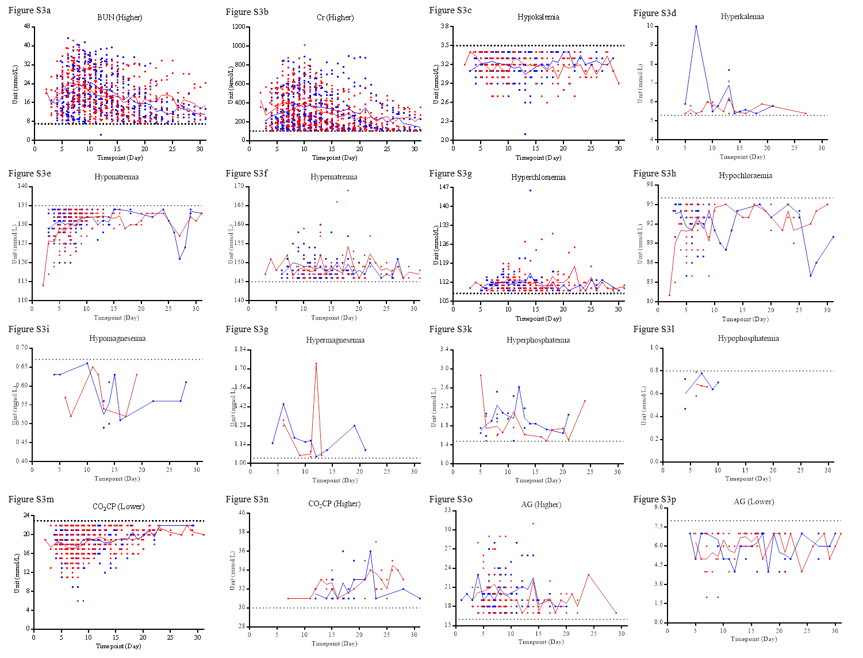
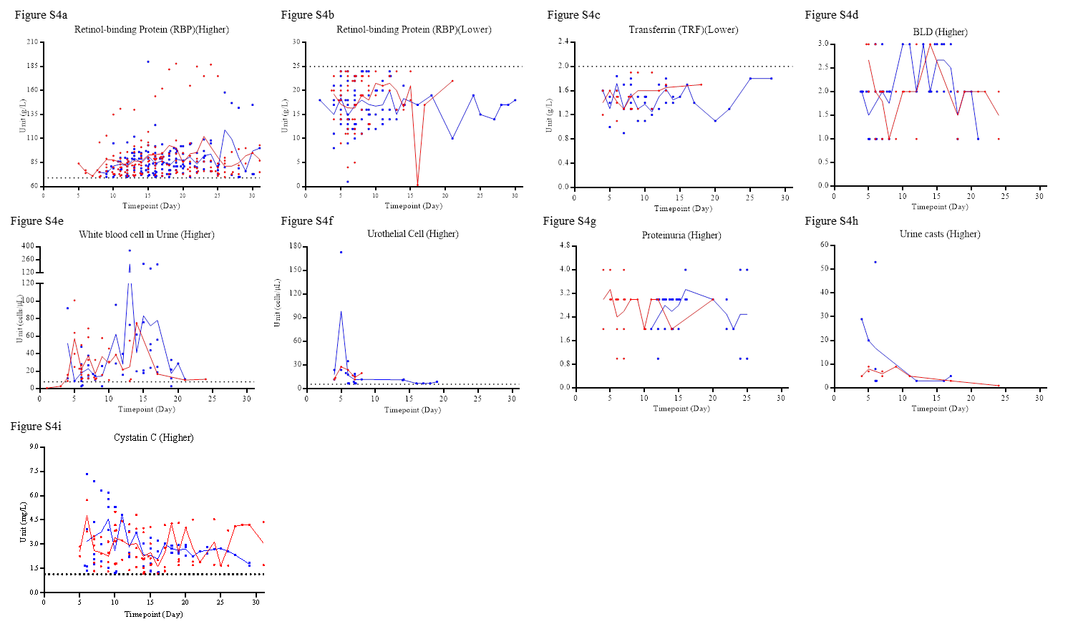
Supplementary Figure 3 and 4. The outliers of the indicators without significantly statistical differences in the lab findings of kidney from disease onset to 31st day. ‘Higher’ or ‘Lower’ indicate the outliers were higher or lower than the upper or lower limit of normal critical value, respectively. The red dots and lines or the blue squares and lines indicate the data from the EBV group or the Non-EBV group, respectively.

