Supplementary Table 4. Comparison of indicators without significantly statistical differences in blood routine between the EBV group and Non-EBV group.
Indexes | EBV group (Var./Po./%) | Non-EBV group (Var./Po./%) | p1 | p2
WBC (Lower) | 3.45(3.16-3.75/8/13) | 3.18(2.98-3.39/10/16) | 0.80 | 0.11
WBC (Higher) | 15.96(13.89-18.02/49/79) | 14.90(13.25-16.54/47/73) | 0.53 | 0.43
RDW-SD (Higher) | 53.61(52.60-54.62/10/16) | 52.52(51.69-53.35/5/8) | 0.18 | 0.09
PLT (Lower) | 60.08(52.46-67.70/56/90) | 64.26(56.84-71.68/60/94) | 0.53 | 0.42
PLT (Higher) | 344.50(333.60-355.40/20/32) | 360.20(345.20-375.20/25/39) | 0.46 | 0.10
RBC (Higher) | 5.95(5.74-6.16/18/29) | 5.96(5.86-6.05/19/30) | 1 | 0.98
RBC (Lower) | 3.32(3.22-3.43/40/65) | 3.24(3.10-3.37/37/58) | 0.47 | 0.30
LYC (Lower) | 0.65(0.54-0.75/6/10) | 0.59(0.52-0.66/11/17) | 0.30 | 0.30
LYC (Higher) | 7.38(6.07-8.70/38/61) | 7.28(5.98-8.58/47/73) | 0.84 | 0.91
LYM% (Lower) | 15.18(14.44-15.92/36/58) | 15.01(14.16-15.86/38/59) | 1 | 0.76
EOS (Lower) | 0.23(0.02-0.03/39/63) | 0.02(0.02-0.03/38/59) | 0.72 | 0.58
EOS% (Lower) | 0.25(0.21-0.28/39/63) | 0.20(0.14-0.26/37/58) | 0.59 | 0.05*
HB (Higher) | 175.10(170.20-180.00/22/35) | 172.2(168.20-176.20/23/36) | 1 | 0.30
HCT (Lower) | 29.63(28.92-30.33/43/69) | 28.47(27.05-29.90/41/64) | 0.57 | 0.15
HCT (Higher) | 54.06(50.11-58.02/12/19) | 53.84(52.47-55.20/15/23) | 0.67 | 0.90
NEUT (Higher) | 11.40(10.14-12.66/37/60) | 11.50(10.08-12.92/37/58) | 0.86 | 0.91
NEUT (Lower) | 1.40(1.58-1.63/10/16) | 1.53(1.42-1.63/12/19) | 0.82 | 0.29
NEUT% (Higher) | 81.26(79.89-82.63/16/26) | 80.81(79.51-82.12/17/27) | 1 | 0.62
NEUT% (Lower) | 35.10(32.72-37.47/25/40) | 35.84(34.19-37.50/35/55) | 0.11 | 0.60
MONO (Higher) | 1.40(1.21-1.59/55/89) | 1.31(1.10-1.53/55/86) | 0.79 | 0.53
MONO% (Higher) | 11.32(10.86-11.78/60/97) | 11.14(10.86-11.61/61/95) | 1 | 0.57
MONO% (Lower) | 1.26(0.18-2.35/8/13) | 1.85(1.17-2.52/12/19) | 0.47 | 0.24
MCV (Lower) | 83.63(82.84-84.42/28/45) | 82.76(82.01-83.50/24/38) | 0.47 | 0.11
P-LCR (Higher) | 47.52(46.48-48.57/42/68) | 48.65(47.46-49.84/47/73) | 0.56 | 0.14
MPV (Lower) | 8.60(8.49-8.71/13/21) | 8.58(8.43-8.74/10/16) | 0.49 | 0.85
ESR (Higher) | 33.08(26.12-40.05/23/37) | 39.25(34.25-44.25/20/31) | 0.57 | 0.14
BASO (Higer) | 0.15(0.14-0.16/20/32) | 0.19(0.12-0.26/17/27) | 0.56 | 0.23
BASO% (Higher) | 1.63(1.48-1.78/27/44) | 1.73(1.53-1.92/33/52) | 0.38 | 0.42
Note: WBC, RDW-SD, PLT, RBC, LYC, LYM%, EOS, EOS%, HB, HCT, NEUT, NEUT%, MONO, MONO%, MCV, P-LCR, MPV, ESR, BASO and BASO% were short for the White Blood Cell, Red Blood Cell Distribution Width-SD, Platlet, Red Blood Cell, Lymphocyte Count, percentage of Lymphocyte, Eosinophils, percentage of Eosinophils, Hemoglobin, Hematocrit, Neutrophils, percentage of Neutrophil, Monocytes, percentage of Monocytes, Mean Corpuscular Volume, Platelet -Larger Cell Ratio, Mean Platelet Volume, Erythrocyte Sedimentation Rate, Basophils, percentage of Basophils, respectively; there were 62 or 64 patients in EBV group or Non-EBV group, respectively; ‘Var.’, ‘Po.’ and ‘%’ were the same as annotation in Table 1.

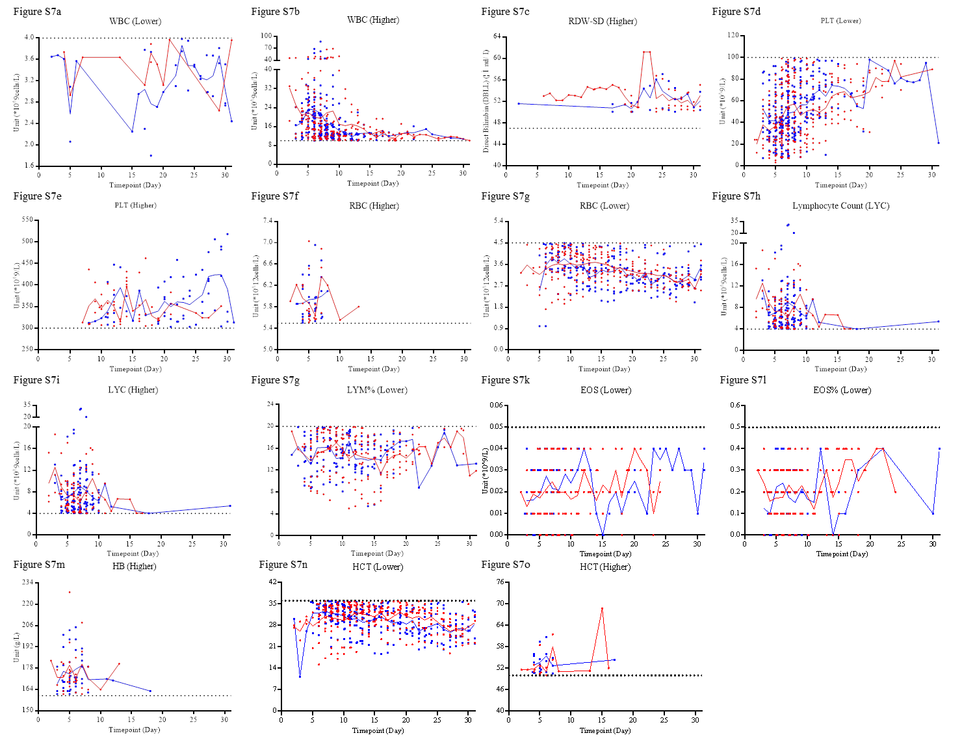
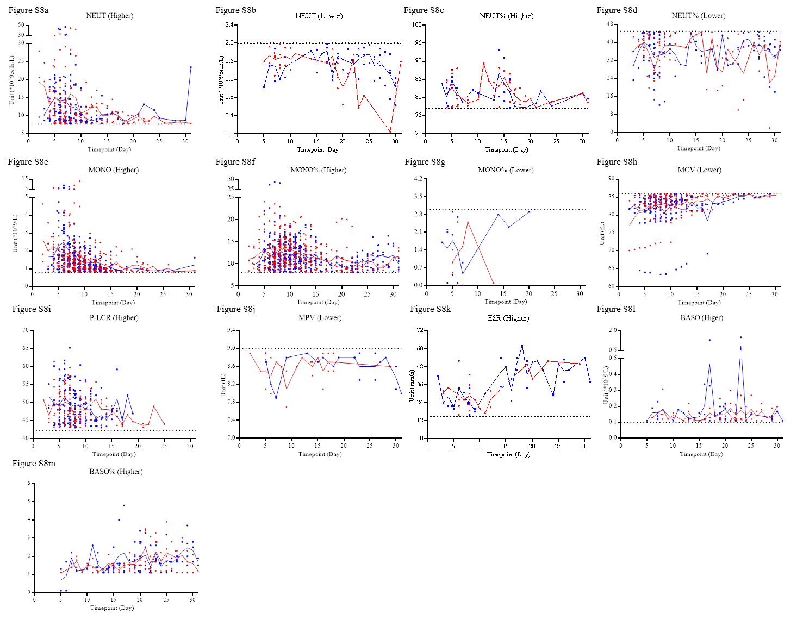
Figure S7 and S8. The outliers of the indicators without significantly statistical differences in the lab findings of blood routine from disease onset to 31st day. ‘Higher’ or ‘Lower’ indicate the outliers were higher or lower than the upper or lower limit of normal critical value, respectively. The red dots and lines or the blue squares and lines indicate the data from the EBV group or the Non-EBV group, respectively.

