Supporting Information

Experimental methods
Materials
The sodium hexafluorophosphate (NaPF₆), diethylene glycol dimethyl ether (G2) and 2-methyloxolane (MO) wre purchased from DoDo Chem. Common ether electrolyte (CCE) was prepared by dissolving 0.8 M NaPF₆ in G2 solvent. Weakly solvated electrolyte (WSE) was prepared by dissolving 0.8 M NaPF₆ in MO solvent. Co-intercalated electrolyte (CIE) was prepared by dissolving 0.8 M NaPF₆ in G2: MO = 7:3 vol%. All electrolyte preparation processes are carried out in a glovebox filled with Ar (H₂O < 0.1 ppm and O₂ < 0.1 ppm).
Hard carbon (HC) materials were purchased from Baisige New Energy Co., Ltd. The HC anode was prepared by mixing the active material, CMC, SBR and conductive carbon black (weight ratio 92:1.5:3.5:3) in deionized water to form a homogeneous slurry. The slurry was spread on a copper foil and dried at 80 °C for 8-12 h. Then, it was perforated into a circular electrode sheet with a diameter of 12 mm and a loading of 2.5-3.0 mg cm⁻². Glass fiber (GF/D, Whatman) as separator and metallic sodium (purchase from Canrd Technology Co. Ltd.) as counter electrode were assembled with HC anode to form HC||Na coin cells.
The Ah-level pouch batteries are composed of O3-Na_{2/3}Ni_{1/3}Fe_{1/3}Mn_{1/3}O₂ (NFM) cathode (15 mg cm⁻² for each side, active mass 95.3%, 60 mm×80 mm) and HC anode (6.25 mg cm⁻² for each side, active mass 94.5%, 63 mm×84 mm) coated on Al foil. The N/P ratio is approximately 1.15. The amount of electrolyte added is about 5 mL.

Electrochemical tests
The HC||Na half cells with various electrolyte were assembled in Ar-filled gloveboxes using 2032-type coin cells with Na metal and HC. The amount of electrolyte was controlled at 100 μL for each HC||Na cell. The voltage ranges of HC||Na cells and NFM||HC pouch batteries were 0 to 2.5 V and 1.8 to 3.8 V, respectively. The Na⁺ storage performance was examined in a galvanostatic charge-discharge test in the potential range from 0-2.5 V on NEWARE Battery Test System (BTS-610, Shenzhen, China). The ion conductivity of the electrolyte was measured at different temperatures using the CHI660D electrochemical workstation through electrochemical impedance spectroscopy (EIS) technology.

Characterization
Fourier transform infrared (FTIR) spectra was performed to analyze the solvation structure on an FTIR Spectrometer (Nicolet iS10). Raman spectra of the electrolytes were collected with a spectrometer (Thermo Fischer DXR). The SEI on HC surface was characterized by X-ray Photoelectron Spectroscopy (XPS, ThermoFisher ESCALAB 250Xi). High-resolution transmission electron microscope (HRTEM) was obtained by the JEM-F200 transmission electron microscope at 200 kV. The crystal structures of HC were characterized by a powder X-ray diffractometer (X’Pert PRO, PANalytical) with Cu Kα radiation (λ = 0.15406 nm). The ¹H NMR was conducted on Bruker AVANCE spectrometer (Bruker, Germany). The Flight time secondary ion mass spectrometry (TOF-SIMS) data were collected on ION-TOF-GmbH-TOF.SIMS 5-100, Germany, equipped with a 30 keV Bi³⁺ gun for analysis beam, Cs⁺ gun for sputtering beam.

Theoretical calculations
The binding energy between solvent molecules and Na⁺ was calculated on density functional theory (DFT) by the Gaussian 16 package. The geometry optimization was conducted at B3LYP/6-31+g(d) level and a higher level of B3LYP/6-311++g(d,p) was applied for the single point calculation. All calculations take into account the empirical revision of DFT-D3.¹ The solvation effect was considered with the universal solvation model of polarized continuum model (PCM). The electrostatic potential involved in the analyses was evaluated by Multiwfn.²
The molecular dynamics simulations were used the Gromacs 2019 with all-atom optimized potential liquid simulation (OPLS-AA) force field.³ Force field parameters for PF₆⁻ were obtained directly from the literature,⁴ while force field parameters for other electrolyte components were generated using the LigParGen web server.⁵ Advanced restrained electrostatic potential (RESP2) atomic charges were employed, which were calculated using the Multiwfn program.⁶ The PACKMOL program was used to construct the initial simulation boxes with dimensions of 70 × 70 × 70 Å³ and filled with electrolyte components. First, the temperature is allowed to slowly ramp up from 0 K to 298 K in 1 ns, then, 10 cycles of quench-anneal kinetics were performed from 298 K to 500 K within 4 ns to eliminate the persistence of the metastable state. The particle-mesh Ewald (PME) method with a cut-off distance of 12 Å was applied to treat the electrostatic interactions and the van der Waals forces. During the pre-equilibrium simulation, the temperature is controlled by the V-rescale algorithm and the pressure is controlled by the Berendsen. Finally, MD simulations were performed in the NPT system for 20 ns at a temperature of 298 K and a pressure of 1 bar. During the final simulation, the temperature is controlled by the Nose-Hover algorithm and the pressure is controlled by the Parrinello-Rahman. The final 10-ns NPT simulation was output every 10000 steps and used to analyze the radial distribution function (g(r)) and the solvation structure. Visualization of simulated structures using the Visual Molecular Dynamics program (VMD).⁷ We used our own TCL script and analyzed the solvation structure based on the Python package MDTraj.⁸
The diffusion energy barriers of Na⁺/Na⁺-G2 chelates in carbon layers were calculated using Vienna Ab-initio Simulation Package (VASP) by a method of the density-functional theory (DFT),⁹ and the generalized gradient approximation (GGA) in the Perdew-Burke-Ernzerhof (PBE) formulation.¹⁰ The dispersion corrections were introduced by a method of DFT-D3. The cutoff energy was set to 400 eV throughout the computations. Partial occupancies of the Kohn−Sham orbitals were allowed under the occasion which uses the Gaussian smearing method and a width of 0.05 eV. These settings ensure convergence of the total energies to within 10⁻⁵ eV. Structure relaxation proceeded until all forces on atoms were less than 0.03 eV Å⁻¹. Visualization was carried out using VESTA software.

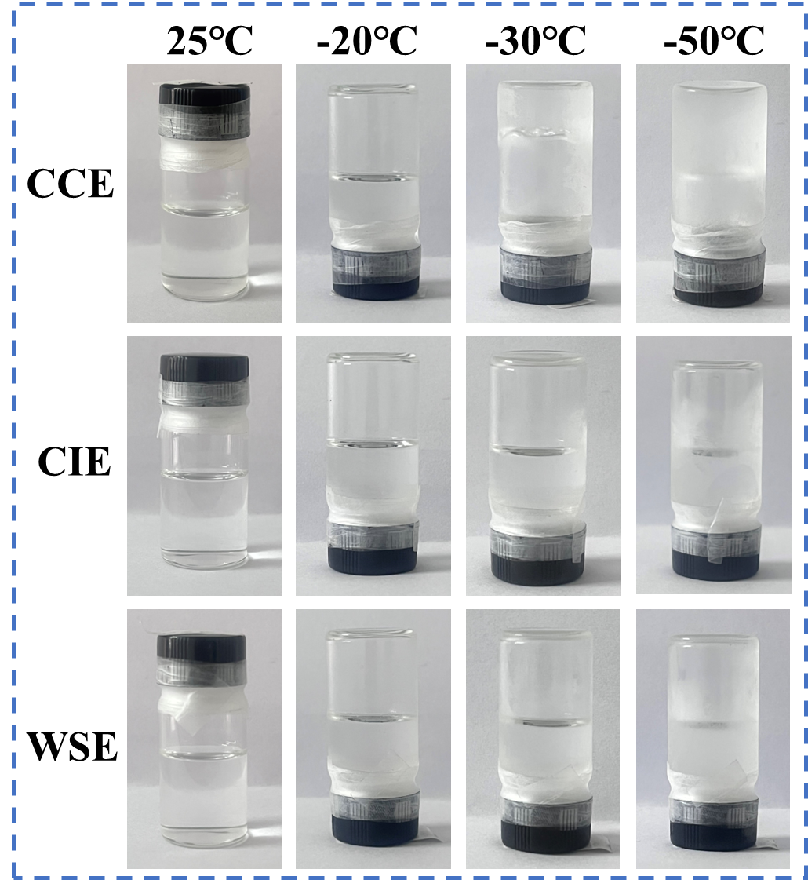
Figure S1. Optical photographs of various electrolytes at different temperatures.

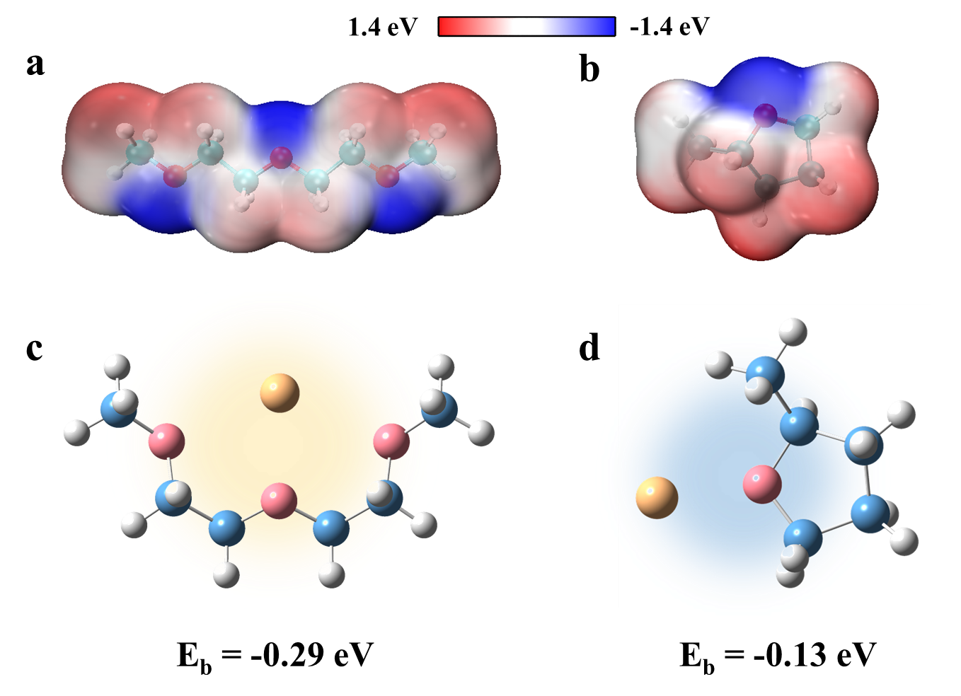
Figure S2. The electrostatic potential and binding energies with Na⁺ of (a, c) G2 and (b, d) MO, respectively.

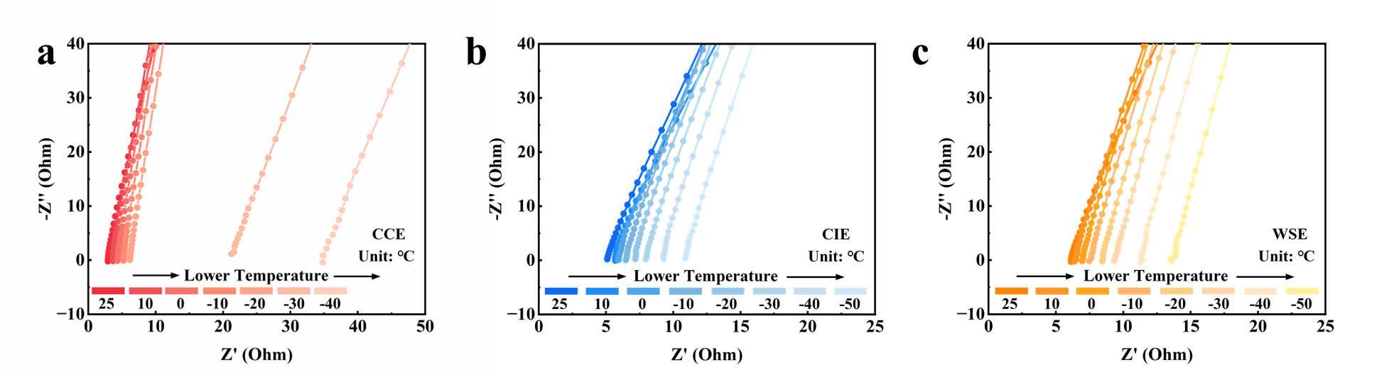
Figure S3. Nyquist plots of (a) CCE, (b) CIE, and (c) WSE at different temperatures.

Figure S4. RDF of Na⁺ solvation configurations obtained from MD simulations in CIE at -20°C.

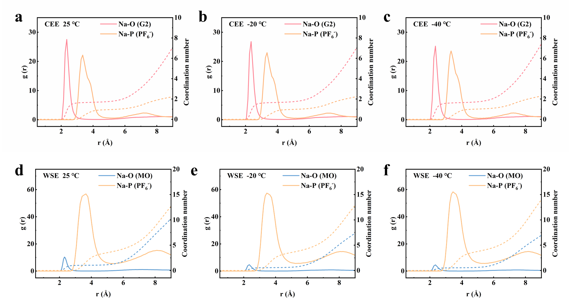
Figure S5. RDF of Na⁺ solvation configurations obtained from MD simulations in (a-c) CCE and (d-f) WSE at -40°C - 25°C.

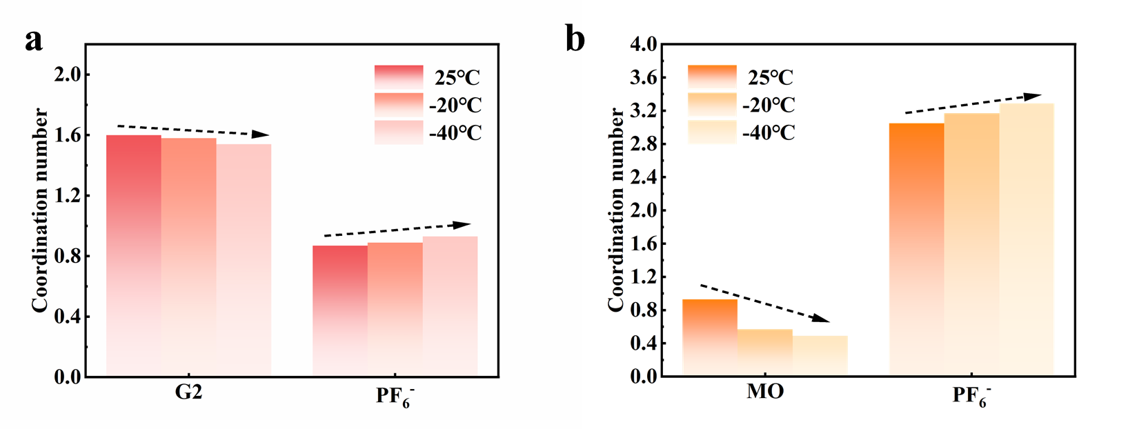
Figure S6. Coordination number changes obtained from MD simulation at different temperatures of (a) CCE and (b) WSE.

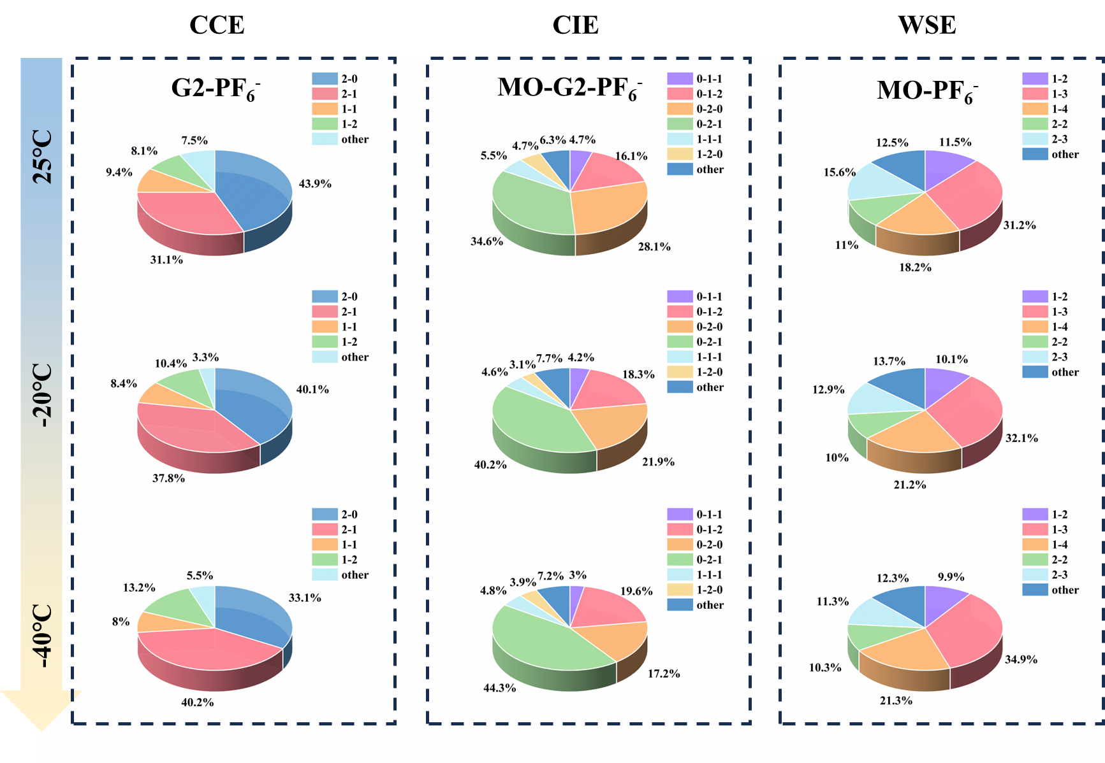
Figure S7. Statistical analysis of solvent-anion coordination environment of various electrolytes at different temperatures.

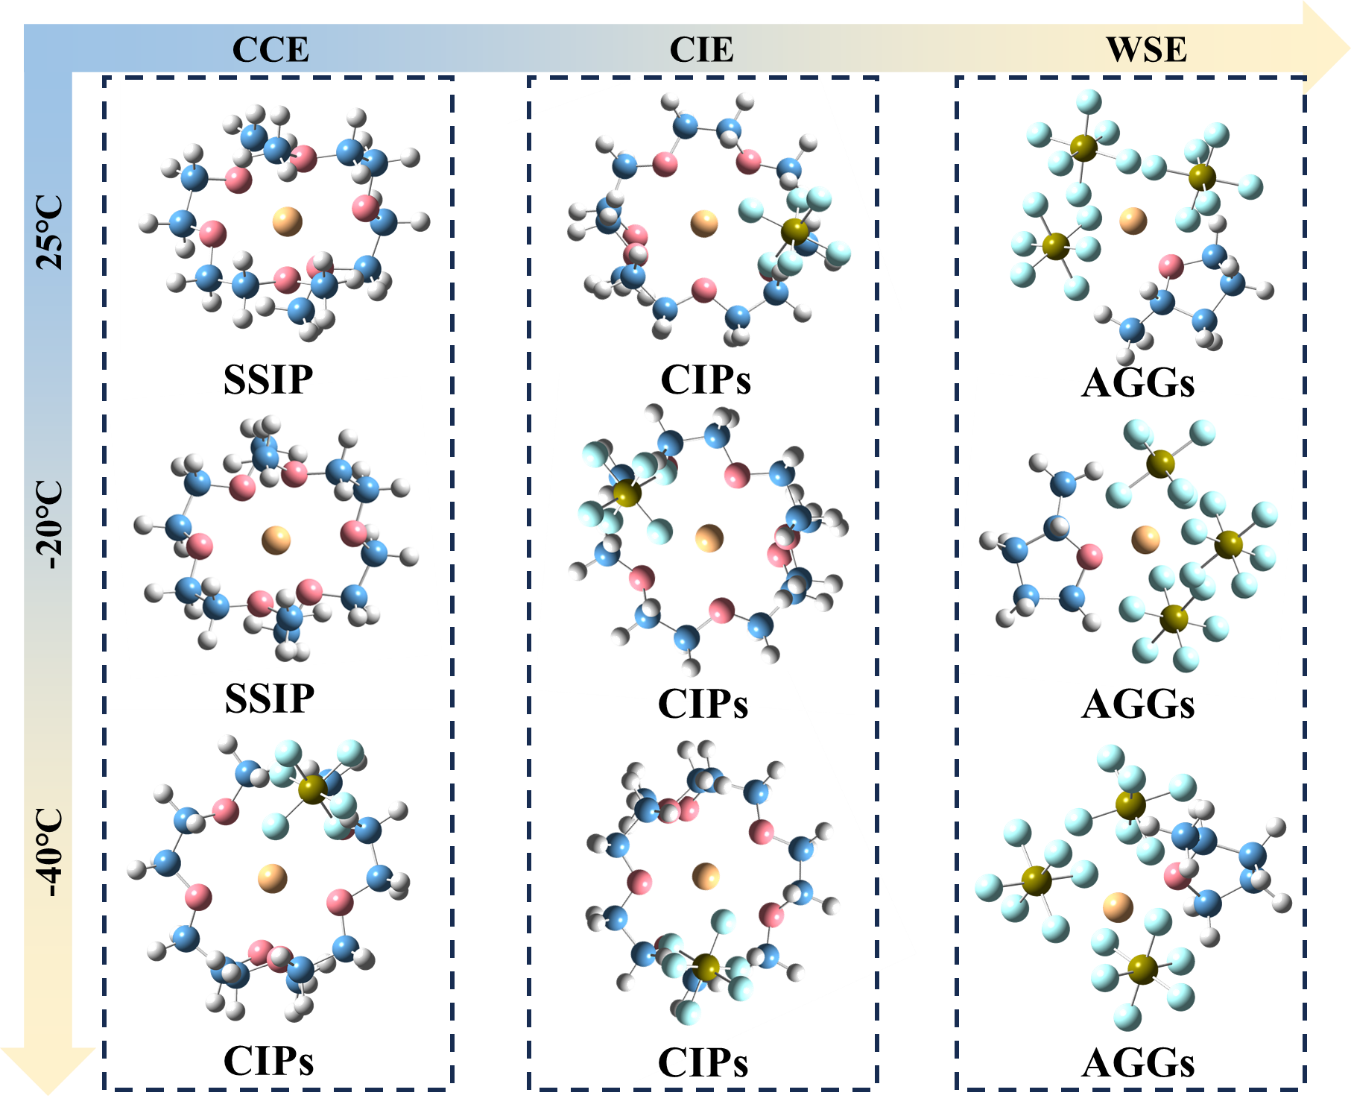
Figure S8. Typical solvation structures of various electrolytes at different temperatures.

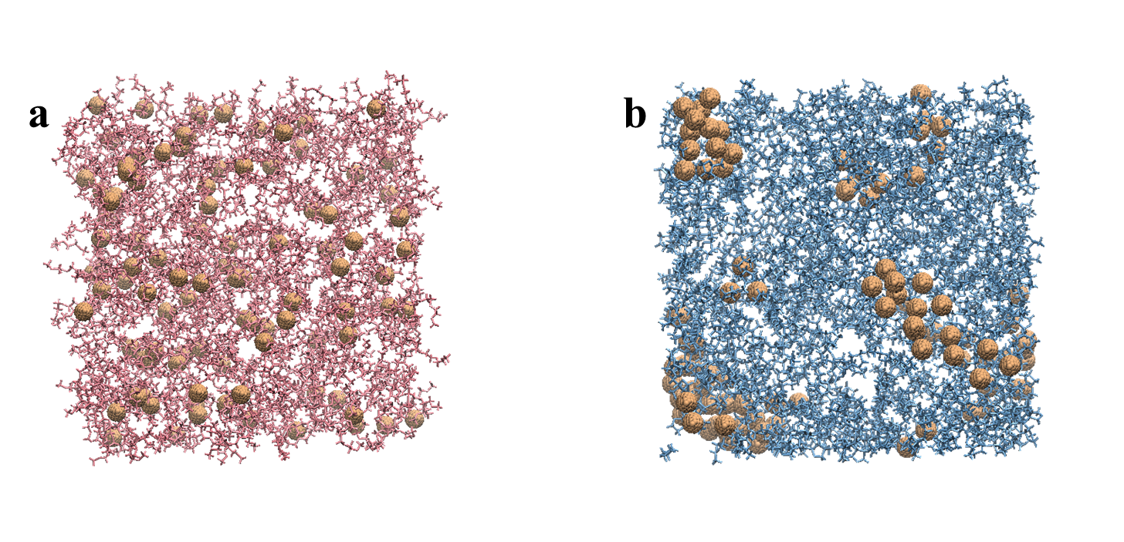
Figure S9. MD simulation snapshot of solvent environment of (a) CCE and (d) WSE.

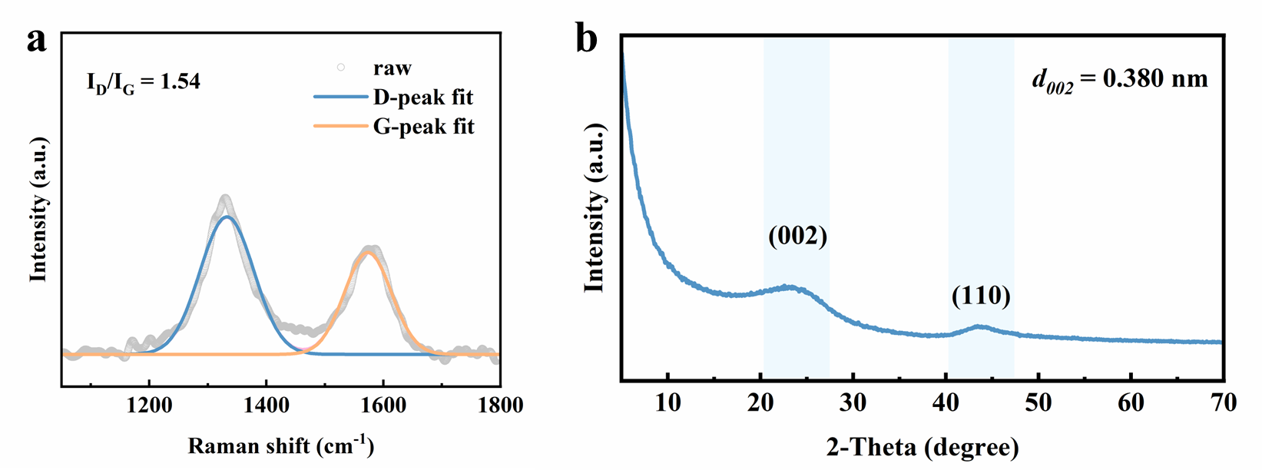
Figure S10. (a) XRD patterns and (b) Raman spectra of the hard carbon material used in this work.

Figure S11. Rate performance of various electrolytes at 25℃.

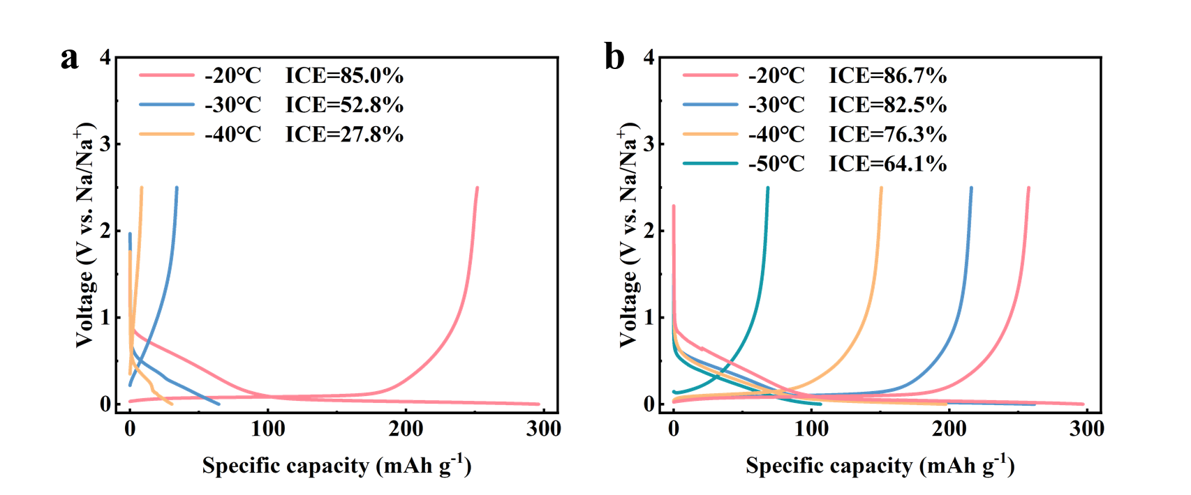
Figure S12. Charge/discharge curves of HC||Na cells at 20 mA g⁻¹ in first cycle using (a) CCE and (b) WSE at different temperatures.

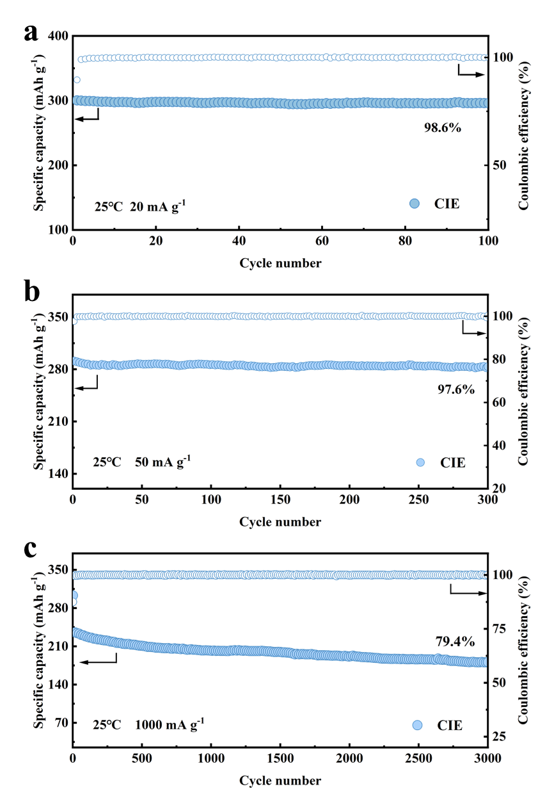
Figure S13. Cycling performance of HC||Na cells using CIE at 25℃ with current density of (a) 20 mA g⁻¹, (b) 50 mA g⁻¹ and (c) 1000 mA g⁻¹.

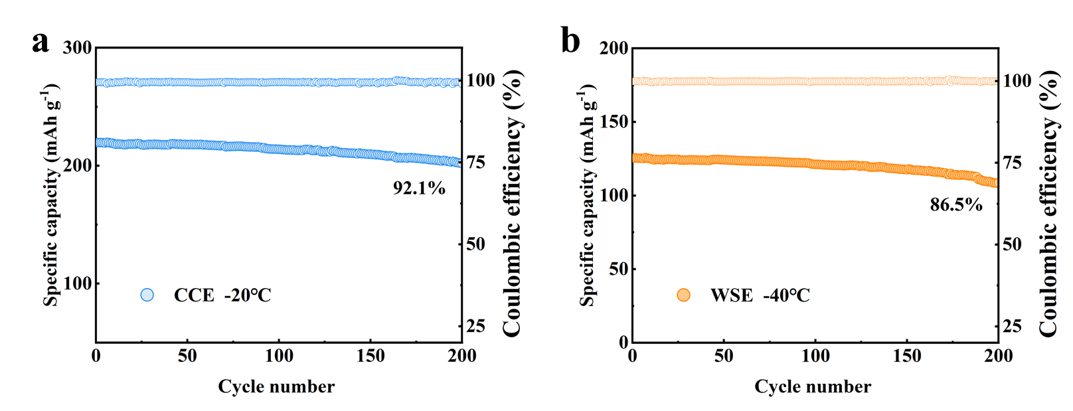
Figure S14. Low temperature cycling performance of HC||Na cells with (a) CCE and (b) WSE.

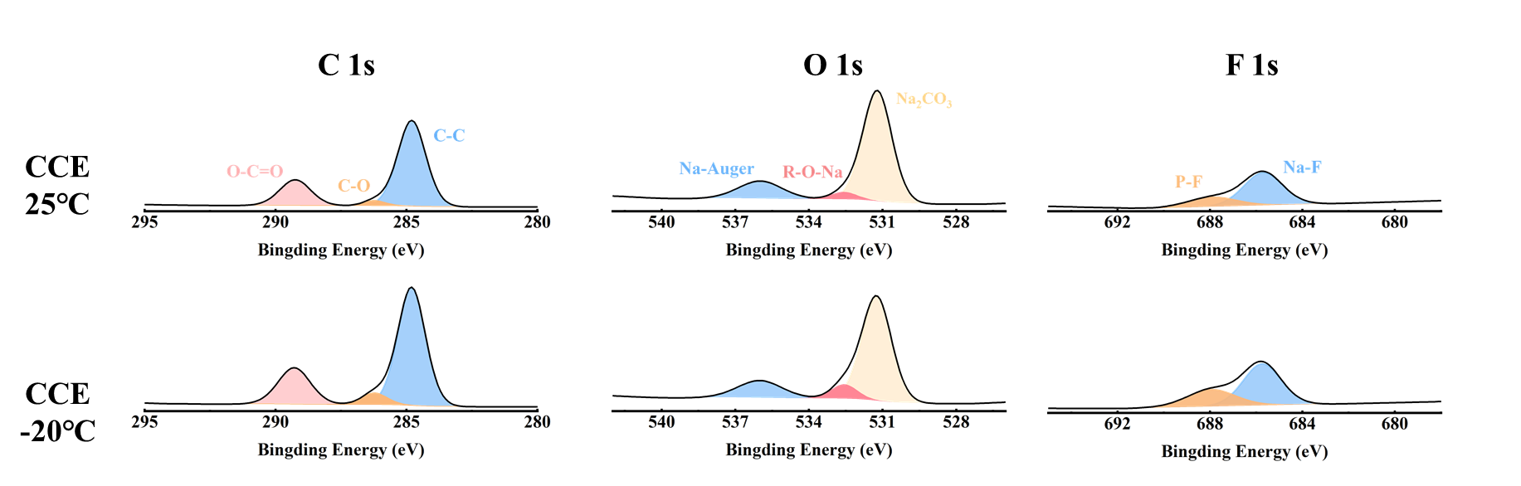
Figure S15. XPS spectra (C 1s, O 1s, F1s) of HC anodes after cycling using CCE at different temperatures.

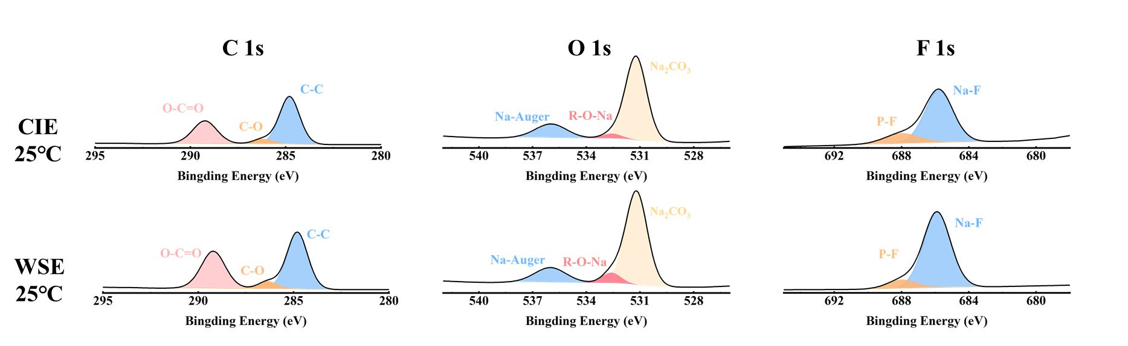
Figure S16. XPS spectra (C 1s, O 1s, F1s) of HC anodes after cycling using CCE and WSE at 25℃.

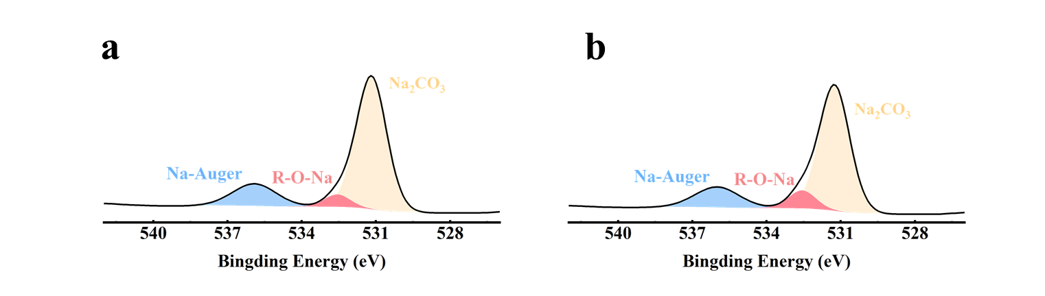
Figure S17. XPS spectra (O 1s) of HC anodes after cycling using (a) CCE and (b) WSE at -40℃.

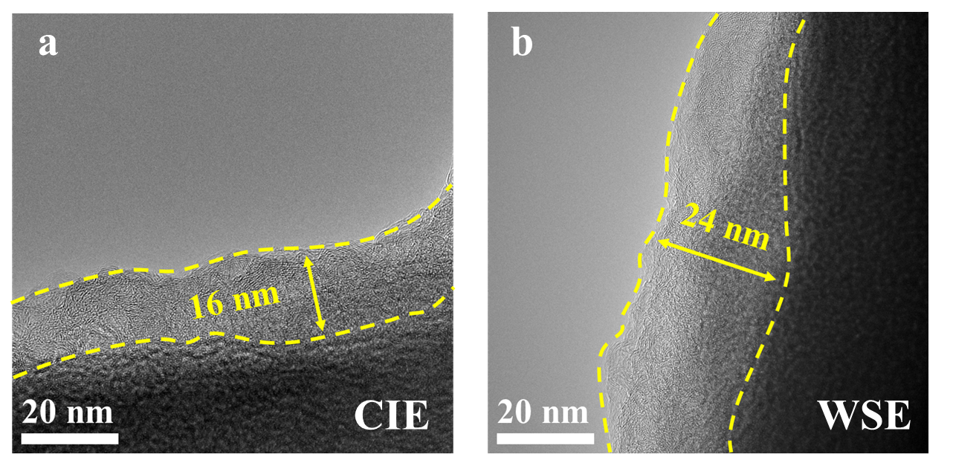
Figure S18. HRTEM images of HC anodes after 10 cycles using (a) CIE and (b) WSE at 25℃.

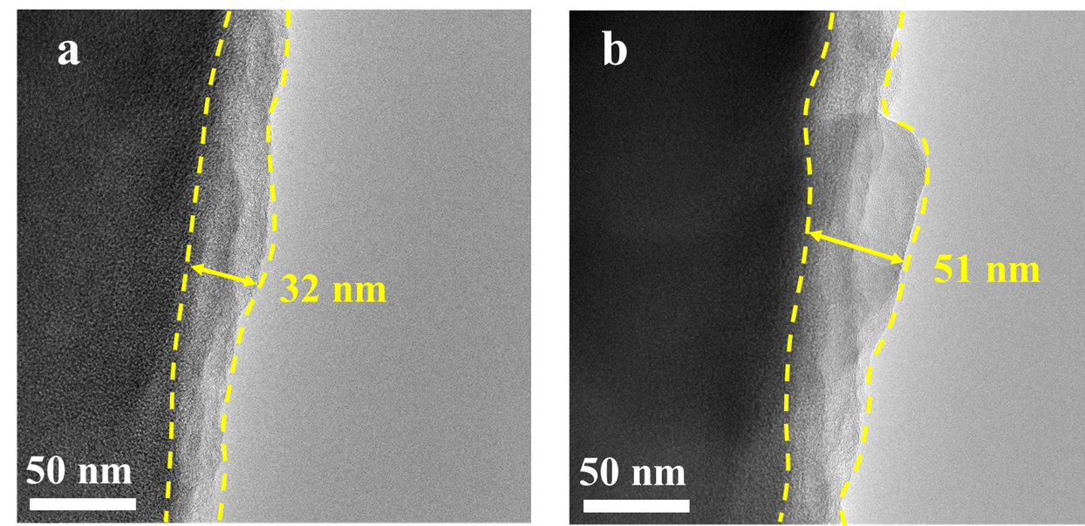
Figure S19. HRTEM images of HC anodes after 10 cycles using CCE at (a) 25℃ and (b) -20℃.

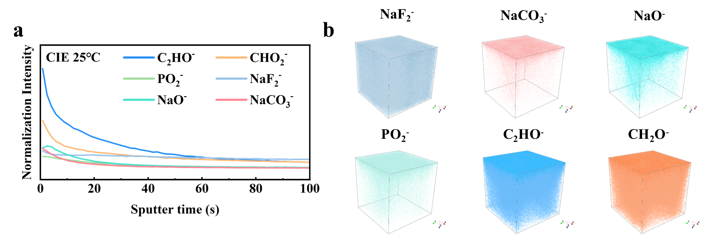
Figure S20. (a) Normalized TOF-SIMS depth profiles of C₂HO⁻, CHO₂⁻, PO₂⁻, NaF₂⁻, NaO⁻ and NaCO₃⁻ ionic fragments in HC anode after 10 cycles using CIE at 25℃. (b) 3D reconstruction images resolved by TOF-SIMS.

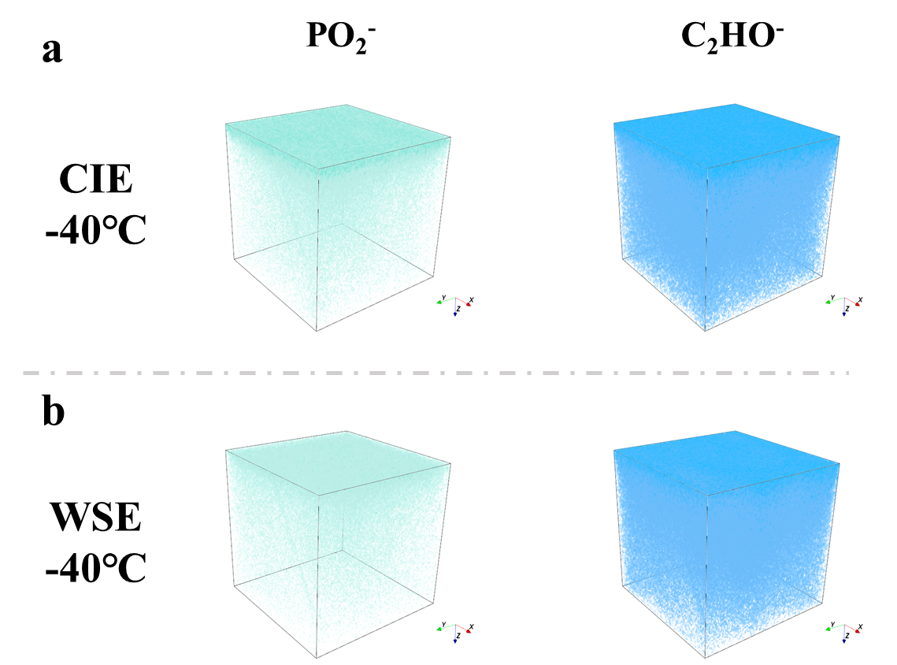
Figure S21. 3D reconstruction images of PO₂⁻ and C₂HO⁻ resolved by TOF-SIMS in (a) CIE and (b) WSE at -40℃.

Figure S22. Ex-situ Raman spectra of HC electrode using WSE at -40 ℃.

Figure S23. GITT curves of the HC||Na cells at -40 ℃.

Figure S24. Diffusion coefficients of different electrolytes during the charging process.

Figure S25. In-situ EIS curves during the charge process of different electrolytes.

Figure S26. R_{ct} values at different voltages.

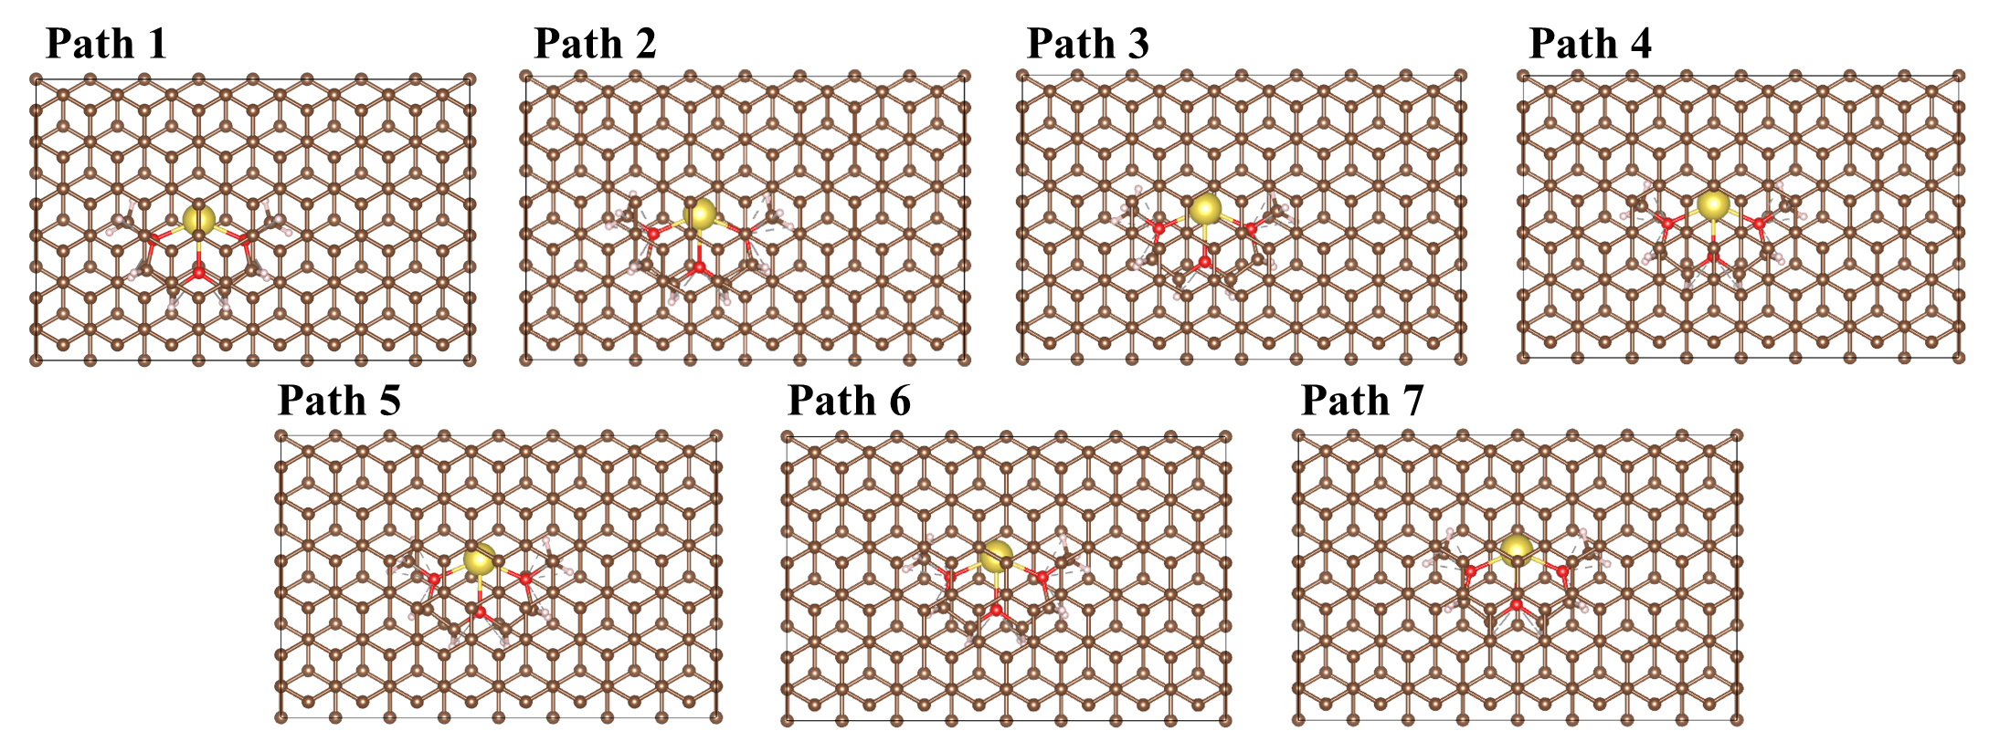
Figure S27. Migration path of Na⁺-G2 chelate in carbon layer.

Figure S28. The diffusion energy barrier of a single Na⁺.

Table S1. Partial physical properties of solvents.

Solvent | Melting point  (℃) | Dielectric constant | Viscosity  (mPa s) | Donor number  (kcal mol⁻¹)
G2 | -68 | 7.2 | 0.98 | 19
MO | -136 | 6.97 | 0.65 | 18

Table S2. The specific formulation of different electrolytes.

Electrolyte name | Electrolyte formulation
CCE | 0.8 M NaPF₆ in G2 = 100 vol%
CIE | 0.8 M NaPF₆ in G2:MO = 7:3 vol%
WSE | 0.8 M NaPF₆ in MO = 100 vol%

Table S3. Comparison of ICE of HC at different temperatures between CIE and previously reported SIB electrolytes.
Label | Electrolyte | Room  temperature  ICE (%) | Low  temperature ICE (%) | References
A | NaPF₆ in DEGDME  + 0.25 M MTPPB | 96.6 | 90.4 (-20℃) | Angew. Chem. Int. Ed. 2025, 64, e202416939
B | NaFSI in DMC/TFP | 81 | / | Nature Energy 7,  718–725 (2022)
C | NaClO₄ in TMP/TFEP | 82.3 | / | J. Am. Chem. Soc.2024, 146, 23, 15751–15760
D | NaPF₆ in PC/TFEP/DEC | 82.4 | / | Angew. Chem. Int. Ed. 2024, 63, e202407717
E | NaTFSI in EC/PC/EP-NaDFOB/SN | 70.2 | / | Angew. Chem. Int. Ed. 2024, 63, e202401051
F | NaPF₆ in DME | 82.5 | 60.7 (-20℃) | Nano Energy 132 (2024) 110362
G | NaFSI in PC/EC | 85 | / | Energy Storage Materials 16 (2019) 146–154
H | NaPF₆ in /EC/DEC | 91 | / | Nature Commun 16, 3634 (2025)
I | NaFSI in AN+ 0.05 M NaDFOB | ≈81 | / | Adv. Energy Mater. 2025, 2405319
J | NaFSI in EC/PC/HFE/FEC | 79.94 | / | Nano Energy 136 (2025) 110777
This work | CIE | 93.7 | 91.4 (-20℃)  80.5 (-50℃) | This work

Table S4. Comparison of the capacity of sodium-ion pouch cells at low temperatures between this work and previously reported.
Label | Capacity  (mAh) | Temperature  (%) | References
Ref. S1 | 890.35 | -20 | Energy Storage Materials 73 (2024) 103805
Ref. S2 | 350 | -20 | J. Am. Chem. Soc. 2025, 147, 5162−5171
Ref. S3 | 70 | -20 | Angew. Chem. Int. Ed. 2025, 64, e202424028
Ref. S4 | 1060 | -25 | Adv. Mater. 2024, 36, 2312161
Ref. S5 | 450 | -25 | Adv. Mater. 2024, 36, 2408161
Ref. S6 | 729 | -30 | Energy Storage Materials 75 (2025) 103997
Ref. S7 | 884 | -40 | Adv. Energy Mater. 2025, 15, 2403306
Ref. S8 | 255 | -40 | Angew. Chem. Int. Ed. 2025, e202502693
This work | 1042  977  790 | -30  -40  -50 | This work

Table S5. Pouch cell details and parameters.
 | Specifications | Values | Units | Mass (g)
Cathode (O3-NFM- Super P- CNT- PVDF@Al foil) | Active material ratio | 95.3% | / | 11.52
Cathode (O3-NFM- Super P- CNT- PVDF@Al foil) | Electrode mass load | 15 × 2 | mg cm⁻² | 11.52
Cathode (O3-NFM- Super P- CNT- PVDF@Al foil) | Number of layers | 8 | / | 11.52
Cathode (O3-NFM- Super P- CNT- PVDF@Al foil) | Electrode size | 60 × 80 | mm | 11.52
Cathode (O3-NFM- Super P- CNT- PVDF@Al foil) | Reversible capacity | 108 | mAh g⁻¹ | 11.52
Anode (HC- Super P- CMC- SBR- water@Al foil) | Active material ratio | 94.5 | / | 5.04
Anode (HC- Super P- CMC- SBR- water@Al foil) | Electrode mass load | 6.2 × 2 | mg cm⁻² | 5.04
Anode (HC- Super P- CMC- SBR- water@Al foil) | Number of layers | 8 | mm | 5.04
Anode (HC- Super P- CMC- SBR- water@Al foil) | Electrode size | 62 × 82 | / | 5.04
Anode (HC- Super P- CMC- SBR- water@Al foil) | Reversible capacity | 300 | mAh g⁻¹ | 5.04
Separator (PP) | Number of layers | 8 | / | 0.48
Current collector  (Al foil) | Mass area density | 2.49 | mg cm⁻² | 2.01
Current collector  (Al foil) | Thickness | 9 | μm | 2.01
Electrolyte (CIE) | Volume | 4 | ml | 3.80
Electrolyte (CIE) | Electrolyte-to-capacity (E/C) | 3.17 | g Ah⁻¹ | 3.80
Package | Al-plastic film and tab | / | / | 3.04
Pouch cell | Capacity | 1.2 | Ah | 22.85  (without package)  25.89  (with package)
Pouch cell | Average voltage | 3.1 | V | 22.85  (without package)  25.89  (with package)
Pouch cell | Energy | 3.72 | Wh | 22.85  (without package)  25.89  (with package)
Pouch cell | Energy density (without package) | 163 | Wh kg⁻¹ | 22.85  (without package)  25.89  (with package)
Pouch cell | Energy density (with package) | 144 | Wh kg⁻¹ | 22.85  (without package)  25.89  (with package)

Note: The specific energy reported in Wh kg⁻¹ in the manuscript do not consider the packages, we give more detailed cell parameters in the table above and include the packages in the calculations.

References
1 Grimme, S., Antony, J., Ehrlich, S. & Krieg, H. A consistent and accurate ab initio parametrization of density functional dispersion correction (DFT-D) for the 94 elements H-Pu. The Journal of Chemical Physics 132 (2010). https://doi.org/10.1063/1.3382344
2 Zhang, J. & Lu, T. Efficient evaluation of electrostatic potential with computerized optimized code. Physical Chemistry Chemical Physics 23, 20323-20328 (2021). https://doi.org/10.1039/D1CP02805G
3 Abraham, M. J. et al. GROMACS: High performance molecular simulations through multi-level parallelism from laptops to supercomputers. SoftwareX 1-2, 19-25 (2015). https://doi.org/https://doi.org/10.1016/j.softx.2015.06.001
4 Sambasivarao, S. V. & Acevedo, O. Development of OPLS-AA Force Field Parameters for 68 Unique Ionic Liquids. Journal of Chemical Theory and Computation 5, 1038-1050 (2009). https://doi.org/10.1021/ct900009a
5 Dodda, L. S., Cabeza de Vaca, I., Tirado-Rives, J. & Jorgensen, W. L. LigParGen web server: an automatic OPLS-AA parameter generator for organic ligands. Nucleic Acids Research 45, W331-W336 (2017). https://doi.org/10.1093/nar/gkx312
6 Lu, T. & Chen, F. Multiwfn: A multifunctional wavefunction analyzer. Journal of Computational Chemistry 33, 580-592 (2012). https://doi.org/https://doi.org/10.1002/jcc.22885
7 Humphrey, W., Dalke, A. & Schulten, K. VMD: Visual molecular dynamics. Journal of Molecular Graphics 14, 33-38 (1996). https://doi.org/https://doi.org/10.1016/0263-7855(96)00018-5
8 McGibbon, Robert T. et al. MDTraj: A Modern Open Library for the Analysis of Molecular Dynamics Trajectories. Biophysical Journal 109, 1528-1532 (2015). https://doi.org/https://doi.org/10.1016/j.bpj.2015.08.015
9 Hohenberg, P. & Kohn, W. Inhomogeneous Electron Gas. Physical Review 136, B864-B871 (1964). https://doi.org/10.1103/PhysRev.136.B864
10 Perdew, J. P., Burke, K. & Ernzerhof, M. Generalized Gradient Approximation Made Simple. Physical Review Letters 77, 3865-3868 (1996). https://doi.org/10.1103/PhysRevLett.77.3865

