Tables
Table 1 Characteristics of the participants
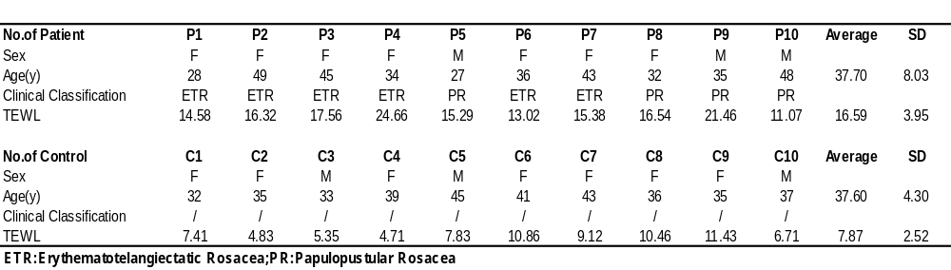

Table 2 Differential lipids of the lipidome with VIP>1 and p value<0.05
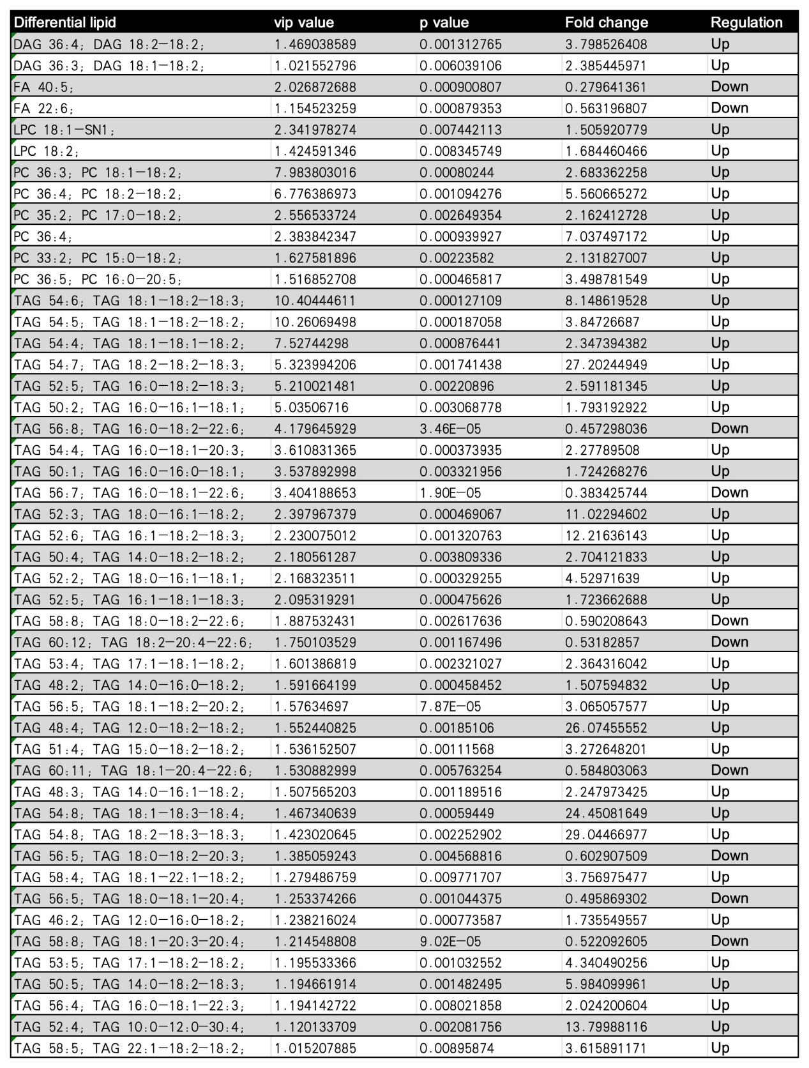

Table 3 Correlation between TEWL and SSL levels
