Supplementary material

Supplementary table X. Clinical information of control and TSC cases
ID | PA  Diagnosis | Sex | Onset epilepsy age (y) | Age at operation  (m/y) | Gene | Cause of death | Brain area
1 | Control | M | - | 12 | - | Myocarditis | Frontal cortex
2 | Control | F | - | 16 | - | Intramedullary spinal cord tumor | Frontal cortex
3 | Control | F | - | 5 | - | Pneumonia | Frontal cortex
4 | TSC | M | 0 | 2 | TSC2 | - | Frontal cortex
5 | TSC | M | 0 | 5 | TSC2 | - | Frontal cortex
6 | TSC | F | 0 | 8 | TSC2 | - | Frontal cortex
7 | TSC | F | 0 | 0 | TSC2 | - | Temporal cortex
8 | TSC | F | 0 | 17 | TSC2 | - | Parietal cortex
9 | FCD2a | M | 5 | 11 | MTOR | - | Frontal cortex
10 | FCD2a | F | 2 | 9 | MTOR | - | Frontal cortex
11 | FCD2b | M | 1 | 14 | MTOR | - | Frontal cortex
12 | FCD2b | M | 3 | 5 | MTOR | - | Frontal cortex
13 | FCD2b | M | 1 | 15 | MTOR | - | Frontal cortex
14 | FCD2a | F | 0 | 1 | DEPDC5 | - | Frontal cortex
15 | FCD2a | F | 0 | 10 | DEPDC5 | - | Frontal cortex
16 | FCD2a | M | 0 | 0 | DEPDC5 | - | Frontal cortex

Supplementary table X. Cell type markers used in annotation of cell type clusters.
Cell type | Marker genes
Glutamatergic neurons | SLC17A7, SATB2, SLC17A6, GRIN1
GABAergic neurons | GAD1, GAD2
Astrocytes | ALDH1L1, AQP4, SLC1A2, S100B
Microglia | PTPRC, ITGAM, P2RY12, TMEM119
Oligodendrocytes | OLIG1, CLDN11, MOG, MBP
OPCs | PDGFRA, CSPG4
Endothelial cells | CLDN5, PECAM1
Perictyes | PDGFRB

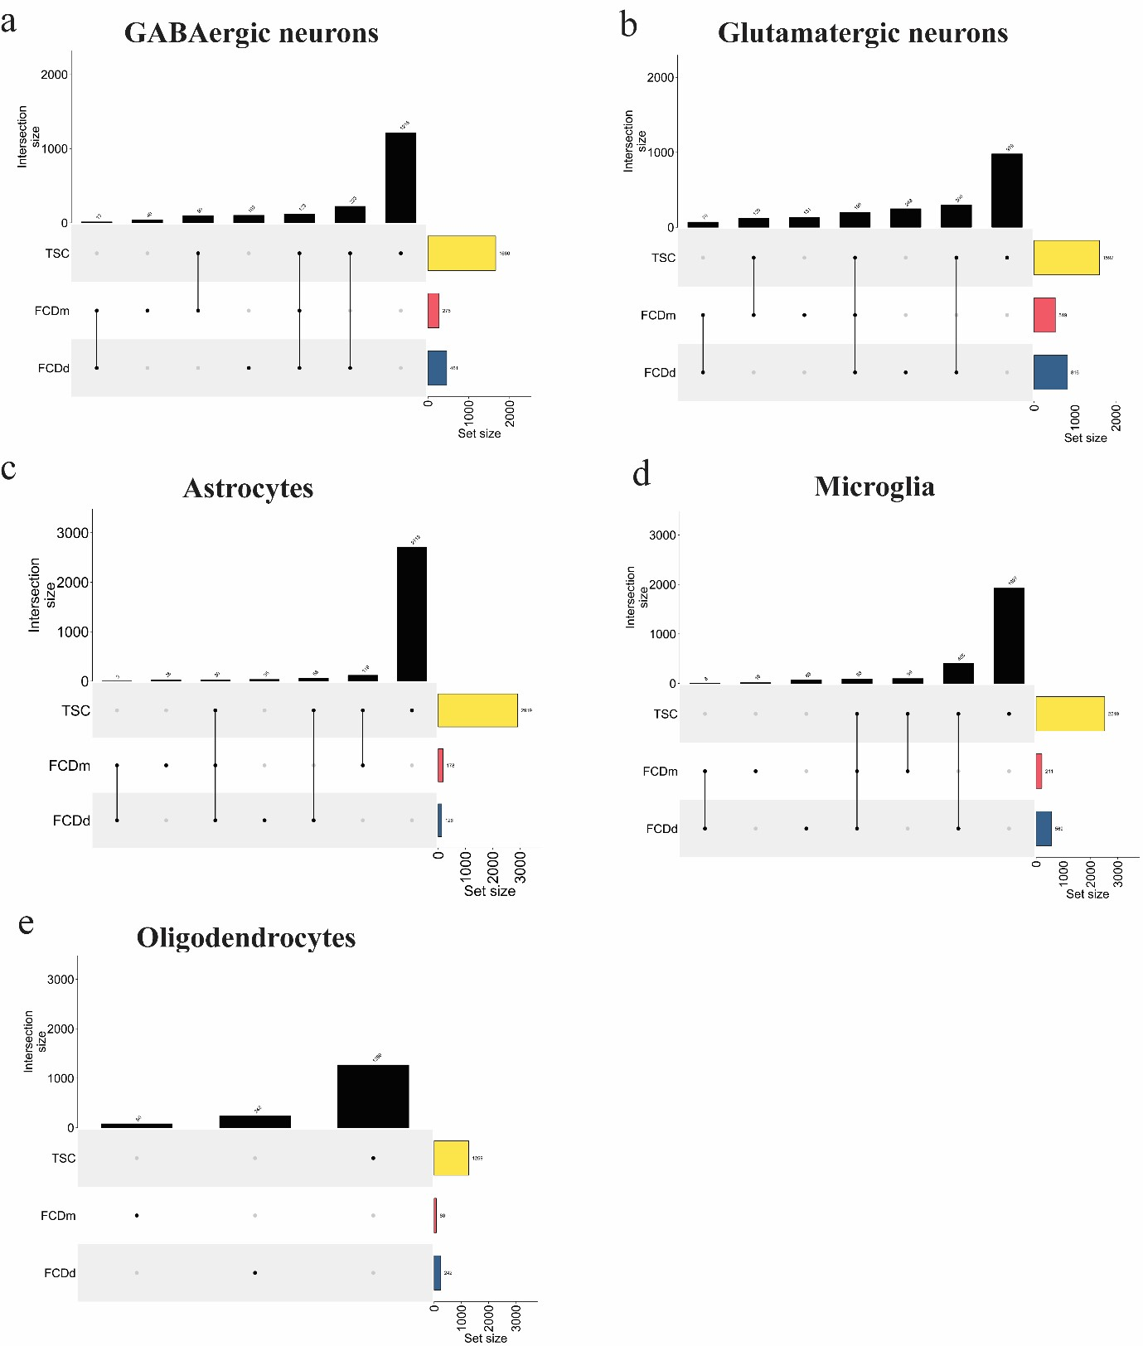
Supplementary figure 1. Enrichment of differentially expressed genes (DEGs) in distinct cell types across TSC and FCD subtypes.
Bar plots display the number of significant DEGs identified in (a) GABAergic neurons, (b) glutamatergic neurons, (c) astrocytes, (d) microglia, and (e) oligodendrocytes across TSC, FCD_mTOR (FCDm), and FCD_DEPDC5 (FCDd) cases. The upset plots below each bar plot indicate the overlap of DEGs among the three conditions. The black bars in the upper panel represent the number of significant DEGs in each cell type per condition, with a notably higher number observed in TSC compared to FCDm and FCDd. The lower panel highlights the intersection of DEGs among conditions, with color coding representing the set size. Yellow, red, and blue bars correspond to TSC-, FCDm-, and FCDdspecific DEGs, respectively.
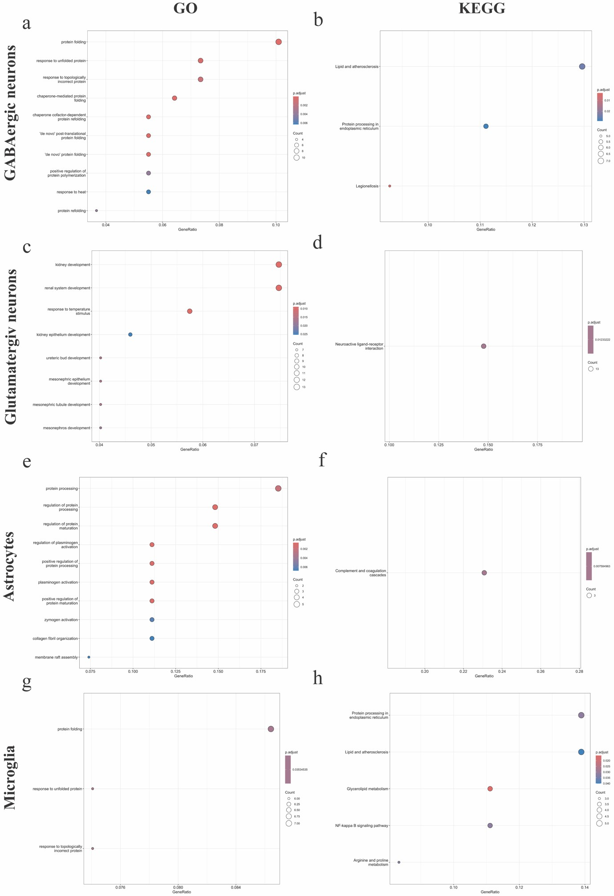
Supplementary figure 2. Gene Ontology (GO) and Kyoto Encyclopedia of Genes and Genomes (KEGG) pathway enrichment analysis of differentially expressed genes (DEGs) in distinct cell types. Dot plots illustrate the enriched (a, c, e, g) Gene Ontology (GO) biological processes and (b, d, f, h) KEGG pathways for DEGs identified in (a–b) GABAergic neurons, (c–d) glutamatergic neurons, (e–f) astrocytes, and (g–h) microglia. The x-axis represents the gene ratio, while the y-axis lists the top enriched terms. Dot size corresponds to the number of DEGs associated with each term, and color intensity represents the adjusted p-value, with darker colors indicating higher significance. Notable enrichment is observed in processes related to neuronal function and glial activation.

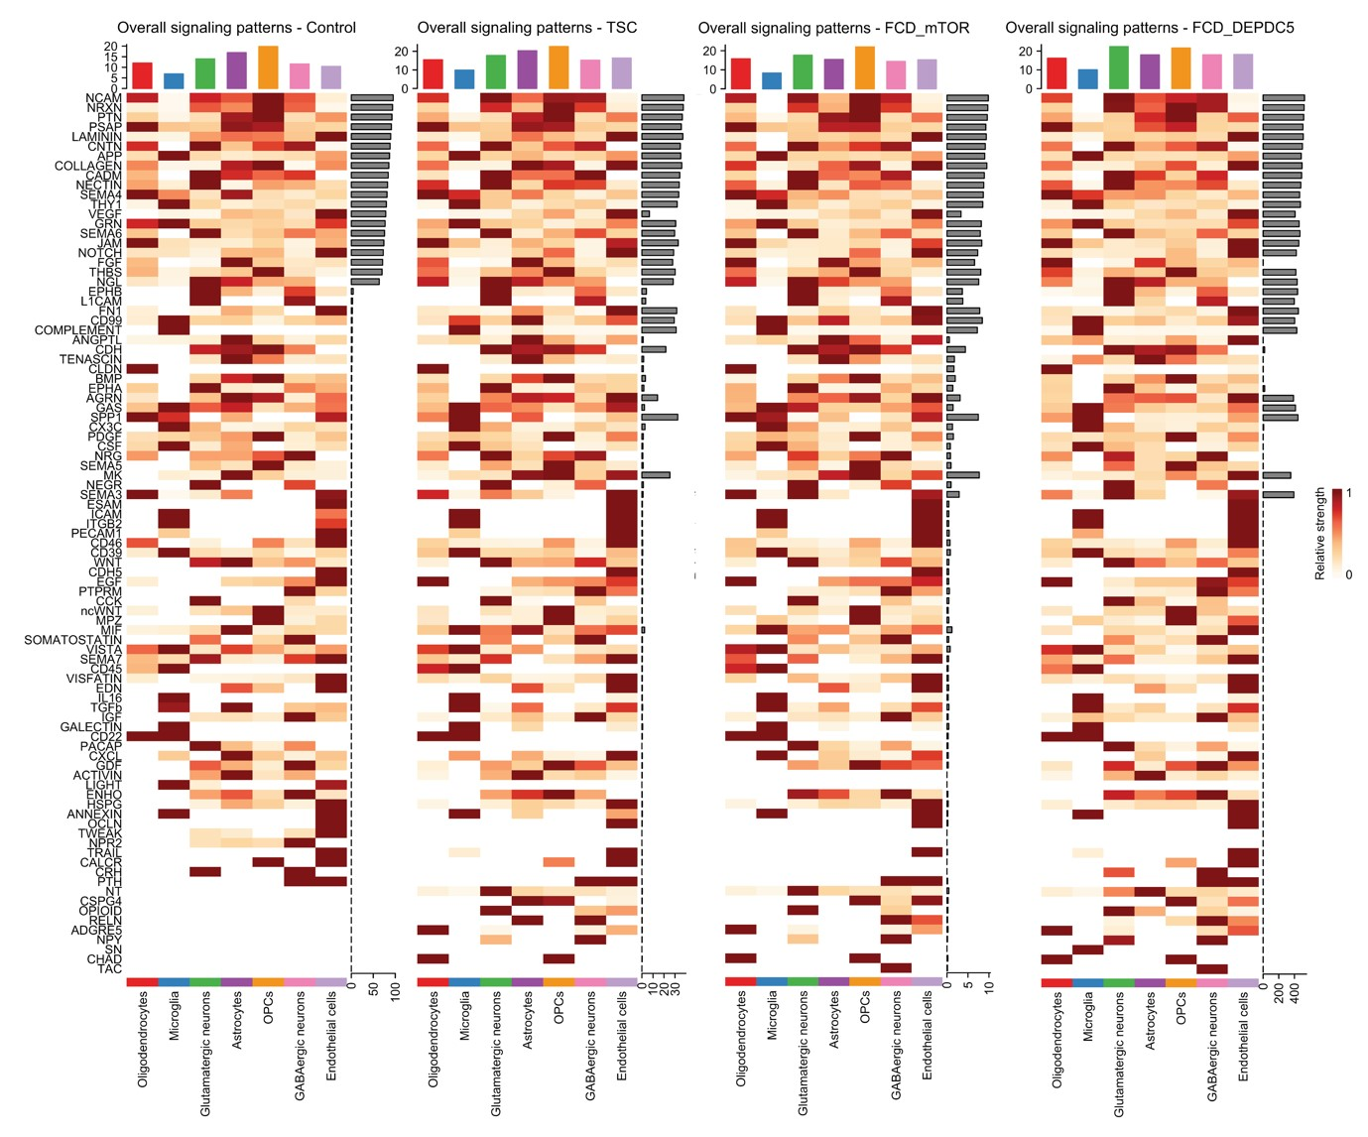 Supplementary figure 3. Overall signaling patterns across control, TSC, FCD_mTOR and FCD_DEPDC5. Heatmaps display the relative signaling strength of signaling pathways across cell groups, with rows representing signaling pathways and columns representing cell types. Values are row-scaled, reflecting the relative contribution of each pathway. The top barplots indicate the total signaling strength for each cell type by summing all pathway contributions, while the side bar plots represent the total signaling strength for each pathway across all cell types. (A) Control samples. (B) TSC samples. (C) FCD_mTOR samples. (D). FCD_DEPDC5 samples.

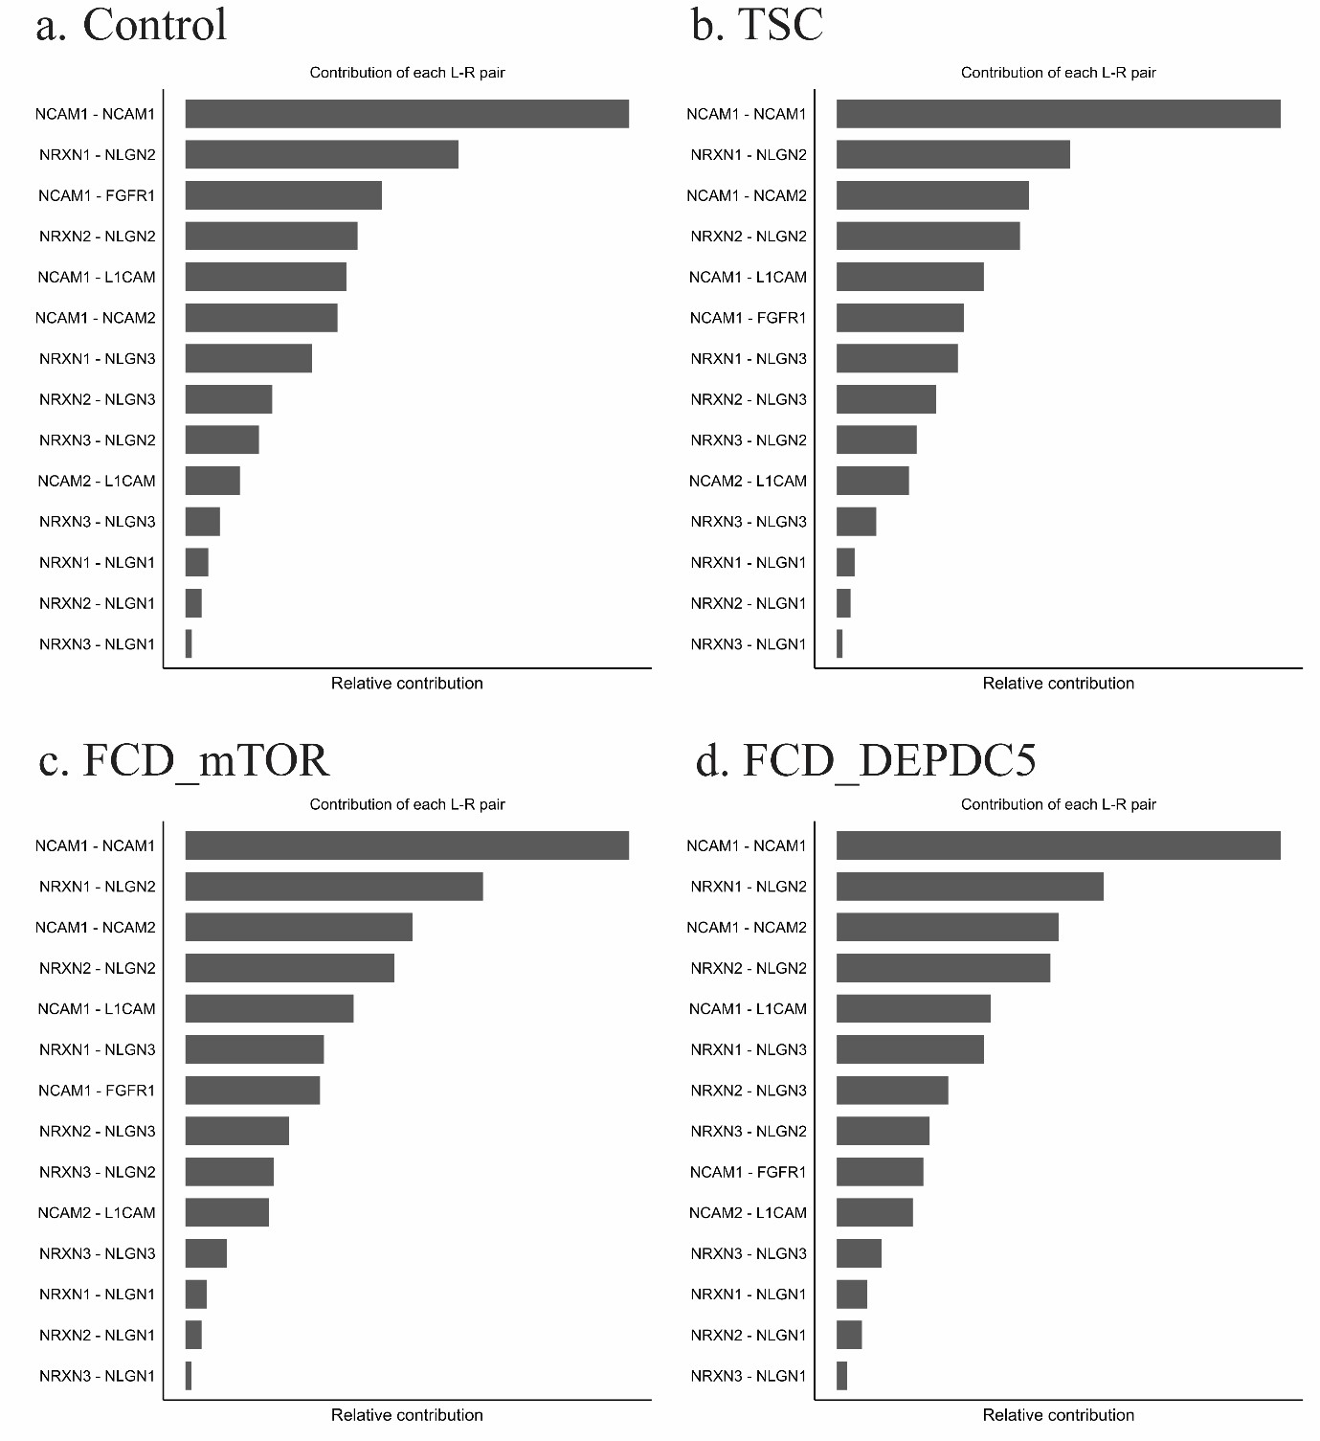
Supplementary figure 4. Top ligand-receptor (L-R) interactions in control and disease conditions. Bar plots represent the relative contribution of the most enriched ligand-receptor (L-R) interaction pairs in (a) control, (b) TSC, (c) FCD_mTOR, and (d) FCD_DEPDC5 conditions. The x-axis denotes the relative contribution of each L-R pair, while the y-axis lists the top L-R interactions identified in each condition. Nectin (NCAM)-related interactions are among the most prevalent across all conditions, with notable differences in their relative contributions between control and disease states.

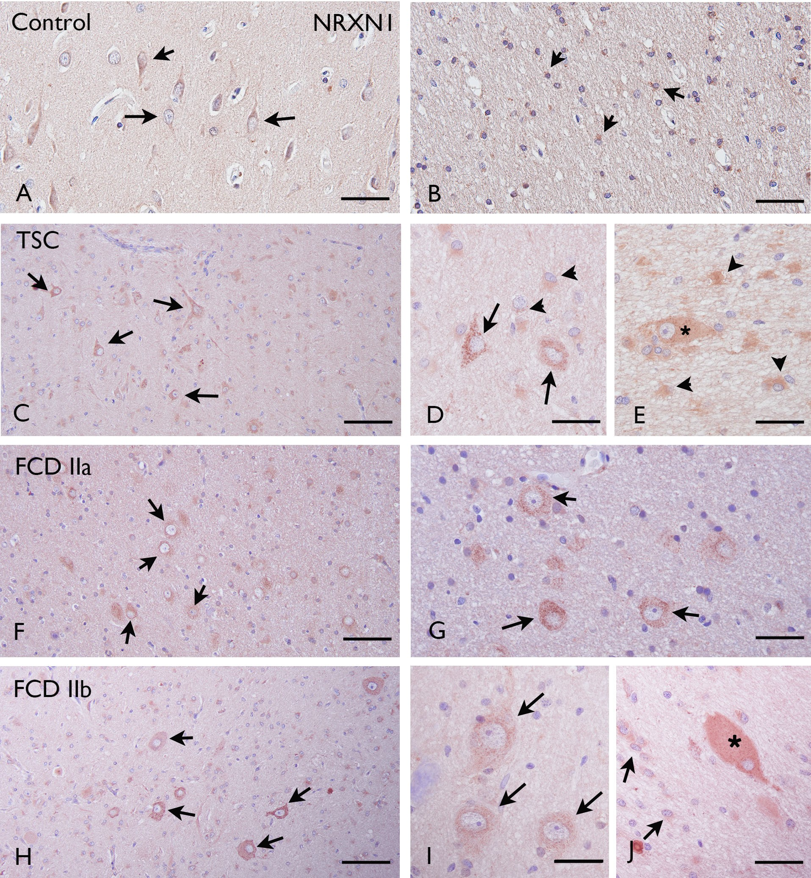

Supplementary figure 5. Cellular expression pattern of NRXN1 (neurexin-1) immunoreactivity (IR) in tuberous sclerosis complex (TSC) and focal cortical dysplasia type IIa (FCD IIa) and FCD type IIb (FCD IIb). Panels A-B (control cortex, A and white matter, B): NRXN1 IR was observed in neurons (arrows in A) and in few astrocytes (arrows in b). Panels C-E (TSC), F-G (FCD IIa) and panels H-J (FCD IIb): NRXN1 IR was observed in dysmorphic neurons (arrows C-D, F-I), as well as in reactive astrocytes (arrowheads in D-E; arrows in J). NRXN1 was also observed in giant cells in TSC (asterisk in E), as well as in balloon cells in FCD IIb (asterisk in J). Scale bars in A-B, D-G, I-J: 40 µm; C,F and H: 80 µm.

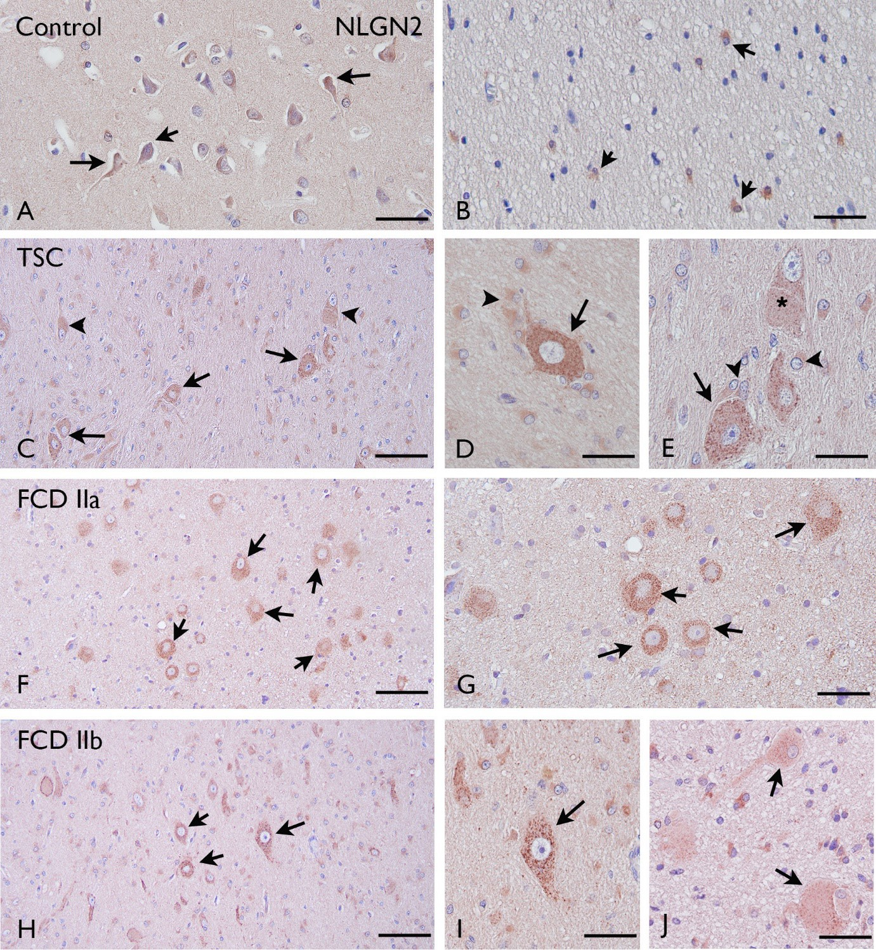 Supplementary figure 6. Cellular expression pattern of NLGN2 (neuroligin-2) immunoreactivity (IR) in tuberous sclerosis complex (TSC) and focal cortical dysplasia type IIa (FCD IIa) and FCD type IIb (FCD IIb). Panels A-B (control cortex, A and white matter, B): NLGN2 IR was observed in neurons (arrows in A) and in few astrocytes (arrows in b). Panels C-E (TSC), F-G (FCD IIa) and panels H-J (FCD IIb): NLGN2 IR was observed in dysmorphic neurons (arrows C-I), as well as in reactive astrocytes (arrowheads in D-E, I-J). NLGN2 was also observed in giant cells in TSC (arrowhead in C and asterisk in E), as well as in balloon cells in FCD IIb (asterisk in J). Scale bars in A-B, D-G, I-J: 40 µm; C,F and H: 80 µm.

