B₄-engine as the rotational driver of the B₁₃⁺ Cluster: Study based on BOMD and AdNDP analysis
Sourav Ranjan Ghosh^{a,b} , Sasthi Charan Halder^{a,c}and Atish Dipankar Jana^{a,d,*}
ª Center for Research in Nanoscience and Crystal Engineering , Sibani Mandal Mahavidyalaya,
Namkhana, South 24 Parganas, 743357, India
^{b} Department of Physics, Heritage Institute of Technology, Kolkata, 700107, India
^{c}Department of Physics, Behala College, Parnasree, Kolkata, 700060, India
^{d}Institute of Astronomy Space and Earth Science, P-177, CIT Road, Scheme 7m, Ultadanga Station,
Kolkata, 700054, India.

*E-mail: atishdipankarjana@yahoo.in

Supplementary Information
TOC for supplementary materials
Fig.S1.a) Snapshots from the BOMD simulation at different time frames for B₄ GS cluster
b) time evolution of diagonal B(1)-B(3) atom distance
c) time evolution of diagonal B(2)-B(4) atom distance
Fig.S2.Time evolution of two corner distances for B₄GS cluster at 300K
Fig.S3. Canonical Molecular Orbital (CMO) of B₄ TS and GS cluster
Fig.S4. Energy levels of LUMO and HOMO to HOMO -5 for the B₄TS and GS
configuration
Fig. S5. AdNDP orbital of B₁₃⁺ GS forming its square (S) and diamond (D1 and D2) motifs

Table S1.Optimized bond length of the B₁₃⁺ TS and GS cluster
Table S2.Occupation Number and energy of the AdNDP Orbitals
Table S3.NAO composition of the AdNDP 2c-2e Orbitals
Table S4. NAO composition of the AdNDP 4c-2e Orbitals

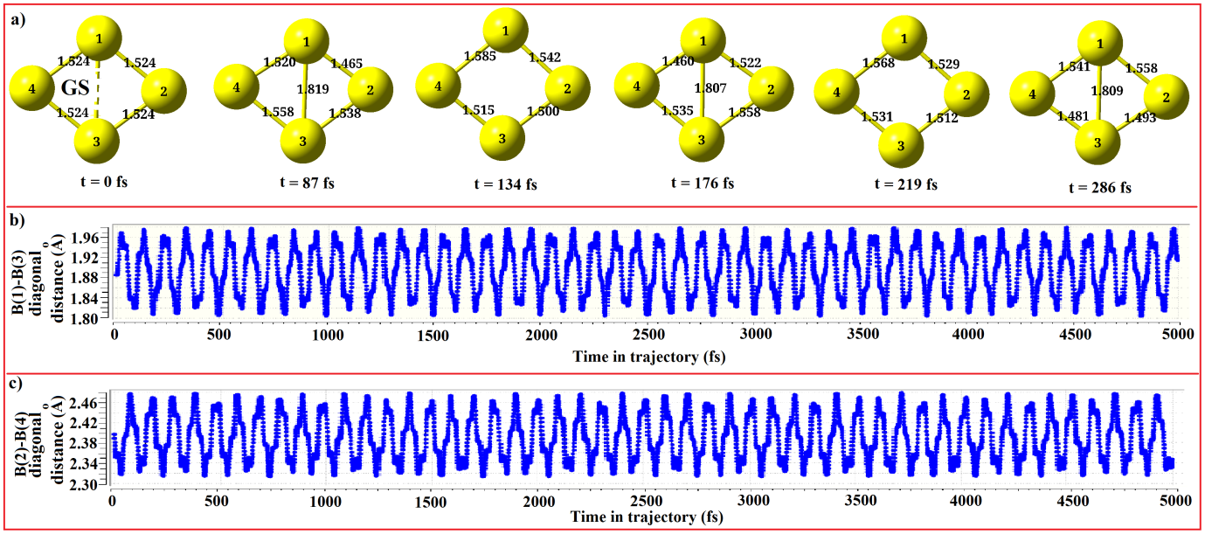
Fig.S1.a)Snapshots from the BOMD simulation at different time frames for B₄ GS cluster
b)time evolution of diagonal B(1)-B(3) distance
c) time evolution of diagonal B(2)-B(4)distance
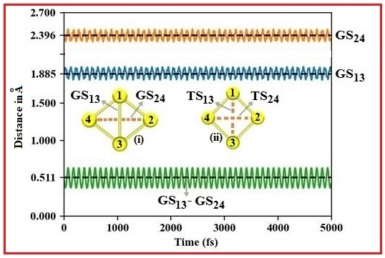
Fig.S2.Time evolution of two corner distancesfor B₄GS in comparison with optimized corner distance for GS (i), with their difference and TS (ii) corner distance

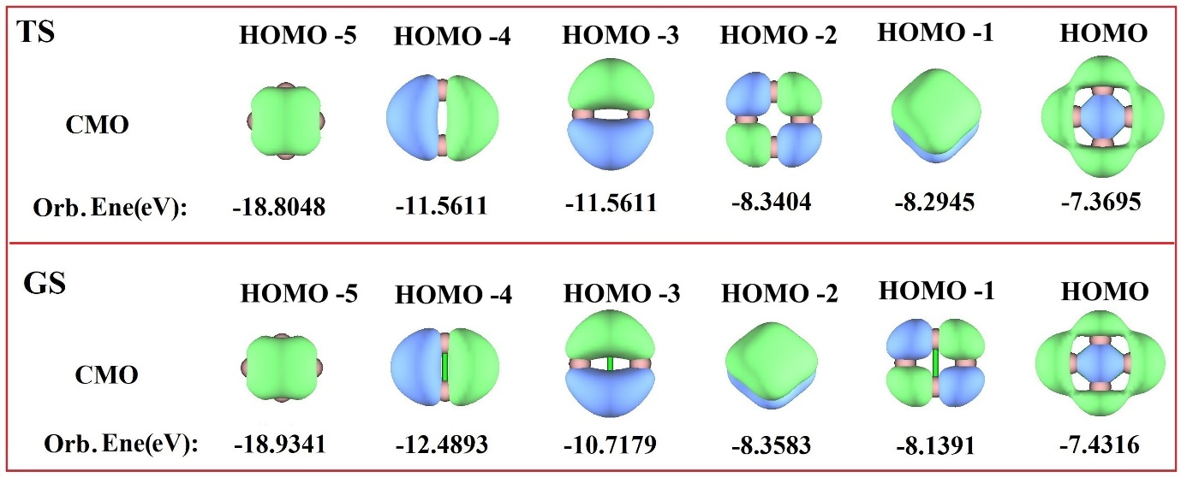
Fig. S3. Canonical Molecular Orbital (CMO) of B₄ TS and GS cluster

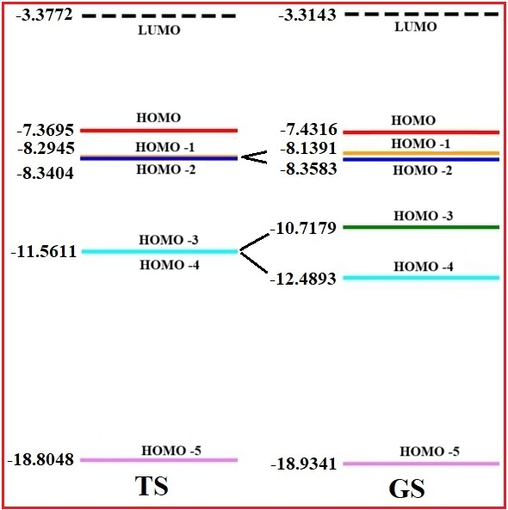
Fig.S4. Energy levels of LUMO and HOMO to HOMO-5 for the B₄ TS and GS

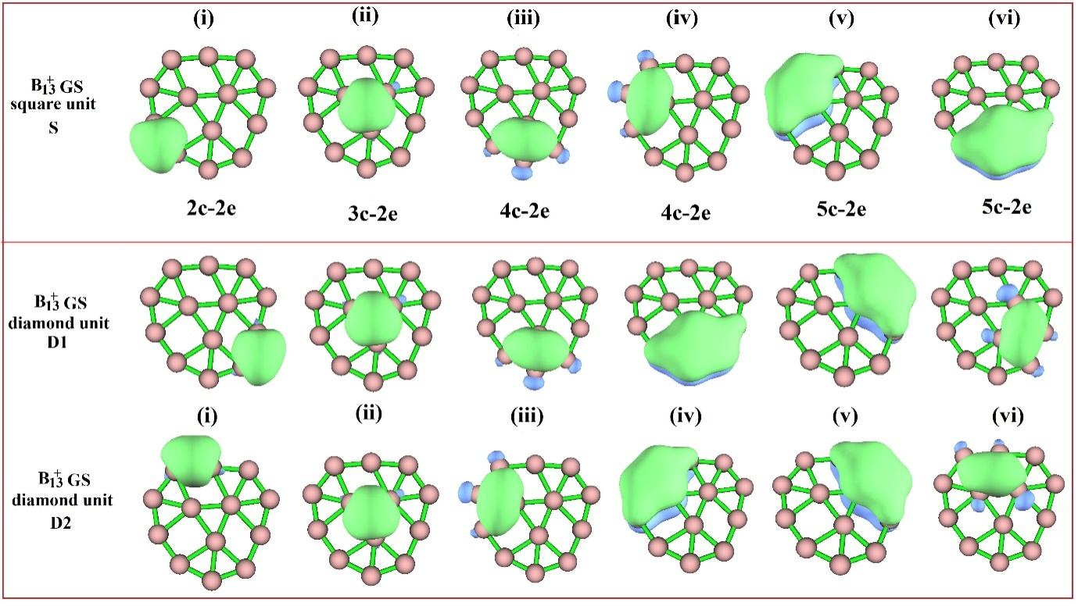
Fig. S5. AdNDP orbital in the forming of B₁₃⁺ GS square (S) and diamond (D1 and D2) units

Table S1. Optimized bond length of the B₁₃⁺ TS and GS cluster
Bond | Bond length in Å
Bond | B₁₃⁺(TS) | B₁₃⁺(GS)
B(1)-B(2) | 1.757 | 1.790
B(1)-B(3) | 1.757 | 1.712
B(1)-B(4) | 1.696 | 1.689
B(1)-B(5) | 1.792 | 1.827
B(1)-B(13) | 1.792 | 1.742
B(2)-B(3) | 1.696 | 1.712
B(2)-B(6) | 1.819 | 1.827
B(2)-B(7) | 1.676 | 1.689
B(2)-B(8) | 1.702 | 1.742
B(2)-B(9) | 1.855 | 1.951
B(3)-B(9) | 1.855 | 1.814
B(3)-B(10) | 1.702 | 1.678
B(3)-B(11) | 1.676 | 1.678
B(3)-B(12) | 1.819 | 1.814
B(4)-B(5) | 1.537 | 1.547
B(4)-B(13) | 1.537 | 1.536
B(5)-B(6) | 1.585 | 1.587
B(6)-B(7) | 1.570 | 1.547
B(7)-B(8) | 1.539 | 1.536
B(8)-B(9) | 1.594 | 1.588
B(9)-B(10) | 1.591 | 1.594
B(10)-B(11) | 1.540 | 1.539
B(11)-B(12) | 1.591 | 1.570
B(12)-B(13) | 1.588 | 1.585

Table S2. Occupation Number and energy of the AdNDP Orbitals

AdNDP Orbital No. | Occupation No. |  | Energy (eV)
AdNDP Orbital No. | TS | GS | TS | GS
1 | 1.9971 | 1.9800 | -13.1727 | -12.9292
2 | 1.9971 | 1.9800 | -13.1727 | -12.9292
3 | 1.9971 | 1.9800 | -13.1727 | -12.9292
4 | 1.9971 | 1.9800 | -13.1727 | -12.9292
5 | 2.0000 | 2.0000 | -14.2369 | -14.5843
6 | 2.0000 | 2.0000 | -8.2919 | -8.3602

Table S3. NAO composition of the AdNDP 2c-2e Orbitals
B₄ TS Orbital | (i) | (ii) | (iii) | (iv)
NAO terms to shells | B(1) 2s 25.872%  B(1) 2px 23.704%  B(2) 2s 25.872%  B(2) 2py23.704% | B(2) 2s 25.872%  B(2) 2py23.704%  B(3) 2s 25.872%  B(3) 2px23.704% | B(3) 2s 25.872%  B(3) 2px 23.704%  B(4) 2s 25.872%  B(4) 2py23.704% | B(4) 2s 25.872%  B(4) 2py23.704%  B(1) 2s 25.872%  B(1) 2px23.704%
NAO terms to atoms | B(1) 50.00%  B(2) 50.00% | B(2) 50.00%  B(3) 50.00% | B(3) 50.00%  B(4) 50.00% | B(4) 50.00%  B(1) 50.00%
B₄ GS Orbital | (i) | (ii) | (iii) | (iv)
NAO terms to shells | B(1) 2s 21.861%  B(1) 2px 27.320%  B(1) 2py 1.000%  B(2) 2s 27.776%  B(2) 2py 21.796% | B(2) 2s 27.776%  B(2) 2py 21.796%  B(3) 2s 21.861%  B(3) 2px 27.320%  B(3) 2py 1.000% | B(3) 2s 21.861%  B(3) 2px 27.320%  B(3) 2py 1.000%  B(4) 2s 27.776%  B(4) 2py 21.796% | B(4) 2s 27.776%  B(4) 2py 21.796%  B(1) 2s 21.861%  B(1) 2px 27.320%  B(1) 2py 1.000%
NAO terms to atoms | B(1) 50.333%  B(2) 49.667% | B(2) 49.667%  B(3) 50.333% | B(3) 50.333%  B(4) 49.667% | B(4) 49.667%  B(1) 50.333%

Table S4. NAO composition of the AdNDP 4c-2e Orbitals
B₄ TS |  |  | B₄ GS
Orbital | (v) | (vi) | (v) | (vi)
NAO terms to shells | B(1) 2py 24.170%  B(2) 2px 24.170%  B(3) 2py 24.170%  B(4) 2px 24.170% | B(1) 2pz 24.846%  B(2) 2pz 24.846 %  B(3) 2pz 24.846 %  B(4) 2pz 24.846 % | B(1) 2s 1.850%  B(1) 2py 23.454%  B(2) 2px 23.577%  B(3) 2s 1.850%  B(3) 2py 23.454%  B(4) 2px 23.577% | B(1) 2pz 28.740%  B(2) 2pz20.955%  B(3) 2pz28.740%  B(4) 2pz20.955%
NAO terms to atoms | B(1) 25.00%  B(2) 25.00%  B(3) 25.00%  B(4) 25.00% | B(1) 25.00%  B(2) 25.00%  B(3) 25.00%  B(4) 25.00% | B(1) 25.833%  B(2) 24.167 %  B(3) 25.833%  B(4) 24.167 % | B(1) 28.945%  B(2) 21.055%  B(3) 28.945%  B(4) 21.055%

