Supplementary File … The English version of the questionnaire

Contents
＜Initial screening for eligibility 2
＜Demographics: 3
＜Health and medical history: (first time only) 4
<Initial/Follow-up> Testing for novel coronavirus infection:. 6
<Initial/Follow-up> Symptoms due to novel coronavirus infection/vaccination:. 7
<Initial and follow-up> Social life status after post-neoplastic coronavirus and recovery: 11
<Initial/Follow-up> Vaccination against new coronavirus:. 19

<First time only> Eligibility Screening:
- Do you currently live in Japan?
  - Yes, sir.
  - No (→ not applicable)
- Where did you learn about this survey?
  - Hospital where the patient was hospitalized and treated for new coronavirus infection
  - Hospitals and clinics visited as outpatients with new coronavirus infection
  - private inspection center
  - Municipal inspection sites
  - Vaccination site
  - Other ( )
- Are you over 20 years old?
  - Yes, sir.
  - No (→ not applicable)
- Please select all of the following that apply to you.
  - Contact with a new coronavirus-positive person within 2 weeks
  - Symptoms associated with novel coronavirus (fever, dry cough, fatigue, etc.)
  - Tested for novel coronavirus (does not include over-the-counter drugstore/internet shopping tests)
  - Vaccinated against the new coronavirus.
(→ If none of the above apply to you, you are not eligible)

＜Population Statistics:
- Please enter your email address. (A follow-up survey will be sent to this email address.) [personal information system].
- Please give us your name. [personal information system].
- Please provide your date of birth. [personal information system].
  - □□□ date in □□□ year A.D.
- Please enter your state of residence
- Please tell us your gender
  - masculine gender
  - female
  - Other
  - I don't want to disclose.
- Which of the following applies to your race? (If you are unable to determine, please select one that you consider close or provide additional details)
  - Mongoloid (Asian)
  - Australoid (Australian descent)
  - Negroid Capoid (African descent)
  - Caucasoid (European descent)
  - Other (□)
- What was your last educational background?
  - junior high school graduation
  - high school graduation
  - Junior college or vocational school graduate
  - Graduated from a four-year college or university
  - Completion of Graduate School
- What is your profession?
  - full time
  - part time (esp. female part time employees)
  - after retirement
  - Unemployed/ Unemployed
  - Housewife/Househusband
  - Heian-period student of government administration
  - Other
  - I don't want to answer.

＜Health and medical history: (first time only)
- What is your current height?
  - □cm
- What is your current weight?
  - □kg
- (For women) Are you pregnant? If pregnant, how many months pregnant?
- Pregnancy□ Months
- Not pregnant
- I don't know.
- Please indicate the most applicable information about your smoking habit.
- I still smoke habitually (□ cigarettes/day/total□ I have smoked for a year)
- Smoked in the past but not currently smoking (□ cigarettes per day/total□ smoked for years)
- Never smoked before
- From past to present, please tell us what applies to you.
- depression
- Anxious (including those diagnosed with anxiety, obsessive-compulsive disorder (OCD), or post-traumatic stress disorder (PTSD))
- Insomnia, sleep disorders
- heart disease
- stroke
- ischemic heart disease
- Other cardiovascular diseases
- kidney trouble
- high blood pressure
- diabetes mellitus
- Rheumatoid arthritis, psoriasis, multiple sclerosis, Crohn's disease, other autoimmune diseases
- Moderate to severe asthma, COPD, emphysema, other lung diseases
- Seasonal allergies (e.g., hay fever)
- Allergy to medications or vaccines
- Gastroesophageal reflux disease/gastric ulcer
- Blood clots, sickle cell, thalassemia, thrombocytopenia, other blood disorders
- After organ transplantation
- Diseases other than those listed above
- Are you currently taking any medications to treat the symptoms you just answered?
(Show all items answered in 12. Answer each item)
- Taking.
- Not taking
- Are you currently undergoing treatment for cancer?
- Yes, sir.
- No, sir.

<Initial/Follow-up> Testing for novel coronavirus infection:.
- Have you been tested for novel coronavirus infection? (Do not include over-the-counter tests from drugstores/internet retailers)
- Yes, sir.
- No, sir.
- (If you have been inspected) Please enter the date of inspection.
- A.D. □Year□ Month□ Day
- (For those who have been tested) Please tell me all types of new coronavirus tests
- PCR test
- Antigen test (nose swab or saliva test)
- Antibody test (blood test)
- I don't know.
- (If you have been tested) Have you tested positive for the new coronavirus?
- Yes (first time)
- Yes (had had it before and re-infected)
- No, sir.
- Do any family members in the same household have symptoms similar to those of the new coronavirus?
- Yes, sir.
- No, sir.
- Has the family been tested and tested positive for the new coronavirus?
- Yes, sir.
- No, sir.

<Initial/Follow-up> Symptoms due to novel coronavirus infection/vaccination:.
- Please select all symptoms that apply to you that have occurred within the last 2 weeks from now.
- generation of heat
- chill
- cough
- fatigue
- Shortness of breath/difficulty breathing
- headache
- dizziness
- eye pain
- blurred vision
- Muscle and joint pain
- muscle spasm
- Skin rash or discoloration of fingers and toes
- nasal congestion
- nasal mucus
- sore throat
- taste disorder
- olfactory disorder
- decrease in appetite
- nausea
- vomiting
- diarrhea
- Chest pain, chest tightness
- pulsation
- Language impairment or loss of motor function
- insomnia
- depression
- anxiety
- (If vaccinated) Pain, redness, and swelling at the site of injection
- (if vaccinated) Swollen lymph nodes (e.g., swollen glands, underarms, neck, other areas)
- (if vaccinated) Severe allergic reaction (swelling of lips and tongue, shortness of breath, severe hives, etc.)
- Other symptoms
- Symptoms are nothing.
- (If you chose "other symptoms") Please describe the other symptoms in detail
- □ (Free description)
- Please select all symptoms that apply to the time when you were diagnosed with novel coronavirus infection.
- Undiagnosed infection with novel coronavirus
- generation of heat
- chill
- cough
- fatigue
- Shortness of breath/difficulty breathing
- headache
- dizziness
- eye pain
- blurred vision
- Muscle and joint pain
- muscle spasm
- Skin rash or discoloration of fingers and toes
- nasal congestion
- nasal mucus
- sore throat
- taste disorder
- olfactory disorder
- decrease in appetite
- nausea
- vomiting
- diarrhea
- Chest pain, chest tightness
- pulsation
- Language impairment or loss of motor function
- insomnia
- depression
- anxiety
- Other symptoms
- Symptoms are nothing.
- (If you chose "other symptoms") Please describe the other symptoms in detail
- □
- When did symptoms of new coronavirus infection, such as cough and lethargy, first appear?
  - □□□ date in □□□ year A.D.
- Have you seen a health care provider from 2 weeks ago to present? (including visits and telemedicine)
- (For those who have received a medical examination) Please tell us how you received the medical examination.
- Physician Visits
- Go to a hospital for a medical examination (excluding emergency room visits)
- Go to a clinic or clinic for a medical examination (except for emergency room visits)
- Go to the emergency room to see a doctor.
- Ambulance for emergency care
- remote medical examination
- Other
- Please tell us the month and date of your visit.
- □□□ date in □□□ year A.D.
- What is the reason for your visit?
- Because of concerns about new coronavirus infection
- Because I was worried about adverse reactions to the vaccine.
- For follow-up after infection with novel coronavirus
- Other
- (If hospitalized) For how long were you hospitalized? Please answer in days.
- □days
- (For those who were hospitalized) During your hospitalization, please indicate whether any of the following procedures were performed.
- Oxygen administration using nasal cannula and oxygen mask (in conscious state)
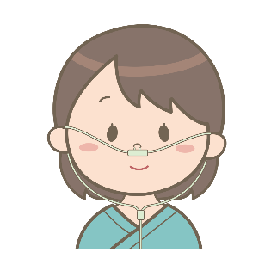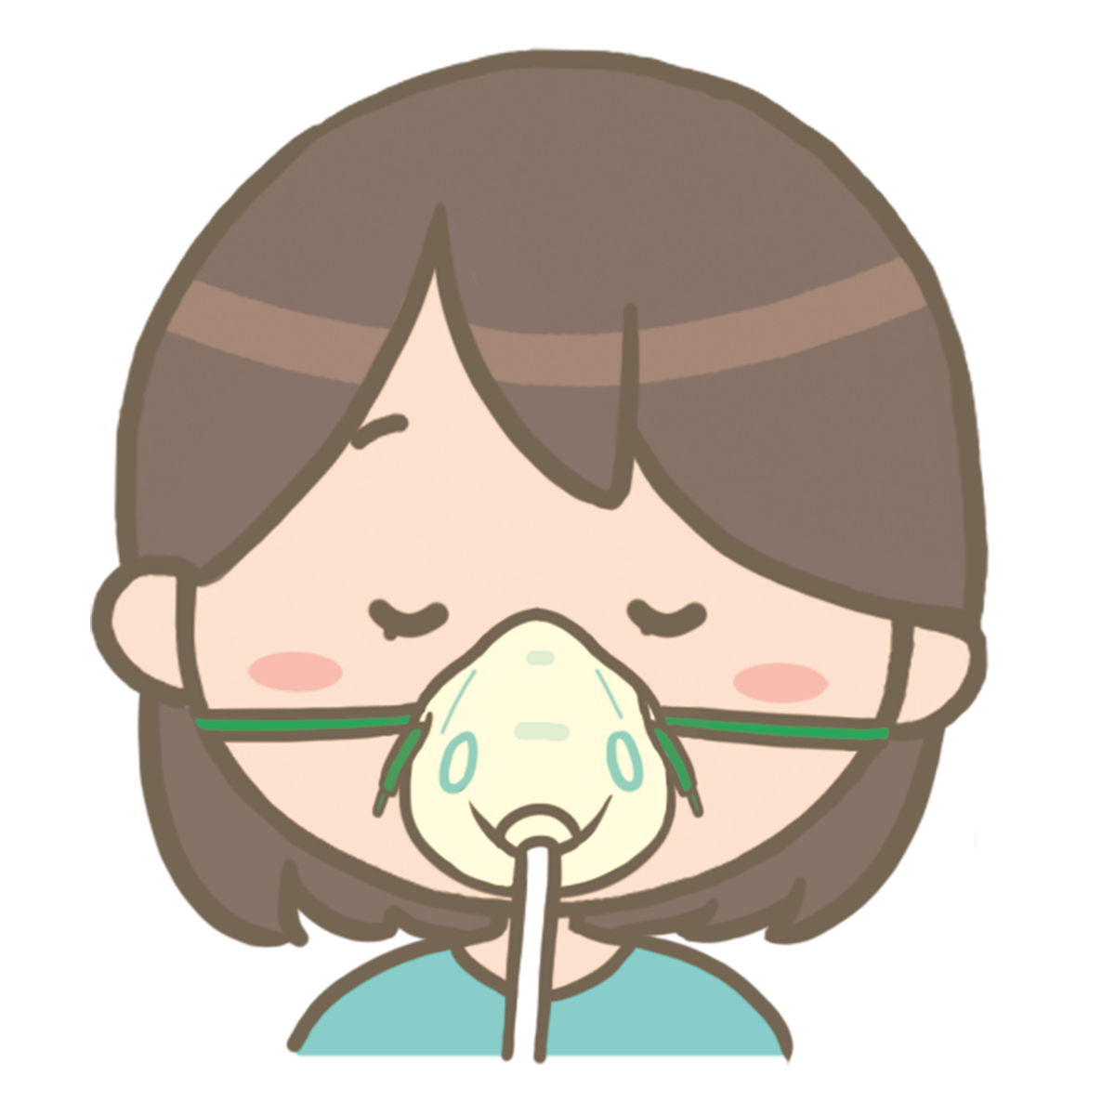
- Oxygen administration with ventilator (unconsciousness)
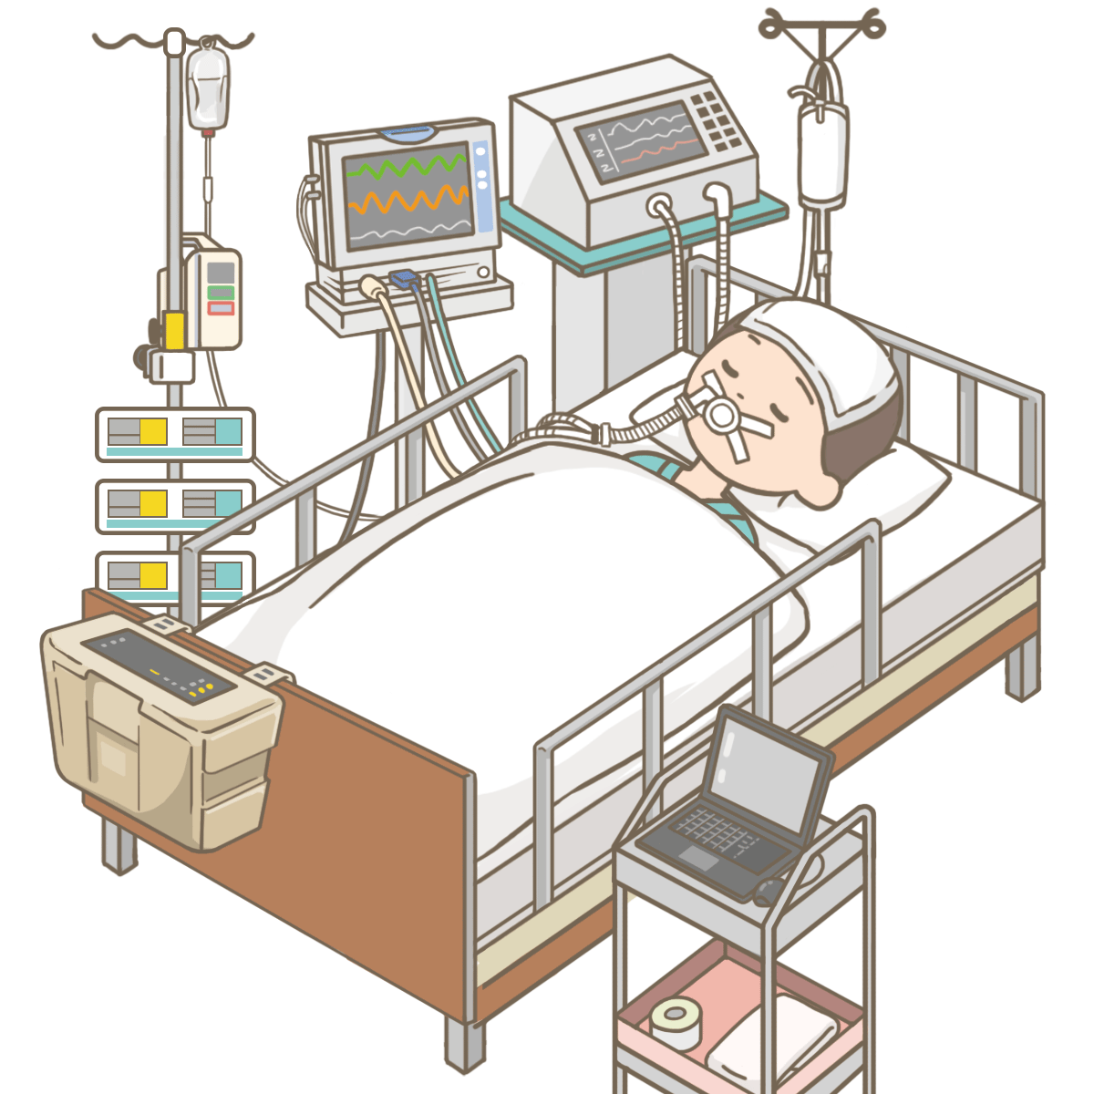
- Not receiving oxygen.
- I don't know.

- (If hospitalized) During your hospitalization, did you take oral or intravenous steroids for treatment?
  - Yes, sir.
  - No, sir.

<Initial and follow-up> Social life status after post-neoplastic coronavirus and recovery:
- Have you had any of the following symptoms as a sequelae of the new coronavirus? Please select all that apply. How long did the symptoms last?
- Fever (from □Mon □ to □Mon □/continuing to the present) (max. □C)
- Dyspnea/shortness of breath (from □May □ to □May □/continuing to the present)
- Hair removal (from □March □ to □March □/continuing to the present)
- Taste disorder (from □ month □ to □ month □/continuing to the present)
- Olfactory disturbance (from □ month □ to □ month □/continuing to the present)
- Fatigue (from □March □ to □March □/continuing to the present)
- There were no permanent injuries.
- (If you selected "dyspnea/shortness of breath") Please describe the severity of your symptoms.
- 0 feel nothing
- 0.5 very weak
- 1 slightly weak
- 2 weak
- 3 medium
- 4 slightly strong
- 5 strong
- 6
- 7 quite strong
- 8
- 9
- 10 maximum strength
- (For those who selected "hair loss") Please describe the symptom(s).
- alopecia areata
  - minor illness
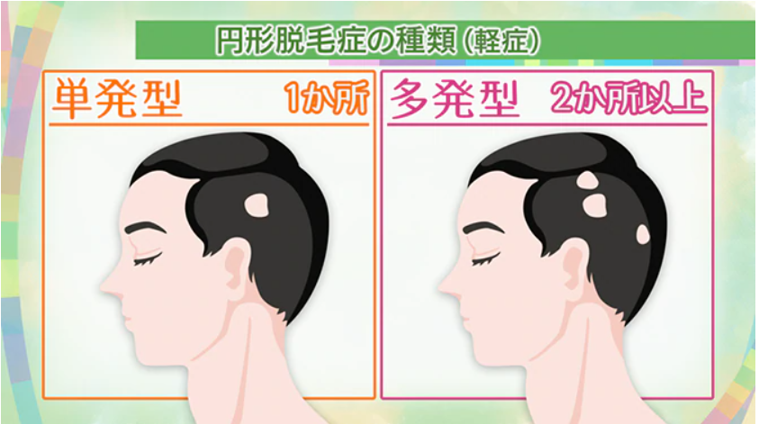
    - one-shot (e.g. story)
    - poly-
  - serious illness
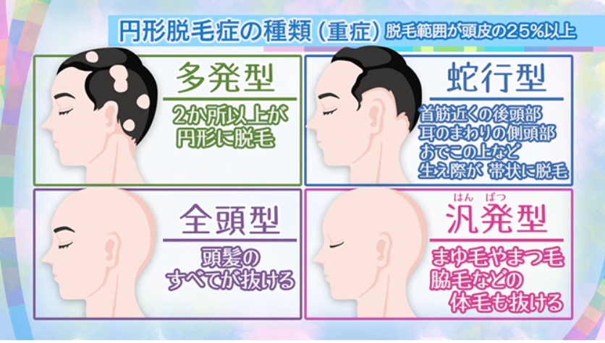
    - poly-
    - Whole-head type
    - serpentine
    - generic type
- diffuse alopecia
- (For those who selected "taste disorder") Please indicate the severity of your symptoms.
  - sweetness
    - I know/sometimes I know/I don't know
  - acidity
    - I know/sometimes I know/I don't know
  - saltiness
    - I know/sometimes I know/I don't know
  - bitterness
    - I know/sometimes I know/I don't know
  - umami (fifth category of taste, corresponding to the flavour of glutamates)
    - I know/sometimes I know/I don't know
- (For those who selected olfactory impairment) Please indicate the severity of your symptoms.
  - cooked rice
    - I know/sometimes I know/I don't know/I haven't drank recently or never drank.
  - miso
    - I know/sometimes I know/I don't know/I haven't drank recently or never drank.
  - laver
    - I know/sometimes I know/I don't know/I haven't drank recently or never drank.
  - soy sauce
    - I know/sometimes I know/I don't know/I haven't drank recently or never drank.
  - bakery
    - I know/sometimes I know/I don't know/I haven't drank recently or never drank.
  - butter
    - I know/sometimes I know/I don't know/I haven't drank recently or never drank.
  - curry
    - I know/sometimes I know/I don't know/I haven't drank recently or never drank.
  - Sauteed garlic
    - I know/sometimes I know/I don't know/I haven't drank recently or never drank.
  - unfinished
    - I know/sometimes I know/I don't know/I haven't drank recently or never drank.
  - strawberry (esp. the garden strawberry, Fragaria x ananassa)
    - I know/sometimes I know/I don't know/I haven't drank recently or never drank.
  - green tea
    - I know/sometimes I know/I don't know/I haven't drank recently or never drank.
  - coffee
    - I know/sometimes I know/I don't know/I haven't drank recently or never drank.
  - chocolate
    - I know/sometimes I know/I don't know/I haven't drank recently or never drank.
  - Household Gas
    - I know/sometimes I know/I don't know/I haven't drank recently or never drank.
  - food scraps
    - I know/sometimes I know/I don't know/I haven't drank recently or never drank.
  - lumber
    - I know/sometimes I know/I don't know/I haven't drank recently or never drank.
  - sweat
    - I know/sometimes I know/I don't know/I haven't drank recently or never drank.
  - feces
    - I know/sometimes I know/I don't know/I haven't drank recently or never drank.
  - blooming (esp. of cherry blossoms)
    - I know/sometimes I know/I don't know/I haven't drank recently or never drank.
  - perfume
    - I know/sometimes I know/I don't know/I haven't drank recently or never drank.
- (If you chose "Fatigue") For each of the following questions, please put a "0" in the number that applies.
During the past week, I have been:
  - When I'm tired, I don't feel like doing anything.
    - No 1 2 3 4 5 6 7 Yes
  - Exercise makes me tired.
    - No 1 2 3 4 5 6 7 Yes
  - tired easily
    - No 1 2 3 4 5 6 7 Yes
  - I'm tired and can't move as much as I'd like.
    - No 1 2 3 4 5 6 7 Yes
  - Fatigue-related problems often occur.
    - No 1 2 3 4 5 6 7 Yes
  - Fatigue prevents me from continuing to be strong.
    - No 1 2 3 4 5 6 7 Yes
  - Fatigue prevents them from fulfilling their duties and responsibilities
    - No 1 2 3 4 5 6 7 Yes
  - Fatigue is one of the three most annoying symptoms
    - No 1 2 3 4 5 6 7 Yes
  - Fatigue interferes with work, family, and social life
    - No 1 2 3 4 5 6 7 Yes
- [First] Do you continue to work after treatment for new coronavirus infection?
  - Ongoing.
  - I'm on leave.
  - Resigned, forced to resign
  - Not working to begin with.
- [Follow-up] Are you currently employed? (Do you have a job that involves remuneration)
  - No, sir.
  - Yes, sir.

The following questions ask about the past 7 days. Please do not include today.
- (For those who work) In the past 7 days, how many hours did you miss work due to health problems? Please include all hours you missed due to health problems and all hours you were late or left early.
- □Hours.
- (For those who work) In the past 7 days, how many hours did you take off from work for non-health reasons, including holidays, national holidays, and time off to participate in this survey?
- □Hours.
- (For those who work) In the past 7 days, how many hours did you actually work?
- □Hours (If "0 hours", please proceed to Question 6 (Question 45)).
- (For those who work) During the past 7 days, how much did your health problems affect your productivity while at work?
Please recall a day when the amount or type of work you did was limited, when you were unable to accomplish the tasks you wanted to do, or when you were unable to work as carefully as usual. If the impact of the health problem on your work was only slight, choose a small number. If the impact was severe, choose a higher number.
Please consider only how much health problems have affected your productivity while working.
Please only consider how much health problems have affected your productivity while at work.
Health problems did not affect their work. |  |  |  |  |  |  |  |  |  |  |  | Health problems completely interfered with my work.
Health problems did not affect their work. | 0 | 1 | 2 | 3 | 4 | 5 | 6 | 7 | 8 | 9 | 10 | Health problems completely interfered with my work.
Circle the number
- （In the past 7 days, how much did your health problems affect your daily activities outside of work?
Daily activities are those activities that you normally perform, such as housework, shopping, childcare, exercise, and study. Think of a day when the amount or type of activity was limited or you were not able to do as much of it as you would have liked. If the impact of the health problem on your daily activities was slight, choose a small number. If the impact was severe, choose a higher number.
Please consider only the extent to which health problems have affected your daily activities outside of work.
Health problems did not affect daily activities |  |  |  |  |  |  |  |  |  |  |  | Health problems completely interfered with various daily activities.
Health problems did not affect daily activities | 0 | 1 | 2 | 3 | 4 | 5 | 6 | 7 | 8 | 9 | 10
Circle the number
- Please select all that apply to your experiences and feelings in your social life with the new coronavirus.
- When infected with a new type of coronavirus, people feel discriminated against and alienated from those around them.
- Isolated by rumors that are not true
- I think foreigners are more likely to transmit the new coronavirus.
- I think the new coronavirus is a godsend.
- I'm afraid of new coronavirus infected people.
- Afraid to tell others that you have been infected with the new coronavirus
- Nervous or anxious when you see news or articles about the new coronavirus on TV, newspapers, or social networking sites
- It is embarrassing to be infected with a new coronavirus.
- I feel sorry for those infected with the new coronavirus.
- New coronavirus cases are the result of irresponsible behavior.
- I think people infected with the new coronavirus should be quarantined from society.
- I think people who are in contact with people infected with the new coronavirus should be quarantined from society.
- Families of those infected with the new coronavirus should treat infected family members kindly.
- If you are infected with the new coronavirus, you may approach uninfected people
- Fear of infection from medical personnel or concentrated contacts on public transportation or in the city.
- Guilt over having been infected with the new coronavirus
- People recovering from new coronavirus infection should stay away from the workplace/returning to work was actually difficult
- Healthcare workers should avoid using public transportation to reduce the risk of infection.
- Medical personnel should not return to their homes to avoid infecting their families.
- I think healthcare workers should not go out in private to avoid infecting others around them.
- Other (□)

The following questions will ask you how you think about your health.
It is a great way to Know how you feel each day and how much freedom you have in your daily activities
This will be helpful in
- What is your health status? Please choose the one that applies to you most often
- Best for.
- Very good.
- good
- Not so good
- not good
- The following questions are common activities that are performed on a daily basis. Do you find it difficult to do these activities for health reasons? If so, how much? (For each of the following questions, please choose the one that best describes you)
- Moderate activity, e.g., cleaning the house and yard, taking a walk for an hour or two, etc.
  - Very difficult
  - a little difficult
  - not at all difficult
- Go up a few flights of stairs.
  - Very difficult
  - a little difficult
  - not at all difficult
- In the past month, have you had any of the following problems with your work or daily activities (e.g., housework) due to physical reasons? (For each of the following questions, please choose the one that best describes you.)
- I couldn't do my job or usual activities as well as I thought I could.
  - always
  - Almost always
  - sometimes
  - rarely
  - having none of it
- Some activities were not possible due to the nature of my work or daily activities.
  - always
  - Almost always
  - sometimes
  - rarely
  - having none of it
- In the past month, have you had any of the following problems at work or in your daily activities (e.g., housework) for psychological reasons (e.g., because you felt depressed or anxious)? (For each of the following questions, please choose the one that best describes your experience)
- I couldn't do my job or usual activities as well as I thought I could.
- always
- Almost always
- sometimes
- rarely
- having none of it
- I could not concentrate as much as usual on my work or usual activities.
- always
- Almost always
- sometimes
- rarely
- having none of it
- In the past month, how much has pain interfered with your usual work (including housework)? (Choose the number that best describes your experience)
- I was not disturbed at all.
- Slightly blocked.
- A little disturbed.
- Much disturbed.
- I couldn't get along.
- The following questions are about how you have felt in the past month. (For each of the following questions, please choose the one that best describes you.)
- Did you feel calm and relaxed?
  - always
  - Almost always
  - sometimes
  - rarely
  - having none of it
- Were you full of energy?
  - always
  - Almost always
  - sometimes
  - rarely
  - having none of it
- Feeling down and depressed?
  - always
  - Almost always
  - sometimes
  - rarely
  - having none of it
- In the past month, how much time did physical or psychological reasons prevent you from visiting friends or relatives? (Please choose the number that best describes your experience.)
- always
- Almost always
- sometimes
- rarely
- having none of it

<Initial/Follow-up> Vaccination against new coronavirus:.
- Have you received the new coronavirus vaccine?
- Yes, sir.
- No, sir.
- Have you ever been told by your doctor that he or she does not recommend vaccination with the novel coronavirus vaccine due to your pre-existing medical condition?
- Yes, sir.
- No, sir.
- What is the date of your first new coronavirus vaccine?
- A.D. □Year□ Month□ Day
- Now I'm going to ask you about the second round of vaccinations.
- Yes, sir.
- No, sir.
- Have you ever been told by your doctor that a second vaccination is not recommended due to a pre-existing condition of your own?
- Yes, sir.
- No, sir.
- Please provide the date of the second vaccination.
- A.D. □Year□ Month□ Day

