Supporting Information

Energy‒autonomous all‒in‒one visual interactive interface with a high optical contrast ratio achieved within seconds

Han Bi¹², Xuan Zhao*¹², Shuchang Zhao¹², Liubing Fan¹², Haonan Si¹², Qingliang Liao*¹², and Yue Zhang*¹²

- Academy for Advanced Interdisciplinary Science and Technology, Key Laboratory of Advanced Materials and Devices for Post-Moore Chips, Ministry of Education, University of Science and Technology Beijing, Beijing 100083, People’s Republic of China.
- Beijing Key Laboratory for Advanced Energy Materials and Technologies, Beijing Advanced Innovation Center for Materials Genome Engineering, School of Materials Science and Engineering, University of Science and Technology Beijing, Beijing 100083, People’s Republic of China.

Corresponding authors:
Xuan Zhao, E-mail: xuanzhao@ustb.edu.cn;
Qingliang Liao, E-mail: liao@ustb.edu.cn;
Yue Zhang, E-mail: yuezhang@ustb.edu.cn.

Supplementary Notes
Note S1 Preparation and characterization of WO_{3-x} electrodes 3
Note S2 Discussion on growth mechanisms and morphological evolution of WO_{3-x} electrodes 4
Note S3 Comparison of electrochromic properties with Al³⁺-injected and proton-injected 6
Note S4 Comparison of sensing performance with varied microstructural sizes of gel electrolytes 8
Supplementary Figures
Fig. S1 Preparation and morphology of WO_{3-x} electrodes by current pulsed electrodeposition process. 9
Fig. S2 Cross-section morphology image of WO_{3-x} electrodes. 9
Fig. S3 TEM image (inset: FFT pattern) of WO_{3-x} electrodes, and corresponding EDS mapping illustrate the spatial distribution of W and O elements. 10
Fig. S4 XRD pattern of WO_{3-x} electrodes. 10
Fig. S5 XPS spectra of WO_{3-x} electrodes.. 11
Fig. S6 Preparation and morphology of WO_{3-x} electrodes via constant voltage and current electrodeposition. 12
Fig. S7 Preparation and morphology of WO_{3-x} electrodes via voltage pulsed electrodeposition. 13
Fig. S8 Schematic diagram of the WO_{3-x} growth mechanism. 14
Fig. S9 First-principles calculations of structural models and energies for Al³⁺ and proton in PSS and WO₃. 15
Fig. S10 Schematic diagram of the structure with Al³⁺ and proton as transport ions 16
Fig. S11 Comparison of the elemental composition among three WO_{3-x} samples. 17
Fig. S12 Comparison of the electrochromic properties with Al³⁺ and proton as transport ions. 18
Fig. S13 Comparison of CE for devices with Al³⁺ and proton as transport ions. 19
Fig. S14 Voltage drops across individual layers. 20
Fig. S15 Correlation between Gly content and water content in the microstructured gel electrolyte. 21
Fig. S16 Sensing signals with varying Gly content in response to dynamic mechanical and static mechanical stimuli. 21
Fig. S17 Gel electrolyte fabrication using steel-ball templates. 22
Fig. S18 Cross-sectional morphology of the microstructured gel electrolyte. 22
Fig. S19 Sensing performance with microstructured gel electrolytes at varying microstructure sizes. 23
Fig. S20 A series of transmittance spectra after aging for different durations. 24
Fig. S21 Energy level transition diagram of coloration/bleaching mechanisms. 26
Fig. S22 Optical characterization of the Al mesh fabricated via lithography technology on ITO.. 25
Supplementary Table
Table S1. Comparison of the perceptibility and timeliness of all‒solid‒state devices with various inserted ions studied in recent years. 27
References 28

Note S1 Preparation and characterization of WO_{3-x} electrodes
The current pulsed electrodeposited WO_{3-x} electrode is shown in Fig. S1a, with zoomed in plots of the first and last 10 cycles presented in Fig. S1b. The porous interconnected network formed by current pulse electrodeposition consists of flaky WO_{3-x} with an approximate thickness of 3 nm (Fig. S1c and d), while cross-sectional analysis reveals a film thickness of about 200 nm (Fig. S2). The structural features of the current pulsed WO_{3-x} are further investigated using TEM, as shown in Fig. 3, which confirms the flaky morphology. Corresponding EDS mapping confirms the absence of detectable impurities. Fast fourier transform (FFT) results indicate the presence of nanocrystals dispersed within the majority of the amorphous matrix. The XRD pattern of the electrodeposited WO₃ electrode (Fig. S4) shows two broadened diffraction peaks after subtracting the ITO contributions, indicating the amorphous nature of WO_{3-x}¹. XPS analysis confirms that the current pulsed WO_{3-x} contains only W, O, and C as shown in Fig. S5a. The W 4f spectrum obtained via high-resolution X-ray photoelectron spectroscopy (XPS) is shown in Fig. S5b, revealing the presence of W 4f_{7/2}, W 4f_{5/2} and W 5p_{3/2} peaks. The spectrum can be deconvoluted into two sets of doublet peaks: the first doublet peaks at 35.1 and 37.3 eV are assigned to W⁶⁺, and the second doublet peaks at 34.7 and 36.8 eV can be attributed to W⁵⁺. The presence of W⁵⁺ signifies the presence of oxygen vacancies on the WO_{3-x} surface. The high-resolution O 1s spectrum (Fig. S5c) reveals three distinct peaks: a lattice oxygen peak at 530.6 eV, a surface oxygen vacancy peak at 531.9 eV, and a minor peak at 532.8 eV, attributed to adsorbed water on the WO_{3−x} surface².

Note S2 Discussion on growth mechanisms and morphological evolution of WO_{3-x} electrodes
A uniform particle distribution was observed in WO_{3-x} prepared via constant voltage and constant current electrodeposition, as shown in the corresponding electrodeposition process and SEM images in Fig. S6. Notably, the particle sizes of WO_{3-x} synthesized under constant voltage and constant current are approximately 60 nm and 20 nm, respectively. The porous interconnecting network formed by voltage pulse electrodeposition consists of flaky WO_{3-x} with an approximate thickness of 20 nm, as shown in the corresponding electrodeposition process and SEM images in Fig. S7, consistent with prior literature reports³.
The growth mechanisms and morphological evolution is shown in Fig. S8. During deposition, variations in current and voltage are correlated with the resistance (R) of WO_{3-x}. It is assumed that WO_{3-x} maintains homogeneity and a constant resistivity during electrodeposition. R can be calculated as follow⁴:
R = ρL/S
where ρ, L, and S represent the resistivity, length and cross-sectional area of WO_{3-x}, respectively. During continuous-cathodic electrodeposition, the uniform electric field distribution across the ITO surface and electrostatic repulsion between the negatively charged substrate and anions promote simultaneous nucleation over the entire substrate. Consequently, WO_{3-x} synthesized via continuous electrodeposition forms small granular structures. With a constant applied voltage, the current decreases as the film thickness increases. This reduction in current diminishes cathodic polarization, resulting in larger, loosely packed particles. Conversely, under high current density conditions, cathodic polarization intensifies, driving dense nucleation and yielding small, compact particles. The reaction occurring during electrodeposition can be described by the following equation³:
2WO₄²⁻ + 4H₂O₂ → W₂O₁₁²⁻ + 2OH⁻ + 3H₂O
W₂O₁₁²⁻ + (2 + 3x) H⁺ + 3xe⁻ → 2 H_{x}WO₃ + (2 + x) / 2 H₂O + (8 - x) ₄ O₂
H_{x}WO₃ → WO₃ + xH+ xe⁻
The film exhibits a blue color during the electrodeposition process, which is primarily attributed to the presence of H_{x}WO₃. Building on the previous discussion, during discontinuous cathodic electrodeposition, H_{x}WO₃ deposits initially form isolated islands on the substrate. The high aspect ratio of these islands locally enhances the electric field through the lightning-rod effect, where electric field lines concentrate at geometric protrusions⁵. During the zero-voltage/current intervals between deposition pulses, the surface charge of H_{x}WO₃ nuclei relaxes to a positive state. Subsequent deposition preferentially occurs at these positively charged surfaces due to electrostatic attraction with anions, while the lightning-rod effect further drives growth at island edges. This synergy between surface charge and field focusing promotes the interlacing of granules into a porous flake network. Concurrently, newly nucleated islands near the flakes oxidatively dissolve under anodic potentials during intervals, refining the network to a thinner flaky structure.

Note S3 Comparison of electrochromic properties with Al³⁺-injected and proton-injected
Proton-injected WO_{3-x} exhibits a higher concentration of W⁴⁺ compared to its Al³⁺-injected counterparts, which is consistent with its deeper optical coloration (Fig. S12a). This absorption mechanism arises from small polaron formation during coloration, where spatial separation between intercalated ions (H⁺/Al³⁺) and compensating electrons induces localized charge distortions. Optical absorption originates from polaron hopping between adjacent non-equivalent W sites, a process that can be described by the following equation^{6,7}:
W⁵⁺(i) + W⁶⁺(j) + հω₅₆ → W⁶⁺(i) + W⁵⁺(j) (հω₅₆ ≈ 1.05 eV)
W⁴⁺(i) + W⁵⁺(j) + հω₄₅ → W⁵⁺(i) + W⁴⁺(j) (հω₄₅ ≈ 1.75 eV)
The relative abundance of W⁴⁺, W⁵⁺, and W⁶⁺ sites varies dynamically with charge intercalation levels. Polaron hopping between these mixed-valence tungsten sites mediates optical absorption, where an increased proportion of W⁴⁺ sites enhances absorption intensity. Smaller ionic radii correlate with higher charge densities, which promote localized electron transfer to form W⁴⁺-polaron pairs at equivalent intercalation levels. This phenomenon arises because a reduced ionic radius increases the probability of electron localization at tungsten sites, thereby amplifying polaron hopping between adjacent W⁴⁺ and W⁵⁺ states.¹.
The influence of proton and Al³⁺ as transport ions on the perceptibility was compared. The optical transmittance spectra using Al³⁺ and proton as transport ions are shown in Fig. S12b and Fig. 2d, respectively. For the device with Al³⁺ as transport ions, the initial transmittance in the visible range (700 nm) is 89.4%, which decreases to 16.3% under mechanical stimulation, yielding an optical contrast ratio (ΔT) of 73.1%. In contrast, the pristine proton-injected device exhibit a baseline transmittance of 86.4%, which plummets to 0.5% after mechanical stimulation, achieving a significantly enhanced ΔT of 85.9%. These trends align with the W 4f XPS spectra (Fig. S12a), where proton intercalation induces a higher proportion of reduced W⁴⁺/W⁵⁺ states compared to Al³⁺-mediated electrochromic. The results conclusively demonstrate that protons, as transport ions, significantly amplify the optical responsiveness of the energy-autonomous device.
The influence of proton and Al³⁺ as transport ions on the timeliness was compared. The devices were subjected to sustained mechanical stimuli after a 5 s delay, with coloration time defined as the duration required to reach 90% of the total optical contrast ratio. As shown in Fig. S12c, the proton-injected device achieved full coloration at 700 nm within 3.2 s, significantly outperforming the Al³⁺-injected which took 10.4 s. Complementary wavelength dependent analyses (Fig. S12d and e) further validate this trend: at 600 nm, the coloration time for proton and Al³⁺ devices were 3.1 s and 7.0 s, respectively, while at 800 nm, the times were 4.58 s (proton) and 5.4 s (Al³⁺). The accelerated kinetics in proton- injected device result from the smaller ionic radius and higher charge density of H⁺, which enhance ion migration and electron localization efficiency. These results confirm protons as superior charge carriers for rapid mechano-optical switching.
Current-time profiles in Fig. S13a demonstrate that mechanical stimuli trigger an instantaneous current peak (conducting state) followed by a gradual decay, attributed to charge saturation in WO_{3-x}. The proton- injected device exhibit a higher peak current density (5.07 mA cm⁻²) and faster decay kinetics than their Al³⁺ counterpart, indicating enhanced ion-electron exchange efficiency. Correspondingly, the proton-injected device achieves the CE of 121.92 cm² C⁻¹ at 700 nm, surpassing the Al³⁺-injected device (71.62 cm² C⁻¹, Fig. S13b). This marked improvement in CE confirms that proton transport minimizes energy dissipation during electrochromic switching.

Note S4 Comparison of sensing performance with varied microstructural sizes of gel electrolytes
We used steel balls with diameters of 0.5, 0.7 and 1mm to prepare templates (Fig. S17a), with the Gly content fixed at 3.4%, resulting in gel electrolytes with various microstructure sizes, as shown in Fig. S17b. The surface profile of the microstructured gel polymer electrolyte is presented in Fig. S18. These engineered surface protrusions concentrate localized stress under mechanical loading, critically enhancing the sensitivity and accuracy of stimuli detection. Voltage-output versus applied mechanical stimuli profiles (Fig. S19) reveal a microstructure-dependent trade-off. Device with larger microstructures display higher sensitivity at low forces but suffer rapid signal saturation due to limited deformation range. Conversely, smaller microstructures exhibit lower sensitivity but broader linear detection, as their reduced feature size facilitates electrode-electrolyte contact under deformation, maximizing charge transfer efficiency. Larger protrusions resist compression, enabling precise low-force detection, while smaller features deform readily, delaying saturation.

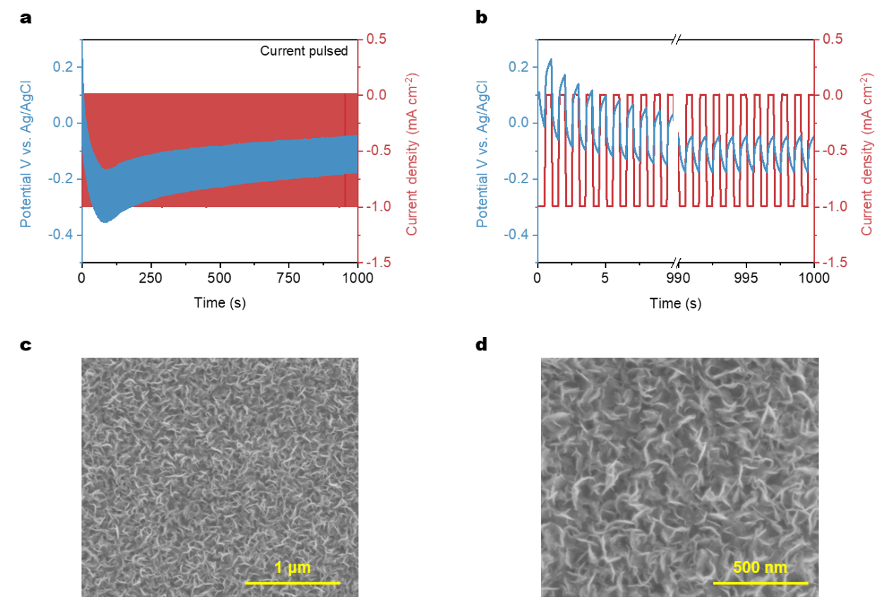
Fig. S1 Preparation and morphology of WO_{3-x} electrodes by current pulsed electrodeposition process. (a) Current-voltage-time responses during the electrodeposition process. (b) Zoomed in plots of the first and last 10 cycles. (c) Corresponding SEM image and (d) HRSEM image.

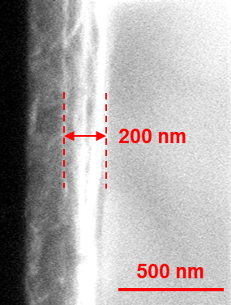

Fig. S2 Cross-section morphology image of WO_{3-x} electrodes.

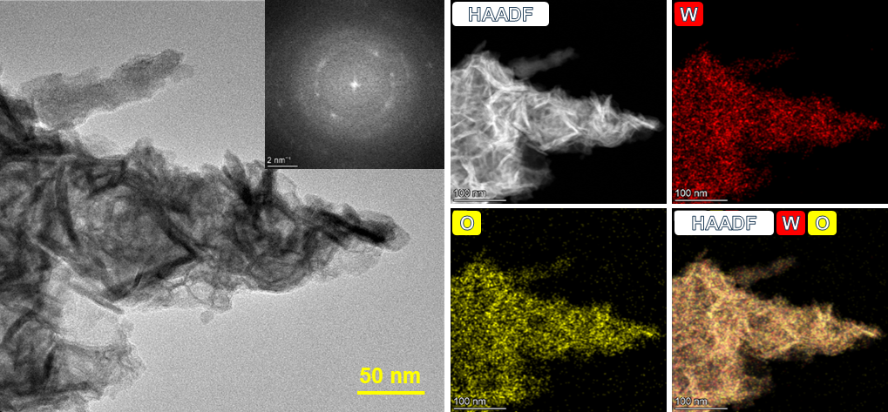

Fig. S3 TEM image (inset: FFT pattern) of WO_{3-x} electrode, and corresponding EDS mapping illustrate the spatial distribution of W and O elements.

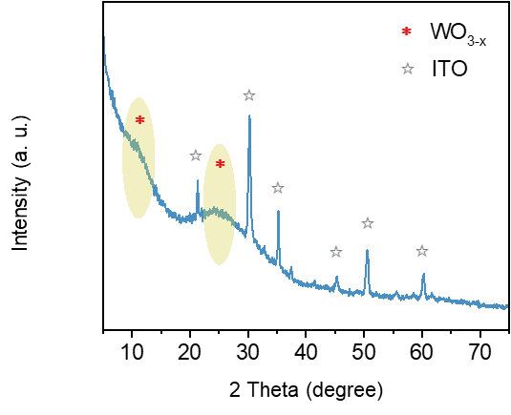

Fig. S4 XRD pattern of WO_{3-x} electrodes.

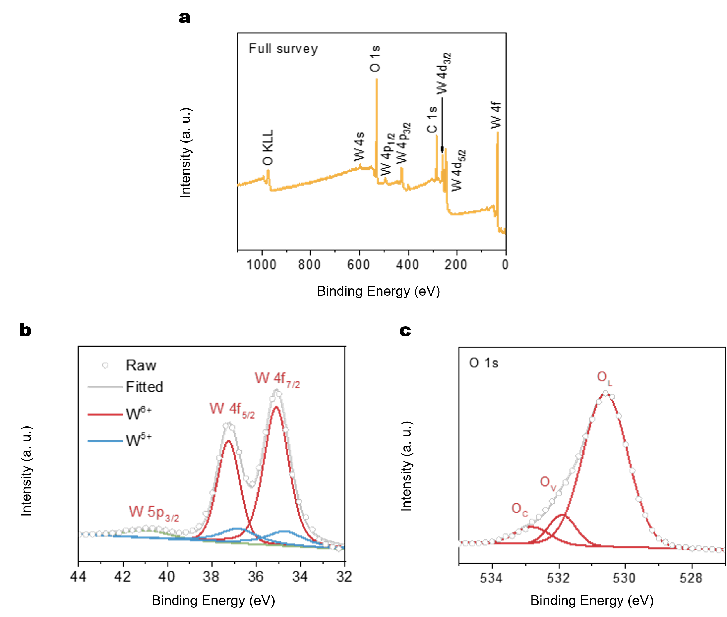

Fig. S5 XPS spectra of WO_{3-x} electrodes. (a) Full survey spectrum, (b) the detailed W 4f and (c) O 1s peak.
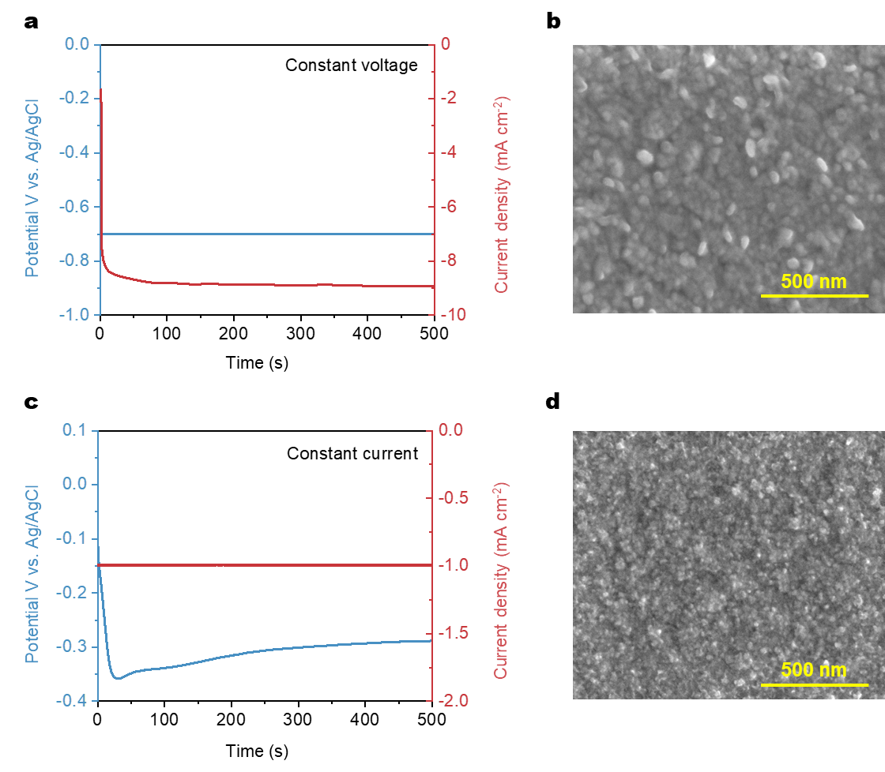
Fig. S6 Preparation and morphology of WO_{3-x} electrodes via constant voltage and current electrodeposition. (a) Current-voltage-time responses during constant voltage electrodeposition (-0.7 V, 500 s) and (b) corresponding SEM image, which reveals a morphology composed of larger particles. (c) Current-voltage-time responses during constant current electrodeposition process (-1.0 mA cm⁻², 500 s) and (d) corresponding SEM image, which reveals a morphology composed of small particles.

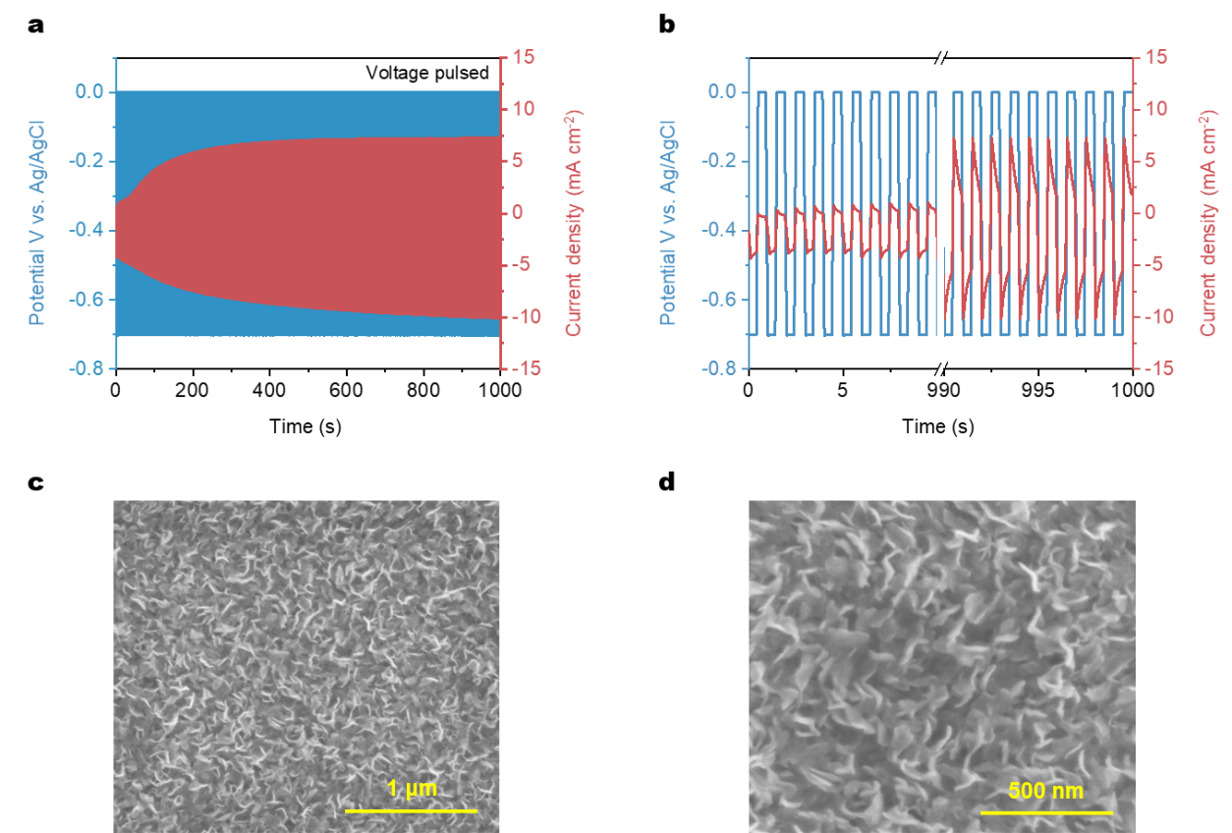
Fig. S7 Preparation and morphology of WO_{3-x} electrodes via voltage pulsed electrodeposition. (a) Current-voltage-time responses during voltage pulsed electrodeposition (-0.7 V, 0.5 s, 0 V, 0.5 s, 1000 cycles). (b) Zoomed in plots of the first and last 10 cycles. (c) Corresponding SEM image and (d) HRSEM image.

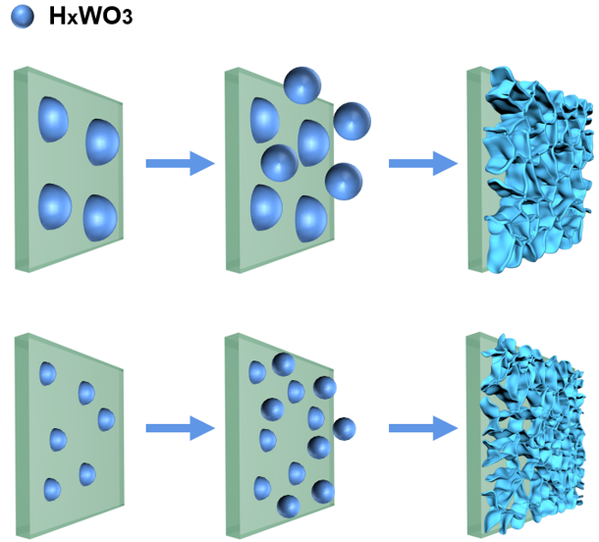

Fig. S8 Schematic diagram of the WO_{3-x} growth mechanism.

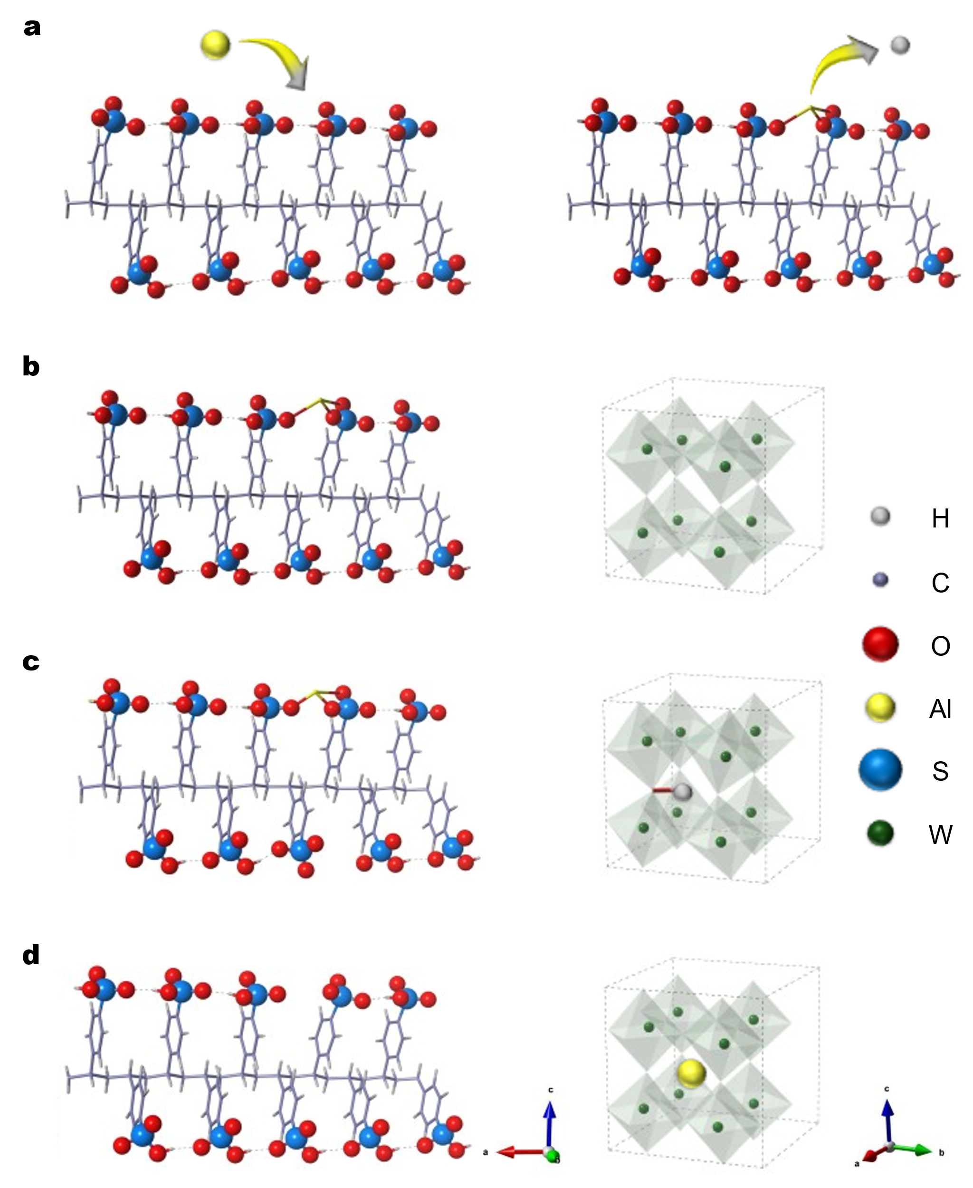
Fig. S9 First-principles calculations of structural models and energies for Al³⁺ and proton in PSS and WO₃. (a) Al³⁺ is adsorbed on PSS, displacing protons. (b) Both a proton and Al³⁺ are adsorbed on PSS, leaving pristine WO₃. (c) A proton is transferred from PSS to WO₃. (d) Al³⁺ is transferred from PSS to WO₃. Crystalline WO₃ with a monoclinic structure (ICSD #80057) models amorphous WO₃ containing 48 atoms. A single PSS chain with five repeating units was used to model the structure of PSS. Periodic boundary conditions were applied to all the structures.

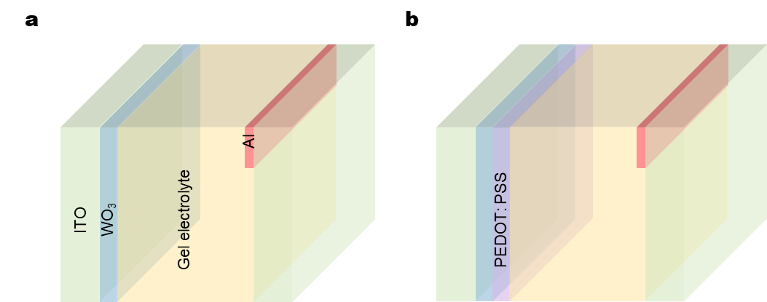
Fig. S10 Schematic diagram of the structure with (a) Al³⁺ and (b) proton as transport ions, following removal of microstructure from gel electrolyte. These structures are utilized for spectral data acquisition to eliminate microstructural interference.

Fig. S11 Comparison of the elemental composition among three WO_{3-x} samples.

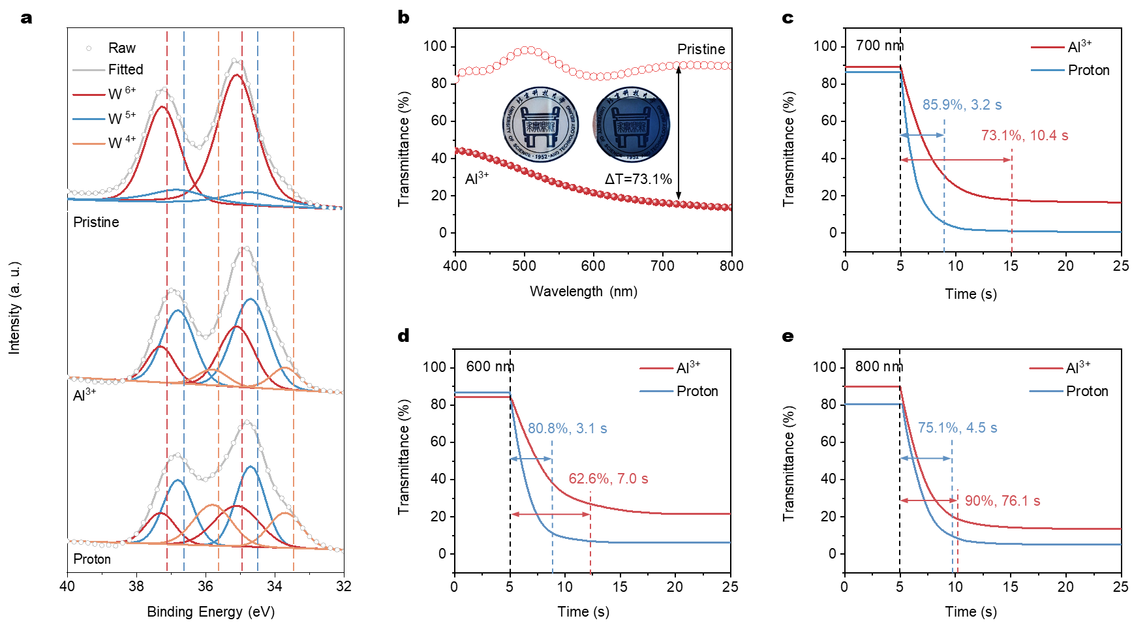
Fig. S12 Comparison of the electrochromic properties with Al³⁺ and proton as transport ions. (a) W 4f XPS spectra of WO_{3-x} in pristine, Al³⁺-injected and proton-injected states, individually. (b) Transmittance spectra with Al³⁺ as transport ions, along with corresponding photographs as illustrations. The coloration curve at (c) 700 nm, (d) 600 nm, and (e) 800 nm.

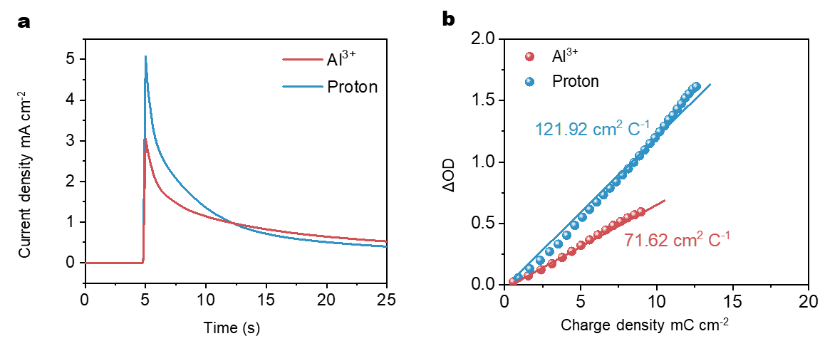
Fig. S13 Comparison of CE for devices with Al³⁺ and proton as transport ions. (a) Chronoamperometry curve under sustained mechanical stimulus. (b) ΔOD versus injected charge density at λ = 700 nm.

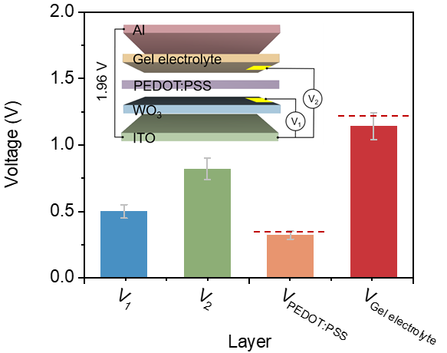

Fig. S14 Voltage drops across individual layers.
A gold electrode (~50 nm thick, 1*1cm²) was sputtered onto the WO₃ layer, followed by spin-coating the PEDOT: PSS layer. Subsequently, another gold electrode (~50 nm thick, 1*1cm²) was sputtered onto the PEDOT:PSS layer. The voltages of V₁ and V₂ were measured directly, with the theoretical intrinsic potential being 1.96 V. The partial pressure of each layer was calculated using the following equation:
V_{WO3} = V₁
V_{PEDOT: PSS} = V₂ – V₁
V_{Gel electrolyte} = 1.96 - V₂
This proves that the device remains stable throughout its operation.

Fig. S15 Correlation between Gly content and water content in the microstructured gel electrolyte.

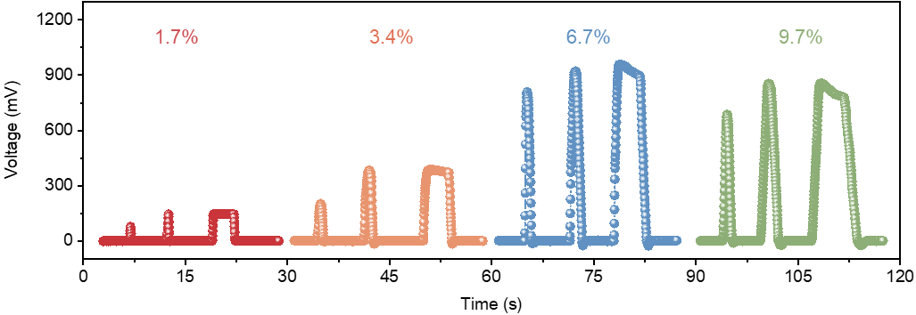
Fig. S16 Sensing signals with varying Gly content in response to dynamic mechanical (2 kPa, 4 kPa) and static mechanical (4 kPa, 3 s) stimuli.
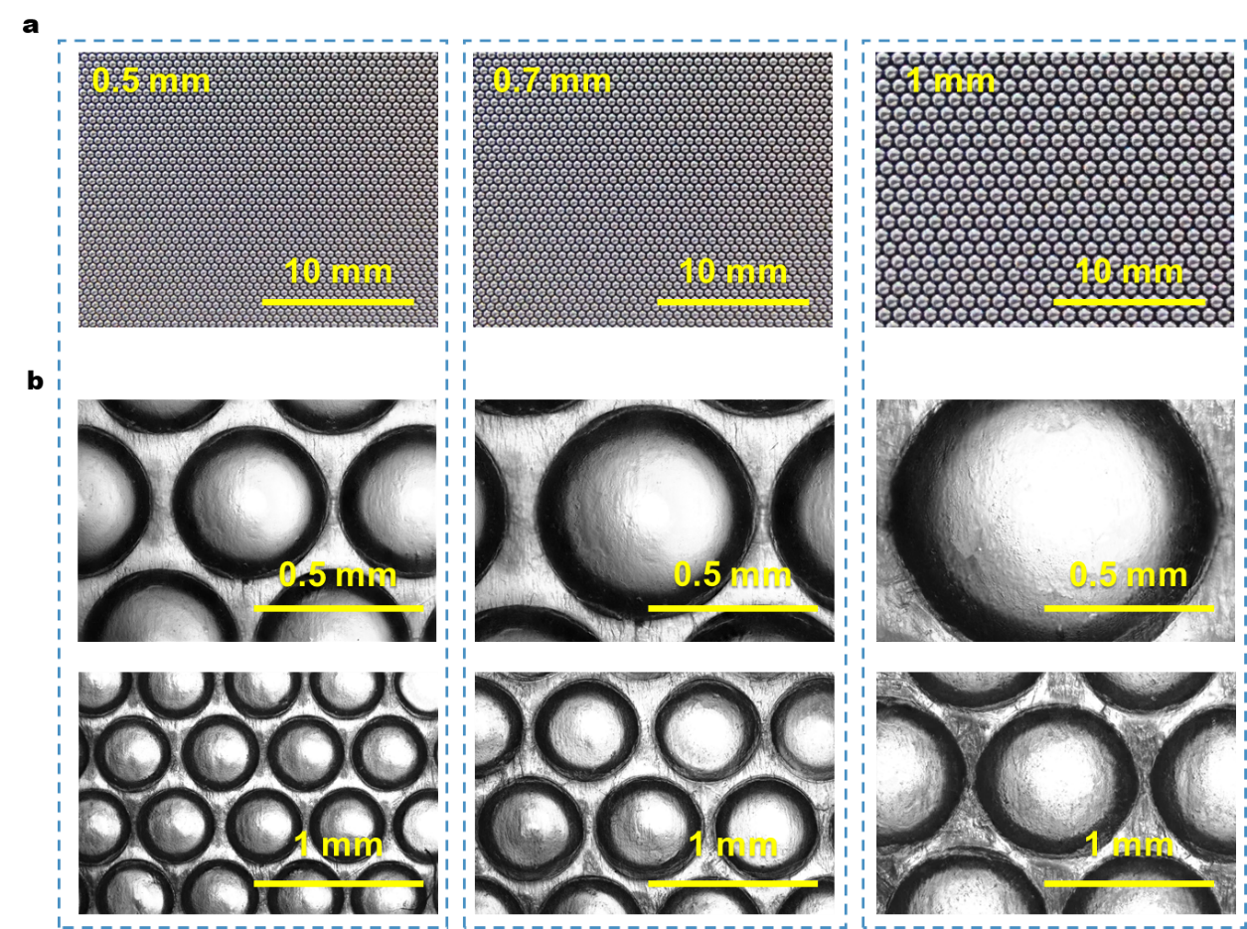

Fig. S17 Gel electrolyte fabrication using steel-ball templates. (a) Photographs of steel-ball templates with varying sizes. (b) Corresponding gel electrolytes prepared with the templates.

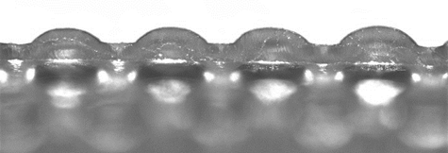

Fig. S18 Cross-sectional morphology of the microstructured gel electrolyte.

Fig. S19 Sensing performance with microstructured gel electrolytes at varying microstructure sizes.

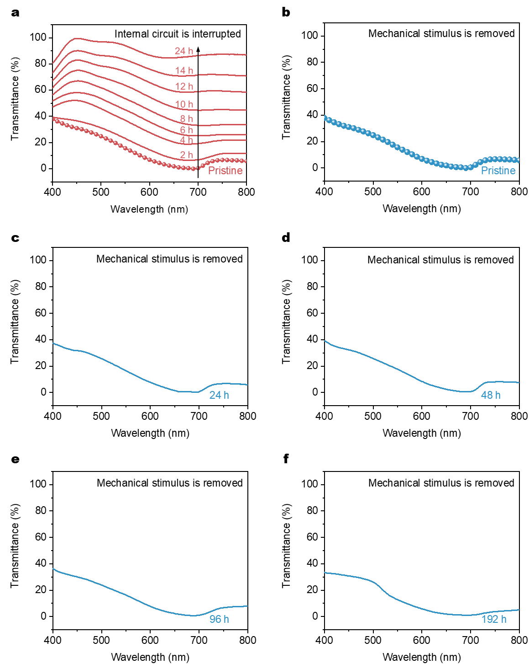

Fig. S20 A series of transmittance spectra after aging for different durations.

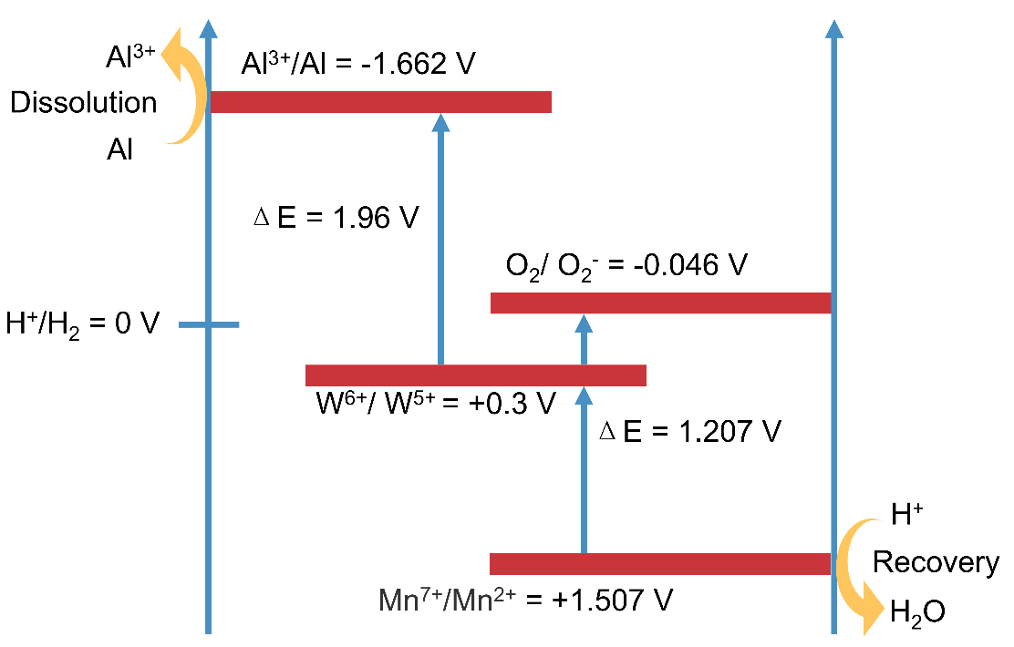

Fig. S21 Energy level transition diagram of coloration/bleaching mechanisms.

During the bleaching process, the WO_{3-x} electrodes and KMnO₄ electrodes are connected, the intrinsic interfacial potential between KMnO₄ electrode (Mn⁷⁺/Mn²⁺ = +1.507 V vs. SHE) and WO_{3-x} electrode (W⁶⁺/W⁵⁺ = +0.3 V vs. SHE) facilitates the reduction of Mn⁷⁺ as it gains electrons, transforming into Mn²⁺. Concurrently, W⁴⁺ and W⁵⁺ spontaneously lose electrons, releasing protons and reducing H_{x}WO₃ to WO_{3-x}⁸.

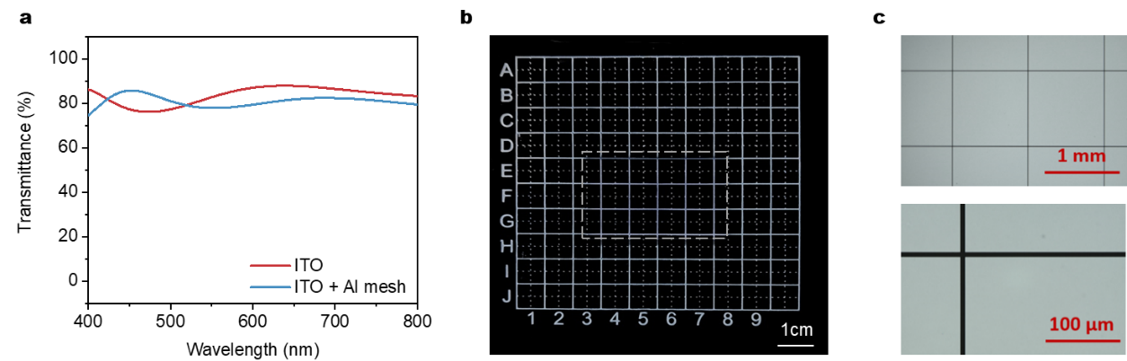
Fig. S22 Optical characterization of the Al mesh fabricated via lithography technology on ITO. (a) Transmittance spectra of ITO before and after the Al mesh fabrication. (b) Photograph of Al mesh/ITO structure after lithography. (c) Optical microscopy image of the Al mesh on ITO.

The Al mesh features a width of 200 nm, a thickness of 200 nm, and a spacing of 1 mm. Importantly, the transmittance of the counter electrode shows no significant change after the Al mesh is lithographically patterned on the ITO substrate.

Table S1. Comparison of the perceptibility and timeliness of all‒solid‒state devices with various inserted ions studied in recent years.
Electrochromic  System | Optical  contrast (%) | Coloration time (s) | Cations | Ref.
WO₃-PEDOT:PSS | 74 | 0.7 | Proton | 9
WO₃ | 58 | 10 | H⁺ | 10
P-WO₃ | 56.4 | 1.7 | Li⁺ | 11
Nb₁₈W₁₆O₉₃ | 65.4 | 13.2 | Li⁺ | 12
WO₃ | 60 | 5 | Li⁺ | 13
W₁₈O₄₉ NW/Ti₃C₂T_{x} | 61 | 4.5 | Li⁺ | 14
NiO nanorods//WO₃ nanorods | 65 | 2.7 | Li⁺ | 15
m-WO₃//α-MnO₂ | 65.7 | 11.4 | Zn²⁺ | 16
Zn//WO_{3-x} | 55 | 3.5 | Zn²⁺ | 17
Zn//WO₃//Carbon cloth | 40 | 2.5 | Zn²⁺ | 18
Al³⁺//MoO_{3-y}-WO_{3-x}//H₂O₂ | 49.1 | 36 | Al³⁺ | 19
Zn//WO₃//MnO₂ | 80 | 30 | Zn²⁺/Al³⁺ | 20
Zn mesh//PB | 67.2 | 3.6 | Zn²⁺/K⁺ | 21
Zn//PB//MnO₂ | 80.6 | 10 | Zn²⁺/K⁺ | 22
Proton | 85.9 | 3.2 | Proton | This work

References
1. Li, H.Z., Firby, C.J. & Elezzabi, A.Y. Rechargeable Aqueous Hybrid Zn²⁺/Al³⁺ Electrochromic Batteries. Joule. 3, 2268-2278 (2019).
2. Chen, M.J. et al. Oxygen vacancy modulated amorphous tungsten oxide films for fast-switching and ultra-stable dual-band electrochromic energy storage smart windows. Mater Horiz. 10, 2191-2203 (2023).
3. Cai, G.F. et al. Ultra-large optical modulation of electrochromic porous WO₃ film and the local monitoring of redox activity. Chem Sci. 7, 1373-1382 (2016).
4. Vijayakumar, E. et al. Development of Tungsten Trioxide Using Pulse and Continuous Electrodeposition and Its Properties in Electrochromic Devices. J Electrochem Soc. 166, 86-92 (2019).
5. Park, S.H., Shin, H.S., Kim, Y.H., Park, H.M. & Song J.Y. Template-free and filamentary growth of silver nanowires: application to anisotropic conductive transparent flexible electrodes. Nanoscale. 5, 1864-1869 (2013).
6. Zhang, S.L., Cao, S., Zhang, T.R., Fisher, A. & Lee, J.Y. Al³⁺ intercalation/de-intercalation-enabled dual-band electrochromic smart windows with a high optical modulation, quick response and long cycle life. Energ Environ Sci. 11, 2884-2892 (2018).
7. Guo, J.J. et al. Prominent Electrochromism Achieved Using Aluminum Ion Insertion/Extraction in Amorphous WO₃ Films. J Phys Chem C. 122, 19037-19043 (2018).
8. Dean, J.A. LANGE'S HANDBOOK OF CHEMISTRY, Mater Manuf Process. 5, 687-688 (1990).
9. Shao, Z.W. et al. All-solid-state proton-based tandem structures for fast-switching electrochromic devices. Nat Electron. 5, 45-52 (2022).
10. Guo, Y.J. et al. Wearable Hybrid Device Capable of Interactive Perception with Pressure Sensing and Visualization. Adv Funct Mater. 32, 2203585 (2022).
11. Poh, W.C., Eh, A.L-S., Wu, W.T., Guo, X.Y. & Lee, P.S. Rapidly Photocurable Solid-State Poly(ionic liquid) Ionogels For Thermally Robust and Flexible Electrochromic Devices. Adv Mater. 34, 2206952 (2022).
12. Cai, G.F. et al. Tunable Intracrystal Cavity in Tungsten Bronze-Like Bimetallic Oxides for Electrochromic Energy Storage. Adv Energy Mater. 12, 2103106 (2022).
13. Fang, H.J. et al. Multifunctional hydrogel enables extremely simplified electrochromic devices for smart windows and ionic writing boards. Mater Horiz. 5, 1000-1007 (2018).
14. Hassan, M. et al. Enhanced Transport Kinetics of Electrochromic Devices by W₁₈O₄₉ NW/Ti₃C₂T_{x} Composite Films. Adv Funct Mater. 34, 2310535 (2024).
15. Phan, G.T. et al. Nanorod-based smart windows with solid-gel electrolyte: An integrated electrochromic and pseudocapacitive technology for energy-saving and conversion. Nano Energy. 132, 110374 (2024).
16. Deng, C.F. et al. High-performance all-solid-state electrochromic asymmetric Zn-ion supercapacitors for visualization of energy storage devices. J Mater Chem A. 10, 17326-17337 (2022).
17. Li, J. et al. Ultrathin Smart Energy-Storage Devices for Skin-Interfaced Wearable Electronic. ACS Energy Lett. 8, 1-8 (2023).
18. Wu, W.T. et al. Self-Powered and Light-Adaptable Stretchable Electrochromic Display. Adv Energy Mater. 13, 2204103 (2023).
19. Wu, W.T. et al. Self-Powered Rewritable Electrochromic Display based on WO_{3-x} Film with Mechanochemically Synthesized MoO_{3-y} Nanosheets. ACS Appl. Mater. Interfaces. 13, 20326-20335 (2021).
20. Yong, W.X., Liu, W.N, Xin, X.Y. & Fu, G.D. A bifunctional self-powered electrochromic and thermochromic smart window with enhanced privacy protection ability. J. Mater. Chem. A. 13, 1755-1765 (2025).
21. Haizeng Li, H.Z., Wu Z. & Elezzabi, A.Y. Transparent Zinc-Mesh Electrodes for Solar-Charging Electrochromic Windows. Adv. Mater. 32, 2003574 (2020).
22. Xu, G. et al. Potential Gradient-Driven Dual-Functional Electrochromic and Electrochemical Device Based on a Shared Electrode Design. Adv. Sci., 11, 2401948 (2024).

