Online Supplementary Materials

Title: The CCL2-driven monocyte-macrophage axis in progressive fibrosing hypersensitivity Pneumonitis

Authors: Rita F. Santos, Catarina Gouveia Cardoso, Ana Pinto, Melany Gonçalves, Luciana Oliveira, David Barros Coelho, André Terras Alexandre, Natália Melo, Patrícia Caetano Mota, Inês Neves, Verónica Cardoso, Susana Guimarães, Conceição Souto Moura, André Carvalho, Luís Flores, Fernando Friões, Pedro Fernandes, Andreia Coelho, Oksana Sokhatska, Marília Beltrão, Luís Delgado, Francisco Vasques-Nóvoa, Adelino Leite Moreira, António Morais, Margarida Saraiva, Hélder Novais Bastos

METHODS
Flow cytometry
Whole blood cell profile was determined using the following combination of anti-human antibodies: FITC CD45 (clone HI30), PercP-Cy5.5 CD11b (clone M1/70), PE CCR2 (clone K036C2), PE/Dazzle 594 CD15 (clone SSEA-1), PE-Cy7 CD3 (clone OKT3), APC Siglec 8 (clone 7C9), APC-Cy7 HLA-DR (clone L243), BV421 CD11c (clone 3.9), BV510 CD16 (clone 3G8), BV650 CD4 (clone OKT4), BV711 CD14 (clone M5E2), BV785 CD8 (clone SK1) (all from BioLegend), cFR685 CD19 (clone HIB19) and cFR720 CD56 (clone HCD56) from Cytek. Cell profile of the BALF samples was determined using the following combination of anti-human antibodies: FITC CD45 (clone HI30), PerCP-Cy5.5 CD3 (clone UCHT1), PE CCR2 (clone K036C2), PE/Dazzle 594 CD15 (clone SSEA-1), PE-Cy5 CD206 (clone 15-2), PE-Cy7 CD169 (clone 7-239), APC Siglec 8 (clone 7C9), APC-Cy7 HLA-DR (clone L243), BV421 CD11c (clone 3.9), BV510 CD16 (clone 3G8), BV605 CD163 (clone GHI/61), BV650 CD123 (clone 6H6), BV711 CD14 (clone M5E2), BV785 CD24 (clone ML5) (all from BioLegend), cFR685 CD19 (clone HIB19) and cFR720 CD56 (clone HCD56) from Cytek.

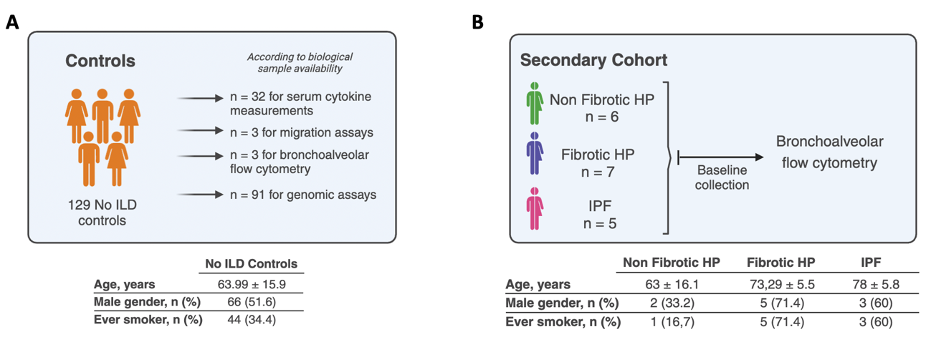
FIGURE LEGENDS

Fig. S1: Schematic representation of the non-interstitial lung disease (no-ILD) controls (A) used across different analyses and assays and individuals in the secondary cohort used for bronchoalveolar lavage flow cytometry according to diagnosis (B). General demografic information is depicted in the tables bellow. Age is shown as mean ± standard deviation

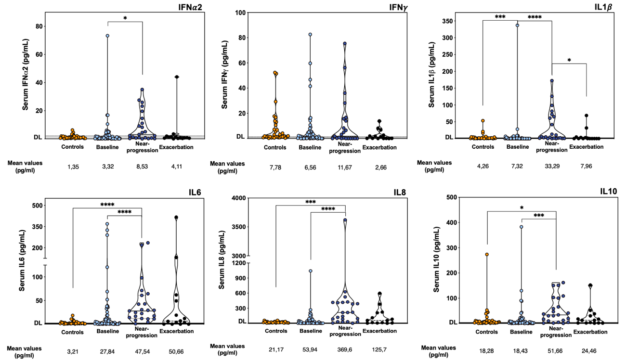
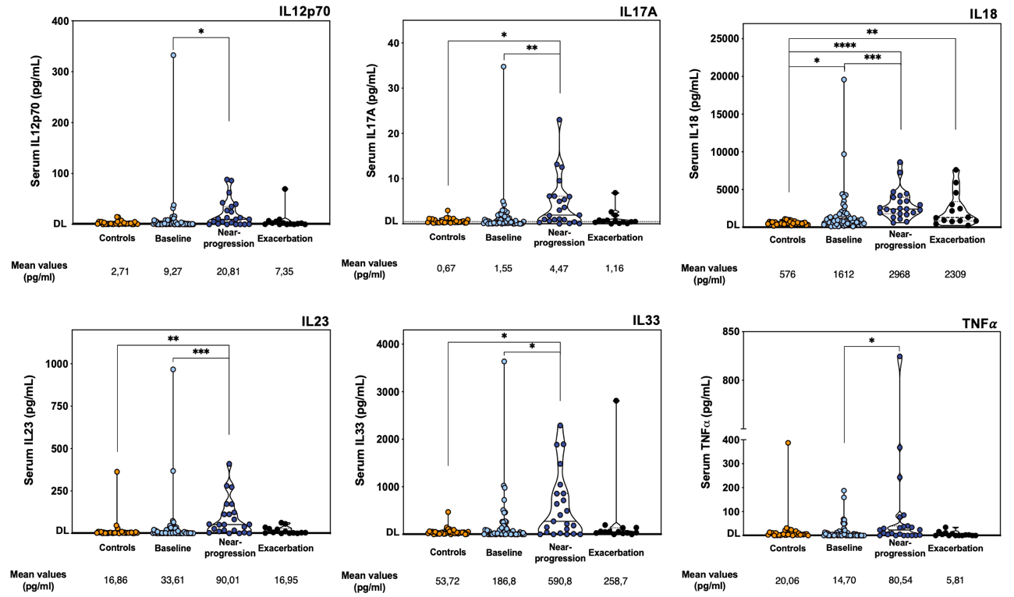

Fig. S2: Quantification of serum inflammatory cytokines and chemokines in fibrotic hypersensitivity pneumonitis (HP) patients across disease phases. Serum levels of IFN-α2, IFN-γ, IL-1β, IL-6, IL-8 (CXCL8), IL-10, IL-12p70, IL-17A, IL-18, IL-23, IL-33 and TNFα, were measured by ELISA. Patients were stratified according to disease phase: baseline samples from 58 patients (light blue circles), samples collected near a progression event from 23 patients (dark blue circles), and samples taken during acute exacerbation from 14 patients (black circles), which includes one patient of the prospective FL cohort followed from baseline. Thirty-two controls included are displayed in orange circles. Each dot represents one patient. Violin plots include horizontal lines indicating the median and quartiles, mean values are displayed below each condition. Data were analyzed with Kruskal-Wallis and Dunn’s multiple comparison test, with significance indicated as *P < 0.05, **P < 0.01, ***P < 0.005, ****P < 0.001.
Detection levels (DL) are identified and are the following: IFN-α 2 2.1 pg/mL, IFN-γ 1.3 pg/mL, IL-1β 1.5 pg/mL, IL-6 1.5 pg/mL, IL-8 (CXCL8) 2 pg/mL, IL-10 2 pg/mL, IL-12p70 2 pg/mL, IL-17A 0.5 pg/mL, IL-18 1.3 pg/mL, IL-23 1.8 pg/mL, IL-33 4.4 pg/mL, and TNFα 0.9 pg/mL.

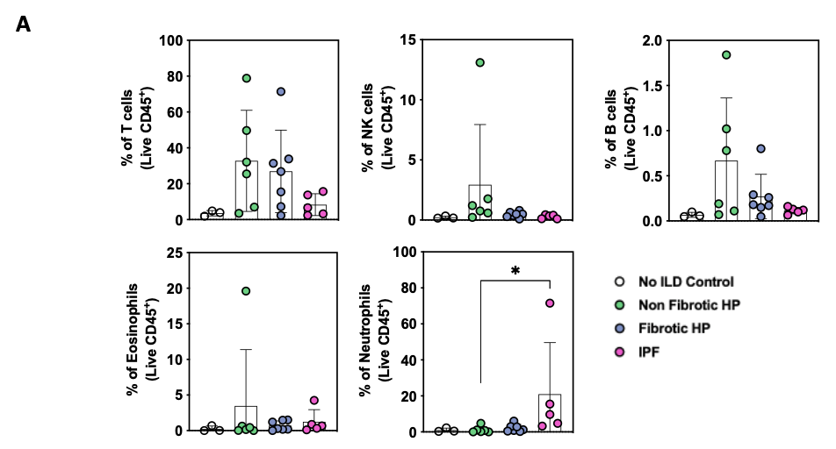
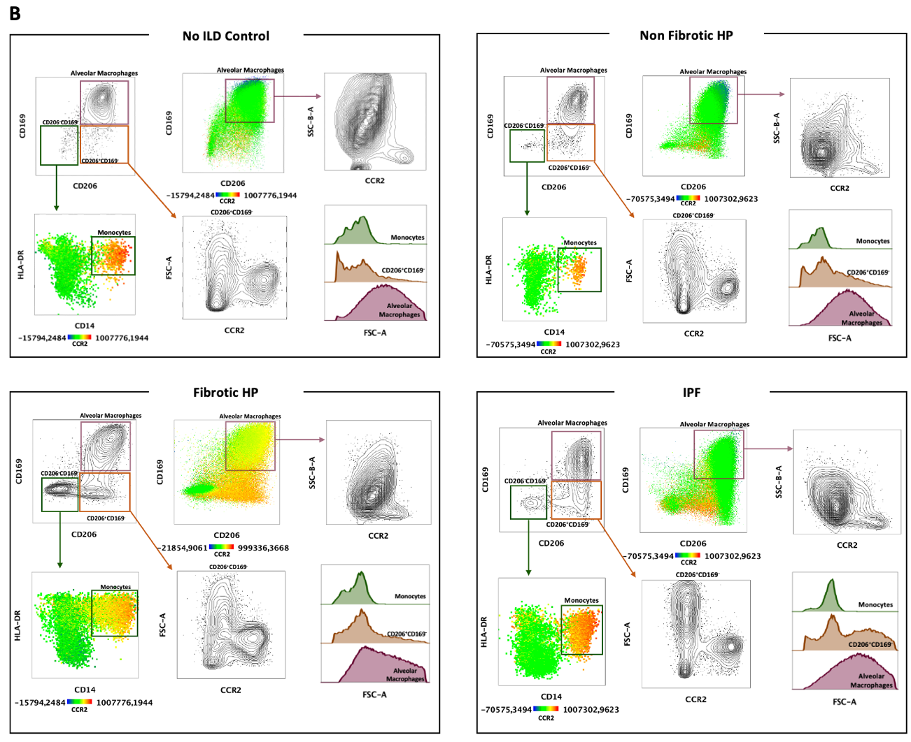
Fig. S3: Flow cytometry analysis of bronchoalveolar lavage cells. A) Flow cytometry analysis of bronchoalveolar lavage cells of no-ILD control subjects (white circles), non-fibrotic HP (green circles), fibrotic HP (blue circles) and idiopathic pulmonary fibrosis (IPF) patients (pink circles). Frequencies of T cells, natural killer (NK) cells, B cells, eosinophils and neutrophils in live CD45⁺ cells. Each dot represents one patient and horizontal lines indicate the respective mean ± SD. Data were analyzed with Kruskal-Wallis and Dunn’s multiple comparison test, *P < 0.05. B) Monocytes, alveolar macrophages and monocytes derived macrophages were analyzed by flow cytometry within the live (live-dead dye negative) CD45⁺ cells and after gating out the main cell populations (neutrophils, T cells, B cells, NK cells). Exemplificative contour plots are displayed for each condition and CCR2 expression heatmaps within monocytes (CD206⁻CD169⁻HLADR⁺CD14⁺), alveolar macrophages (CD206⁺CD169⁺) and monocytes derived macrophages (CD206⁺CD169⁻) are shown. Cell size comparison is illustrated in the histograms according to the forward scatter area (FSC-A).

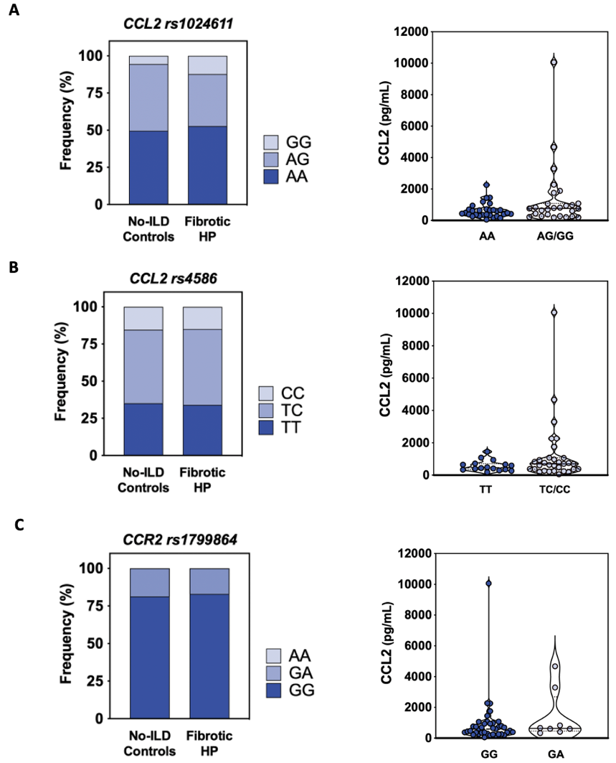
Fig. S4: CCL2 and CCR2 single nucleotide polymorphisms (SNPs) show no significant impact on fibrotic hypersensitivity pneumonitis (HP) incidence or baseline CCL2 serum levels. Genomic DNA was extracted from peripheral blood samples of 91 No-ILD controls and 57 fibrotic HP patients and SNP genotyping were performed by Axiom Human Genotyping SARS-COV-2 Array. Left panels: Genotype frequencies are depicted using a blue color scale. Right panels: Baseline CCL2 serum levels in fibrotic HP patients are stratified according to the presence of the SNP minor allele. A) CCL2 rs1024611: wild-type allele A; minor allele G. B) CCL2 rs4586: wild-type allele T; minor allele C. C) CCR2 rs1799864: wild-type allele G; minor allele A. Each dot represents an individual patient. Violin plots illustrate the distribution of serum levels, with horizontal lines indicating the median and quartiles.
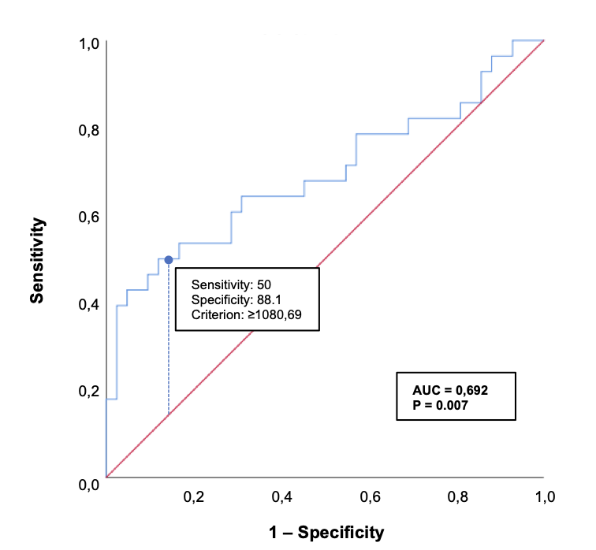

Fig. S5: Receiver operating characteristic (ROC) curve analysis was performed to evaluate the diagnostic performance of the biomarker. For each potential threshold, the Youden index (J = sensitivity + specificity – 1) was calculated. The optimal cutoff value was defined as the threshold corresponding to the maximum Youden index, thereby providing the best balance between sensitivity and specificity for discriminating between the stable and progressive disease states.

