Supporting Information for
Shifting Dynamics: Decoupling of Carbon and Water Cycles in the Amazon Rainforest
Contents of this File:
Figures S1-15

Supplementary Figure 1
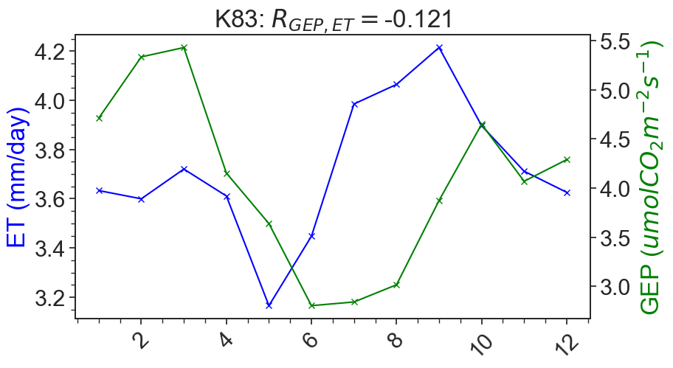
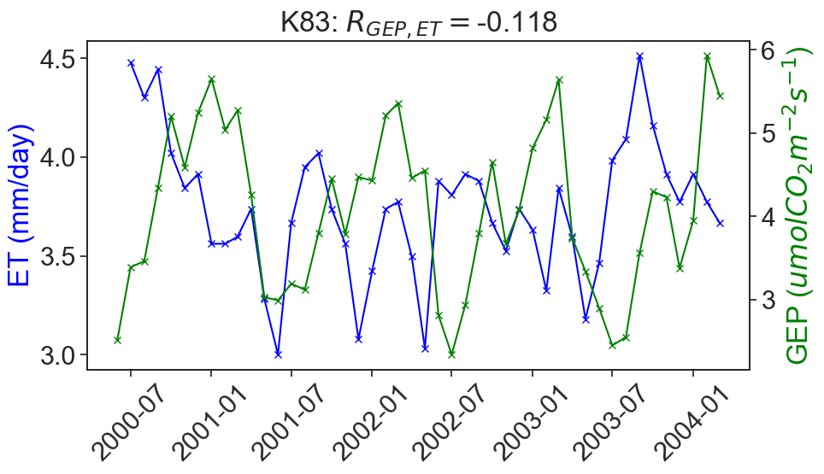
Supplementary Figure 1: Logged forest site K83. Top panel is long-term time series of GEP and ET, bottom panel is the climatology of GEP and ET.

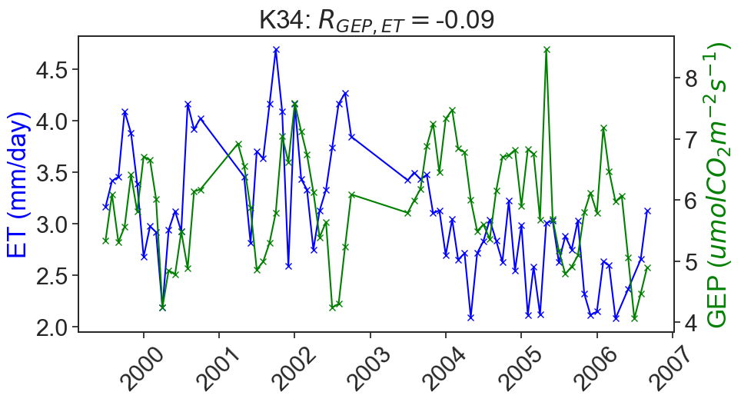
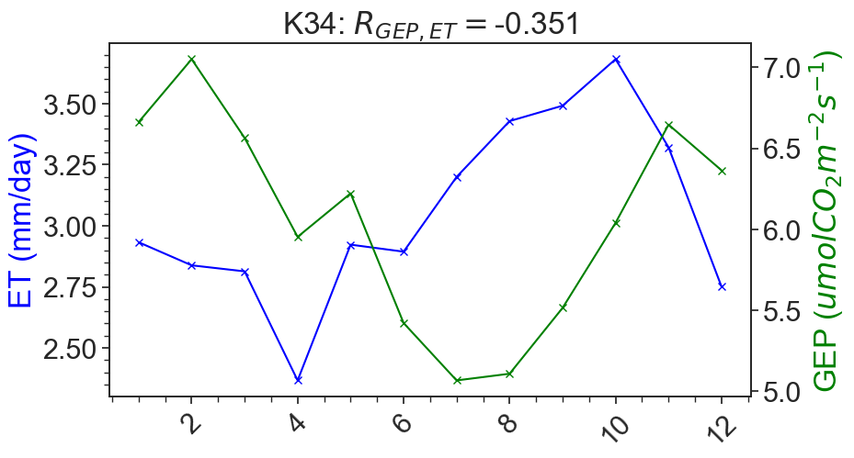
Supplementary Figure 2
Supplementary Figure 2: Intact Forest site K34. Top panel is long term time series of GEP and ET, bottom panel is the climatology of GEP and ET.

Supplementary Figure 3

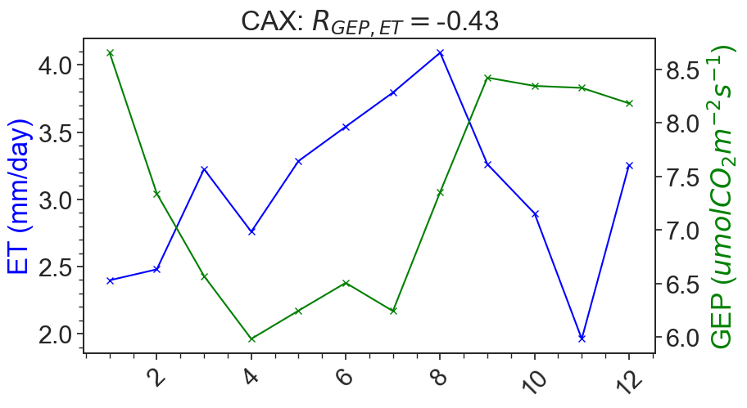
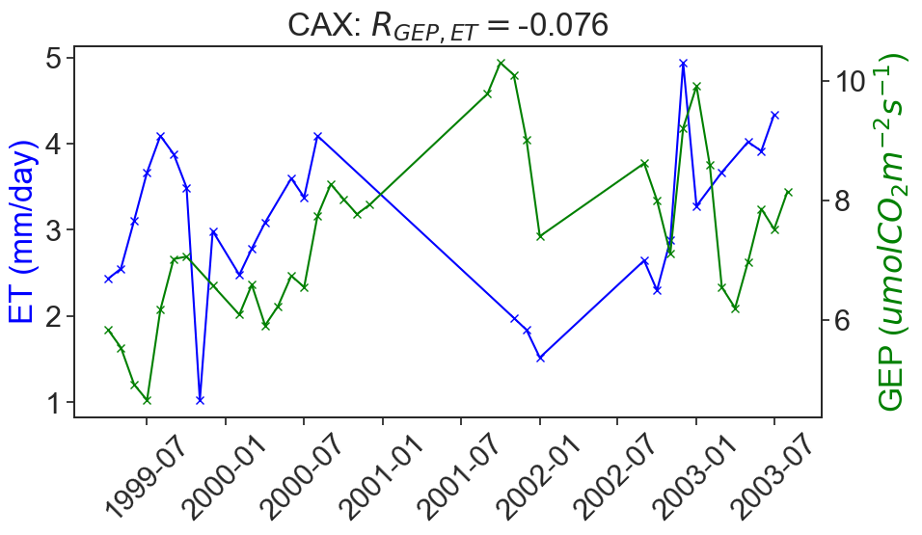
Supplementary Figure 3: Intact Forest site CAX. Top panel is long-term time series of GEP and ET, bottom panel is the climatology of GEP and ET.

Supplementary Figure 4
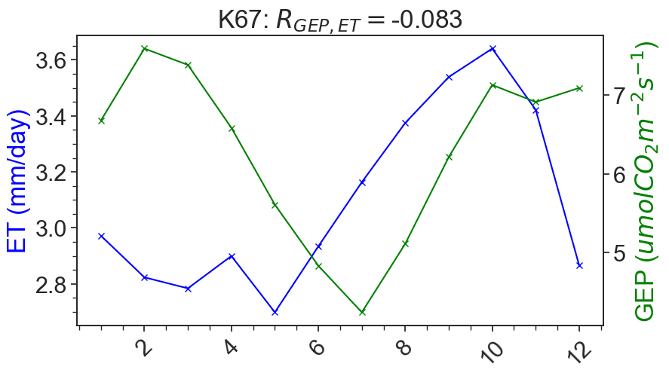
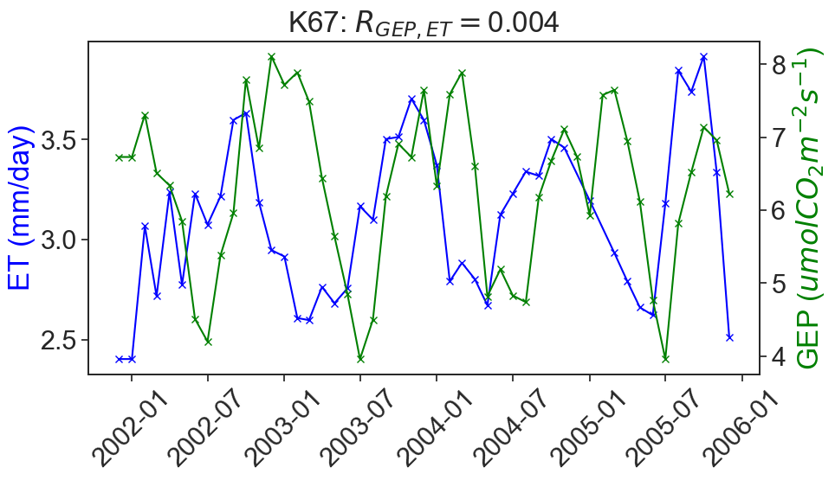
Supplementary Figure 4: Tropical forest site K67. Top panel is long-term time series of GEP and ET, bottom panel is the climatology of GEP and ET.

Supplementary Figure 5
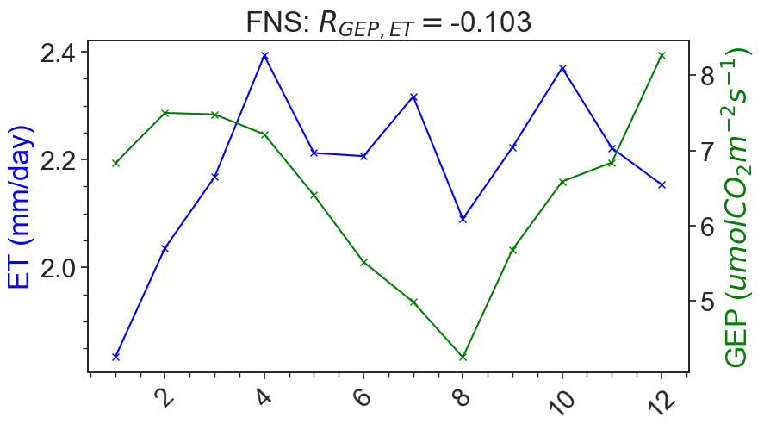
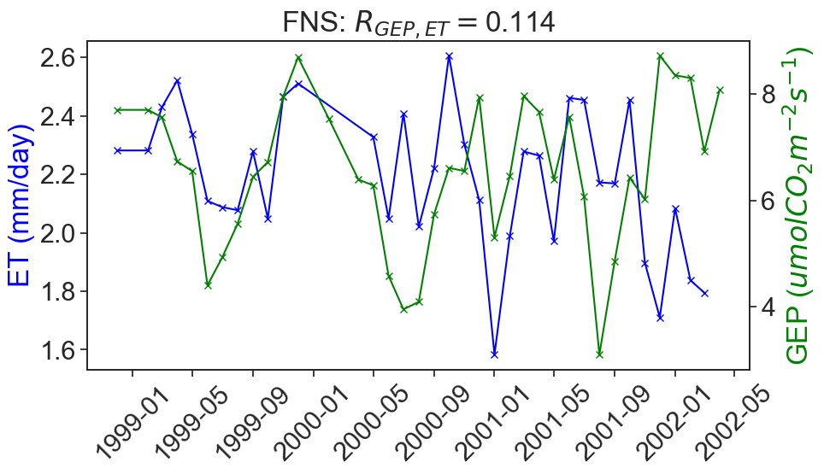
Supplementary Figure 5: Pasture site FNS. Top panel is long-term time series of GEP and ET, bottom panel is the climatology of GEP and ET.

Supplementary Figure 6
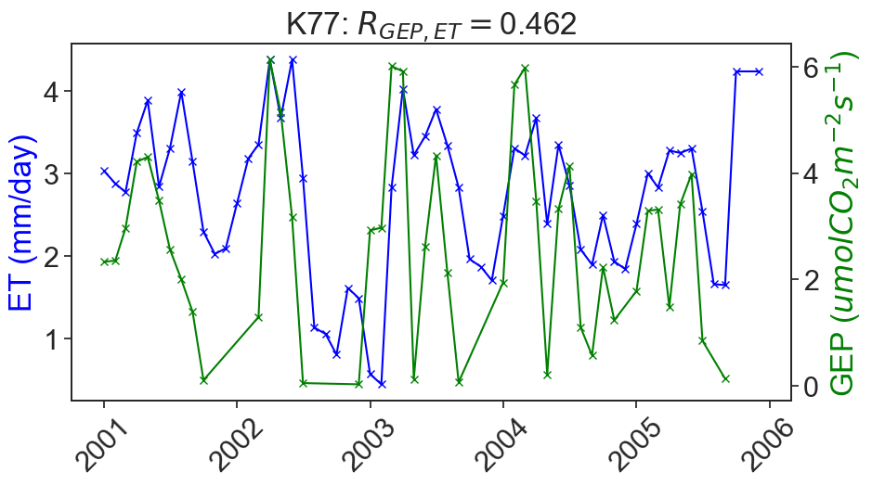
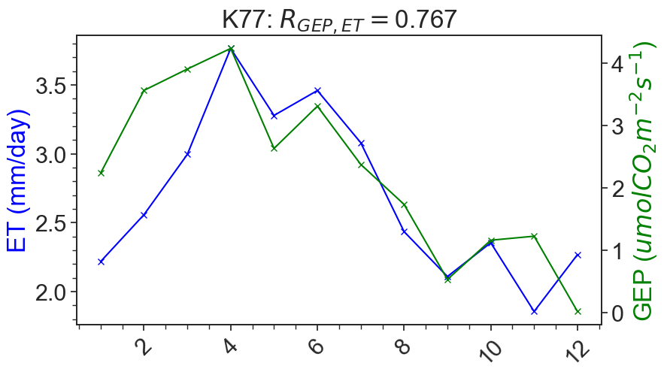
Supplementary Figure 6: Pasture site K77. Top panel is long-term time series of GEP and ET, bottom panel is the climatology of GEP and ET.

Supplementary Figure 7
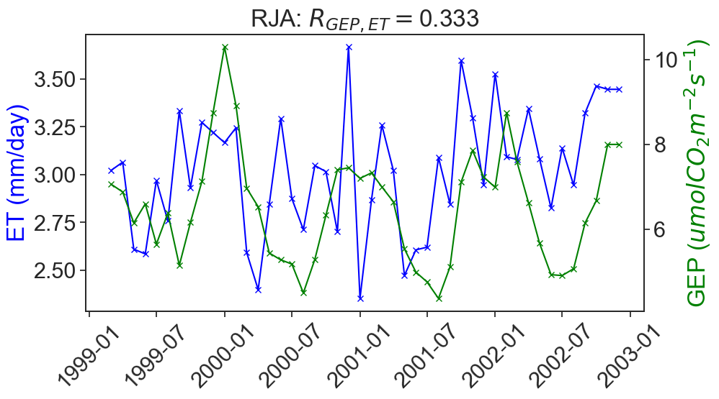
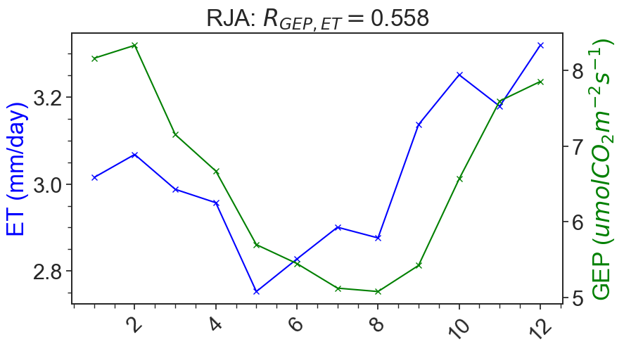
Supplementary Figure 7: Tropical dry forest site RJA. Top panel is long-term time series of GEP and ET, bottom panel is the climatology of GEP and ET.

Supplementary Figure 8

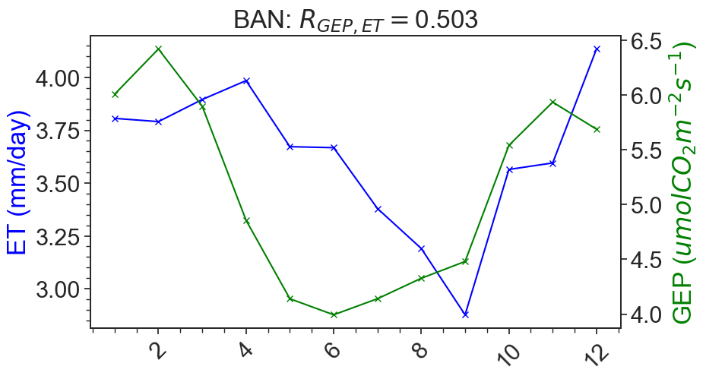
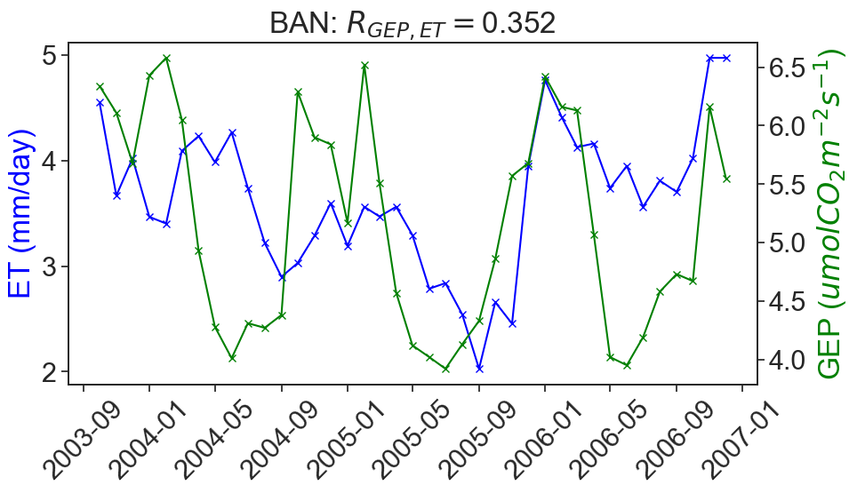
Supplementary Figure 8: Seasonally flooded forest site BAN. Top panel is long-term time series of GEP and ET, bottom panel is the climatology of GEP and ET.

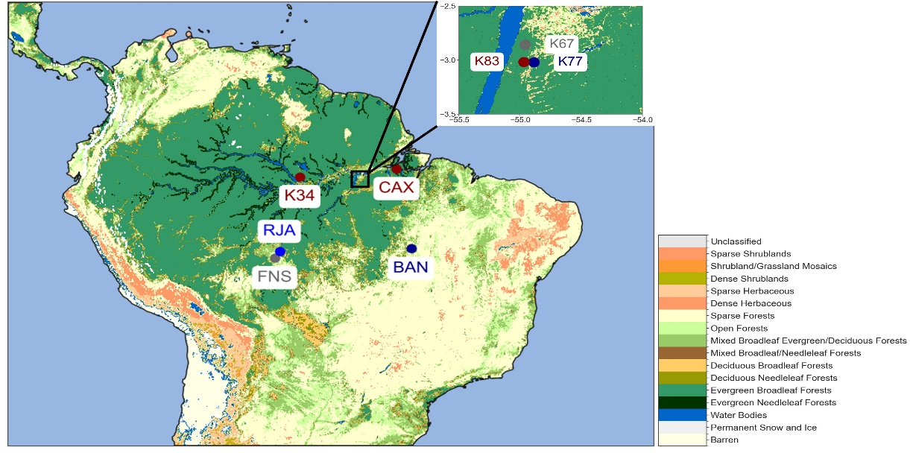
Supplementary Figure 9
Supplementary Figure 9: The 2005 MODIS land cover with the locations of the flux towers and their correlation strength and direction superimposed on top. 2005 is chosen as most of the flux tower data is publicly available in the early 2000s.

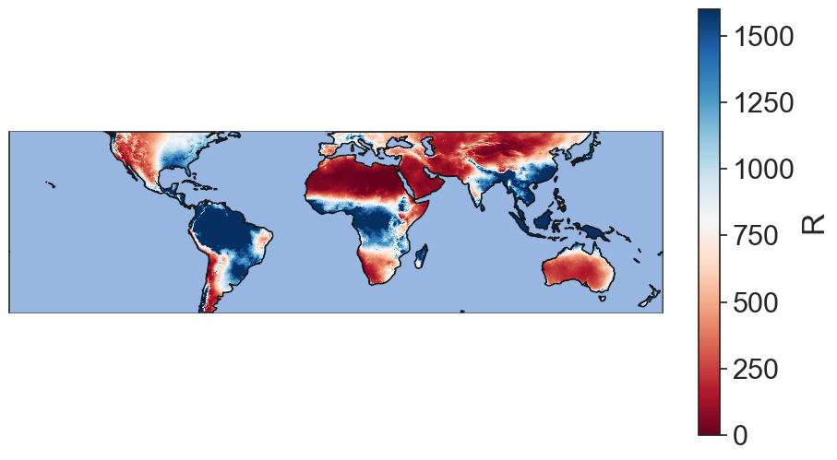
Supplementary Figure 10
Supplementary Figure 10: Mean annual precipitation between $50°S$ and $50°N$. Units are mm/year. Color bar threshold is 0-1600 mm/year.

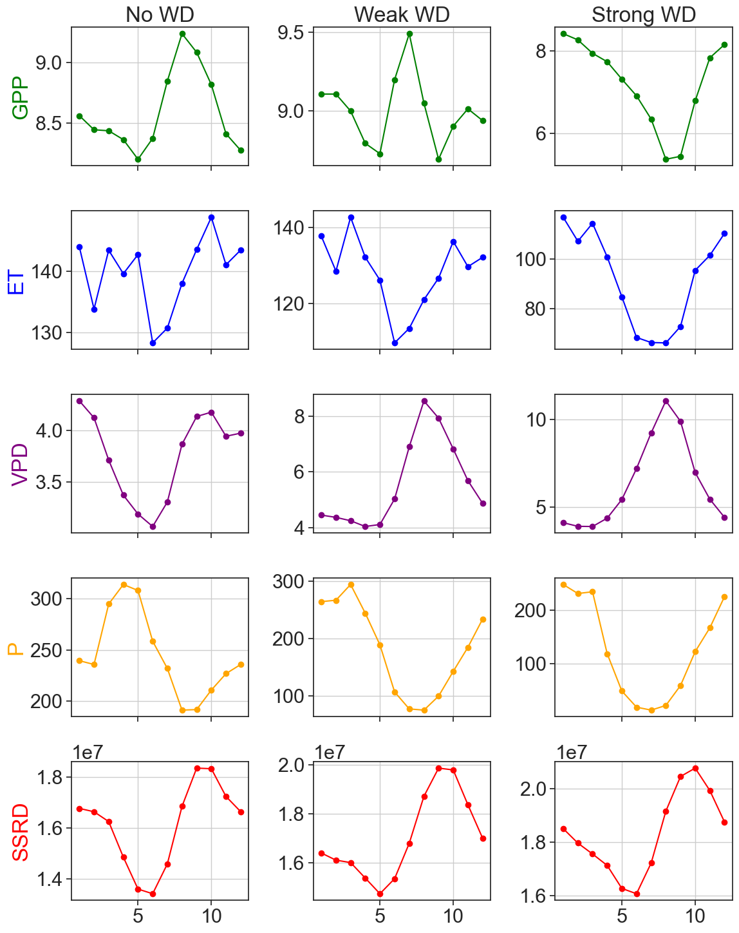
Supplementary Figure 11
Supplementary Figure 11: Seasonal cycles of GPP (green, units: $gC m^{-2} day^{-1}$), ET (blue, units: mm/month), VPD (purple, units: hPa), P (orange, units: mm/month), and SSRD (red, units: $J/m^{2}$) for the no WD, Weak WD, and Strong WD regions.

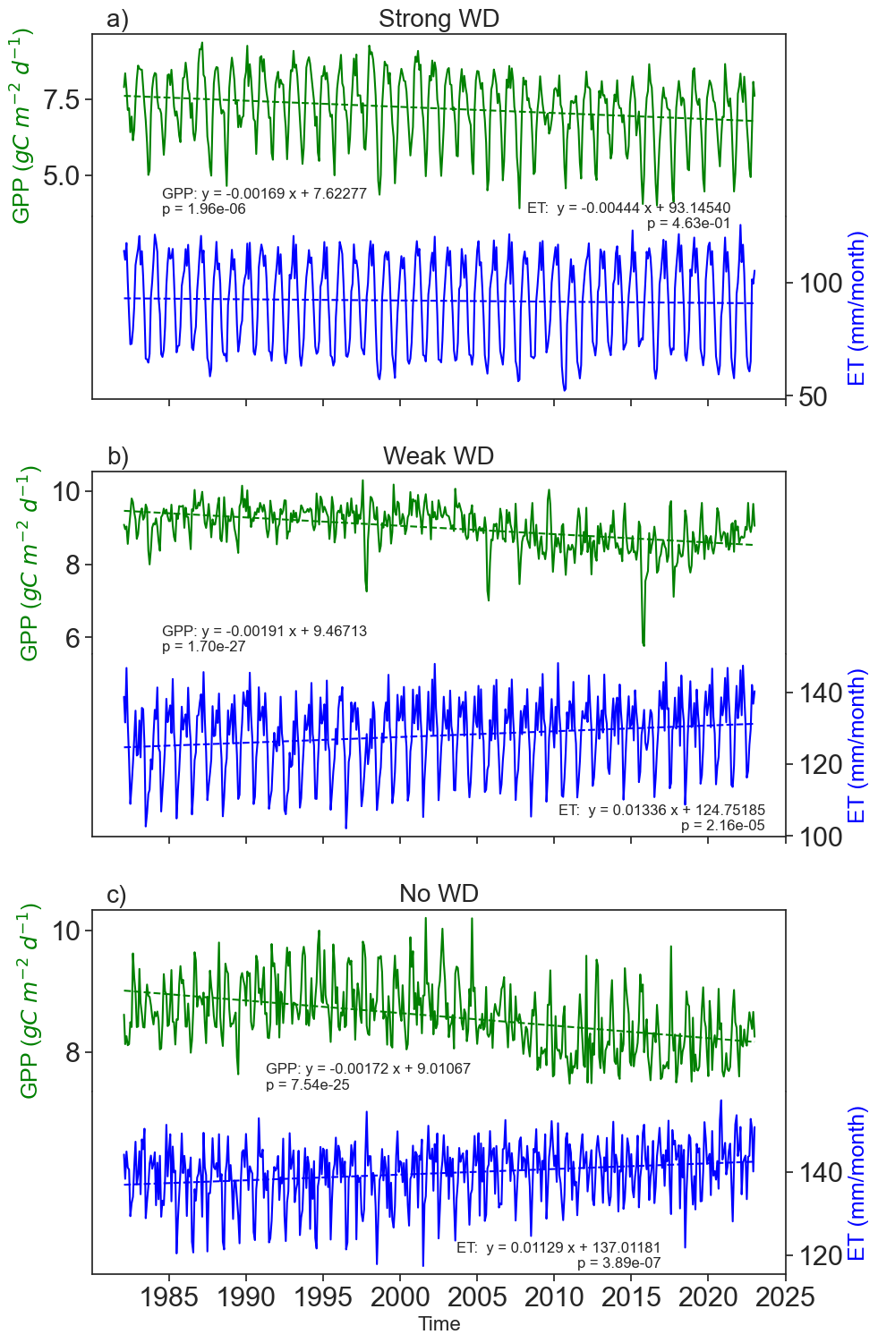
Supplementary Figure 12
Supplementary Figure 12: GPP and ET, and their trend lines, averaged over a) the no WD region; b) the weak WD region; and c) the strong WD region.

Supplementary Figure 13
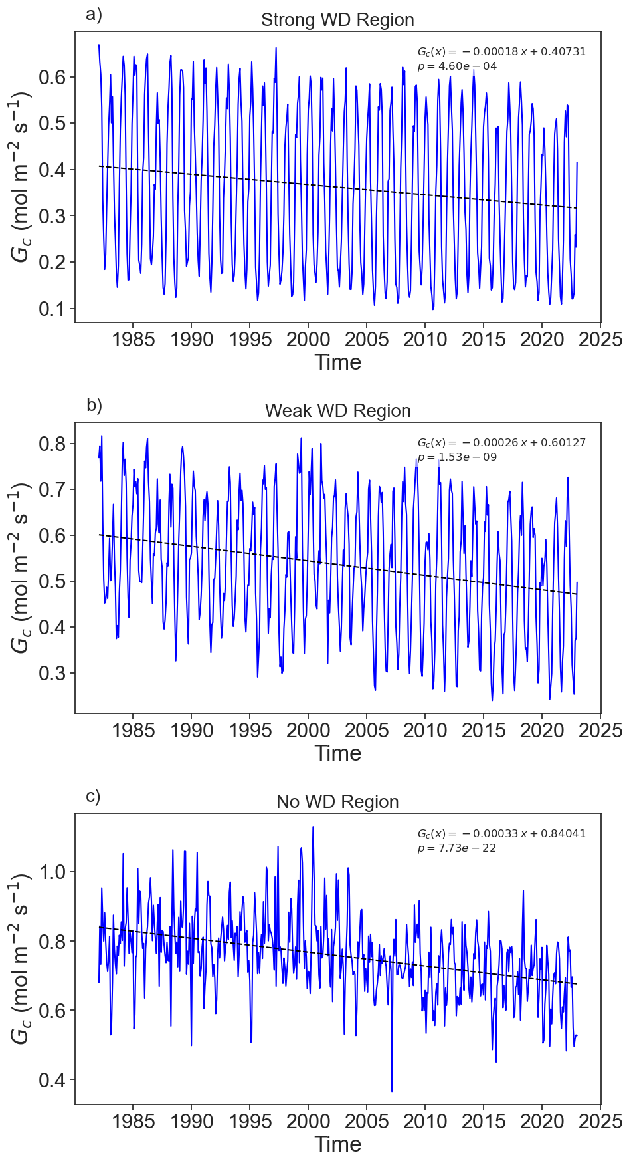
Supplementary Figure 13: Canopy conductance ($G_c$), and its trend lines, for a) the strong WD region, b) the weak WD region, and c) the no WD region.
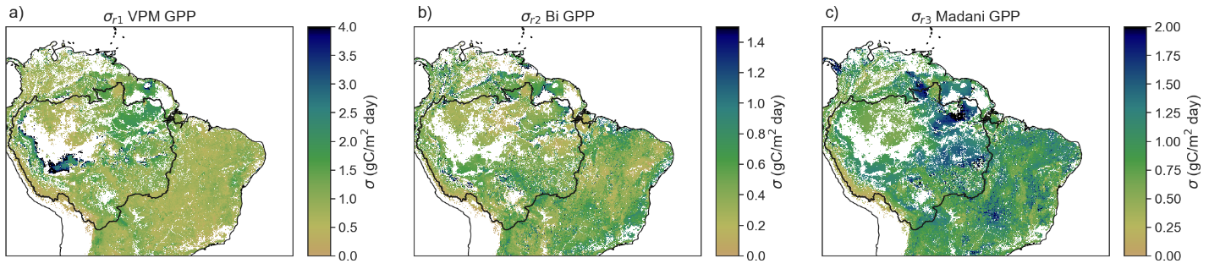
Supplementary Figure 14
Supplementary Figure 14: Triple Collocation over time for each grid point for a) VPM GPP (Zhang et al., 02017); b) Bi et al. (2022) GPP; and c) Madani et al. (2020) GPP.

Supplementary Figure 15
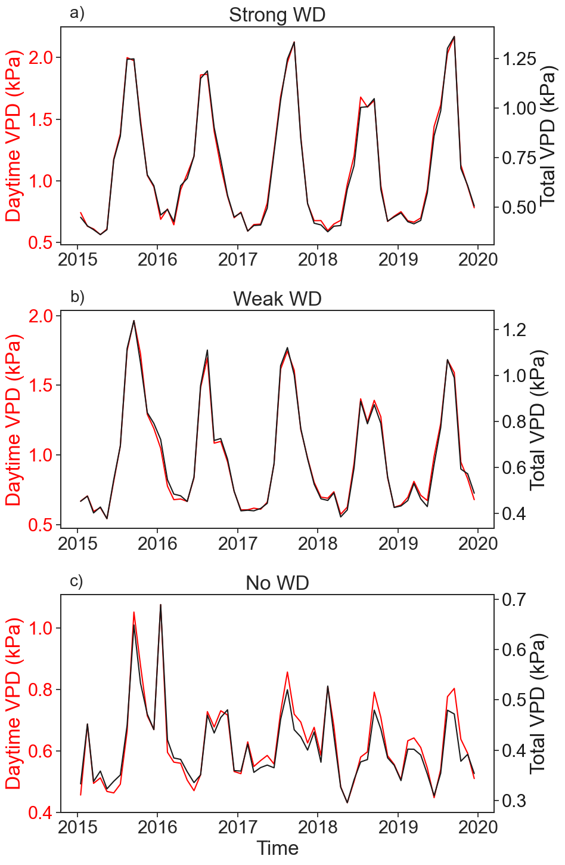
Supplementary Figure 15: Comparison of daytime only VPD (red) with daytime and nighttime (total) VPD (black) in the a) strong WD region, b) weak WD region, and c) no WD region.

