Supplementary Information
Synthesis of stable zinc-phosphate micro/nanoparticles under acid and alkaline conditions
Journal of Nanoparticle Research
Benjamín Valdez-Salas¹*†, Karen Guillén-Carvajal¹*†, Ernesto Beltrán-Partida¹, Jorge Salvador-Carlos¹, Mario Alberto Curiel-Álvarez², Nicola Nedev²
*Correspondence: benval@uabc.edu.mx, kguillen@uabc.edu.mx
†These authors contributed equally to this work.
¹Core Facility- Química y materiales avanzados, Instituto de Ingeniería, Universidad Autónoma de Baja California, Blvd. Benito Juárez and Normal s/n., 21280 Mexicali, Baja California, México
²Core Facility- Semiconductores y manufactura avanzada, Instituto de Ingeniería, Universidad Autónoma de Baja California, Blvd. Benito Juárez and Normal s/n., 21280 Mexicali, Baja California, México

Table S1 Composition of chemical synthesis tests for ZnP in both acidic and alkaline media using droplets as a measure. A= acid, B= alkaline, HCl= hydrochloric acid, citric acid= AC, ascorbic acid= AA, and CC= Cocobetaine
Medium | Name | N$H_{4}OH$ | $$HCl$$ | AC | AA | CC
 | Preliminar
B | ZnPB | 13 | - | - | - | 1%
A | ZnPA | - | 2 | - | - | 1%
 | Trial
B | 1BHCl | 13 / - | - | - | - | 1%
B | 2BHCl | 13 / 15 | - | - | - | 0.5%
B | 3BHCl | 15 / - | - | - | - | 0.1%
B | 1BAC | 20 / 19 | - | - | - | 1%
B | 2BAC | 13 / - | - | - | - | 0.5%
B | 3BAC | 14 / 14 | - | - | - | 0.1%
B | 1BAA | 10 / - | - | - | - | 1%
B | 2BAA | 12 / - | - | - | - | 0.5%
B | 3BAA | 10 / - | - | - | - | 0.1%
A | 1HCl | - | 3 / 4 | - | - | 1%
A | 2HCl | - | 3 / - | - | - | 0.5%
A | 3HCl | - | 2 / - | - | - | 0.1%
A | 1AC | - | - | 14 / - | - | 1%
A | 2AC | - | - | 18 / - | - | 0.5%
A | 3AC | - | - | 10 / 14 | - | 0.1%
A | 1AA | - | - | - | 40 / - | 1%
A | 2AA | - | - | - | 30 / - | 0.5%
A | 3AA | - | - | - | 20 / - | 0.1%

Table S2 Preliminary resuspension tests in ZnP in a chemical medium. HCl = hydrochloric acid, citric acid = AC, ascorbic acid = AA, and CC = Cocobetaine
Name | $$HCl$$ | AC | AA | CC | Alkaline medium
1BHCl | YES | X | X | X | X
2BHCl | YES | X | X | X | X
3BHCl | YES | X | X | X | X
1BAC | YES | YES | X | X | X
2BAC | YES | YES | YES | X | X
3BAC | YES | YES | X | X | X
1BAA | YES | YES | YES | X | X
2BAA | YES | YES | YES | X | X
3BAA | YES | YES | YES | X | X

Table S3 Yield and quantity of each acid used for the resuspension of 10 mL of ZnP synthesis solution in a basic medium. The quantity is in drops. A= acid, B= alkaline, HCl= hydrochloric acid, citric acid= AC, ascorbic acid= AA, and CC= Cocobetaine
Name | $$HCl$$ | AC | AA | CC | Yield (%)
1BHCl | 15 | - | - | 1% | 53.9083
2BHCl | 20 | - | - | 0.5% | 57.6405
3BHCl | 20 | - | - | 0.1% | 78.3744
1BAC | 25 | 12 | - | 1% | 66.7634
2BAC | 20 | - | - | 0.5% | 52.2496
3BAC | 8 | - | - | 0.1% | 62.2019
1BAA | - | - | 60 | 1% | 50.1762
2BAA | - | - | 60 | 0.5% | 41.0533
3BAA | - | - | 40 | 0.1% | 2.9028

Table S4 DLS response for the presence of MCPs and NPs upon resuspension. + Positive result, - Negative result. HCl = hydrochloric acid, citric acid = AC, ascorbic acid = AA, and CC = Cocobetaine
C | Acid medium |  |  | Alkaline medium
CC | 1% | 0.5% | 0.1% | 1% | 0.5% | 0.1%
AC | - | - | + | + | - | +
HCl | + | - | - | - | + | -
AA | + | + | - | + | - | -

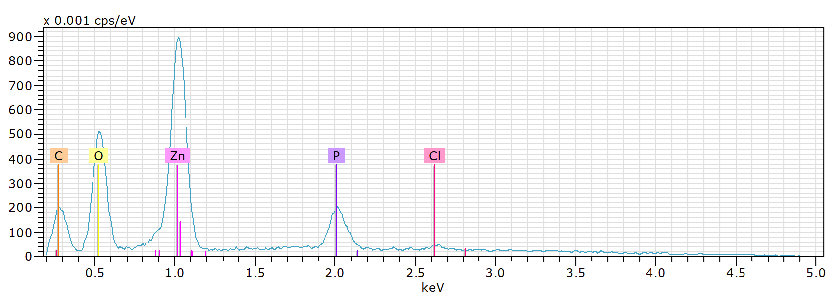
Fig. S1 Analysis of the chemical composition by EDS of ZnP in alkaline medium
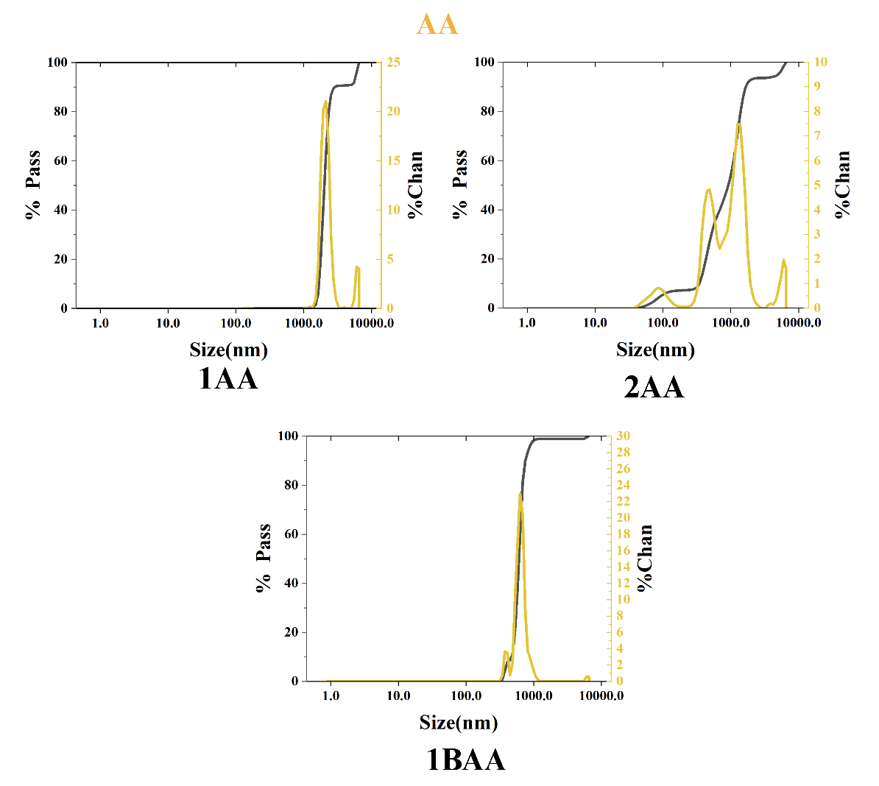

Fig. S2 Size distribution of MCPs obtained in acidic and alkaline media using ascorbic acid (AA). 1AA corresponds to 1% cocobetaine (CC), 2AA corresponds to 0.5% CC, and 1BAA is in alkaline media using 1% CC

