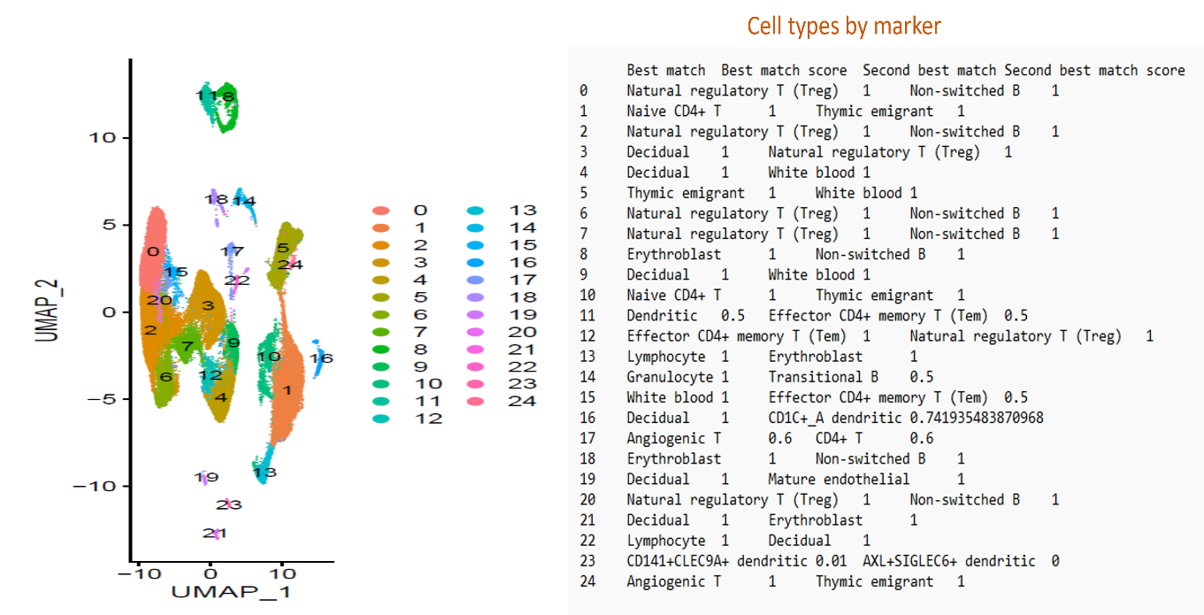 Supplementary1. UMAP dimensionality reduction shows distinct clustering of cells based on transcriptional profiles. Clusters were annotated using canonical marker genes (Figure 1).

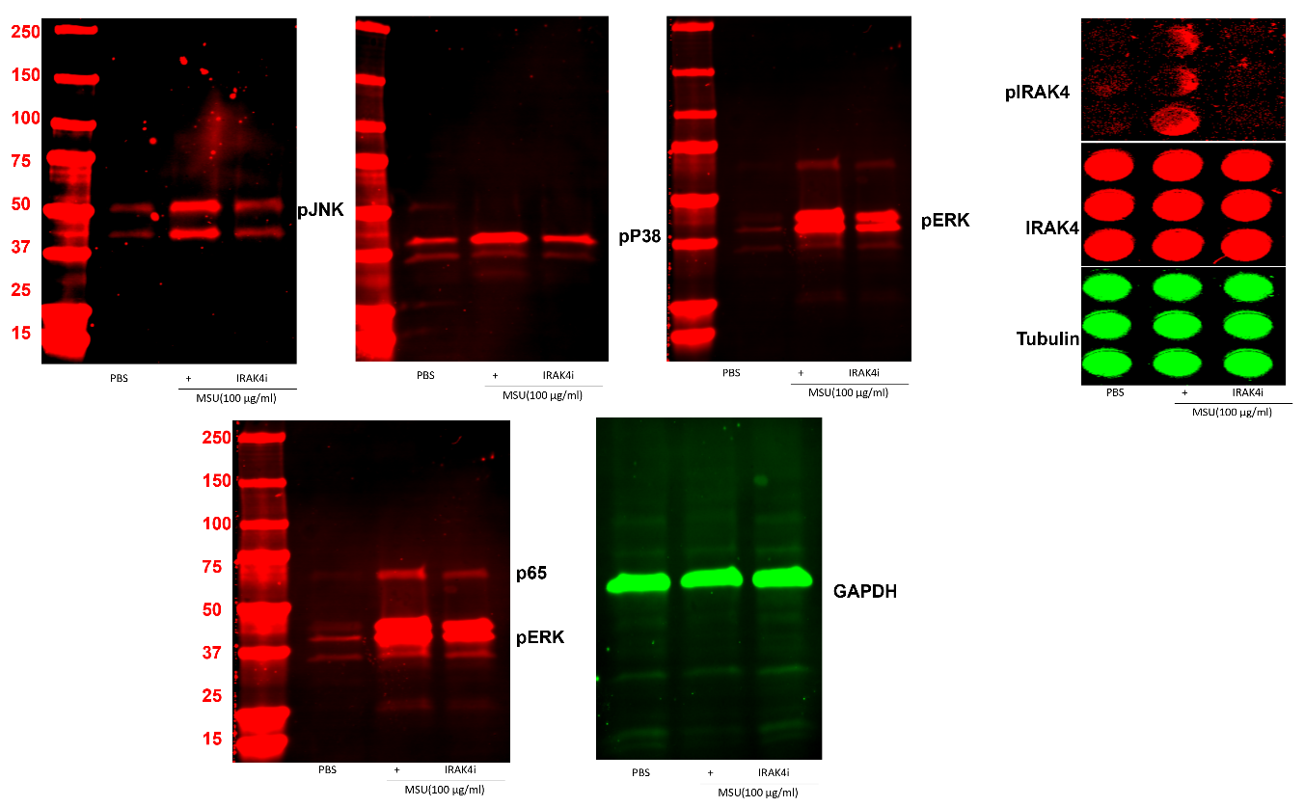
Supplementary 2. Raw western blots of figure 4.

