Supplementary Information

Table S1. Number of rats examined per round by experimental line.

Line | Round 1 | Round 2 | Round 3
Control | 12 | 6 | 6
WT | 12 |  | 11
TgTH0 |  | 12
TgTH-MID |  | 11
TgTH-HIGH |  |  | 15

Table S2. Number of rats of each sex examined by experimental line.

Line | Male | Female
Control | 12 | 12
WT | 11 | 12
TgTH0 | 6 | 6
TgTH-MID | 5 | 6
TgTH-HIGH | 7 | 8

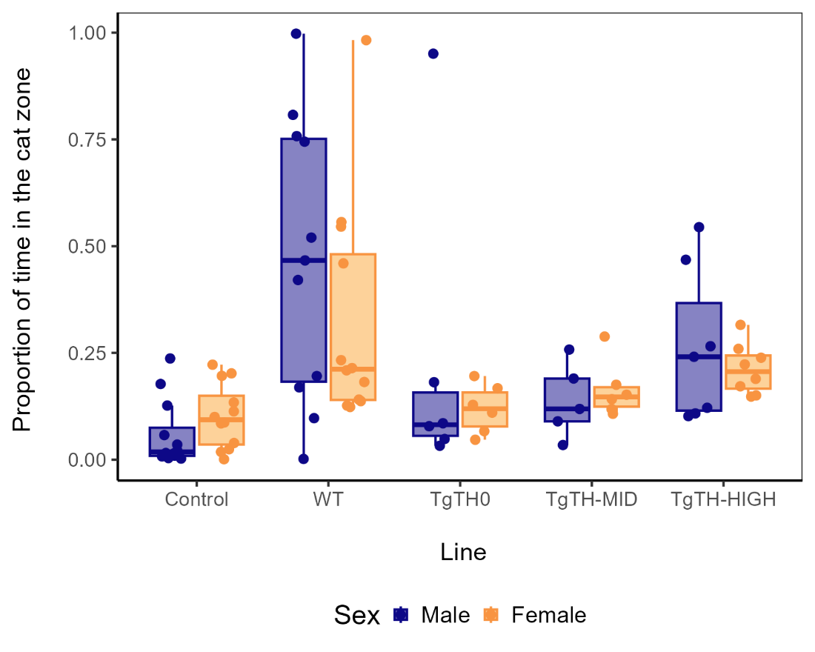
Figure S1. Proportion of time spent in the cat zone. Distribution of the observations by line and sex.

Table S3. Proportion of time spent in the cat zone. Posterior means and 95% credible intervals (CrIs; see Figure 2).
Line | Mean | 95% CrI lower limit | 95% CrI upper limit
Control | 0.084 | 0.054 | 0.128
WT | 0.443 | 0.324 | 0.571
TgTH0 | 0.107 | 0.075 | 0.153
TgTH-MID | 0.155 | 0.111 | 0.209
TgTH-HIGH | 0.243 | 0.185 | 0.315

Table S4. Proportion of time spent in the cat zone. Posterior mean differences between lines and 95% credible intervals (CrIs; see Figure 2). Differences whose 95% credible interval does not include the value of zero are considered relevant and are highlighted in grey.

Lines | Mean | 95% CrI lower limit | 95% CrI upper limit
Control - TgTH0 | -0.023 | -0.079 | 0.031
Control - TgTH-MID | -0.071 | -0.134 | -0.009
Control - TgTH-HIGH | -0.159 | -0.238 | -0.088
TgTH0 - TgTH-MID | -0.048 | -0.113 | 0.012
TgTH0 - TgTH-HIGH | -0.136 | -0.213 | -0.065
TgTH-MID - TgTH-HIGH | -0.088 | -0.170 | -0.010
WT - Control | 0.359 | 0.235 | 0.489
WT - TgTH0 | 0.336 | 0.210 | 0.464
WT - TgTH-MID | 0.288 | 0.160 | 0.420
WT - TgTH-HIGH | 0.200 | 0.067 | 0.339

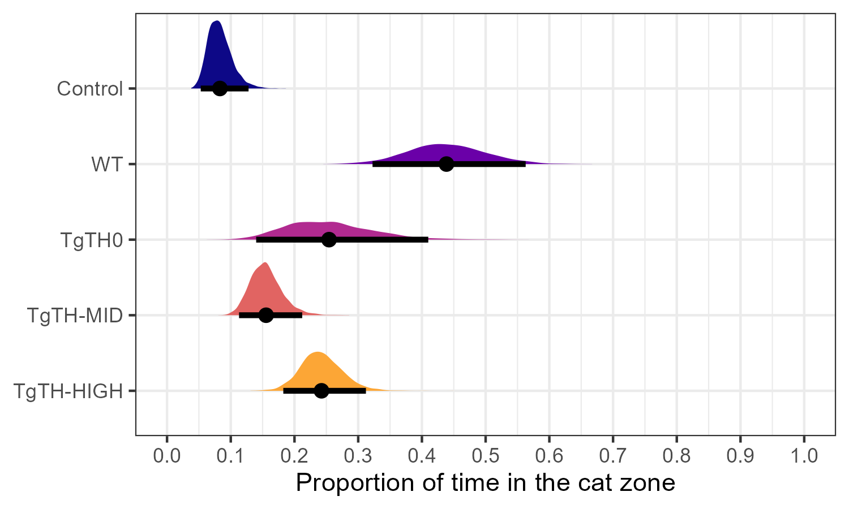
Figure S2. Proportion of time spent in the cat zone (including the extreme value). Posterior distributions of the mean and 95% credible intervals, by experimental line.

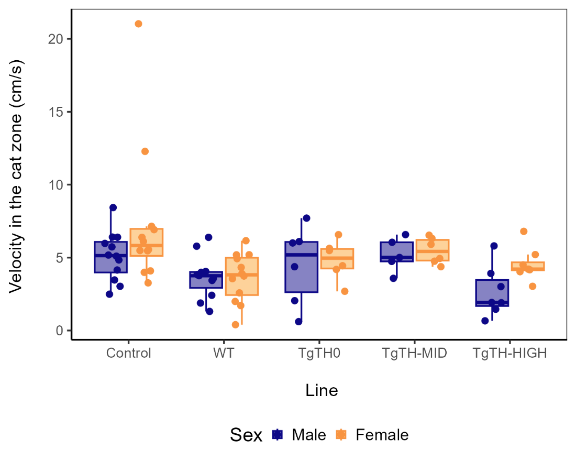

Figure S3. Velocity (cm/s) in the cat zone. Distribution of the observations by line and sex.

Table S5. Velocity (cm/s) in the cat zone. Posterior means and 95% credible intervals (CrIs; see Figure 3).
Line | Mean | 95% CrI lower limit | 95% CrI upper limit
Control | 5.412 | 4.720 | 6.092
WT | 3.668 | 2.966 | 4.377
TgTH0 | 4.760 | 3.711 | 5.786
TgTH-MID | 5.343 | 4.391 | 6.276
TgTH-HIGH | 3.677 | 2.804 | 4.507

Table S6. Velocity (cm/s) in the cat zone. Posterior mean differences between lines and 95% credible intervals (CrIs; see Figure 3). Differences whose 95% credible interval does not include the value of zero are considered relevant and are highlighted in grey.

Lines | Mean | 95% CrI lower limit | 95% CrI upper limit
Control - TgTH0 | 0.652 | -0.583 | 1.895
Control - TgTH-MID | 0.069 | -1.120 | 1.256
Control - TgTH-HIGH | 1.735 | 0.663 | 2.838
TgTH0 - TgTH-MID | -0.583 | -1.986 | 0.842
TgTH0 - TgTH-HIGH | 1.083 | -0.212 | 2.467
TgTH-MID - TgTH-HIGH | 1.666 | 0.359 | 2.927
WT - Control | -1.744 | -2.758 | -0.731
WT - TgTH0 | -1.092 | -2.349 | 0.162
WT - TgTH-MID | -1.675 | -2.823 | -0.520
WT - TgTH-HIGH | -0.009 | -1.106 | 1.103

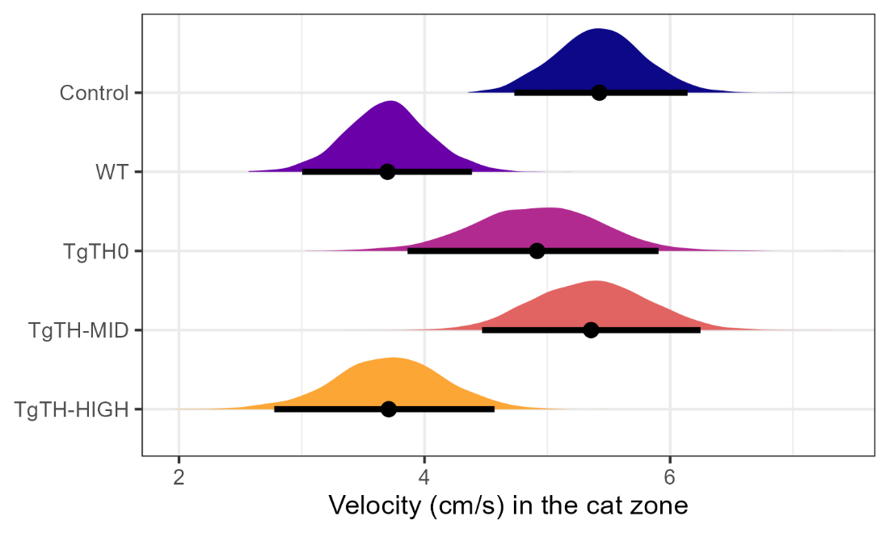

Figure S4. Velocity in the cat zone (including extreme value). Posterior distributions of the mean and 95% credible intervals, by experimental line.

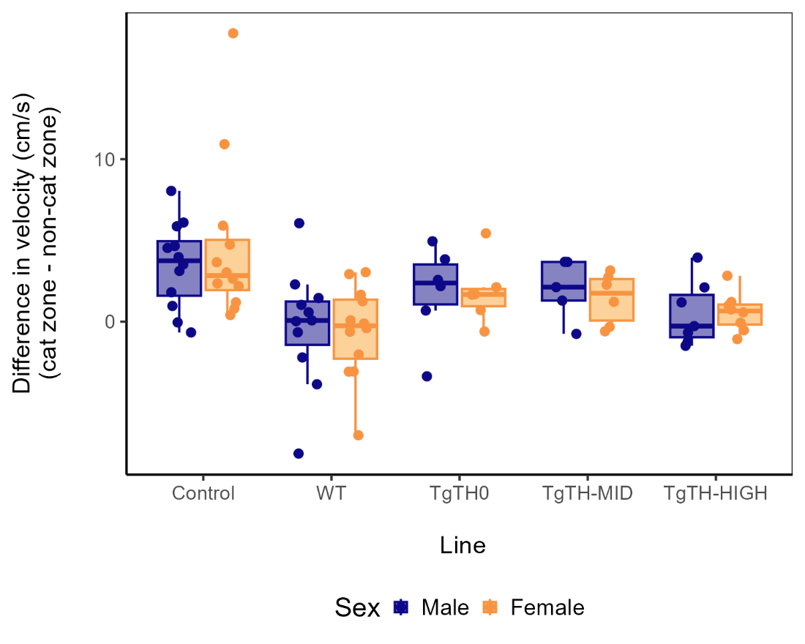

Figure S5. Distribution of observations for difference in velocity (cm/s) between the cat zone and the non-cat zone (cat zone – non-cat zone) by line and sex.

Table S7. Difference in velocity (cm/s) in the cat zone and non-cat zone (cat zone – non-cat zone). Posterior means and 95% credible intervals (CrIs; see Figure 4).

Line | Mean | 95% CrI lower limit | 95% CrI upper limit
Control | 3.309 | 2.247 | 4.414
WT | -0.159 | -1.213 | 0.862
TgTH0 | 1.917 | 0.518 | 3.327
TgTH-MID | 1.749 | 0.344 | 3.116
TgTH-HIGH | 0.474 | -0.636 | 1.631

Table S8. Difference in velocity (cm/s) in the cat zone and non-cat zone (cat zone – non-cat zone). Posterior mean differences between lines and 95% credible intervals (CrIs; see Figure 4). Differences whose 95% credible interval does not include the value of zero are considered relevant and are highlighted in grey.
Lines | Mean | 95% CrI lower limit | 95% CrI upper limit
Control - TgTH0 | 1.393 | -0.361 | 3.192
Control - TgTH-MID | 1.561 | -0.167 | 3.339
Control - TgTH-HIGH | 2.835 | 1.252 | 4.413
TgTH0 - TgTH-MID | 0.168 | -1.807 | 2.138
TgTH0 - TgTH-HIGH | 1.442 | -0.345 | 3.192
TgTH-MID - TgTH-HIGH | 1.274 | -0.575 | 3.047
WT - Control | -3.468 | -5.029 | -2.003
WT - TgTH0 | -2.076 | -3.799 | -0.365
WT - TgTH-MID | -1.908 | -3.653 | -0.192
WT - TgTH-HIGH | -0.633 | -2.191 | 0.880

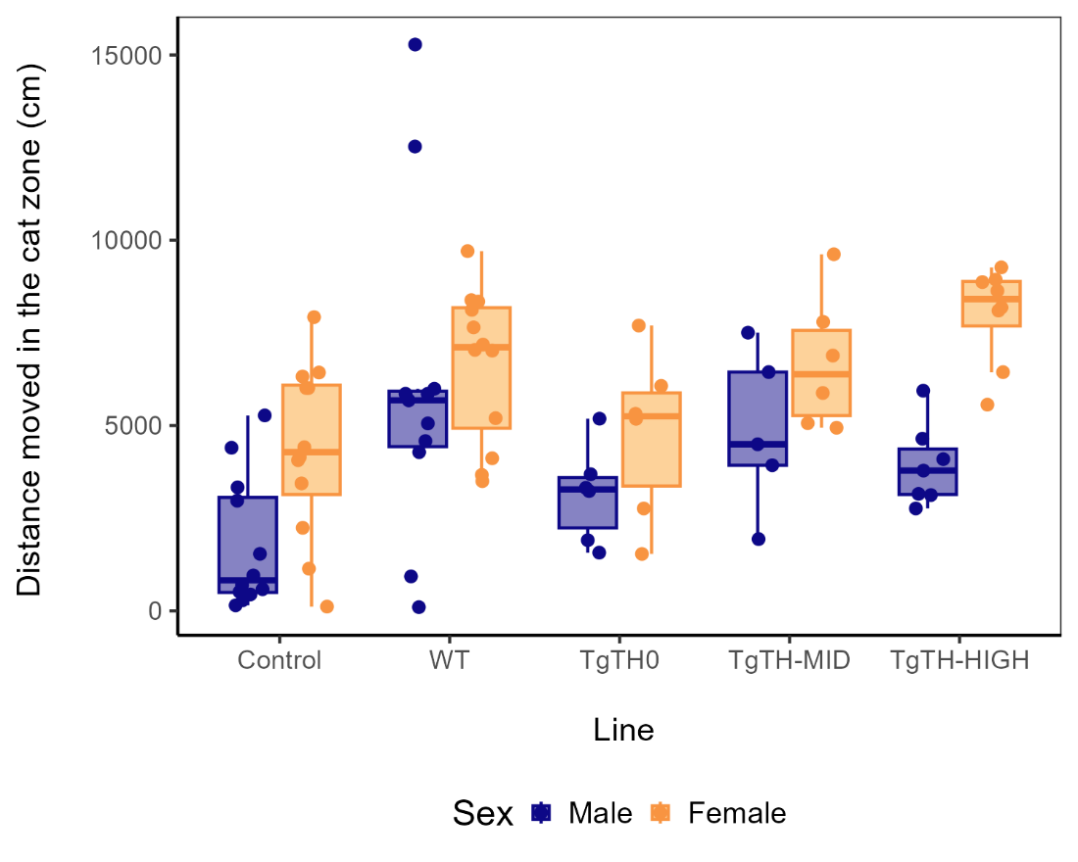
Figure S6. Distance (cm) moved in the cat zone. Distribution of the observations, by line and sex.

Table S9. Distance (cm) moved in the cat zone. Posterior means and 95% credible intervals (CrIs; see Figure 5).
Sex | Line | Mean | 95% CrI lower limit | 95% CrI upper limit
Male | Control | 1,796.614 | 807.409 | 2,801.757
Female | Control | 4,261.909 | 3,252.688 | 5,232.110
Male | WT | 4,747.165 | 3,687.648 | 5,812.523
Female | WT | 7,212.460 | 6,161.477 | 8,239.566
Male | TgTH0 | 2,798.066 | 1,478.664 | 4,117.265
Female | TgTH0 | 5,263.361 | 3,925.289 | 6,605.784
Male | TgTH-MID | 4,457.514 | 3,101.459 | 5,797.528
Female | TgTH-MID | 6,922.809 | 5,592.463 | 8,271.264
Male | TgTH-HIGH | 4,789.745 | 3,635.757 | 6,000.124
Female | TgTH-HIGH | 7,255.040 | 6,045.978 | 8,407.114

Table S10. Distance (cm) moved in the cat zone. Posterior mean differences between lines and 95% credible intervals (CrIs; see Figure 5). Differences whose 95% credible interval does not include the value of zero are considered relevant and are highlighted in grey.
Sex | Lines | Mean | 95% CrI lower limit | 95% CrI upper limit
Male | Control - TgTH0 | -1,001 | -2,544 | 492
Male | Control - TgTH-MID | -2,661 | -4,205 | -1,175
Male | Control - TgTH-HIGH | -2,993 | -4,339 | -1,608
Male | WT - Control | 2,951 | 1,708 | 4,209
Male | TgTH0 - TgTH-MID | -1,659 | -3,435 | 88
Male | TgTH0 - TgTH-HIGH | -1,992 | -3,650 | -342
Male | TgTH-MID - TgTH-HIGH | -332 | -1,988 | 1,307
Male | WT - TgTH0 | 1,949 | 342 | 3,497
Male | WT - TgTH-MID | 290 | -1,276 | 1,824
Male | WT - TgTH-HIGH | -43 | -1,472 | 1,384
Female | Control - TgTH0 | -1,001 | -2,544 | 492
Female | Control - TgTH-MID | -2,661 | -4,205 | -1,175
Female | Control - TgTH-HIGH | -2,993 | -4,339 | -1,608
Female | WT - Control | 2,951 | 1,708 | 4,209
Female | TgTH0 - TgTH-MID | -1,659 | -3,435 | 88
Female | TgTH0 - TgTH-HIGH | -1,992 | -3,650 | -342
Female | TgTH-MID - TgTH-HIGH | -332 | -1,988 | 1,307
Female | WT - TgTH0 | 1,949 | 342 | 3,497
Female | WT - TgTH-MID | 290 | -1,276 | 1,824
Female | WT - TgTH-HIGH | -43 | -1,472 | 1,384

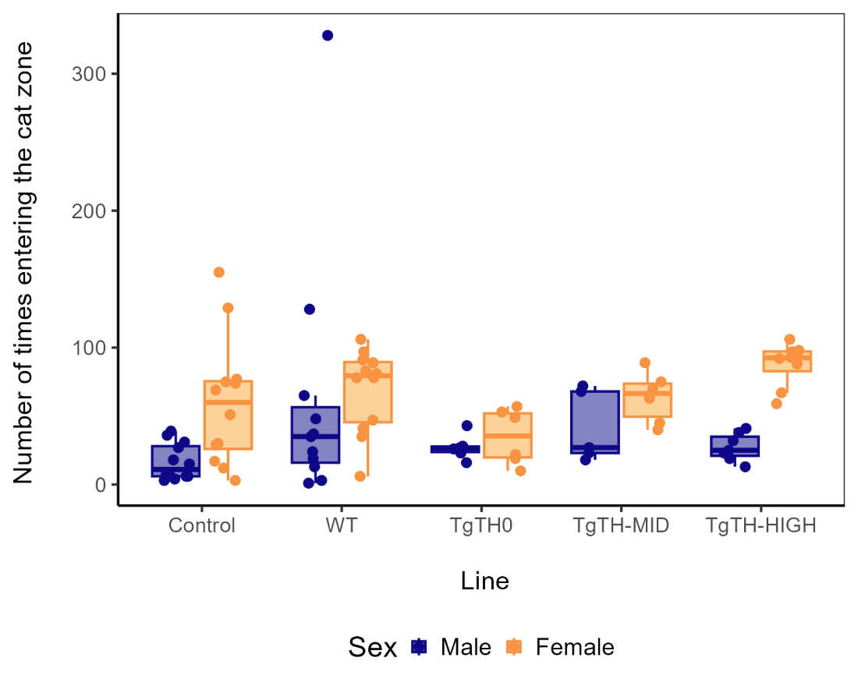

Figure S7. Frequency to enter the cat zone. Distribution of the observations, by line and sex.

Table S11. Frequency of entering the cat zone. Posterior means and 95% credible intervals (CrIs; see Figure 6).

Sex | Mean | 95% CrI lower limit | 95% CrI upper limit
Male | 28.766 | 22.989 | 35.911
Female | 65.530 | 52.671 | 81.493

Table S12. Frequency of entering the cat zone. Posterior mean difference between lines and 95% credible interval (CrI; see Figure 6). Differences whose 95% credible interval does not include the value of zero are considered relevant and are highlighted in grey.
Sex | Mean | 95% CrI lower limit | 95% CrI upper limit
Female -Male | 36.764 | 21.879 | 54.261

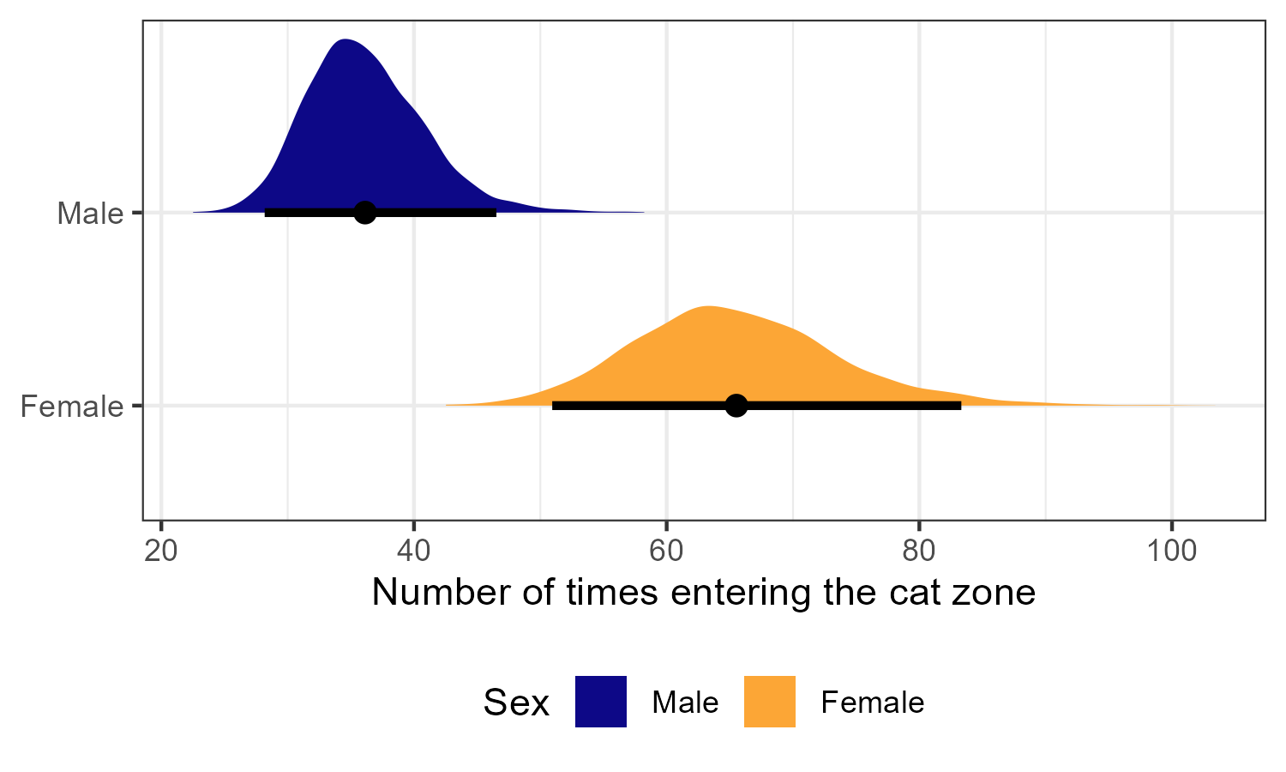
Figure S8. Frequency to enter the cat zone (including the extreme value). Posterior distribution of the means and 95% credible intervals, by sex.

