Supplementary Information for
Joint Brittle-Ductile Control on Orogen Collapse Rates
Rawi Dawood^{1,2*}, Jean‐Arthur Olive³, Einat Aharonov¹
¹ Institute of Earth Sciences, The Hebrew University, Jerusalem, Israel.² Geological Survey of Israel, Yesha'yahu Leibowitz 32, Jerusalem, Israel. ³ Laboratoire de Géologie, CNRS - École Normale Supérieure - PSL University, Paris, France.
*Corresponding author. e-mail: rawi.dawood@mail.huji.ac.il

The Supplementary Information Sections:
Further Information on Modeling Strain Rates in Tibet and the Apennines
Further Information on Partial Melt Channel
Supplementary figures and tabels
Supplementary figure 1: Weak crust and extension strain rates in the Tibetan Plateau.
Supplementary figure 2: Fault strength ($S_{f}=\left(1-λ\right)μ^{*}$)
Supplementary figure 3: Seismic Velocity Cross-Sections Along the Apennines and Southeastern Tibetan Plateau
Supplementary figure 4: The impact of plagioclase partial melt on channel thickness and fault strength
Supplementary figure 5: The impact of wet quartzite partial melt on channel thickness and fault strength
Supplementary figure 6: Schematic drawing of the frictional–viscous fault system model.
Supplementary Table 1: Rheological flow laws used in modeling the weak crustal layer.
Supplementary Table 2: Tibetan plateau best-fit model parameters.
Supplementary Table 3: Apennines best-fit model parameters.
Supplementary Table 4: parameters used for modeling the strain vs. topography in fig. 4.
Supplementary Table 5: plagioclase partial melt model parameters
Supplementary Table 6: wet quartzite partial melt model parameters

Modeling the strain rate
This section describes the methods for measuring strain rates and elevation data from the Apennines and Tibet, and how we compared them with our model results.

2.1. The Apennines
Extensional strain rates in the Apennines were measured along approximately 90 km long and 30 km wide transects. These transects were oriented perpendicular to the mountain chain's strike¹. The extension rates were derived from long-term (15 ± 3 kyr) slip rate measurements across exposed fault scarps². The data from refs.^{1,2} also includes the mean elevation $(h_{mean})$ along each transect. Our model uses the maximum topography ($h$) and mountain slope length (W) as inputs to compute the extensional velocity of the upper crust, or equivalently, the strain rate along the slope (Fig. 2 and Supplementary Fig. 6).
We assume the maximum topography ($h$) at each transect is approximately twice the mean elevation ($h_{mean})$ of the transect, as illustrated by the red and blue topographic profiles in Fig. 1a, c. The mountain slope length (W) was measured for each transect and ranges between 40–60 km, as exemplified by the red and blue profiles. Using these values, we calculated the extensional velocity of the upper crust (equation (22), u₁ in Figure 2). Since strain is calculated for a 90 km transect, we divide the modeled extensional velocity (u₁​) by 90 km to compare the modeled and measured strain rates for each transect.
The thickness of the brittle upper crust in the Apennines is 13-16 km^{3–5}. In our model, we use 13 km as the thickness of the brittle upper crust ($h_{BUC}$). For the temperature of the weak crustal layer (equation (24)), we assume: an average surface heat flow of 50 m·W/m², typical for this area⁶, to derive the temperature versus depth through the upper crust, assuming a surface temperature of 10°C, crustal heat production of 1×10⁻⁶ W/m³, and thermal conductivity of 2.5 J/s·m·K.

2.1. The Tibetan plateau
Extensional strain rates in the Tibetan Plateau were measured using GPS velocity along transects oriented parallel to the extension direction. Ref.7 reports data from 19 transacts, each transect spanning 700 km in length and approximately 50 km width⁷ (Supplementary Fig. 1). The dataset from Ref.⁷ also includes the mean elevation $(h_{mean})$ along each transect⁷. Since the transects are situated on the plateau, their mean elevation approximates the model's maximum topography input ($h$). The characteristic slope length , beneath which the weak crustal flow is present, is about 1500 km⁸ (Supplementary Fig. 1). We use this characteristic length as the slope length (W) and $h$ for each transect to calculate the extensional velocity (equation 22 (u₁ in Figure 2)). Since strain is calculated for a 700 km transect, we divide the modeled extensional velocity (u₁​) by 700 km to compare the modeled and measured strain rates.
The thickness of the brittle upper crust in the Tibet is 15-20 km^{9–14}. In our model, we use 15 km as the thickness of the brittle upper crust ($h_{BUC}$). For the temperature of the weak crustal layer (equation (24)), we assume an average surface heat flow of 100 m·W/m², typical for this area¹⁵, to derive the temperature versus depth through the upper crust, assuming a surface temperature of 10°C, crustal heat production of 1×10⁻⁶ W/m³, and thermal conductivity of 2.5 J/s·m·K.

Partial melting
While our model assumes a weak crustal channel with no melting, several studies suggest that the mid-to-lower crust of Tibet is partially molten, with estimated melt fractions ranging from 8–35%^{16–19}. It is also possible that the mid-to-lower crust of the Apennines is partially molten⁵. Partial melting of approximately 8% is believed to lower the viscosity, decreasing the pre-exponential factor (I) in equations (15) and (22) by an order of magnitude. To assess how melting may affect both the required channel thickness and fault strength necessary to fit the observed strain rate-elevation correlation in Tibet⁷, we increased the pre-exponential factor (A) in equation (22 ) by orders of magnitude (10, 100, and 1000) for both plagioclase and wet quartzite (supplementary tables. 5 and 6).
For both plagioclase and wet quartzite, increasing (A) reduces the width of the required channel to fit the observed strain rate-elevation correlation in Tibet⁷. In the case of plagioclase, the model indicates that extremely weak faults are necessary to fit the data, for all values of the pre-exponential factor, similar to the case with no melting where A is unchanged. For wet quartzite, the model suggests that as A increases, the fault strength $(S_{f}=μ^{*}(1-λ)$) must decrease to optimally fit the data (Supplementary figures 4 and 5 and supplementary tables. 5 and 6). Given the unrealistic nature of extremely weak faults (see Supplementary figures 2 for the interpretation of extremely low $S_{f}$ in term of $μ$ and $λ$), we can rule out the possibility of plagioclase as the dominant material in the weak crustal layer. Therefore, our findings suggest that the rheology of this layer is more consistent with quartz-rich rocks, characterized by a stress exponent of approximately 2.
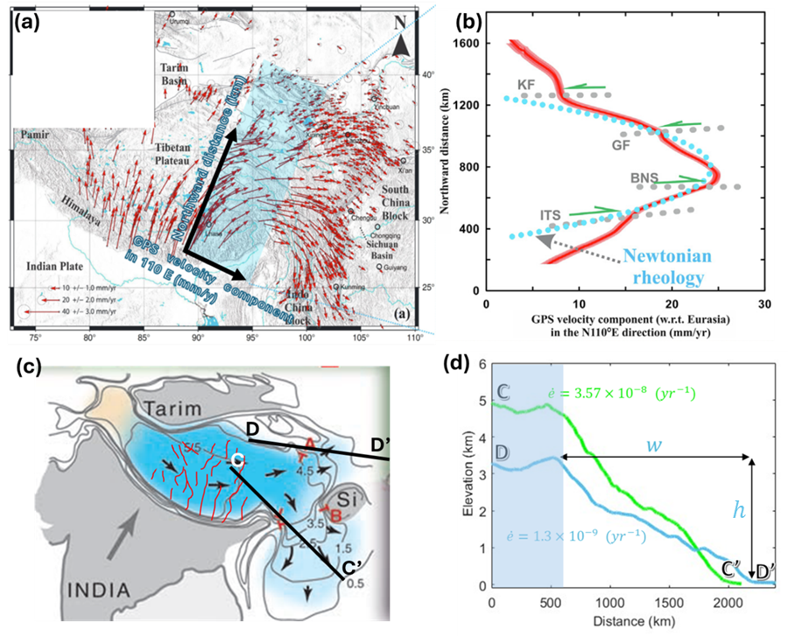
Supplementary Figure 1: Weak crust and extension strain rates in the Tibetan Plateau. (a) Horizontal GPS velocities of crustal motion relative to stable Eurasia (red arrows). Blue shaded rectangle shows the location of the profiles⁷ for the topography verses strain rate data (modified from ref.⁷). (b) The mean GPS velocity component (red line), along with its error (shaded region), projected in the N110°E direction across the blue-shaded swath profile, which represents the mean direction of Tibetan crustal extension (modified from ref.⁷).(c) A map of the Tibetan region showing the approximate area of deep crustal flow (blue shading) with topographic contours. Inferred lower crustal flow directions are indicated by black arrows, while normal faults are outlined in red (Modified from ref. ²⁰). (d) Topographic profiles (C-C' in green and D-D' in turquoise). The corresponding strain rates along each profile are also depicted. The blue shaded area in (a) represents the shaded region, and as can be seen, their mean topography from ref.⁷ is the maximum topography in our model input.
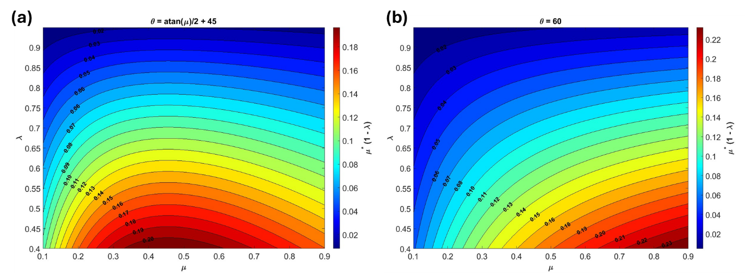
Supplementary Figure 2: Contour plots of fault strength, $S_{f}=\left(1-λ\right)μ^{*},$ as function of λ and μ for (a) Optimally oriented fault. (b) Fault dip = 60°.

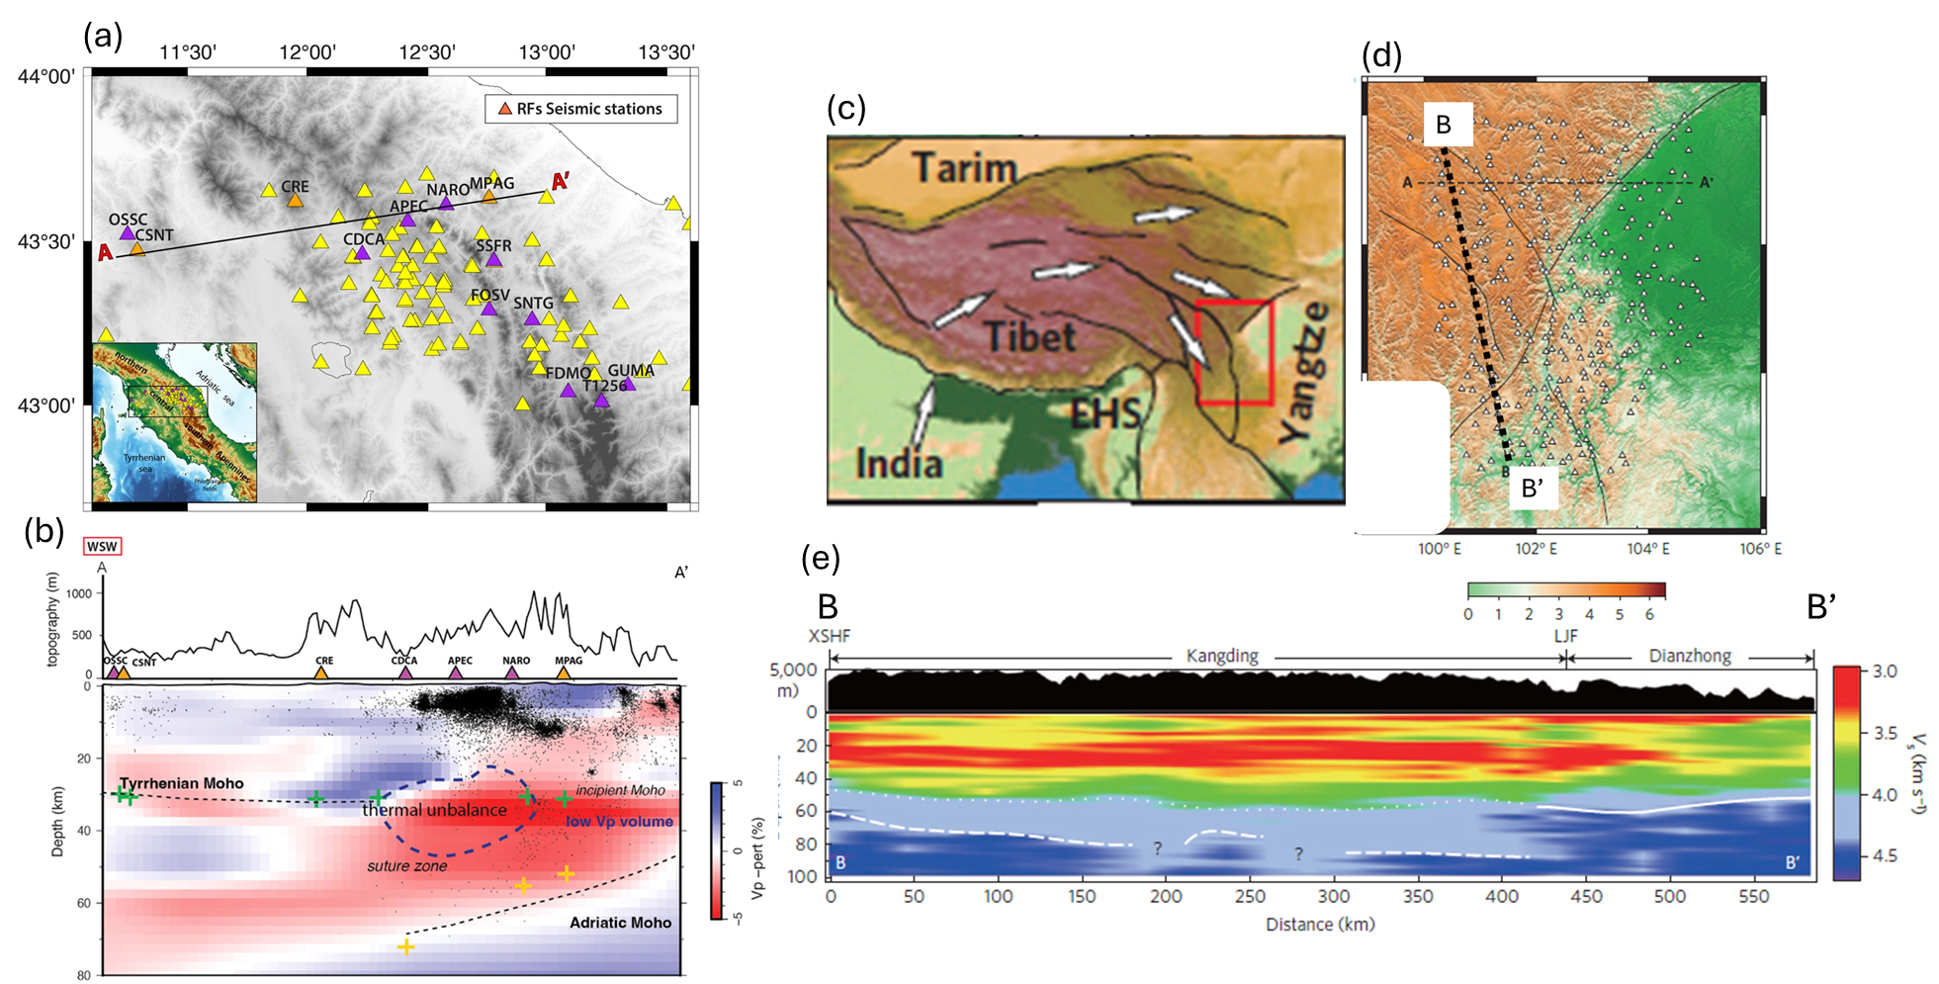
Supplementary Figure 3: (a-b) Vp cross-section along the Apennines. (a) Map illustrating the distribution of seismic stations (triangles) utilized for the Receiver Function analysis. (b) Vp cross-section along the A-A' profile shown in panel (a). Black dots represent earthquake epicenters. A low-velocity zone, likely corresponding to a weak crustal layer, is discernible between the seismic discontinuity and the Moho (Modified from ref. ⁵). (c-e) Vs cross-section along the southeastern margin of the Tibetan Plateau. (c) Regional map of Tibet, with a red polygon outlining the location of the seismic cross-section. (d) Zoomed view of the red polygon area. (e) Vs cross-section along the southeastern margin of the Tibetan Plateau (C–C′ in panel (d)). Solid white lines indicate the Moho, while dotted and dashed white lines represent the top and bottom of the transitional crust. The Tibetan Plateau’s crust shows significant lateral thickness variations and distinct intra-crustal low-velocity zones, potentially corresponding to a weak crustal layer (Modified from ref. ¹⁴).

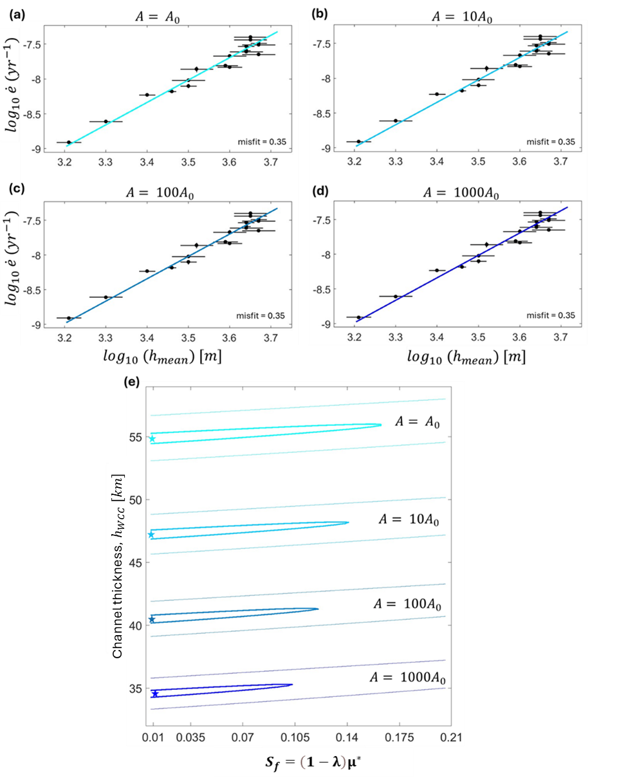
Supplementary Figure 4: Effect of Partial Melting on Channel Thickness and Fault Strength for plagioclase rheology channel. (a – d) Log-log plots of our model-predicted strain rate for plagioclase rheology with varying pre-exponential factors (A): (a) Baseline case with $A= A_{0 }$, where $A_{0 }$ represents the pre-exponential factor for plagioclase without melt (Supplementary Table 1), (b) increased by factors of 10 ($A= {10A}_{0}$), (c) A increased by a factor of 100 $(A= {100A}_{0})$ , and (d) A increased by a factor of 1000 $(A= {1000A}_{0})$. As shown, these different pre-exponential factors fit the observed strain rate-elevation correlation in Tibet⁷. (e) A contour plot illustrating the misfit between predicted and observed data demonstrates the relationship between fault strength and WCC thickness. The thick and thin lines represent misfits of 0.4 and 1, respectively, while the star indicates the optimal parameter combination that minimizes the misfit.
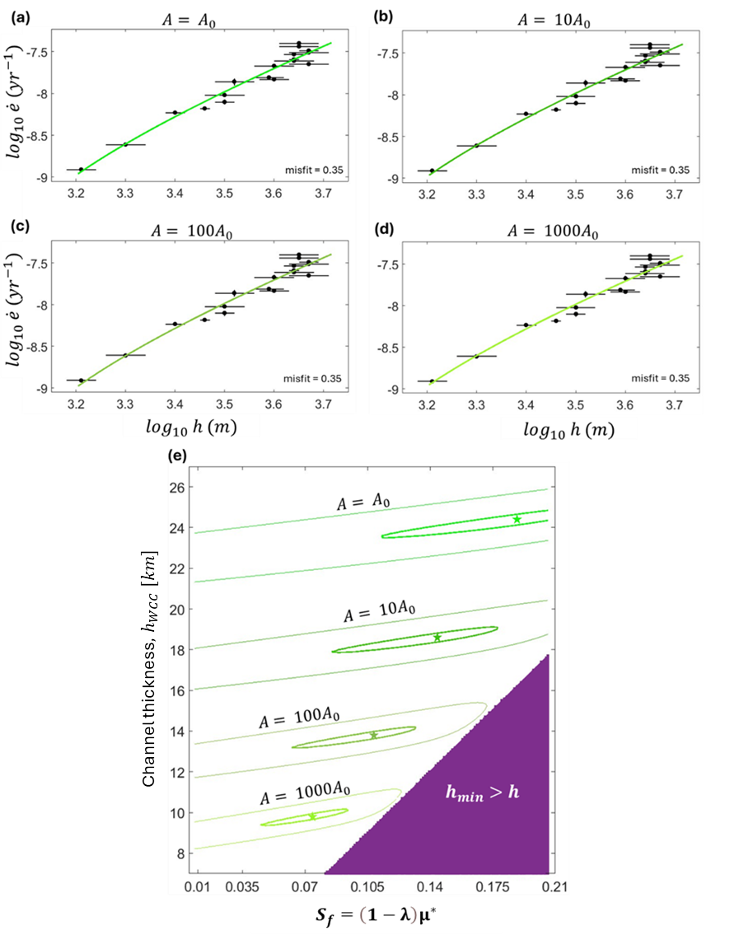
Supplementary Figure 5: Effect of Partial Melting on Channel Thickness and Fault Strength for wet quartzite rheology channel. (a – d) Log-log plots of the predicted strain rate for wet quartzite rheology with varying pre-exponential factors (A): (a) Baseline case with $A= A_{0 }$, where $A_{0 }$ represents the pre-exponential factor for plagioclase without melt (Supplementary Table 1), (b) increased by factors of 10 ($A= {10A}_{0}$), (c) A increased by a factor of 100 $(A= {100A}_{0})$ , and (d) A increased by a factor of 1000 $(A= {1000A}_{0})$. As shown, these different pre-exponential factors fit the observed strain rate-elevation correlation in Tibet⁷. (e) A contour plot illustrating the misfit between predicted and observed data demonstrates the relationship between fault strength and weak layer thickness. The thick and thin lines represent misfits of 0.4 and 1, respectively, while the star indicates the optimal parameter combination that minimizes the misfit. The purple area indicates parameter combinations where the model predicts the mountains wouldn't undergo extension by normal faults.

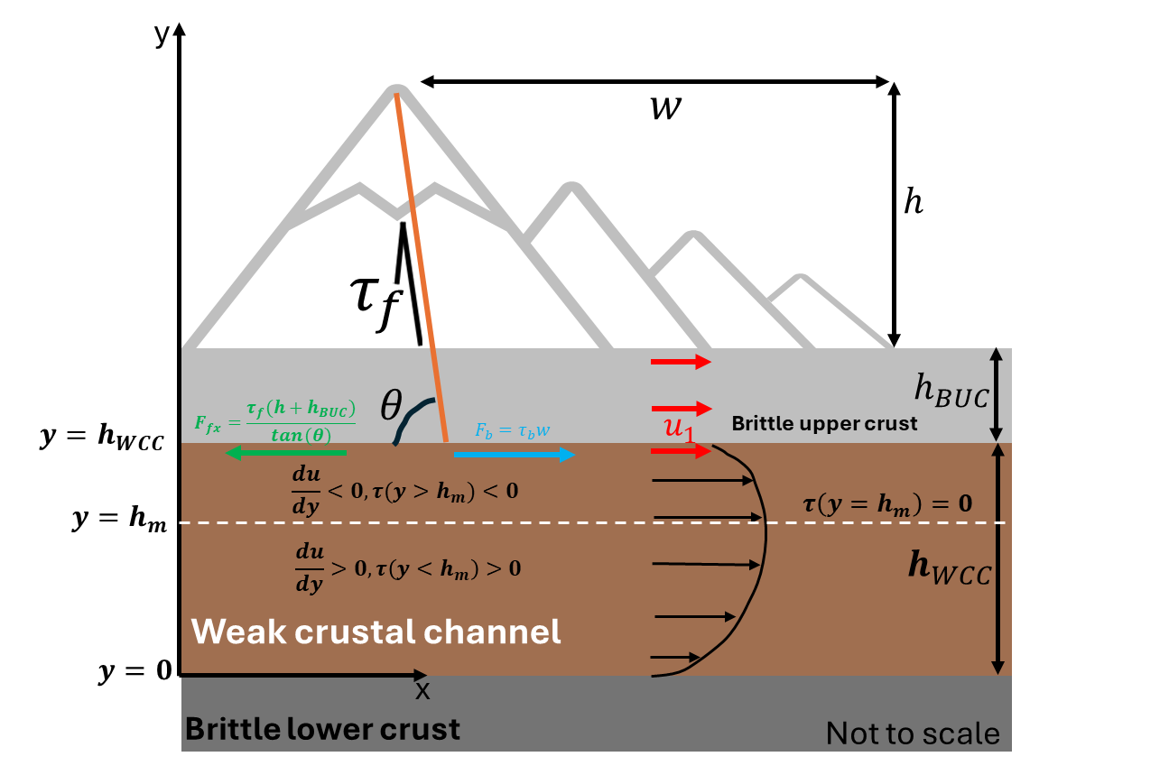
Supplementary figure. 6: Schematic drawing of the frictional–viscous fault system model. The model consists of three distinct layers representing the Earth's crust in orogenic belts. The uppermost layer, the brittle upper crust, is depicted with a mountain-like topography of height $h$ and slope length W. Its thickness varies spatially, being thinner $h_{BUC}$ away from the mountain and thicker $h+h_{BUC}$ at the peak. An orange line indicates a normal fault. The second layer, the weak crustal layer, has a constant thickness ($h_{WCC}$​) and deforms viscously due to plastic flow. Black arrows illustrate the flow profile, which is driven by the topographic gradient. As a result of the flow, shear stress is exerted within the weak layer, where at a height of $y= h_{m}$​, the velocity reaches its maximum and the shear stress is zero. Below this point ($y< h_{m}$​), the shear stress is positive; above this point $y> h_{m}$, the shear stress is negative. Consequently, the shear force at the base of the upper crust ($F_{b}$ blue arrow) is positive, in accordance with Newton's third law. In contrast, the fault friction force ($F_{fx}$ green arrow) is negative as it opposes the shear force.

Material | A (MPa^{−n} s⁻¹) | n | Q (kJ mol⁻¹)
Quartz (Q2)²¹ | 3e-4 | 2 | 170
quartzite (wet) (QW) ²² | 3.2e-4 | 2.3 | 154
felsic granulite (FG)²³ | 8e-3 | 3.1 | 243
plagioclase An75 (P)²³ | 3.3e-4 | 3.2 | 238
Quartz (Q4)²⁴ | 11.2e-11 | 4 | 135
Supplementary Table 1: Rheological flow laws used in modeling the weak crustal layer (WCC). n represents the stress exponent, A is a material property, and Q denotes the activation energy.
Material | $$h_{WCC} \left[km\right]$$ | $$S_{f}=\left(1-λ\right)μ^{*}$$
Quartz (Q2) | 26.5 | 0.2
quartzite (wet) (QW) | 24 | 0.18
felsic granulite (FG) | 47.5 | 0.028
plagioclase An75 (P) | 54.8 | 0.025
Quartz (Q4) | 88.1 | 0.011
Supplementary Table 2: Tibetan plateau best-fit model parameters (channel thickness $h_{WCC}$ and fault strength ${(S}_{f}=\left(1-λ\right)μ^{*}$)) for various weak crustal rheologies.

Material | $$h_{WCC} \left[km\right]$$ | $$S_{f}=\left(1-λ\right)μ^{*}$$
Quartz (Q2) | 14 | 0.09
quartzite (wet) (QW) | 10.5 | 0.07
felsic granulite (FG) | 27.5 | 0.025
plagioclase An75 (P) | 32.2 | 0.018
Quartz (Q4) | 36.2 | 0.011
Supplementary Table 3: Apennine best-fit model parameters (channel thickness $h_{WCC}$ and fault strength, ${(S}_{f}=\left(1-λ\right)μ^{*}$)) for various weak crustal rheologies.
Channel thickness ($h_{WCC} \left[km\right]$) | 15
Normal brittle upper crust thickness (h_{uc} (km)) | 10
Mountain slope length W (km) | 100
Fault friction (μ) | 0.6
μ* | 0.33 (calculated using s eq. 6 in the main text)
Pore pressure ratio (λ) | 0.4
$$S_{f}=\left(1-λ\right)μ^{*}$$ | 0.198
h_{min}(m) | 800 (calculated using eq. 18)
Average surface heat flow | 50 m·W/m²
Surface temperature | 10°C
Thermal conductivity | 2.5 J/s·m·K
Crustal heat production | 1×10⁻⁶ W/m³

Supplementary Table 4: parameters used for modeling the strain vs. topography in fig. 4.
Material | A (MPa^{−n} s⁻¹) | n | Q (kJ mol⁻¹) | $$h_{WCC} \left[km\right]$$ | $$S_{f}=\left(1-λ\right)μ^{*}$$
plagioclase An75 (P)²³ (f1) | 3.3e-4 | 3.2 | 238 | 54.8 | 0.025
plagioclase An75 (P) (f10) | 10*(3.3e-4) | 3.2 | 238 | 47.2 | 0.024
plagioclase An75 (P) (f100) | 100*(3.3e-4) | 3.2 | 238 | 40.5 | 0.024
plagioclase An75 (P) (f1000) | 1000*(3.3e-4) | 3.2 | 238 | 34.6 | 0.01
Supplementary Table 5: best-fit model parameters (channel thickness $h_{WCC}$ and fault strength ${(S}_{f}=\left(1-λ\right)μ^{*}$)) for plagioclase rheology with varying pre-exponential factors (A) by orders of magnitude (1, 10, 100, and 1000).

Material | A (MPa^{−n} s⁻¹) | n | Q (kJ mol⁻¹) | $$h_{WCC} \left[km\right]$$ | $$S_{f}=\left(1-λ\right)μ^{*}$$
quartzite (wet) (QW) ²² (f1) | 3.2e-4 | 2.3 | 154 | 24.4 | 0.19
quartzite (wet) (QW) (f10) | 10*(3. 2e-4) | 2.3 | 154 | 18.5 | 0.14
quartzite (wet) (QW) (f100) | 100*(3. 2e-4) | 2.3 | 154 | 13.8 | 0.1
quartzite (wet) (QW) (f1000) | 1000*(3. 2e-4) | 2.3 | 154 | 9.8 | 0.07
Supplementary Table 6: best-fit model parameters (channel thickness $h_{WCC}$ and fault strength ${(S}_{f}=\left(1-λ\right)μ^{*}$)) for wet quartzite rheology with varying pre-exponential factors (A) by orders of magnitude (1, 10, 100, and 1000).

References
1. Cowie, P. A., Scholz, C. H., Roberts, G. P., Faure Walker, J. P. & Steer, P. Viscous roots of active seismogenic faults revealed by geologic slip rate variations. Nat. Geosci. 6, (2013).
2. Faure Walker, J. P. et al. Relationship between topography, rates of extension and mantle dynamics in the actively-extending Italian Apennines. Earth Planet. Sci. Lett. 325–326, (2012).
3. Chiarabba, C. & De Gori, P. The seismogenic thickness in Italy: constraints on potential magnitude and seismic hazard. Terra Nov. 28, (2016).
4. Boncio, P., Tinari, D. P., Lavecchia, G., Visini, F. & Milana, G. The instrumental seismicity of the Abruzzo Region in Central Italy (1981-2003): Seismotectonic implications. Boll. della Soc. Geol. Ital. 128, (2009).
5. Menichelli, I., Bianchi, I. & Chiarabba, C. A lower crust shear zone facilitates delamination and continental subduction under the Apennines. Commun. Earth Environ. 5, (2024).
6. Anatomy of an Orogen: the Apennines and Adjacent Mediterranean Basins. Anatomy of an Orogen: the Apennines and Adjacent Mediterranean Basins (2001). doi:10.1007/978-94-015-9829-3.
7. Panda, D., Mondal, A. & Kundu, B. Eastward “glacier-like flow” of the Tibetan crust constrained from power-law rheology. J. Asian Earth Sci. 177, (2019).
8. Clark, M. K. & Royden, L. H. Topographic ooze: Building the eastern margin of Tibet by lower crustal flow. Geology 28, (2000).
9. Yang, Y. et al. A synoptic view of the distribution and connectivity of the mid-crustal low velocity zone beneath Tibet. Journal of Geophysical Research: Solid Earth vol. 117 at https://doi.org/10.1029/2011JB008810 (2012).
10. Bao, X., Song, X. & Li, J. High-resolution lithospheric structure beneath Mainland China from ambient noise and earthquake surface-wave tomography. Earth Planet. Sci. Lett. 417, (2015).
11. Zhang, Z. et al. An overview of the crustal structure of the Tibetan plateau after 35 years of deep seismic soundings. J. Asian Earth Sci. 40, (2011).
12. Wei, S. et al. Regional earthquakes in northern Tibetan Plateau: Implications for lithospheric strength in Tibet. Geophys. Res. Lett. 37, (2010).
13. Andronicos, C. L., Velasco, A. A. & Hurtado, J. M. Large-scale deformation in the India-Asia collision constrained by earthquakes and topography. Terra Nov. 19, (2007).
14. Liu, Q. Y. et al. Eastward expansion of the Tibetan Plateau by crustal flow and strain partitioning across faults. Nat. Geosci. 7, (2014).
15. Jiang, G. et al. Terrestrial heat flow of continental China: Updated dataset and tectonic implications. Tectonophysics 753, (2019).
16. Wang, Q. et al. Pliocene-Quaternary crustal melting in central and northern Tibet and insights into crustal flow. Nat. Commun. 7, (2016).
17. Chen, J. et al. Melting conditions in the modern Tibetan crust since the Miocene. Nat. Commun. 9, (2018).
18. Zhang, X. Z. et al. Tibetan Plateau growth linked to crustal thermal transitions since the Miocene. Geology 50, (2022).
19. Unsworth, M. J. et al. Crustal rheology of the Himalaya and Southern Tibet inferred from magnetotelluric data. Nature 438, (2005).
20. Royden, L. H., Burchfiel, B. C. & Van Der Hilst, R. D. The geological evolution of the Tibetan plateau. Science vol. 321 at https://doi.org/10.1126/science.1155371 (2008).
21. Richter, B., Stünitz, H. & Heilbronner, R. The brittle-to-viscous transition in polycrystalline quartz: An experimental study. J. Struct. Geol. 114, (2018).
22. Kirby, S. H. & Kronenberg, A. K. Rheology of the lithosphere: Selected topics. Reviews of Geophysics vol. 25 at https://doi.org/10.1029/RG025i006p01219 (1987).
23. Kirby, S. H. Rheology of the lithosphere. Reviews of Geophysics vol. 21 at https://doi.org/10.1029/RG021i006p01458 (1983).
24. Hirth, G., Teyssier, C. & Dunlap, W. J. An evaluation of quartzite flow laws based on comparisons between experimentally and naturally deformed rocks. Int. J. Earth Sci. 90, (2001).

