Unique Atmospheric Boundary Layer Structures Driven by Lake Effects
Weiyao Ma^{1,2,3}, Weiqiang Ma^{1,2,4,5}, Zhipeng Xie¹, Binbin Wang¹, Haoran Shi³, R. Iestyn Woolway³, Yaoming Ma^{1,2,4,5,6}
1. Land-Atmosphere Interaction and its Climatic Effects Group, State Key Laboratory of Tibetan Plateau Earth System, Resources and Environment (TPESRE), Institute of Tibetan Plateau Research, Chinese Academy of Sciences, Beijing 100101, China
2. University of Chinese Academy of Sciences, Beijing 100049, China
3. School of Ocean Sciences, Bangor University, Menai Bridge, Anglesey, UK
4. National Observation and Research Station for Qomolongma Special Atmospheric Processes and Environmental Changes, Dingri Tibet 858200, China
5. Lanzhou University, Lanzhou Gansu 730000, China
6. China Three Gorges University, Yichang Hubei 443002, China
Corresponding author: Weiqiang Ma, wqma@itpcas.ac.cn

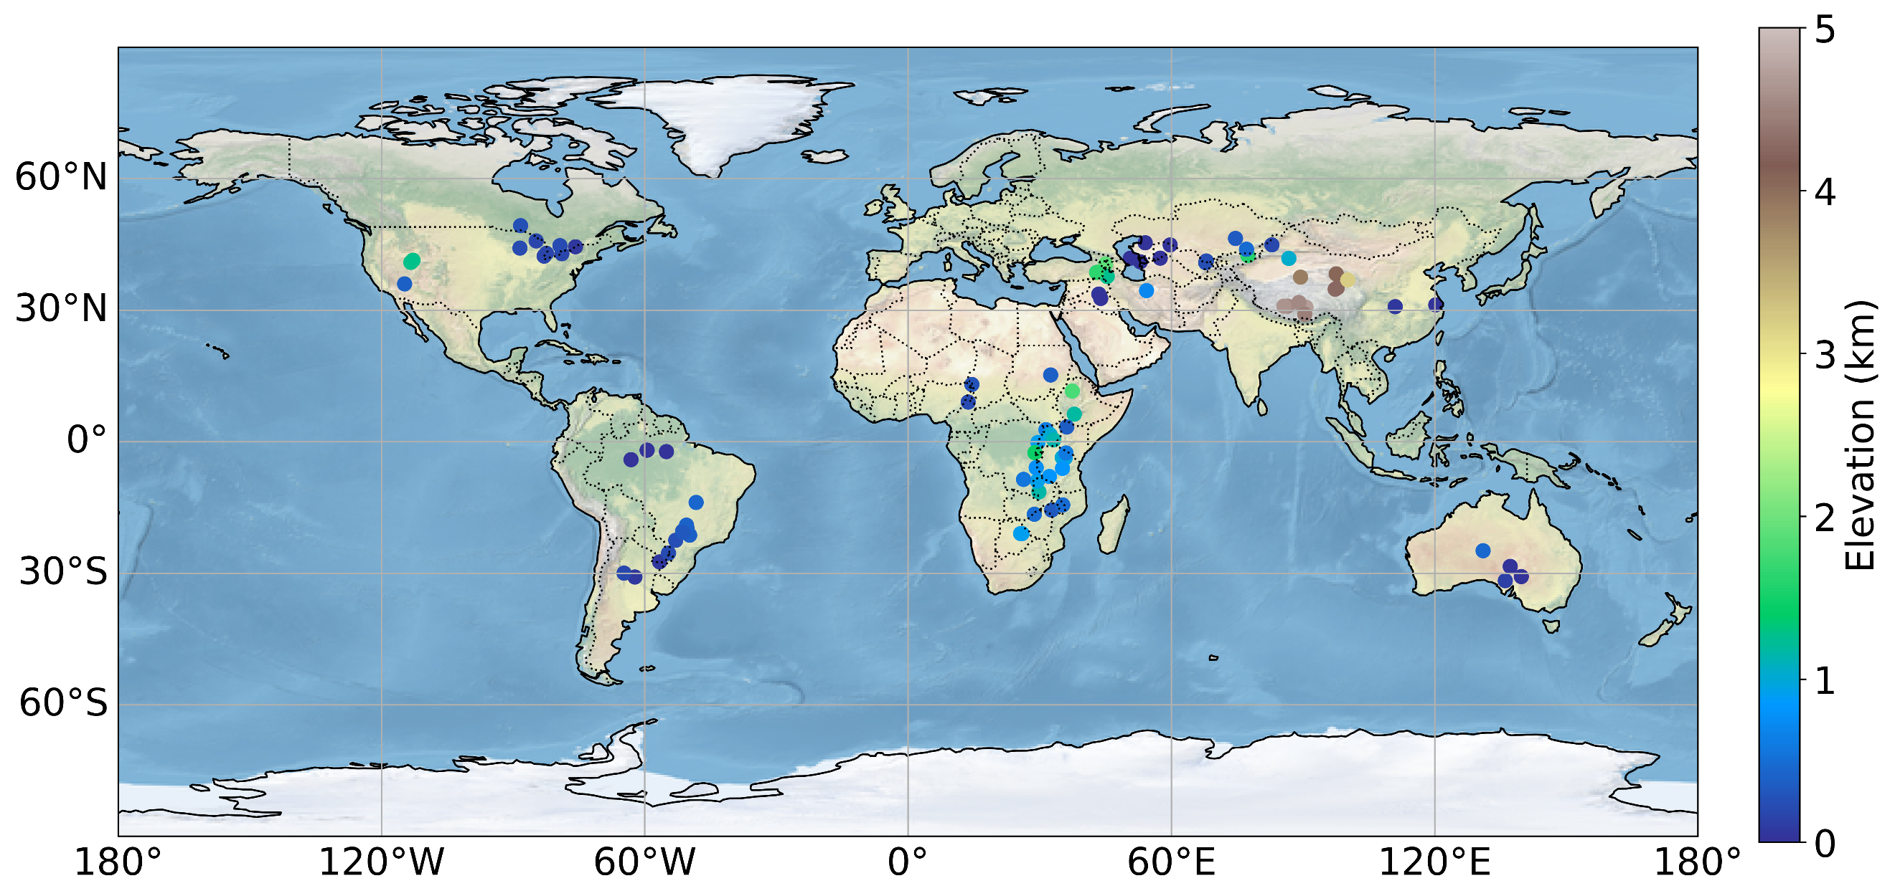
Supplementary Figure 1. Global distribution and elevation of selected lakes.
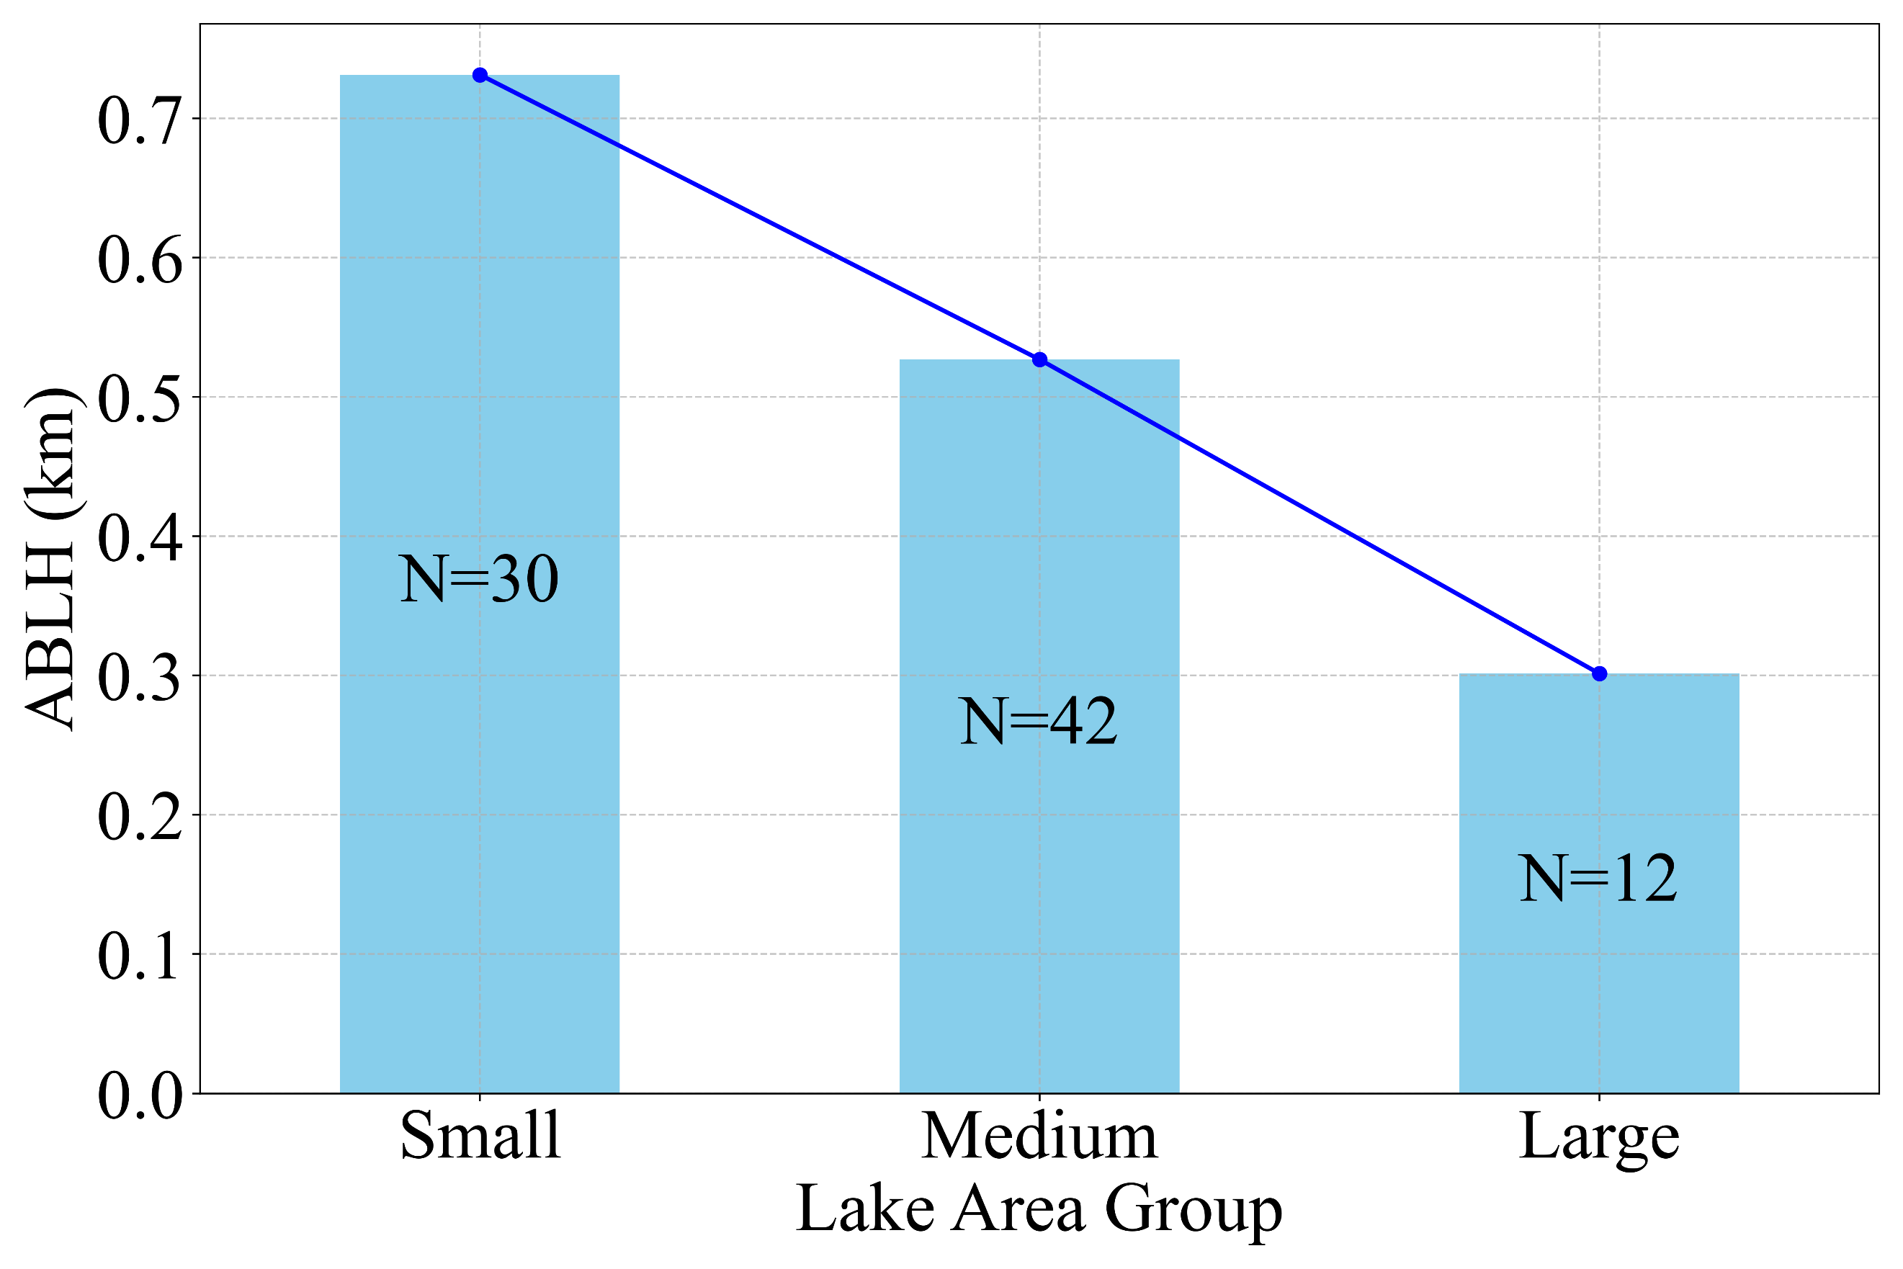
Supplementary Figure 2. Reduction of diurnal ABLH variation with increasing lake area, categorized by: small (<1000 km²), medium (1000-10,000 km²), large (>10,000 km²).
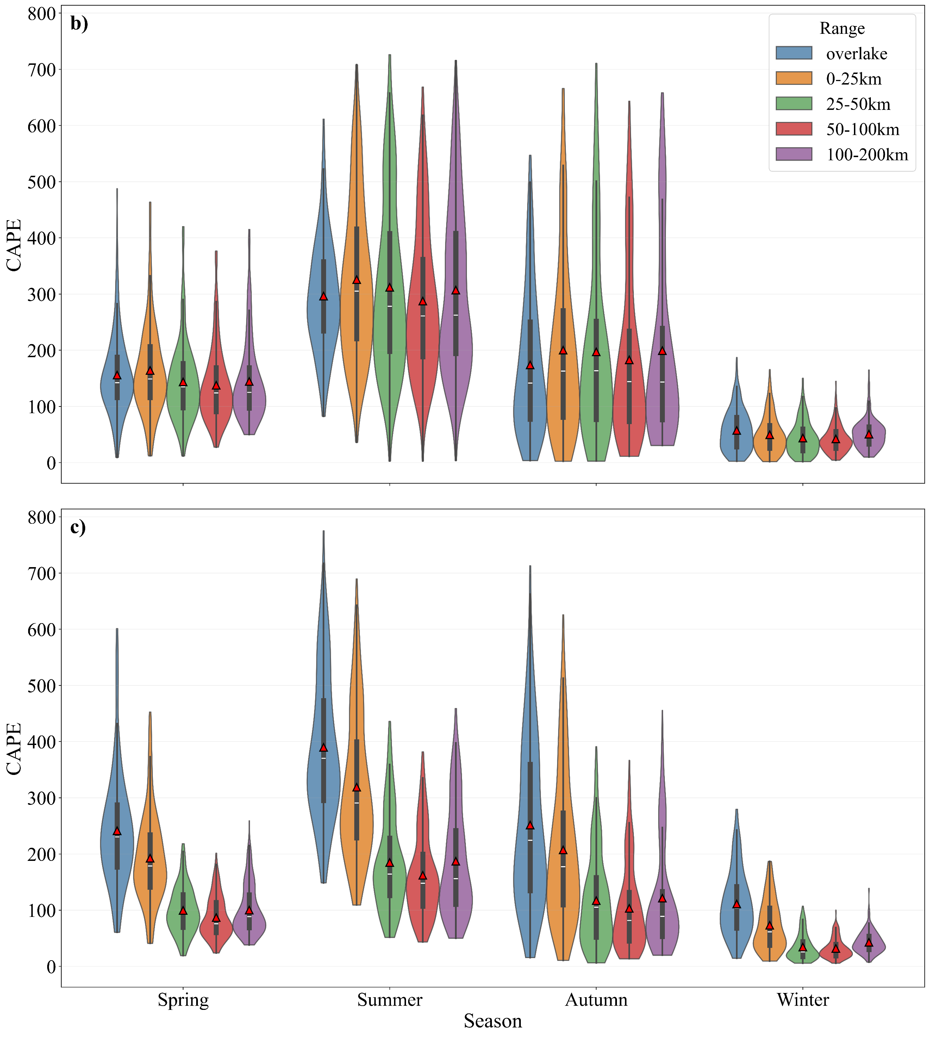
Supplementary Figure 3. Seasonal variations in daily mean CAPE across distances from lakes during
a) daytime, and b) nighttime, red triangles indicate the mean CAPE for each distance group in each season.

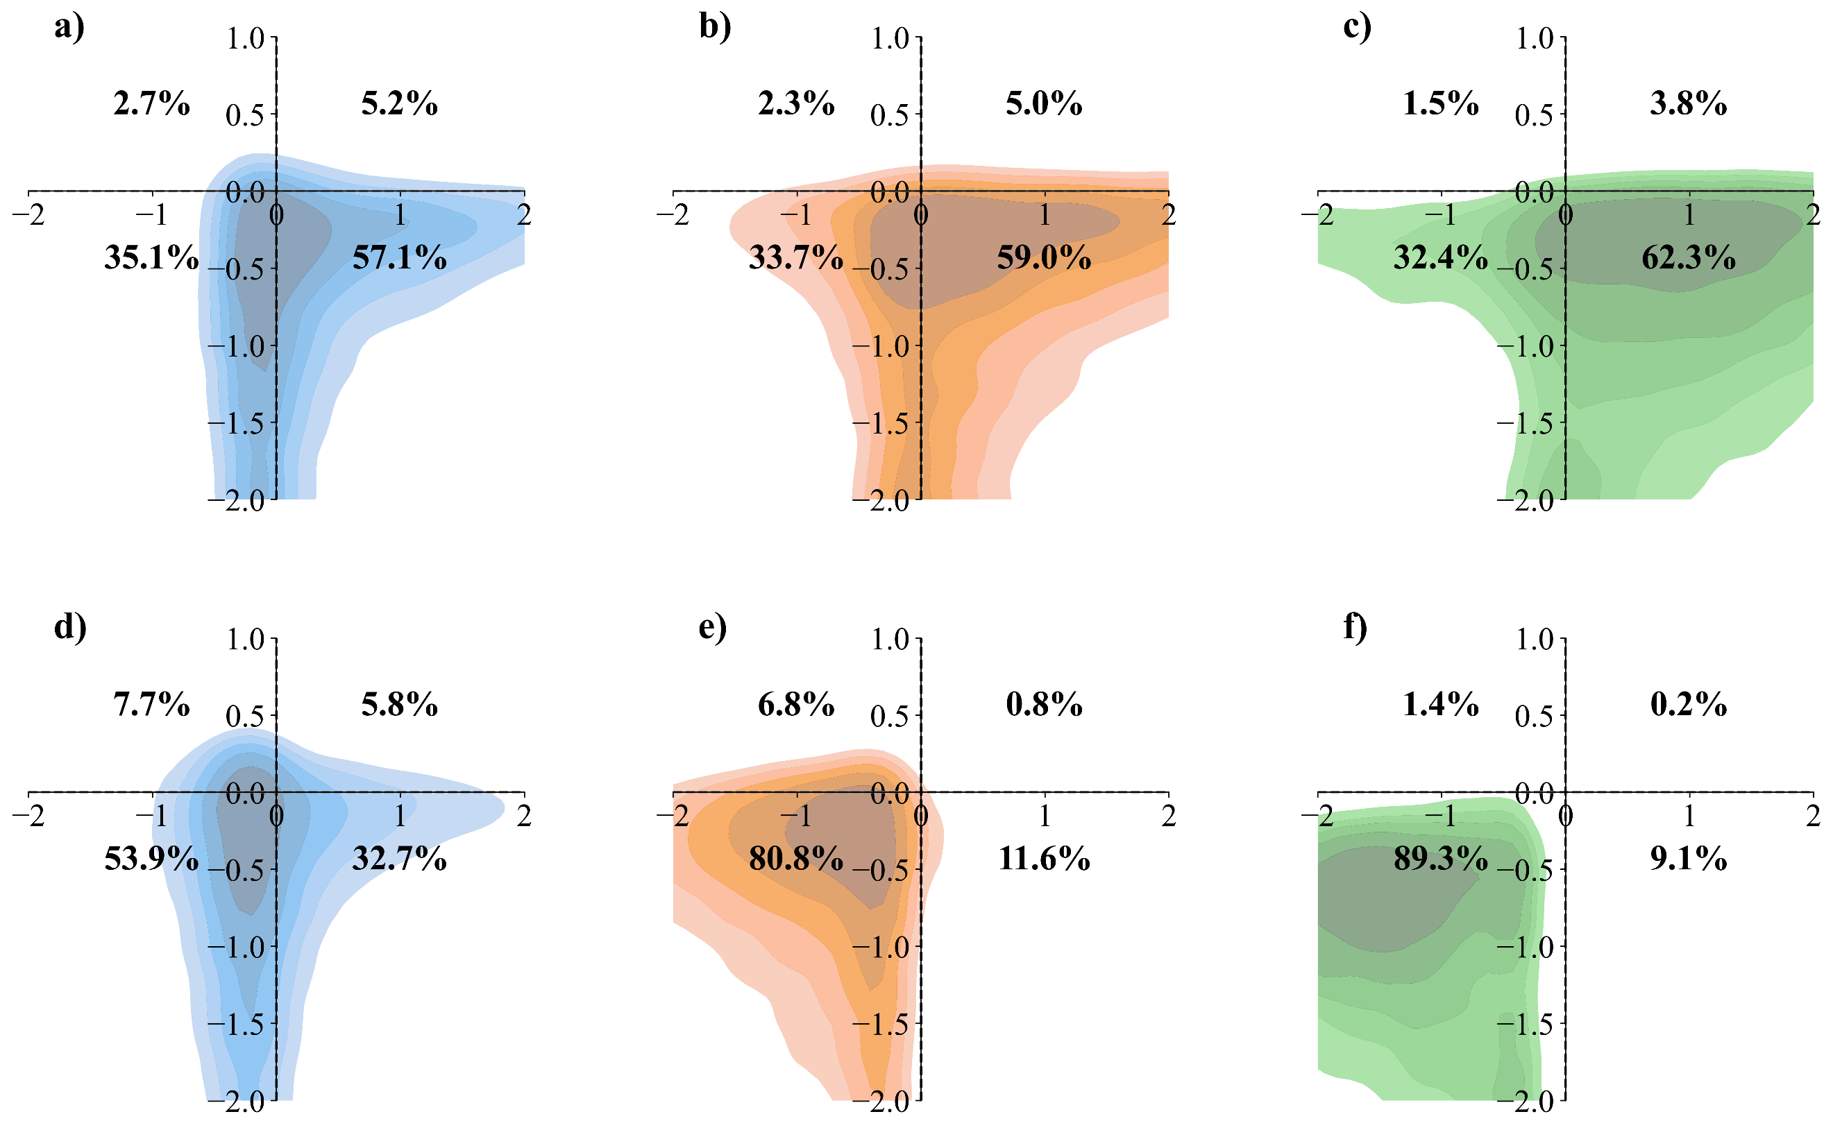
Supplementary Figure 4. Joint distribution of Ri and CAPE across different lake regions, with quadrants representing distinct atmospheric regimes. Panels a-e show the two-dimensional kernel density estimates of Ri and log₁₀(CAPE), where a-c correspond to overlake, lake-adjacent and lake-distal region during daytime; d-f show the same regions during nighttime. Ri is centered at the critical stability threshold (Ri – 0.25), CAPE is centered at the convection threshold of 1000j/kg (log₁₀(CAPE) - 3). Quadrants represent, Q1: stable with strong convection (Ri > 0.25, CAPE > 1000 J/kg), Q2: unstable with strong convection (Ri < 0.25, CAPE > 1000 J/kg), Q3: unstable with weak convection (Ri < 0.25, CAPE < 1000 J/kg), Q4: stable with weak convection (Ri < 0.25, CAPE < 1000J/kg).

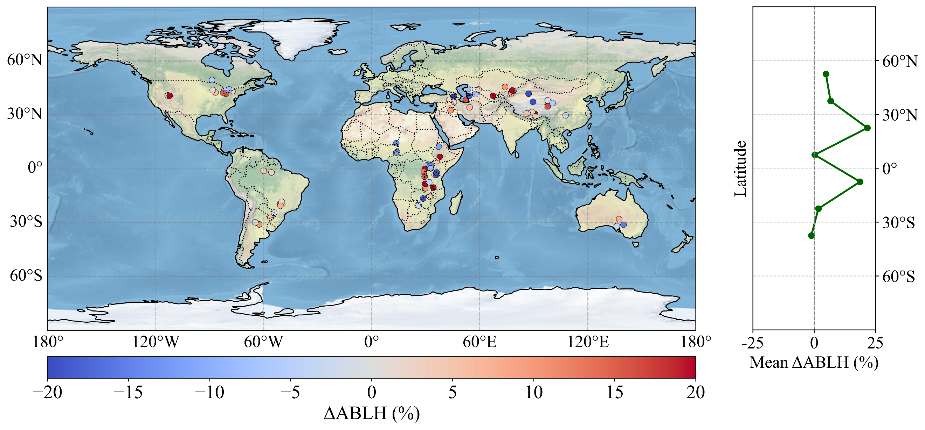
Supplementary Figure 5. Spatial pattern and latitudinal distribution of the percentage difference in ABLH (ΔABLH) between downwind and upwind regions across global lake-adjacent areas during summer and autumn.

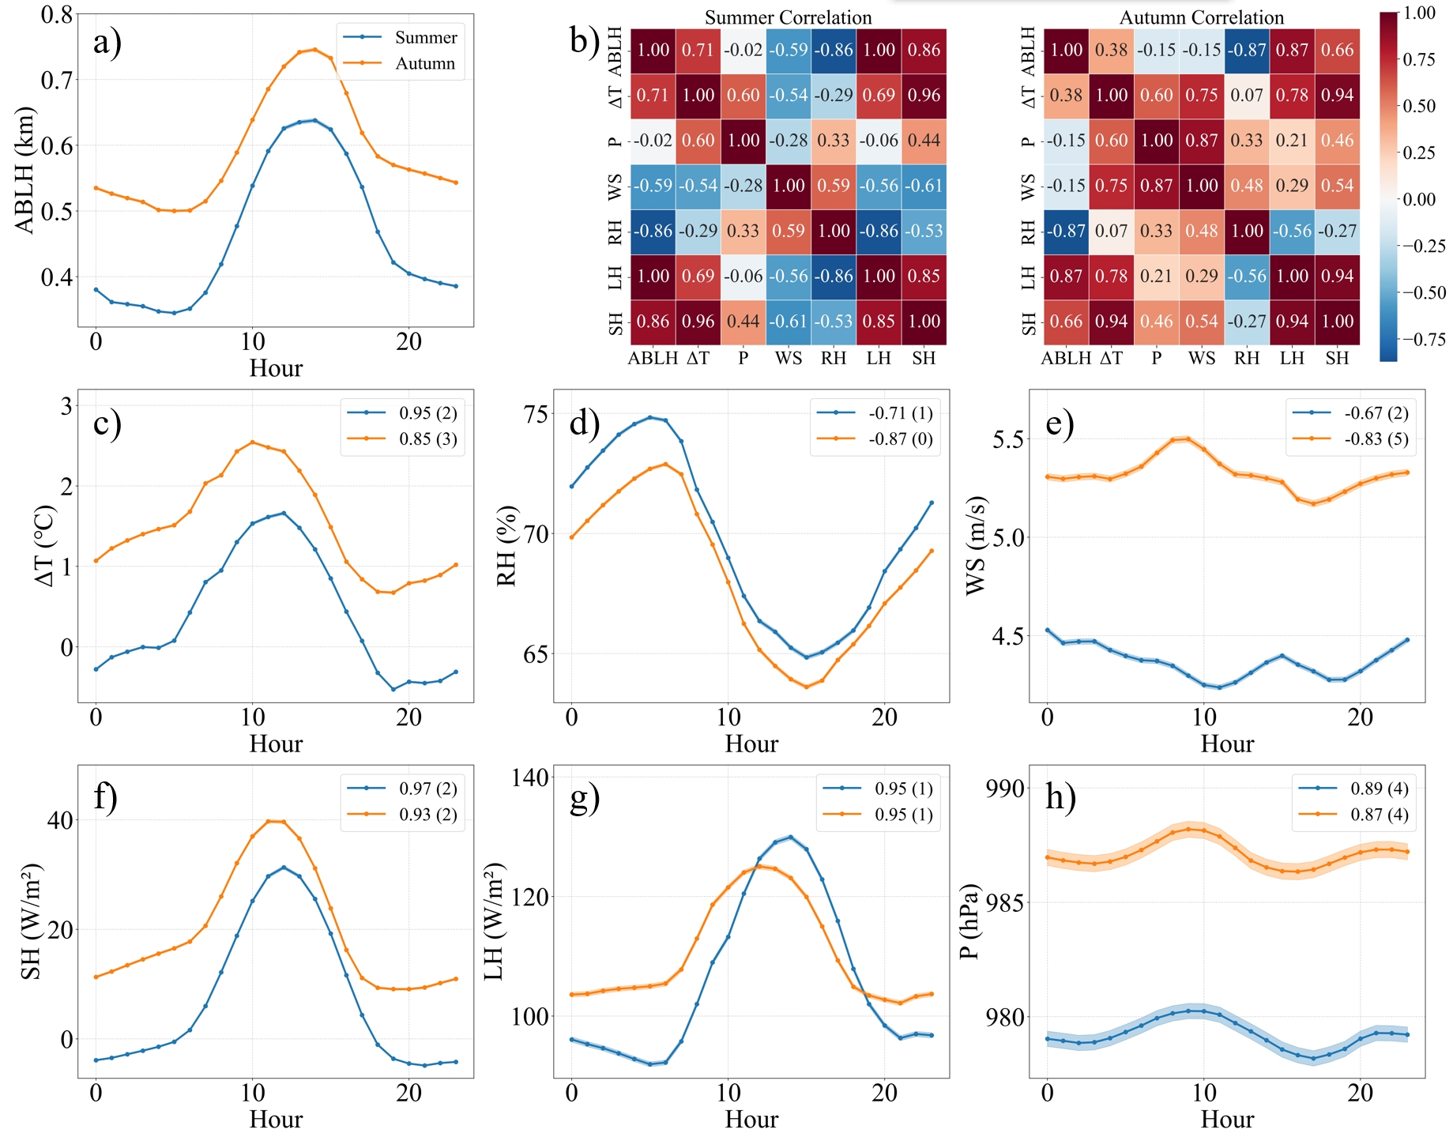
Supplementary Figure 6. Diurnal variations and Inter-correlations of meteorological factors during Summer and Autumn. a), and c)-h) display the hourly variations of ABLH, ΔT, RH, WS, SH, LH, and P for summer and autumn; b) shows the correlation matrix among these variables.

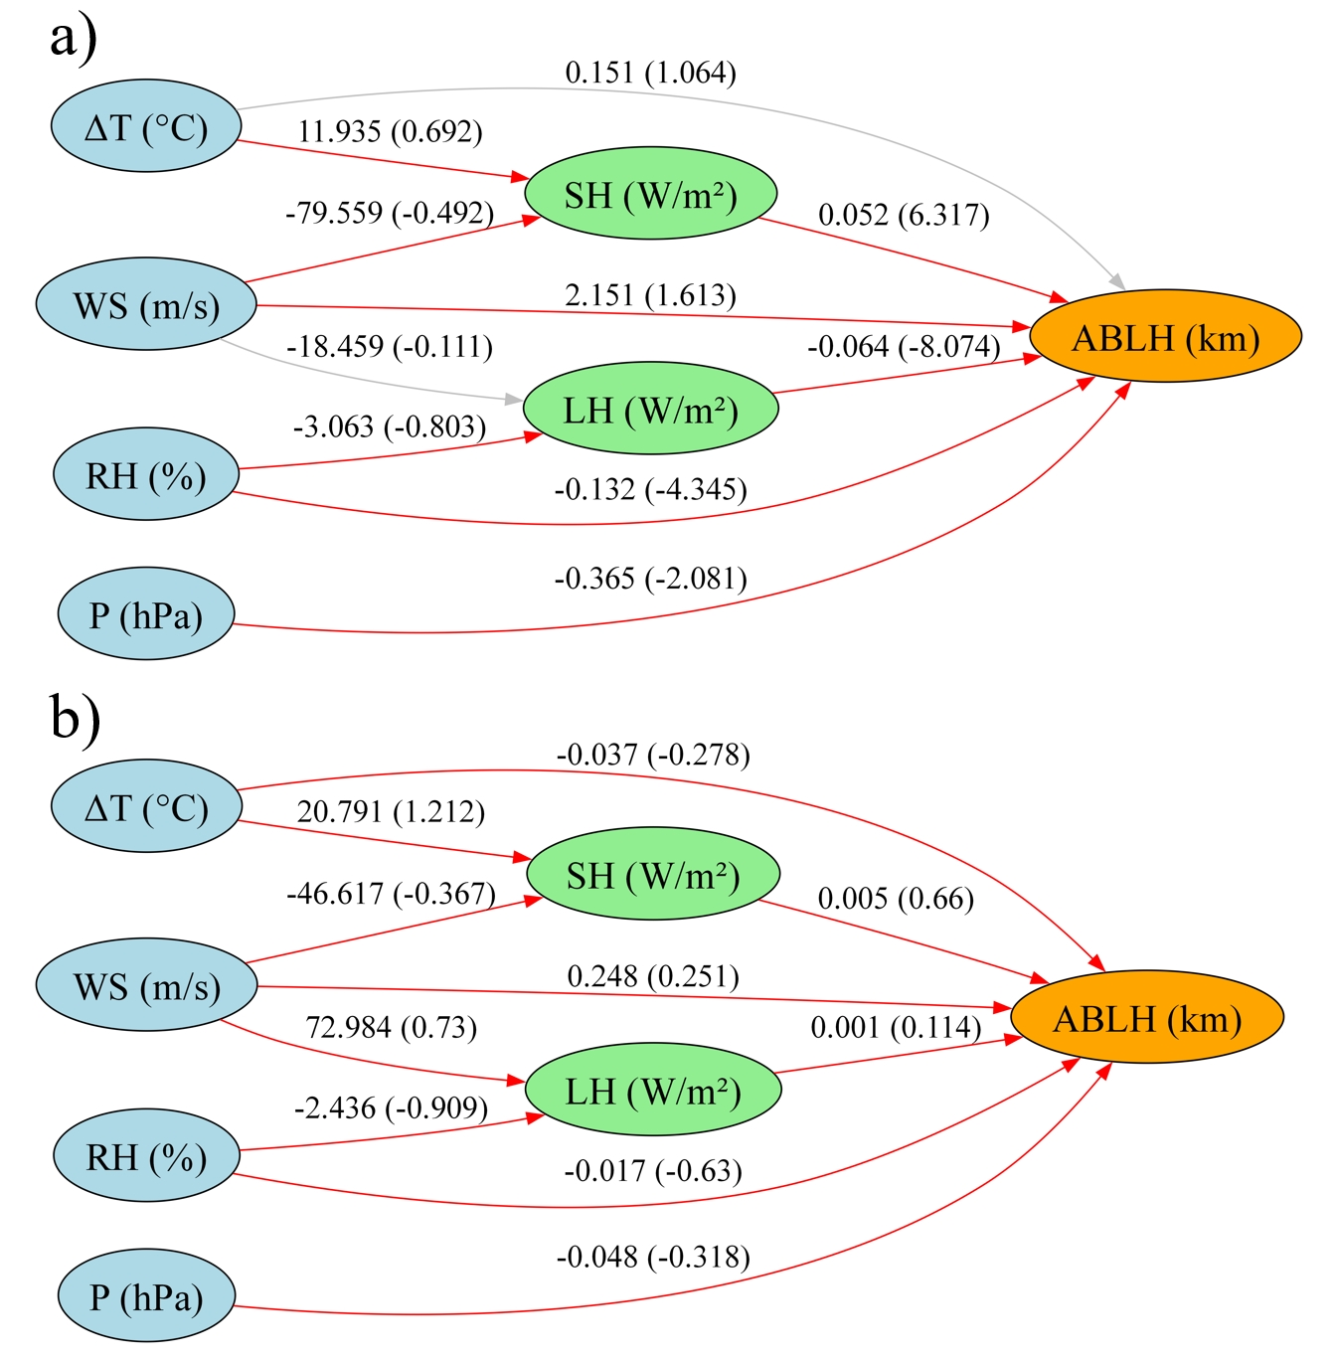
Supplementary Figure 7. Seasonal SEM analysis of meteorological influences on ABLH over lakes. a) is summer, b) is autumn. Red arrows indicate statistically significant pathways (p<0.05). Numbers along arrows represent unstandardized (standardized) path coefficients. Factors considered include Temperature Difference (ΔT), Surface Pressure (P), Wind Speed (WS), Relative Humidity (RH), Latent Heat Flux (LH), and Sensible Heat Flux (SH).

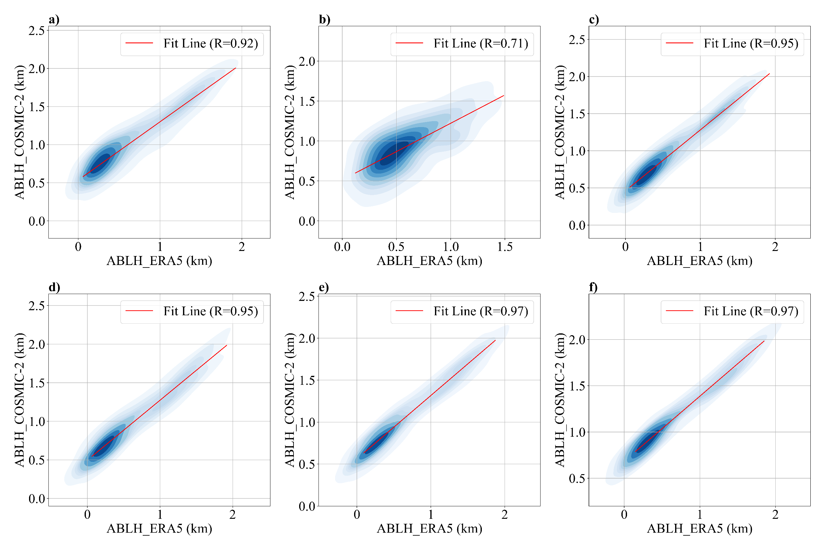
Supplementary Figure 8. Comparative analysis of ABLH in different region COSMIC-2 and ERA5 data: probability density distribution. (a) All Regions, (b) Overlake, (c) 0–25 km from lake, (d) 25–50 km from lake, (e) 50–100 km from lake, (f) 100–200 km from lake
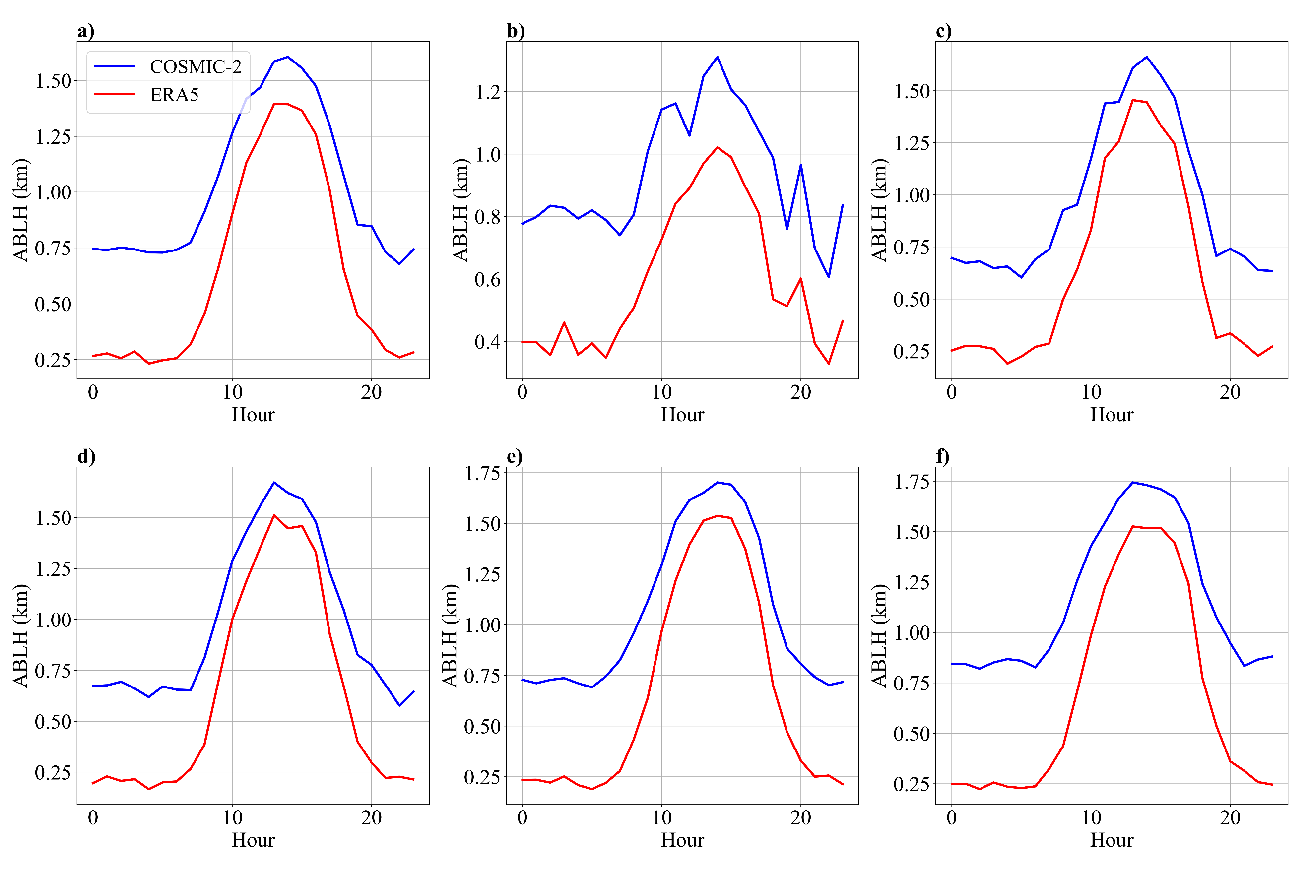
Supplementary Figure 9. Same as supplement figure 8, but for hourly variations

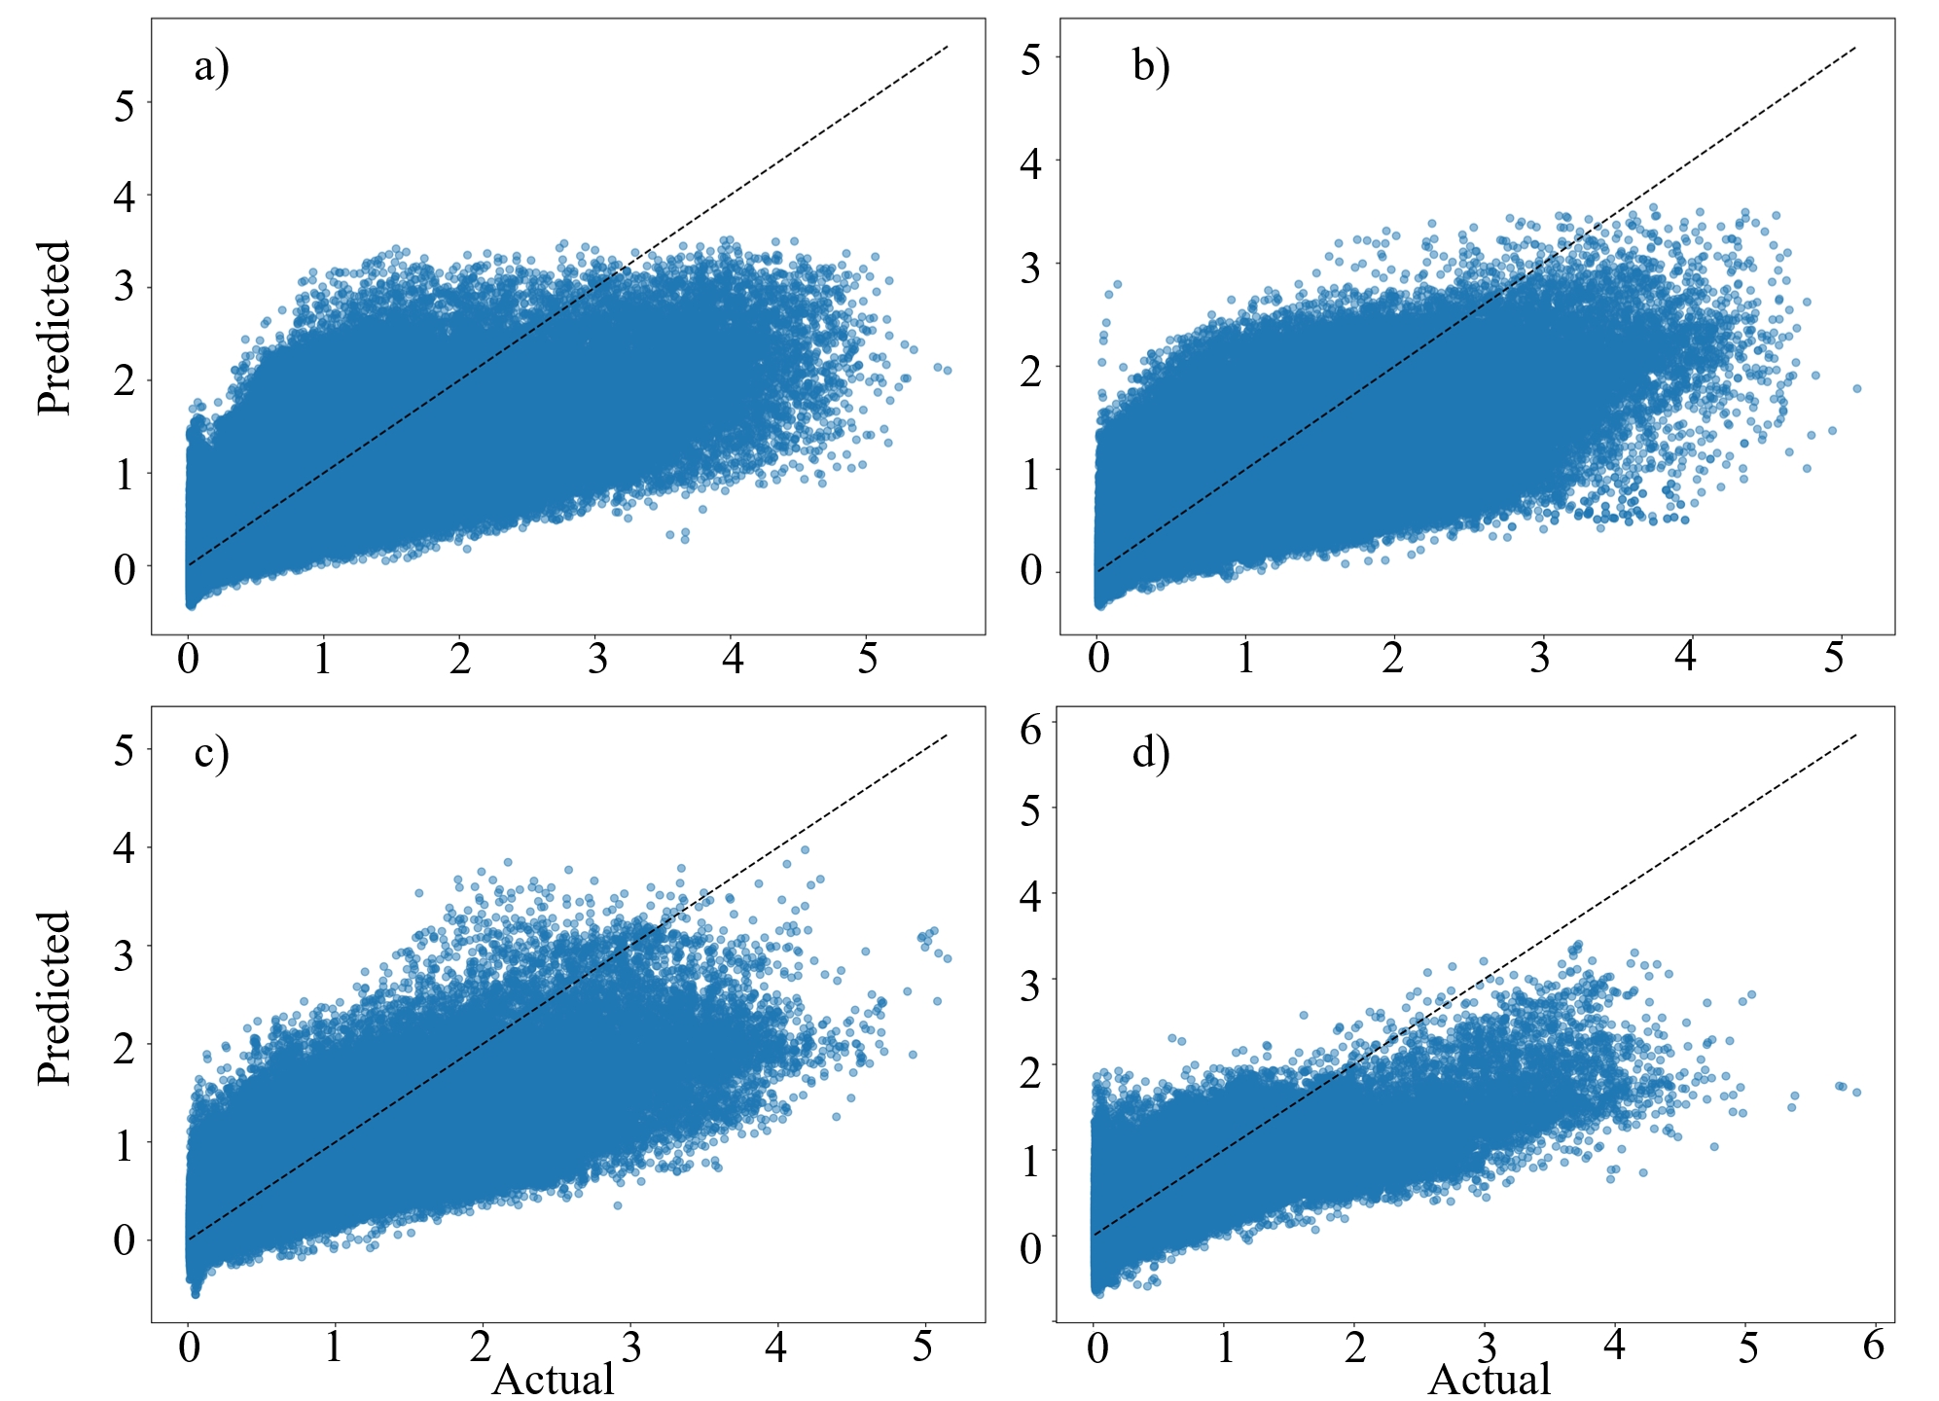
Supplementary Figure 9. Verification results (Predicted vs Actual) of GAM in all lakes. a) is results in spring, b) is in summer, c) is in autumn, d) is in winter

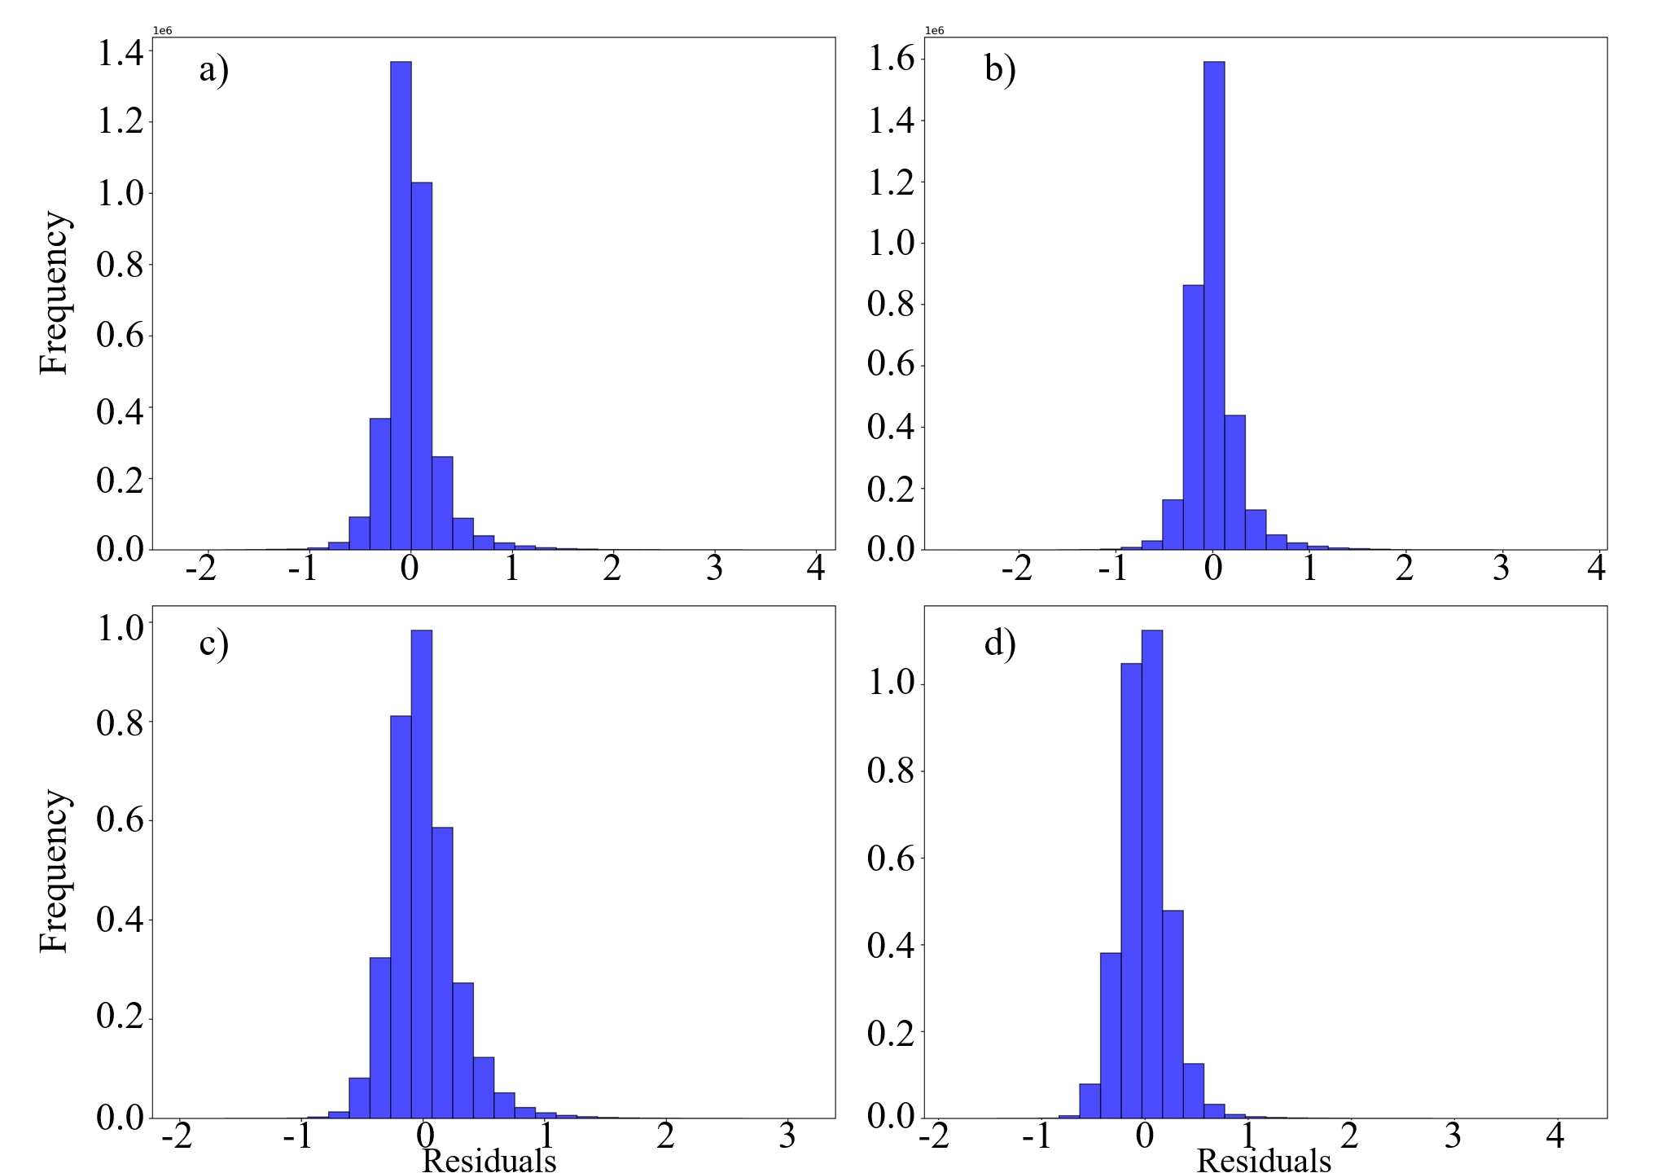
Supplementary Figure 10. Residuals distribution of GAM in all lakes. a) is results in spring, b) is in summer, c) is in autumn, d) is in winter

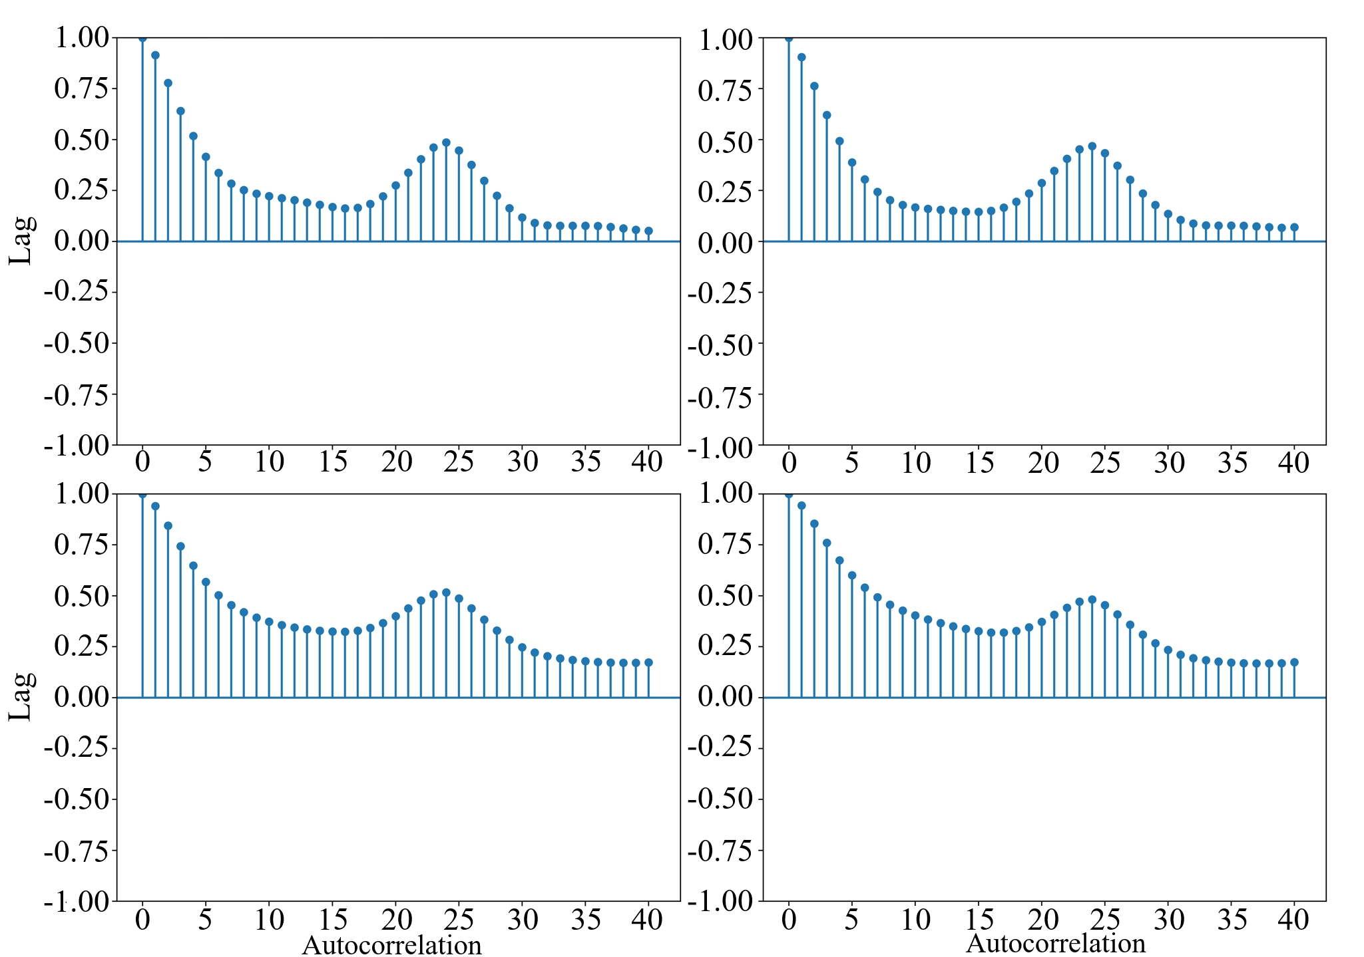
Supplementary Figure 11. Autocorrelation of Residuals of GAM in all lakes. a) is results in spring, b) is in summer, c) is in autumn, d) is in winter

Supplementary Table1. General characteristics of the 84 lakes investigated in this study.
Lake_name | Area | Depth_avg | Elevation | Longitude | Latitude
Abaya | 1084.75 | 7.4 | 1176 | 37.86 | 6.30
Agua Vermelha Reservoir | 507.07 | 21.9 | 379 | -50.35 | -19.87
Albert | 5526.92 | 25 | 615 | 31.41 | 2.76
Amadeus | 575.53 | 0.2 | 456 | 131.02 | -24.85
Aperea Reservoir | 1111.23 | 18.9 | 75 | -56.63 | -27.39
Ayakkum | 616.34 | 10 | 3876 | 89.43 | 37.56
Aydar | 2742.41 | 16.2 | 241 | 67.80 | 40.87
Balbina Reservoir | 2304.63 | 7.6 | 38 | -59.48 | -1.91
Balkhash | 16717.89 | 6.7 | 338 | 74.60 | 46.39
Bangweulu | 1763.53 | 1 | 1163 | 29.81 | -11.43
Bonneville Salt Flat | 776.39 | 0.3 | 1282 | -113.31 | 40.93
Bosten | 961.84 | 9.1 | 1050 | 86.75 | 41.83
Buhayrat ath Tharthar | 1698.86 | 25.6 | 44 | 43.46 | 33.69
Cahora Bassa Reservoir | 2048.68 | 30.8 | 317 | 32.70 | -15.59
Caspian Sea | 377001.91 | 200.5 | -29 | 50.63 | 41.87
Chad | 18751.52 | 0.1 | 282 | 14.53 | 13.08
Chah-e Khorasan | 540.41 | 0.5 | 710 | 54.34 | 34.48
Chardarinskoye | 745.08 | 9 | 248 | 67.96 | 41.24
Chiquita | 6132.89 | 2.4 | 69 | -62.25 | -30.84
Coari | 642 | 20 | 20 | -63.14 | -4.07
Ebi | 564.86 | 1.4 | 194 | 82.89 | 44.92
Edward | 2241.98 | 34.2 | 912 | 29.60 | -0.14
Erie | 25767.79 | 19.4 | 172 | -78.91 | 42.90
Eyasi | 1200.3 | 0.5 | 1027 | 35.11 | -3.59
Eyre | 8026.7 | 3 | -15 | 137.21 | -28.43
Frome | 2508.03 | 0.5 | 1 | 139.73 | -30.75
Gairdner | 3373.98 | 1 | 121 | 136.08 | -31.69
Great Salt | 6478.85 | 3.5 | 1282 | -112.83 | 41.41
Gyaring | 520.58 | 9 | 4290 | 97.31 | 34.81
Hala | 585.6 | 30 | 4076 | 97.56 | 38.30
Huron | 59399.3 | 59.8 | 175 | -82.42 | 43.00
Ilha Solteira Reservoir | 1077.23 | 19.7 | 323 | -51.38 | -20.37
Issyk Kul | 6195.93 | 280.5 | 1601 | 77.43 | 42.49
Itaipu | 1156.44 | 25.1 | 217 | -54.59 | -25.41
Jebel Aulia Reservoir | 933.5 | 3.7 | 380 | 32.49 | 15.24
Kara-Bogaz-Gol | 18666.8 | 101 | -30 | 52.91 | 41.06
Kariba Reservoir | 5276.89 | 35.1 | 487 | 28.76 | -16.52
Kaydak | 3683.91 | 12.5 | -29 | 54.02 | 45.40
Kivu | 2400.88 | 237 | 1461 | 28.89 | -2.49
Kyoga | 2788.19 | 3 | 1034 | 32.35 | 1.61
Lagdo Reservoir | 623.12 | 12.5 | 213 | 13.69 | 9.06
Lago Grande Do Curuai | 944.75 | 4.7 | 1 | -55.07 | -2.24
Large Aral Sea | 23865.91 | 1.1 | 29 | 59.71 | 44.91
Malawi | 29544 | 261.3 | 476 | 35.24 | -14.42
Manyara | 546.19 | 3 | 954 | 35.81 | -3.65
Mead | 580.95 | 63.2 | 372 | -114.74 | 36.02
Michigan | 57726.84 | 84.2 | 175 | -84.75 | 45.82
Mweru wa Ntipa | 1449.04 | 3 | 933 | 29.44 | -8.94
Nam | 1963.82 | 44.4 | 4724 | 90.66 | 30.71
Natron | 886.35 | 0.7 | 602 | 35.97 | -2.55
Ngoring | 617.76 | 17.4 | 4267 | 97.78 | 35.11
Nipigon | 4505.95 | 55 | 258 | -88.31 | 49.31
Ntwetwe Pan | 2589.79 | 0.5 | 904 | 25.63 | -20.94
Ontario | 19347.36 | 84.8 | 73 | -75.79 | 44.48
Porto Primavera Reservoir | 1204.99 | 16.6 | 252 | -52.96 | -22.47
Promissao Reservoir | 511.18 | 14.5 | 379 | -49.78 | -21.30
Qapshaghay Bogeni Reservoir | 1205.95 | 23.3 | 475 | 77.10 | 43.92
Qinghai | 4266.55 | 16.8 | 3194 | 100.20 | 36.92
Razazah | 1330.22 | 19.5 | 29 | 43.89 | 32.70
Rukwa | 5894.78 | 3.5 | 801 | 32.20 | -7.91
Saint Clair | 1161.17 | 2.9 | 173 | -82.94 | 42.35
Salinas Grandes | 1033.67 | 0.3 | 179 | -64.73 | -29.96
Sao Simao Reservoir | 583.59 | 21.5 | 399 | -50.50 | -19.02
Sarygamysh | 3772.03 | 12.2 | 2 | 57.45 | 41.89
Serra da Mesa Reservoir | 922.61 | 59 | 443 | -48.30 | -13.84
Sevan | 1242.22 | 26.5 | 1898 | 44.99 | 40.55
Siling | 1749.53 | 28 | 4539 | 89.05 | 31.78
Simcoe | 767.03 | 13.4 | 216 | -79.34 | 44.74
Sua Pan | 2962.07 | 2 | 903 | 25.95 | -20.94
Sulunga | 801.86 | 0.5 | 823 | 35.18 | -6.06
Taihu | 2338 | 2 | 3 | 120.23 | 31.23
Tana | 3059.34 | 9.3 | 1786 | 37.41 | 11.57
Tanganyika | 32826.65 | 577 | 767 | 29.19 | -5.91
Tangra | 825.06 | 120 | 4535 | 86.50 | 30.95
Three Gorges Reservoir | 852.97 | 46.1 | 62 | 111.00 | 30.82
Tres Irmaos Reservoir | 591.71 | 22.7 | 321 | -51.30 | -20.67
Turkana | 7473.43 | 31.8 | 361 | 36.14 | 3.37
Upemba | 607.97 | 1.5 | 565 | 26.30 | -8.58
Urmia | 4932.76 | 0.4 | 1267 | 45.37 | 37.71
Van | 3568.73 | 170.1 | 1645 | 42.95 | 38.64
Victoria | 67166.22 | 41.1 | 1134 | 33.19 | 0.43
Winnebago | 645.53 | 6.4 | 226 | -88.45 | 44.19
Yamdrok | 566.97 | 28.2 | 4442 | 90.38 | 29.10
Zhari Namco | 958.1 | 25 | 4612 | 85.64 | 30.95

Supplementary Table 2. GAM result for the 84 over-lake region, ‘-’ means data missing.
Lake_name | WS | ΔT | P | RH | LH | SH
Abaya | 0.08 | 0.14 | 0.11 | 0.09 | 0.06 | 0.51
Agua Vermelha Reservoir | 0.06 | 0.28 | 0.04 | 0.33 | 0.16 | 0.15
Albert | 0.19 | 0.11 | 0.11 | 0.23 | 0.11 | 0.25
Amadeus | - | - | - | - | - | -
Aperea Reservoir | 0.22 | 0.13 | 0.14 | 0.26 | 0.11 | 0.15
Ayakkum | 0.20 | 0.12 | 0.12 | 0.27 | 0.19 | 0.10
Aydar | 0.11 | 0.21 | 0.08 | 0.26 | 0.09 | 0.25
Balbina Reservoir | 0.11 | 0.14 | 0.05 | 0.41 | 0.13 | 0.16
Balkhash | 0.23 | 0.17 | 0.03 | 0.22 | 0.22 | 0.13
Bangweulu | 0.13 | 0.10 | 0.14 | 0.30 | 0.11 | 0.21
Bonneville Salt Flat | 0.19 | 0.05 | 0.19 | 0.13 | 0.15 | 0.28
Bosten | 0.23 | 0.14 | 0.09 | 0.15 | 0.20 | 0.20
Buhayrat ath Tharthar | 0.30 | 0.08 | 0.06 | 0.16 | 0.19 | 0.20
Cahora Bassa Reservoir | 0.10 | 0.16 | 0.10 | 0.30 | 0.12 | 0.22
Caspian Sea | 0.21 | 0.27 | 0.03 | 0.23 | 0.10 | 0.15
Chad | 0.04 | 0.21 | 0.21 | 0.22 | 0.10 | 0.21
Chah-e Khorasan | 0.10 | 0.14 | 0.11 | 0.16 | 0.09 | 0.40
Chardarinskoye | - | - | - | - | - | -
Chiquita | 0.19 | 0.10 | 0.12 | 0.22 | 0.17 | 0.20
Coari | - | - | - | - | - | -
Ebi | - | - | - | - | - | -
Edward | 0.15 | 0.17 | 0.07 | 0.23 | 0.04 | 0.33
Erie | 0.17 | 0.22 | 0.21 | 0.29 | 0.04 | 0.07
Eyasi | 0.09 | 0.20 | 0.10 | 0.30 | 0.15 | 0.15
Eyre | 0.24 | 0.24 | 0.05 | 0.33 | 0.10 | 0.04
Frome | 0.31 | 0.21 | 0.07 | 0.15 | 0.17 | 0.09
Gairdner | 0.27 | 0.18 | 0.04 | 0.16 | 0.18 | 0.17
Great Salt | 0.20 | 0.16 | 0.14 | 0.25 | 0.19 | 0.06
Gyaring | 0.36 | 0.10 | 0.05 | 0.15 | 0.17 | 0.17
Hala | 0.35 | 0.06 | 0.06 | 0.15 | 0.24 | 0.15
Huron | 0.21 | 0.12 | 0.12 | 0.25 | 0.10 | 0.19
Ilha Solteira Reservoir | - | - | - | - | - | -
Issyk Kul | 0.16 | 0.12 | 0.03 | 0.19 | 0.26 | 0.24
Itaipu | 0.23 | 0.12 | 0.06 | 0.28 | 0.17 | 0.14
Jebel Aulia Reservoir | - | - | - | - | - | -
Kara-Bogaz-Gol | 0.12 | 0.29 | 0.05 | 0.32 | 0.08 | 0.14
Kariba Reservoir | 0.20 | 0.14 | 0.17 | 0.20 | 0.15 | 0.14
Kaydak | 0.25 | 0.28 | 0.06 | 0.16 | 0.06 | 0.20
Kivu | 0.09 | 0.20 | 0.13 | 0.46 | 0.09 | 0.04
Kyoga | 0.06 | 0.29 | 0.09 | 0.39 | 0.05 | 0.12
Lagdo Reservoir | 0.14 | 0.11 | 0.29 | 0.05 | 0.05 | 0.36
Lago Grande Do Curuai | 0.12 | 0.22 | 0.03 | 0.36 | 0.21 | 0.07
Large Aral Sea | 0.17 | 0.23 | 0.10 | 0.28 | 0.10 | 0.11
Malawi | 0.19 | 0.13 | 0.13 | 0.21 | 0.11 | 0.24
Manyara | 0.16 | 0.25 | 0.07 | 0.32 | 0.09 | 0.11
Mead | 0.12 | 0.16 | 0.10 | 0.09 | 0.10 | 0.43
Michigan | 0.17 | 0.19 | 0.07 | 0.32 | 0.13 | 0.12
Mweru wa Ntipa | 0.18 | 0.09 | 0.10 | 0.24 | 0.08 | 0.31
Nam | 0.17 | 0.18 | 0.09 | 0.18 | 0.17 | 0.21
Natron | 0.13 | 0.15 | 0.09 | 0.27 | 0.06 | 0.30
Ngoring | 0.40 | 0.07 | 0.06 | 0.12 | 0.18 | 0.17
Nipigon | 0.19 | 0.15 | 0.09 | 0.22 | 0.21 | 0.14
Ntwetwe Pan | 0.07 | 0.08 | 0.20 | 0.19 | 0.34 | 0.12
Ontario | 0.26 | 0.14 | 0.12 | 0.24 | 0.10 | 0.14
Porto Primavera Reservoir | - | - | - | - | - | -
Promissao Reservoir | - | - | - | - | - | -
Qapshaghay Bogeni Reservoir | 0.25 | 0.16 | 0.03 | 0.23 | 0.15 | 0.18
Qinghai | 0.28 | 0.20 | 0.04 | 0.13 | 0.21 | 0.14
Razazah | 0.27 | 0.18 | 0.08 | 0.11 | 0.15 | 0.20
Rukwa | 0.20 | 0.27 | 0.10 | 0.27 | 0.06 | 0.11
Saint Clair | 0.27 | 0.12 | 0.09 | 0.33 | 0.10 | 0.09
Salinas Grandes | 0.12 | 0.30 | 0.12 | 0.12 | 0.14 | 0.20
Sao Simao Reservoir | 0.09 | 0.18 | 0.04 | 0.36 | 0.13 | 0.20
Sarygamysh | 0.26 | 0.19 | 0.03 | 0.30 | 0.07 | 0.15
Serra da Mesa Reservoir | - | - | - | - | - | -
Sevan | 0.11 | 0.08 | 0.07 | 0.28 | 0.21 | 0.24
Siling | 0.26 | 0.18 | 0.15 | 0.18 | 0.10 | 0.14
Simcoe | 0.27 | 0.19 | 0.08 | 0.22 | 0.17 | 0.08
Sua Pan | 0.06 | 0.19 | 0.13 | 0.12 | 0.18 | 0.32
Sulunga | - | - | - | - | -
Taihu | 0.18 | 0.12 | 0.15 | 0.22 | 0.16 | 0.16
Tana | 0.08 | 0.11 | 0.05 | 0.18 | 0.35 | 0.23
Tanganyika | 0.28 | 0.04 | 0.14 | 0.17 | 0.13 | 0.24
Tangra | 0.26 | 0.14 | 0.12 | 0.13 | 0.26 | 0.08
Three Gorges Reservoir | 0.08 | 0.25 | 0.05 | 0.29 | 0.23 | 0.10
Tres Irmaos Reservoir | 0.07 | 0.17 | 0.05 | 0.31 | 0.22 | 0.18
Turkana | 0.17 | 0.17 | 0.13 | 0.35 | 0.05 | 0.12
Upemba | - | - | - | - | - | -
Urmia | 0.23 | 0.10 | 0.09 | 0.36 | 0.09 | 0.14
Van | 0.16 | 0.05 | 0.12 | 0.35 | 0.19 | 0.12
Victoria | 0.13 | 0.21 | 0.06 | 0.34 | 0.10 | 0.16
Winnebago | 0.21 | 0.18 | 0.06 | 0.24 | 0.16 | 0.15
Yamdrok | 0.23 | 0.16 | 0.11 | 0.21 | 0.16 | 0.12
Zhari Namco | 0.24 | 0.07 | 0.10 | 0.18 | 0.22 | 0.19

Supplementary Table 3. GAM result for the 84 near-lake region.
Lake_name | WS | ΔT | P | RH | LH | SH
Abaya | 0.05 | 0.23 | 0.05 | 0.26 | 0.13 | 0.28
Agua Vermelha Reservoir | 0.07 | 0.27 | 0.04 | 0.31 | 0.17 | 0.14
Albert | 0.05 | 0.24 | 0.04 | 0.27 | 0.08 | 0.32
Amadeus | 0.09 | 0.13 | 0.18 | 0.24 | 0.12 | 0.24
Aperea Reservoir | 0.17 | 0.13 | 0.09 | 0.28 | 0.19 | 0.14
Ayakkum | 0.22 | 0.11 | 0.05 | 0.15 | 0.22 | 0.25
Aydar | 0.10 | 0.10 | 0.09 | 0.25 | 0.18 | 0.28
Balbina Reservoir | 0.10 | 0.26 | 0.02 | 0.39 | 0.09 | 0.14
Balkhash | 0.18 | 0.28 | 0.04 | 0.18 | 0.16 | 0.16
Bangweulu | 0.05 | 0.16 | 0.04 | 0.47 | 0.12 | 0.16
Bonneville Salt Flat | 0.19 | 0.08 | 0.16 | 0.16 | 0.09 | 0.33
Bosten | 0.08 | 0.25 | 0.06 | 0.20 | 0.21 | 0.21
Buhayrat ath Tharthar | 0.09 | 0.11 | 0.23 | 0.17 | 0.13 | 0.27
Cahora Bassa Reservoir | 0.09 | 0.23 | 0.07 | 0.33 | 0.09 | 0.19
Caspian Sea | 0.07 | 0.11 | 0.03 | 0.30 | 0.27 | 0.22
Chad | 0.06 | 0.27 | 0.25 | 0.16 | 0.11 | 0.14
Chah-e Khorasan | 0.07 | 0.16 | 0.05 | 0.15 | 0.18 | 0.39
Chardarinskoye | 0.12 | 0.14 | 0.11 | 0.21 | 0.14 | 0.28
Chiquita | 0.14 | 0.21 | 0.13 | 0.20 | 0.22 | 0.11
Coari | 0.08 | 0.26 | 0.06 | 0.30 | 0.12 | 0.18
Ebi | 0.18 | 0.13 | 0.14 | 0.19 | 0.07 | 0.30
Edward | 0.05 | 0.20 | 0.13 | 0.23 | 0.22 | 0.16
Erie | 0.25 | 0.25 | 0.07 | 0.15 | 0.15 | 0.13
Eyasi | 0.08 | 0.19 | 0.17 | 0.29 | 0.19 | 0.09
Eyre | 0.08 | 0.09 | 0.28 | 0.21 | 0.08 | 0.25
Frome | 0.14 | 0.09 | 0.22 | 0.20 | 0.11 | 0.25
Gairdner | 0.12 | 0.17 | 0.08 | 0.27 | 0.10 | 0.25
Great Salt | 0.28 | 0.06 | 0.10 | 0.21 | 0.14 | 0.22
Gyaring | 0.35 | 0.12 | 0.05 | 0.16 | 0.19 | 0.14
Hala | 0.39 | 0.05 | 0.05 | 0.17 | 0.26 | 0.08
Huron | 0.22 | 0.23 | 0.05 | 0.26 | 0.16 | 0.10
Ilha Solteira Reservoir | 0.09 | 0.19 | 0.03 | 0.31 | 0.17 | 0.22
Issyk Kul | 0.17 | 0.16 | 0.10 | 0.15 | 0.23 | 0.21
Itaipu | 0.22 | 0.24 | 0.04 | 0.26 | 0.15 | 0.09
Jebel Aulia Reservoir | 0.14 | 0.17 | 0.29 | 0.10 | 0.05 | 0.25
Kara-Bogaz-Gol | 0.07 | 0.29 | 0.12 | 0.20 | 0.18 | 0.15
Kariba Reservoir | 0.10 | 0.17 | 0.08 | 0.23 | 0.10 | 0.32
Kaydak | 0.10 | 0.27 | 0.05 | 0.26 | 0.15 | 0.18
Kivu | 0.03 | 0.22 | 0.05 | 0.36 | 0.15 | 0.18
Kyoga | 0.04 | 0.26 | 0.06 | 0.38 | 0.12 | 0.14
Lagdo Reservoir | 0.04 | 0.10 | 0.33 | 0.08 | 0.11 | 0.34
Lago Grande Do Curuai | 0.12 | 0.23 | 0.06 | 0.33 | 0.18 | 0.08
Large Aral Sea | 0.08 | 0.26 | 0.02 | 0.37 | 0.17 | 0.10
Malawi | 0.13 | 0.30 | 0.04 | 0.31 | 0.11 | 0.10
Manyara | 0.08 | 0.36 | 0.12 | 0.29 | 0.07 | 0.08
Mead | 0.12 | 0.16 | 0.10 | 0.09 | 0.10 | 0.43
Michigan | 0.25 | 0.22 | 0.05 | 0.21 | 0.14 | 0.12
Mweru wa Ntipa | 0.08 | 0.16 | 0.05 | 0.36 | 0.08 | 0.27
Nam | 0.30 | 0.09 | 0.14 | 0.18 | 0.12 | 0.18
Natron | 0.09 | 0.25 | 0.11 | 0.34 | 0.07 | 0.14
Ngoring | 0.39 | 0.11 | 0.05 | 0.19 | 0.13 | 0.13
Nipigon | 0.20 | 0.22 | 0.07 | 0.23 | 0.16 | 0.13
Ntwetwe Pan | 0.05 | 0.13 | 0.15 | 0.19 | 0.16 | 0.32
Ontario | 0.28 | 0.10 | 0.07 | 0.14 | 0.18 | 0.24
Porto Primavera Reservoir | 0.14 | 0.28 | 0.05 | 0.30 | 0.15 | 0.08
Promissao Reservoir | 0.10 | 0.38 | 0.04 | 0.24 | 0.16 | 0.08
Qapshaghay Bogeni Reservoir | 0.23 | 0.12 | 0.04 | 0.23 | 0.13 | 0.25
Qinghai | 0.38 | 0.14 | 0.07 | 0.14 | 0.15 | 0.11
Razazah | 0.14 | 0.10 | 0.17 | 0.18 | 0.05 | 0.36
Rukwa | 0.04 | 0.27 | 0.05 | 0.44 | 0.10 | 0.10
Saint Clair | 0.26 | 0.16 | 0.08 | 0.30 | 0.13 | 0.07
Salinas Grandes | 0.13 | 0.28 | 0.10 | 0.13 | 0.16 | 0.20
Sao Simao Reservoir | 0.08 | 0.12 | 0.04 | 0.32 | 0.17 | 0.27
Sarygamysh | 0.08 | 0.23 | 0.04 | 0.20 | 0.18 | 0.26
Serra da Mesa Reservoir | 0.08 | 0.38 | 0.02 | 0.29 | 0.14 | 0.09
Sevan | 0.19 | 0.23 | 0.08 | 0.16 | 0.23 | 0.11
Siling | 0.21 | 0.12 | 0.14 | 0.16 | 0.14 | 0.23
Simcoe | 0.26 | 0.17 | 0.08 | 0.23 | 0.16 | 0.09
Sua Pan | 0.08 | 0.15 | 0.14 | 0.14 | 0.14 | 0.36
Sulunga | 0.07 | 0.26 | 0.03 | 0.39 | 0.09 | 0.15
Taihu | 0.19 | 0.25 | 0.08 | 0.22 | 0.21 | 0.05
Tana | 0.06 | 0.13 | 0.09 | 0.16 | 0.14 | 0.42
Tanganyika | 0.09 | 0.19 | 0.10 | 0.40 | 0.09 | 0.13
Tangra | 0.25 | 0.11 | 0.08 | 0.17 | 0.10 | 0.29
Three Gorges Reservoir | 0.08 | 0.29 | 0.01 | 0.27 | 0.23 | 0.12
Tres Irmaos Reservoir | 0.13 | 0.28 | 0.04 | 0.25 | 0.16 | 0.14
Turkana | 0.11 | 0.24 | 0.13 | 0.30 | 0.12 | 0.11
Upemba | 0.09 | 0.14 | 0.07 | 0.28 | 0.10 | 0.32
Urmia | 0.21 | 0.10 | 0.10 | 0.21 | 0.12 | 0.26
Van | 0.15 | 0.12 | 0.10 | 0.24 | 0.19 | 0.19
Victoria | 0.09 | 0.22 | 0.03 | 0.36 | 0.15 | 0.15
Winnebago | 0.27 | 0.12 | 0.04 | 0.27 | 0.19 | 0.11
Yamdrok | 0.22 | 0.18 | 0.06 | 0.17 | 0.12 | 0.25
Zhari Namco | 0.21 | 0.10 | 0.08 | 0.16 | 0.19 | 0.25

Supplementary Table 4. GAM result for the 84 far-lake region.
Lake_name | WS | ΔT | P | RH | LH | SH
Abaya | 0.14 | 0.28 | 0.04 | 0.24 | 0.11 | 0.19
Agua Vermelha Reservoir | 0.07 | 0.28 | 0.05 | 0.30 | 0.18 | 0.12
Albert | 0.03 | 0.14 | 0.05 | 0.27 | 0.09 | 0.42
Amadeus | 0.11 | 0.08 | 0.19 | 0.30 | 0.08 | 0.25
Aperea Reservoir | 0.20 | 0.12 | 0.07 | 0.31 | 0.19 | 0.11
Ayakkum | 0.21 | 0.10 | 0.02 | 0.13 | 0.22 | 0.30
Aydar | 0.11 | 0.14 | 0.04 | 0.26 | 0.16 | 0.28
Balbina Reservoir | 0.09 | 0.21 | 0.02 | 0.38 | 0.10 | 0.22
Balkhash | 0.16 | 0.34 | 0.04 | 0.17 | 0.14 | 0.14
Bangweulu | 0.05 | 0.21 | 0.06 | 0.39 | 0.10 | 0.20
Bonneville Salt Flat | 0.13 | 0.09 | 0.17 | 0.19 | 0.10 | 0.31
Bosten | 0.09 | 0.15 | 0.30 | 0.13 | 0.15 | 0.18
Buhayrat ath Tharthar | 0.08 | 0.11 | 0.20 | 0.15 | 0.21 | 0.24
Cahora Bassa Reservoir | 0.09 | 0.24 | 0.05 | 0.34 | 0.11 | 0.17
Caspian Sea | 0.10 | 0.21 | 0.04 | 0.18 | 0.31 | 0.16
Chad | 0.06 | 0.20 | 0.25 | 0.16 | 0.14 | 0.19
Chah-e Khorasan | 0.11 | 0.18 | 0.05 | 0.14 | 0.13 | 0.40
Chardarinskoye | 0.12 | 0.13 | 0.07 | 0.22 | 0.14 | 0.33
Chiquita | 0.13 | 0.24 | 0.09 | 0.19 | 0.25 | 0.10
Coari | 0.11 | 0.30 | 0.04 | 0.28 | 0.14 | 0.13
Ebi | 0.10 | 0.13 | 0.10 | 0.21 | 0.18 | 0.29
Edward | 0.06 | 0.24 | 0.07 | 0.38 | 0.12 | 0.13
Erie | 0.24 | 0.29 | 0.07 | 0.13 | 0.14 | 0.14
Eyasi | 0.04 | 0.26 | 0.06 | 0.36 | 0.12 | 0.15
Eyre | 0.06 | 0.09 | 0.27 | 0.25 | 0.08 | 0.25
Frome | 0.18 | 0.09 | 0.15 | 0.22 | 0.11 | 0.24
Gairdner | 0.09 | 0.22 | 0.18 | 0.25 | 0.07 | 0.18
Great Salt | 0.19 | 0.06 | 0.04 | 0.26 | 0.22 | 0.22
Gyaring | 0.29 | 0.11 | 0.03 | 0.17 | 0.17 | 0.22
Hala | 0.40 | 0.07 | 0.04 | 0.15 | 0.23 | 0.11
Huron | 0.25 | 0.23 | 0.05 | 0.19 | 0.12 | 0.15
Ilha Solteira Reservoir | 0.07 | 0.27 | 0.02 | 0.29 | 0.17 | 0.18
Issyk Kul | 0.16 | 0.10 | 0.05 | 0.10 | 0.21 | 0.37
Itaipu | 0.16 | 0.23 | 0.05 | 0.28 | 0.13 | 0.14
Jebel Aulia Reservoir | 0.10 | 0.13 | 0.27 | 0.10 | 0.04 | 0.35
Kara-Bogaz-Gol | 0.10 | 0.20 | 0.11 | 0.26 | 0.21 | 0.13
Kariba Reservoir | 0.05 | 0.17 | 0.07 | 0.22 | 0.09 | 0.40
Kaydak | 0.10 | 0.32 | 0.04 | 0.25 | 0.12 | 0.16
Kivu | 0.03 | 0.26 | 0.06 | 0.26 | 0.11 | 0.27
Kyoga | 0.03 | 0.22 | 0.05 | 0.39 | 0.12 | 0.19
Lagdo Reservoir | 0.04 | 0.11 | 0.30 | 0.21 | 0.09 | 0.25
Lago Grande Do Curuai | 0.07 | 0.19 | 0.05 | 0.35 | 0.23 | 0.10
Large Aral Sea | 0.08 | 0.21 | 0.10 | 0.25 | 0.19 | 0.17
Malawi | 0.11 | 0.25 | 0.08 | 0.26 | 0.16 | 0.13
Manyara | 0.07 | 0.26 | 0.06 | 0.31 | 0.19 | 0.11
Mead | 0.08 | 0.18 | 0.07 | 0.09 | 0.18 | 0.39
Michigan | 0.23 | 0.17 | 0.05 | 0.19 | 0.24 | 0.11
Mweru wa Ntipa | 0.06 | 0.13 | 0.06 | 0.40 | 0.17 | 0.19
Nam | 0.31 | 0.13 | 0.08 | 0.15 | 0.07 | 0.26
Natron | 0.05 | 0.25 | 0.11 | 0.40 | 0.10 | 0.10
Ngoring | 0.36 | 0.15 | 0.02 | 0.19 | 0.13 | 0.15
Nipigon | 0.18 | 0.21 | 0.07 | 0.24 | 0.16 | 0.14
Ntwetwe Pan | 0.05 | 0.20 | 0.08 | 0.32 | 0.10 | 0.25
Ontario | 0.28 | 0.12 | 0.10 | 0.13 | 0.21 | 0.16
Porto Primavera Reservoir | 0.12 | 0.25 | 0.05 | 0.32 | 0.15 | 0.11
Promissao Reservoir | 0.09 | 0.37 | 0.04 | 0.25 | 0.17 | 0.09
Qapshaghay Bogeni Reservoir | 0.19 | 0.16 | 0.05 | 0.22 | 0.13 | 0.25
Qinghai | 0.36 | 0.13 | 0.05 | 0.12 | 0.17 | 0.18
Razazah | 0.12 | 0.10 | 0.22 | 0.19 | 0.04 | 0.33
Rukwa | 0.05 | 0.20 | 0.05 | 0.41 | 0.08 | 0.22
Saint Clair | 0.26 | 0.14 | 0.08 | 0.28 | 0.14 | 0.10
Salinas Grandes | 0.09 | 0.29 | 0.10 | 0.14 | 0.16 | 0.23
Sao Simao Reservoir | 0.12 | 0.15 | 0.06 | 0.29 | 0.16 | 0.23
Sarygamysh | 0.07 | 0.16 | 0.06 | 0.24 | 0.16 | 0.31
Serra da Mesa Reservoir | 0.05 | 0.38 | 0.02 | 0.29 | 0.19 | 0.07
Sevan | 0.27 | 0.07 | 0.08 | 0.19 | 0.22 | 0.18
Siling | 0.20 | 0.16 | 0.16 | 0.13 | 0.14 | 0.22
Simcoe | 0.24 | 0.13 | 0.11 | 0.19 | 0.18 | 0.15
Sua Pan | 0.07 | 0.17 | 0.06 | 0.25 | 0.16 | 0.28
Sulunga | 0.08 | 0.26 | 0.04 | 0.41 | 0.09 | 0.13
Taihu | 0.17 | 0.31 | 0.08 | 0.25 | 0.17 | 0.03
Tana | 0.05 | 0.18 | 0.10 | 0.16 | 0.08 | 0.43
Tanganyika | 0.10 | 0.09 | 0.06 | 0.45 | 0.10 | 0.20
Tangra | 0.21 | 0.15 | 0.10 | 0.16 | 0.14 | 0.23
Three Gorges Reservoir | 0.08 | 0.34 | 0.02 | 0.27 | 0.19 | 0.10
Tres Irmaos Reservoir | 0.12 | 0.34 | 0.02 | 0.25 | 0.19 | 0.08
Turkana | 0.08 | 0.28 | 0.10 | 0.31 | 0.11 | 0.13
Upemba | 0.10 | 0.21 | 0.06 | 0.22 | 0.07 | 0.33
Urmia | 0.20 | 0.08 | 0.09 | 0.19 | 0.26 | 0.19
Van | 0.13 | 0.09 | 0.18 | 0.19 | 0.26 | 0.16
Victoria | 0.04 | 0.33 | 0.04 | 0.31 | 0.11 | 0.17
Winnebago | 0.30 | 0.12 | 0.03 | 0.27 | 0.17 | 0.11
Yamdrok | 0.15 | 0.14 | 0.11 | 0.15 | 0.05 | 0.39
Zhari Namco | 0.20 | 0.10 | 0.07 | 0.13 | 0.26 | 0.23

Supplementary Table 5. Summary of Lake Effects Across Different Regions
Lake | Region | Lake Effects | Mechanism | Scope | References
Lake Victora | Tropical | Convection formation | Moisture transport | 50 km offshore downwind | ^{1,2}
The African Great Lakes | Tropical | Cooling: -0.70K;  Precipitation: +80%;  Surrounding land: Atmospheric instability | Thermal effect;  Evaporation;  Lake-land breeze | Cooling: Above lake;  Precipitation: Above lake;  Atmospheric instability: 100 km offshore | ³ ⁴
Lake Malawi | Tropical | Enhanced summer rainfall and circulation | Moisture transport | - | ⁵
Lake Winnipeg,  Lake Manitoba | Temperature | Lake breeze affects thermodynamics | Local circulation | 20 km offshore, 100-700 m vertical | ⁶
North American Great Lakes | Temperature | Local precipitation +25%, snowbelt +50-70% | Moisture transport, thermal | - | ^{7,8}
Lakes >300km² on Tibetan Plateau | Temperature | Cloud holes >80% of lake area | Dynamic effect | Equal to lake radius | ⁹
Ngoring Lake, Gyaring Lake | Temperature | increased summer and autumn precipitation | Low-level convergence, updrafts | 3 times the lake area | ¹⁰

Reference

1 Woodhams, B. J. et al. Aircraft observations and sub‐km modelling of the lake–land breeze circulation over Lake Victoria. Quarterly Journal of the Royal Meteorological Society 148, 557-580 (2022).
2 Amador, J. A., Alfaro, E. J., Lizano, O. G. & Magaña, V. O. Atmospheric forcing of the eastern tropical Pacific: A review. Progress in Oceanography 69, 101-142 (2006).
3 Thiery, W. et al. in EGU General Assembly Conference Abstracts. 5818.
4 Verburg, P. & Antenucci, J. P. Persistent unstable atmospheric boundary layer enhances sensible and latent heat loss in a tropical great lake: Lake Tanganyika. Journal of Geophysical Research: Atmospheres 115 (2010).
5 Koseki, S. & Mooney, P. A. Influences of Lake Malawi on the spatial and diurnal variability of local precipitation. Hydrology and Earth System Sciences 23, 2795-2812 (2019).
6 Curry, M., Hanesiak, J., Kehler, S., Sills, D. M. & Taylor, N. M. Ground-based observations of the thermodynamic and kinematic properties of lake-breeze fronts in southern Manitoba, Canada. Boundary-layer meteorology 163, 143-159 (2017).
7 Koriche, S. A. et al. Impacts of Variations in Caspian Sea Surface Area on Catchment‐Scale and Large‐Scale Climate. Journal of Geophysical Research: Atmospheres 126, e2020JD034251 (2021).
8 Wang, J., Xue, P., Pringle, W., Yang, Z. & Qian, Y. Impacts of lake surface temperature on the summer climate over the Great Lakes Region. Journal of Geophysical Research: Atmospheres 127, e2021JD036231 (2022).
9 Yao, X. et al. Observation and process understanding of typical cloud holes above lakes over the Tibetan Plateau. Journal of Geophysical Research: Atmospheres 128, e2023JD038617 (2023).
10 Wen, L., Lv, S., Li, Z., Zhao, L. & Nagabhatla, N. Impacts of the two biggest lakes on local temperature and precipitation in the Yellow River source region of the Tibetan Plateau. Advances in Meteorology 2015, 248031 (2015).

