Supplementary Materials

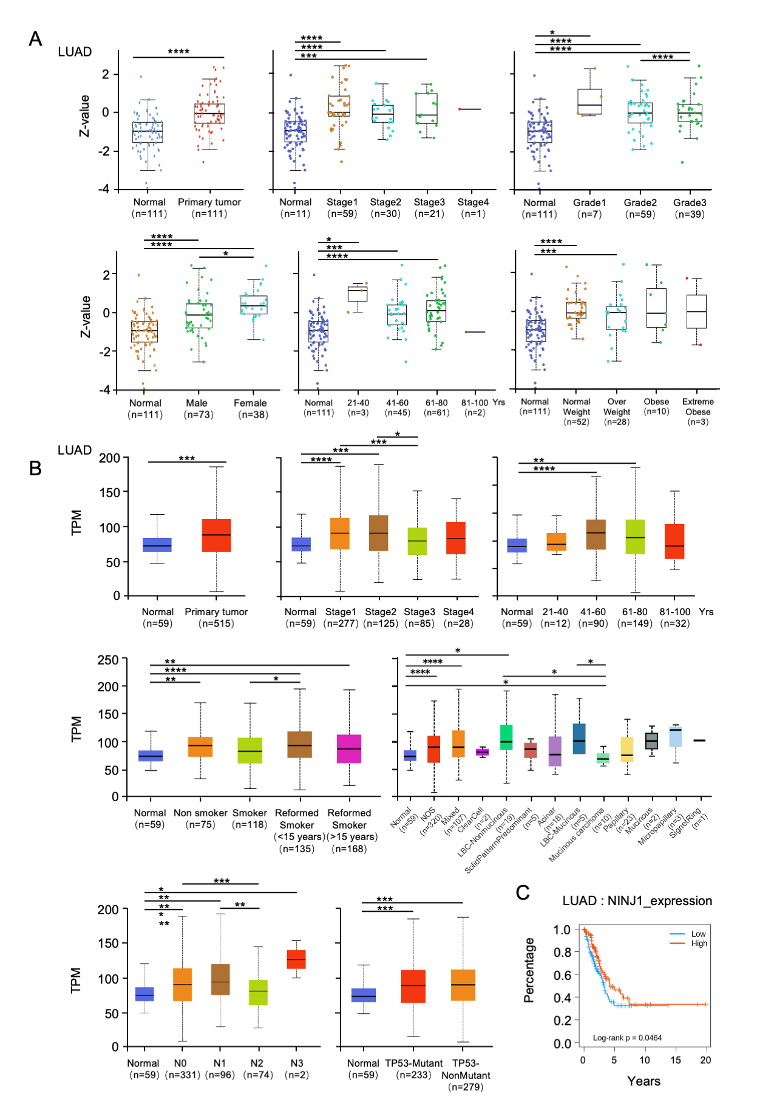 Figure S1. Differential expression analysis of NINJ1 in lung adenocarcinoma and adjacent normal tissues.

(A) NINJ1 expression across different pathological stages of lung adenocarcinoma based on the CPTAC database. (B) Differential expression analysis of NINJ1 in lung cancer tumor tissues versus adjacent normal tissues using data from the TCGA database. (C) Kaplan–Meier survival analysis indicating that patients with high NINJ1 expression exhibit improved overall survival compared to those with low expression. * p < 0.05; ** p < 0.01; *** p < 0.001; **** p < 0.0001.

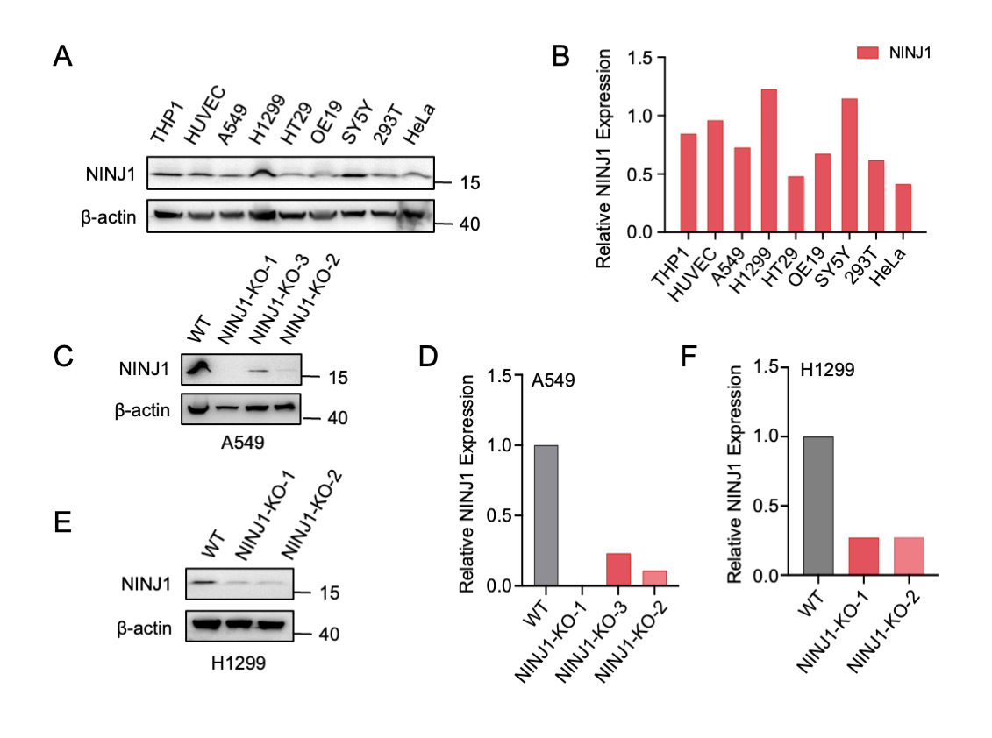 Figure S2. Generation and validation of NINJ1-knockout lung adenocarcinoma cell lines.

(A–B) Western blot analysis and quantification of NINJ1 protein expression across various human cell lines, including THP1 (human myeloid leukemia mononuclear cells), HUVEC (human umbilical vein endothelial cells), A549 and H1299 (human non-small cell lung cancer cells), HT29 (human colon cancer cells), OE19 (human esophageal cancer cells), SY5Y (human neuroblastoma cells), 293T (human embryonic kidney cells), and HeLa (human cervical cancer cells). (C–F) Generation of NINJ1-knockout A549 (C–D) and H1299 (E–F) cell lines using CRISPR-Cas9. (D, F) Quantification of grayscale values from Western blots in panels (C) and (E), showing a significant reduction in NINJ1 protein levels following knockout. Gray bars represent wild-type expression; red bars represent NINJ1-knockout expression levels. * p < 0.05; ** p < 0.01.

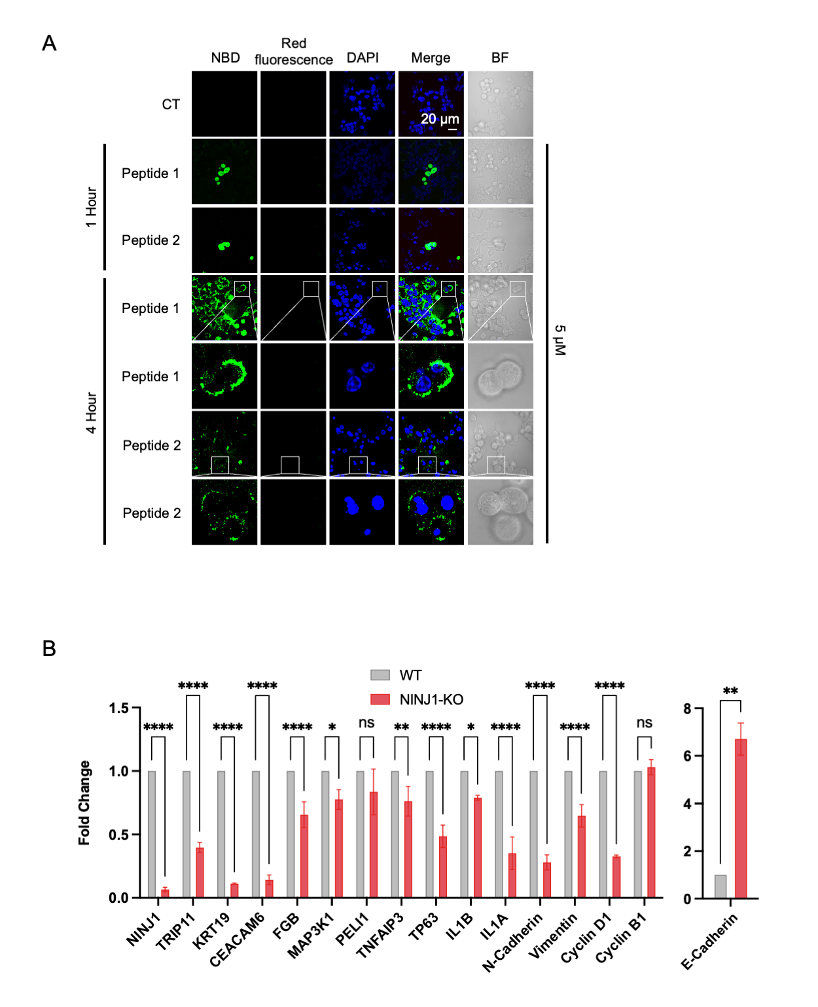 Figure S3. Assessment of gene expression changes following NINJ1 knockout and evaluation of the cellular duration of NINJ1-derived peptide activity.

(A) Immunofluorescence imaging of 293T cells treated with NINJ1-derived short peptides (5 μM) to evaluate their intracellular retention and effect duration. Green: NBD-labeled peptides; Blue: nuclei (DAPI); BF: bright field. Scale bar: 20 μm. (B) qPCR analysis of transcriptional changes in selected genes in A549 cells following NINJ1 knockout. Gray bars represent the negative control group; red bars represent the NINJ1-knockout group. ns: no significant difference; * p < 0.05; ** p < 0.01; *** p < 0.001; **** p < 0.0001.

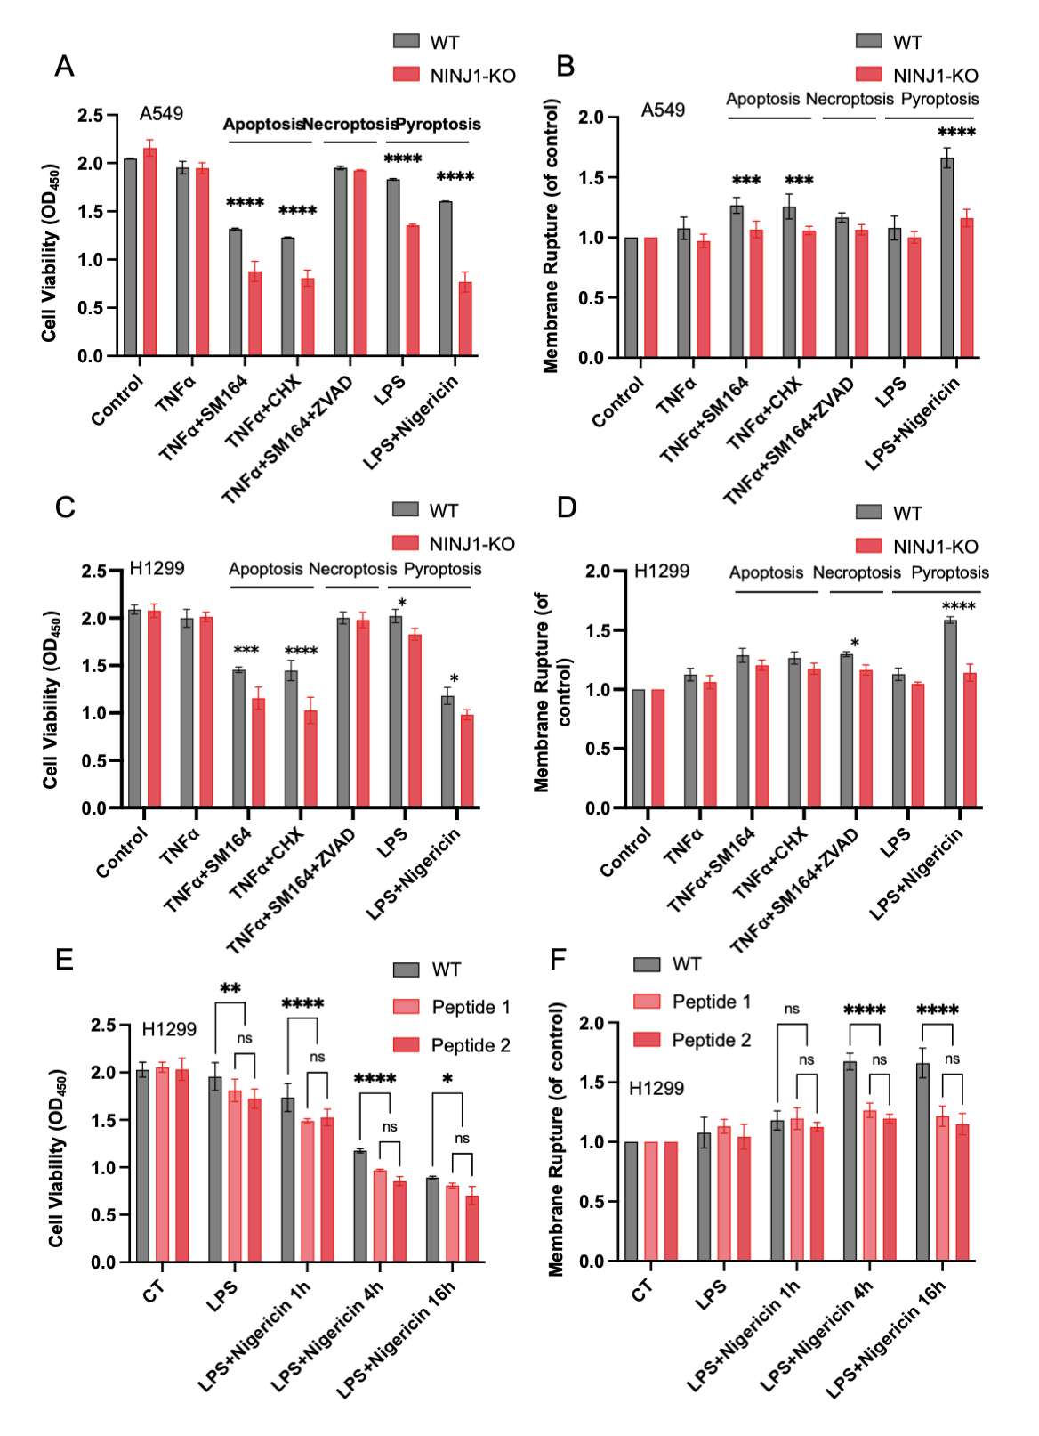 Figure S4. NINJ1 deficiency exacerbates apoptosis while reducing cell membrane rupture in A549 and H1299 cells.

(A, C) CCK-8 assays evaluating cell viability in wild-type and NINJ1-knockout A549 (A) and H1299 (C) cells treated with apoptosis-, necrosis-, or pyroptosis-inducing agents. Apoptosis was induced using TNFα (T, 50 ng/mL) + cycloheximide (CHX, 20 nM) or TNFα + SM164 (100 nM). Necrosis was induced using TNFα + SM164 + ZVAD (5 μM). Pyroptosis was induced using LPS (1 μg/mL) followed by Nigericin (20 nM). For apoptotic and necrotic conditions, TNFα was added for 2 hours, followed by CHX/SM164 or SM164/ZVAD for an additional 4 hours. For pyroptosis, LPS was added for 2 hours, followed by Nigericin for 4 hours. (B, D) LDH release assays measuring cell membrane rupture in A549 (B) and H1299 (D) cells under the same conditions as above. (E) H1299 cells were pre-treated with NINJ1-derived short peptides for 1 hour, followed by pyroptosis induction using LPS and Nigericin. Cell viability was assessed by CCK-8 at 1, 4, and 16 hours post-induction. (F) LDH assay measuring membrane damage in pyroptotic H1299 cells treated as described in (E). LPS (1 μg/mL) was added for 2 hours, followed by Nigericin (20 nM) for 1, 4, or 16 hours. ns: no significant difference; * p < 0.05; ** p < 0.01; *** p < 0.001; **** p < 0.0001.

Table S1. The primers used for qPCR experiments are listed.
Gene | Forward Sequence | Reverse Sequence
NINJ1 | TCTCCATCTCCCTTGTGCTGCA | CTACCACGATGATGAACACCAGG
β-actin | CACCATTGGCAATGAGCGGTTC | AGGTCTTTGCGGATGTCCACGT
WNT5A | TACGAGAGTGCTCGCATCCTCA | TGTCTTCAGGCTACATGAGCCG
WNT5A-AS1 | CAGTGTGGAAGAGTGCTGTGA | TGCCTCTCTTCTGTTGTGGTG
PI3K | CGCCTCTTCTTATCAAGCTCGTG | GAAGCTGTCGTAATTCTGCCAGG
AKT1 | TGGACTACCTGCACTCGGAGAA | GTGCCGCAAAAGGTCTTCATGG
AKT2 | CATCCTCATGGAAGAGATCCGC | GAGGAAGAACCTGTGCTCCATG
CD44 | CCAGAAGGAACAGTGGTTTGGC | ACTGTCCTCTGGGCTTGGTGTT
TRIP11 | GCCACTCAATGAAGGAGAAGGC | GAAACACAACTGTCTTCTCCTGC
KRT19 | AGCTAGAGGTGAAGATCCGCGA | GCAGGACAATCCTGGAGTTCTC
CEACAM6 | GCCTCAATAGGACCACAGTCAC | AGGGCTGCTATATCAGAGCGAC
FGB | CAACGGCATGTTCTTCAGCACG | GTATCTGCCGTTTGGATTGGCTG
MAP3K1 | CCAGACCAGTATCTCAGGAGATG | CCGCTAAACTGTGGCAAGGAGT
PELI1 | AACCAGATCGGCTCAGCAGAGA | ATGCTTCACGGTAGGAGTGTGG
TNFAIP3 | CTCAACTGGTGTCGAGAAGTCC | TTCCTTGAGCGTGCTGAACAGC
TP63 | CAGGAAGACAGAGTGTGCTGGT | AATTGGACGGCGGTTCATCCCT
IL1B | CCACAGACCTTCCAGGAGAATG | GTGCAGTTCAGTGATCGTACAGG
IL1A | TGTATGTGACTGCCCAAGATGAAG | AGAGGAGGTTGGTCTCACTACC
N-Cadherin | CCTCCAGAGTTTACTGCCATGAC | GTAGGATCTCCGCCACTGATTC
E-Cadherin | GCCTCCTGAAAAGAGAGTGGAAG | TGGCAGTGTCTCTCCAAATCCG
Vimentin | AGGCAAAGCAGGAGTCCACTGA | ATCTGGCGTTCCAGGGACTCAT
Cyclin D1 | TCTACACCGACAACTCCATCCG | TCTGGCATTTTGGAGAGGAAGTG
Cyclin B1 | GACCTGTGTCAGGCTTTCTCTG | GGTATTTTGGTCTGACTGCTTGC

