Supplementary materials:
Fig. S1. Screening of stromal factors. Naïve fibroblast and TAF screening from non-metastasized and metastasized colon adenocarcinoma showed minor changes in common and non-hematopoietic marker expression.

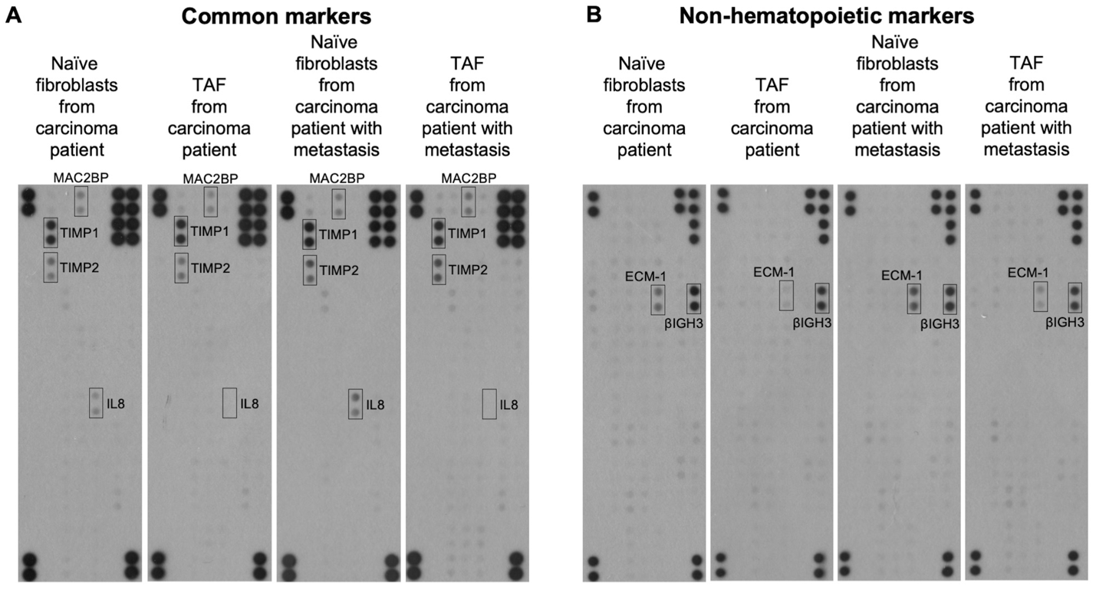

Fig. S2. Signal transduction analysis of fibroblasts and patient’s colon tissue. A. The phosphorylation levels of ERK1/2, AKT (T308 and S473), and p38MAPK were at similar levels in naïve fibroblasts and TAF isolated from non-metastasized and metastasized colon cancer. B, C. Small GTPase RAS and RAC pulldown analysis of HCT116 cells co-cultured with fibroblasts suggested similar kind of fibroblast paracrine effect on cancer cell signaling. D. Signaling analysis from colon tissue homogenates. The activation of signal transduction from normal colon, adenoma, and adenocarcinoma tissues both from non-metastasized and metastasized cancers showed moderate changes mainly in adenoma samples. Differences in cancer tissues from non-metastasized and metastasized cancers do not definitively explain differences in HCT116 proliferation and migration.
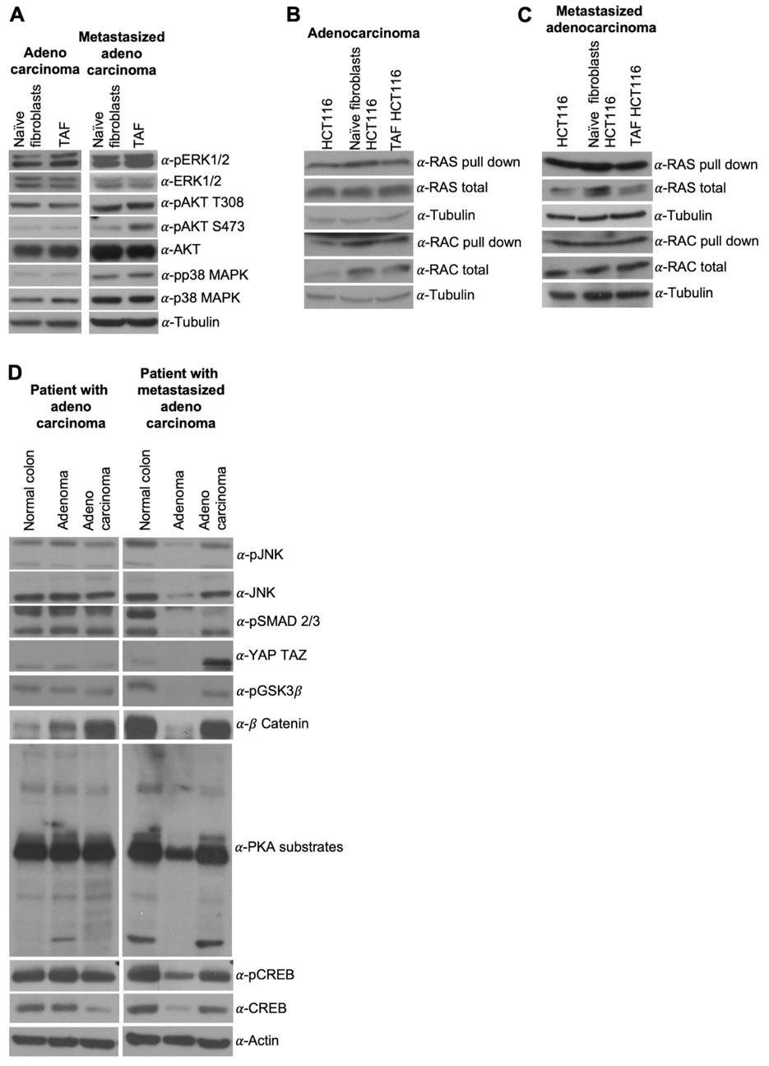
Table S1
Urine analysis of amino acid expression. The analysis of 15 control persons, 19, colon cancer patients, 9 inflammation patients, and three patients diagnosed with gastrointestinal stroma tumor, lymphoma or uterine cancer validated in vitro anomalies in oncometabolite expression in patients (squared values).
