Transcranial photobiomodulation induced frequency-specific dual-pathway glial activation for neurovascular protection vs amyloid clearance in Alzheimer’s disease
Bowen Zhang ^{1,†}, Zemeng Chen ^{1,†}, Louzhe Xu ¹, Songqi Yang ¹, Hui Shen ², Xunbin Wei ^{3,}*, Ting Li ^{1,*}
¹ Biomedical Engineering Institute, Chinese Academy of Medical Sciences and Peking Union Medical College, Tianjin, 300192, China
² Department of Cellular Biology, School of Basic Science, Tianjin Medical University, Tianjin, 300070, China
³ Peking University, China Department of Biomedical Engineering, College of Future Technology, Peking University, Beijing, 100871,
China
Department of Biomedical Engineering, College of Future Technology, Peking University, Beijing, 100871,
China
Department of Biomedical Engineering, College of Future Technology, Peking University, Beijing, 100871,
China
³ Department of Biomedical Engineering, College of Future Technology, Peking University, Beijing, 100871, China
† These authors contributed equally to this work.
*Correspondence to Xunbin Wei: xwei@bjmu.edu.cn (Tel: +86 13248068221); Ting Li: liting@bme.cams.cn (Tel: +86 18002127296)

Supplementary information
Figures
Fig. S1 The performance of 5xFAD mice during NOR and MWM.
Fig. S2 Reconstructed vascular network in prefrontal cortex in 5xFAD mice.
Fig. S3 Near-infrared light stimulation activated astrocytes and microglia.
Fig. S4 Near-infrared light stimulation increased the connection of glial cells and vascular network.
Fig. S5 Near-infrared light stimulation improved he neurodegenerative pathology in 5xFAD mice.
Fig. S6 The correlation analysis of glial cell activation, vascular network and synapse.

Fig S1. The performance of 5xFAD mice during NOR and MWM. (A) The average velocity during the NOR test. (B) Total distance traveled during the NOR test. (C, D) The escape latency (C) and the time percent (D) in the southwest (SW) quadrant during 5-day MWM. (E-H) The escape latency (E), swimming speed (F), latency in SW quadrant (G), and swimming time in SW quadrant (H) of mice at the space exploration experiment of Day 6. Data in (A-B, E-H) are presented as mean ± SD and analyzed by one-way ANOVA with Turkey’s post-hoc tests of multiple groups. Data in (C, D) are analyzed by two-way ANOVA with LSD post-hoc tests of multiple groups.

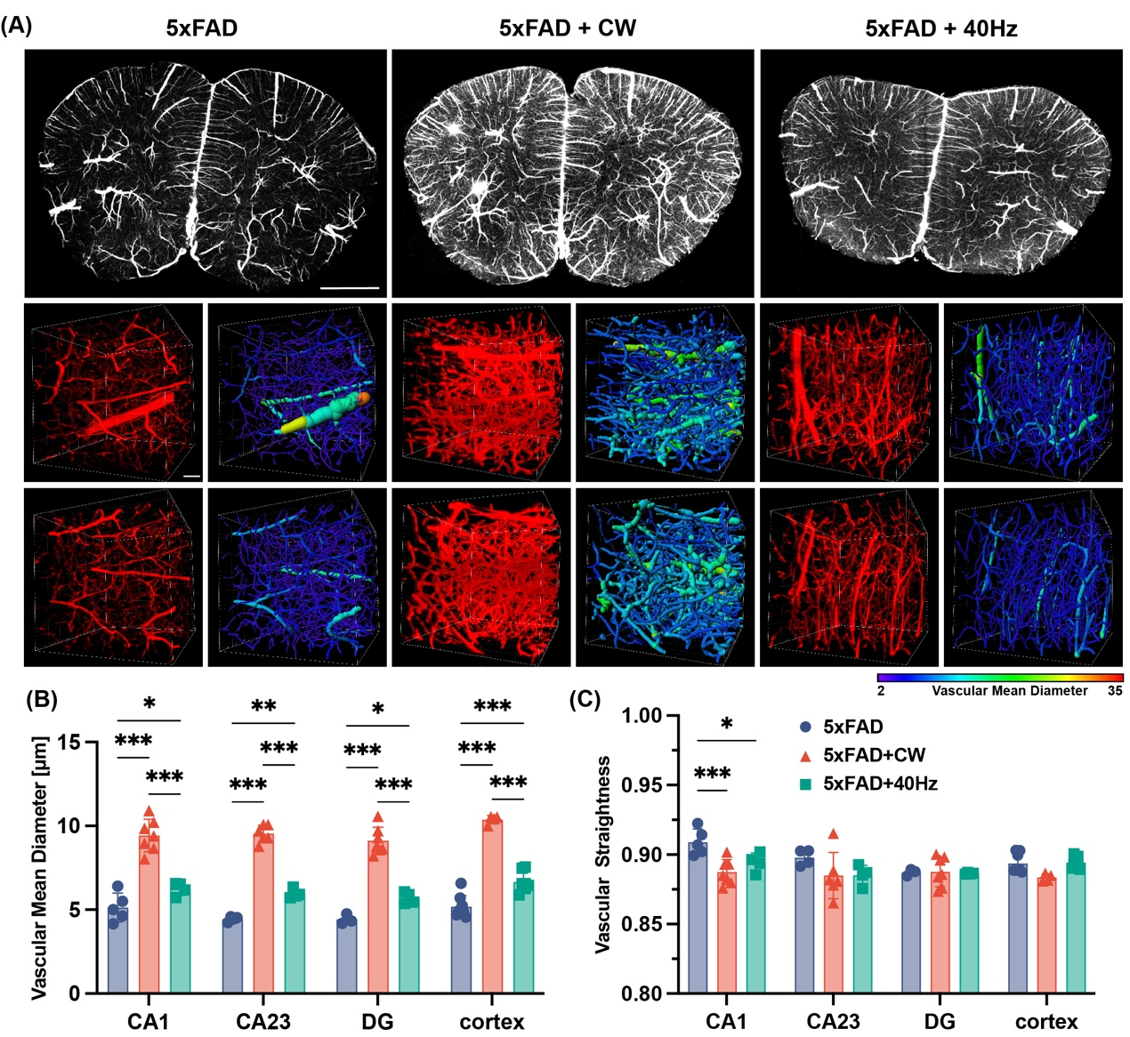
Fig. S2 Near-infrared light stimulation improved vascular network impairment in 5xFAD mice. (A) Representative 3D reconstruction images of vascular network in the prefrontal cortex. The pseudo-color in reconstructed images represents the vascular mean diameter. Scale bar, 1000um. (B, C) The vascular mean diameter (C) and vascular straightness (D) in hippocampus and cortex. Data in (B, C) are presented as mean ± SD and analyzed by two-way ANOVA with Turkey’s post-hoc tests of multiple groups. p-value: *p < 0.05, *p < 0.01, ***p < 0.001.

Fig S3. Near-infrared light stimulation activated astrocytes and microglia. (A, B) Area fraction (A) and average size (B) of GFAP+ astrocyte in hippocampus and cortex of 5xFAD mice. (C, D) Area fraction (C) and average size (D) of S100B+ astrocyte in hippocampus and cortex. (E, F) Area fraction (E) and average size (F) of Iba1+ microglia in hippocampus and cortex. Data are presented as mean ± SD and analyzed by two-way ANOVA with Turkey’s post-hoc tests of multiple groups. p-value: *p < 0.05, *p < 0.01.

Fig.S4 Near-infrared light stimulation increased the connection of glial cells and vascular network. (A, B) Immunofluorescence with anti-CD31 (red) and anti-GFAP (green) antibodies in the CA23 (A) and DG (B) of 5xFAD mice. (C) The area proportion of CD31/GFAP co-localization in hippocampus and cortex. (D) The ratio of CD31 area co-localized with GFAP to total CD31 area. (E) The ratio of GFAP area co-localized with CD31 to total GFAP area. (F, G) Immunofluorescence with Lectin (red) and anti-Iba1 (green) antibodies in the CA23 (F) and DG (G) of 5xFAD mice. (H) The area proportion of Lectin/Iba1 co-localization in hippocampus and cortex. (I) The ratio of Lectin area co-localized with Iba1 to total Lectin area. (J) The ratio of Iba1 area co-localized with Lectin to total Iba1 area. Data in (C-E, H-J) are presented as mean ± SD and analyzed by two-way ANOVA with Turkey’s post-hoc test of multiple groups. p-value: *p < 0.05, ** p < 0.01, *** p < 0.001.

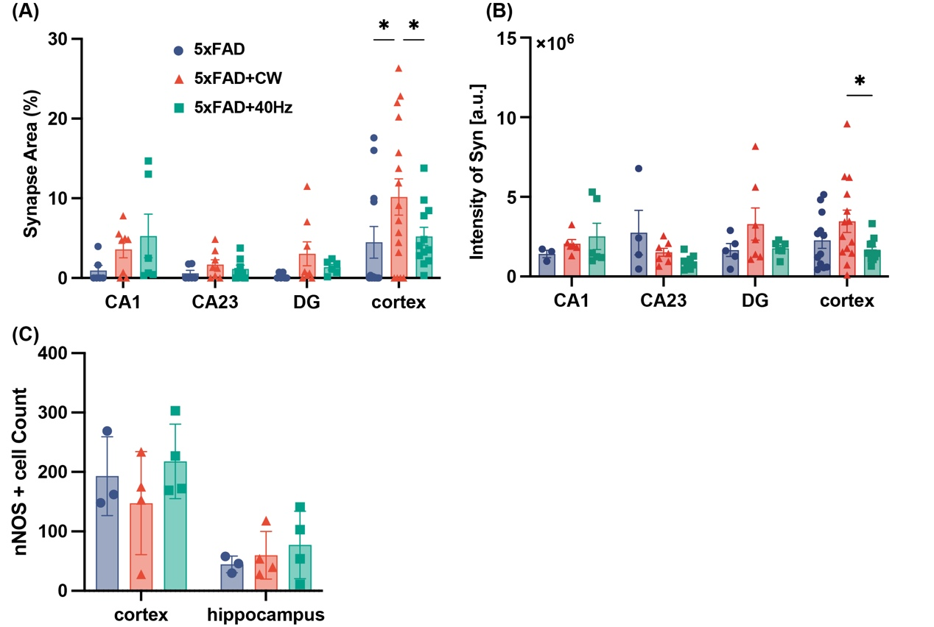
Fig. S5 Near-infrared light stimulation improved he neurodegenerative pathology in 5xFAD mice. (A) The synapse area fraction in hippocampus and cortex. (B) The relative intensity of Syn+ signal in hippocampus and cortex. (C) The nNOS+ neuron count in hippocampus and cortex. Data are presented as mean ± SD and analyzed by two-way ANOVA with Turkey’s post-hoc test of multiple groups. p-value: *p < 0.05.

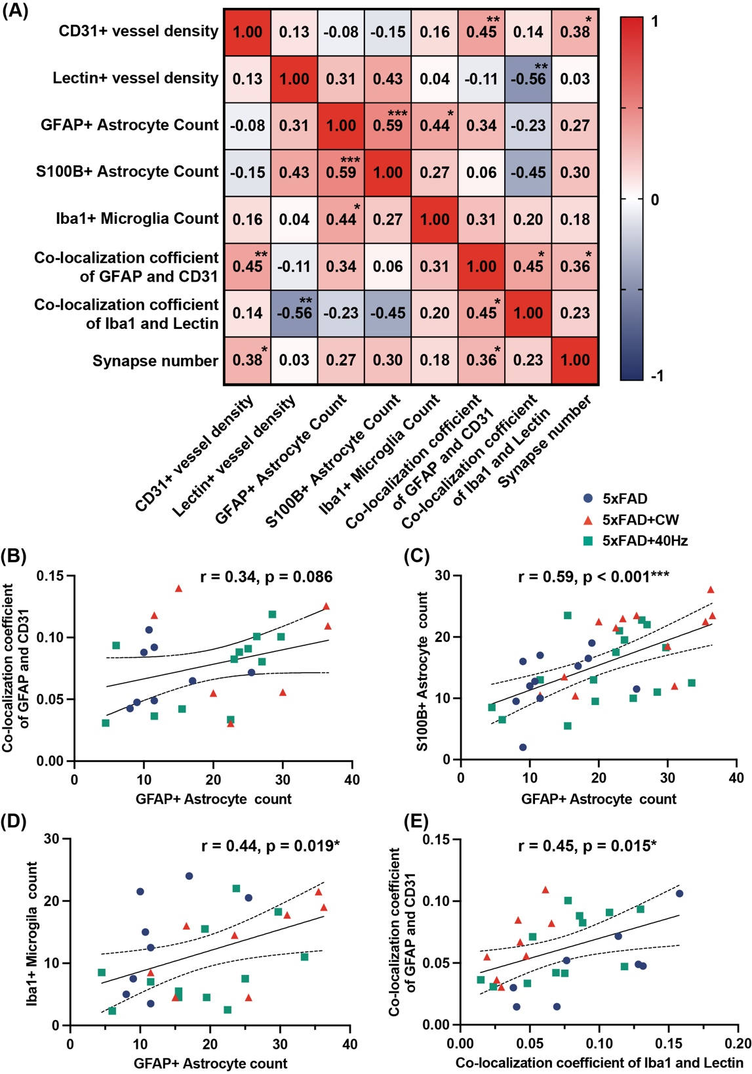
Fig. S6 The correlation analysis of glial cell activation, vascular network and synapse. (A) Correlation matrix among quantitative metrics of glia, vasculature, and synapses. (B) The Pearson’s correlation analysis between GFAP+ astrocyte count and the co-localization coefficient of GFAP+ astrocyte and CD31+ vessel. (C) The Pearson’s correlation analysis between GFAP+ astrocyte count and S100B+ astrocyte count. (D) The Pearson’s correlation analysis between GFAP+ astrocyte count and Iba1+ microglia count. (E) The Pearson’s correlation analysis between the co-localization coefficient of Iba1+ microglia and Lectin+ vessel and the co-localization coefficient of GFAP+ astrocyte and CD31+ vessel. p-value: *p < 0.05, ** p < 0.01, *** p < 0.001.

