Interfacial crystallization and supramolecular self-assembly of spider silk inspired protein at the water-air interface
Pezhman Mohammadi,*,† Fabian Zemke, ‡,⸸ Wolfgang Wagermaier‡ and Markus B. Linder,§
† VTT Technical Research Centre of Finland Ltd., FI-02044 VTT, Finland
‡ Department of Biomaterials, Max Planck Institute of Colloids and Interfaces, D-14476, Potsdam, Germany
⸸ Fachgebiet Keramische Werkstoffe / Chair of Advanced Ceramic Materials, Institute of Materials Science and Technology, Technische Universität Berlin, 10623, Berlin, Germany (current address)
§ Department of Bioproducts and Biosystems, School of Chemical Engineering, Aalto University, FI-02150, Espoo, Finland

Cloning, expression & protein purification
Cloning, expression and protein purification done as described in our earlier publications. ^{1–4} Briefly, DNA sequences encoding bacterial family three cellulose binding module (CBM3) from Ruminiclostridium Thermocellum (PDB Accession number: 1NBC) ⁵ and DNA sequence encoding Aaraneus diadematus major ampulla gland (ADF3) and twelve time repeats of residues 325-368 (eADF3) ^{6–8} were synthesized and codon optimized by GeneArt gene synthesis (ThermoFisher Scientific) for expression in E. coli . Similarly eADF3 sequence was also synthesized and codon optimized by GeneArt gene synthesis for expression in Pichia pastoris. Constructs were either made by conventional piece by piece cloning or golden gate cloning^{9–11}. pE-28a (+) (kanR) (Novagen) expression vector in frame with C-terminal 6×His-tag coding sequence for facilitating the purification was used. Resulting constructs named, CBM-eADF3-CBM, CBM-ADF3-CBM, CBM-eADF3, CBM-CBM, CBM and eADF3. XL1B (New England biolab® 5-alpha F'Iq Competent E. coli (F´ proA⁺B⁺lacI^{q} ∆(lacZ)M15 zzf::Tn10 (Tet^{R}) / fhu A2∆(argF-lacZ)U169 phoA glnV44 Φ80Δ(lacZ)M15 gyrA96 recA1 relA1 endA1 thi-1 hsdR17)) and BL21 (F-ompT hsdSB (rB-mB-) gal dcm (DE3)) (ThermoFisher Scientific) were used as cloning and expression vectors. In general for all the expressions either EnPresso® B medium (BioSilta, Oulu, Finland) technology were used or MagicMediaTM E.coli expression medium (ThermoFisher scientific) according to instructions with some changes otherwise states in the text. After 15-24 hours of induction cells were harvested (Centrifugation at 16,000 ×g, 15min, 4°C), washed and lysed. Proteins were purified using HisTrap FF crude columns (GE Healthcare life Science) connected to a AKTA-Pure liquid chromatography. For high scale purification cells lysed and supernatant heat shocked at 70-75 °C for 30min and then centrifuged at 16,000 ×g for 80 min at 4°C and desalted using Econo-Pac® 10DG column. Samples were then freezed in liquid nitrogen and stored at -80°C until use.
Sample preparation for the analysis
Never dried protein samples were gradually concentrated to the desired concentrations (0.2 %w/v, 2%w/v and 15% w/v) using centrifugal concentrator (Vivospin20) at 845 r.c.f. Unless otherwise stated proteins were in Milli-Q water. For the measurements, pendant droplet of silk solution made by forming approximately 200-500 µL of proteins solution drawn in to a Hamilton® syringe and a droplet with approximately 40 µL volume was made in a humidity controlled box using a flat tipped needle at various relative humidities (20%, 40% and 80% RH ) . Self-assembly of proteins at the air-water interface led to formation of an elastic skin around the pendant droplets.
Optical and polarized microscopy
Samples were imaged on several platforms as follows: (1) Axio observer inverted microscope (Carl Zeiss, Germany) equipped with, motorized stage, AxioCam MRm camera (Zeiss), a × 100/numerical aperture and Zeiss AxioVision software. Images were further processed with ImageJ ¹² or ImageJ Fiji (versions 1.47d) ¹³. (2) Polarized microscopy imaging was done using a Leica DM4500 P LED polarized optical microscope (POM) for the qualitative observation and to study birefringence of the fibers. Samples placed between two cross-polarizers in an optical microscope and interference color resulting from the retardation between ordinary and extraordinary waves at angles ±45 was determined. All the imaging was done on microscope glass slides (24×50mm, with 170µm thickness) that were washed with 10mM NaOH with sonication for 5 minutes and rinsed with water.
Flash-freezing of the pended-droplet for characterization of the skin formation
Verification of the pended droplets were done by plunging the droplets into 1:1 mixture of Liquid propane and ethane (-180 °C). Samples were then handled under liquid nitrogen transferred into a FreeZone 4.5 Liter Cascade Benchtop Freeze Dry Systems equipped with collector cooling chamber of -105°C.
Scanning electron microscopy (SEM)
High resolution SEM imaging was performed via Zeiss (Sigma VP) FE-SEM field emission microscope (Microscopy center, Aalto University, Espoo, Finland) with variable pressure, operating at 1–1.5kV operating. A thin (2 nm) platinum coating was sputtered onto the samples prior to imaging of surfaces only in SEM mode. For further analysis and image processing software package ImageJ ¹² and ImageJ Fiji (versions 1.47d) ¹³ was use.
Raman spectroscopy
A Lab RAM HR UV-NIR single stage dispersive Raman microscope system with an 800mm high resolution spectrograph was used to record Raman Spectra from the speciments. A 633nm @ 30mW (with an estimated power of 3mW on sample) Helium-neon laser was used to focus on the surface of the specimens. An Olympus BX41 with a motorized stage with 50X objective was used to focus the <1μm laser beam to collect the scattered radiation and record the spectra with a high resolution CCD camera (1024x256 (pixel size 26x26 μm)) in region of 700-1800cm⁻¹ with the exposure time of 20 second, accumulation number of 100 and grating of 600.
Micro-mechanical measurement of skin
Tensile testing was performed on a 2 kN tensile/compression module (Kammrath & Weiss GmbH, Germany) using 2 N load cells. The elongation speed was 8.35 µm/second with a gauge length of 10 mm. The ends of the fiber-shaped materials were fixed by gluing them between two pieces of abrasive sandpaper. Before testing, the samples were stabilized at 50% relative humidity overnight. SEM imaging was used to obtain the cross-sectional areas of each sample. In most cases the cross-section was not completely circular, a contour line was drawn to measure the cross-sections. We used Image J software package.
Interfacial tension
Measurements performed using Biolin Scientific Attension Theta Flex optical tensiometer equipped with temperature and humidity controlled unit with the camera resolution of 1984x1264 px (3009 FPS). A pendant drop was made using a micropipette containing 25 μL of either 0.2%, 2% or 15% w/v Silk solution. The Young−Laplace formula was used to calculate the shape change of the pendant drop.^{14,15} The pendant drops were incubated at room temperature in a controlled humidity unit. Changes in the shape of the pendant droplet was characterized using OneAttention Theta Flex software.
Synchrotron wide-angle x-ray scattering (WAXS) measurement
The in-situ x-ray scattering experiments were conducted at BESSY II (Helmholz Zentrum Berlin für Materialien und Energie; Berlin, Germany) at the µSpot beamline (Max-Planck Institute of Colloids and Interfaces, Potsdam, Germany). An energy of 15 keV with a Si111 double monochromator and 100 µm spot-size was used; the sample to detector distance of 311 mm allowed for WAXS investigations. The images were captured with an Eiger 9M detector (pixel size 75x75 µm).

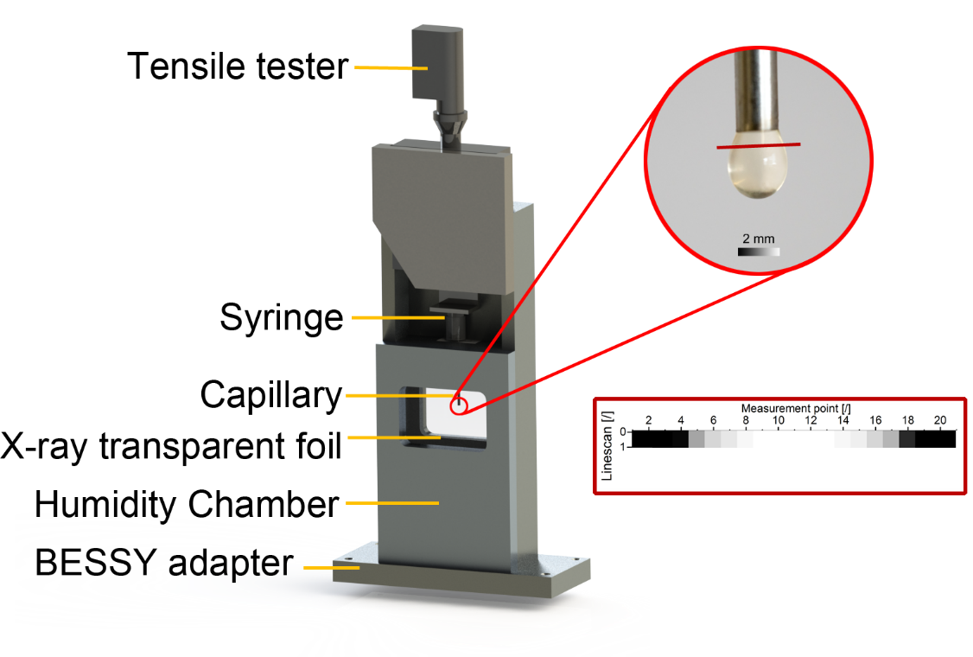
Figure S1. Overview of the used humidity measurement chamber with a motorized tensile testing machine, syringe/cannula and x-ray transparent polymeric windows. The red circle marks the area of interest, where the droplet was formed.
To control the humidity, a custom-made measurement chamber (10 % to 90 % relative humidity, Figure S1) was installed, which was attached to a generator and its air pressure system. This chamber consists of x-ray transparent polymeric windows and a cannula (2 mm diameter) that could be operated remotely with a motorized tensile testing machine.
The defrosted proteinous solutions (0.2 %, 2 % and 15 % w/v Silk solution) were captured inside the cannula, and a droplet was formed. A repeating line scan (4 mm width, step size 200 µm and 10 s exposure time) was used to acquire images directly underneath the cannula over the whole width of the droplet; each sample was investigated for a minimum of 1 h with higher durations for the high humidities. The software DPDAK (Directly programmable data analysis kit) was used for calibration and evaluation of the x-ray spectra using the plugins “Image Input” and “Image Integration 1D”.¹⁶ A quartz standard was used for calibration of the radially integrated images, oversaturated pixels were removed by masking and a background of the empty measurement chamber was subtracted. Furthermore, a transmission correction value was calculated for each measurement point, considering the respective path of the beam through a spherical shape. Finally, Lorentzian peak fits (5000 iterations, least-squares, linear background subtraction) were applied to determine the area and position of the peaks; peak position variations higher than 0.5 and error calculations higher than 0.1 were discarded.
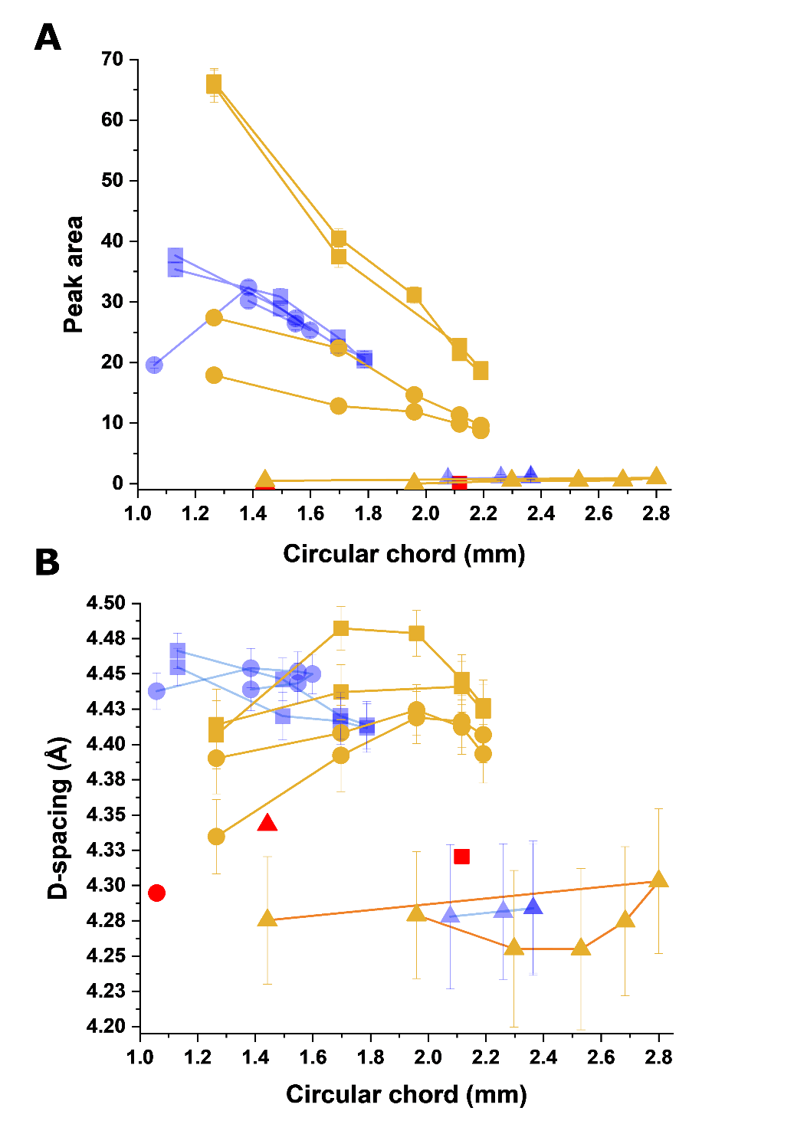
Figure S2. Effect of concentration and humidity on the formation of β-sheets analyzed by in-situ x-ray scattering. (A) Peak area ﬁt over the circular chord for 0.2% w/v, 2% w/v and 15% w/v protein samples at 20% RH, 40% RH and 80% RH. (B) Peak ﬁt position over the circular chord of the droplet corresponding to A. For better clarity, data points for 80% RH for all three concentrations were removed due to the unreliability of detections.
1. Mohammadi, P. et al. Biomimetic Composites with Enhanced Toughening Using Silk Inspired Triblock Proteins and Aligned Nanocellulose Reinforcements. Sci. Adv. 1–12 (2019). doi:10.1126/sciadv.aaw2541
2. Mohammadi, P. et al. Phase transitions as intermediate steps in the formation of molecularly engineered protein fibers. Commun. Biol. 1, 86 (2018).
3. Mohammadi, P., Beaune, G., Stokke, B. T., Timonen, J. V. I. & Linder, M. B. Self-Coacervation of a Silk-Like Protein and Its Use As an Adhesive for Cellulosic Materials. ACS Macro Lett. 1120–1125 (2018). doi:10.1021/acsmacrolett.8b00527
4. Mohammadi, P. et al. Controllable coacervation of recombinantly produced spider silk protein using kosmotropic salts. J. Colloid Interface Sci. (2019). doi:https://doi.org/10.1016/j.jcis.2019.10.058
5. Tormo, J. et al. Crystal structure of a bacterial family-III cellulose-binding domain: a general mechanism for attachment to cellulose. EMBO J. 15, 5739 (1996).
6. Huemmerich, D. et al. Primary structure elements of spider dragline silks and their contribution to protein solubility. Biochemistry 43, 13604–13612 (2004).
7. Guerette, P. a, Ginzinger, D. G., Weber, B. H. & Gosline, J. M. Silk properties determined by gland-specific expression of a spider fibroin gene family. Science 272, 112–5 (1996).
8. Gosline, J. M., Guerette, P. a, Ortlepp, C. S. & Savage, K. N. The mechanical design of spider silks: from fibroin sequence to mechanical function. J. Exp. Biol. 202, 3295–3303 (1999).
9. Engler, C., Kandzia, R. & Marillonnet, S. A one pot, one step, precision cloning method with high throughput capability. PLoS One 3, e3647 (2008).
10. Sanjana, N. E. et al. A transcription activator-like effector toolbox for genome engineering. Nat. Protoc. 7, 171–192 (2012).
11. Yan, P., Gao, X., Shen, W., Zhou, P. & Duan, J. Parallel assembly for multiple site-directed mutagenesis of plasmids. Anal. Biochem. 430, 65–67 (2012).
12. Schneider, C. A., Rasband, W. S. & Eliceiri, K. W. NIH Image to ImageJ: 25 years of image analysis. Nat. Methods 9, 671–675 (2012).
13. Schindelin, J. et al. Fiji: an open-source platform for biological-image analysis. Nat. Methods 9, 676–682 (2012).
14. Gao, L. & McCarthy, T. J. How Wenzel and Cassie were wrong. Langmuir 23, 3762–3765 (2007).
15. Gao, L. & McCarthy, T. J. Wetting 101°. Langmuir 25, 14105–14115 (2009).
16. Benecke, G. et al. A customizable software for fast reduction and analysis of large X-ray scattering data sets: applications of the new DPDAK package to small-angle X-ray scattering and grazing-incidence small-angle X-ray scattering. J. Appl. Crystallogr. 47, 1797–1803 (2014).

