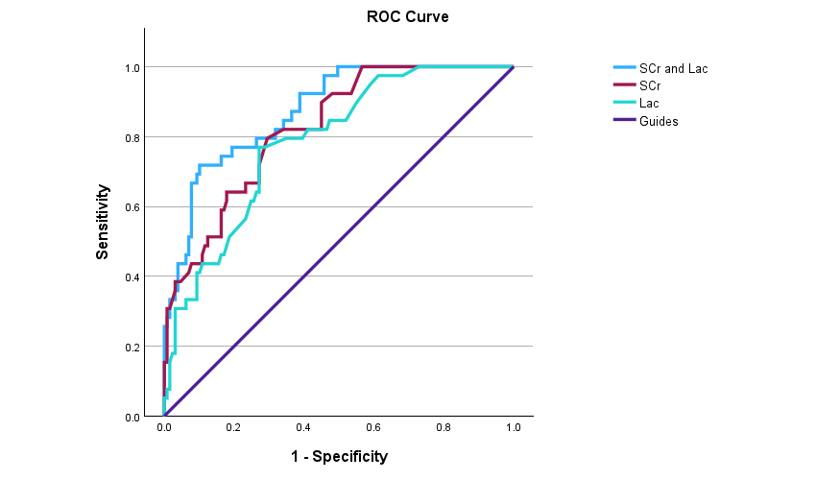
Fig 1 ROC curves for serum creatinine and lactate
 | ROC-AUC | Cut-off value
SCr | 0.824 | 60.5 umol/L
Lac | 0.784 | 3.15 mmol/L
SCr and Lac | 0.875
SCr, serum creatinine; Lac, lactate;
Fig2 ROC curve of serum creatinine at gestational age of 25 to 29 weeks
ROC-AUC=0.892 Cutoff=54.2 Sensitivity=0.92 Specificity=0.757
Fig3 ROC curve of serum creatinine at gestational age of 30 to 34 weeks
ROC-AUC=0.827 Cutoff=62.6 Sensitivity=0.857 Specificity=0.714

Fig4 ROC curve of serum creatinine at gestational age of 35 weeks to 40 weeks
ROC-AUC=0.841 Cutoff=73.5 Sensitivity=0.778 Specificity=0.814

Fig1 shows that although the area of common prediction is more obvious, serum creatinine is a more sensitive indicator of renal function, and lactate has more influencing factors, and is not as sensitive as serum creatinine in renal function changes. In the subsequent COX regression analysis, lactate is not as significant as serum creatinine in affecting mortality. Therefore, in the discussion and subsequent result analysis, the effect of lactate on the entire model was eliminated and only the predicted value of serum creatinine was used for analysis.
Fig2-4, these four figures are the analysis of ROC-AUC after the gestational age is divided into more detailed groups. It can be seen that the Cut-off value of serum creatinine for the area under the curve is gradually increasing with the increase of gestational age. The possible reason is that the kidneys are not fully developed at a younger gestational age, so the change of serum creatinine has a greater impact on the area under the curve. However, after the gestational age is divided into subgroups, the data values may not be comprehensive due to the reduction in sample size. The Cutoff values between the three subgroups are all in the range of 50-75, and the Cutoff value obtained after the overall sample analysis data is 60.5. Combined with the overall data model of renal function changes in NEC and the subsequent verification results, we believe that the serum creatinine value of 60.5 has a more significant impact on neonatal mortality, so we take the value of 60.5 to establish a model to illustrate the impact of serum creatinine on NEC, and do not put the subgroup analysis results of gestational age into the analysis results of the main text for analysis and discussion.

