Supplementary Information for:
Aerosol Acidity Controls Methanesulfonic Acid Evaporation From Aerosols During Antarctic Katabatic Outflow
B.Miljevic¹, M.D. Mallet², C.G. Osuagwu¹ , Z.D. Ristovski¹, R. S. Humphries^{2,3}, P. Selleck³, S.Taylor³ and M.D.Keywood^{2,3}

¹School of Earth and Atmospheric Sciences, Queensland University of Technology, Brisbane, Australia
² Australian Antarctic Program Partnership, Institute for Marine and Antarctic Studies (IMAS), University of Tasmania, Hobart, Australia
³CSIRO Environment, Melbourne, Victoria, Australia

NO₃-CIMS calibration factor
The intensity of SA and MSA was calculated by summing ions originating from each of these two species, normalising them to the sum of the reagent ions and multiplying by a calibration factor as per the equation below:
[X] = C x [Σ(HNO₃)_{n}X⁻ ] / [Σ(HNO₃)_{n}NO₃⁻],
where X is SA or MSA, n = 0-2 and C is a calibration factor (molec. cm⁻³ ncps⁻¹; npcs: normalised counts per second).
The NO₃-CIMS was not directly calibrated for SA in this study due to the complexity of the procedure, however, literature-reported calibration factors are broadly consistent across studies [1]. A value of 8.4 x 10⁹ molecule cm⁻³ ncps⁻¹ was used here as a median of 21 values reported across studies. The studies and their corresponding calibration factors are listed in Supplementary Table 1. The lower and upper literature values of 0.13 x 10¹⁰ and 2.0 x 10¹⁰ molecule cm⁻³ ncps⁻¹ were used to estimate uncertainty. This results in an uncertainty of -75%, +140%. Nevertheless, correction using this value provides the expected order of magnitude for atmospheric concentrations of SA and MSA and does not influence the trends nor the ratio of these species.

E-AIM model
To investigate whether E-AIM can simulate the temporal behaviour of MSA during CAPRICORN-2, we needed a higher time resolution of chemical species used in the model. For that purpose, we used 24 hr PM1 filter data and interpolated it to 1 hr resolution. While this is not the real aerosol chemical composition during Capricorn-2, it provides a sensible high time resolution compositional scenario for investigating MSA gas-particle partitioning. This closely mimics our observational dataset. PM1 filter data and interpolated time series are shown in Supplementary Figure 7. Relative humidity and temperature were obtained from the ship’s underway data.
To investigate the role of pH and RH on MSA partitioning we used filter composition on 30 Jan (chosen as a representative of the “high MSA” period) and total MSA observed at that period, and varied aerosol pH between -1.5 and 3 by varying NH₄⁺ concentrations. The temperature was kept at 273.15 K and RH was varied between 60% and 100%. On several occasions the observed RH was slightly below 60%, but those values were adjusted to 60% as the E-AIM model IV cannot run at RH lower than 60%.

Supplementary Table 1. Literature-based NO₃-CIMS calibration factors for H₂SO₄
Reference | Calibration factor (molecule cm⁻³ ncps⁻¹)
Jokinen et al (2012) [2] | 5.00E+09
Jokinen et al (2012) [2] | 1.89E+10
Rissanen et al (2014) [3] | 1.94E+10
Berndt et al (2015,2016); Jokinen et al (2014, 2015)[4-7] | 1.85E+09
Mutzel et al (2015) [8] | 8.40E+09
Kirkby et al (2016) [9] | 6.50E+09
Kurten et al (2016) [10] | 6.00E+09
Riva (2019) [11] | 2.00E+10
Quelever et al (2019) [12] | 1.65E+09
Pulinen et al (2020) [13] | 3.70E+10
Shen et al (2021) [14] | 2.50E+10
Cheng et al (2021) [15] | 1.66E+10
Xu et al (2021) [16] | 1.57E+10
Xu et al (2021) [16] | 2.00E+10
Wang et al (2022) [17] | 1.10E+10
Baccarini et al (2021) [18] | 6.90E+09
Olin et al (2020) [19] | 1.30E+09
Olin et al (2020) [19] | 9.10E+09
Olin et al (2022) [20] | 2.45E+09
Yuan et al (2024) [21] | 2.49E+09
Shen et al (2022) [22] | 4.13E+10
Shen et al (2024) [23] | 6.20E+09
Median | 8.75E+09

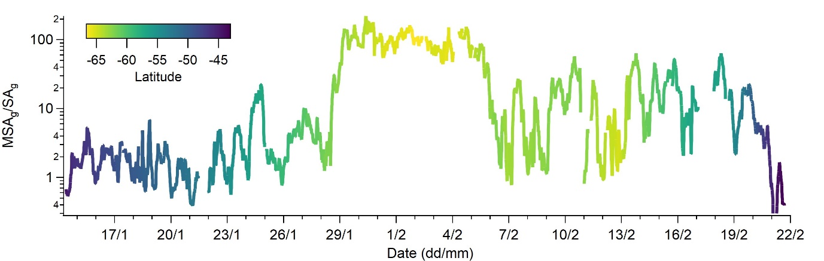
Supplementary Figure 1. The ratio of MSA_{g} to SA_{g} during CAPRICORN-2 voyage.

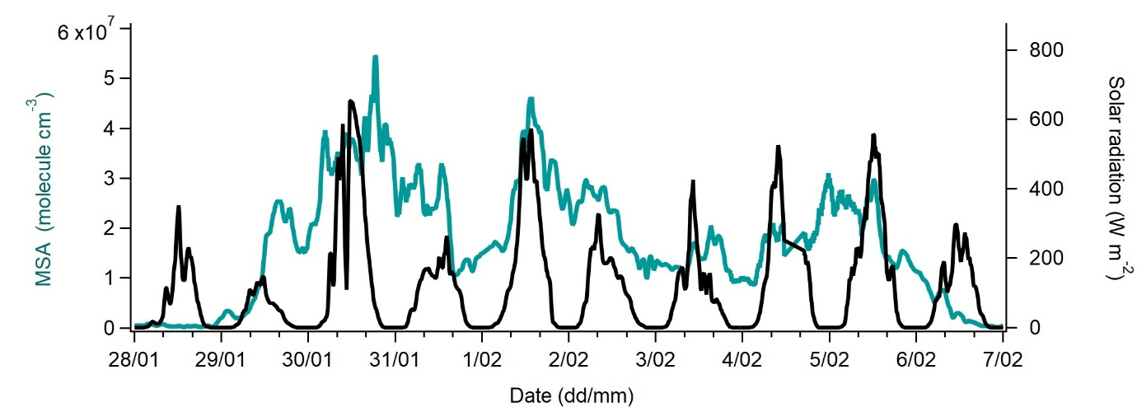
Supplementary Figure 2. Gaseous MSA and solar radiation during the “high MSA” period. MSA concentration (green line) and solar radiation (black line) demonstrate that MSA variability does not consistently align with the solar radiation cycle.
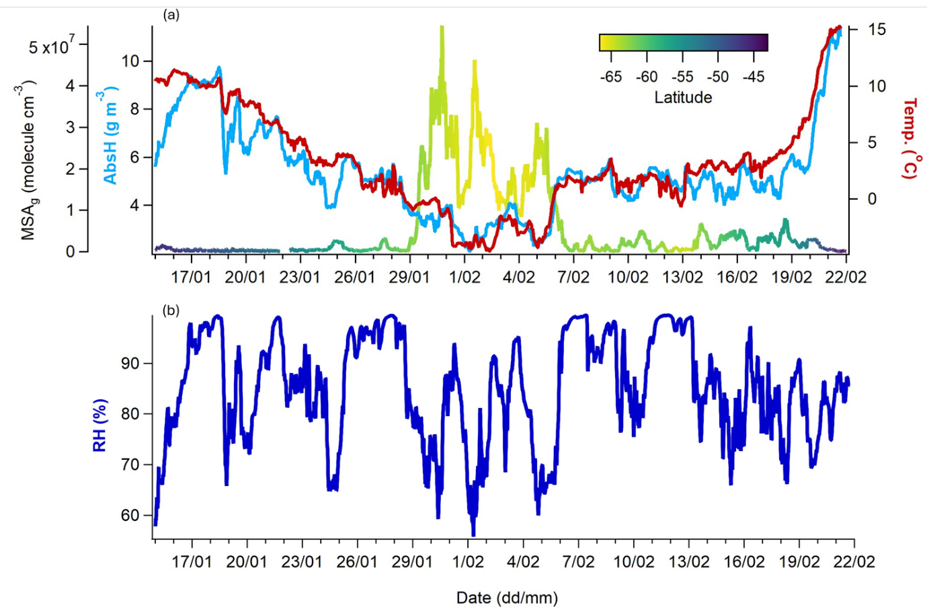
Supplementary Figure 3. Temperature, relative and absolute humidity during CAPRICORN-2. (a) Absolute humidity (AbsH; light blue) and temperature (Temp.; red) shown together with MSA_{g} (coloured by latitude); (b) Rlative humidity (RH) during the voyage.

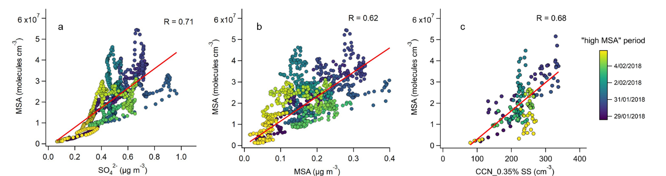
Supplementary Figure 4. Correlation between gaseous MSA and PM1 SO₄²⁻ (a) and MSA_{g} (b) and CCN at 0.35% SS (c) during the “high MSA” period.

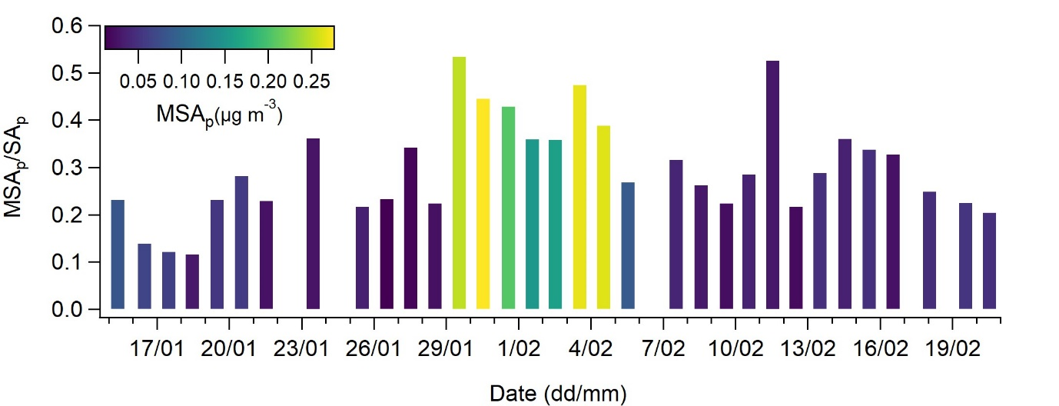
Supplementary Figure 5. Particulate MSA/SA ratio during CAPRICORN-2. MSA_{p}/SA_{p} was calculated from daily PM1 filter measurements and coloured by MSA_{p} mass concentration to emphasise “high MSA” period

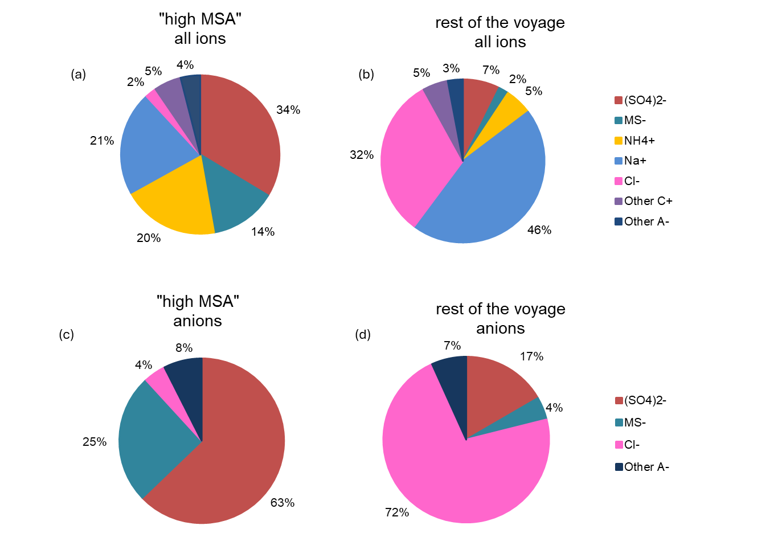
Supplementary Figure 6. PM1 ionic composition during the “high MSA” period (left) and the rest of the voyage(right). (a) and (b) represent all ions and (c) and (d) only anions.

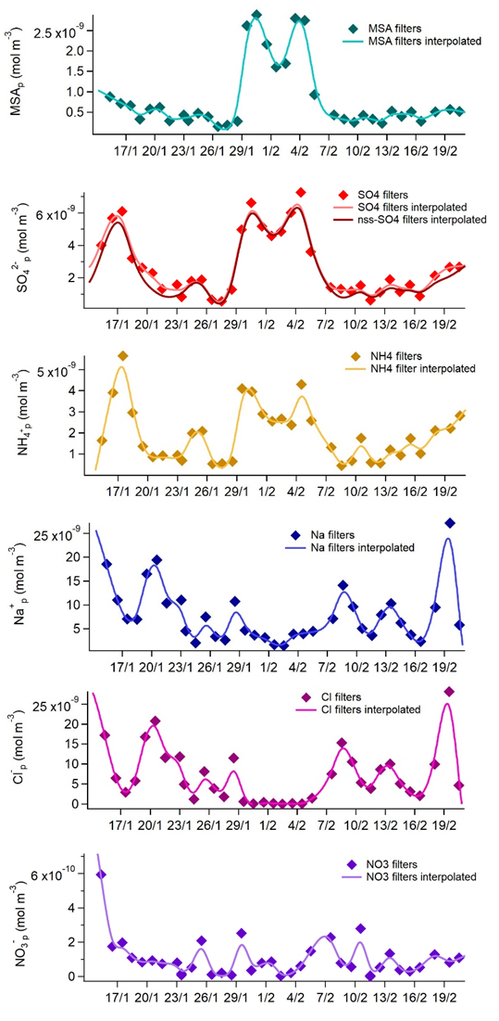
Supplementary Figure 7. Ionic species used in the E-AIM model. Diamonds are filter measurements and lines are smoothed spline interpolation of filter measurements to 1 hr data to create a high-resolution realistic compositional scenario for the E-AIM model. SO₄²⁻ includes total SO₄²⁻ and non sea salt SO₄²⁻ (nss-SO₄²⁻) calculated by subtracting the sea salt contribution to SO₄²⁻ from the total measured SO₄²⁻ (nss-SO₄²⁻​= SO₄^{2−​}−([Na⁺]/[SO₄^{2−​}]​)_{seawater​} × [Na⁺]_{sample}). nss-SO₄²⁻ was used in E-AIM II.

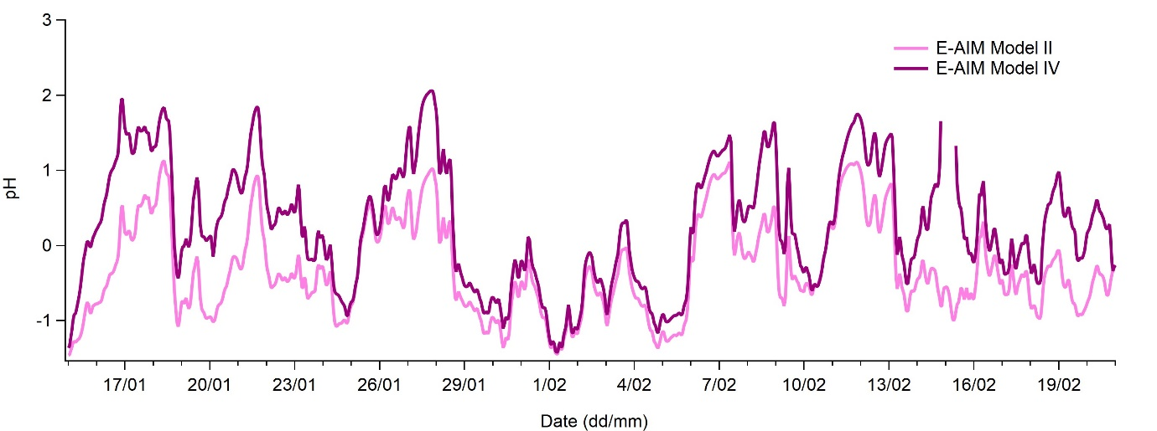
Supplementary Figure 8. Comparison of estimated pH using two E-AIM settings. E-AIM II (pink) uses H⁺ - NH₄⁺ - nssSO₄²⁻ - NO₃⁻ - H₂O (+total MSA) system and here represents secondarily formed particles and E-AIM IV (purple) uses H⁺-NH₄⁺-Na⁺-SO₄²⁻-NO₃⁻-Cl⁻-H₂O (+total MSA) system and is used to represent internal mixture of seas pray and secondarily formed species.

References

1. Alage, S., et al., A nitrate ion chemical-ionization atmospheric-pressure-interface time-of-flight mass spectrometer (NO3− ToFCIMS) sensitivity study. Atmos. Meas. Tech., 2024. 17(15): p. 4709-4724.
2. Jokinen, T., et al., Atmospheric sulphuric acid and neutral cluster measurements using CI-APi-TOF. Atmos. Chem. Phys., 2012. 12(9): p. 4117-4125.
3. Rissanen, M.P., et al., The Formation of Highly Oxidized Multifunctional Products in the Ozonolysis of Cyclohexene. Journal of the American Chemical Society, 2014. 136(44): p. 15596-15606.
4. Berndt, T., et al., Highly Oxidized Second-Generation Products from the Gas-Phase Reaction of OH Radicals with Isoprene. The Journal of Physical Chemistry A, 2016. 120(51): p. 10150-10159.
5. Berndt, T., et al., Gas-Phase Ozonolysis of Cycloalkenes: Formation of Highly Oxidized RO2 Radicals and Their Reactions with NO, NO2, SO2, and Other RO2 Radicals. The Journal of Physical Chemistry A, 2015. 119(41): p. 10336-10348.
6. Jokinen, T., et al., Production of extremely low volatile organic compounds from biogenic emissions: Measured yields and atmospheric implications. Proceedings of the National Academy of Sciences, 2015. 112(23): p. 7123-7128.
7. Jokinen, T., et al., Rapid Autoxidation Forms Highly Oxidized RO2 Radicals in the Atmosphere. Angewandte Chemie International Edition, 2014. 53(52): p. 14596-14600.
8. Mutzel, A., et al., Highly Oxidized Multifunctional Organic Compounds Observed in Tropospheric Particles: A Field and Laboratory Study. Environmental Science & Technology, 2015. 49(13): p. 7754-7761.
9. Kirkby, J., et al., Ion-induced nucleation of pure biogenic particles. Nature, 2016. 533(7604): p. 521-526.
10. Kurtén, T., et al., α-Pinene Autoxidation Products May Not Have Extremely Low Saturation Vapor Pressures Despite High O:C Ratios. The Journal of Physical Chemistry A, 2016. 120(16): p. 2569-2582.
11. Riva, M., et al., Evaluating the performance of five different chemical ionization techniques for detecting gaseous oxygenated organic species. Atmos. Meas. Tech., 2019. 12(4): p. 2403-2421.
12. Quéléver, L.L.J., et al., Effect of temperature on the formation of highly oxygenated organic molecules (HOMs) from alpha-pinene ozonolysis. Atmos. Chem. Phys., 2019. 19(11): p. 7609-7625.
13. Pullinen, I., et al., Impact of NOx on secondary organic aerosol (SOA) formation from α-pinene and β-pinene photooxidation: the role of highly oxygenated organic nitrates. Atmos. Chem. Phys., 2020. 20(17): p. 10125-10147.
14. Shen, H., et al., Highly Oxygenated Organic Nitrates Formed from NO3 Radical-Initiated Oxidation of β-Pinene. Environmental Science & Technology, 2021. 55(23): p. 15658-15671.
15. Cheng, X., et al., Secondary Production of Gaseous Nitrated Phenols in Polluted Urban Environments. Environmental Science & Technology, 2021. 55(8): p. 4410-4419.
16. Xu, Z.N., et al., Multifunctional Products of Isoprene Oxidation in Polluted Atmosphere and Their Contribution to SOA. Geophysical Research Letters, 2021. 48(1): p. e2020GL089276.
17. Wang, Y., et al., Molecular Composition of Oxygenated Organic Molecules and Their Contributions to Organic Aerosol in Beijing. Environmental Science & Technology, 2022. 56(2): p. 770-778.
18. Baccarini, A., et al., Low-Volatility Vapors and New Particle Formation Over the Southern Ocean During the Antarctic Circumnavigation Expedition. Journal of Geophysical Research: Atmospheres, 2021. 126(22): p. e2021JD035126.
19. Olin, M., et al., Traffic-originated nanocluster emission exceeds H2SO4-driven photochemical new particle formation in an urban area. Atmos. Chem. Phys., 2020. 20(1): p. 1-13.
20. Olin, M., et al., Measurement report: Atmospheric new particle formation in a coastal agricultural site explained with binPMF analysis of nitrate CI-APi-TOF spectra. Atmos. Chem. Phys., 2022. 22(12): p. 8097-8115.
21. Yuan, Y., et al., Resolving Atmospheric Oxygenated Organic Molecules in Urban Beijing Using Online Ultrahigh-Resolution Chemical Ionization Mass Spectrometry. Environmental Science & Technology, 2024. 58(40): p. 17777-17785.
22. Shen, J., et al., High Gas-Phase Methanesulfonic Acid Production in the OH-Initiated Oxidation of Dimethyl Sulfide at Low Temperatures. Environmental Science & Technology, 2022. 56(19): p. 13931-13944.
23. Shen, J., et al., New particle formation from isoprene under upper-tropospheric conditions. Nature, 2024. 636(8041): p. 115-123.

