East Amazon forest understory temperatures reached a record high in 2023-2024

Gabriel Hes¹, Vincyane Badouard², Benoit Burban³, Jocelyn Cazal³, Elodie A. Courtois⁴, Géraldine Derroire^{3, 6, 7}, Léa Francoise³, Jean-Yves Goret³, Ariane Mirabel³, Petrus Naisso³, Jérôme Ogée⁵, Laetitia Proux³, Elodie Schloesing⁴, Sylvain Schmitt⁶, Giacomo Sellan³, Clément Stahl³, Jérôme Chave¹

¹Centre Recherche Biodiversité Environnement, CNRS, Université de Toulouse, IRD, INPT, UMR5300, Toulouse, France.
²AMAP, Université de Montpellier, ADEME, IRD, CNRS, CIRAD INRAE, Montpellier, France
³UMR EcoFoG, CNRS, CIRAD, INRAE, AgroParisTech, Université des Antilles, Université de Guyane, Kourou, 97310, France
⁴Independent researcher ENIA (Naturalist Expertise, Instrumentation and Analysis) Matoury, 97351, French Guiana
⁵INRAE, Bordeaux Science Agro, UMR 1391 ISPA, Villenave d’Ornon, France
⁶CIRAD, UPR Forêts et Sociétés, Montpellier, France
⁷University of Brasilia, Department of Forestry, Campus Darcy Ribeiro, Brasília 70.900-910, Brazil

Supplementary information

- Sensor description

Forests | Long-term sensors | Short-term sensors
LAU | 4 | 12
PAR | 3 | 18
NOU | 3 | 57
ITO1 | 6 | 0
ITO2 | 6 | 1
ITO3 | 2 | 2
Total | 24 | 90
Table TS1. Number of long and short-term sensors among the forest sites.

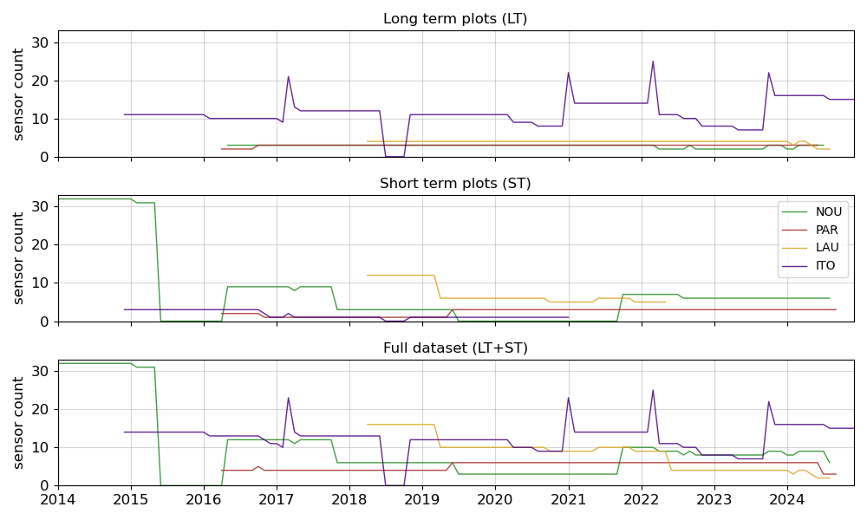
Figure S1. Number of sensors per forest site for the long-term sensors (top), short-term sensors (middle) and all sensors (bottom).

- Temperature time series and ELR correction
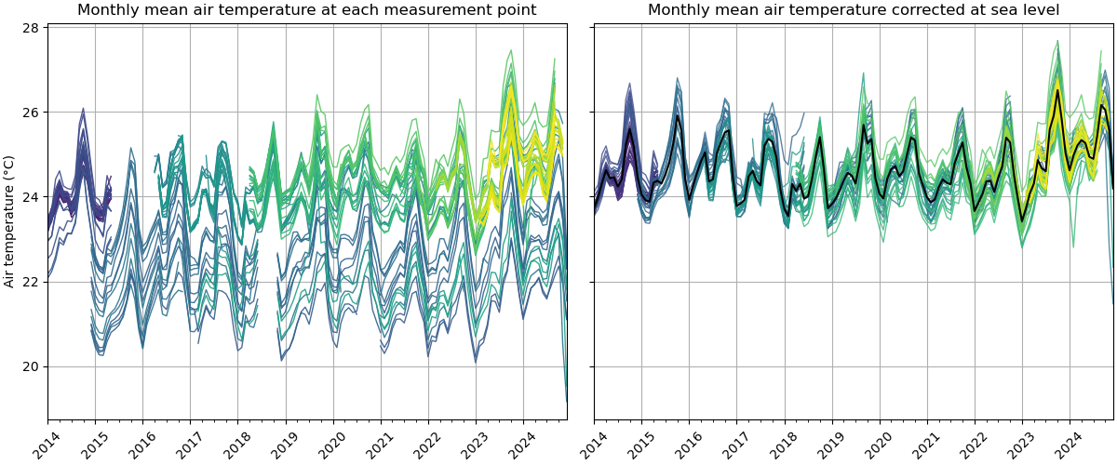
Figure S2. Monthly mean air temperature (°C) time series for each sensor (left) and their equivalent at sea-level (right). The mean is shown in black in the right panel.
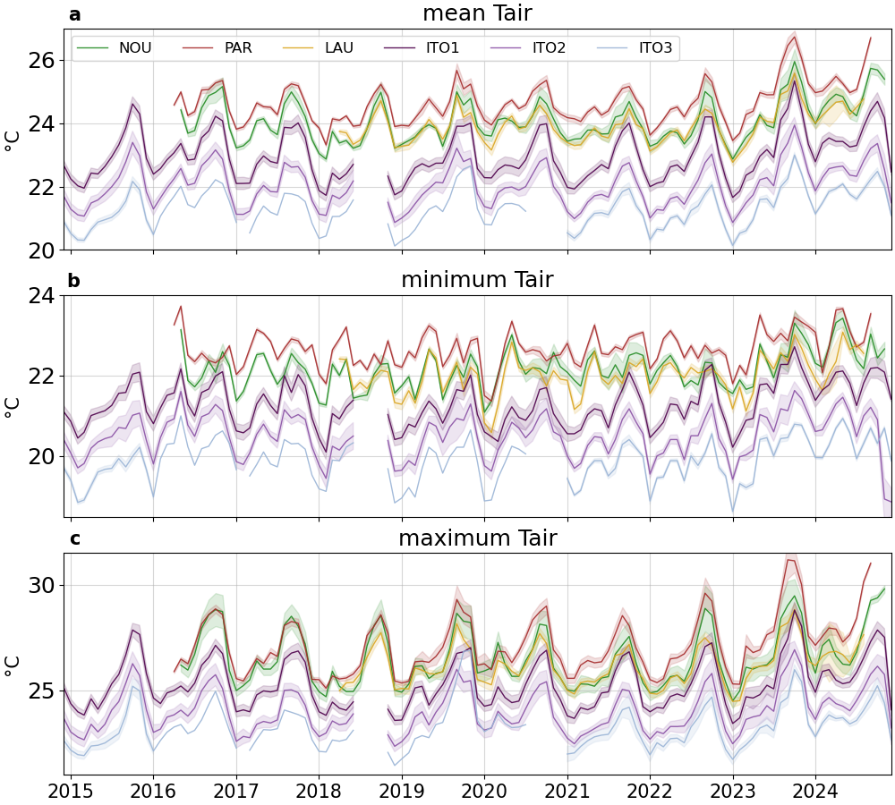
Figure S3. Evolution of monthly mean (a), minimum (b) and maximum (c) understory temperature for long-term sensors at Nouragues (green), Paracou (maroon), Laussat (gold) and Itoupé (ITO1: indigo, ITO2: light indigo and ITO3: light blue). The shaded area represents the standard error of the mean.

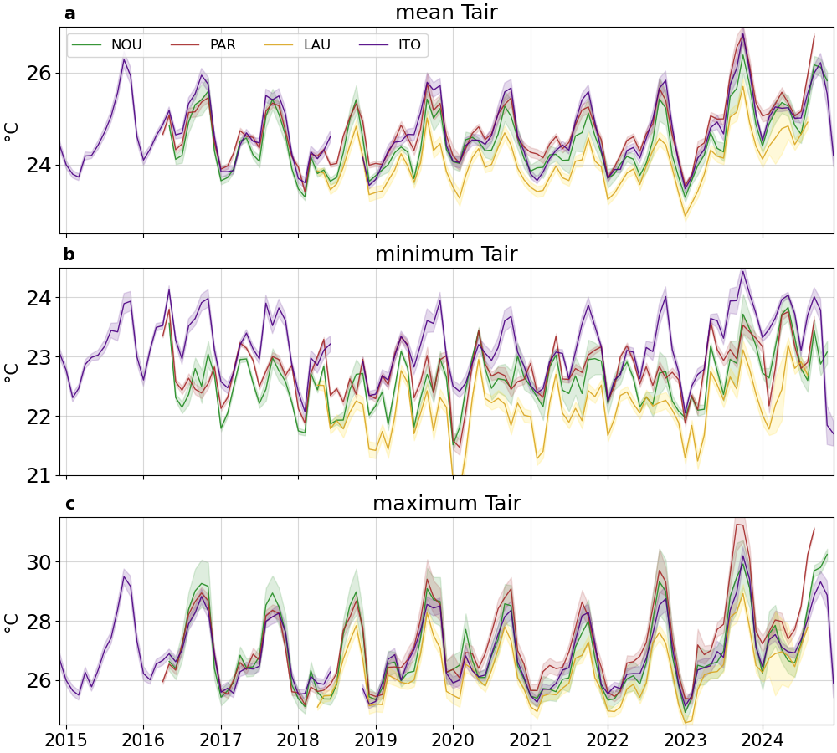
Figure S4. Evolution of monthly mean (a), minimum (b) and maximum (c) understory temperature for long-term sensors once corrected for altitude at Nouragues (green), Paracou (maroon), Laussat (gold) and Itoupé (indigo). The shaded area represents the standard error of the mean.

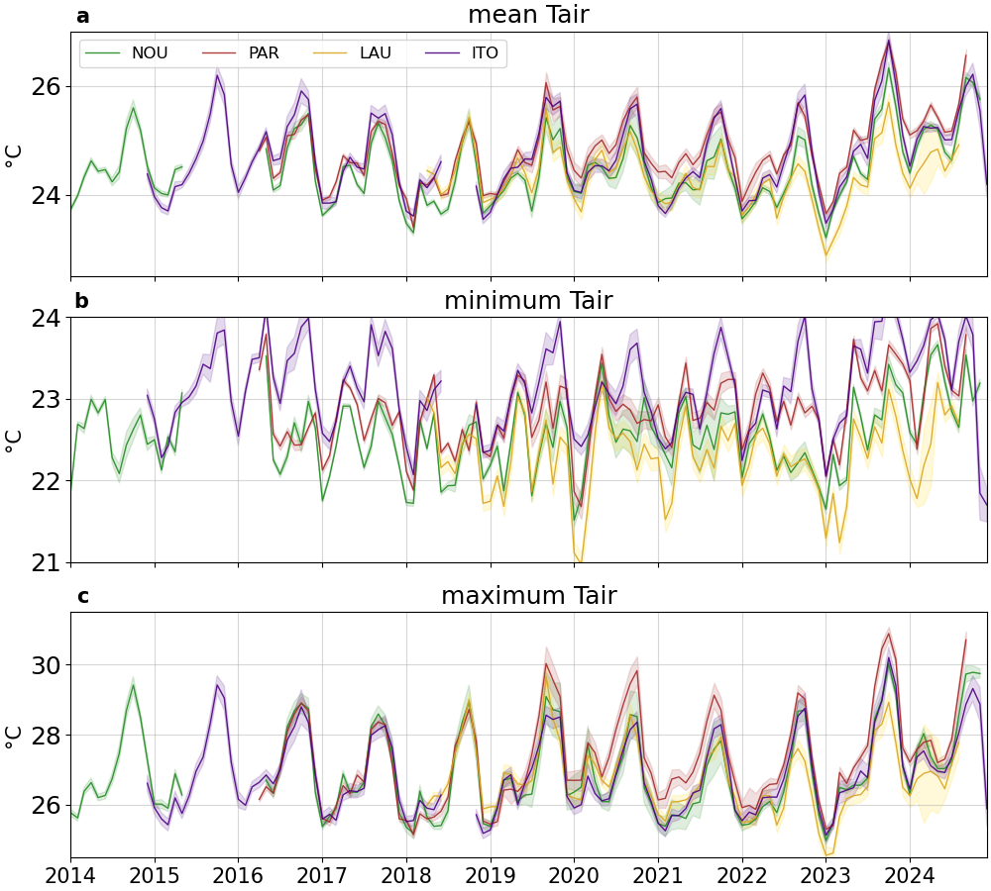
Figure S5. As Fig.S4 but for the full dataset. Evolution of monthly mean (a), minimum (b) and maximum (c) understory temperature for all sensors once corrected for altitude at Nouragues (green), Paracou (maroon), Laussat (gold) and Itoupé (indigo). The shaded area represents the standard error of the mean.

Table TS2. Average monthly mean, minimum and maximum temperature and their corresponding trend over the 2014-2024 period (11 years) for the full dataset (1st line) corrected for altitude and the weather station in Kourou (2nd line).

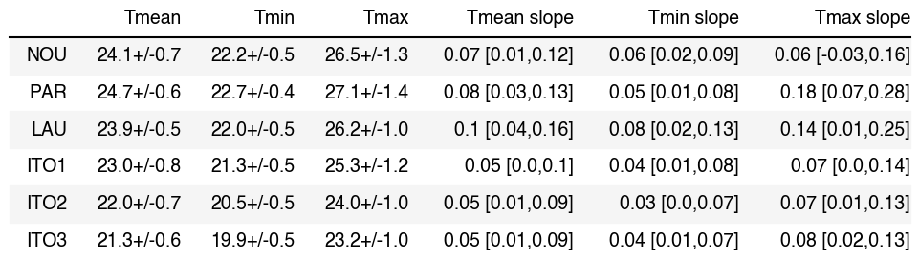

Table TS3. Mean, minimum and maximum understory air temperature (°C) and their corresponding trend (°C/year) over the 2018-2024 period for long-term sensors only.

- ERA5-Land temperatures debiasing
In French Guiana we observed large biases both for mean and variance between weather station monthly temperatures, T_{ws} and ERA5-Land hourly and monthly temperatures, T_{e}. One way to bias-correct T_{e} is to find two parameters a and b such that $T_{ec}=\frac{T_{e}-b}{a}$ where T_{ec} is the ERA5-Land bias-corrected temperature. This problem can be solved provided that the mean and variance of the biased-corrected temperature equals that of the weather station temperature. In other words, the conditions are :
$$\{mean\left(T_{ec}\right)=mean\left(T_{ws}\right) std\left(T_{ec}\right)=std\left(T_{ws}\right)$$
$$⇔\{mean\left(\frac{T_{e}-b}{a}\right)=mean\left(T_{ws}\right) std\left(\frac{T_{e}-b}{a}\right)=std\left(T_{ws}\right)$$
Because the standard deviation is invariant by translation, we reformulate the equations to get a and b:
$$⇔\{b=mean\left(T_{e}\right) - mean\left(T_{ws}\right)*a a=\frac{std\left(T_{e}\right)}{std\left(T_{ws}\right)}$$
$$⇔\{b=mean\left(T_{e}\right) - mean\left(T_{ws}\right)*\frac{std\left(T_{e}\right)}{std\left(T_{ws}\right)} a=\frac{std\left(T_{e}\right)}{std\left(T_{ws}\right)}$$
By combining the expressions of a ad b, we get
$$T_{ec}=\left(T_{e}-mean\left(T_{e}\right)+mean\left(T_{ws}\right)*\frac{std\left(T_{e}\right)}{std\left(T_{ws}\right)}\right)*\frac{std\left(T_{ws}\right)}{std\left(T_{e}\right)}$$
which can be simplified as follows:
$$T_{ec}=\left(T_{e}-mean\left(T_{e}\right)\right)*\frac{std\left(T_{ws}\right)}{std\left(T_{e}\right)} +mean\left(T_{ws}\right)$$

Using linear regressions, we calculated hourly correction parameters (Fig. S9) and monthly correction parameters (Fig. S7 and S8) for each weather station. Then, at each measurement point, we calculated an hourly-debiased ERA5-Land temperature (used in Figure 6) and a monthly-debiased ERA5-Land temperature (used in Figure 7) as shown in Figure S6.
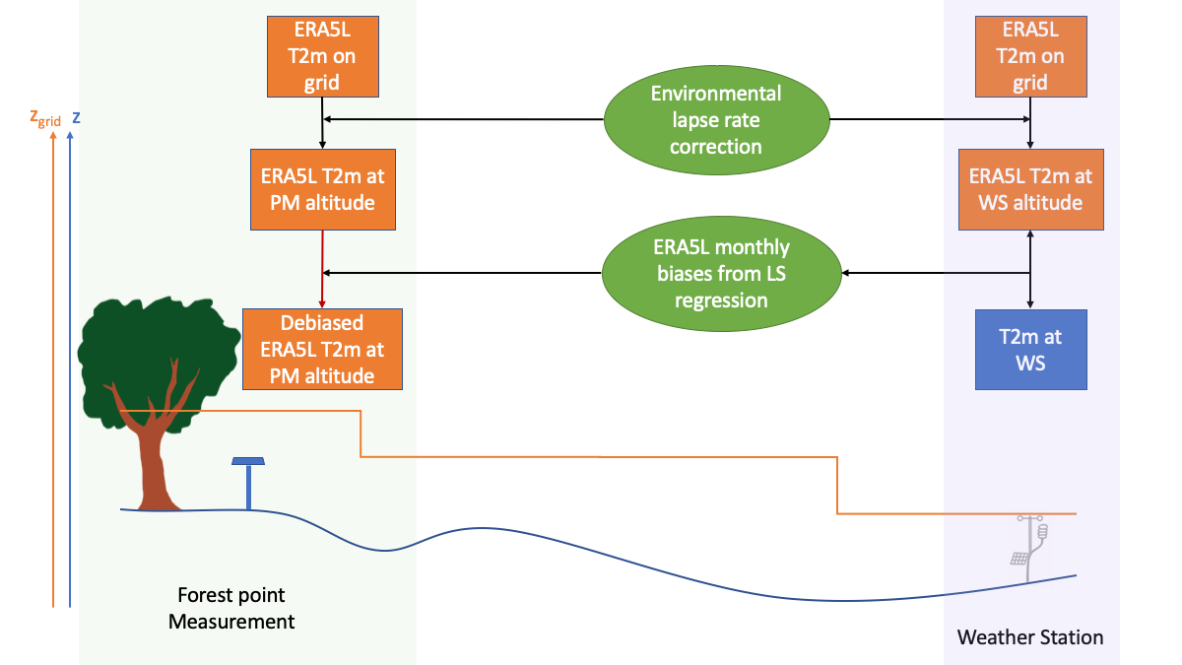
Figure S6. Schematic for ERA5-Land bias correction and adjustment to sensor location. The orange line represents the ERA5-Land grid elevation while the blue curve is the real topography.

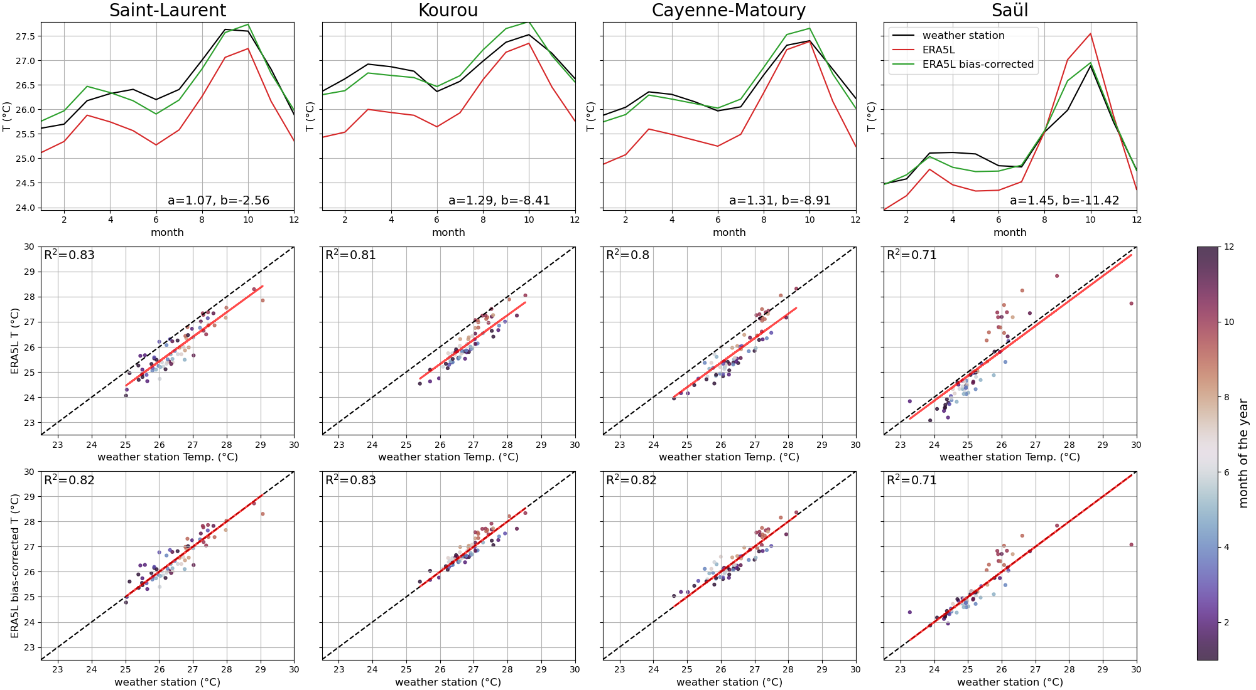
Figure S7. Monthly mean bias-correction in ERA5-Land temperature at four weather stations nearby forest sites. The ERA5-Land bias-corrected temperature T_{ec} is computed over the 2018-2024 period. (a) Seasonal cycle of monthly temperatures from the weather station T_{ws}, ERA5-Land T_{e} and ERA5-Land bias-corrected T_{ec} (a and b correction parameters are displayed) (b) Scatterplot of T_{e} against T_{ws}. (c) Scatterplot of T_{ec} against T_{ws}. The regression line is shown in red. The bias correction allows to realign the data with the 1 :1 slope.
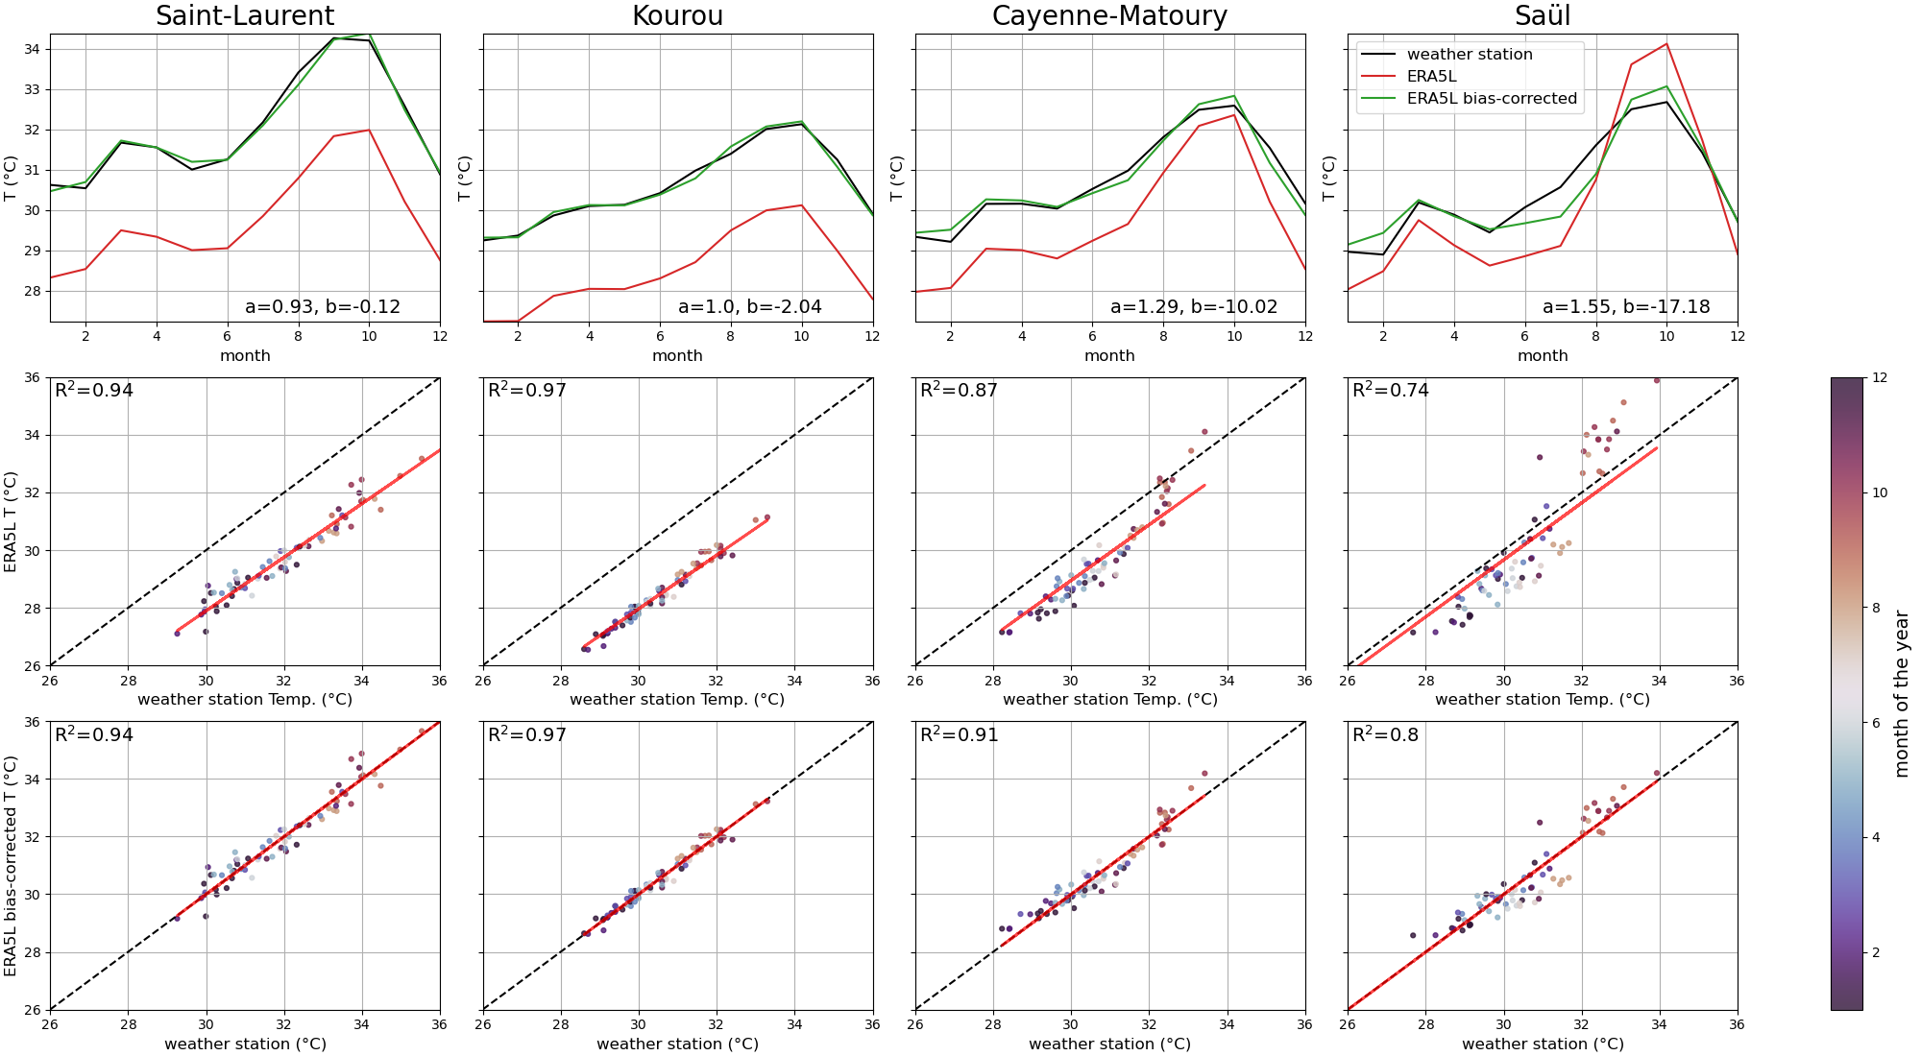Figure S8. Monthly max (95th percentile) bias-correction in ERA5-Land temperature at four weather stations nearby forest sites. The ERA5-Land bias-corrected temperature T_{ec} is computed over the 2018-2024 period. (a) Seasonal cycle of monthly temperatures from the weather station T_{ws}, ERA5-Land T_{e} and ERA5-Land bias-corrected T_{ec} (a and b correction parameters are displayed) (b) Scatterplot of T_{e} against T_{ws}. (c) Scatterplot of T_{ec} against T_{ws}. The regression line is shown in red. The bias correction allows to realign the data with the 1 :1 slope.
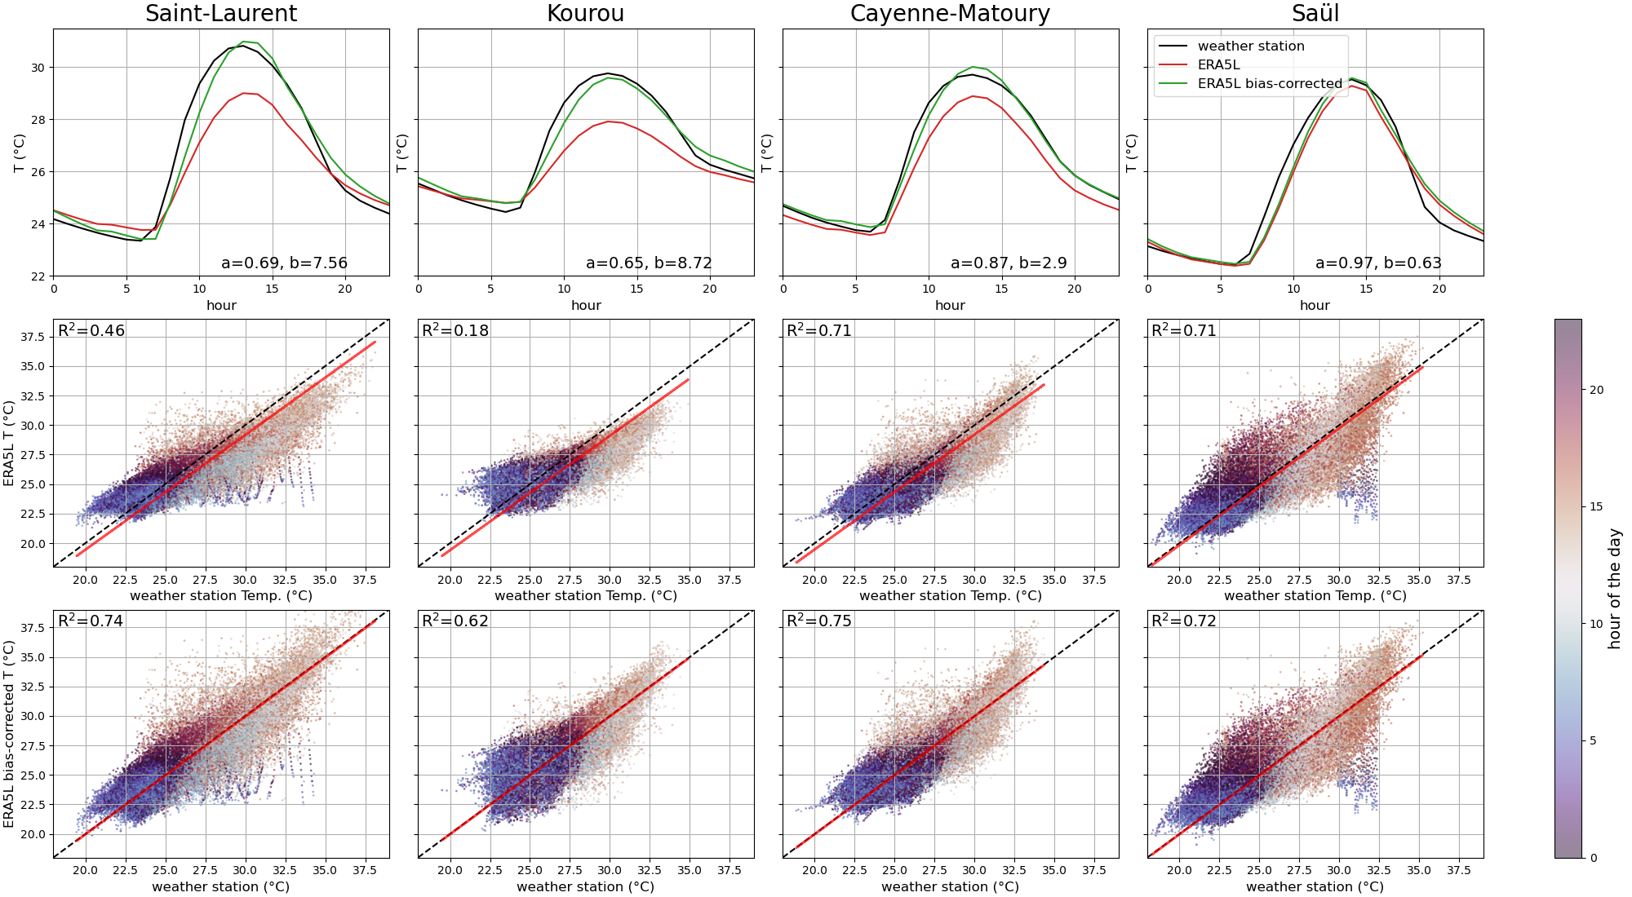
Figure S9. Hourly mean bias-correction in ERA5-Land temperature at four weather stations nearby forest sites. The ERA5-Land bias-corrected temperature T_{ec} is computed over the 2018-2024 period. (a) Daily cycle of hourly temperatures from the weather station T_{ws}, ERA5-Land T_{e} and ERA5-Land bias-corrected T_{ec} (a and b correction parameters are displayed). (b) Scatterplot of T_{e} against T_{ws}. (c) Scatterplot of T_{ec} against T_{ws}. The regression line is shown in red. The bias correction allows to realign the data with the 1 :1 slope.

Forest site | Laussat | Paracou | Nouragues | Itoupé
Nearby weather station | Saint-Laurent du Maroni | Kourou-CSG | Cayenne-Matoury | Saül
Distance between forest site and weather station (km) | 50 | 21 | 92 | 68
a (monthly mean) | 1.07 | 1.29 | 1.31 | 1.45
b (monthly mean) | -2.51 | -8.42 | -8.87 | -11.33
a (monthly max) | 0.93 | 1.0 | 1.29 | 1.55
b (monthly max) | -0.12 | -2.04 | -10.02 | -17.18
a (hourly mean) | 0.69 | 0.65 | 0.87 | 0.97
b (hourly mean) | 7.56 | 8.72 | 2.90 | 0.63
Table TS4. ERA5-Land hourly and monthly correction parameters a and b for mean and maximum temperatures defined at nearby weather station over the 2018-2024 temperature record such that $T_{ec}=\left(T_{e}-b\right)/a$

- Temperature offset

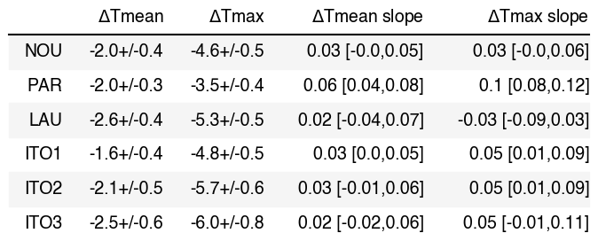Table TS5. Offset for monthly mean and maximum air temperature (°C) and their corresponding trend (°C/year) over the 2018-2024 period.

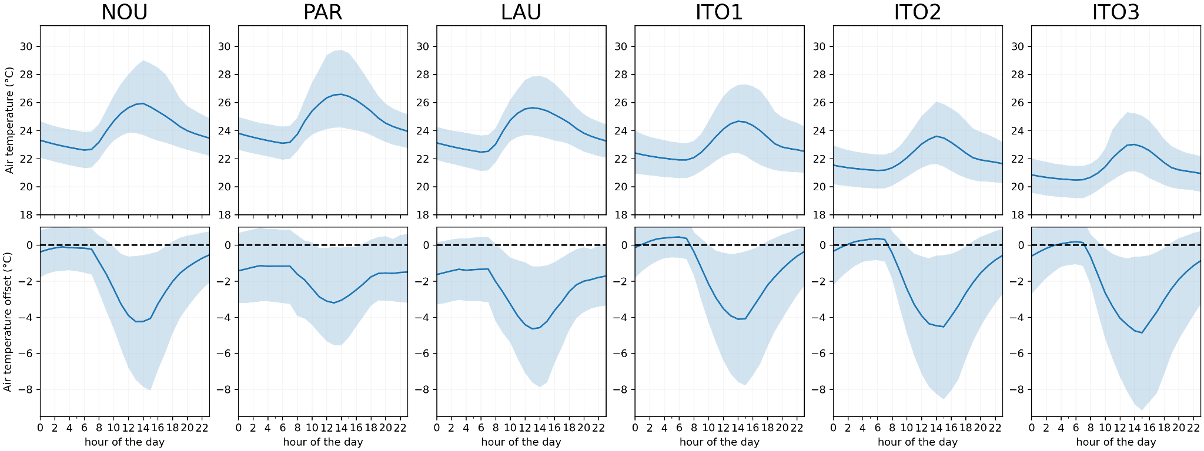Figure S10. Mean daily cycle of air temperature (top) and air temperature offset (bottom) computed with hourly-debiased ERA5L at each forest site. The 90% confidence interval is shown in shaded blue.
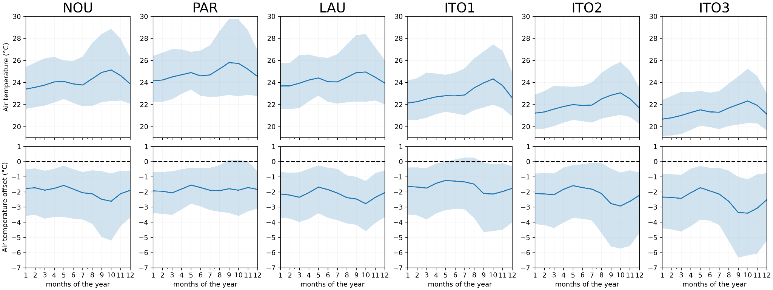Figure S11. Mean seasonal cycle of air temperature (top) and air temperature offset (bottom) computed with monthly-debiased ERA5L at each forest site. The 90% confidence interval is shown in shaded blue.

- 2023-2024 extreme event

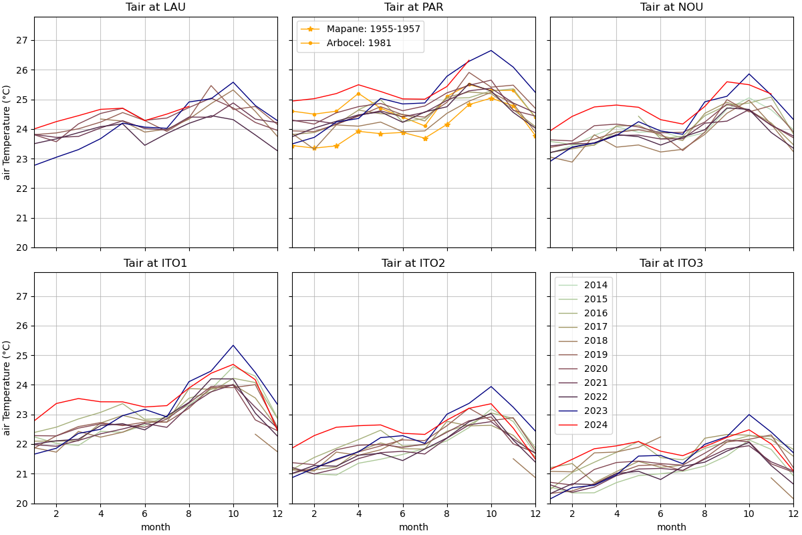
Figure S12. Monthly mean seasonal cycle of the full dataset for all forests (Laussat: LAU, Paracou: Par, Nouragues: NOU, Itoupé 1: ITO1, Itoupé 2: ITO2, Itoupé 3: ITO3). The year 2023 and the year 2024 are shown in navy blue and red respectively. The understory microclimate of two additional historical forest sites Mapane (Schulz 1960) and Arbocel (Finkelstein 1982) are displayed for the 1955-1957 period (yellow stars) and year 1981 (yellow dots) respectively on the Paracou forest panel.

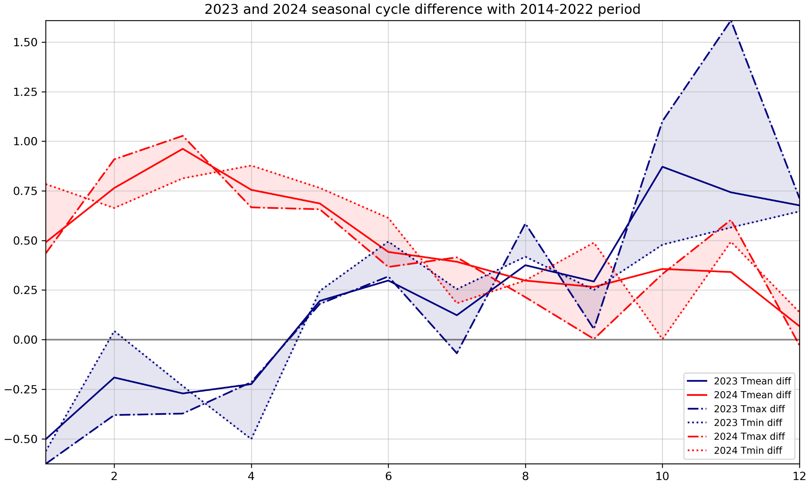Figure S13. Monthly minimum, mean and maximum temperature difference between year 2023 (2024) and the 2014-2022 reference period for all sensors once corrected for altitude.
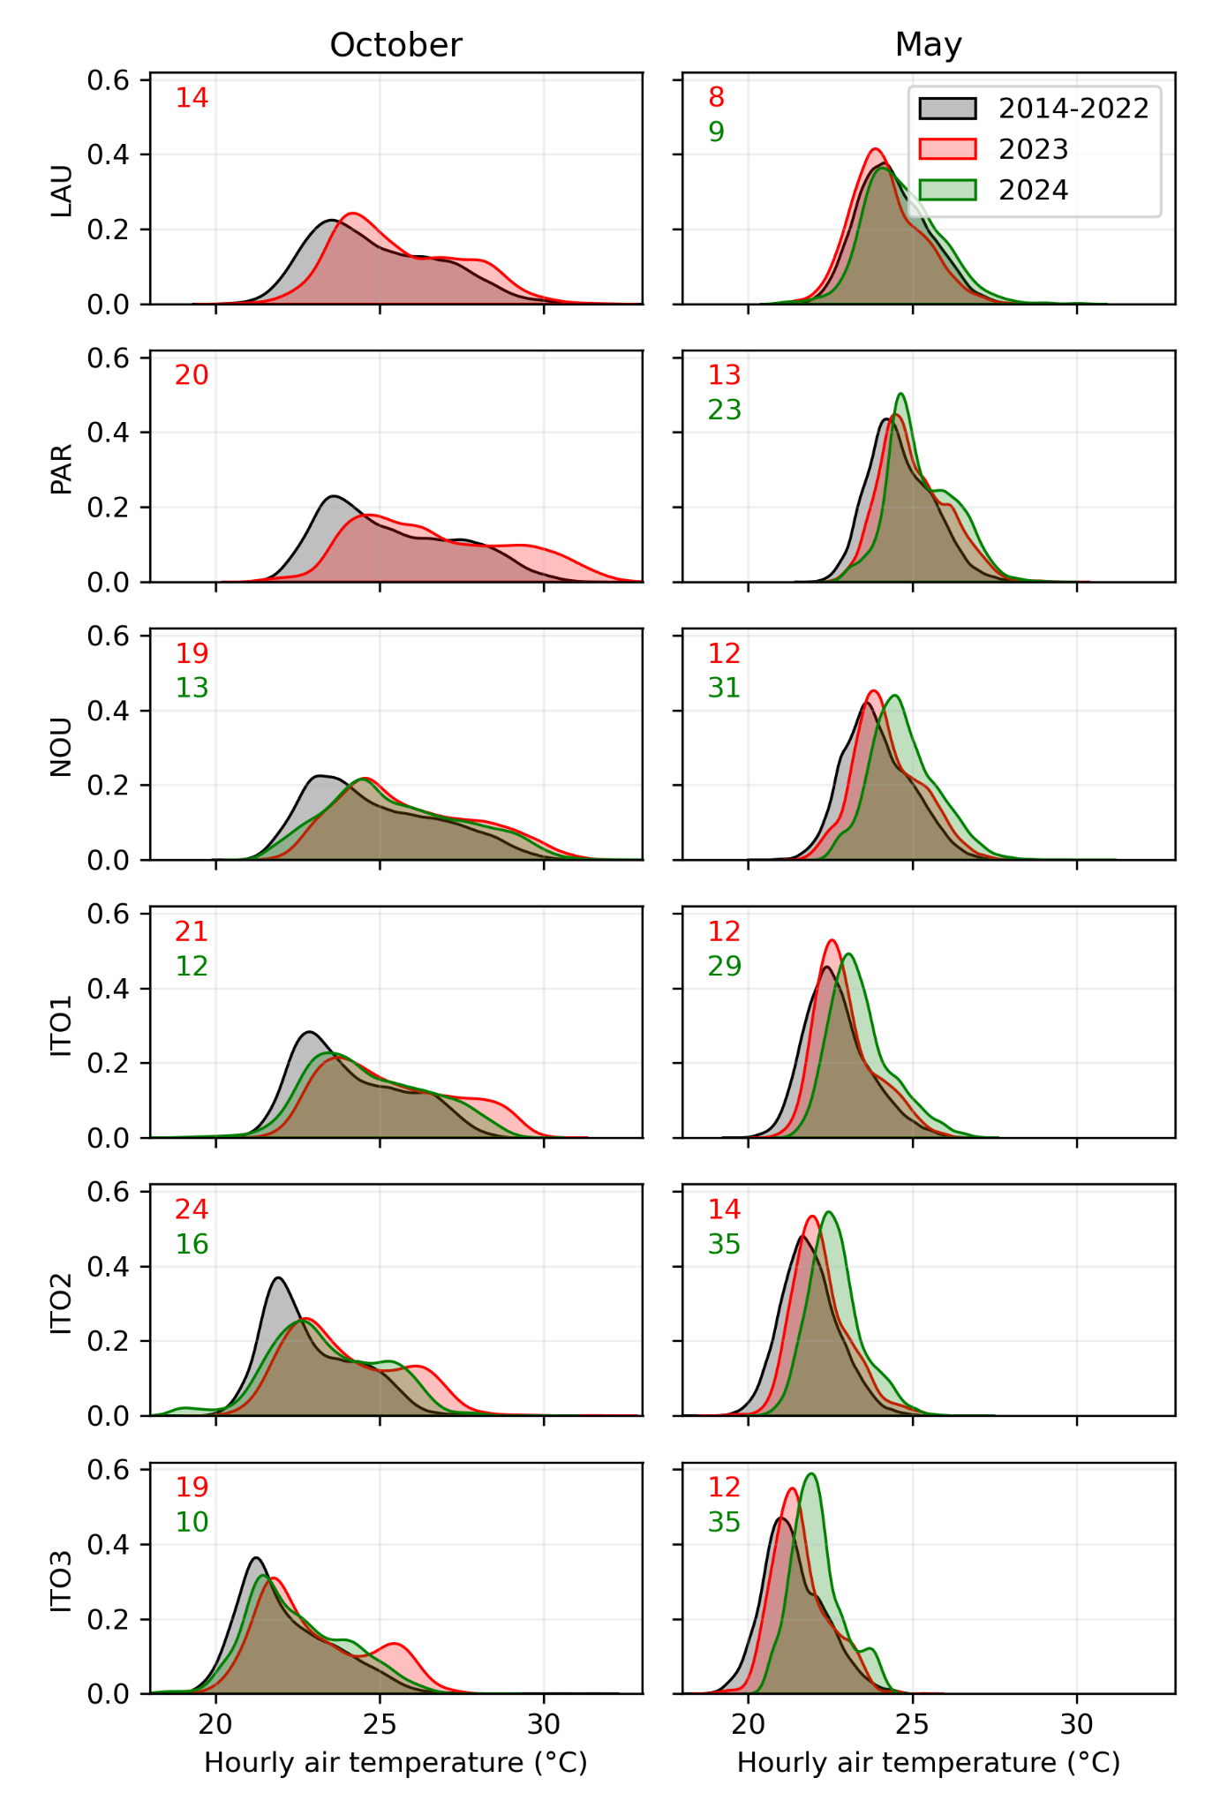
Figure S14. Hourly temperature distribution from the full dataset in October (wet season, left column) and May (dry season, right column) for 2014-2022 period (black), year 2023 (red) and 2024 (green) in each forest. The novelty index (%) for 2023 and 2024 is shown in red and green respectively in the top left corner.

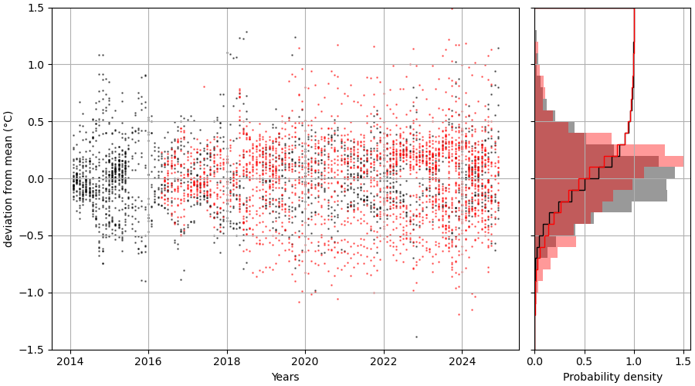
Figure S15. Temporal evolution (a) distribution (shaded) and cumulative distribution (line) (b) of the detrended monthly mean understory temperature for TMS (red) and U23 (black) sensors at sea level.

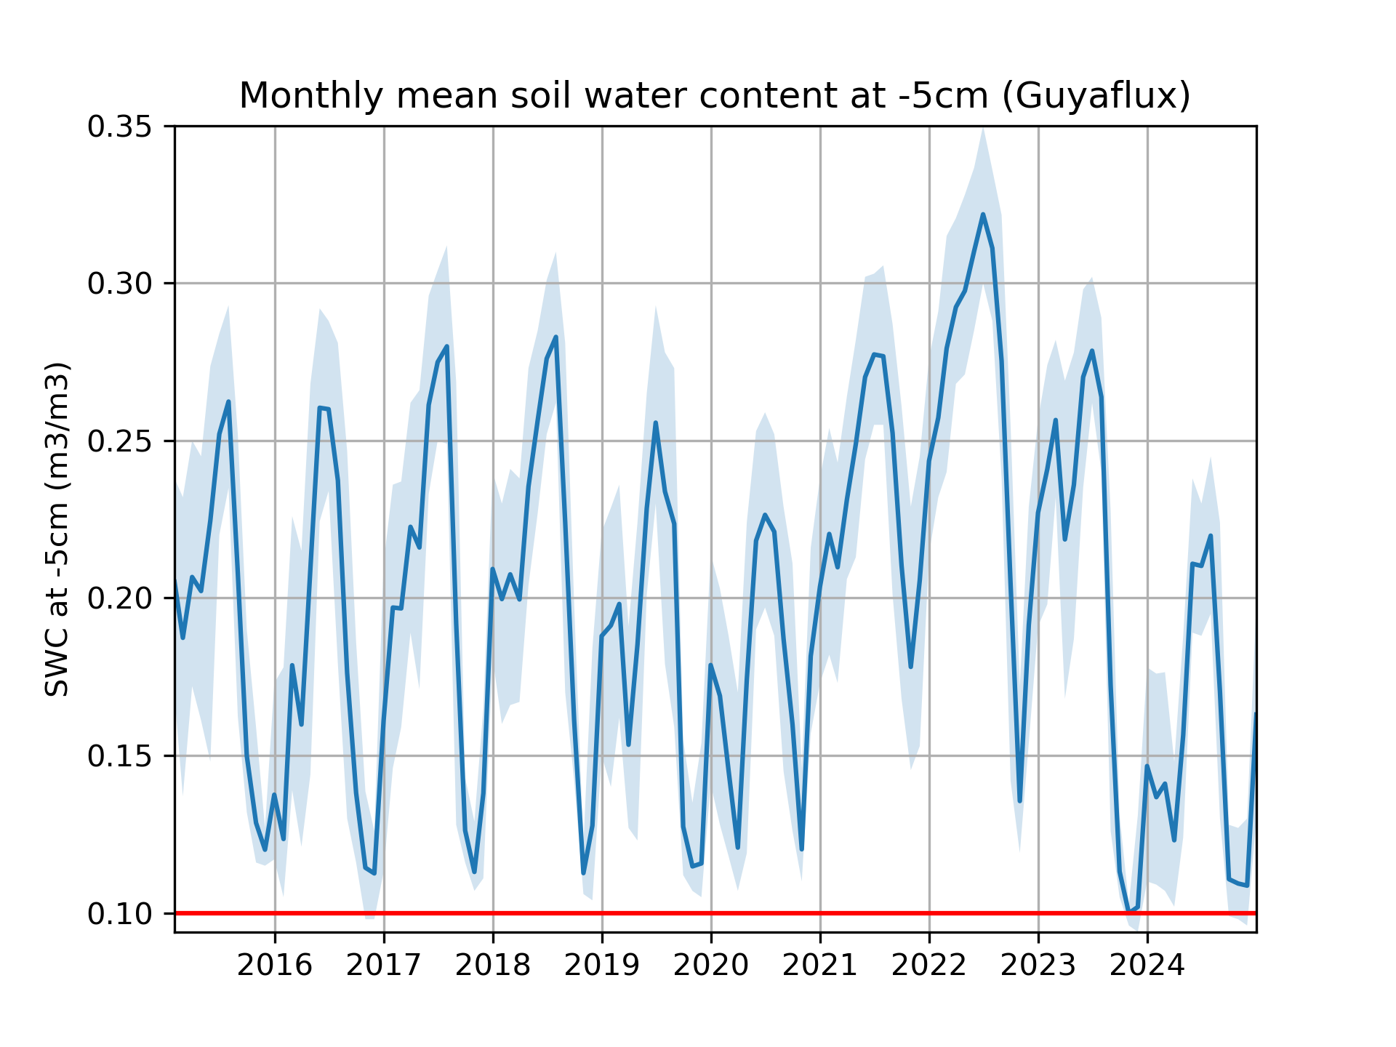
Figure S16. Monthly mean soil water content (SWC) over 2015-2024 measured at 5 cm belowground at the Guyaflux tower in Paracou forest. The range between the 5% and the 95% quantiles is shown in shaded blue. The red line represents the minimum value of the monthly soil water content over the period. It was reached in October 2023.

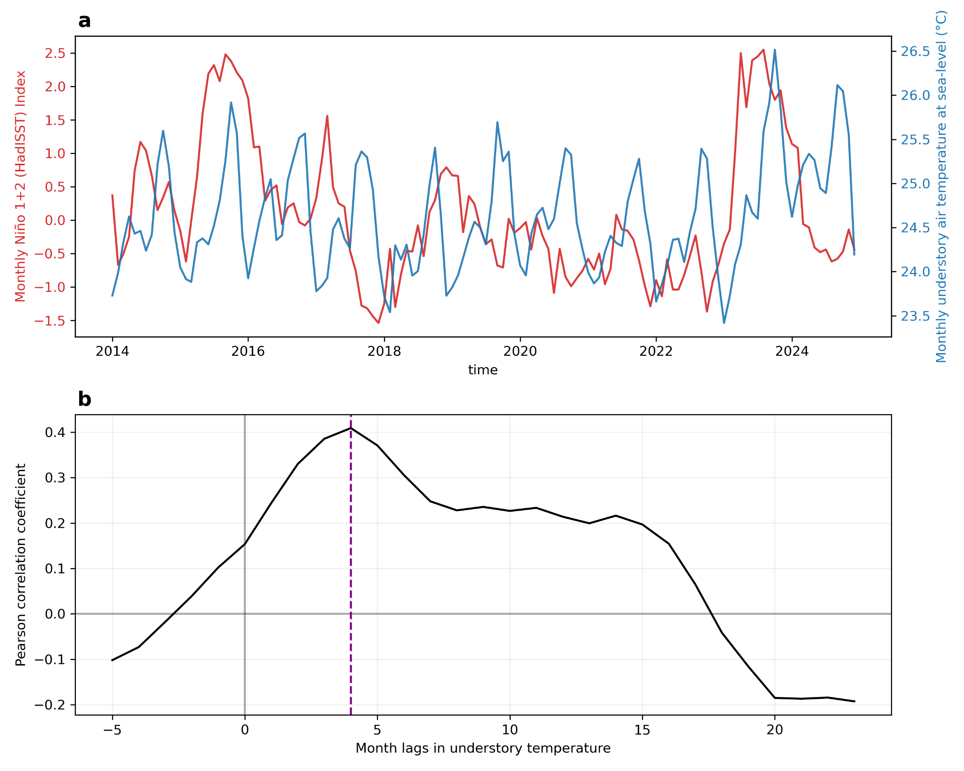
Figure S17. Monthly mean understory air temperature relation to El Niño index. a) Monthly mean understory air temperature at sea-level (blue) and monthly mean El Niño index (1+2 HaddISST, from NOAA/PSL). We observe that both time series are correlated with higher (lower) temperatures occuring after a more positive (negative) El Niño index. Strongly positive (negative) indices correspond to El Niño (La Niña) events. The 2015-2016 and 2023-2024 El Niños and the 2017-2018 and 2022-2023 La Niñas are clearly visible with very positive and negative indices. b) Pearson correlation between monthly mean understory air temperature and the El Niño index for different monthly lags. The maximum correlation coefficient (0.41) is found for a 4-month lag in understory air temperature.

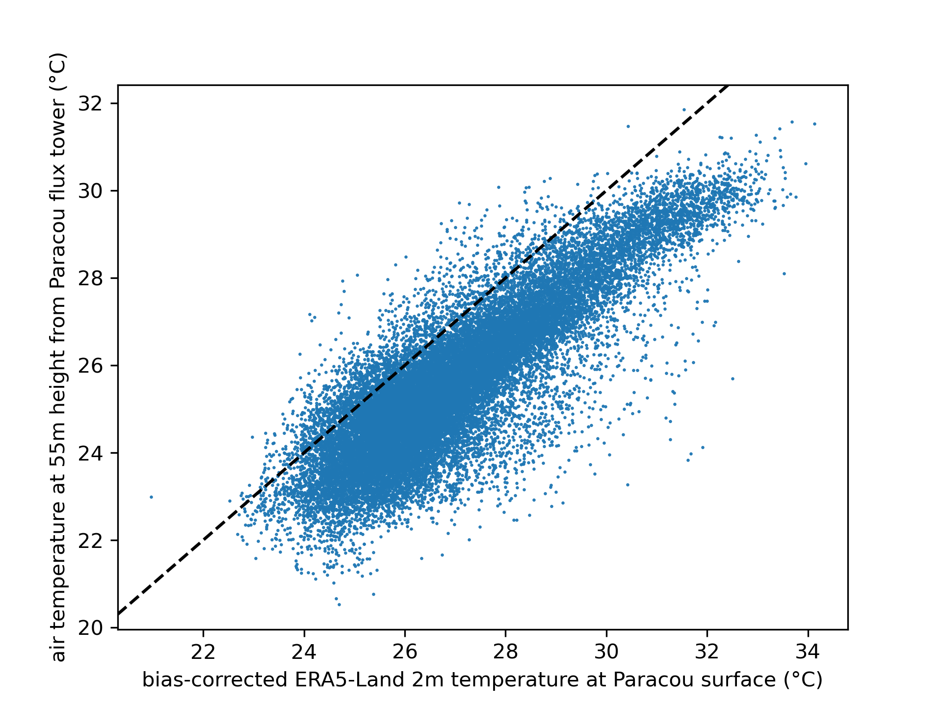
Figure S18: Comparison of hourly air temperature from the flux tower (55m high) and bias-corrected ERA5-Land (surface) at Paracou

