Supporting Information

Single-Atom Cobalt on N-Doped Reduced Graphene Oxide Pushes the Oxygen Reduction Reaction toward 4-Electron Pathway

Francesca Risplendi^{*1}, Nadia Garino^{1,2}, Juqin Zeng^{1,2}, Adriano Sacco², Shweta Mehta¹, Chiara Deriu¹, Laura Fabris¹, Marco Fontana^{1,2}, Angelica Chiodoni², Giancarlo Cicero¹, Micaela Castellino^{*1,2}

¹ Department of Applied Science and Technology, Politecnico di Torino, Corso Duca degli Abruzzi 24, 10129 Torino, Italy
² Center for Sustainable Future Technologies @Polito, Istituto Italiano di Tecnologia, Via Livorno 60, 10144 Torino, Italy

E-mail: francesca.risplendi@polito.it, micaela.castellino@polito.it

S1. Experimental section
S1.1. Synthesis of the catalysts
All the chemicals were used as purchased without further purification. The bare N doped-rGO, used as reference sample, and Co-N-rGO catalysts were fabricated through the procedure reported by Garino et al. [S1].
In a typical synthesis, 50 mg of GO powder (Graphenea SA, Spain) was suspended in 30 mL of double distilled water containing 20 mg of urea (Sigma-Aldrich).
In the case of Co-N-rGO catalysts sample, 30 mg of (CH₃COO)₂Co 4H₂O (Sigma-Aldrich) was added and dissolved in the as-prepared suspension. For both samples, the precursor mixtures were sonicated for 40 min and then transferred in a 100 mL Teflon reactor, equipped with pressure and temperature probes, connected with the microwave furnace (Milestone FlexyWave, Milestone Inc., Shelton, Connecticut). The mixtures were irradiated for 15 min at 180 °C (800 W) and then the reactor was cooled to ambient temperature. The final powder samples were obtained by freeze-drying. A portion of the Co-N-rGO sample was then treated at room temperature in H₂SO₄, to test the presence of Co after the acid attack.

S1.2. Physical and Chemical Characterization
Field emission scanning electron microscopy (FESEM, ZEISS Dual Beam Auriga) was used to evaluate the morphology of the studied material. Transmission electron microscopy (TEM, FEI Tecnai F20ST, 200 kV) and energy dispersive X-ray spectroscopy (EDS, EDAX) were used to evaluate the morphology, structure and composition of the studied material. Samples for FESEM and TEM were prepared by suspending the obtained nanocomposite powder in ethanol than dropping the suspension on a TEM Cu grid with carbon film.
A Versaprobe PHI 5000 scanning X-ray photoelectron spectrometer (monochromatic Al K-alpha X-ray source with energy of 1486.6 eV) was used to study the chemical composition of the material. A spot size of 100 μm was used to collect the photoelectronic signal for both high resolution (HR) and survey spectra. Different values of pass energy were exploited: 187.85 eV for survey spectra and 23.5 eV for HR peaks. All samples were analyzed with a combined electron and argon ion neutralization system, to reduce the charging effect during the measurements. Semi-quantitative atomic compositions and deconvolution procedures were obtained using the dedicated Multipak 9.6 software. All core-level peak energies were referenced to the C1s peak at 284.5 eV (sp² C-C/C-H bonds) and the background contribution in the HR scans was subtracted using a Shirley function.
Raman spectroscopy measurements were performed using a WITec alpha300 apyron confocal microscope, fitted with a lens-based, 600 mm focal length ultra-high throughput spectrometer (UHTS), a Peltier-cooled back-illuminated electron multiplying CCD (EMCCD) camera, a 532 nm excitation line, and a 300 g/mm grating. This configuration affords a spectral resolution that ranges from 2.66 to 2.56 cm⁻¹ in the 1300–1600 cm⁻¹ interval. The Raman spectra of Co-N-rGO and a reference N-rGO sample were obtained by depositing the sample flakes in between a glass microscope slide and a glass cover slip, and focusing on the material with a 100x objective (NA = 0.9). Acquisition parameters were 20 s integration time, 25 accumulations, and a power of 1.2 mW at the objective. To minimize sampling bias, all samples were analyzed as multiple spots (airy disc area ≈ 0.7 μm) randomly selected across different flakes, with N = 33 for both Co-N-rGO and the N-rGO reference. All spectra were baseline-corrected (WITec Project SIX Plus, shape function) and normalized by the intensity of the 2D’ band at ~3190 cm⁻¹. The statistical significance of band shifts and other spectral parameters reported in the manuscript were assessed via a two-tailed t-test after prior evaluation of the homoskedasticity by the Brown and Forsythe test, [S2] while the statistical power was calculated post hoc, using GPower 3.1 [S3,S4].
S1.3. Computational details
All the spin-polarized calculations were performed with Vienna Ab initio Simulation Package (VASP) code [S5–S7]. Electronic wavefunctions were expanded in plane-waves (PWs) and exchange correlations were modeled by Perdew Burke Ernzerhof (PBE) functional [S8]. The electron-ion interaction was described using Projected Augmented Wave (PAW) potential [S9,S10] . Dispersion interactions were included using the DFT-D2 method [S11]. A PW energy cutoff of 400 eV was adopted for all calculations. To investigate the cobalt containing rGO samples, 7×7 graphene supercells were employed. A vacuum of 20 Å thickness was introduced perpendicular to the 2D layers to avoid spurious interaction between periodic replicas. The Brillouin Zone (BZ) of graphene was sampled employing a (12 × 12 × 1) Monkhorst-Pack mesh [S12] and reduced accordingly in case of supercells, to maintain consistent k-points density. Structural relaxations were performed by minimizing the atomic forces and convergence was assumed when the maximum component of the residual forces on the ions was lower than 0.01 eV/Å and the total energies were converged to less than 10⁻⁴ eV. The optimized graphene lattice parameter was calculated as 2.46 Å, in agreement with the previously reported value [S13]. The thermodynamic analysis of electrochemical reaction was conducted within the Computational Hydrogen Electrode (CHE) framework proposed by Nørskov et al. [S14–S16], which relates the chemical potential of a proton-electron pair to hydrogen gas via thermodynamic equilibrium at the Reversible Hydrogen Electrode (RHE) [S17]. The Gibbs free energy of reaction intermediates X (with X = *OOH, *OH, and *O) was computed as:
G_{X} = E_{X} + E_{X}^{ZP} + ∫C_{p}dT - TS_{X} + E_{solv}
Where, for the calculation of the enthalpic and entropic corrections, all degrees of freedom were assumed to be vibrational and treated within the harmonic approximation. Chemical potentials for gaseous species (H₂ and O₂) were calculated using standard ideal-gas methods, while those for liquid H₂O and H₂O₂ were obtained from thermochemical data for bulk liquids.
S1.4. Electrochemical Characterization
All the electrochemical characterizations for ORR were performed at room temperature with a CHI760D electrochemical workstation and a ALS RRDE-3A rotating ring disk electrode apparatus. The catalyst samples were deposited onto a glassy carbon disk/Pt ring working electrode (electrode area 0.1256 cm²) following the procedure reported in [S18]. A Pt wire was used as the counter electrode and Ag/AgCl (3 M Cl⁻) was used as the reference electrode. All the reported potentials refer to the reversible hydrogen electrode (RHE). Unless otherwise specified, all the measurements were carried out in 3-electrodes configuration (disk/reference/counter electrodes) in O₂-saturated 0.1 M KOH aqueous electrolytic solution with 2500 RPM rotation speed. A commercial available reference Pt/C catalyst (Sigma-Aldrich) was used to compare the obtained result on the synthesized material.
CV curves were acquired from 0.18 V to 1.18 V with a scan rate of 10 mV/s in O₂- and N₂- saturated electrolytic solution. RRDE measurements were carried out in 4-electrodes configuration (disk/ring/reference/counter electrodes) by scanning the disk electrode from 0.18 V to 1.18 V (scan rate 5 mV/s) and measuring the currents at disk (I_{D}) and ring (I_{R}), while fixing the ring potential at 1.18 V. The number of electrons involved in the reduction reaction (n) and the corresponding percentage of produced peroxide species (HO₂⁻ %) were calculated using the equations [S18] :
[Equation] (S1)
[Equation] (S2)
where N is the current collection efficiency of the Pt ring. EIS measurements were performed at fixed 0.38 V potential, with an AC signal of 10 mV amplitude and 10⁻² - 10⁴ Hz frequency range. CA curves were acquired at fixed 0.68 V potential.

Figures

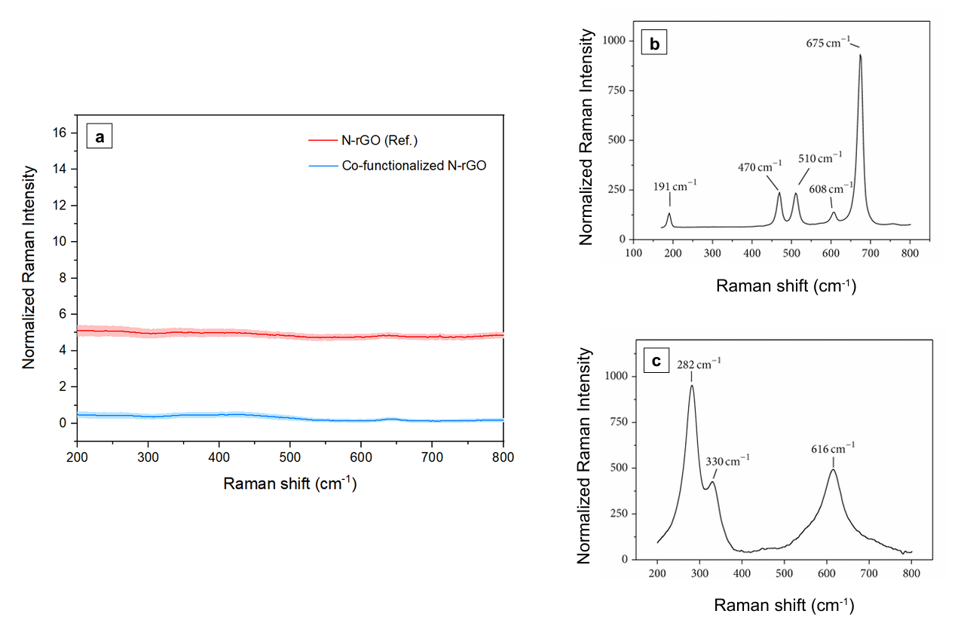
Figure S1. (a) Average (N = 33; shaded areas represent the standard deviation of the mean normalized intensity) Raman spectra of cobalt-functionalized N-rGO and reference N-rGO in the 200–800 cm⁻¹ region, where metal oxides are expected to display their characteristic Raman modes. (b) Reference Raman (λ_{exc} 532 nm) spectra of Co₃O₄ and (c) CoO nanoparticles, adapted from [S19] and licensed under CC BY 4.0, https://creativecommons.org/licenses/by/4.0/.
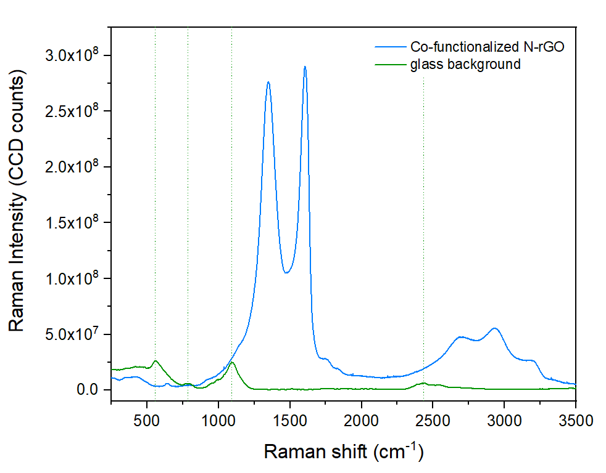
Figure S2. Comparison between the average Raman spectrum of cobalt-functionalized N-rGO (top, blue spectrum) and the Raman spectrum of a glass microscope slide (bottom, green spectrum), which constitutes the background signal from the sample support (bands in the 500–1100 cm⁻¹ are due to tetrahedral Si-O Raman modes). The dotted vertical lines are added to guide the reader’s eye. No bands overlap, as confocality allows for the observation of the sole sample signal.

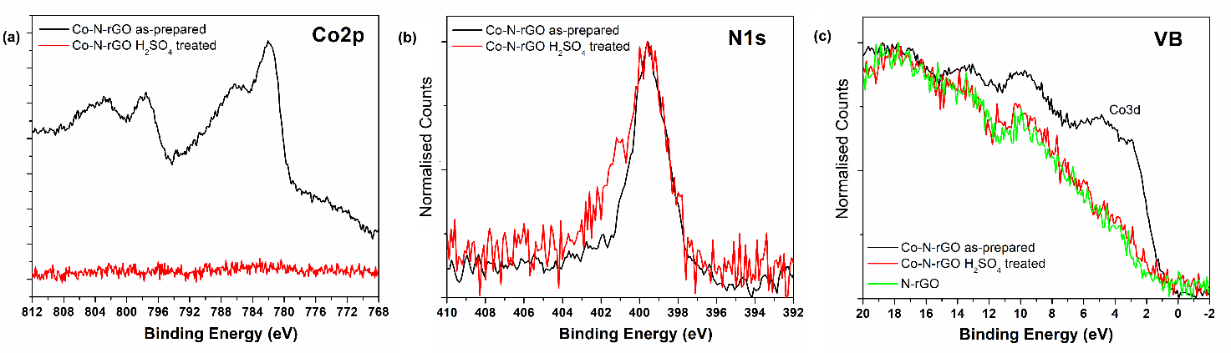
Figure S3. Comparison with expected peaks of CoO and Co2O3. Ref spectra reproduced with permission from Rashad et al. [S19] creative commons. XPS HR spectra for a) Co2p, b) N1s and c) valence band regions for as-prepared and acid treated Co-N-rGO samples, and also bare N-rGO sample for the last region.

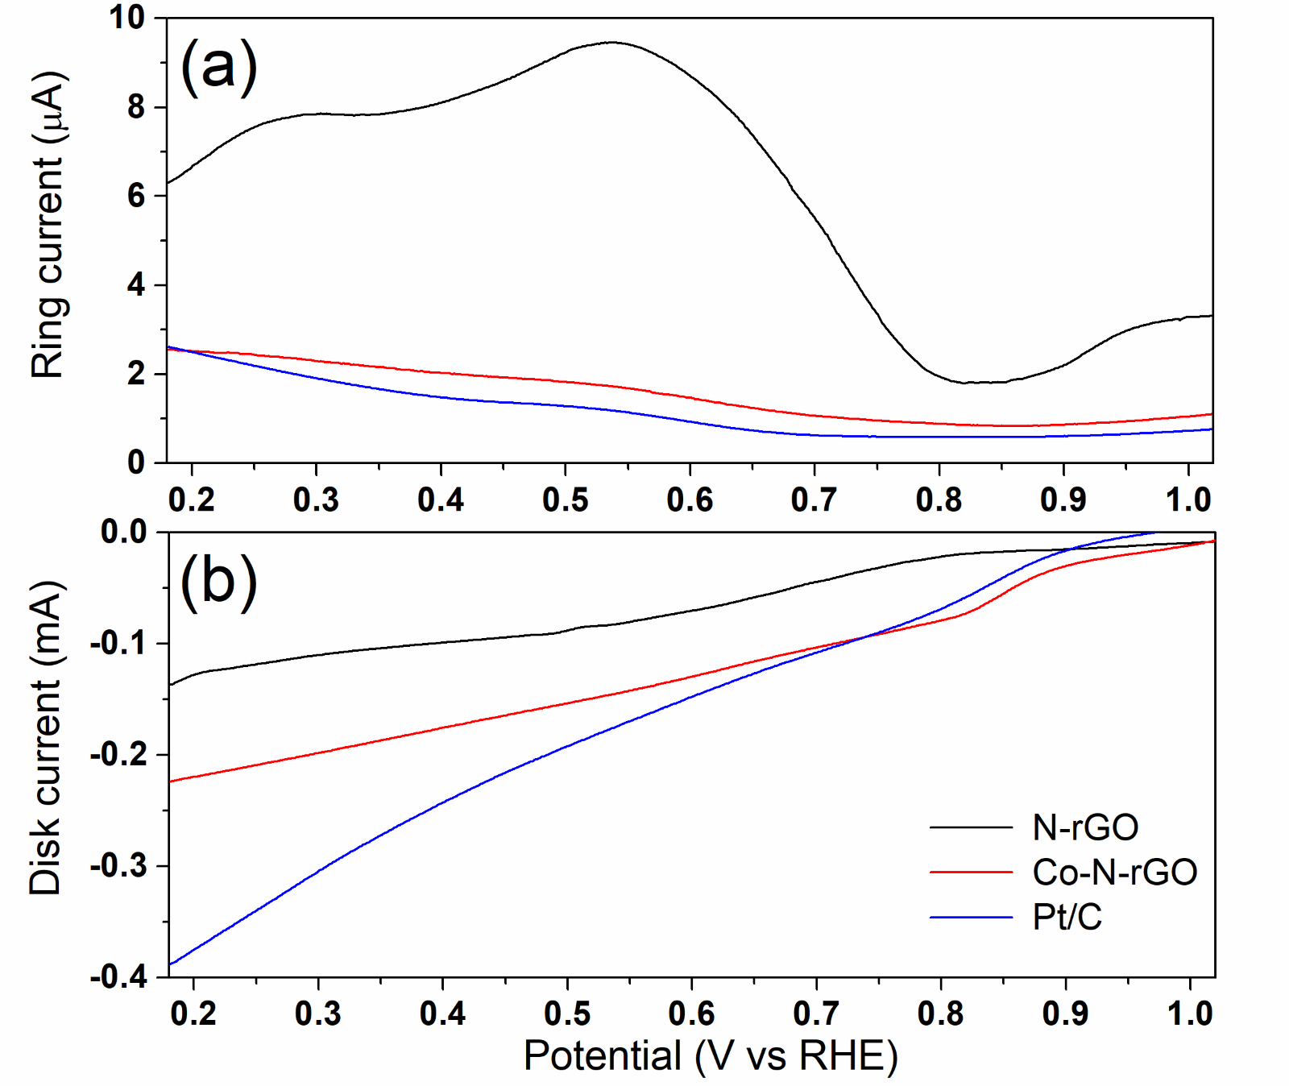
Figure S4. (a) Ring and (b) Disk currents obtained from the RRDE measurements.

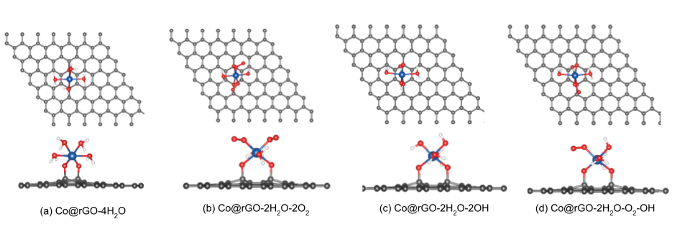
Figure S5. Ball and stick representations of different structures of Co@rGO. In all these structures, Co is bonded with two surface -O⁻ groups. The ligands around Co are (a) four water molecules, (b) two water molecules and two oxygen molecules, (c) two water molecules and two hydroxyl groups (-OH) and (d) two water molecules and one oxygen and one hydroxyl group. Gray spheres represent C atoms, red spheres O atoms, white spheres H atoms and blue sphere Co atom.

Tables
Table S1. Two-tailed t-testª for the D band frequency and post hoc achieved statistical power.
 | N-rGO | Co-N-rGO
Mean | 1346 | 1349
Standard Deviation | 2 | 2
Observations | 33 | 33
Pooled Variance | 2.8257
Hypothesized Mean Difference | 0
α | 0.05
df | 64
t Statistics | -8.9563
P(T≤ t) two-tail | (6.7415)10⁻¹³
t Critical two-tail | 1.9977
Effect size | 1.5000
Power (1-β error P) | 0.9999
ªA t-test assuming equal variances was performed (Brown-Forsythe homoskedasticity test: p-value of 0.5565 with α = 0.05)

Table S2. Two-tailed t-testª for the G band frequency and post hoc achieved statistical power.
 | N-rGO | Co-N-rGO
Mean | 1596 | 1605
Standard Deviation | 3 | 2
Observations | 33 | 33
Variance | 10.1094 | 2.8418
Hypothesized Mean Difference | 0
α | 0.05
df | 49
t Statistics | -15.7105
P(T≤ t) two-tail | (9.1602)10⁻²¹
t Critical two-tail | 2.0096
Effect size | 3.5301
Power (1-β error P) | 1.0000
ªA t-test assuming unequal variances was performed (Brown-Forsythe homoskedasticity test: p-value of 0.00025 with α = 0.05)

Table S3. Summary of Raman spectral parameters.
 | N-rGO | Co-N-rGO
Average D band frequency (cm⁻¹) | 1346 | 1349
Average G band frequency (cm⁻¹) | 1596 | 1605
FWHM of G band (cm⁻¹) | 114 | 90
Average 2D band frequency (cm⁻¹) | 2677 | 2688
Average D+D’ band frequency (cm⁻¹) | 2914 | 2935
Average 2D’ band frequency (cm⁻¹) | 3189 | 3197
I_{D}/I_{G} | 0.94 | 0.95
Crystallite size L_{a} (nm) ª | 21 | 20
Raman-active defect density n_{D} (number/cm⁻²) ^{b} | (2.01)10¹¹ | (2.06)10¹¹
Observations | 33 | 33
ªL_{a} (nm) = [(2.4)10⁻¹⁰] λ_{exc}⁴ (I_{D}/I_{G})⁻¹ [S20] ^{b} n_{D} (cm⁻²) = [(7.3)10⁹] E_{exc}⁴ (I_{D}/I_{G}) [S21]

Table S4: XPS fitting results for the Co2p_{3/2} region, according to T. Ivanova et al. [S22] model.
Co2p_{3/2} region
Peak | Position (eV) | Area (%)
Co(II) | 780.8 | 35.1
Satellite 1 | 782.8 | 23.2
Satellite 2 | 785.4 | 22.5
Satellite 3 | 788.4 | 19.3

References:
[S1] Garino, N. et al. (2019). Proving the existence of Mn porphyrin-like complexes hosted in reduced graphene oxide with outstanding performance as oxygen reduction reaction catalysts. 2D Materials. https://doi.org/10.1088/2053-1583/ab2449.
[S2] Brown, M.B. and Forsythe, A.B. (1974). Robust Tests for the Equality of Variances. Journal of the American Statistical Association. https://doi.org/10.2307/2285659.
[S3] Faul, F. et al. (2009). Statistical power analyses using G*Power 3.1: Tests for correlation and regression analyses. Behavior Research Methods. https://doi.org/10.3758/BRM.41.4.1149.
[S4] Faul, F. et al. (2007). G*Power 3: A flexible statistical power analysis program for the social, behavioral, and biomedical sciences. Behavior Research Methods. https://doi.org/10.3758/BF03193146.
[S5] Kresse, G. and Hafner, J. (1994). Ab initio molecular-dynamics simulation of the liquid-metal–amorphous-semiconductor transition in germanium. Physical Review B. https://doi.org/10.1103/PhysRevB.49.14251.
[S6] Kresse, G. and Furthmüller, J. (1996). Efficient iterative schemes for ab initio total-energy calculations using a plane-wave basis set. Physical Review B. https://doi.org/10.1103/PhysRevB.54.11169.
[S7] Kresse, G. and Furthmüller, J. (1996). Efficiency of ab-initio total energy calculations for metals and semiconductors using a plane-wave basis set. Computational Materials Science. https://doi.org/10.1016/0927-0256(96)00008-0.
[S8] Perdew, J.P. et al. (1996). Generalized Gradient Approximation Made Simple. Physical Review Letters. https://doi.org/10.1103/PhysRevLett.77.3865.
[S9] Blöchl, P.E. (1994). Projector augmented-wave method. Physical Review B. https://doi.org/10.1103/PhysRevB.50.17953.
[S10] Kresse, G. and Joubert, D. (1999). From ultrasoft pseudopotentials to the projector augmented-wave method. Physical Review B. https://doi.org/10.1103/PhysRevB.59.1758.
[S11] Grimme, S. (2006). Semiempirical GGA‐type density functional constructed with a long‐range dispersion correction. Journal of Computational Chemistry. https://doi.org/10.1002/jcc.20495.
[S12] Monkhorst, H.J. and Pack, J.D. (1976). Special points for Brillouin-zone integrations. Physical Review B. https://doi.org/10.1103/PhysRevB.13.5188.
[S13] Garino, N. et al. (2021). Facilely synthesized nitrogen-doped reduced graphene oxide functionalized with copper ions as electrocatalyst for oxygen reduction. npj 2D Materials and Applications. https://doi.org/10.1038/s41699-020-00185-x.
[S14] Nørskov, J.K. et al. (2004). Origin of the overpotential for oxygen reduction at a fuel-cell cathode. Journal of Physical Chemistry B. https://doi.org/10.1021/jp047349j.
[S15] Rossmeisl, J. et al. (2005). Electrolysis of water on (oxidized) metal surfaces. Chemical Physics. https://doi.org/10.1016/j.chemphys.2005.05.038.
[S16] Rossmeisl, J. et al. (2007). Electrolysis of water on oxide surfaces. Journal of Electroanalytical Chemistry. https://doi.org/10.1016/j.jelechem.2006.11.008.
[S17] Jerkiewicz, G. (2020). Standard and Reversible Hydrogen Electrodes: Theory, Design, Operation, and Applications. ACS Catalysis. https://doi.org/10.1021/acscatal.0c02046.
[S18] Garino, N. et al. (2016). Microwave-Assisted Synthesis of Reduced Graphene Oxide/SnO2 Nanocomposite for Oxygen Reduction Reaction in Microbial Fuel Cells. ACS Applied Materials and Interfaces. https://doi.org/10.1021/acsami.5b11198.
[S19] Rashad, M. et al. (2013). CuO and Co3O4 nanoparticles: Synthesis, characterizations, and raman spectroscopy. Journal of Nanomaterials. https://doi.org/10.1155/2013/714853.
[S20] Cançado, L.G. et al. (2011). Quantifying Defects in Graphene via Raman Spectroscopy at Different Excitation Energies. Nano Letters. https://doi.org/10.1021/nl201432g.
[S21] Bruna, M. et al. (2014). Doping dependence of the Raman spectrum of defected graphene. ACS Nano. https://doi.org/10.1021/nn502676g
[S22] Ivanova, T. et al. (2007). X-ray photoelectron spectra and electron structure of polynuclear cobalt complexes. Journal of Electron Spectroscopy and Related Phenomena. https://doi.org/10.1016/j.elspec.2006.12.005.

