Supporting information for
Ultra-high power efficiency organic light-emitting diodes based on hot-exciton-assisted exciplex (HEAE) system

Jingli Lou, Junwei He, Baoxi Li, Yichao Chen, Han Zhang*, Ben Zhong Tang, Zhiming Wang*

Table of Contents
1. Synthesis and characterization............................................................................................3
2. Photophysical properties of hot-exciton materials.............................................................6
3. Computational results...........................................................................................................7
4. Electrochemical and thermal stability measurements.......................................................9
5. Photophysical properties of exciplexes...............................................................................9
6. Exciton and carrier dynamics............................................................................................12
7. Sensitization performances................................................................................................13
8. NMR spectroscopy..............................................................................................................14
9. References............................................................................................................................16

- Synthesis and Characterization:
Scheme S1. Molecular structure and synthetic route of 2t-2MCz-CNMCz and 4t-2MCz-CNMCz.
4-(2,7-dibromo-9H-carbazol-9-yl)-3-methylbenzonitrile (1): 3-methy-4-fluoro benzonitrile (4.05 g, 30 mmol), 2,7-Dibromo-9H-Carbazole (8.13 g, 25 mmol) and K₂CO₃ (10.37 g, 75 mmol) were were stirred for 30 min in deaerated and dehydrated N,Ndimethylformamide (50 mL) under nitrogen at room temperature; Then the reaction mixture was heated up to 150 °C and reacted for 12 h. After cooled to room temperature, the reaction mixture was poured into a large amount of water and extracted twice with dichloromethane. After the solvent was evaporated under reduced pressure, the residue was purified by column chromatography on silica-gel (dichloromethane/petroleum) to afford white solid of 2Br-CNCz in 82% yield. ¹H NMR (500 MHz, CD₂Cl₂), δ (TMS, ppm): 8.01 (d, J = 8.3 Hz, 2H), 7.83 (d, J = 1.1 Hz, 1H), 7.75 (dd, J = 8.1, 1.9 Hz, 1H), 7.48 (d, J = 8.1 Hz, 1H), 7.44 (dd, J = 8.3, 1.7 Hz, 2H), 7.16 (d, J = 1.6 Hz, 2H), 2.01 (s, 3H). 13C NMR (125 MHz, CD₂Cl₂), δ (TMS, ppm): 142.86, 140.38, 140.33, 137.00, 132.84, 131.53, 125.21, 123.12, 123.10, 121.45, 119.38, 114.73, 114.17, 18.60. HRMS (C₂₀H₁₂Br₂N₂): m/z 439.9347 (M⁺, calcd 439.9447).
(9-(4-(tert-butyl)phenyl)-9H-carbazol-3-yl)boronic acid (2): 3-bromo-9H-carbazole (1.48 g, 6 mmol), 1-(tert-butyl)-4-iodobenzene (1.82 g, 7.2 mmol), acetic acid (2.28 g, 7.2 mmol), and PdCl₂(dppf) ( 0.2g, 0.3 mmol) were placed in a 100 mL round bottom flask and stirred for 30 min under nitrogen at room temperature. Then 50 mL 1,4-dioxane was injected into the bottle, and the reaction mixture reﬂuxed for 12 h under a nitrogen atmosphere. After cooled to room temperature, the reaction mixture was poured into a large amount of water and extracted twice with DCM. evaporated this reaction solution under reduced pressure. After the solvent was evaporated under reduced pressure, the residue was purified by column chromatography on silica-gel (dichloromethane/petroleum) to afford white solid of 1.5 g in 73% yield. ¹H NMR (500 MHz, CD₂Cl₂) δ 8.98 (d, J = 2.0 Hz, 1H), 8.84–8.80 (m, 1H), 8.37–8.34 (m, 2H), 8.23–8.10 (m, 5H), 8.02 (dd, J = 6.3, 5.0 Hz, 2H), 2.25 (s, 1H), 2.14 (s, 9H).
3-bromo-9-(3,5-di-tert-butylphenyl)-9H-carbazole (3): 3-bromo-9H-carbazole (1.48 g, 6 mmol), 1,3-di-tert-butyl-5-iodobenzene (2.28 g, 7.2 mmol), acetic acid (2.28 g, 7.2 mmol), and PdCl₂(dppf) ( 0.2g, 0.3 mmol) were placed in a 100 mL round bottom flask and stirred for 30 min under nitrogen at room temperature. Then 50 mL 1,4-dioxane was injected into the bottle, and the reaction mixture reﬂuxed for 12 h under a nitrogen atmosphere. After cooled to room temperature, the reaction mixture was poured into a large amount of water and extracted twice with DCM. evaporated this reaction solution under reduced pressure. After the solvent was evaporated under reduced pressure, the residue was purified by column chromatography on silica-gel (dichloromethane/petroleum) to afford white solid of 1.7 g in 65% yield. ¹H NMR (400 MHz, CD₂Cl₂) δ 8.27 (d, J = 1.5 Hz, 1H), 8.10 (d, J = 7.8 Hz, 1H), 7.56–7.25 (m, 7H), 1.55–1.21 (m, 19H).
4-(9,9''-bis(4-(tert-butyl)phenyl)-9H,9'H,9''H-[3,2':7',3''-tercarbazol]-9'-yl)-3-methylbenzonitrile (2t-2MCz-CNMCz): A mixture of compound 4-(2,7-dibromo-9H-carbazol-9-yl)-3-methylbenzonitrile (0.44 g, 1 mmol), (9-(4-(tert-butyl)phenyl)-9H-carbazol-3-yl)boronic acid ( 1.03 g, 3 mmol), Pd(PPh3)4 (0.12 g, 0.1 mmol) and K₂CO₃ (0.48 g, 3.5 mmol) was added in 250 mL two-neck bottle under nitrogen. Then, a mixed solvent system of toluene, C₂H₅OH and H₂O (v/v/v = 8:1:1) was injected into the bottle, and the reaction mixture was refluxed for 7 h. After cooling to room temperature, the mixture was poured into water and extracted twice with dichloromethane, and then dried over anhydrous magnesium sulfate. After filtration, the solvent was evaporated under reduced pressure and the residue was purified by silica-gel column chromatography (dichloromethane/petroleum). White solid of 2MCz-CNMCz was obtained 0.48 g in 55% yield. ¹H NMR (500 MHz, CD₂Cl₂) δ 8.50–8.16 (m, 6H), 7.98–7.58 (m, 11H), 7.54–7.26 (m, 13H), 1.66–1.18 (m, 22H). ¹³C NMR (101 MHz, CD₂Cl₂) δ 126.85 (s), 126.78–126.38 (m), 126.24 (d, J = 20.6 Hz), 125.66 (s), 120.71 (s), 120.27 (s), 119.94 (s), 118.87 (s), 110.12 (s), 107.91 (s), 53.99 (s), 53.72 (s), 53.45 (s), 53.18 (s), 52.91 (s), 34.70 (s), 31.15 (s), 17.70 (s), -0.41 (s). MALDI-TOF-MS (m/z): calcd for C₆₄H₅₂N₄, 876.419; found, 899.4086.
4-(9,9''-bis(3,5-di-tert-butylphenyl)-9H,9'H,9''H-[3,2':7',3''-tercarbazol]-9'-yl)-3-methylbenzonitrile (4t-2MCz-CNMCz): A mixture of compound 4-(2,7-dibromo-9H-carbazol-9-yl)-3-methylbenzonitrile ( 0.44 g, 1 mmol), (9-(3,5-di-tert-butylphenyl)-9H-carbazol-3-yl)boronic acid ( 1.20 g, 3 mmol), Pd(PPh₃)₄ (0.12 g, 0.1 mmol) and K₂CO₃ (0.48 g, 3.5 mmol) was added in 250 mL two-neck bottle under nitrogen. Then, a mixed solvent system of toluene, C₂H₅OH and H₂O (v/v/v = 8:1:1) was injected into the bottle, and the reaction mixture was refluxed for 7 h. After cooling to room temperature, the mixture was poured into water and extracted twice with dichloromethane, and then dried over anhydrous magnesium sulfate. After filtration, the solvent was evaporated under reduced pressure and the residue was purified by silica-gel column chromatography (dichloromethane/petroleum). White solid of 2MCz-CNMCz was obtained 0.49 g in 50% yield. ¹H NMR (500 MHz, CD₂Cl₂) δ 8.42–8.12 (m, 6H), 7.70 (dddd, J = 26.4, 24.6, 19.1, 7.0 Hz, 13H), 7.53–7.17 (m, 15H), 7.04 (s, 1H), 2.12 (d, J = 16.1 Hz, 4H), 1.64–1.19 (m, 25H), 0.89 (ddd, J = 21.4, 15.3, 7.3 Hz, 5H). ¹³C NMR (101 MHz, CD₂Cl₂) δ 152.79 (s), 126.18 (s), 125.70 (s), 121.42 (s), 120.99 (s), 120.51 (d, J = 43.6 Hz), 119.88 (s), 118.87 (s), 110.16 (d, J = 13.2 Hz), 107.91 (s), 53.99 (s), 53.72 (s), 53.44 (s), 53.17 (s), 52.90 (s), 35.07 (s), 31.18 (s), -0.41 (s). MALDI-TOF-MS (m/z): calcd for C₇₂H₆₈N₄, 988.544; found, [M⁺] 989.5519.
- Photophysical properties of hot-exciton materials
Figure S1. (a) UV-vis absorption (black), fluorescence spectra in 300 K (red), and phosphorescence spectra (blue) of 2t-2MCz-CNMCz and 4t-2MCz-CNMCz. (b) Transient PL decay curves in toluene solutions (top) and neat films (bottom). (c) p-Polarized angle-dependent PL radiance in neat films. (d) UV-vis absorptions in different solvents with various polarities. (e) UV-vis absorptions of 2t-2MCz-CNMCz and 4t-2MCz-CNMCz in different solvents with various polarities. (f) Solvatochromic Lippert–Mataga models of 2t-2MCz-CNMCz and 4t-2MCz-CNMCz.

Table S1. Optical, thermal, and electronic properties of 2t-2MCz-CNMCz and 4t-2MCz-CNMCz.
Compound | λ_{abs} ª (nm) | λ_{em} (nm) |  |  | Φ_{PL}^{c} (%) |  |  | τ^{d} (ns) |  | E_{S1}/E_{T1}/ΔE_{S1T1}^{e}  (eV) |  | HOMO/LUMO^{f} (eV)
Compound | λ_{abs} ª (nm) | solnª | film^{b} |  | solnª | film^{b} |  | solnª | film^{b} |  |  | HOMO/LUMO^{f} (eV)
2t-2MCz-CNMCz | 349 | 392 | 406 |  | 85.3 | 60.3 |  | 1.1 | 1.2 | 3.29/2.68/0.61 | 2.24/5.53
4t-2MCz-CNMCz | 345 | 393 | 425 |  | 93.2 | 55.6 |  | 1.2 | 2.2 | 3.32/2.77/0.55 | 2.24/5.54
ªIn toluene solution (10^{─5} M) at room temperature.
^{b}In neat film. ^{c}Absolute PLQY evaluated using a calibrated integrating sphere.
^{d}Fluorescence lifetime. ^{e}Estimated from the onsets of the fluorescence and phosphorescence spectra in toluene at 77 K. ^{f}HOMO and LUMO were measured from the oxidation potential by cyclic voltammetry with ferrocene as the external standard.

Table S2. Absorption and emission peak positions of 2t-2MCz-CNMCz in different solvents.
Solvents | εª | n | f (ε,n)^{b} | λ_{a} (nm) | λ_{f} (nm) | ν_{a}-ν_{f} (cm⁻¹)^{c}
n-Hexane | 1.90 | 1.375 | 0.001 | 344 | 386 | 3163
Triethylamine | 2.42 | 1.401 | 0.048 | 346 | 388 | 3129
Butyl ether | 3.08 | 1.399 | 0.096 | 346 | 390 | 3261
Isopropyl ether | 3.88 | 1.368 | 0.145 | 346 | 388 | 3129
Ethyl ether | 4.34 | 1.352 | 0.167 | 345 | 389 | 3279
Tetrahydrofuran | 7.58 | 1.407 | 0.210 | 347 | 393 | 3373
Dichloromethane | 8.93 | 1.424 | 0.217 | 349 | 397 | 3464
Dimethyl formamide | 37.00 | 1.427 | 0.276 | 350 | 397 | 3383
Acetone | 20.70 | 1.359 | 0.284 | 348 | 393 | 3290
Acetonitrile | 37.50 | 1.344 | 0.305 | 347 | 395 | 3502
ªThe solvent dielectric constant and n is the solvent refractive index. ^{b}The orientational polarizability of solvents. ^{c}The Stokes shift.

Table S3. Absorption and emission peak positions of 4t-2MCz-CNMCz in different solvents.
Solvents | εª | n | f (ε,n)^{b} | λ_{a} (nm) | λ_{f} (nm) | ν_{a}-ν_{f} (cm⁻¹)^{c}
n-Hexane | 1.90 | 1.375 | 0.001 | 339 | 387 | 3659
Triethylamine | 2.42 | 1.401 | 0.048 | 342 | 388 | 3467
Butyl ether | 3.08 | 1.399 | 0.096 | 343 | 389 | 3448
Isopropyl ether | 3.88 | 1.368 | 0.145 | 341 | 389 | 3619
Ethyl ether | 4.34 | 1.352 | 0.167 | 341 | 389 | 3619
Tetrahydrofuran | 7.58 | 1.407 | 0.210 | 345 | 393 | 3540
Dichloromethane | 8.93 | 1.424 | 0.217 | 345 | 398 | 3860
Dimethyl formamide | 37.00 | 1.427 | 0.276 | 348 | 398 | 3610
Acetone | 20.70 | 1.359 | 0.284 | 346 | 394 | 3521
Acetonitrile | 37.50 | 1.344 | 0.305 | 344 | 397 | 3881
ªThe solvent dielectric constant and n is the solvent refractive index. ^{b}The orientational polarizability of solvents. ^{c}The Stokes shift.

- Computational results
Figure S2. The frontier orbital distributions and NTOs distribution of 2t-2MCz-CNMCz and 4t-2MCz-CNMCz.

Table S4. Energy levels and SOC of singlet and triplet states of 2t-2MCz-CNMCz.
n= | 1 | 2 | 3 | 4 | 5
S_{n} /eV | 3.226 | 3.874 | 3.887 | 3.964 | 3.997
T_{n} /eV | 2.461 | 3.174 | 3.416 | 3.428 | 3.459
(〈S₁ĤSOT_{n}〉) /cm^{─1} | 0.033 | 0.224 | 0.072 | 0.173 | 0.117

Table S5. Energy levels and SOC of singlet and triplet states of 4t-2MCz-CNMCz.
n= | 1 | 2 | 3 | 4 | 5
S_{n} /eV | 3.223 | 3.870 | 3.886 | 3.960 | 3.994
T_{n} /eV | 2.461 | 3.170 | 3.413 | 3.425 | 3.459
(〈S₁ĤSOT_{n}〉) /cm^{─1} | 0.033 | 0.206 | 0.081 | 0.191 | 0.117

Figure S3. The HOMO, LUMO distribution, and proposed hot-exciton mechanisms of 2t-2MCz-CNMCz and 4t-2MCz-CNMCz. The S₁ energy level of 2t-2MCz-CNMCz and 4t-2MCz-CNMCz was calculated to be 3.23 eV to 3.22 eV, and the T₁ energy levels are also calculated to be 2.46 eV and 2.46 eV. It can be noted that the energy gaps (ΔE_{ST}) between the high-lying triplet states (T₂, T₃, and T₄) and S₁ states are relatively small for both 2t-2MCz-CNMCz and 4t-2MCz-CNMCz. This kind of energy-level distribution could facilitate the triplet-to-singlet conversion through the hot-exciton channels. According Figure S2, the NTO distribution of T₂ level exhibits the hybrid local and charge-transfer feature. In addition, for both 2t-2MCz-CNMCz and 4t-2MCz-CNMCz, the spin-orbital coupling (SOC) values between S₁ and T₂ (〈S₁ĤSOT₂〉) are remarkably larger than 〈S₁ĤSOT₃〉 and 〈S₁ĤSOT₄〉, which implies that T₂→S₁ might be dominant in the hot-exciton channels (Table S4 and S5).
- Electrochemical and thermal stability measurements

Figure S4. (a) Thermogravimetric analysis curves. (b) Differential scanning calorimetry curves. Cyclic voltammograms of (c) 2t-2MCz-CNMCz and (d) 4t-2MCz-CNMCz, measured in DCM/DMF containing 0.1 m tetra-n-butylammonium hexafluorophosphate.
- Photophysical properties of exciplexes
Figure S5. PL spectra of donor and acceptor.

Figure S6. Fluorescence spectra (black line) at 300 K and phosphorescence spectra (red line) at 77 K of different exciplex films.
Figure S7. The transient PL decay curves of C-type exciplexes.

Figure S8. Variable-angle PL measurement of films of three HE-type exciplexes and the exciplexes doping DPEPO of different ratios. Θ was orientation factor. For fully horizontal dipoles, Θ equals 100% and isotropic dipole orientation, Θ equals 67%. The refractive indices of the functional materials and the emitters were measured on J. A. Woolam V-VASE spectroscopic ellipsometer with a wavelength range of 300-1000 nm. The step size was 10 nm, and the incident angle was 75°. The material neat films were prepared by evaporating on crystalline silicon and the thickness of each material films were 30 nm. In this work, the refractive indices of HATCN, TAPC, TcTa, exciplex, PO-T2T at were measured as 1.57±0.1, 1.75±0.1, 1.53±0.1, 1.79±0.1 (H1), 1.74±0.1 (H1: DPEPO=1: 0.5), 1.72±0.1 (H1: DPEPO=1: 1), and 1.69±0.1 (H1: DPEPO=1: 2) green emission. The OLED model was constructed by Ansys Lumerical FDTD, and the vertical optical outcoupling efficiencies (η⊥) were evaluated to 0.55%, 0.55%, 0.57%, and 0.56%, and the horizontal optical outcoupling efficiencies (η∥) were evaluated to 46.8%, 46.8%, 47.4%, and 48.2%. Based on the horizontal transition dipole ratios (Θ//), the optical outcoupling efficiencies (η_{out}) were calculated to be 25.8%, 27.7%, 30.8%, and 34.3%, respectively.

Table S6. Optical coupling output efficiencies of OLEDs with doping H1 into DPEPO host.
Device | percentage by weight of H1 and spacer | optical coupling output efficiency [%]
D0 | 1: 0.5 | 27.7
D1 | 1: 1 | 30.8
D2 | 1: 2 | 34.3

- Exciton and carrier dynamics
Figure S9. The MEL responses of devices H1, H2, and H3 at different current densities of (a) 10 mA cm^{─2}, (b) 15 mA cm^{─2}, and (c) 20 mA cm^{─2}, respectively.
The Δ g factor model:
$$MEL=A\frac{B}{{(\left|B\right|+B_{0})}^{2}}+C∙\sqrt{\left|B\right|}$$
in which MEL is the change of EL intensity as the magnetic field strength changed under constant current, B is the magnetic field strength, A and B₀ represent the fitting constant and linewidth at low magnetic field (0-50 mT), respectively, and C is the fitting constant at high magnetic field.
Table S7. The values of C of devices H1, H2, and H3 at different current densities.
Device | 5 mA cm^{─2} | 10 mA cm^{─2} | 15 mA cm^{─2} | 20 mA cm^{─2}
H1 | 0.135 | 0.086 | 0.103 | 0.102
H2 | 0.122 | 0.099 | 0.089 | 0.095
H3 | 0.100 | 0.093 | 0.073 | 0.074

Figure S10. (a) Current density-voltage and (b) hole carrier mobilities (μ_{h})-electric field (f) curves of electron-only (EODs) and hole-only devices (HODs) of hot-exciton materials. The EODs and HODs were fabricated with the configuration of ITO/TmPyPB (10 nm)/EML (80 nm)/TmPyPB (10 nm)/LiF (1 nm)/Al (120 nm), and ITO/TAPC (10 nm)/EML (80 nm)/TAPC (10 nm)/Al (120 nm), in which the EML is 2MCz-CNMCz, 2t-2MCz-CNMCz, and 4t-2MCz-CNMCz, respectively. (c) Relative intensity of TBRb versus position and voltage, in which the position is the distance from TBRb to TcTa.

Table S8. The electron carrier and hole carrier mobilities of HE-type donors.
at E=6.4 ×10⁵ V cm^{─1} | $μ_{e}$[cm² V^{─1} s^{─1}] | $μ_{h}$[cm² V^{─1} s^{─1}]
2MCz-CNMCz | 3.5×10^{─4} | 3.3×10^{─3}
2t-2MCz-CNMCz | 1.2×10^{─4} | 5.5×10^{─4}
4t-2MCz-CNMCz | 1.9×10^{─4} | 2.2×10^{─4}

- Sensitization performances
Figure S11.The PL spectra of sensitized films.

Table S9. EQE_{max}-λ_{max} summary data of OLEDs with high PE.
λ_{max} (nm) | EQE_{max} (%) | PE_{max} (lm W⁻¹) | Reference
544 | 37.7 | 232.8 | this work
568 | 40.5 | 223.5 | this work
526 | 30.7 | 176.6 | this work
534 | 33.4 | 203.6 | this work
536 | 34.4 | 166.3 | Ref.1
532 | 36.1 | 187.7 | Ref.2
558 | 40.5 | 205.8 | Ref.3
560 | 38.7 | 170.7 | Ref.3
540 | 37.6 | 136.8 | Ref.4
540 | 41.9 | 197.3 | Ref.5

- NMR spectroscopy
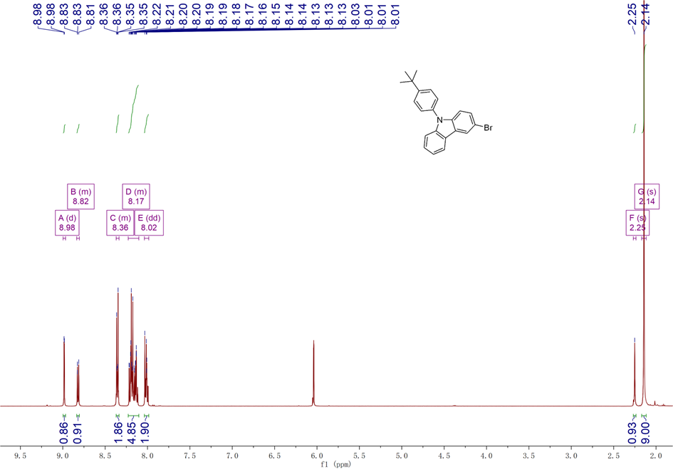
Figure S12. ¹H-NMR Spectrum of 2 in CD₂Cl₂.

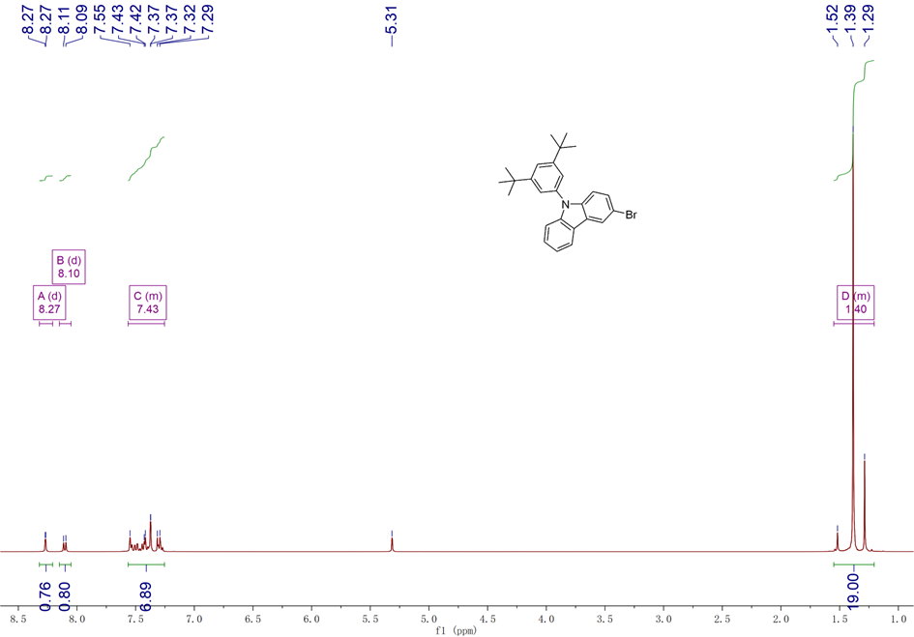
Figure S13. ¹H-NMR Spectrum of 3 in CD₂Cl₂.

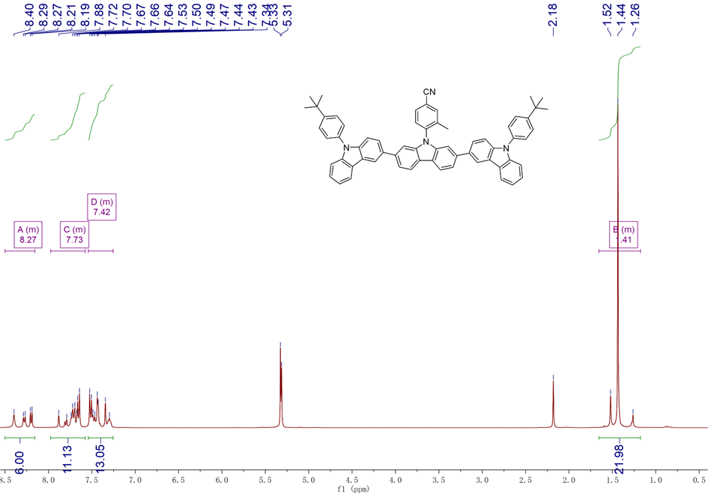
Figure S14. ¹H-NMR Spectrum of 2t-2MCz-CNMCz in CD₂Cl₂.

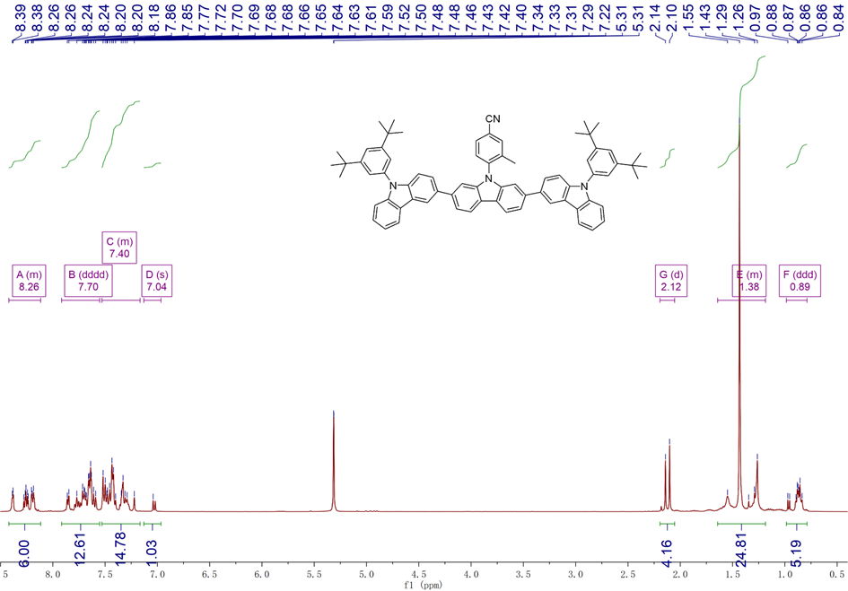
Figure S15. ¹H-NMR Spectrum of 4t-2MCz-CNMCz in CD₂Cl₂.

- References
[1] Wu, X., Peng, X., Chen, L., Tang, B. Z., & Zhao, Z. Through-space conjugated molecule with dual delayed fluorescence and room temperature phosphorescence for high performance OLEDs, ACS Mater. Lett. 5, 664−672 (2023).
[2] Yin C. et al. Ultra-low power-consumption OLEDs via phosphor-assisted thermally-activateddelayed-fluorescence-sensitized narrowband emission, Nat. Commun. 16, 30 (2025).
[3] Hu Y. X. et al. Efficient selenium-integrated TADF OLEDs with reduced roll-off, Nat. Photon. 16, 803−810 (2022).
[4] Fu, Y., Liu, H., Tang, B. Z., & Zhao, Z. Realizing efficient blue and deep-blue delayed fluorescence materials with record-beating electroluminescence efficiencies of 43.4%, Nat. Commun. 14, 2019 (2023).
[5] Zeng J. et al. Purely organic room-temperature phosphorescence sensitizers for highly efficient hyperfluorescence OLEDs, Sci. Adv. 11, eadt7899 (2025).

