Fasting-driven suppression of disease activity in rheumatoid arthritis – Supplementary files

Bérénice Hansen^{1*}, Rémy Villette^{1*}, Viacheslav Petrov¹, Cédric C Laczny¹, Farhad Vahid², Kirsten Roomp¹, Etienne Hanslian^{3,4}, Daniela A Koppold^{3,4}, Anika Rajput Khokhar⁵, Michael Jeitler^{3,4}, Nico Steckhan^{3,6}, Torsten Bohn², Sebastian Schade⁷, Brit Mollenhauer^{7,8}, Andreas Michalsen^{3,4}, Jochen G Schneider^{1,9,10*+,} Paul Wilmes^{1,9*+}

- Luxembourg Centre for Systems Biomedicine, University of Luxembourg, Esch-sur-Alzette, Luxembourg
- Nutrition and Health Research Group, Department of Precision Health, Luxembourg Institute of Health, 1 A-B, Rue Thomas Edison, 1445 Strassen, Luxembourg
- Institute for Social Medicine, Epidemiology and Health Economics, Charité Universitätsmedizin Berlin, Berlin, Germany
- Department of Internal and Integrative Medicine, Immanuel Hospital Berlin-Wannsee Branch, Berlin, Germany
- Department of Dermatology, Venereology and Allergology, Charité Universitätsmedizin Berlin, Berlin, Germany
- Digital Health-Connected Healthcare, Hasso Plattner Institute, University of Potsdam, Potsdam, Germany
- Paracelsus-Elena-Klinik Kassel, Kassel, Germany
- Department of Neurology, University Medical Center Göttingen, Göttingen, Germany
- Department of Life Sciences and Medicine, University of Luxembourg, Esch-sur-Alzette, Luxembourg
- Department of Internal Medicine II, Saarland University Hospital and Saarland University Faculty of Medicine, Homburg, Germany

*Contributed equally

+Corresponding authors:
Jochen G. Schneider,
jochen.schneider@uni.lu,
+352 46 66 44 6154

Paul Wilmes
paul.wilmes@uni.lu
+352 46 66 44 6188

Luxembourg Centre for Systems Biomedicine,
University of Luxembourg, Campus Belval,
7, avenue des Hauts-Fourneaux,
L-4362 Esch-sur-Alzette, Luxembourg

FIGURES
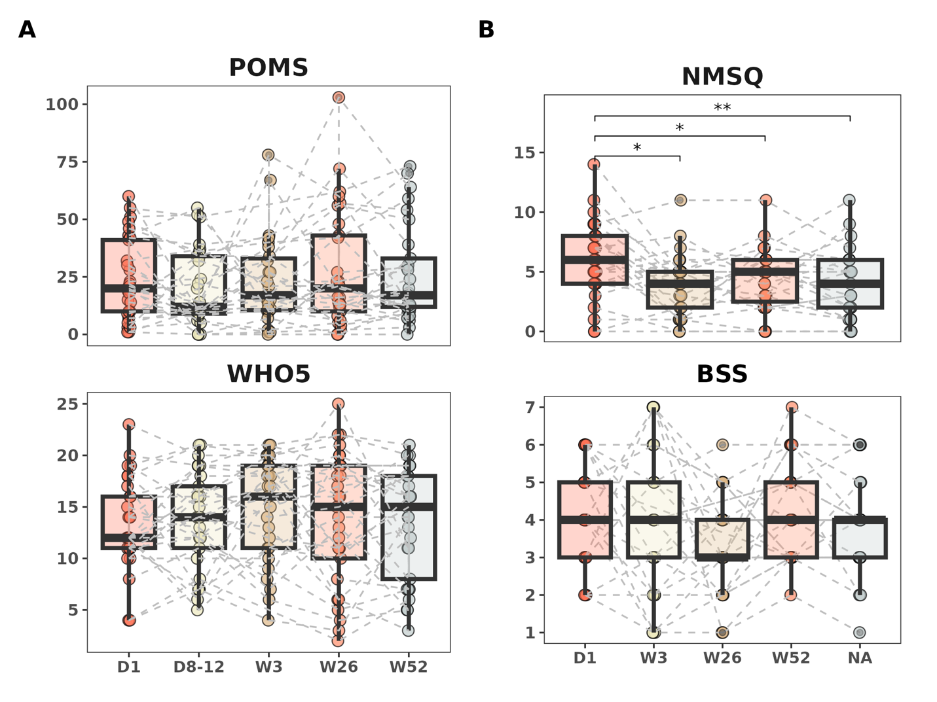

Supplementary figure 1. Additional scores measured during the intervention.
Changes reflected in the answers to the different health questionnaires over time. A. Profile moods of states (POMS), Quality-of-Life Questionnaire (WHO-5) and B. Non-motor symptoms questionnaire (NMSQ) and Bristol stool scale (BSS). Each dot represents an individual patient, with the dots connected by a dashed line indicating the longitudinal changes observed for the same patient. P-values are derived from a paired Wilcoxon test for all timepoints against the baseline (Day 1). D, Day; W, Week

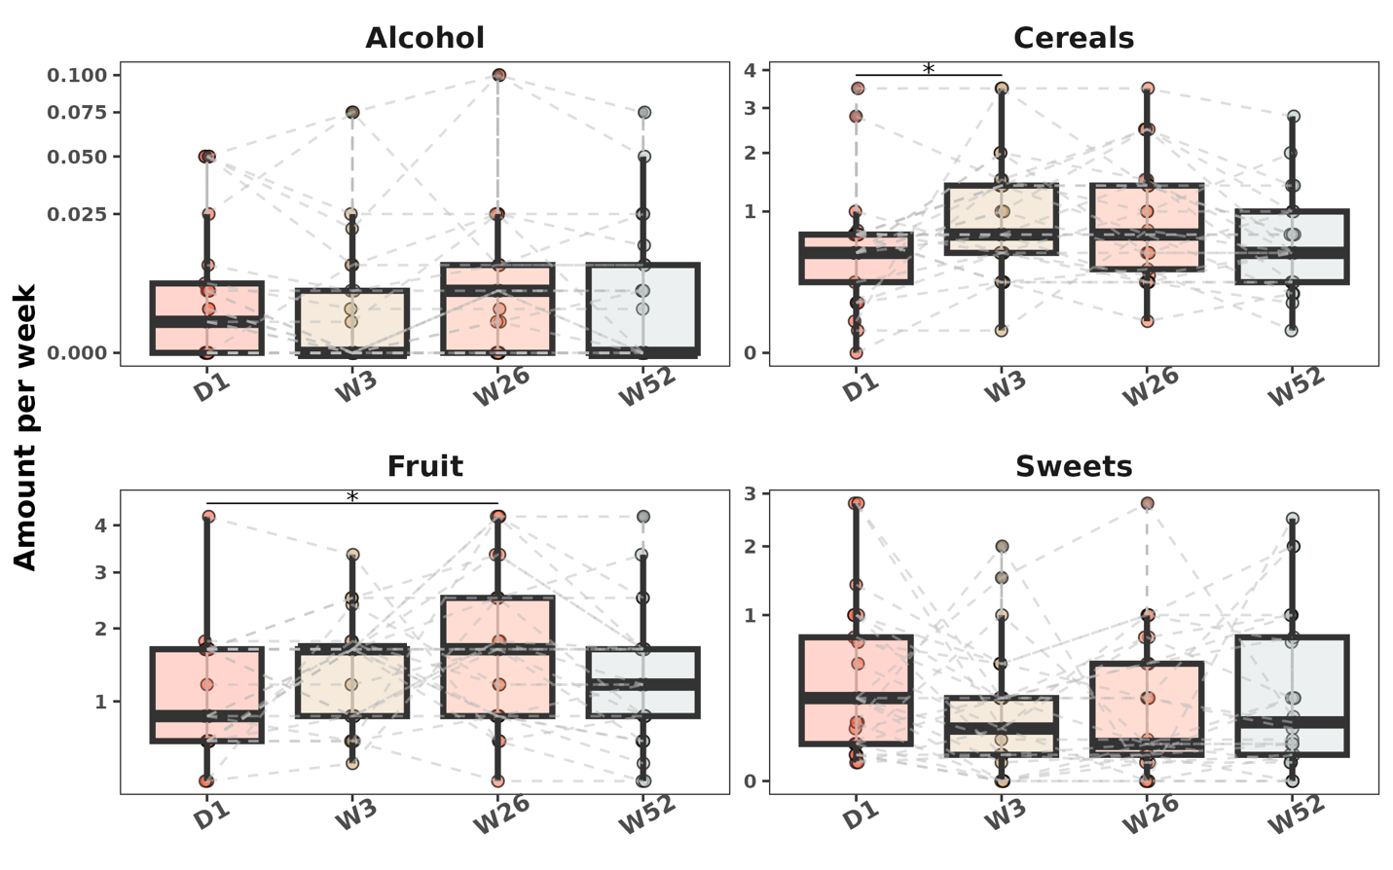

Supplementary figure 2. Change of consumption of different food groups during the intervention.
Consumption of different food groups over the 12 months of the study period. Significant changes can be observed for the consumption of cereals on week 3 (W3) and fruit intake on week 26 (W26). P-values are derived from a paired Wilcoxon test for all timepoints against the baseline (Day 1). D, Day; W, Week

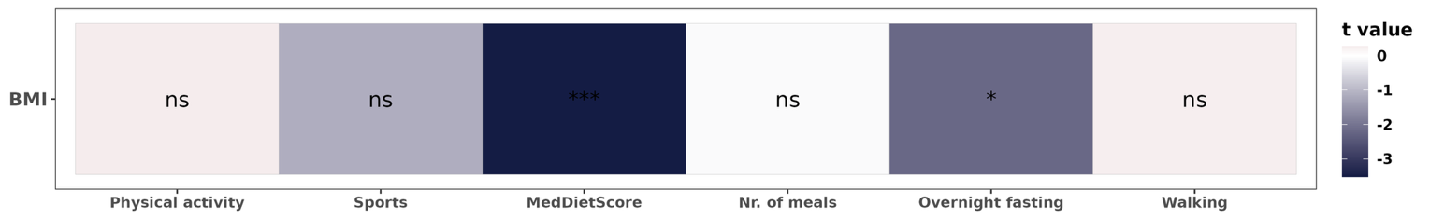

Supplementary figure 3. A linear mixed-effects model for assessing the impact of different effects on body mass index.
The fixed effects include the physical activity, sports, an adherence to a Mediterranean diet (MedDietScore), as well as the duration of the overnight fast and the niumbers of meals. The response variable is the body mass index (BMI). D, Day; W, Week.

