Appendices

Appendix A: Model structure
A linear optimisation model of a combined India-GCC power system was developed using OSeMOSYS, an open-source energy system modelling tool. The model scope was as follows:
Geographic scope (14 regions):
Bahrain, Kuwait, Oman, Qatar, Saudi Arabia (4 regions), UAE
India (5 regions)
Powerplant technologies (14 types): Coal, Natural Gas, Oil, Diesel, Waste, Biomass, Hydro, Geothermal, Wind, Solar photovoltaics, Concentrating Solar Power, Wind, Wave, and Nuclear
Time resolution (96 representative ‘time slices’): 24 hours, 4 seasons
Model horizon: 2015-2050

A simplified structure of the model is shown below.
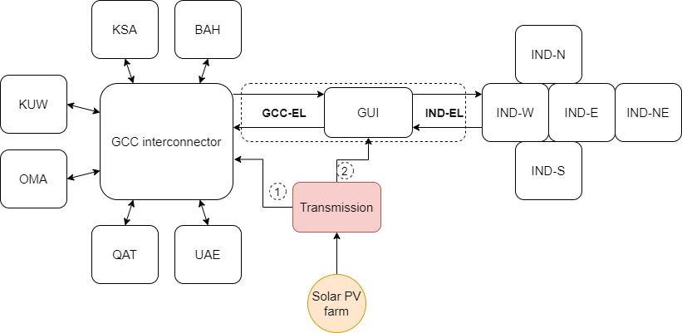
Figure 12. Simplified model structure

Appendix B: Scenario table
Table 5. Summary of twenty-five 'samples' covering the ranges of cost variables
Sample | CapitalCost | DiscountRate | DiscountRateIdv | FixedCostPercent
0 | 507 | 5.78% | 5.07% | 1.5%
1 | 1703 | 7.78% | 6.03% | 1.7%
2 | 1548 | 6.13% | 9.12% | 1.6%
3 | 1396 | 8.87% | 8.04% | 2.0%
4 | 921 | 5.30% | 7.64% | 1.6%
5 | 1445 | 5.85% | 6.57% | 1.8%
6 | 1573 | 8.61% | 9.23% | 1.5%
7 | 1301 | 8.22% | 7.00% | 1.3%
8 | 1981 | 6.84% | 7.57% | 1.4%
9 | 963 | 9.25% | 6.94% | 1.4%
10 | 1043 | 9.57% | 9.89% | 1.5%
11 | 565 | 8.44% | 9.46% | 1.6%
12 | 1192 | 5.41% | 8.26% | 1.9%
13 | 801 | 7.19% | 5.72% | 1.9%
14 | 602 | 8.18% | 5.39% | 1.7%
15 | 1655 | 6.50% | 8.50% | 1.3%
16 | 1911 | 7.36% | 6.72% | 1.8%
17 | 1808 | 9.08% | 6.21% | 1.2%
18 | 642 | 9.67% | 9.67% | 1.3%
19 | 1094 | 6.26% | 5.83% | 2.0%
20 | 1333 | 5.02% | 5.55% | 1.3%
21 | 1247 | 9.86% | 8.86% | 2.0%
22 | 863 | 7.92% | 7.39% | 2.1%
23 | 1843 | 6.71% | 8.69% | 2.0%
24 | 721 | 7.59% | 7.84% | 1.8%

Appendix C: Risk Sensitivity
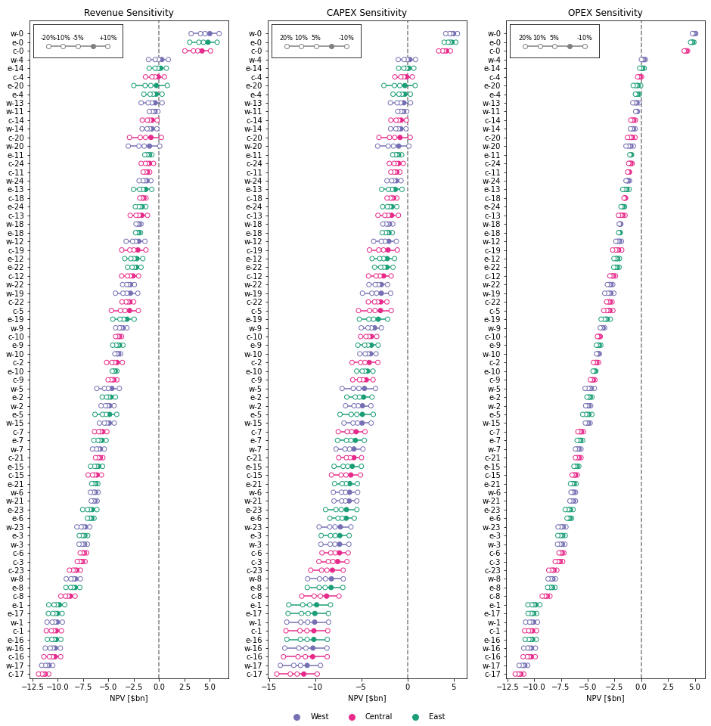
Figure 13: NPV impairment due to interdiction of CAPEX, OPEX, and revenue

