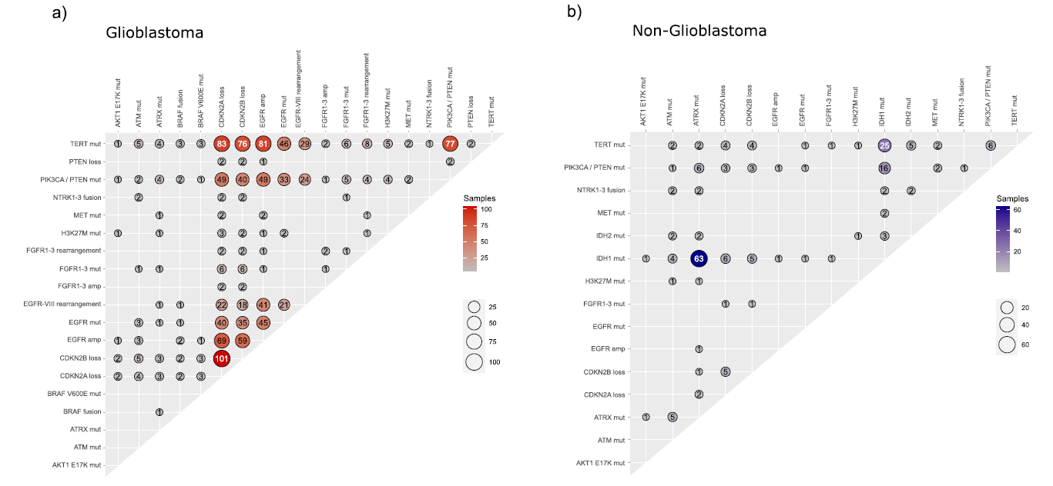
Supplementary Figure 1: Total co-mutations in GBM (A) and co-mutations in non-GBM (B).
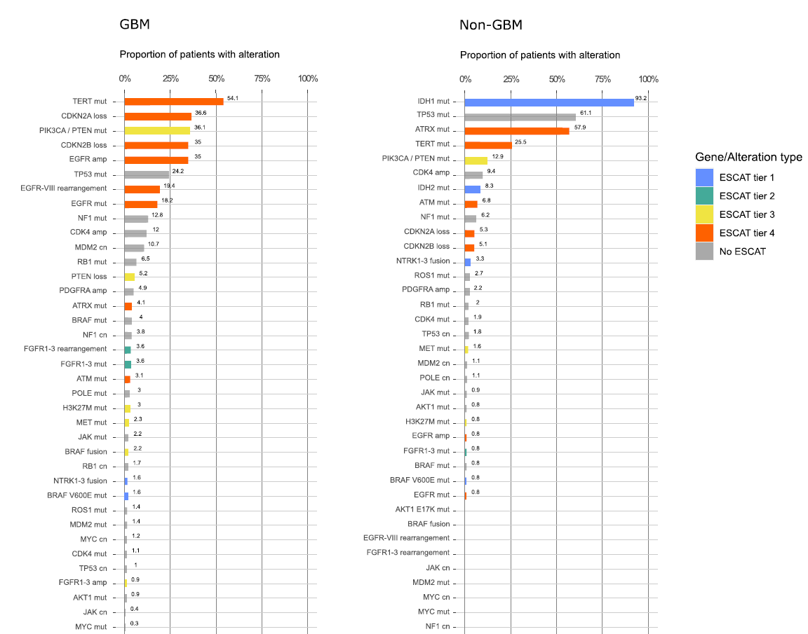
Supplementary Figure 2: Total gene alterations separated by GBM (A) and non-GBM subtypes (B). *Legend: Blue stands for Tier 1 molecular alterations, green stands for Tier 2, yellow for Tier 3, orange for Tier 4, and grey as NO ESCAT was found. Proportion of patients with the molecular alteration in the X-axes per glioma type.

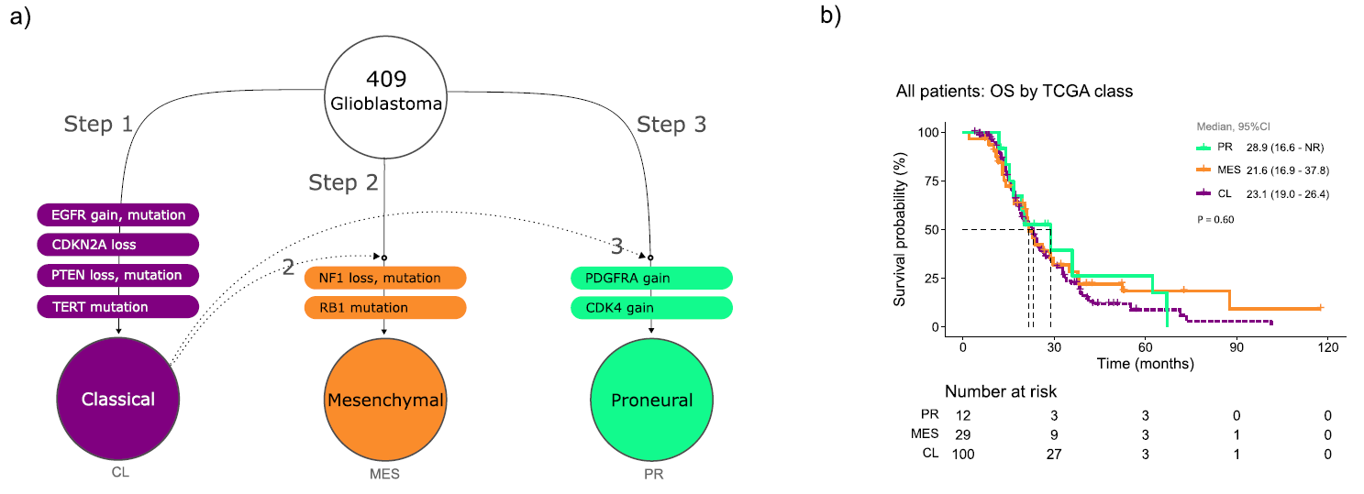
Supplementary Figure 3: Exploratory analysis of the adapted molecular classification with NGS information into classical, mesenchymal, and proneural (A), and the Kaplan Meier curves of the three groups (B). *Legend: The mutations that needed to be present to classify as classical were EGFR gain/mutation, CDKN2A/B loss, PTEN loss/mutation, and TERT mutation, to classify as mesenchymal were NF1 loss/mutation, and RB1 mutation, and to be classified as proneural PDGFRA gain or CDK4 gain. Note that IDH1 were excluded since now they are not considered GBM.

