Appendices

Descriptive Statistics
 |  | Pre |  | Post
 |  | Control | Treatment | Control | Treatment | DiD, OLS
young | Age | 29.266 | 31.991 | 28.778 | 31.979 | 0.476696306 | ***
young | Education: less than vocational degree | 0.263 | 0.283 | 0.209 | 0.226 | -0.00312199
young | Education: vocational degree | 0.579 | 0.54 | 0.592 | 0.547 | -0.00551911
young | Education: Tertiary | 0.158 | 0.178 | 0.199 | 0.227 | 0.008641096 | .
young | Occupation: Lower (ISCO 7-9) | 0.199 | 0.196 | 0.149 | 0.159 | 0.012596896 | *
young | Occupation: Middle (ISCO 3-6) | 0.666 | 0.644 | 0.674 | 0.634 | -0.01758087 | **
young | Occupation: High (ISCO 1-2) | 0.135 | 0.16 | 0.177 | 0.207 | 0.00498397
young | Swiss citizenship | 0.57 | 0.561 | 0.612 | 0.553 | -0.04999321 | ***
prime | Age | 38.33 | 41.951 | 38.802 | 41.973 | -0.44975757 | ***
prime | Education: less than vocational degree | 0.313 | 0.345 | 0.274 | 0.288 | -0.01703447 | *
prime | Education: vocational degree | 0.542 | 0.534 | 0.559 | 0.574 | 0.021773037 | **
prime | Education: Tertiary | 0.145 | 0.121 | 0.167 | 0.138 | -0.00473856
prime | Occupation: Lower (ISCO 7-9) | 0.217 | 0.236 | 0.187 | 0.201 | -0.00571035
prime | Occupation: Middle (ISCO 3-6) | 0.644 | 0.64 | 0.645 | 0.652 | 0.01094226
prime | Occupation: High (ISCO 1-2) | 0.139 | 0.124 | 0.168 | 0.147 | -0.00523191
prime | Swiss citizenship | 0.626 | 0.662 | 0.631 | 0.686 | 0.018830583 | *
older | Age | 47.991 | 51.952 | 48.159 | 51.974 | -0.14674281 | .
older | Education: less than vocational degree | 0.341 | 0.339 | 0.309 | 0.299 | -0.00795409
older | Education: vocational degree | 0.565 | 0.585 | 0.587 | 0.614 | 0.007407147
older | Education: Tertiary | 0.093 | 0.076 | 0.104 | 0.087 | 0.000546948
older | Occupation: Lower (ISCO 7-9) | 0.22 | 0.206 | 0.201 | 0.194 | 0.007264817
older | Occupation: Middle (ISCO 3-6) | 0.667 | 0.69 | 0.666 | 0.681 | -0.00741411
older | Occupation: High (ISCO 1-2) | 0.113 | 0.104 | 0.134 | 0.125 | 0.000149294
older | Swiss citizenship | 0.741 | 0.79 | 0.741 | 0.787 | -0.00352888
Table A1: Unweighted descriptive statistics by age group with a DiD estimate

 |  | Pre |  | Post
 |  | Control | Treatment | Control | Treatment | DiD, OLS
overall | Age | 35.17 | 35.268 | 35.146 | 35.245 | 0.000774587
overall | Education: less than vocational degree | 0.287 | 0.287 | 0.286 | 0.287 | 0.000603498
overall | Education: vocational degree | 0.575 | 0.577 | 0.574 | 0.575 | -0.00230865
overall | Education: Tertiary | 0.138 | 0.135 | 0.139 | 0.138 | 0.00170515
overall | Occupation: Lower (ISCO 7-9) | 0.205 | 0.206 | 0.204 | 0.203 | -0.00132095
overall | Occupation: Middle (ISCO 3-6) | 0.667 | 0.667 | 0.667 | 0.668 | 0.000681519
overall | Occupation: High (ISCO 1-2) | 0.128 | 0.127 | 0.13 | 0.129 | 0.000639429
overall | Swiss citizenship | 0.624 | 0.626 | 0.623 | 0.623 | -0.00268551
young | Age | 29.266 | 31.992 | 29.019 | 31.981 | 0.236507097 | ***
young | Education: less than vocational degree | 0.263 | 0.262 | 0.262 | 0.261 | -0.00050935
young | Education: vocational degree | 0.579 | 0.581 | 0.578 | 0.579 | -0.00042877
young | Education: Tertiary | 0.158 | 0.156 | 0.16 | 0.16 | 0.000938118
young | Occupation: Lower (ISCO 7-9) | 0.199 | 0.199 | 0.196 | 0.195 | -0.00218975
young | Occupation: Middle (ISCO 3-6) | 0.666 | 0.666 | 0.667 | 0.669 | 0.001547898
young | Occupation: High (ISCO 1-2) | 0.135 | 0.135 | 0.137 | 0.137 | 0.000641848
young | Swiss citizenship | 0.57 | 0.572 | 0.57 | 0.569 | -0.00334675
prime | Age | 38.33 | 41.947 | 38.919 | 41.976 | -0.55971587 | ***
prime | Education: less than vocational degree | 0.313 | 0.312 | 0.309 | 0.314 | 0.006814351
prime | Education: vocational degree | 0.542 | 0.545 | 0.544 | 0.54 | -0.00666608
prime | Education: Tertiary | 0.145 | 0.144 | 0.148 | 0.146 | -0.00014827
prime | Occupation: Lower (ISCO 7-9) | 0.217 | 0.217 | 0.215 | 0.215 | -1.9341E-05
prime | Occupation: Middle (ISCO 3-6) | 0.644 | 0.645 | 0.643 | 0.644 | 0.000786459
prime | Occupation: High (ISCO 1-2) | 0.139 | 0.139 | 0.142 | 0.141 | -0.00076712
prime | Swiss citizenship | 0.626 | 0.628 | 0.624 | 0.625 | -0.00087526
older | Age | 47.991 | 51.948 | 48.243 | 51.975 | -0.22417984 | **
older | Education: less than vocational degree | 0.341 | 0.336 | 0.341 | 0.336 | 0.0004849
older | Education: vocational degree | 0.565 | 0.571 | 0.567 | 0.57 | -0.00317208
older | Education: Tertiary | 0.093 | 0.093 | 0.092 | 0.095 | 0.002687181
older | Occupation: Lower (ISCO 7-9) | 0.22 | 0.216 | 0.22 | 0.222 | 0.005800792
older | Occupation: Middle (ISCO 3-6) | 0.667 | 0.672 | 0.666 | 0.664 | -0.00570366
older | Occupation: High (ISCO 1-2) | 0.113 | 0.113 | 0.114 | 0.114 | -9.7128E-05
older | Swiss citizenship | 0.741 | 0.744 | 0.738 | 0.739 | -0.00188309
Table A2: Weighted descriptive statistics by age group with a DiD estimate

Alternative analysis strategy

In this appendix we used men as a control group, comparing women who had reductions in their pension contributions to men of the same age who faced no changes in pension contributions. This approach does not suffer the limitations of the primary approach with respect to the treatment criterion of age, being correlated with the outcomes (unemployment duration and reemployment income), but suffers from a lack of comparability between men and women in the Swiss labour market. As illustrated in Table A1, men and women are significantly different with respect to educational attainment, occupation, and country of origin, and face differing labor market trends. Using entropy weighting it is possible to adjust women in the post-reform period and same-aged men in the pre- and post-reform period to look like women in the pre-reform period with respect to age, education, country of origin and managerial status. Research suggests however, that there are still likely underlying differences with respect to occupation and industry.
 |  | Pre |  | Post
 |  | Control | Treatment | Control | Treatment | DiD, OLS
overall | Age | 39.218 | 39.217 | 39.608 | 39.665 | 0.058
overall | Education: less than vocational degree | 0.258 | 0.314 | 0.239 | 0.263 | -0.032 | ***
overall | Education: vocational degree | 0.56 | 0.547 | 0.548 | 0.57 | 0.035 | ***
overall | Education: Tertiary | 0.182 | 0.139 | 0.213 | 0.167 | -0.003
overall | Occupation: Lower (ISCO 7-9) | 0.463 | 0.211 | 0.415 | 0.181 | 0.018 | ***
overall | Occupation: Middle (ISCO 3-6) | 0.346 | 0.652 | 0.363 | 0.65 | -0.018 | ***
overall | Occupation: High (ISCO 1-2) | 0.191 | 0.137 | 0.223 | 0.169 | 0.000
overall | Swiss citizenship | 0.557 | 0.64 | 0.55 | 0.648 | 0.015 | **
young | Age | 31.994 | 31.991 | 31.963 | 31.979 | 0.019
young | Education: less than vocational degree | 0.23 | 0.283 | 0.216 | 0.226 | -0.042 | ***
young | Education: vocational degree | 0.551 | 0.54 | 0.532 | 0.547 | 0.026 | ***
young | Education: Tertiary | 0.219 | 0.178 | 0.253 | 0.227 | 0.016 | **
young | Occupation: Lower (ISCO 7-9) | 0.436 | 0.196 | 0.379 | 0.159 | 0.020 | **
young | Occupation: Middle (ISCO 3-6) | 0.356 | 0.644 | 0.38 | 0.634 | -0.034 | ***
young | Occupation: High (ISCO 1-2) | 0.209 | 0.16 | 0.241 | 0.207 | 0.015 | *
young | Swiss citizenship | 0.54 | 0.561 | 0.509 | 0.553 | 0.022 | **
prime | Age | 41.981 | 41.951 | 41.969 | 41.973 | 0.034 | *
prime | Education: less than vocational degree | 0.283 | 0.345 | 0.253 | 0.288 | -0.027 | ***
prime | Education: vocational degree | 0.56 | 0.534 | 0.548 | 0.574 | 0.051 | ***
prime | Education: Tertiary | 0.157 | 0.121 | 0.198 | 0.138 | -0.024 | ***
prime | Occupation: Lower (ISCO 7-9) | 0.489 | 0.236 | 0.43 | 0.201 | 0.024 | **
prime | Occupation: Middle (ISCO 3-6) | 0.334 | 0.64 | 0.354 | 0.652 | -0.008
prime | Occupation: High (ISCO 1-2) | 0.177 | 0.124 | 0.217 | 0.147 | -0.016 | **
prime | Swiss citizenship | 0.542 | 0.662 | 0.554 | 0.686 | 0.011
older | Age | 51.983 | 51.952 | 51.98 | 51.974 | 0.025
older | Education: less than vocational degree | 0.286 | 0.339 | 0.264 | 0.299 | -0.019 | *
older | Education: vocational degree | 0.58 | 0.585 | 0.581 | 0.614 | 0.028 | **
older | Education: Tertiary | 0.134 | 0.076 | 0.155 | 0.087 | -0.009
older | Occupation: Lower (ISCO 7-9) | 0.489 | 0.206 | 0.467 | 0.194 | 0.010
older | Occupation: Middle (ISCO 3-6) | 0.342 | 0.69 | 0.339 | 0.681 | -0.006
older | Occupation: High (ISCO 1-2) | 0.169 | 0.104 | 0.194 | 0.125 | -0.004
older | Swiss citizenship | 0.621 | 0.79 | 0.632 | 0.787 | -0.014
Table A3: Unweighted descriptive statistics by age group with a DiD estimate, using same-age men as the control group

 |  | Pre |  | Post
 |  | Control | Treatment | Control | Treatment | DiD, OLS
young | Age | 39.218 | 39.292 | 39.231 | 39.302 | -0.003
young | Education: less than vocational degree | 0.258 | 0.251 | 0.255 | 0.249 | 0.002
young | Education: vocational degree | 0.56 | 0.565 | 0.561 | 0.558 | -0.008 | .
young | Education: Tertiary | 0.182 | 0.185 | 0.184 | 0.193 | 0.006 | .
young | Occupation: Lower (ISCO 7-9) | 0.463 | 0.453 | 0.461 | 0.449 | -0.002
young | Occupation: Middle (ISCO 3-6) | 0.346 | 0.352 | 0.347 | 0.352 | -0.001
young | Occupation: High (ISCO 1-2) | 0.191 | 0.194 | 0.192 | 0.199 | 0.003
young | Swiss citizenship | 0.557 | 0.567 | 0.556 | 0.565 | -0.001
young | Age | 31.994 | 31.995 | 31.987 | 31.995 | 0.006
young | Education: less than vocational degree | 0.23 | 0.224 | 0.226 | 0.22 | 0.000
young | Education: vocational degree | 0.551 | 0.554 | 0.551 | 0.548 | -0.007
young | Education: Tertiary | 0.219 | 0.222 | 0.222 | 0.231 | 0.007
young | Occupation: Lower (ISCO 7-9) | 0.436 | 0.426 | 0.43 | 0.415 | -0.005
young | Occupation: Middle (ISCO 3-6) | 0.356 | 0.361 | 0.358 | 0.365 | 0.001
young | Occupation: High (ISCO 1-2) | 0.209 | 0.213 | 0.212 | 0.22 | 0.004
young | Swiss citizenship | 0.54 | 0.549 | 0.539 | 0.548 | 0.000
prime | Age | 41.981 | 41.987 | 41.983 | 41.981 | -0.008
prime | Education: less than vocational degree | 0.283 | 0.277 | 0.28 | 0.279 | 0.005
prime | Education: vocational degree | 0.56 | 0.562 | 0.562 | 0.556 | -0.008
prime | Education: Tertiary | 0.157 | 0.161 | 0.158 | 0.164 | 0.003
prime | Occupation: Lower (ISCO 7-9) | 0.489 | 0.479 | 0.491 | 0.476 | -0.004
prime | Occupation: Middle (ISCO 3-6) | 0.334 | 0.34 | 0.333 | 0.341 | 0.001
prime | Occupation: High (ISCO 1-2) | 0.177 | 0.181 | 0.177 | 0.183 | 0.003
prime | Swiss citizenship | 0.542 | 0.55 | 0.541 | 0.548 | -0.001
older | Age | 51.983 | 51.989 | 51.991 | 51.987 | -0.010
older | Education: less than vocational degree | 0.286 | 0.271 | 0.281 | 0.27 | 0.004
older | Education: vocational degree | 0.58 | 0.591 | 0.584 | 0.581 | -0.013
older | Education: Tertiary | 0.134 | 0.138 | 0.135 | 0.149 | 0.009
older | Occupation: Lower (ISCO 7-9) | 0.489 | 0.474 | 0.488 | 0.487 | 0.013
older | Occupation: Middle (ISCO 3-6) | 0.342 | 0.35 | 0.341 | 0.34 | -0.009
older | Occupation: High (ISCO 1-2) | 0.169 | 0.175 | 0.171 | 0.173 | -0.004
older | Swiss citizenship | 0.621 | 0.636 | 0.622 | 0.635 | -0.002
Table A4: Weighted descriptive statistics by age group with a DiD estimate, using same-age men as the control group

As illustrated in Figure A1, unweighted per-trends in duration are not parallel, though weighted trends are. Unemployment durations seem to increase for treated women in the period of pension reform, a reverse effect, but then the differences between men and women return to their 2000, pre-reform levels once the reform has been fully implemented. This change less likely reflects a policy impact, and more likely reflects a significant shift in male and female labor markets, as female unemployment grew significantly quicker during from 2003 to 2007 than men’s (Figure A5).

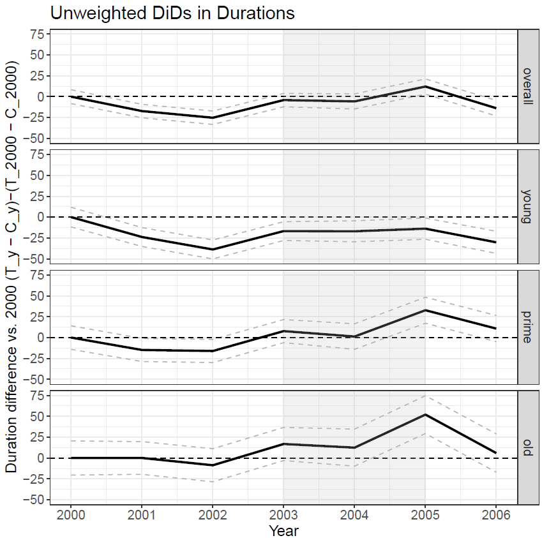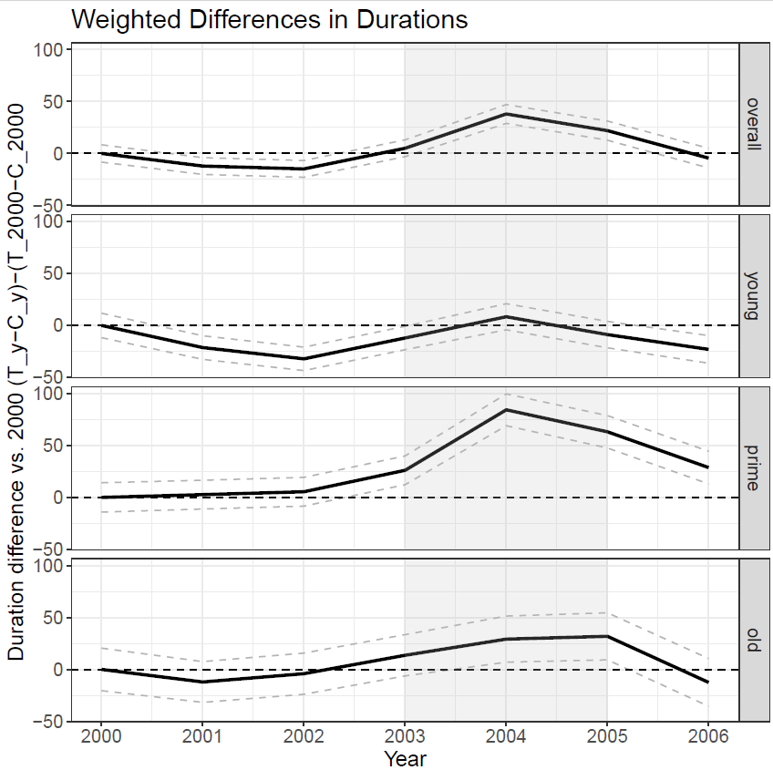
Figure A1: The difference between the unemployment duration (days) for the treated and control groups versus the difference in 2000 using same-age men as the control group, by year of unemployment start, raw (L) and weighted (R). Shaded area indicates time from policy announcement to implementation.

Figure A2 illustrates the change in the gap between the treated (women) and control (men) compared to the baseline year of 2000. Overall, we see a sudden increase in the period of policy change, which is rapidly downward adjusted once the policy has been implemented. Notably, the estimate is consistent with a prior version of this paper that used social security data as the main data rather than unemployment insurance.

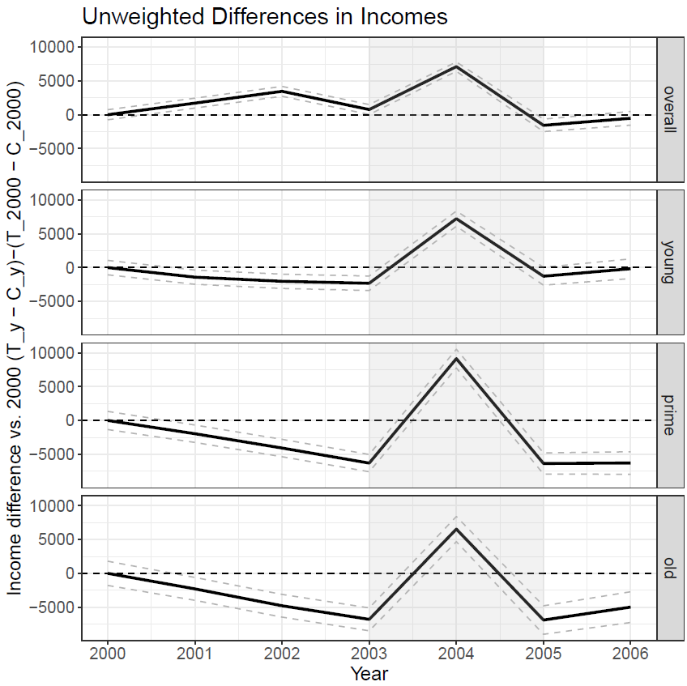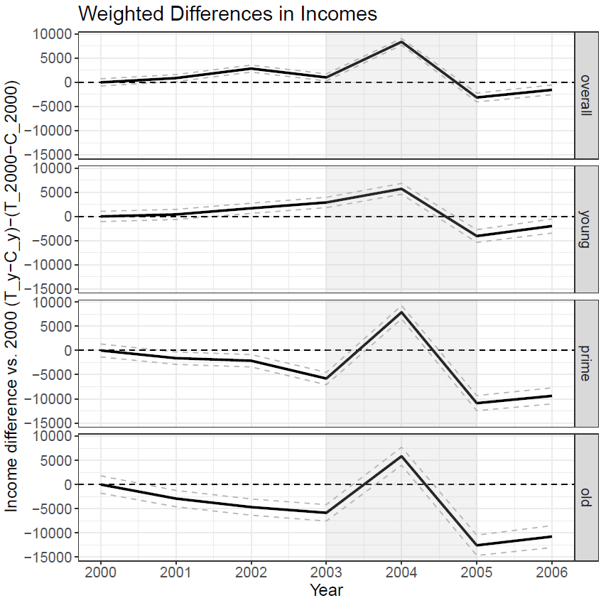
Figure A2: The difference between annual reemployment income for the treated and control groups versus the difference in 2000 using same-age men as the control group, by year of unemployment start, raw (L) and weighted (R). Shaded area indicates time from policy announcement to implementation.

In Figure A3 we see the DiD estimates for unemployment duration, which reflect what was anticipated by the time trend plot: there is an increase in unemployment duration, primarily driven by prime-age women, following the reform. As noted before this is likely not due to the reform, but due to a macro-level divergence, i.e., the relative increase in unemployment rates for women compared to men of 1.5 ppts during this period (Figure A5). The fact that the increase in unemployment duration among treated women is concentrated among prime-age individuals, makes sense given that younger women tend to experience brief unemployment spells regardless of macroeconomic fluctuations, while older women are more likely to exit the labor force in response to deteriorating conditions. Prime-age women, by contrast, are more likely to remain active job seekers facing longer unemployment durations during the downturn.

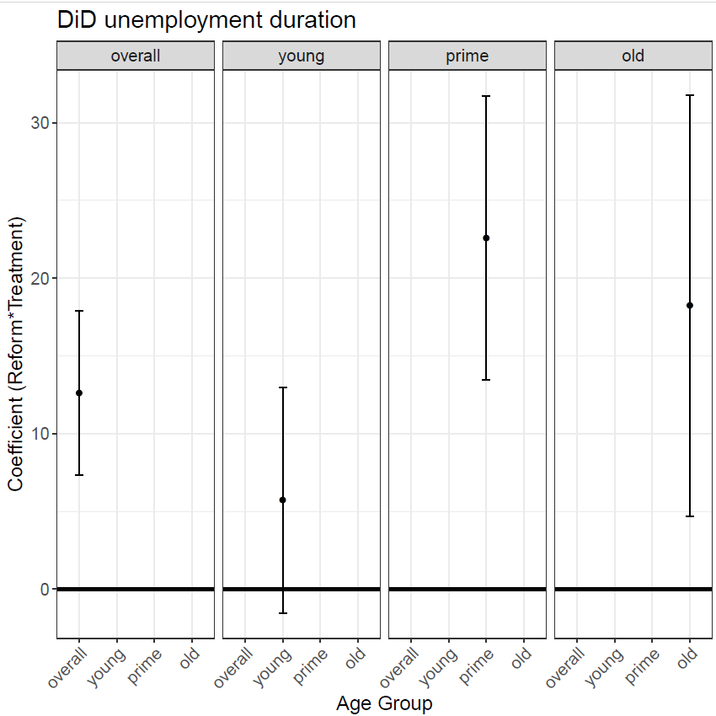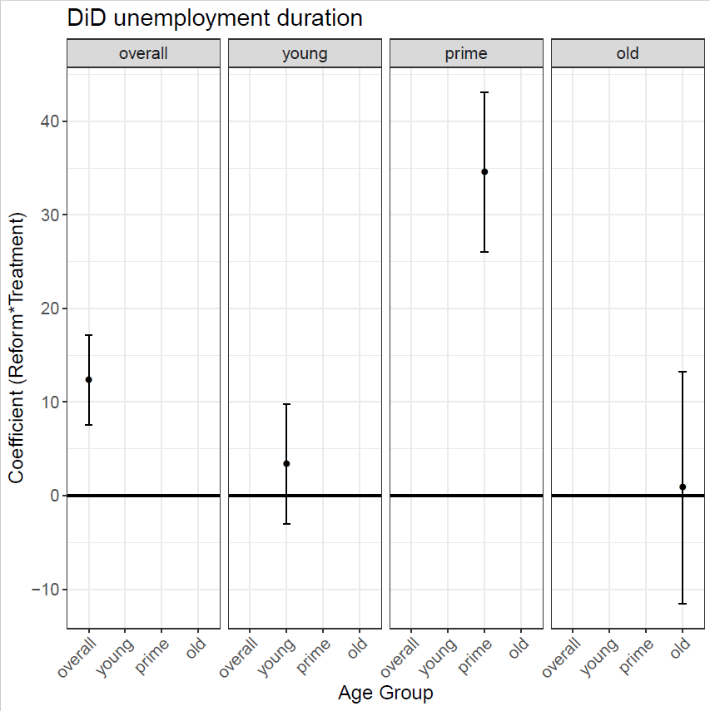

Figure A3: DiD estimates for days unemployment duration using same-age men as the control group, OLS DiD estimate (L) and OLS with entropy weights (R)

In Figure A5 we see that with weighting and OLS adjustment the DiD estimate suggests a slight increase in income for women who had a reduction in employer contribution rates following the reform. In Table A5 we can see that these effects are largely driven by older women— a group particularly subject to labour market selectivity. The observed income effect likely reflects selection bias: as the female labour market deteriorated, only higher-wage older women re-entered employment, inflating average reemployment wages. Thus, the effect is unlikely to reflect the pension reform per se.

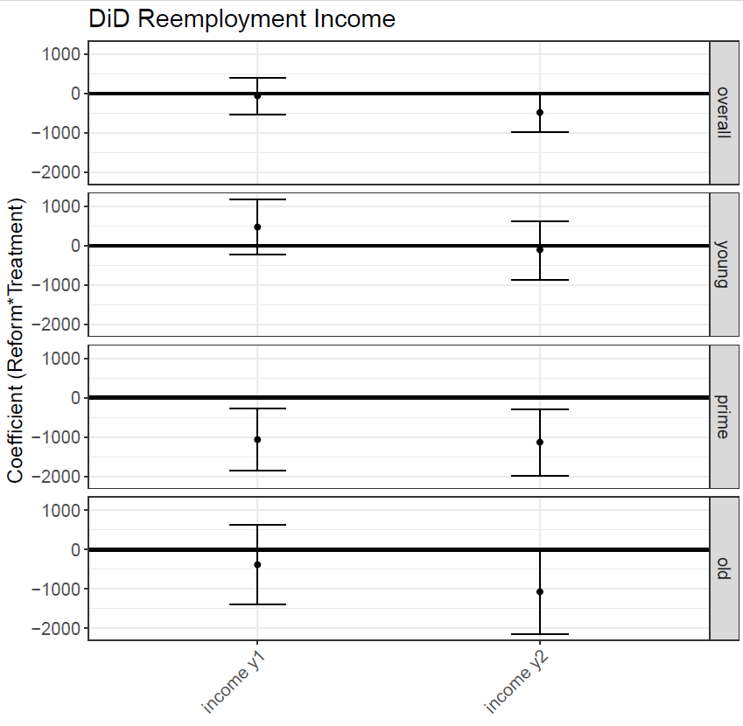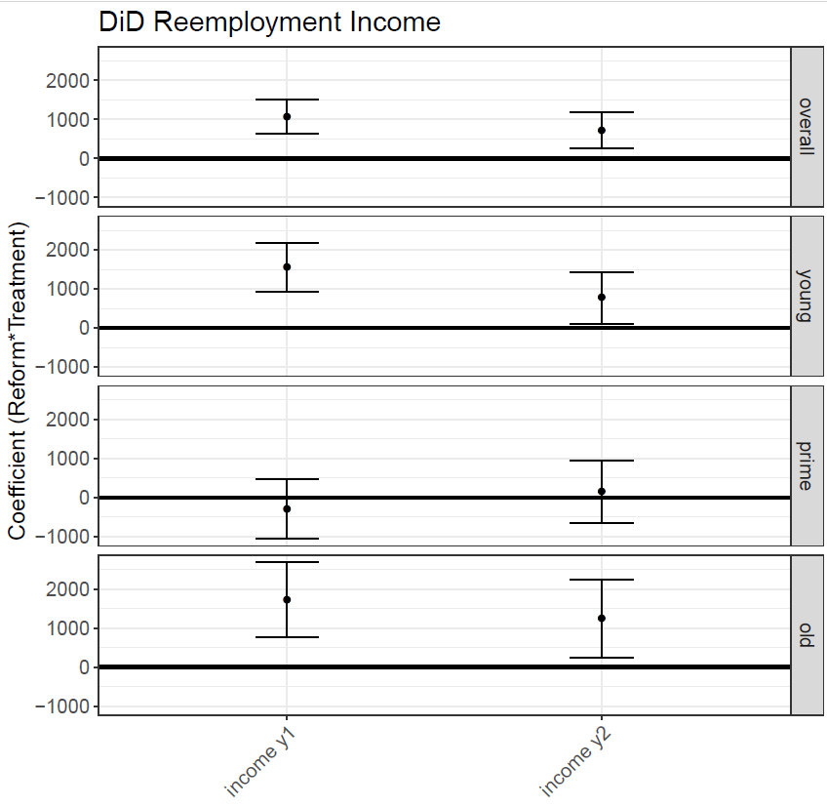
Figure A4: DiD estimates for annual reemployment income in years 1 & 2 following unemployment start using same-age men as the control group, OLS DiD estimate (L) OLS with entropy weights (R)

 |  | duration |  | income y1 |  | income y2 |  | income y3 |  | income y4 |  | income y5
unweighted | overall | 12.602 | *** | -66.719 |  | -491.987 | . | -287.764 |  | 480.321 | . | 857.652 | **
unweighted | (se) | (2.698) |  | (239.240) |  | (251.082) |  | (262.282) |  | (271.435) |  | (278.757)
unweighted | young | 5.719 |  | 474.383 |  | -121.794 |  | 17.461 |  | 1026.827 | * | 1253.089 | **
unweighted | (se) | (3.698) |  | (358.066) |  | (376.488) |  | (395.624) |  | (410.300) |  | (422.743)
unweighted | prime | 22.588 | *** | -1064.046 | ** | -1140.028 | ** | -622.942 |  | -174.214 |  | 59.054
unweighted | (se) | (4.660) |  | (406.687) |  | (426.257) |  | (442.612) |  | (458.050) |  | (471.748)
unweighted | older | 18.214 | ** | -382.933 |  | -1075.312 | * | -1378.280 | * | -724.145 |  | 239.466
unweighted | (se) | (6.909) |  | (519.066) |  | (544.946) |  | (566.594) |  | (582.913) |  | (591.255)
weighted | overall | 12.328 | *** | 1070.994 | *** | 720.291 | ** | 259.044 |  | 635.354 | * | 1004.108 | ***
weighted | (se) | (2.443) |  | (222.710) |  | (231.777) |  | (242.596) |  | (251.637) |  | (258.354)
weighted | young | 3.393 |  | 1550.041 | *** | 773.367 | * | 438.282 |  | 486.267 |  | 873.812 | *
weighted | (se) | (3.268) |  | (323.858) |  | (338.421) |  | (356.304) |  | (370.654) |  | (382.221)
weighted | prime | 34.572 | *** | -289.371 |  | 147.768 |  | 207.568 |  | 556.997 |  | 931.436 | *
weighted | (se) | (4.333) |  | (390.486) |  | (404.031) |  | (420.973) |  | (435.679) |  | (447.710)
weighted | older | 0.892 |  | 1721.637 | *** | 1241.740 | * | -255.682 |  | 1082.762 | * | 1627.500 | **
weighted | (se) | (6.323) |  | (488.710) |  | (510.703) |  | (531.460) |  | (548.140) |  | (556.563)
Table A5: Unweighted and weighted DiD estimates for unemployment duration and reemployment income 1 to 5 years following reemployment using same-age men as the control group

Men and women have relatively segregated labour markets in Switzerland. As noted in the main text, to make a solid estimate of the wage gap, comparable men can only be found for 55% of the women in the private sector. Thus, men and women’s occupations have also very different trends. As illustrated in Figure A5, from 2002 to 2007 men and women’s unemployment rates diverged with women suffering relatively higher unemployment rates (a gap shifting from .4 ppts in unemployment to 1.5 ppts). This means that when we compare reemployment and reemployment wages for treated women versus the male control group, women re-enter the marketplace post unemployment in increasingly unfriendly conditions—which likely explains both the DiD estimates of longer unemployment durations among prime-age women and higher reemployment incomes among older women.

Figure A5: Unemployment rate (ILO definition) for men vs. women

