Multiscale Dynamics and Climatic Drivers of Aircraft Icing in China: Insights from 13 Years of Pilot Reports (2011-2023)

Supplementary Information

Table of Contents

Supplementary Figures

Supplementary Figure 1 Variation of temperature and humidity at different altitudes in East Asia from 2011 to 2023, data source: ERA5 reanalysis data.
Supplementary Figure 2 Potential height fields and wind fields at (a) 1000hPa; (b) 850hPa; (c) 700hPa; (d) 500hPa synthesized in China from 2011 to 2023.
Supplementary Figure 3 Potential height fields and wind fields at (a) 1000hPa; (b) 850hPa; (c) 700hPa; (d) 500hPa synthesized in China from 2011 to 2023.
Supplementary Figure 4 Vertical distribution profiles of (a) temperature and (b) cloud water content; (c) variations in vertical distribution of temperature and (d) relative humidity over time in Beijing during winter from 2019 to 2023.
Supplementary Figure 5 Variations in vertical distribution of temperature and relative humidity over time in the Sichuan Basin from 2019 to 2023 during winter.
Supplementary Figure 6 Variations in vertical distribution of temperature and relative humidity over time in the eastern coastal regions of China from 2019 to 2023 during winter. (a)-(b) are for Shanghai and Zhejiang Province; (c)-(d) are for Guangdong Province
Supplementary Figure 1 Variation of temperature and humidity at different altitudes in East Asia from 2011 to 2023, data source: ERA5 reanalysis data.

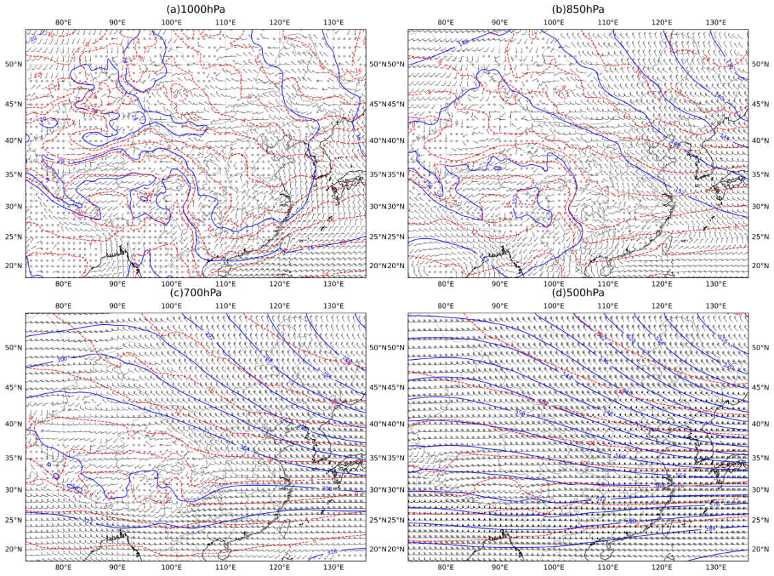
Supplementary Figure 2 Potential height fields and wind fields at (a) 1000hPa; (b) 850hPa; (c) 700hPa; (d) 500hPa synthesized in China from 2011 to 2023.

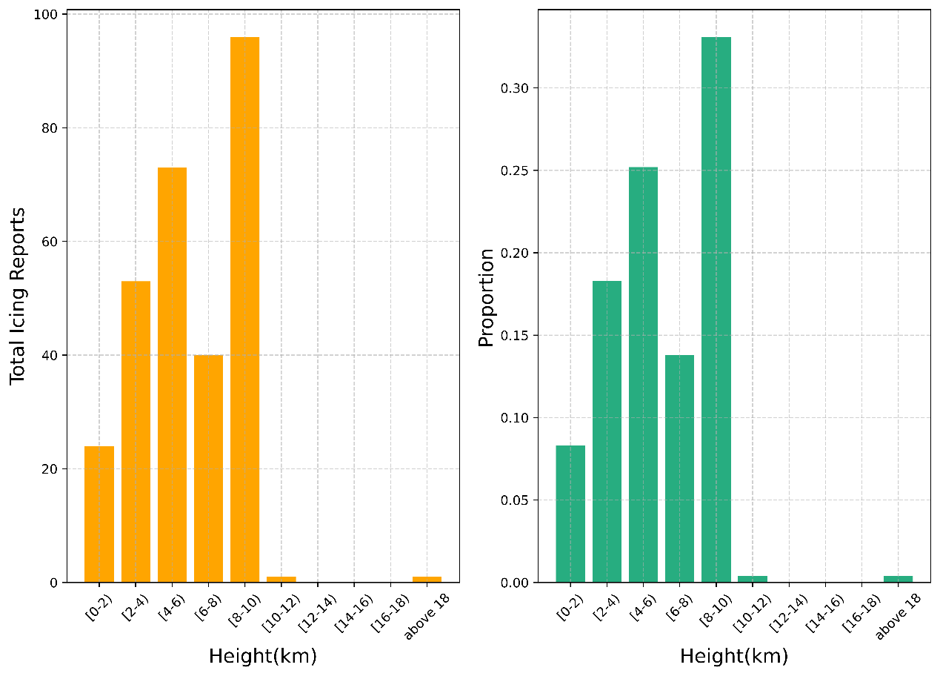
Supplementary Figure 3 The total frequency and proportion of moderate or above aircraft icing events changes with height in Beijing from 2019 to 2023 during winter.

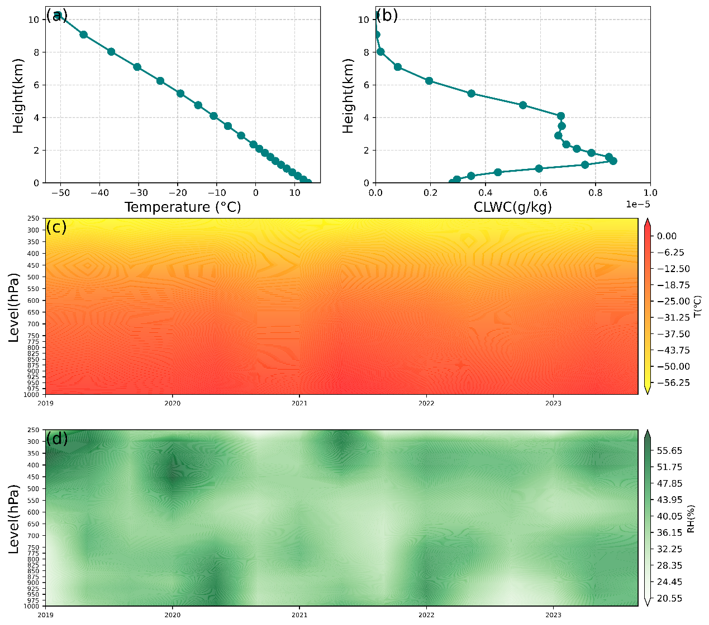
Supplementary Figure 4 Vertical distribution profiles of (a) temperature and (b) cloud water content; (c) variations in vertical distribution of temperature and (d) relative humidity over time in Beijing during winter from 2019 to 2023.

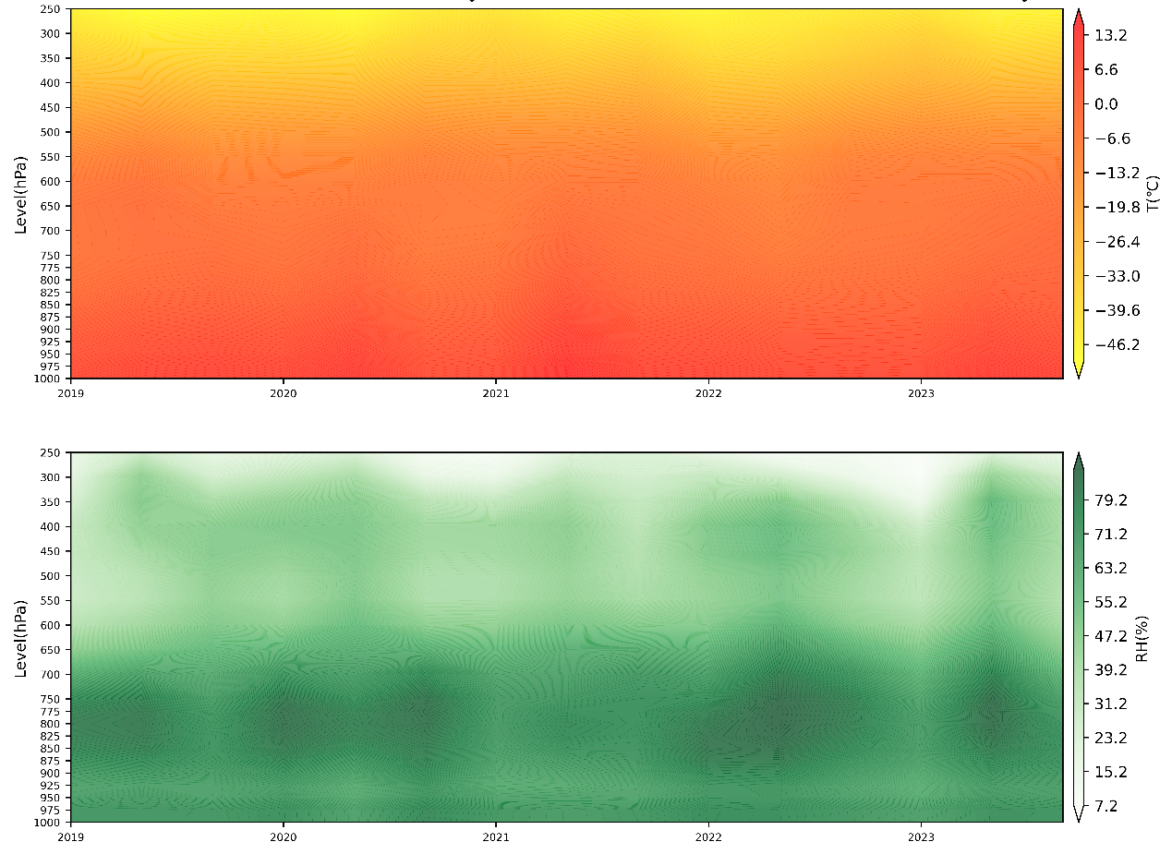
Supplementary Figure 5 Variations in vertical distribution of temperature and relative humidity over time in the Sichuan Basin from 2019 to 2023 during winter.
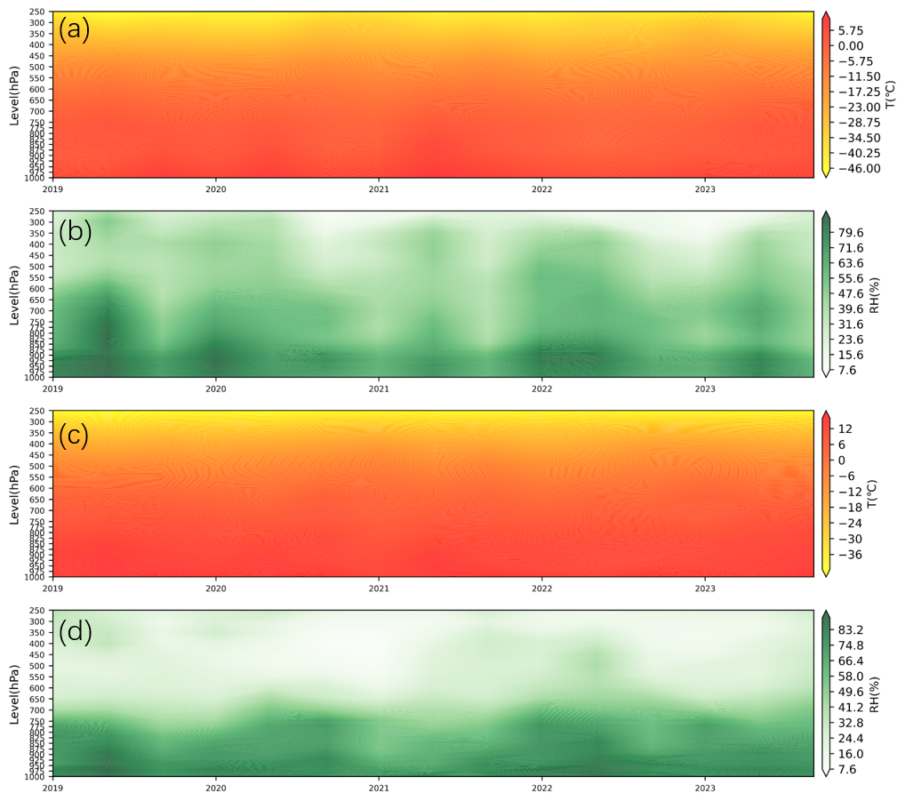
Supplementary Figure 6 Variations in vertical distribution of temperature and relative humidity over time in the eastern coastal regions of China from 2019 to 2023 during winter. (a)-(b) are for Shanghai and Zhejiang Province; (c)-(d) are for Guangdong Province.

