Supplementary Material

Flexible use of multimodal communicative strategies in adult chimpanzees (Pan troglodytes)

Angèle Lombrey, Adriana Luna, Nick Dannenmann, Katerina Harvati, Ulrich Knief, Marlen Fröhlich
Table S1: Information on group composition
Research setting | Social group | Number of subjects | Number of male subjects | Number of female subjects | Total group size
Captive | A | 13 | 2 | 11 | 21
Captive | B | 6 | 1 | 5 | 6
Captive | L | 30 | 13 | 17 | 33
Semi-wild | C2 | 29 | 8 | 21 | 56
Semi-wild | C4 | 9 | 5 | 4 | 13

Table S2: Subject information and sample size per subject represented by the amount of coded signal utterances
Subject | Group | Setting | Sex | Age | Rank | Sample size
Alex | B | Captive | M | 21 | 1 | 96
Bambari | A | Captive | F | 21 | 5 | 64
Bea | L | Captive | F | 27 | NA | 13
Bobby | C4 | Sanctuary | M | 28 | NA | 38
Carol | C2 | Sanctuary | F | 25 | NA | 94
Coco | C2 | Sanctuary | F | 37 | NA | 30
Commander | C4 | Sanctuary | M | 22 | NA | 146
Corry | A | Captive | F | 45 | 7 | 240
Daisy | C2 | Sanctuary | F | 17 | NA | 93
David | C2 | Sanctuary | M | 20 | NA | 154
Daza | B | Captive | F | 36 | 3 | 92
Debbie | C2 | Sanctuary | F | 20 | NA | 139
Diana | C2 | Sanctuary | F | 31 | NA | 36
Diz | C2 | Sanctuary | F | 14 | NA | 81
Dolly | C2 | Sanctuary | F | 25 | NA | 277
Donald | L | Captive | M | 28 | NA | 53
Dora | C2 | Sanctuary | F | 33 | NA | 139
Dorien | A | Captive | F | 41 | 6 | 50
Doug | C2 | Sanctuary | M | 19 | NA | 92
Espe | L | Captive | F | 31 | NA | 104
Fetz | L | Captive | M | 16 | NA | 53
Fraukje | A | Captive | F | 45 | 9 | 75
Freddy | L | Captive | M | 35 | NA | 20
Frederike | B | Captive | F | 48 | 5 | 26
Frodo | A | Captive | M | 28 | 1 | 146
Garibal | L | Captive | M | 26 | NA | 29
Gartenzwerg | L | Captive | F | 39 | NA | 107
Girlie | L | Captive | F | 18 | NA | 34
Gregor | L | Captive | M | 33 | NA | 81
Heronemo | L | Captive | M | 37 | NA | 12
Hope | B | Captive | F | 31 | 2 | 33
Ignaz | L | Captive | M | 33 | NA | 28
Jack | C4 | Sanctuary | M | 13 | NA | 154
Jacky | L | Captive | F | 52 | NA | 10
Jeudi | B | Captive | F | 56 | 4 | 39
John | C2 | Sanctuary | M | 15 | NA | 93
Judy | C2 | Sanctuary | F | 26 | NA | 103
Kamboo | C4 | Sanctuary | F | 26 | NA | 24
Kathy | C4 | Sanctuary | F | 23 | NA | 73
Kisha | A | Captive | F | 18 | 8 | 85
Lindi | L | Captive | F | 26 | NA | 22
Little Jane | C2 | Sanctuary | F | 37 | NA | 232
Little Jenkins | C4 | Sanctuary | F | 15 | NA | 31
Lutz | L | Captive | M | 18 | NA | 29
Maggie | C2 | Sanctuary | F | 36 | NA | 62
Maja | A | Captive | F | 35 | 10 | 212
Malia | L | Captive | F | 16 | NA | 52
Mary | C4 | Sanctuary | F | 16 | NA | 20
Masya | C2 | Sanctuary | F | 31 | NA | 57
MaxC | C2 | Sanctuary | M | 15 | NA | 49
MaxL | L | Captive | M | 26 | NA | 52
Mickey | C2 | Sanctuary | M | 34 | NA | 111
Misha | C2 | Sanctuary | F | 34 | NA | 102
Moyo | C2 | Sanctuary | M | 14 | NA | 95
Nana | L | Captive | F | 26 | NA | 56
Natascha | A | Captive | F | 41 | 5 | 59
Negine | L | Captive | F | 22 | NA | 16
Nikki | C2 | Sanctuary | F | 24 | NA | 74
Nina | C2 | Sanctuary | F | 19 | NA | 68
Noel | C2 | Sanctuary | F | 45 | NA | 84
Pan | C2 | Sanctuary | M | 33 | NA | 64
Panya | L | Captive | F | 16 | NA | 18
Para | L | Captive | F | 24 | NA | 49
Paul | L | Captive | M | 31 | NA | 30
Paulinchen | L | Captive | F | 34 | NA | 38
Pippa | C2 | Sanctuary | F | 33 | NA | 113
Pitch | L | Captive | F | 26 | NA | 20
Riet | A | Captive | F | 44 | 3 | 42
Robert | A | Captive | M | 46 | 2 | 25
Sandra | A | Captive | F | 28 | 5 | 114
Scholzi | L | Captive | F | 35 | NA | 39
Scholzon | L | Captive | M | 23 | NA | 30
Sinkie | C4 | Sanctuary | M | 28 | NA | 41
Swela | A | Captive | F | 26 | 7 | 228
Tai | A | Captive | F | 19 | 4 | 142
Tess | C2 | Sanctuary | F | 23 | NA | 224
Tilly | C2 | Sanctuary | F | 21 | NA | 182
Toto | L | Captive | M | 42 | NA | 32
Trixie | C2 | Sanctuary | F | 32 | NA | 75
Val | C4 | Sanctuary | M | 22 | NA | 195
Violet | C2 | Sanctuary | F | 31 | NA | 189
Vis | C2 | Sanctuary | M | 18 | NA | 60
Wazlaw | L | Captive | M | 31 | NA | 40
Zicklein | L | Captive | F | 23 | NA | 39
Zina | L | Captive | F | 18 | NA | 35
Zira | B | Captive | F | 24 | 3 | 34
Zora | L | Captive | F | 13 | NA | 70

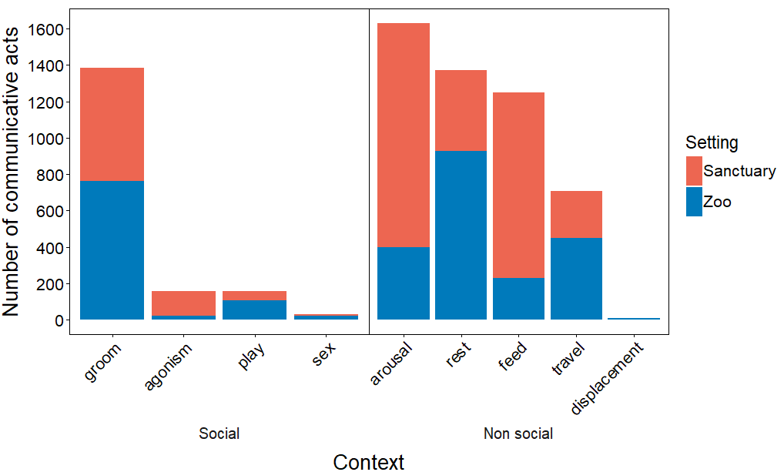
Figure S1: Distribution of the communicative acts across the nine social contexts recorded. Bars represent the number of communicative acts recorded in each research setting.

Table S3: Definition of the modifiers used in the BORIS coding scheme (S: signaller; R: recipient)
Modifier | Definition
Social context | Behaviour of S just before the emission of the signal
agonism | S is engaged in a conflict with either R or other individuals
arousal | S is excited and/or stressed out, often showed by loud vocalizations and/or emotional running
displacement | S expresses stereotypical behaviours
feed | S is eating or being fed
groom | S is grooming or being groomed by R or another individual
play | S is engaged in a play session
sex | S is having sex
travel | S is travelling over a long distance
rest | S is steady or self-grooming
other
NA | unknown due to poor visibility
Sensory channel | Sensory channel through which the signal is perceived by R (multiple choice)
Auditory | S's behaviour produces a sound and is perceived through hearing
Visual | S's behaviour is perceived via eye sight
Seismic | S's behaviour is perceived through substrate movement
Tactile | S's behaviour is perceived through body contact
Co-occurring signal types | Combination with another signal type (multiple choice)
no | no
yes - plus facial | combination with facial expression
yes - plus facial fixed | obligatory combination with facial expression
yes - plus manual | combination with manual gesture
yes - plus body | combination with bodily, non-manual gesture
yes - plus vocal | combination with vocalization
yes - plus vocal fixed | obligatory combination with vocalization
NA | unknown due to poor visibility
Social goal | Apparent aim of S, as evident by cease of communication and previous behaviour
Acquire object | R gives signaller object, e.g. food item
Attend to spec location | R adjusts behaviour to focus attention on indicated location
Climb on me | R (infant) climbs on signaller’s body
Dominance | R acknowledges that S is higher ranking
Affiliation/greeting | R reacts in an apparently affiliative way
Follow me - sex | R follows S, usually in consortship
Move away | R moves away from signaller
Move closer | R moves closer to signaller
Sexual attention | R responds sexually
Seek reassurance | S want R to reassure them
Give reassurance | S want R to calm down
Reposition body | R moves (and hold) body into indicated position
Start grooming | S wants R to groom them
Start play | play between signaller and recipient
Stop action | R either ceases current behaviour or change behaviour to direct it toward another individual
Travel with me | R travels together with S
Tolerance | S signals in a submissive way, no particular behavioural outcome is looked for
Other
NA | unknown
Response | Response of R in reaction to S's behaviour
none | No response or ignorance by R
Social goal | R responds in a way that seems appropriate to S's signal
responds with visual attention only | R looks at S (but no other response)
behavioural response - signal | R responds with a signal - "negotiation”; ≠ from a signal-like response produced as an automatic reaction to S's signal
behavioural response - move away | R moves away from S
behavioural response - aggressive | R reacts in an aggressive or agonistic way to S's signal
NA | Not clearly visible, unknown
Recipient | Recipient ID  Single choice: only dyadic communicative acts are considered - broad behaviour (e.g. vocalizations) for which one precise recipient cannot be identified are not included

Table S4: Distribution of signal cases across different groups, contexts and communicative strategies
 | Social Groups |  |  |  |  | Context
 | Group A | Group B | Group C2 | Group C4 | Group L | Non-social | Social
Multicomponent communicative acts
Non MC | 1194 | 270 | 2305 | 627 | 971 | 3822 | 1545
MC | 209 | 46 | 709 | 44 | 118 | 967 | 159
Multisensory communicative acts
Non MS | 748 | 216 | 1569 | 442 | 752 | 2673 | 1054
MS | 660 | 100 | 1444 | 232 | 355 | 2138 | 653

Table S5: Fixed effects estimates from the random intercept models (including Subject ID as a random effect) for both communicative strategies
Fixed effects | Estimate | Std. Error | Z value | Pr
Multicomponent acts
(Intercept) | - 2.721 | 0.346 | - 7.860 | 3.84e-15 ***
Age | 0.066 | 0.073 | 0.899 | 0.369
SexM | - 0.337 | 0.162 | - 2.084 | 0.037 *
SettingSanctuary | 0.497 | 0.176 | 2.824 | 0.005 ***
ContextSocial | 0.346 | 0.124 | 2.781 | 0.005 ***
RecAttentionState_YNT | 0.149 | 0.134 | 1.115 | 0.265
Multisensory acts
(Intercept) | - 3.341 | 0.309 | - 10. 814 | <2e-16 ***
Age | 0.077 | 0.057 | 1.345 | 0.179
SexM | - 0.080 | 0.126 | - 0.632 | 0.527
SettingSanctuary | 0.293 | 0.132 | 2.219 | 0.027 *
ContextSocial | 0.189 | 0.097 | 1.942 | 0.052
RecAttentionState_YNT | 2.815 | 0.132 | 21.296 | <2e-16 ***

Table S6: BRN model comparison estimates for both communicative strategies (ri = random intercept model; ris = random intercept and slope model)
Model | npar | AIC | BIC | logLik | deviance | Chisq | Df | Pr
Multicomponent acts
ri | 9 | 5041.326 | 5102.332 | -2511.663 | 5023.326 | NA | NA | NA
ris | 12 | 5046.031 | 5127.372 | -2511.015 | 5022.031 | 1.295 | 3 | 0.730
Multisensory acts
ri | 9 | 7437.807 | 7498.847 | -3709.904 | 7419.807 | NA | NA | NA
ris | 12 | 7399.303 | 7480.689 | -3687.651 | 7375.303 | 44.505 | 3 | 1.179e-09

