Additional File 6: Forest Plots for Subgroup Analysis by Intervention Type
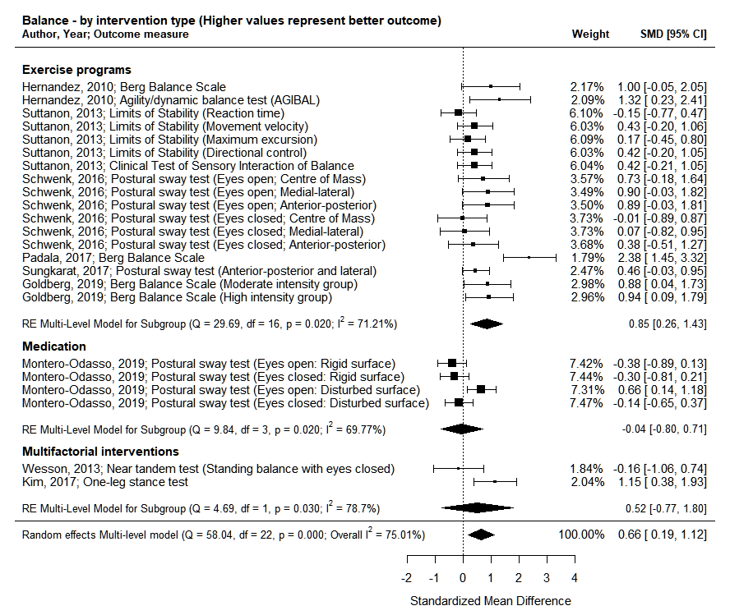
Test for differences between groups (based on Intervention type): p=0.44 (non-significant)
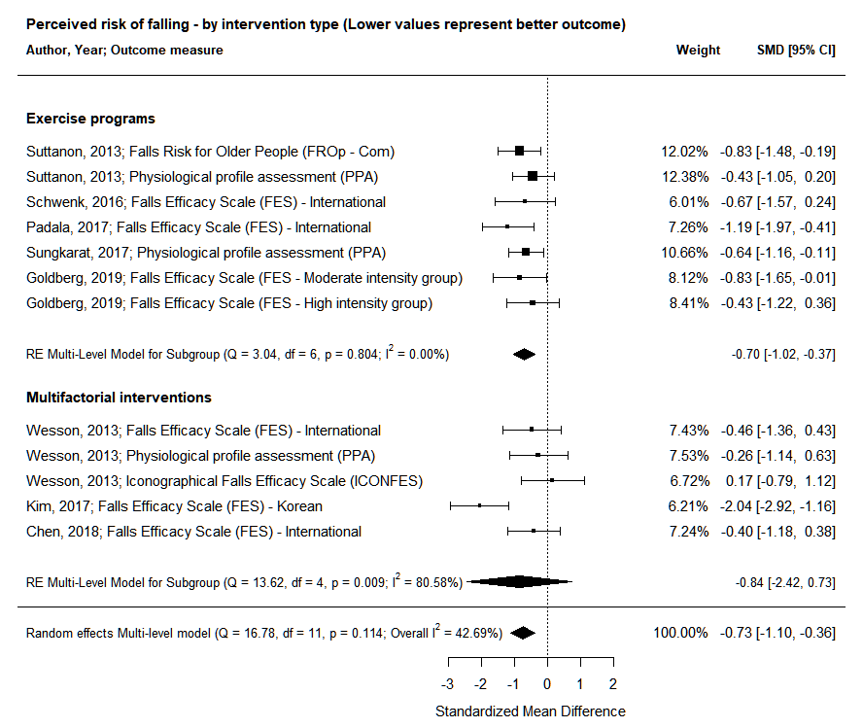
Test for differences between groups (based on Intervention type): p=0.93 (non-significant)
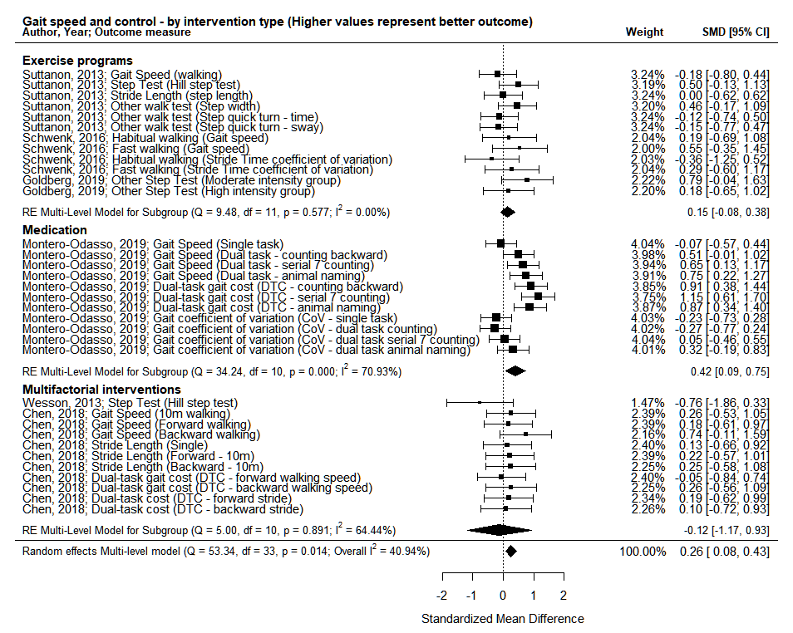
Test for differences between groups (based on Intervention type): p=0.27 (non-significant)

