In silico design and synthesis of novel thiazole derivatives as antitubercular agents
Mr. Vighnesh Dilip Jathar¹, Dr. Nutan Rao¹*

- Department of Pharmaceutical Chemistry, Vivekanand Education Society’s College of Pharmacy (Autonomous), Hashu Advani memorial complex, behind collector’s office, chembur (e), mumbai – 400 074. Chembur, Mumbai, India
*E-mail: nutan.rao@ves.ac.in

SUPPLEMENTARY MATERIAL

The synthesized compound
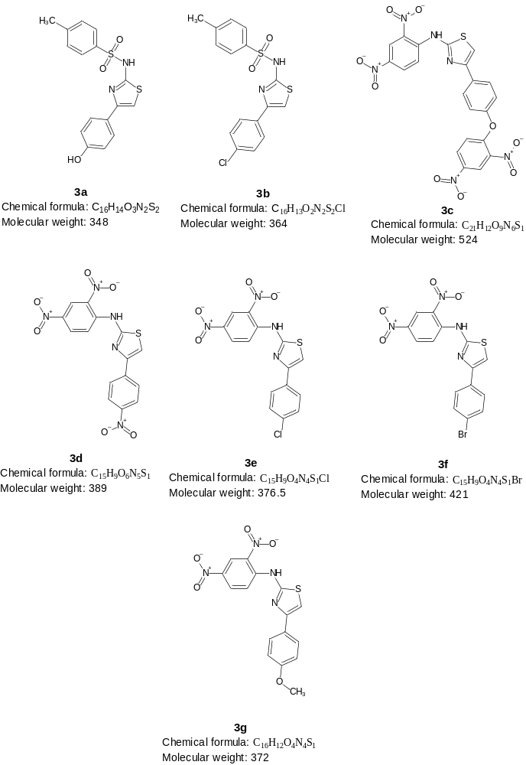

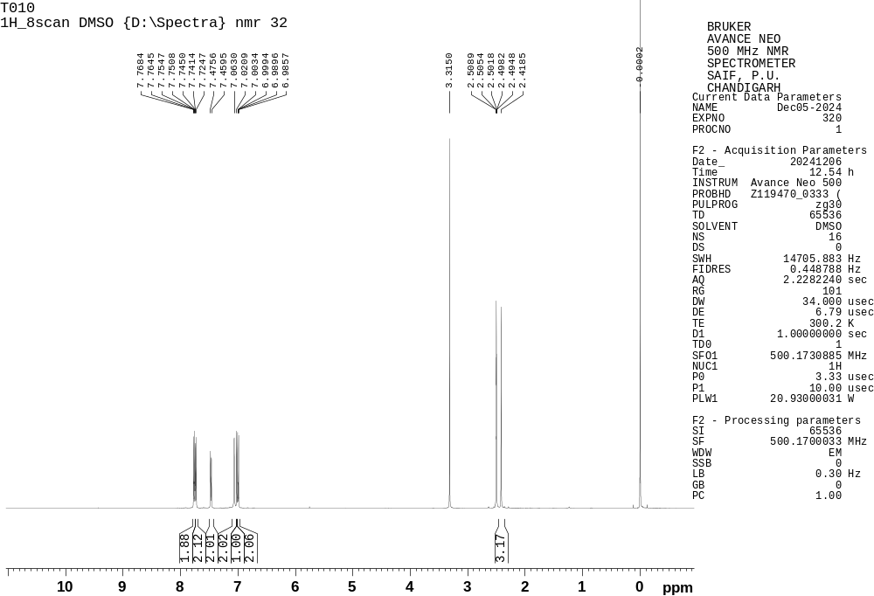
Figure S1. ¹H NMR spectrum of 3a

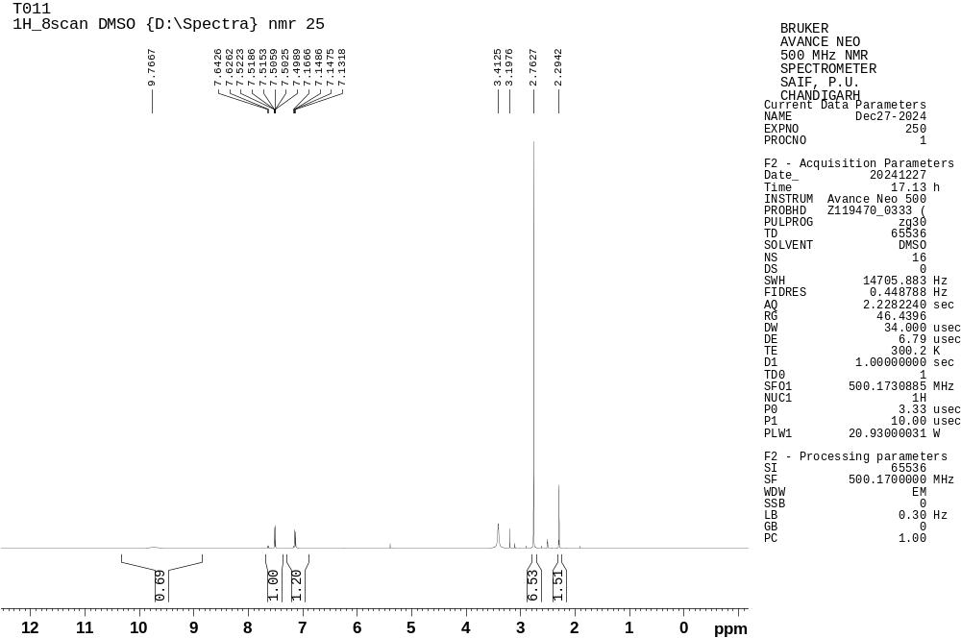
Figure S2. ¹H NMR spectrum of 3b
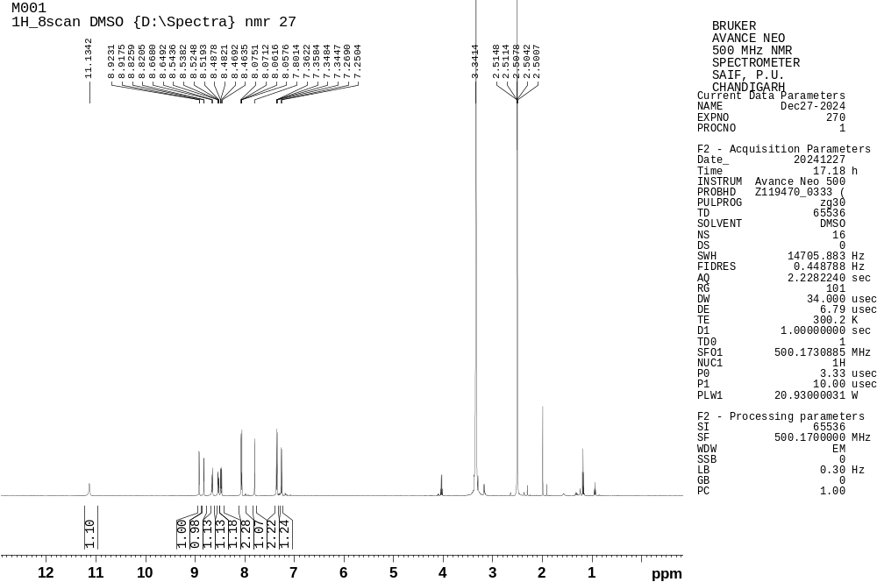
Figure S3. ¹H NMR spectrum of 3c
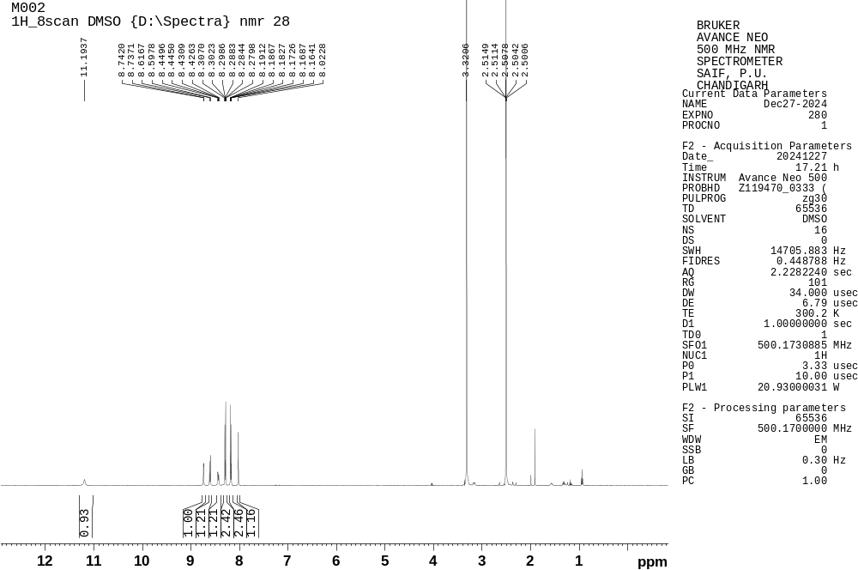
Figure S4. ¹H NMR spectrum of 3d
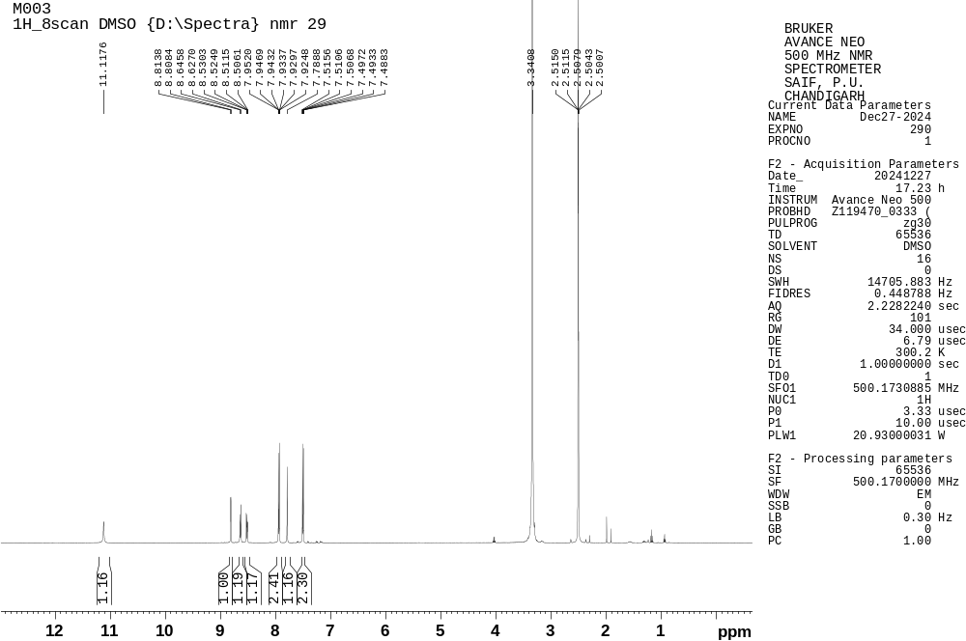
Figure S5. ¹H NMR spectrum of 3e
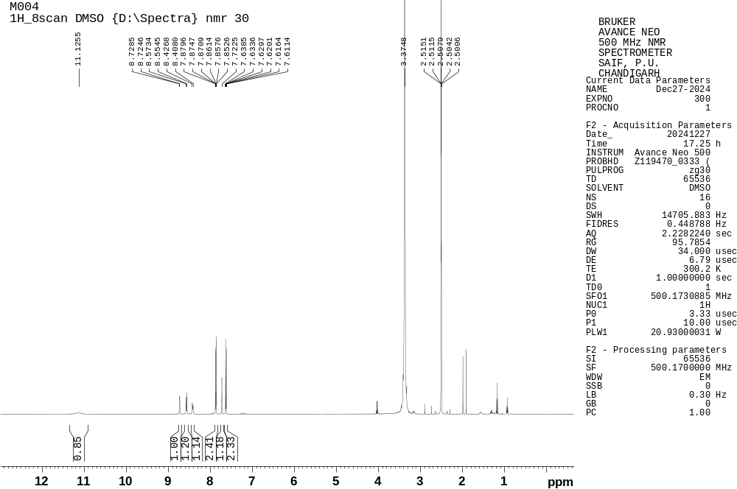
Figure S6. ¹H NMR spectrum of 3f
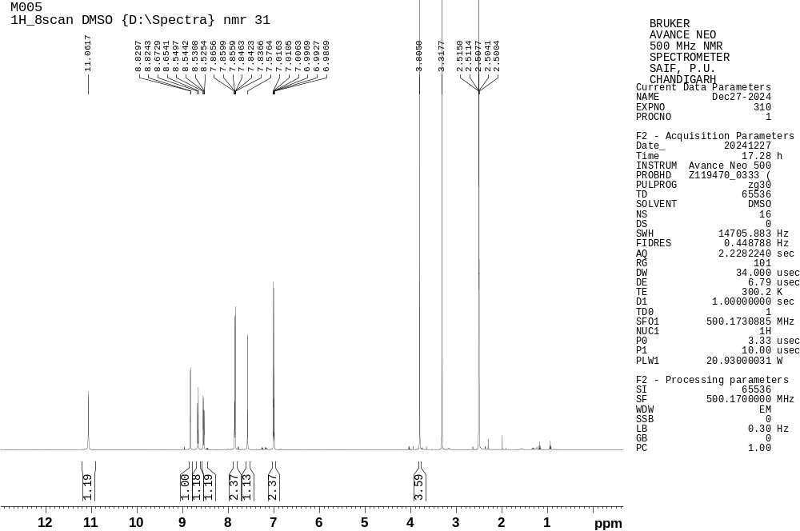
Figure S7. ¹H NMR spectrum of 3g

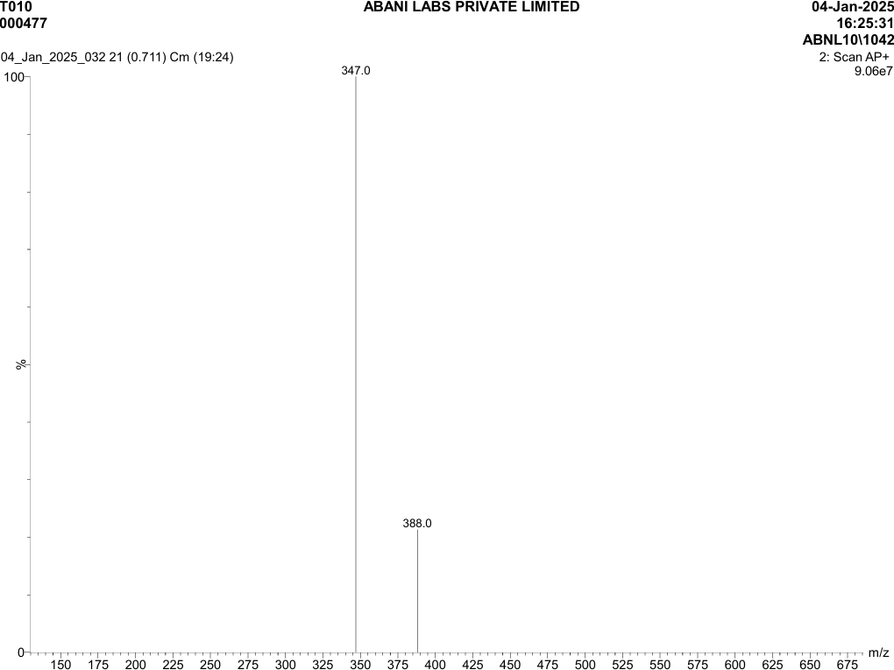
Figure S8. MS [M+H] Spectrum of 3a

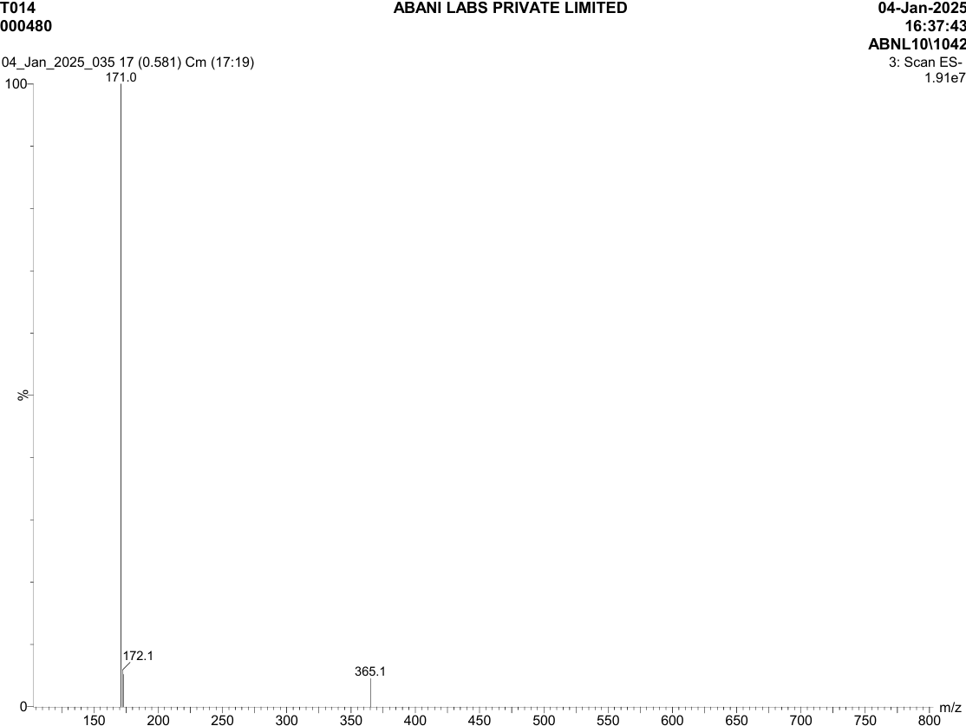
Figure S9. MS [M+H] Spectrum of 3b
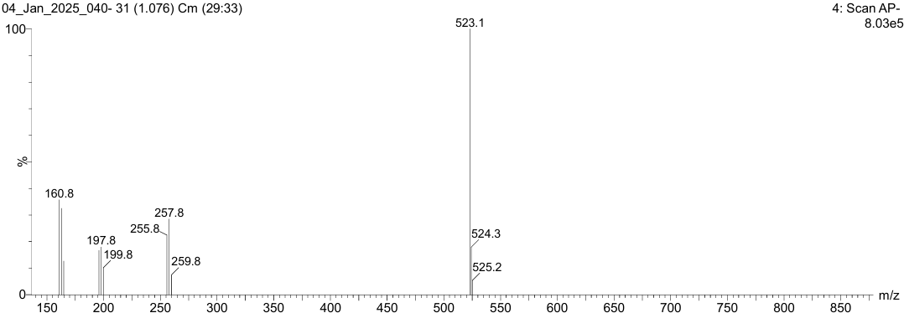
Figure S10. MS [M+H] Spectrum of 3c
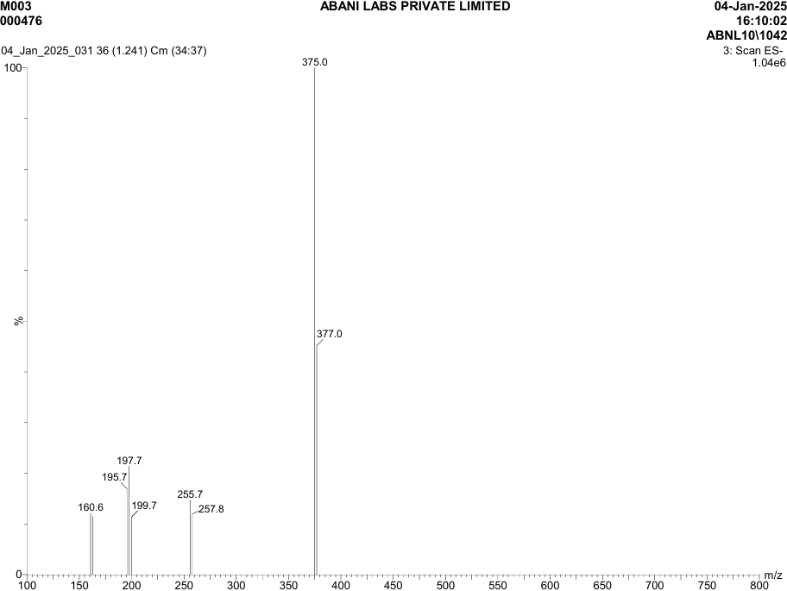
Figure S10. MS [M+H] Spectrum of 3e
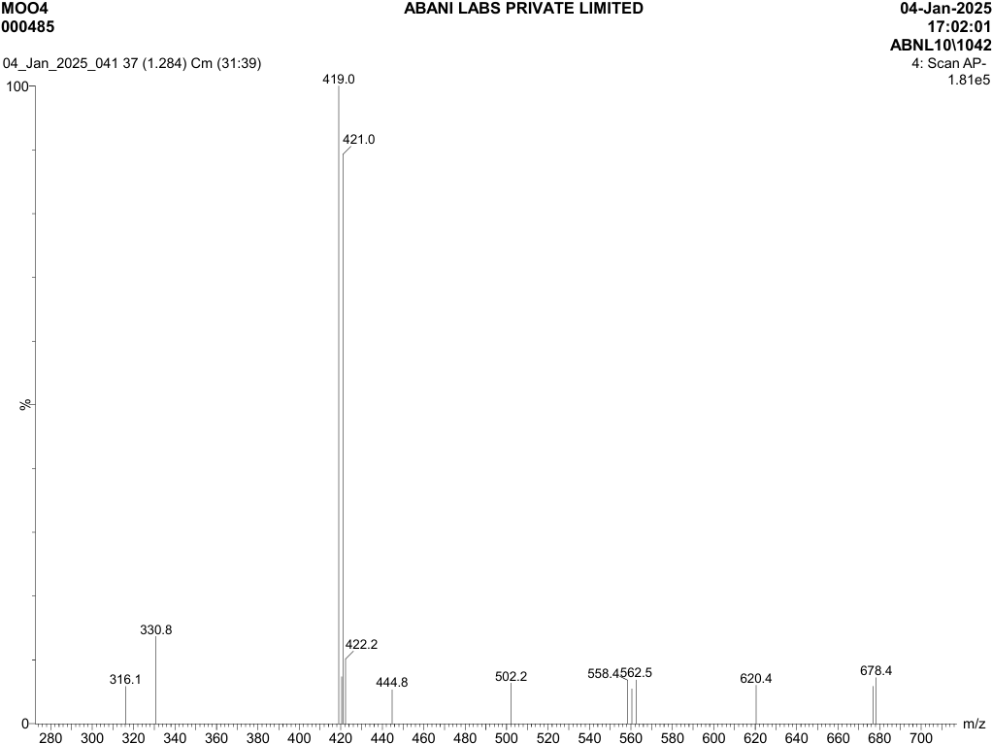
Figure S11. MS [M+H] Spectrum of 3f
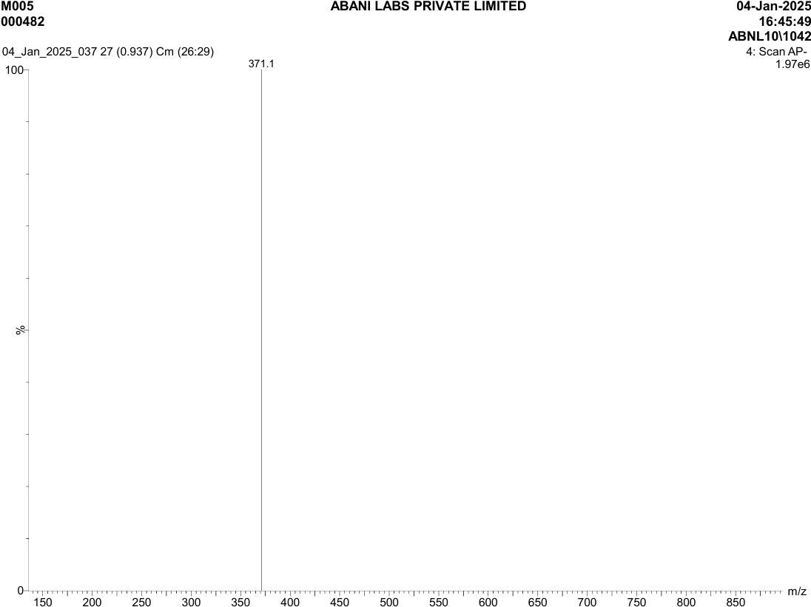
Figure S12. MS [M+H] Spectrum of 3g
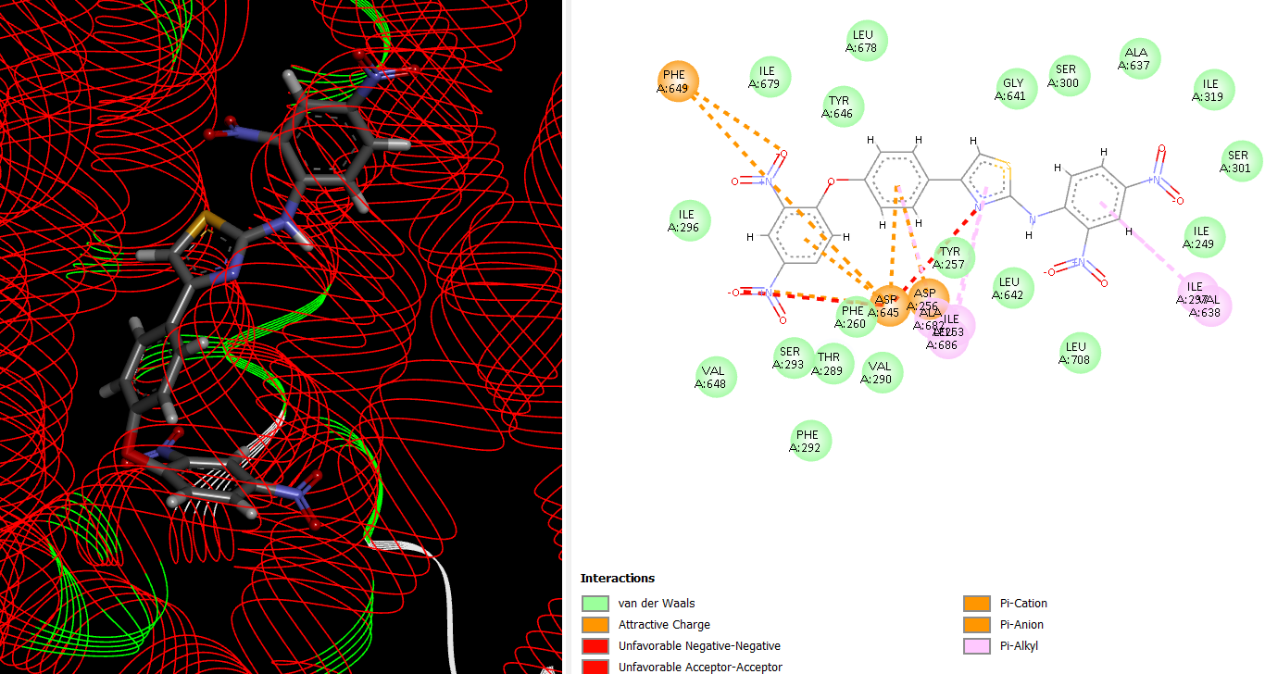
Figure S13. 3D conformer of compound 3c docked on MmpL3 receptor (B) binding interactions of compound 3c with MmpL3 receptor
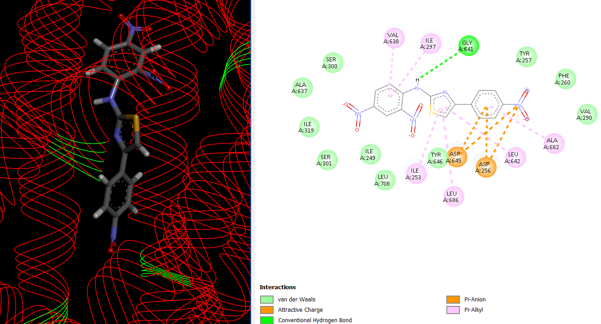
Figure S14. 3D conformer of compound 3d docked on MmpL3 receptor (B) binding interactions of compound 3d with MmpL3 receptor

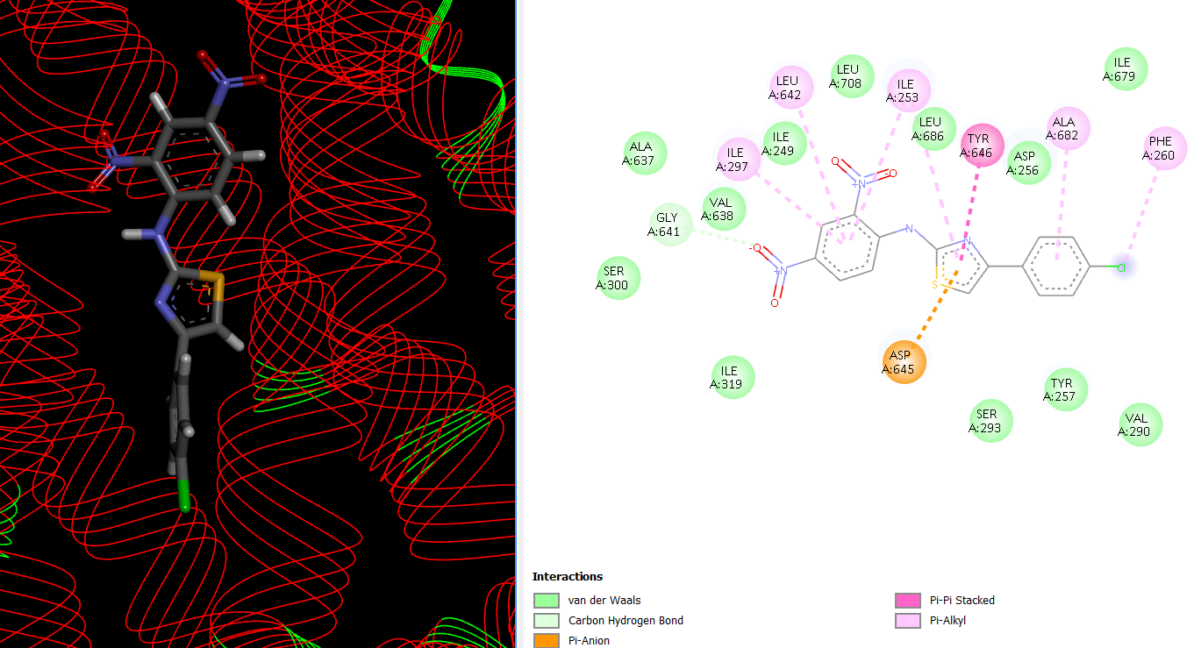
Figure S15. 3D conformer of compound 3e docked on MmpL3 receptor (B) binding interactions of compound 3e with MmpL3 receptor
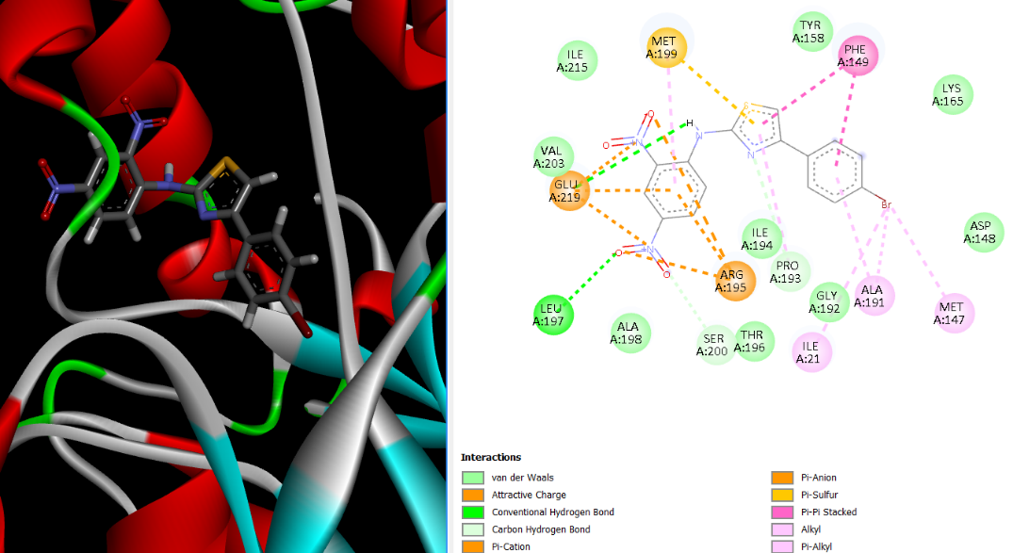
Figure S16. 3D conformer of compound 3f docked on MmpL3 receptor (B) binding interactions of compound 3f with MmpL3 receptor
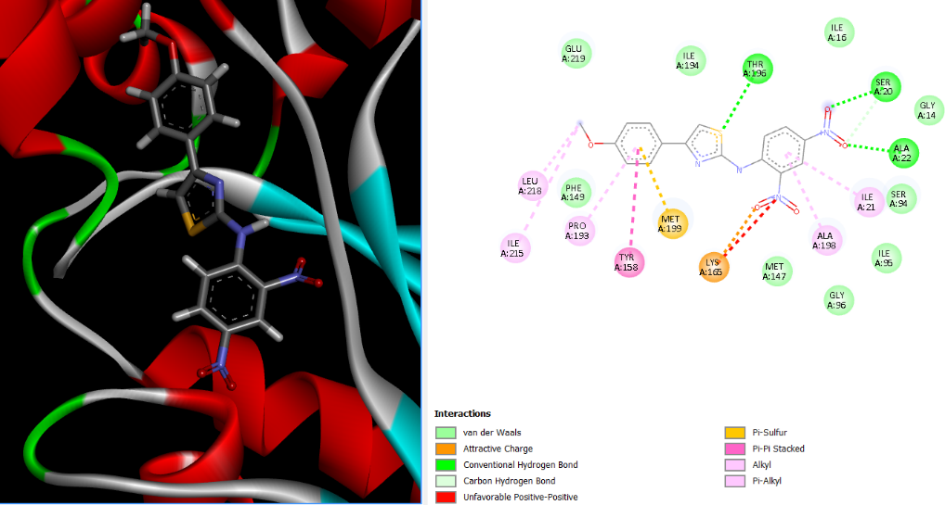
Figure S17. 3D conformer of compound 3g docked on MmpL3 receptor (B) binding interactions of compound 3g with MmpL3 receptor

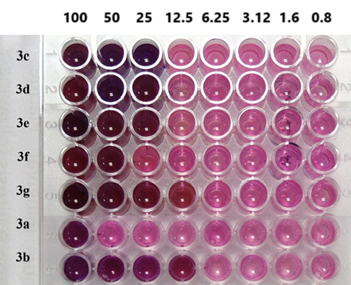
Figure S18. Microplate Alamar Blue Assay for antitubercular activity

