Supplementary Information

Regional, functional and transcriptomic decoding of multidimensional brain structure alterations in obsessive-compulsive disorder

Contents

SUPPLEMENTARY FIGURES 3
Supplementary Figure 1. Data sites. 3
Supplementary Figure 2. Structural similarity networks. 4
Supplementary Figure 3. Intersubject consistency of structural similarity networks. 5
Supplementary Figure 4. Influence of threshold selection on structural similarity networks. 6
Supplementary Figure 5. Regional alterations across cortical and subcortical neuroimaging phenotypes with unadjusted p-values. 7
Supplementary Figure 6. Average effect sizes of case-control comparisons of vertex-wise subcortical area. 8
Supplementary Figure 7. Average effect sizes of case-control comparisons of vertex-wise subcortical area. 9
Supplementary Figure 8. Proportion of vertices showing differences in case-control comparisons of vertex-wise subcortical area. 10
Supplementary Figure 9. Proportion of vertices showing differences in case-control comparisons of vertex-wise radial distance. 11
Supplementary Figure 10. Pairwise correlations among neuroimaging phenotypes. 12
Supplementary Figure 11. Regional alterations across cortical and subcortical neuroimaging phenotypes throughout neurodevelopment 13
Supplementary Figure 12. Leave-one-dataset-out analysis to detect potential influential samples. 14
Supplementary Figure 13. Statistical testing of spatial associations. 15
Supplementary Figure 14. Generalizability and stability of CCA models during split-half cross-validation. 16

SUPPLEMENTARY TABLES 17
Supplementary Table 1. Demographic characteristics of cases and controls. 17
Supplementary Table 2. Clinical characteristics of cases. 19
Supplementary Table 3. Acquisition parameters of MRI data 21
Supplementary Table 4. Demographic characteristics of participants who provided in vivo tissue samples collected during deep brain stimulation procedures. 23

SUPPLEMENTARY FIGURES

Supplementary Figure 1. Data sites.
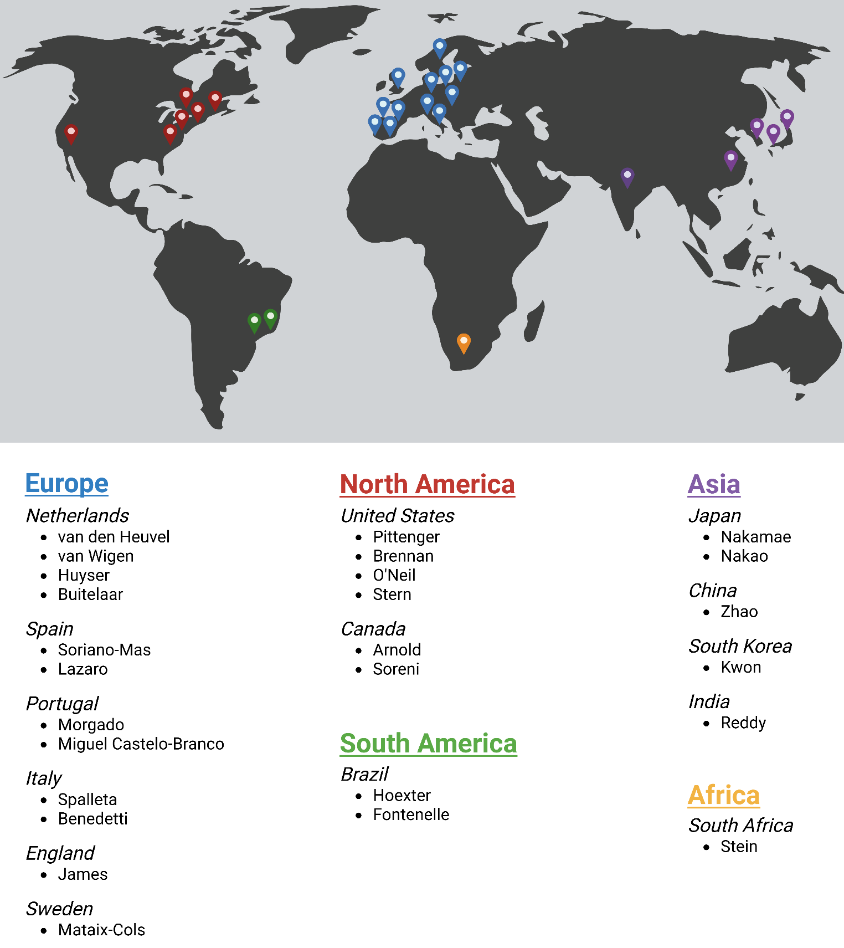

A world map showing the distribution of ENIGMA-OCD sites globally. Note that some sites include more than one dataset, as detailed in Supplementary Tables 1–3.

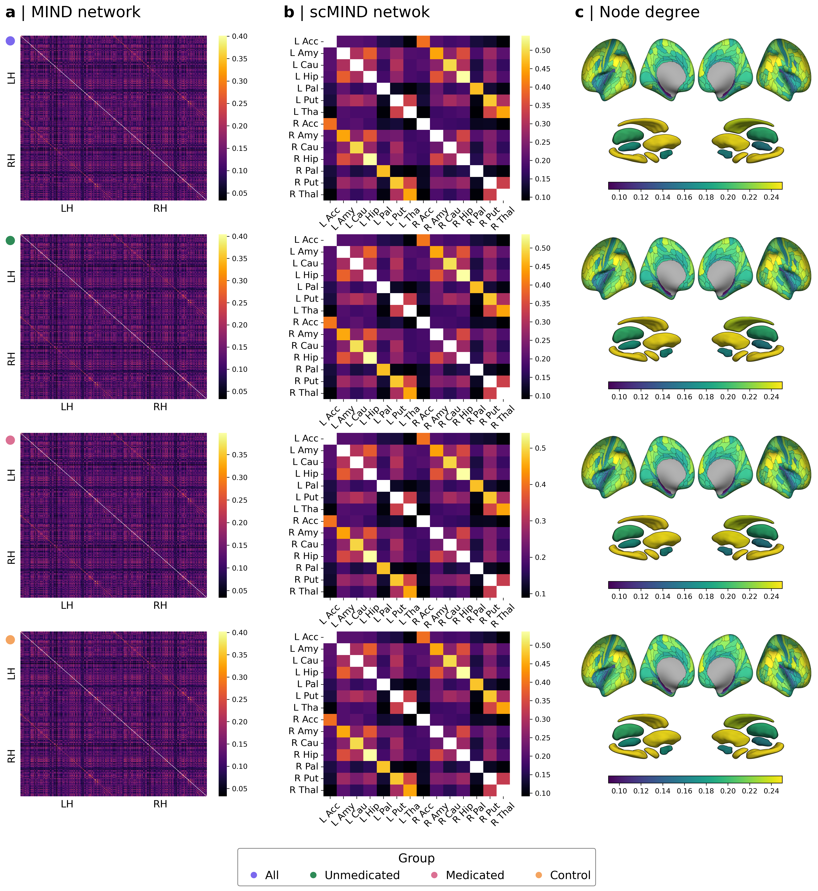
Supplementary Figure 2. Structural similarity networks.
a, for each group, individual-level MIND networks were constructed by computing the inverse of the Kullback-Leibler divergence between multivariate distributions of vertex-wise cortical surface area, thickness, volume, mean curvature, and sulcal depth for each pair of cortical regions defined by the HCPMMP parcellation. Thresholding was not applied to these networks, which were then averaged across participants. b, for each group, individual-level scMIND networks were constructed using the same similarity metric as the MIND networks but applied to the multivariate distributions of the Jacobian determinant (a proxy for surface area) and radial distance for each pair of seven subcortical regions: the amygdala, thalamus, hippocampus, caudate, putamen, pallidum, and accumbens. Non-thresholded networks were then averaged across participants. c, for the group-averaged MIND and scMIND networks, nodal degree was computed as the average edge weight of all edges connected to a region for cortical and subcortical regions, respectively.

Supplementary Figure 3. Intersubject consistency of structural similarity networks.

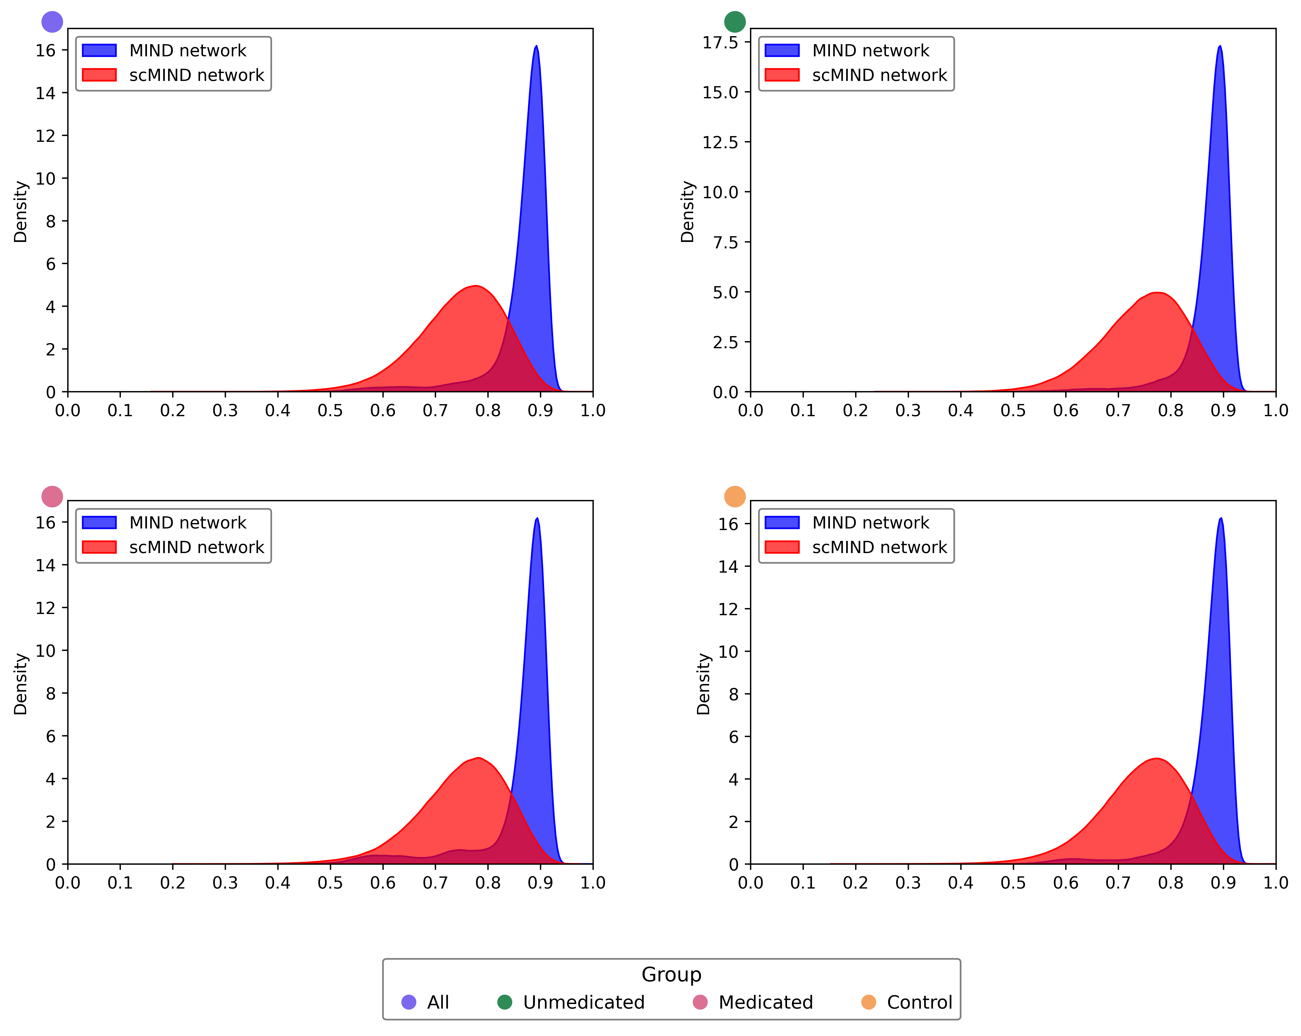

To assess inter-subject consistency of MIND and scMIND networks in all OCD cases (purple), unmedicated OCD cases (green), medicated OCD cases (pink), and controls (yellow), individual-level networks were computed for each group without thresholding. The upper diagonal edges of these networks were correlated between all possible pairs of individuals within each group. For each group, the resulting correlation distributions were plotted as density plots. Both networks showed high inter-subject consistency, with MIND networks exhibiting slightly higher average consistency and lower variability compared to scMIND networks.

Supplementary Figure 4. Influence of threshold selection on structural similarity networks.

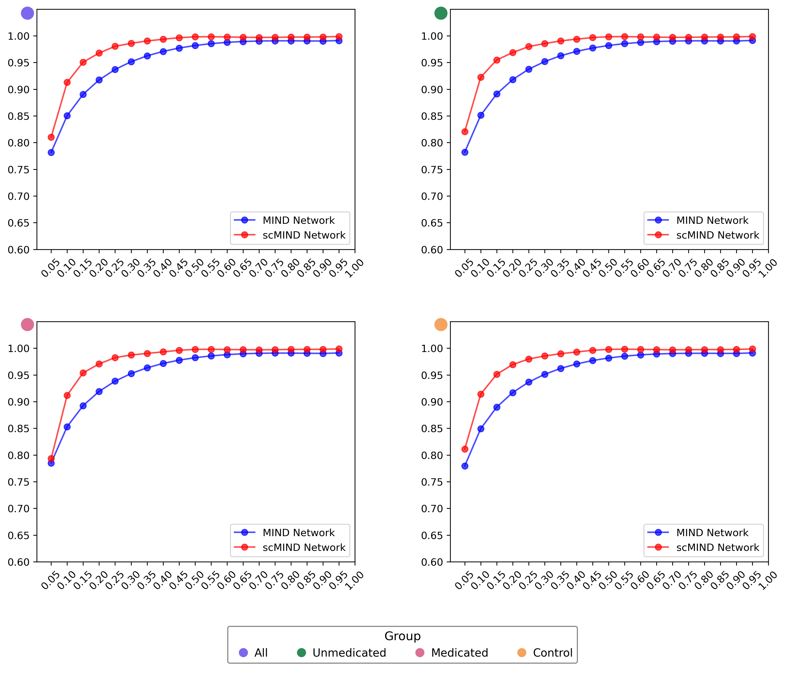

To examine the influence of thresholding on MIND and scMIND networks among all OCD cases (purple), unmedicated OCD cases (green), medicated OCD cases (pink), and controls (yellow), individual-level networks were computed for each group. These networks were thresholded at densities ranging from 5% to 100% in increments of 5%. For each threshold, the individual-level networks were averaged within each group to generate group-level networks. The Pearson correlation was then computed between the group-level network at each threshold and the corresponding group-level unthresholded network. The results were plotted, showing that both MIND and scMIND group-level networks exhibited high correlations across all thresholds in all groups, indicating robustness to the choice of threshold at the individual level.

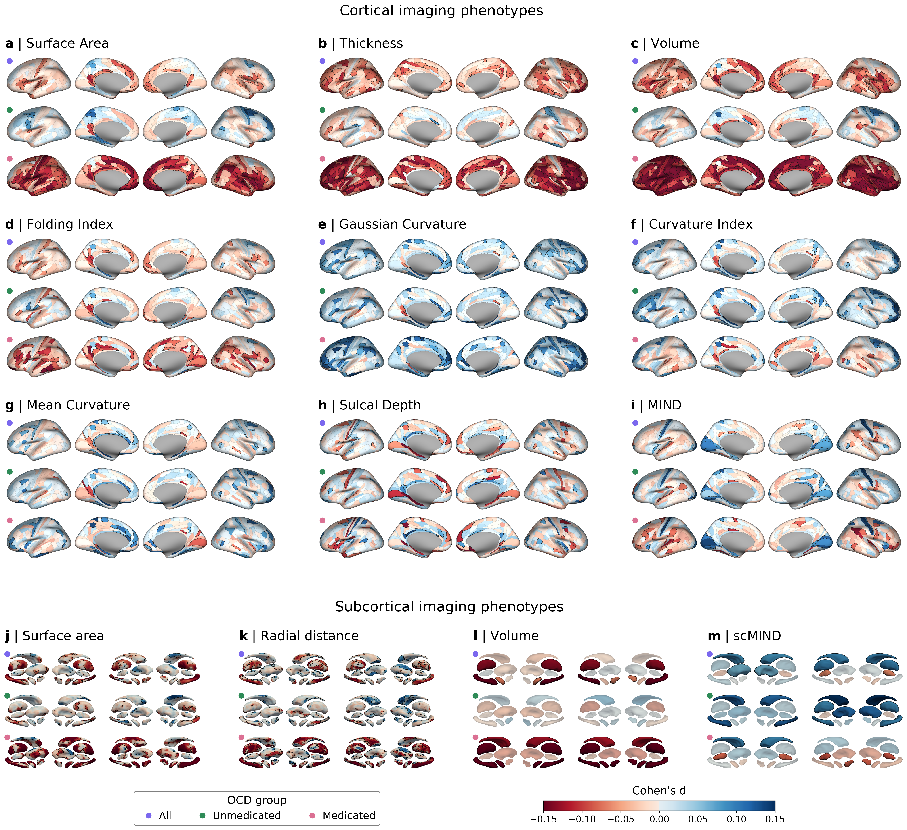
Supplementary Figure 5. Regional alterations across cortical and subcortical neuroimaging phenotypes with unadjusted p-values.

Results shown here are similar to Figure 2, with the only difference being that statistically significant regions (or vertices) without FDR correction are emphasized with bold colors, while non-significant regions are muted.

Supplementary Figure 6. Average effect sizes of case-control comparisons of vertex-wise subcortical area.

Linear models were used to compare cases and controls for vertex-wise subcortical area (proxied by the Jacobian determinant) across seven subcortical regions, as estimated using the ENIGMA shape analysis pipeline. These models controlled for age, sex, total intracranial volume, and Euler number. Comparisons were conducted separately for all OCD cases, unmedicated cases, and medicated cases. For all OCD cases (purple), unmedicated OCD cases (green), and medicated OCD cases (pink), statistically significant positive (blue) and negative (red) Cohen's d effect sizes for the diagnosis — before FDR correction (left) and after FDR correction (right) — were averaged separately for each subcortical region. Thal, Thalamus; Put, Putamen; Pall, Pallidum; Hipp, Hippocampus; Caud, Caudate; Amyg, Amygdala; Acc, Accumbens.

Supplementary Figure 7. Average effect sizes of case-control comparisons of vertex-wise subcortical area.

Linear models were used to compare cases and controls for vertex-wise radial distance across seven subcortical regions, as estimated using the ENIGMA shape analysis pipeline. These models controlled for age, sex, total intracranial volume, and Euler number. Comparisons were conducted separately for all OCD cases, unmedicated cases, and medicated cases. For all OCD cases (purple), unmedicated OCD cases (green), and medicated OCD cases (pink), statistically significant positive (blue) and negative (red) Cohen's d effect sizes for the diagnosis — before FDR correction (left) and after FDR correction (right) — were averaged separately for each subcortical region. Thal, Thalamus; Put, Putamen; Pall, Pallidum; Hipp, Hippocampus; Caud, Caudate; Amyg, Amygdala; Acc, Accumbens.

Supplementary Figure 8. Proportion of vertices showing differences in case-control comparisons of vertex-wise subcortical area.

Linear models were used to compare cases and controls for vertex-wise subcortical area (proxied by the Jacobian determinant) across seven subcortical regions, as estimated using the ENIGMA shape analysis pipeline. These models controlled for age, sex, total intracranial volume, and Euler number. Comparisons were conducted separately for all OCD cases, unmedicated cases, and medicated cases. For all OCD cases (purple), unmedicated OCD cases (green), and medicated OCD cases (pink), the proportion of vertices with statistically significant positive (blue) and negative (red) diagnosis effects — before FDR correction (left) and after FDR correction (right) — was plotted separately for each subcortical region. Thal, Thalamus; Put, Putamen; Pall, Pallidum; Hipp, Hippocampus; Caud, Caudate; Amyg, Amygdala; Acc, Accumbens.

Supplementary Figure 9. Proportion of vertices showing differences in case-control comparisons of vertex-wise radial distance.

Linear models were used to compare cases and controls for vertex-wise radial distance across seven subcortical regions, as estimated using the ENIGMA shape analysis pipeline. These models controlled for age, sex, total intracranial volume, and Euler number. Comparisons were conducted separately for all OCD cases, unmedicated cases, and medicated cases. For all OCD cases (purple), unmedicated OCD cases (green), and medicated OCD cases (pink), the proportion of vertices with statistically significant positive (blue) and negative (red) diagnosis effects — before FDR correction (left) and after FDR correction (right) — was plotted separately for each subcortical region. Thal, Thalamus; Put, Putamen; Pall, Pallidum; Hipp, Hippocampus; Caud, Caudate; Amyg, Amygdala; Acc, Accumbens.

Supplementary Figure 10. Pairwise correlations among neuroimaging phenotypes.
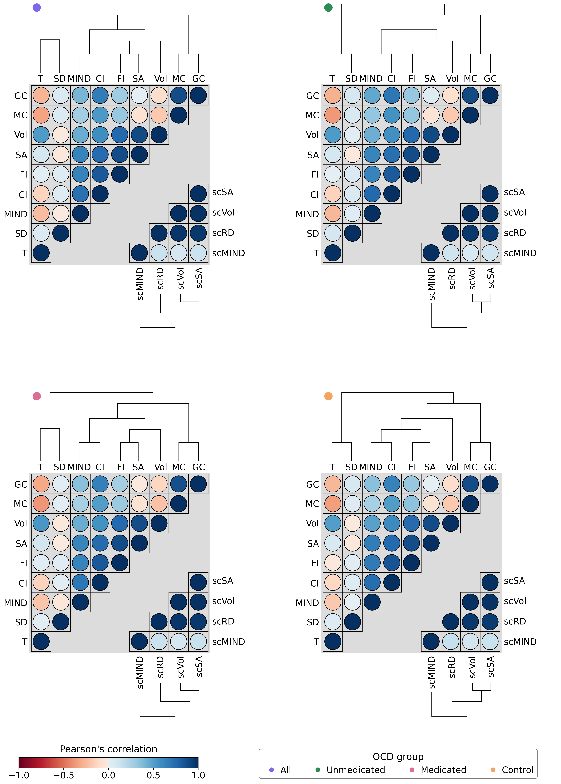

For all OCD cases (purple), unmedicated OCD cases (green), medicated OCD cases (pink), and controls (yellow), neuroimaging phenotypes were averaged across regions. Pearson correlation coefficients were then computed between all pairs of neuroimaging phenotypes. Hierarchical clustering was then applied to the resulting cortical and subcortical correlation matrices. SA, Surface Area; T, Thickness; Vol, Volume; FI, Folding Index; GC, Gaussian Curvature; CI, Curvature Index; MC, Mean Curvature; SD, Sulcal Depth; scSA, subcortical Surface Area (Jacobian); scRD, subcortical Radial Distance; scVol, subcortical Volume.

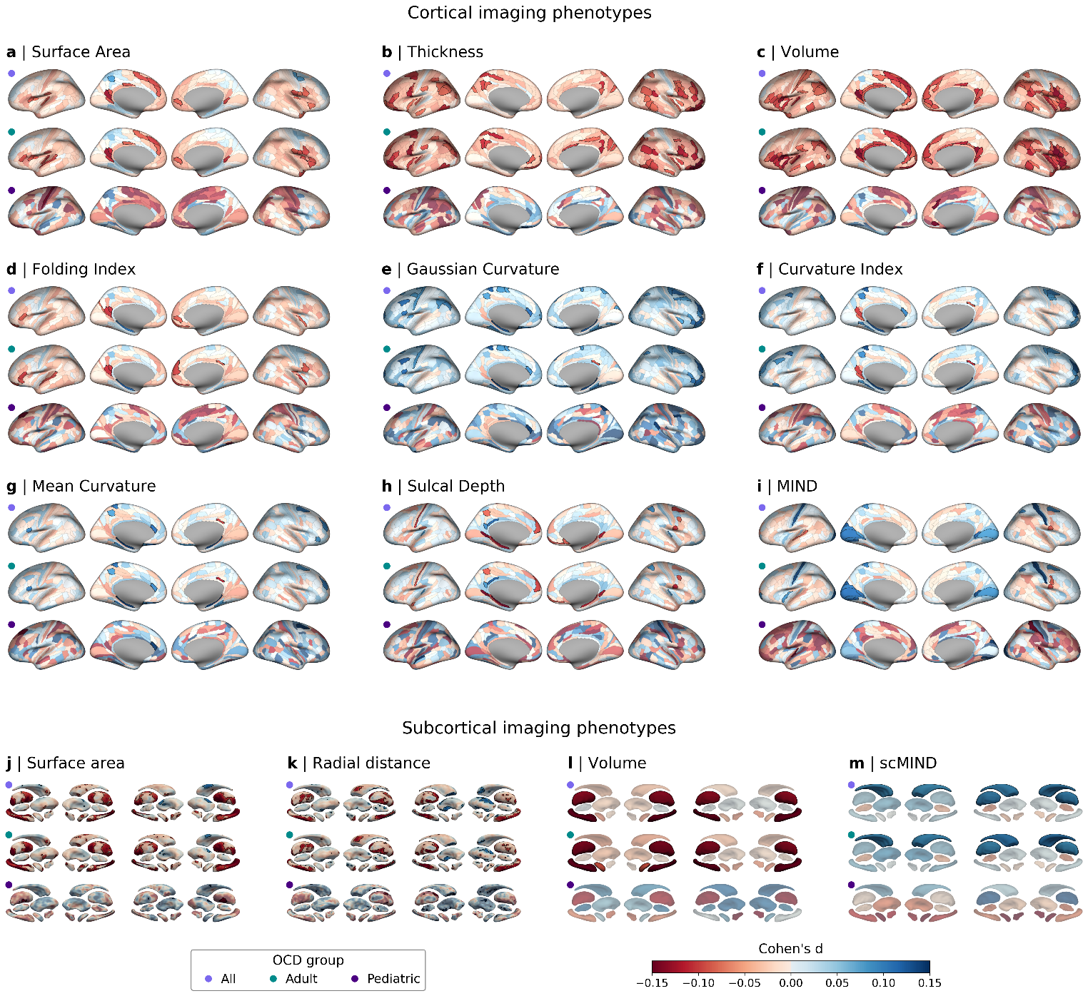
Supplementary Figure 11. Regional alterations in OCD across cortical and subcortical neuroimaging phenotypes throughout neurodevelopment

This analysis is similar to that presented in Figure 1 but stratifies participants into pediatric (age < 18 years) and adult (age ≥ 18 years) subgroups. As in Figure 1, FDR correction for multiple comparisons was applied across subgroups (all, purple; adult, green; pediatric, dark purple), neuroimaging phenotypes, regions, and both tails of the distribution. As a result, the results for all participants shown in this figure may differ slightly from those presented in Figure 1, due to the application of FDR correction across different subgroups in the analysis shown here.

Supplementary Figure 12. Leave-one-dataset-out analysis to detect potential influential samples.
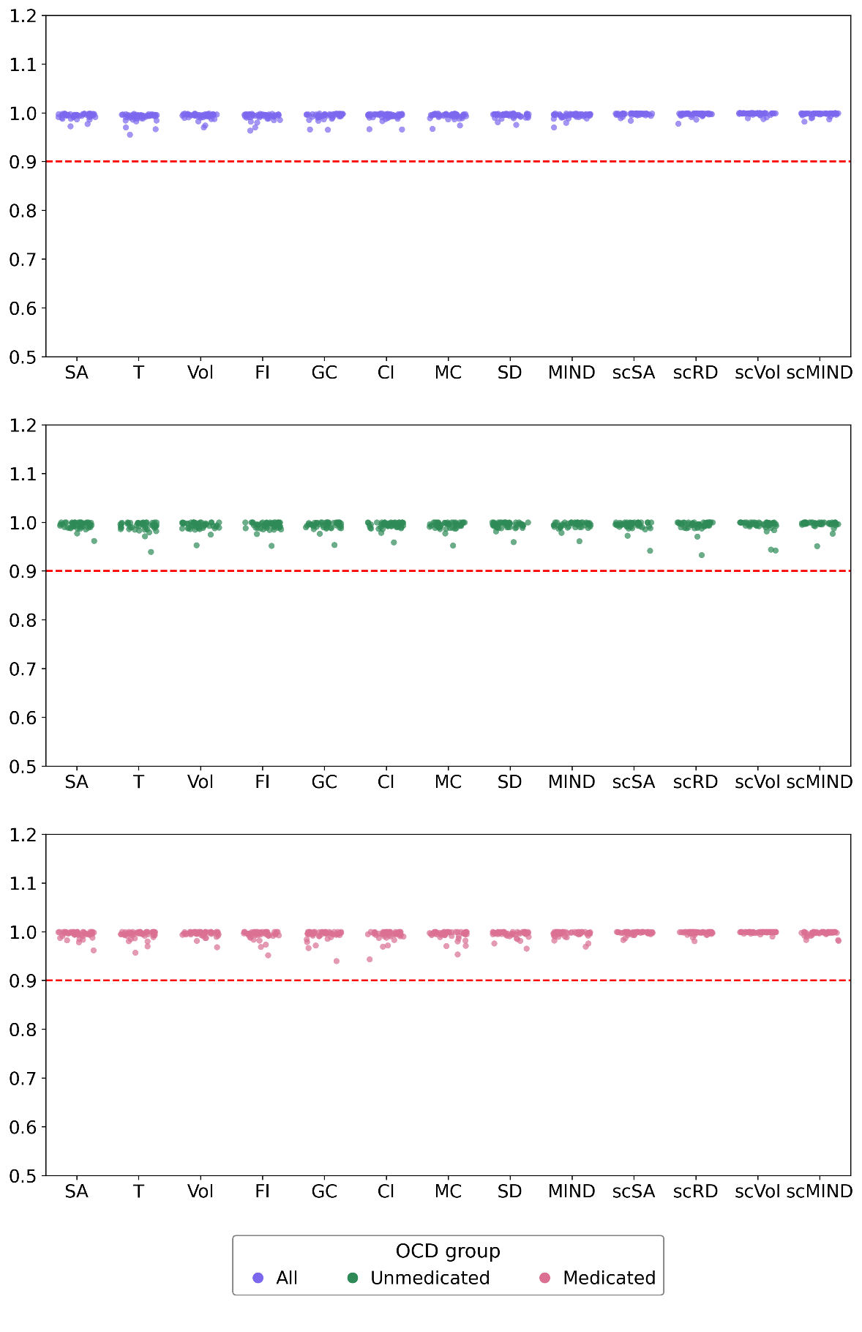

To assess potential influential samples in the linear models comparing case-control differences in structural neuroimaging phenotypes, a leave-one-out sensitivity analysis was performed. For each structural neuroimaging phenotype, the linear models were re-estimated by leaving one sample out, and the Cohen's d values for regional case-control differences (either across regions or vertices) were Pearson-correlated with the corresponding Cohen's d values obtained using the full dataset. This analysis was conducted separately for the case-control comparisons of all OCD cases, unmedicated OCD cases, and medicated OCD cases. In the strip plots, the y-axis represents the Pearson correlation, with the horizontal red line indicating a correlation of 0.9. Each dot represents a sample that was omitted in the analysis.

Supplementary Figure 13. Statistical testing of spatial associations.
The spatial testing workflow begins by estimating effect sizes for each brain region and neuroimaging phenotype using linear models, where Y represents an neuroimaging phenotype for a region, X is the variable of interest (diagnosis), and Z contains nuisance variables (age, sex, total intracranial volume, and Euler number). Permuted effect sizes are computed using the Freedman-Lane approach by first fitting a nuisance-only model to express Y as the sum of the estimated response (Ŷ_{z}) and residuals (res_{z}). These residuals capture variance not explained by the nuisance variables and are permuted via multiplication with a permutation matrix (P). Applying this approach across regions and neuroimaging phenotypes generates an OCD-control effect size matrix with permuted effect sizes (note that this can be done more efficiently, as described in the Methods section, using residual-forming and projection matrices from the nuisance-only model). This OCD-control matrix is then subjected to canonical correlation analysis with transcriptional components derived from the Allen Human Brain Atlas via diffusion map embedding. Repeating this process multiple times enables estimation of surrogate distributions for canonical correlations and cross-loadings, which are used for statistical testing.

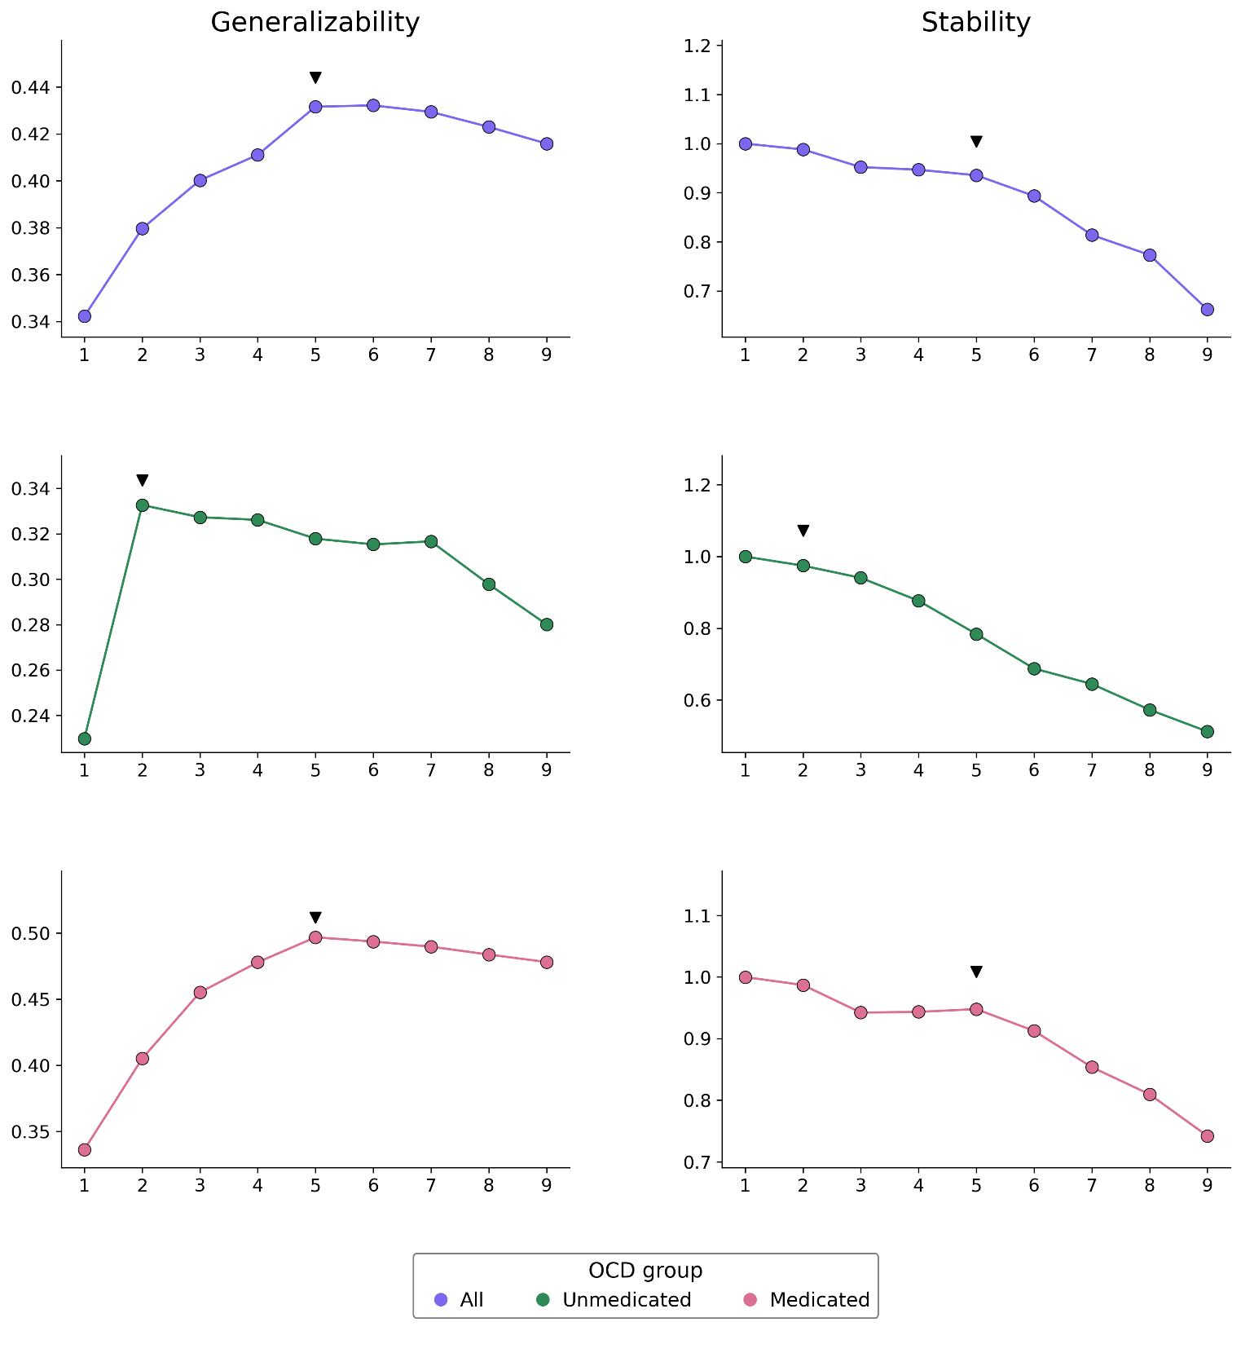
Supplementary Figure 14. Generalizability and stability of CCA models during split-half cross-validation.
The performance of canonical correlation analysis (CCA) models linking OCD-control maps to the three transcriptional components from the Allan Human Brain Atlas (AHBA) was assessed via a split-half cross-validation approach. First, OCD and control participants were split into training and testing sets. For each set, Cohen’s d values for OCD-control differences were computed. CCA was then performed on the training set, and the first canonical correlation was computed on the testing set. This procedure was repeated for all 551 possible map combinations. Model performance was defined as the average of two metrics: (1) the mean out-of-sample canonical correlation with the three transcriptional components (indicating generalizability of association) and (2) the mean correlation of CCA weights across training folds (indicating model stability). The left plots show the highest average out-of-sample canonical correlation for models with N maps (1 ≤ N ≤ 9) as indicated on the x axis, while the right plots show the highest average correlation of model weights for the same range of N. These analyses were conducted separately for all OCD cases (purple), unmedicated OCD cases (green), and medicated OCD cases (pink).

SUPPLEMENTARY TABLES

Supplementary Table 1. Demographic characteristics of cases and controls.

 |  | OCD |  |  |  | Control
PI | n | Age  (Mean ± SD) | Sex  (% male) |  | n | Age  (Mean ± SD) | Sex  (% male)
Arnold | 19 | 11.96 ± 2.09 | 57.9 |  | 17 | 12.52 ± 2.68 | 52.9
Benedetti | 89 | 35.08 ± 11.13 | 66.3 |  | 75 | 32.52 ± 12.51 | 41.3
Benedetti | 20 | 40.00 ± 10.78 | 60.0 |  | 28 | 31.39 ± 11.82 | 57.1
Brennan | 27 | 30.93 ± 11.10 | 59.3 |  | 21 | 34.43 ± 12.03 | 47.6
Buitellar | 21 | 10.19 ± 1.40 | 61.9 |  | 60 | 10.45 ± 1.02 | 71.7
Castelo-Branco | 15 | 31.20 ± 9.16 | 53.3 |  | 15 | 30.53 ± 8.88 | 53.3
Castelo-Branco | 19 | 31.11 ± 9.78 | 100.0 |  | 22 | 26.09 ± 5.30 | 100.0
Fontenelle | 27 | 38.48 ± 13.45 | 59.3 |  | 28 | 35.04 ± 11.99 | 46.4
van den Heuvel | 13 | 32.85 ± 10.29 | 76.9 |  | 52 | 37.92 ± 12.69 | 67.3
van den Heuvel | 41 | 37.61 ± 10.08 | 46.3 |  | 38 | 39.18 ± 11.43 | 50.0
van den Heuvel | 54 | 33.54 ± 9.19 | 29.6 |  | 47 | 31.40 ± 7.47 | 38.3
van den Heuvel | 46 | 34.00 ± 10.78 | 52.2 |  | 41 | 32.39 ± 10.43 | 43.9
Hoexter | 38 | 30.74 ± 9.10 | 36.8 |  | 36 | 27.33 ± 7.66 | 33.3
Hoexter | 126 | 31.16 ± 13.75 | 40.5 |  | 75 | 25.83 ± 13.53 | 41.3
Huyser | 29 | 13.34 ± 2.55 | 37.9 |  | 26 | 13.19 ± 2.83 | 38.5
James | 26 | 16.62 ± 1.58 | 53.8 |  | 26 | 16.50 ± 1.48 | 53.8
Kwon | 105 | 25.26 ± 6.52 | 63.8 |  | 89 | 26.26 ± 6.90 | 60.7
Kwon | 45 | 24.76 ± 5.36 | 75.6 |  | 99 | 24.02 ± 3.43 | 55.6
Kwon | 41 | 28.10 ± 6.71 | 63.4 |  | 45 | 24.89 ± 5.35 | 64.4
Lazaro | 64 | 14.91 ± 2.27 | 59.4 |  | 41 | 15.46 ± 2.03 | 51.2
Mataix-Cols | 44 | 38.68 ± 10.90 | 43.2 |  | 33 | 36.12 ± 11.26 | 36.4
Morgado | 46 | 30.41 ± 10.61 | 39.1 |  | 109 | 29.88 ± 9.22 | 41.3
Morgado | 74 | 29.73 ± 9.75 | 41.9 |  | 103 | 27.35 ± 7.69 | 37.9
Nakamae | 81 | 31.99 ± 9.31 | 46.9 |  | 48 | 30.25 ± 7.80 | 41.7
Nakamae | 34 | 33.31 ± 9.70 | 35.3 |  | 39 | 30.18 ± 7.47 | 46.2
Nakao | 47 | 33.26 ± 11.12 | 38.3 |  | 55 | 33.44 ± 10.51 | 36.4
O Neil | 49 | 33.31 ± 11.04 | 51.0 |  | 25 | 30.76 ± 11.77 | 56.0
O Neil | 53 | 12.47 ± 2.76 | 49.1 |  | 37 | 13.19 ± 2.55 | 48.6
Pittenger | 34 | 34.35 ± 12.92 | 50.0 |  | 76 | 32.78 ± 10.31 | 60.5
Pittenger | 20 | 36.70 ± 12.09 | 30.0 |  | 23 | 34.26 ± 14.06 | 30.4
Pittenger | 39 | 31.41 ± 11.38 | 46.2 |  | 34 | 29.62 ± 7.98 | 61.8
Reddy | 234 | 29.38 ± 6.92 | 53.0 |  | 197 | 26.78 ± 4.99 | 62.4
Reddy | 15 | 14.07 ± 1.79 | 53.3 |  | 15 | 13.40 ± 2.35 | 53.3
Reddy | 47 | 26.87 ± 6.53 | 63.8 |  | 45 | 27.29 ± 6.51 | 73.3
Soreni | 25 | 12.88 ± 2.55 | 32.0 |  | 20 | 11.70 ± 2.94 | 40.0
Soriano-  Mas | 33 | 33.00 ± 10.10 | 36.4 |  | 33 | 28.52 ± 5.52 | 39.4
Soriano-  Mas | 160 | 35.46 ± 9.47 | 51.9 |  | 137 | 34.22 ± 9.77 | 54.0
Spalletta | 16 | 33.75 ± 9.85 | 81.2 |  | 39 | 34.47 ± 11.11 | 43.6
Spalletta | 86 | 36.48 ± 11.86 | 65.1 |  | 115 | 36.76 ± 10.74 | 61.7
Stein | 31 | 33.29 ± 12.03 | 38.7 |  | 22 | 31.55 ± 11.04 | 27.3
Stein | 22 | 31.86 ± 10.83 | 54.5 |  | 26 | 31.92 ± 11.02 | 30.8
Stern | 13 | 28.08 ± 8.06 | 23.1 |  | 10 | 25.10 ± 3.60 | 40.0
Stern | 77 | 33.00 ± 12.58 | 36.4 |  | 16 | 36.12 ± 12.47 | 43.8
Stern | 5 | 38.80 ± 16.39 | 40.0 |  | 50 | 31.44 ± 10.35 | 52.0
van Wingen | 22 | 34.14 ± 10.31 | 50.0 |  | 24 | 32.75 ± 13.45 | 50.0
van Wingen | 31 | 30.94 ± 9.37 | 54.8 |  | 14 | 31.57 ± 9.24 | 42.9
Zhao | 52 | 28.23 ± 9.25 | 55.8 |  | 38 | 26.00 ± 7.59 | 55.3
All | 2255 | 29.96 ± 11.57 | 48.8 |  | 2264 | 28.66 ± 10.98 | 48.5

Supplementary Table 2. Clinical characteristics of cases.

PI | % medicated  (n = 1914) | YBOCS (Mean ± SD)  (n = 1988) | % late-onset  (n = 1734) | % depression  (n = 1854) | % anxiety  (n = 1823) | Illness duration (Mean ± SD)  (n = 788)
Arnold | - | 23.12 ± 4.74 | - | - | - | -
Benedetti | 74.7 | 30.91 ± 5.53 | 32.1 | 12.9 | 1.2 | 19.92 ± 11.37
Benedetti | 100.0 | 29.87 ± 4.84 | 43.8 | 11.8 | 17.6 | 23.69 ± 12.47
Brennan | 71.4 | 25.85 ± 5.05 | 22.2 | 37.0 | - | 18.30 ± 12.33
Buitellar | 38.1 | 14.10 ± 8.55 | 0.0 | 0.0 | 0.0 | -
Castelo-Branco | 93.3 | 26.00 ± 6.20 | 50.0 | 0.0 | 0.0 | 13.91 ± 7.49
Castelo-Branco | 94.7 | - | 21.1 | 0.0 | 0.0 | 15.33 ± 11.33
Fontenelle | 100.0 | 26.96 ± 6.29 | 32.0 | - | - | 21.40 ± 12.33
van den Heuvel | - | - | - | 0.0 | 0.0 | -
van den Heuvel | 0.0 | 21.59 ± 6.18 | 31.6 | 19.5 | 34.1 | -
van den Heuvel | 0.0 | 22.71 ± 6.13 | 29.4 | 44.1 | 23.7 | -
van den Heuvel | 52.2 | 24.30 ± 4.66 | 28.3 | 15.2 | 26.1 | -
Hoexter | 0.0 | 25.26 ± 5.22 | 21.1 | 34.2 | 60.5 | 13.39 ± 6.66
Hoexter | 64.2 | 28.41 ± 7.03 | 11.0 | 33.9 | 56.0 | 23.58 ± 12.40
Huyser | 0.0 | 24.86 ± 4.95 | 0.0 | 20.7 | 44.8 | -
James | 100.0 | 19.50 ± 7.67 | - | - | - | -
Kwon | 12.4 | 26.75 ± 6.62 | 46.9 | 59.5 | 66.3 | 6.77 ± 5.69
Kwon | 24.4 | 21.67 ± 6.64 | 36.4 | 61.4 | 81.8 | 8.10 ± 5.18
Kwon | 100.0 | 23.47 ± 6.65 | 39.0 | 72.7 | 81.8 | 9.44 ± 6.96
Lazaro | 80.3 | 19.21 ± 7.53 | 0.0 | 1.6 | 29.5 | -
Mataix-Cols | 56.2 | 25.86 ± 7.70 | 57.6 | 7.9 | 10.8 | -
Morgado | 82.6 | 27.24 ± 5.61 | 41.3 | 0.0 | 0.0 | 12.87 ± 8.26
Morgado | 95.9 | 25.61 ± 5.73 | 59.7 | 11.6 | 5.8 | 10.14 ± 8.85
Nakamae | 48.1 | 25.02 ± 6.43 | 78.8 | 22.2 | 11.1 | 7.30 ± 6.76
Nakamae | 0.0 | 22.41 ± 6.94 | 70.6 | 20.6 | 8.8 | 8.09 ± 6.10
Nakao | - | - | - | - | - | -
O Neil | 32.7 | 24.61 ± 4.33 | 0.0 | 22.4 | 53.1 | 3.34 ± 5.94
O Neil | 13.2 | 23.81 ± 3.95 | 0.0 | 7.5 | 39.6 | -
Pittenger | 47.1 | 27.15 ± 5.74 | 70.6 | 55.9 | 84.0 | -
Pittenger | - | 26.75 ± 5.18 | 50.0 | 50.0 | 40.0 | -
Pittenger | 34.2 | 21.95 ± 4.99 | - | 17.9 | 17.9 | -
Reddy | 36.3 | 25.98 ± 6.32 | 65.0 | 30.3 | 8.1 | -
Reddy | 86.7 | 22.40 ± 7.14 | 0.0 | 6.7 | 26.7 | -
Reddy | 0.0 | 25.15 ± 7.73 | 66.0 | 22.7 | 17.0 | -
Soreni | - | 22.52 ± 4.24 | - | - | - | -
Soriano-Mas | 100.0 | 23.88 ± 6.62 | 34.4 | 12.1 | 21.2 | 15.23 ± 10.30
Soriano-Mas | 95.0 | 24.56 ± 6.40 | 66.9 | 20.0 | 17.5 | -
Spalletta | - | - | - | - | - | -
Spalletta | - | - | - | - | - | -
Stein | - | 24.61 ± 5.43 | - | 0.0 | 12.9 | -
Stein | - | 21.64 ± 7.58 | - | 4.5 | 0.0 | -
Stern | 53.8 | 23.42 ± 5.22 | - | 7.7 | 61.5 | -
Stern | 50.6 | 23.84 ± 5.49 | - | 5.2 | 50.6 | -
Stern | 40.0 | 25.00 ± 8.40 | - | 0.0 | 20.0 | -
van Wingen | 85.0 | 22.43 ± 6.18 | 42.9 | - | - | -
van Wingen | 54.8 | 25.10 ± 3.92 | 40.0 | - | - | -
Zhao | 1.9 | 25.12 ± 4.65 | 63.5 | 0.0 | 0.0 | -
All | 50.7 | 24.86 ± 6.62 | 42.6 | 22.3 | 26.5 | 12.96 ± 10.96

Supplementary Table 3. Acquisition parameters of MRI data.

PI | Acquisition parameters
Arnold | Matrix 192 x 240, 256 slices, Voxel size = 1 mm ISO
Benedetti | Matrix 256 x 256, 220 slices, Voxel size 1.0 mm ISO
Benedetti | Matrix 256 x 256, 182 slices, Voxel size 1 mm ISO
Brennan | Matrix 256 x 256, 128 slices, Voxel size = 1.3 x 1 x 1.3 mm
Buitellar | Matrix 256 x 256, 176 slices, Voxel size = 1.2 mm ISO
Castelo-Branco | Matrix 84 x 84, 29 slices, Voxel size 3 x 3 x 4 mm
Castelo-Branco | Matrix 84 x 84, 29 slices, Voxel size 3 x 3 x 4 mm
Fontenelle | Matrix 256 x 256, 160 slices, Voxel size 1 mm ISO
van den Heuvel | Matrix 256 x 256, 168 slices, Voxel size 1 m ISO
van den Heuvel | Matrix 256 x 256, 172 slices, Voxel size 1 x 0.977 x 0.977
van den Heuvel | Matrix 256 x 160, 160 slices, Voxel size 1 x 1.5 mm
van den Heuvel | Matrix 256 x 256, 168 slices, Voxel size 1 m ISO
Hoexter | Matrix 256 x 192, 248 slices, Voxel size 0.94 x 0.94 x 0.80 mm
Hoexter | Matrix 240 x 240, 208 slices, Voxel size 1 x 1 x 1 mm
Huyser | Matrix 256 x 256, 182/180 slices, Voxel size 1.2 x 1.2 x 0.833 / 0.833 / 1 x 0.5 x 0.5
James | Matrix 256 x 256, 256 slices, Voxel size 1 x 1 mm
Kwon | Matrix 256 x 256, 208 slices, Voxel size 0.45 x 0.45 x 0.9 mm
Kwon | Matrix 256 x 256, 124 slices, Voxel size 1 x 1 x 1 mm
Kwon | Matrix 256 x 512, 160-208 slices, Voxel size 0.82 x 0.82 x 1.5 mm
Lazaro | Matrix 256 x 256, 240 slices, Voxel size 1 mm ISO
Mataix-Cols | Matrix 256 x 256, 182 slices, Voxel size 0.94 x 0.94 x 1.5 mm
Morgado | Matrix 256 x 256, 176 slices, Voxel size 1 mm ISO
Morgado | Matrix 256 x 256, 176 slices, Voxel size 1 mm ISO
Nakamae | Matrix 256 x 256, 130 slices, Voxel size 0.98 x 0.98 x 1.5 mm
Nakamae | Matrix 256 x 256, 170 slices, Voxel size 1.0 x 1.0 x 1.0 mm
Nakao | Matrix 240 x 240, 190 slices, Voxel size 1.8 x 1.8 x 1.8 mm
O Neil | Matrix 256 x 256, 176 slices, Voxel size 1.0 x 1.0 x 1.0 mm
O Neil | Matrix 256 x 256, 176 slices, Voxel size 1.0 x 1.0 x 1.0 mm
Pittenger | Matrix 256 x 256, 176 slices, Voxel size 1.0 mm ISO
Pittenger | Matrix 320 x 320, 224 slices, Voxel size 0.8 mm ISO
Pittenger | Matrix 300 x 300, 297 slices, Voxel size 0.8 mm ISO
Reddy | Matrix 256 x 256, 192 slices, Voxel size 1 mm ISO
Reddy | Matrix 256 x 256, 165 slices, Voxel size 1 mm ISO
Reddy | Matrix 256 x 160, 160 slices, Voxel size 0.98 x 0.98 x 1 mm
Soreni | Matrix 512 x 512, 148 slices, Voxel size 0.468 x 0.469 x 1 mm
Soriano-Mas | Matrix 320 x 320, 220 slices, Voxel size 0.75 mm ISO
Soriano-Mas | Matrix 256 x 256, 130 slices, Voxel size 1.2 mm ISO
Spalletta | Matrix 432 x 432, 190 slices, Voxel size 0.54 x 0.54 x 0.9 mm
Spalletta | Matrix 256 x 256, 176 slices, Voxel size 1 mm ISO
Stein | Matrix 256 x 256, 160 slices, Voxel size 1 mm ISO
Stein | Matrix 256 x 256, 160 slices, Voxel size 1.3 x 1.3 x 1.0 mm
Stern | Matrix 320 x 320, 224 slices, Voxel size 0.8 m ISO
Stern | Matrix 320 x 320, 208 slices, Voxel size 0.8 m ISO
Stern | Matrix 320 x 320, 224 slices, Voxel size 0.8 m ISO
van Wingen | Matrix 256 x 256, 150 slices, Voxel size 1 mm ISO
van Wingen | Matrix 256 x 256, 182 slices, Voxel size 1.2 x 0.883 x 0.883 mm
Zhao | Matrix 256 x 256, 192 slices, Voxel size 1 mm ISO

Supplementary Table 4. Demographic characteristics of participants who provided in vivo tissue samples collected during deep brain stimulation procedures.

Participant | Diagnosis | Age | Sex
Case #1 | OCD | 57 | F
Case #2 | OCD | 59 | M
Case #3 | OCD | 29 | M
Case #3 | OCD | 29 | M
Case #4 | Parkinson | 48 | F
Case #5 | Parkinson | 33 | M
Case #5 | Parkinson | 33 | M
Case #6 | Dystonia | 43 | F
Case #7 | Dystonia | 33 | M
Case #7 | Dystonia | 33 | M

