Supplementary Materials

Identifying genetic variation associated with environmental variation and drought-tolerance phenotypes in ponderosa pine

Mengjun Shu, Emily V. Moran

Table S1 Principal component analysis on allele frequencies with a total of 4,155,896 SNPs for 223 individuals of Pinus ponderosa.

K | % explained variation |  | p-valuea
PC1 | 0.7813 | 8.00e-09 ***
PC2 | 0.7420 | 8.00e-09 ***
PC3 | 0.6934 | 0.5001
Tracy-Widom test: * = p < 0.05; ** = p < 0.01; *** =p < 0.001.

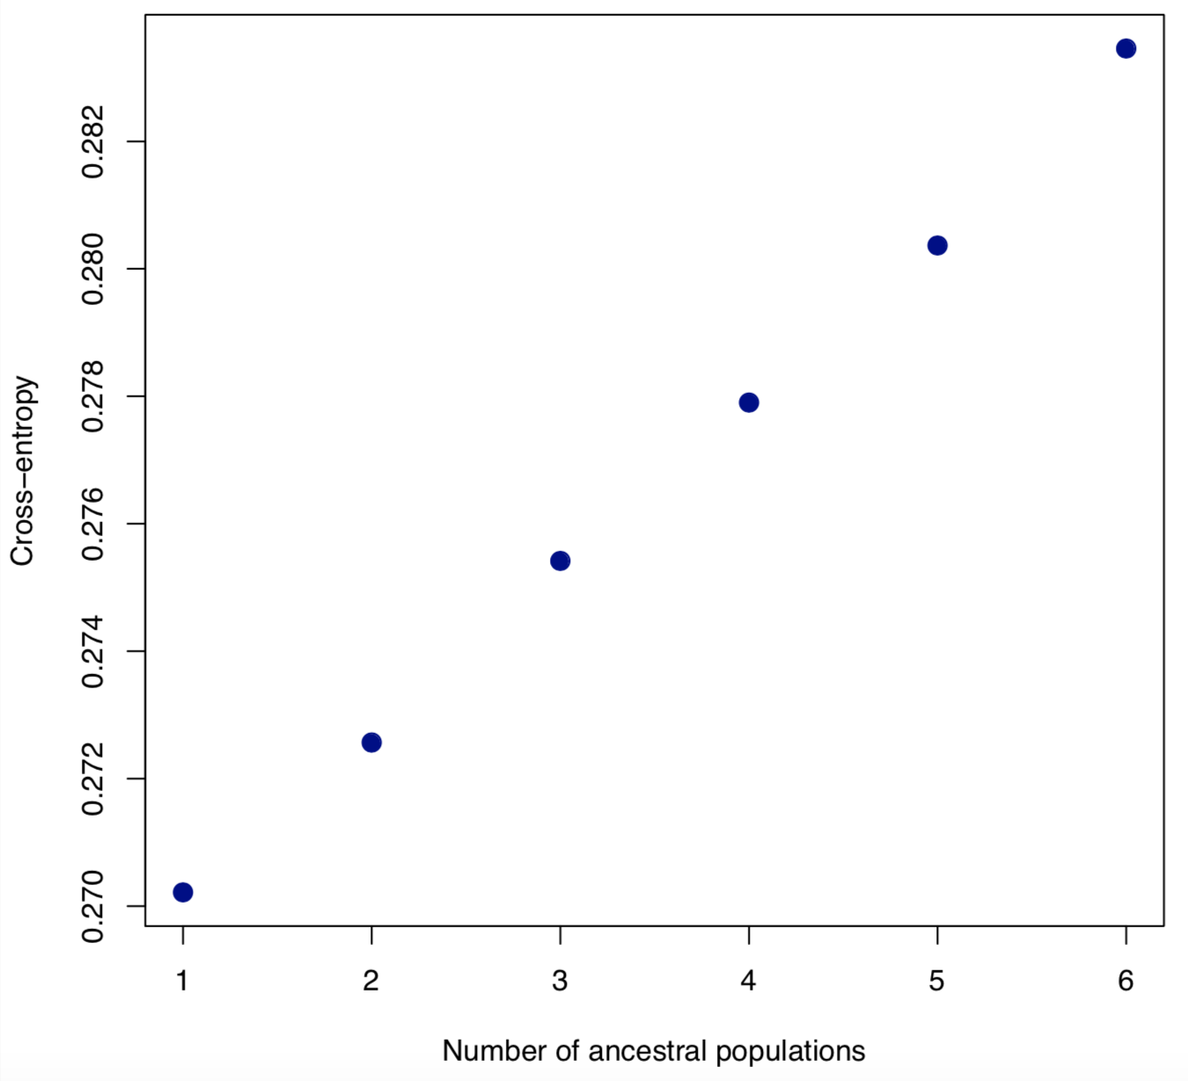
Figure S1 Plot of Cross-validation (CV) error of 223 ponderosa pine individuals based on a total of 4,155,896 SNPs at K=1, 2, 3, 4, 5, 6.

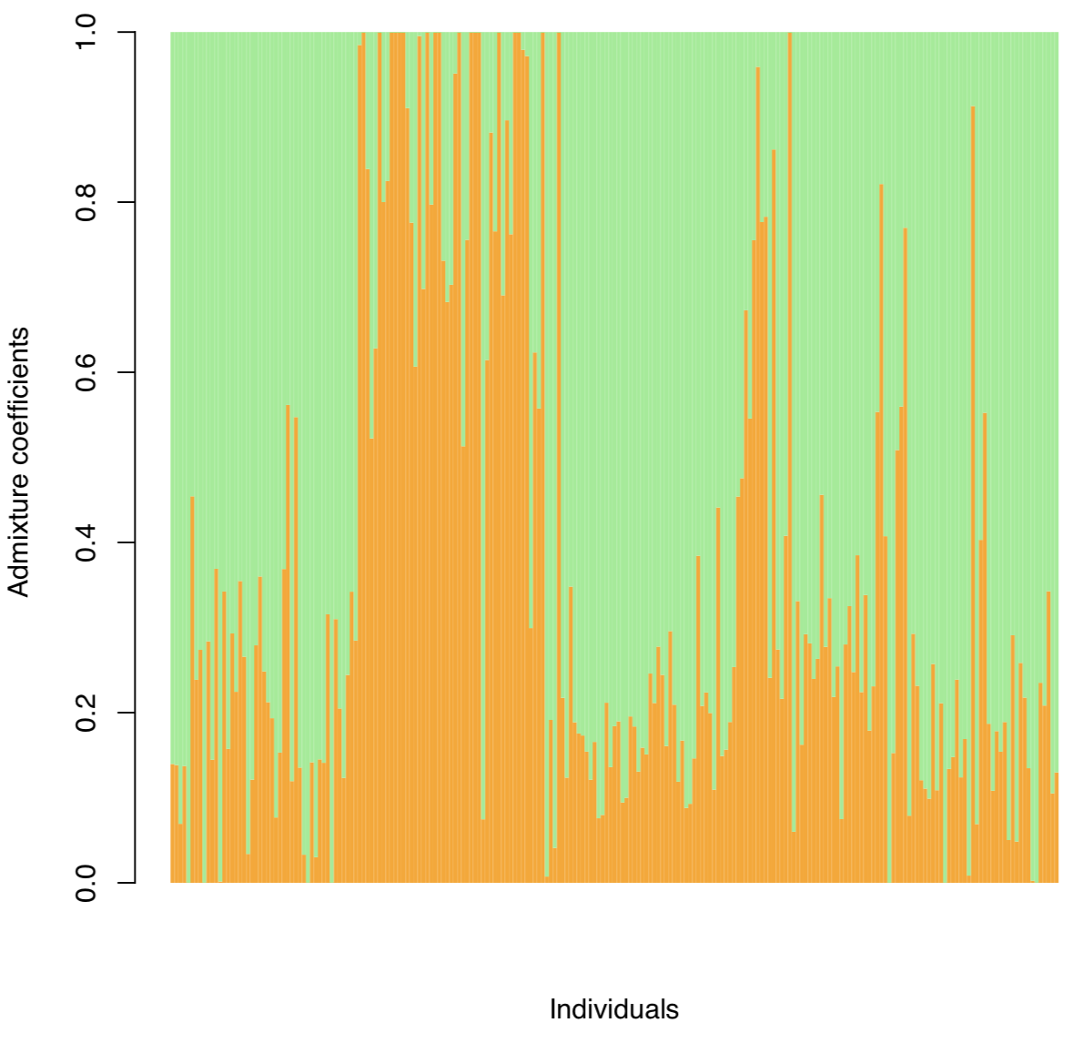
Figure S2 Admixture analysis of 223 individuals based on a total of 4,155,896 SNPs at K=2.

Figure S3 PCA analysis of 30-year averages (1951-1980) of all the 18 environmental variables from BCM model.

Figure S4. Greenhouse setup for 10 boxes of tubes, including five wet and five drought ones. There are 100 seedling tubes in each of the boxes.

