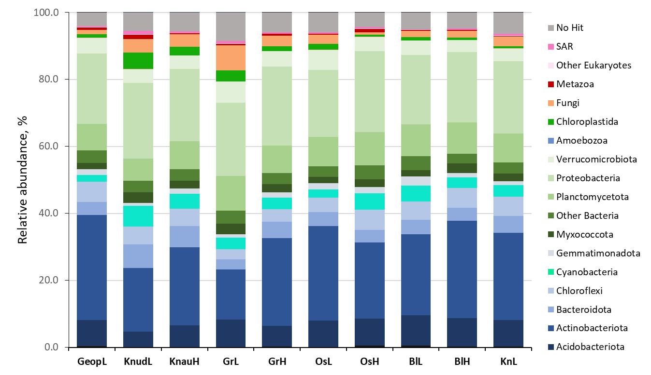
Supplementary Figure 1 – Taxonomic profile of the biocrusts based on rRNAs obtained by metagenomic sequencing.

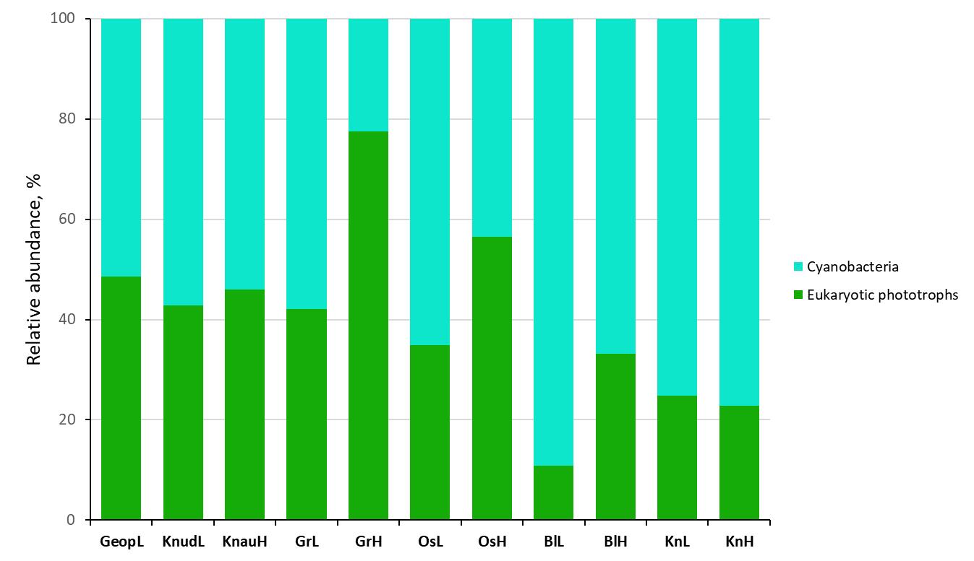
Supplementary Figure 2 – Relative abundances of phototrophic community of cyanobacteria and eukaryotic phototrophs based on 16S and 18S rRNA, respectively.

