Supplementary Materials for

Urbanization-induced squeeze effect reshapes dry–wet abrupt alternations in Chinese cities
Huang Shuzhe et al.

This PDF file includes:
Text S1
Figure S1 to S20
Table S1 to S4

Introduction
- Text S1. Validation of city-scale urbanization effects (UE) on DWAA against station-scale UE
- Fig. S1. The diagram for the identification of DWAA event and its characteristics.
- Fig. S2. Spatial distribution of climate zones (a), river basins (b), selected urban boundaries (c), and the 100 largest Chinese cities (d).
- Fig. S3. Comparisons between city-scale urbanization effect (UE) and station-scale UE on DWAA characteristics.
- Fig. S4. Spatial extents and land cover distributions over three representative urban agglomerations for WRF simulations.
- Fig. S5. Validation of WRF-simulated precipitation and temperature over three urban agglomerations.
- Fig. S6. Spatial distributions of the effects of urbanization on DWAA characteristics in different seasons.
- Fig. S7. The effects of urbanization on DWAA characteristics over Chinese urban agglomerations.
- Fig. S8. Spatial distributions of urbanization effects on DWAA in different urbanization periods.
- Fig. S9. Distributions of urbanization effects (UE) on D-W events with different extremity levels.
- Fig. S10. Distributions of urbanization effects (UE) on W-D events with different extremity levels.
- Fig. S11. Spatial distribution of urbanization effects on DWAA with different transition speed.
- Fig. S12. Box plots of urbanization effects in cities with different categories of urban area (UA), urban expansion rate (UR), NDVI, and DEM.
- Fig. S13. Relationship between urbanization effects on DWAA characteristics and urban heat island effect (UHI)/urban dry island effect (UDI).
- Fig. S14. Pixel-scale distributions of urbanization effects (UE) on D-W events over the 25th to the 100th largest Chinese cities (C25-C100).
- Fig. S15. Pixel-scale distributions of urbanization effects (UE) on W-D events over the 25th to the 100th largest Chinese cities (C25-C100).
- Fig. S16. Box plots of urbanization effects on WRF-simulated DWAA characteristics in urban and rural regions under urbanized scenario.
- Fig. S17. Changes of surface D-W associated factors between urbanized and non-urbanized scenarios during different periods of D-W events in three urban agglomerations.
- Fig. S18. Changes of D-W associated factors in various pressure levels between urbanized and non-urbanized scenarios during different periods of D-W events in three urban agglomerations.
- Fig. S19. Changes of W-D associated factors between urbanized and non-urbanized scenarios during different periods of W-D events in three urban agglomerations.
- Fig. S20. Changes of W-D associated factors in various pressure levels between urbanized and non-urbanized scenarios during different periods of W-D events in three urban agglomerations.
- Table S1. The domain information of selected urban agglomerations in WRF simulation.
- Table S2. The configuration of WRF simulation in this study.
- Table S3. The percentages of red-, orange-, green-, and blue-toned pixels within the 25th-75th largest cities for D-W events.
- Table S4. The percentages of red-, orange-, green-, and blue-toned pixels within the 25th-75th largest cities for W-D events.

Text S1 Validation of city-scale urbanization effects (UE) on DWAA against station-scale UE
To validate the results of city-scale UE on DWAA transition duration and severity, we conduct station-scale quantification using in-situ observations. Firstly, we define urban and rural stations using the time-varying GISA-new dataset. Specifically, we separate the study period with an interval of 5 years. In each sub-period, we create a circular buffer for each in-situ station and calculate the proportion of impervious surface areas within the buffer. We consider a station as an urban station if the proportion of impervious surface areas exceeds a predefined threshold. Otherwise, the station is defined as rural station. Following previous studies, we select 2 km and 33% as the buffer distance and proportion threshold, respectively¹⁻⁴. In this case, each station is dynamically classified during the study period. Then we pair rural stations for each urban station within its 100 km buffer area to minimize confounding factors in quantifying urbanization effects. The rural stations with elevation differences larger than 500 m from paired urban stations are also excluded to control the topographical effects. For each urban-rural pair, we calculate the average precipitation and temperature and identify DWAA events with two characteristics following the methods in the main text. Finally, we quantify station-scale UE by calculating the differences of Sen’s slope values between each paired urban and rural series.
To compare with station-scale results, we pair the city-scale results of UE with all station-scale results within the urban boundaries. The comparison of city-scale results and station-scale results is shown in Supplementary Fig. S3. In general, the quantified UE between two spatial scales represents significantly positive relationship, with the Pearson correlation coefficients of UE on D-W transition duration, D-W severity, W-D transition duration, and W-D severity achieved 0.483 (p < 0.000), 0.396 (p < 0.000), 0.306 (p < 0.000), and 0.384 (p < 0.000). These results further prove the robustness of our multi‐scale urbanization analysis.
References
1. Sun, Y., Zhang, X., Ren, G., Zwiers, F. W. & Hu, T. Contribution of urbanization to warming in China. Nat. Clim. Change 6, 706–709 (2016).
2. Wang, J. et al. Anthropogenic emissions and urbanization increase risk of compound hot extremes in cities. Nat. Clim. Change 11, 1084–1089 (2021).
3. Huang, S. et al. Urbanization amplified asymmetrical changes of rainfall and exacerbated drought: analysis over five urban agglomerations in the Yangtze River Basin, China. Earth’s Future 11, e2022EF003117 (2023).
4. Yu, X. et al. Asymmetrical shift toward less light and more heavy precipitation in an urban agglomeration of East China: intensification by urbanization. Geophys. Res. Lett. 49, e2021GL097046 (2022).

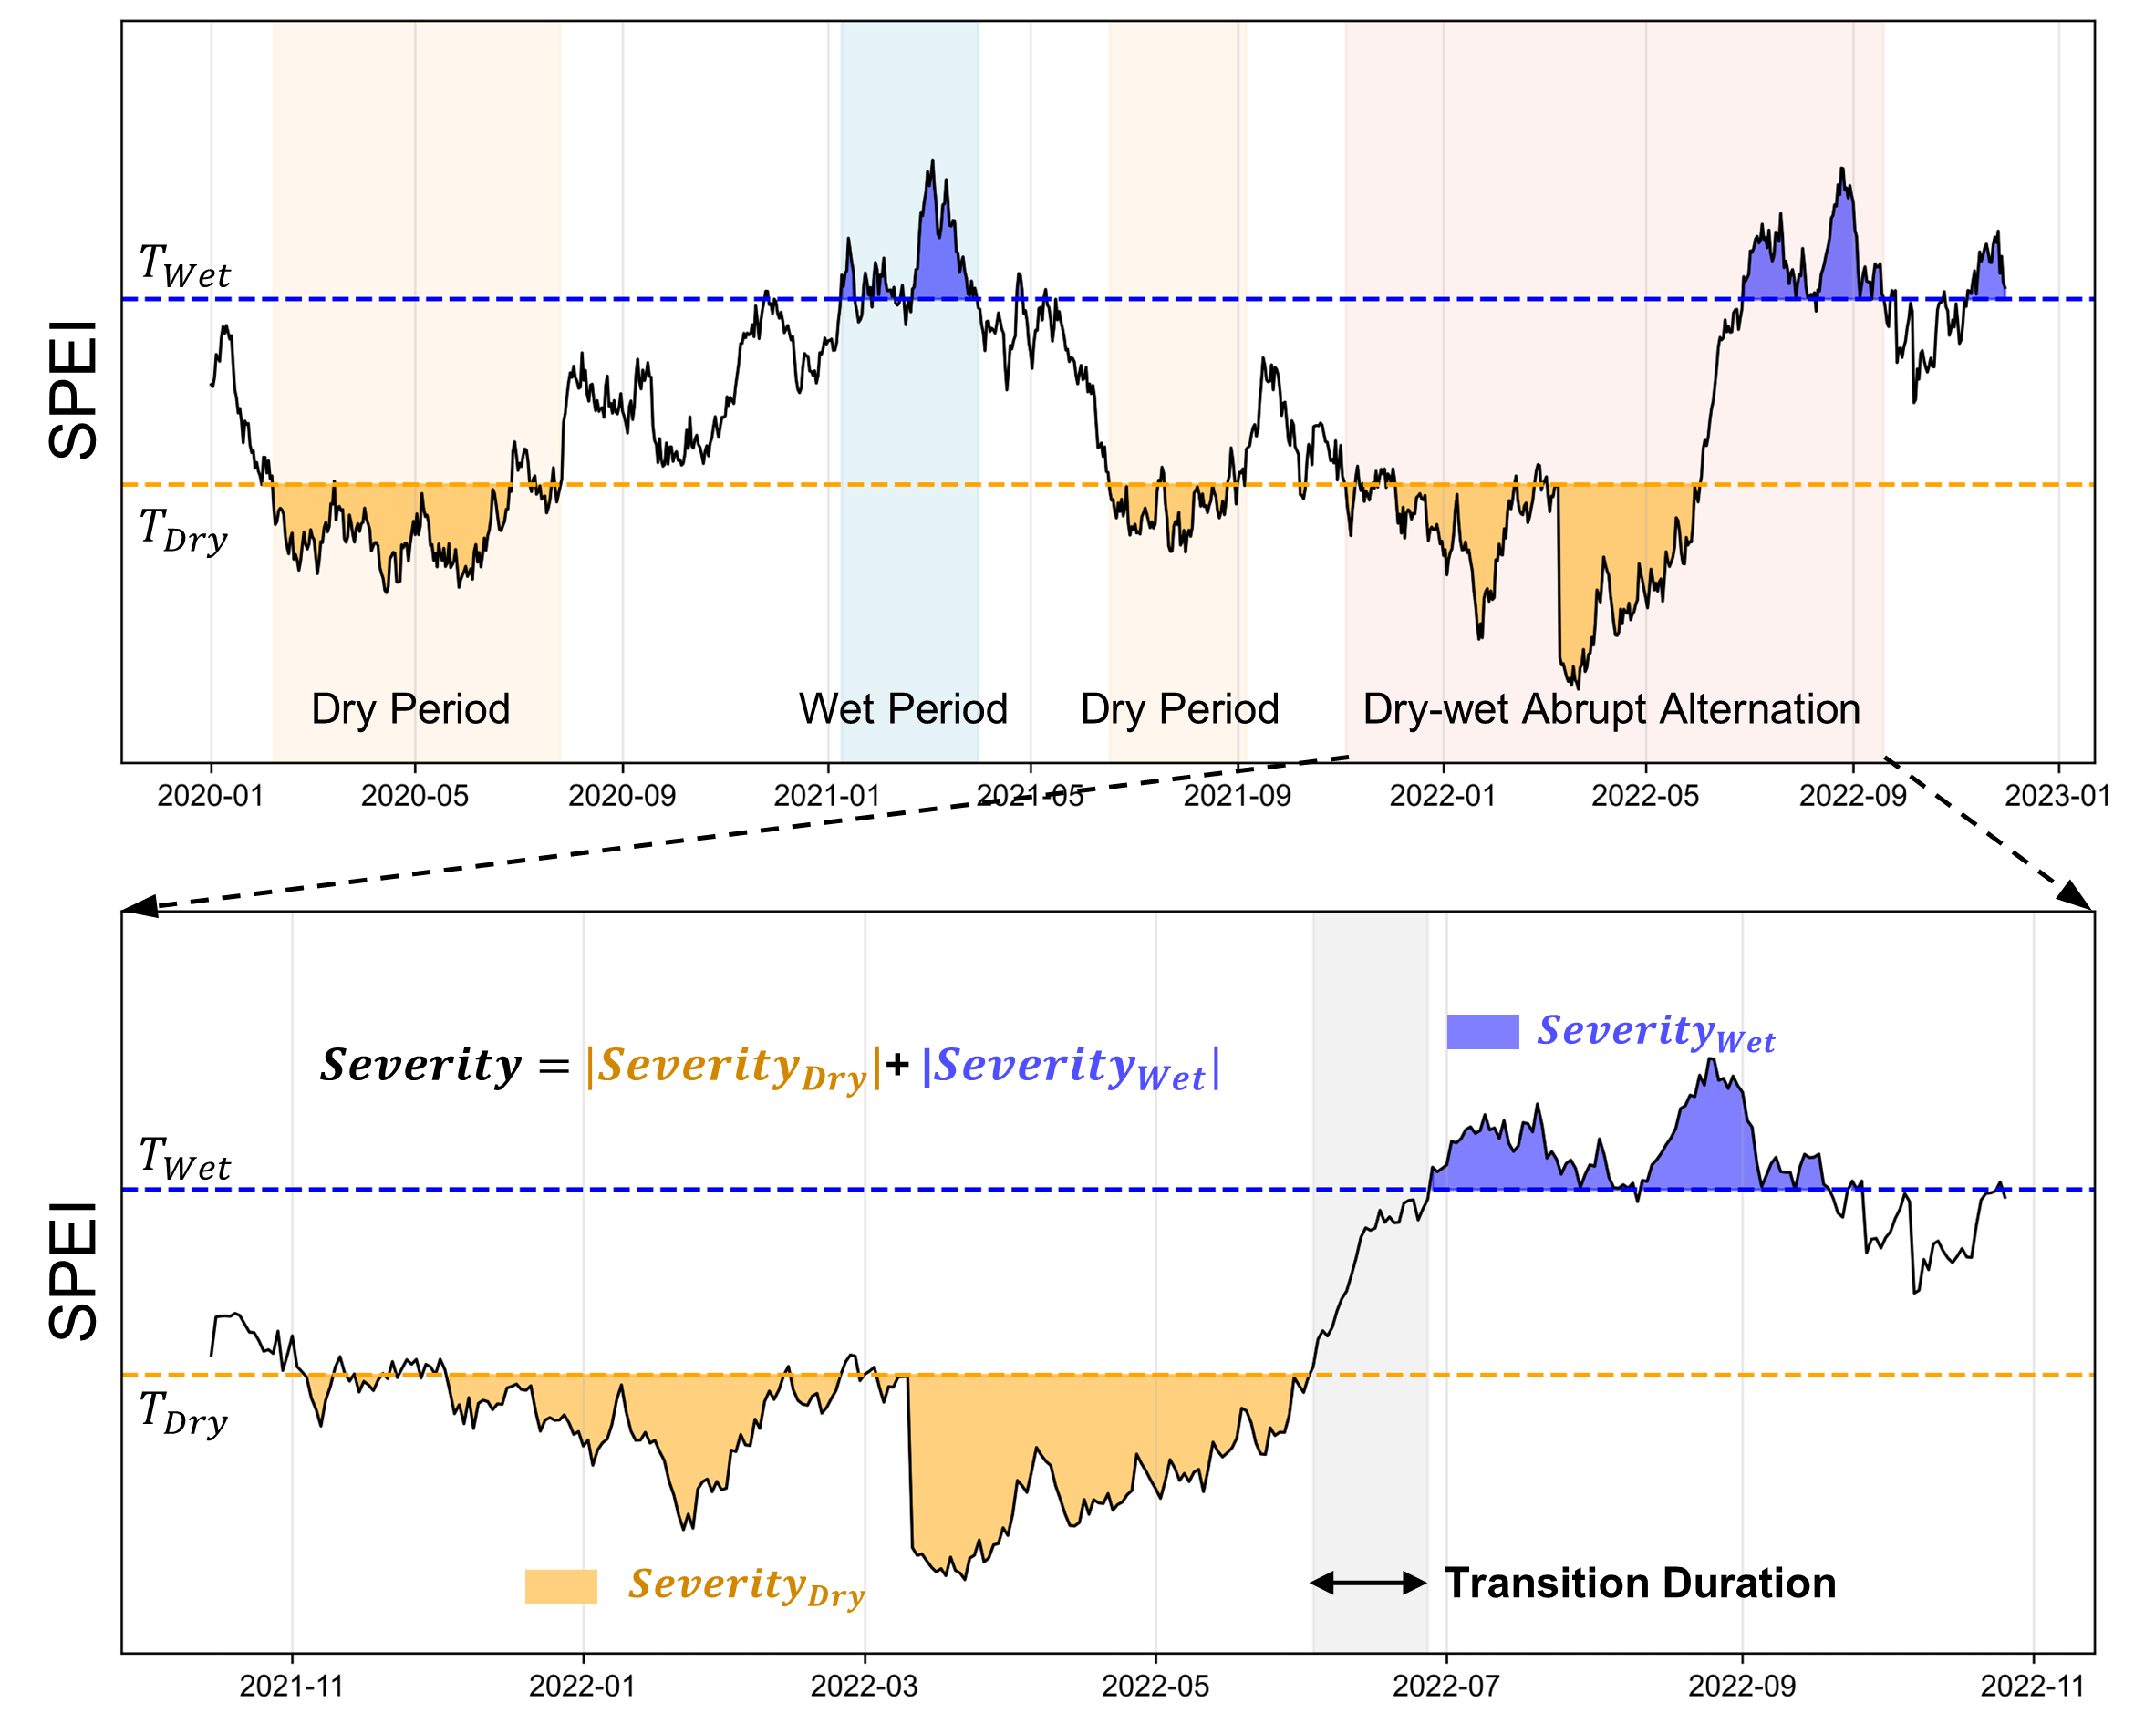

Fig. S1. The diagram for the identification of DWAA event and its characteristics. The orange, blue, red, and grey shaded areas represent dry period, wet period, DWAA period, and DWAA transition period. $T_{Wet}$ and $T_{Dry}$ are the thresholds for defining dry days and wet days.

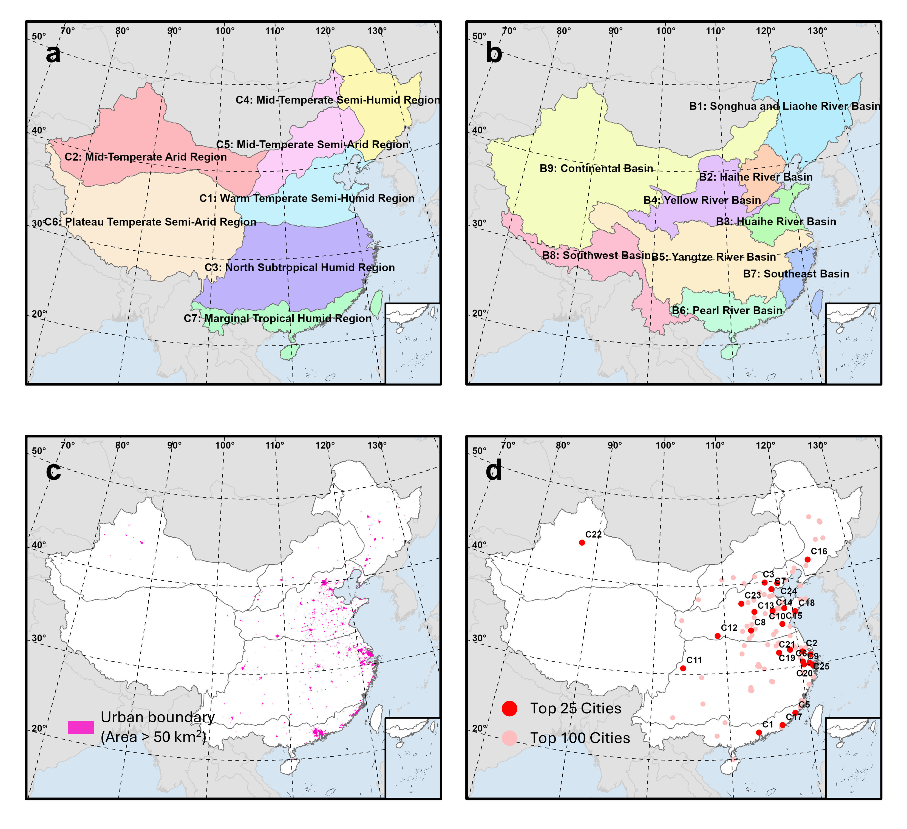

Fig. S2. Spatial distribution of climate zones (a), river basins (b), selected urban boundaries (c), and the 100 largest Chinese cities (d).

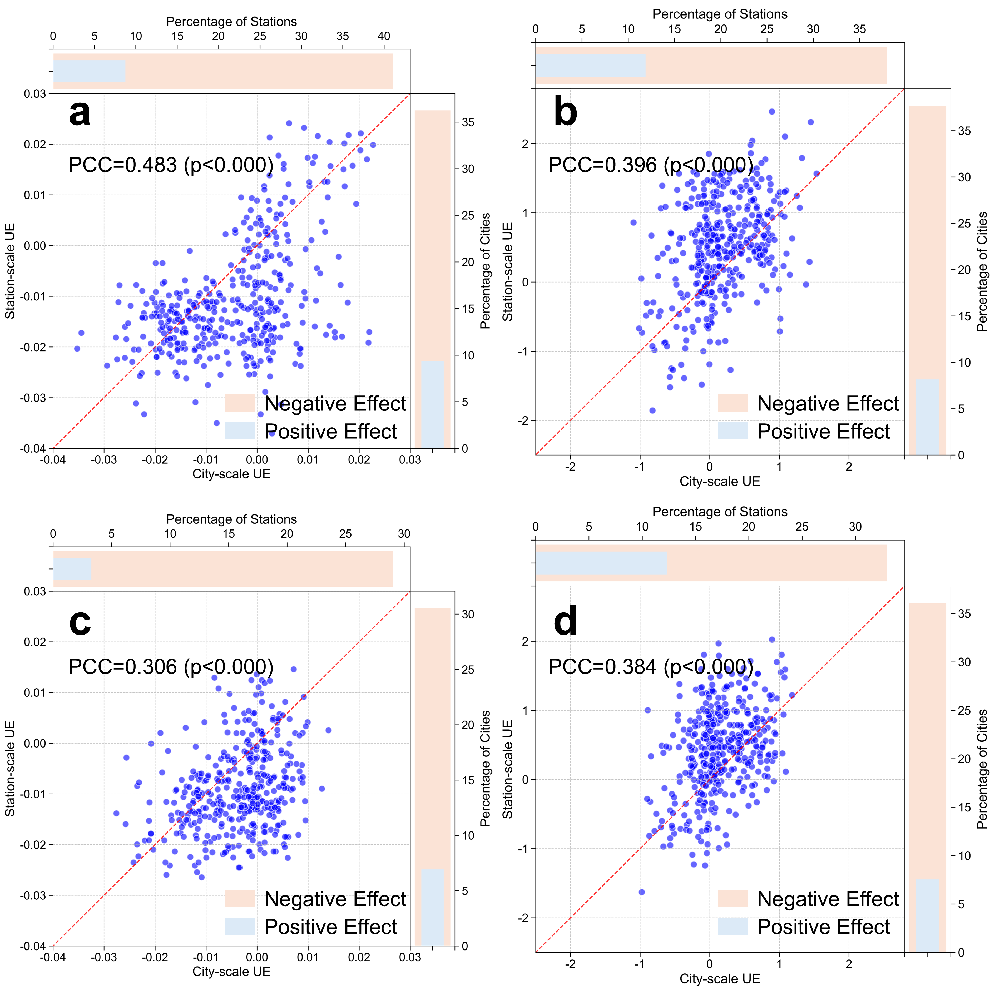

Fig. S3. Comparisons between city-scale urbanization effect (UE) and station-scale UE on DWAA characteristics. a-d are the comparisons of UE for D-W transition duration, D-W severity, W-D transition duration, and W-D severity, respectively. For each panel, the horizontal bar chart shows the percentages of stations with significantly negative (orange) and positive (blue) UE, while the vertical bar chart shows the percentages of cities with significantly negative (orange) and positive (blue) UE. The Pearson correlation coefficients between city-scale UE and station-scale UE are also presented in the figure.

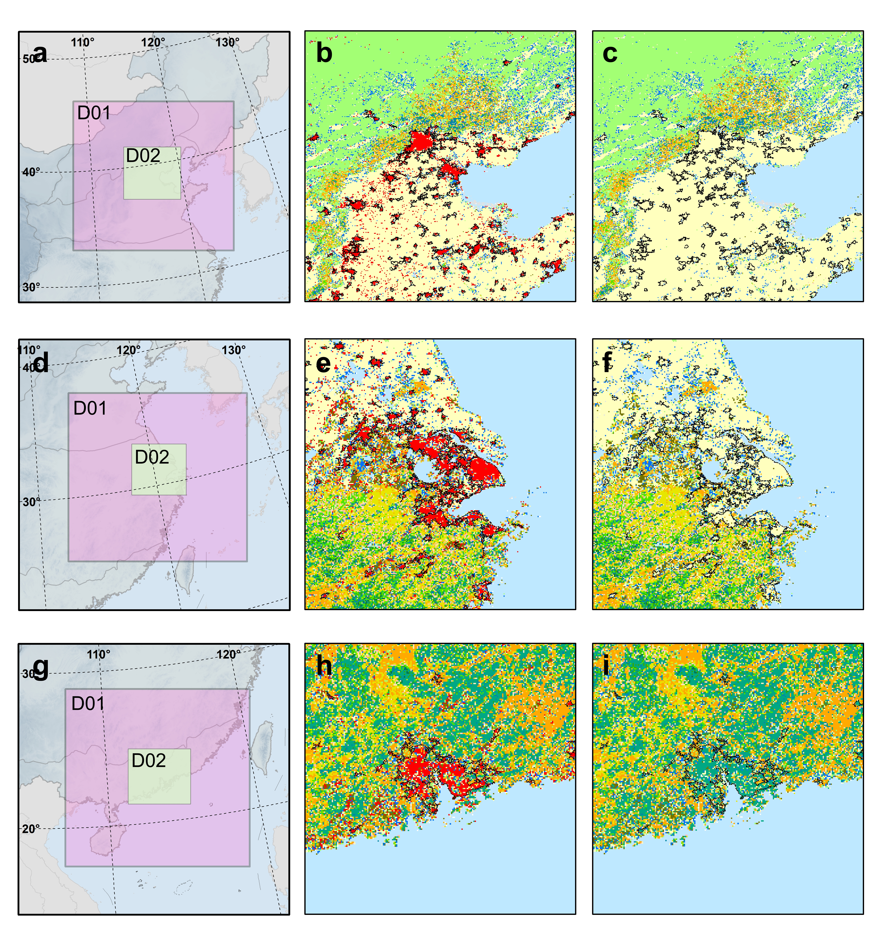

Fig. S4. Spatial extents and land cover distributions over three representative urban agglomerations for WRF simulations. a, d, and g show the spatial extents of outer domain (D01) and inner domain (D02) for Beijing-Tianjin-Hebei (BTH), Pearl River Basin (PRB), and Yangtze River Delta (YRD) urban agglomerations. The second column and the third column exhibit the land cover distributions for three regions under urbanized scenario and non-urbanized scenario, respectively. The red pixels represent urban pixels.

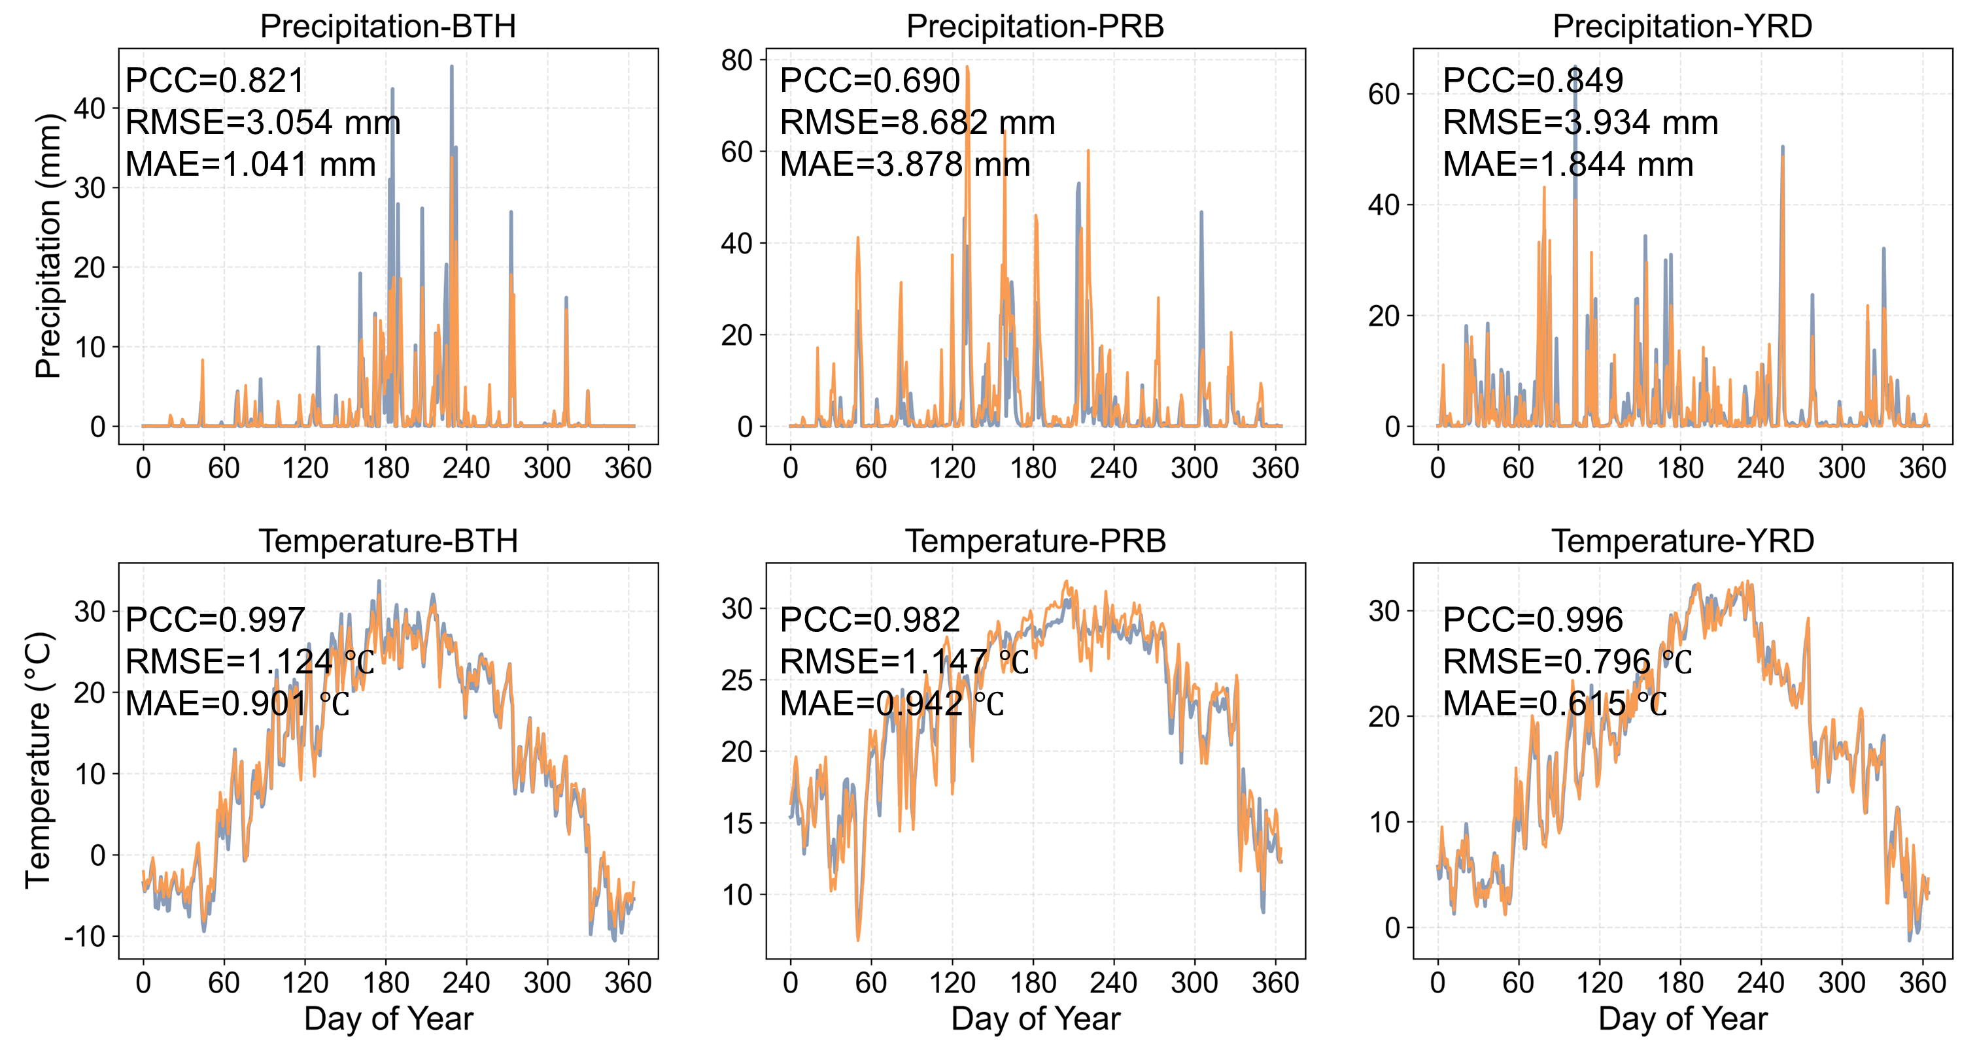

Fig. S5. Validation of WRF-simulated precipitation and temperature over three urban agglomerations. The validation is conducted in 2022 under control (i.e., urbanized) scenario. The orange and blue lines represent observations and WRF simulations, respectively.

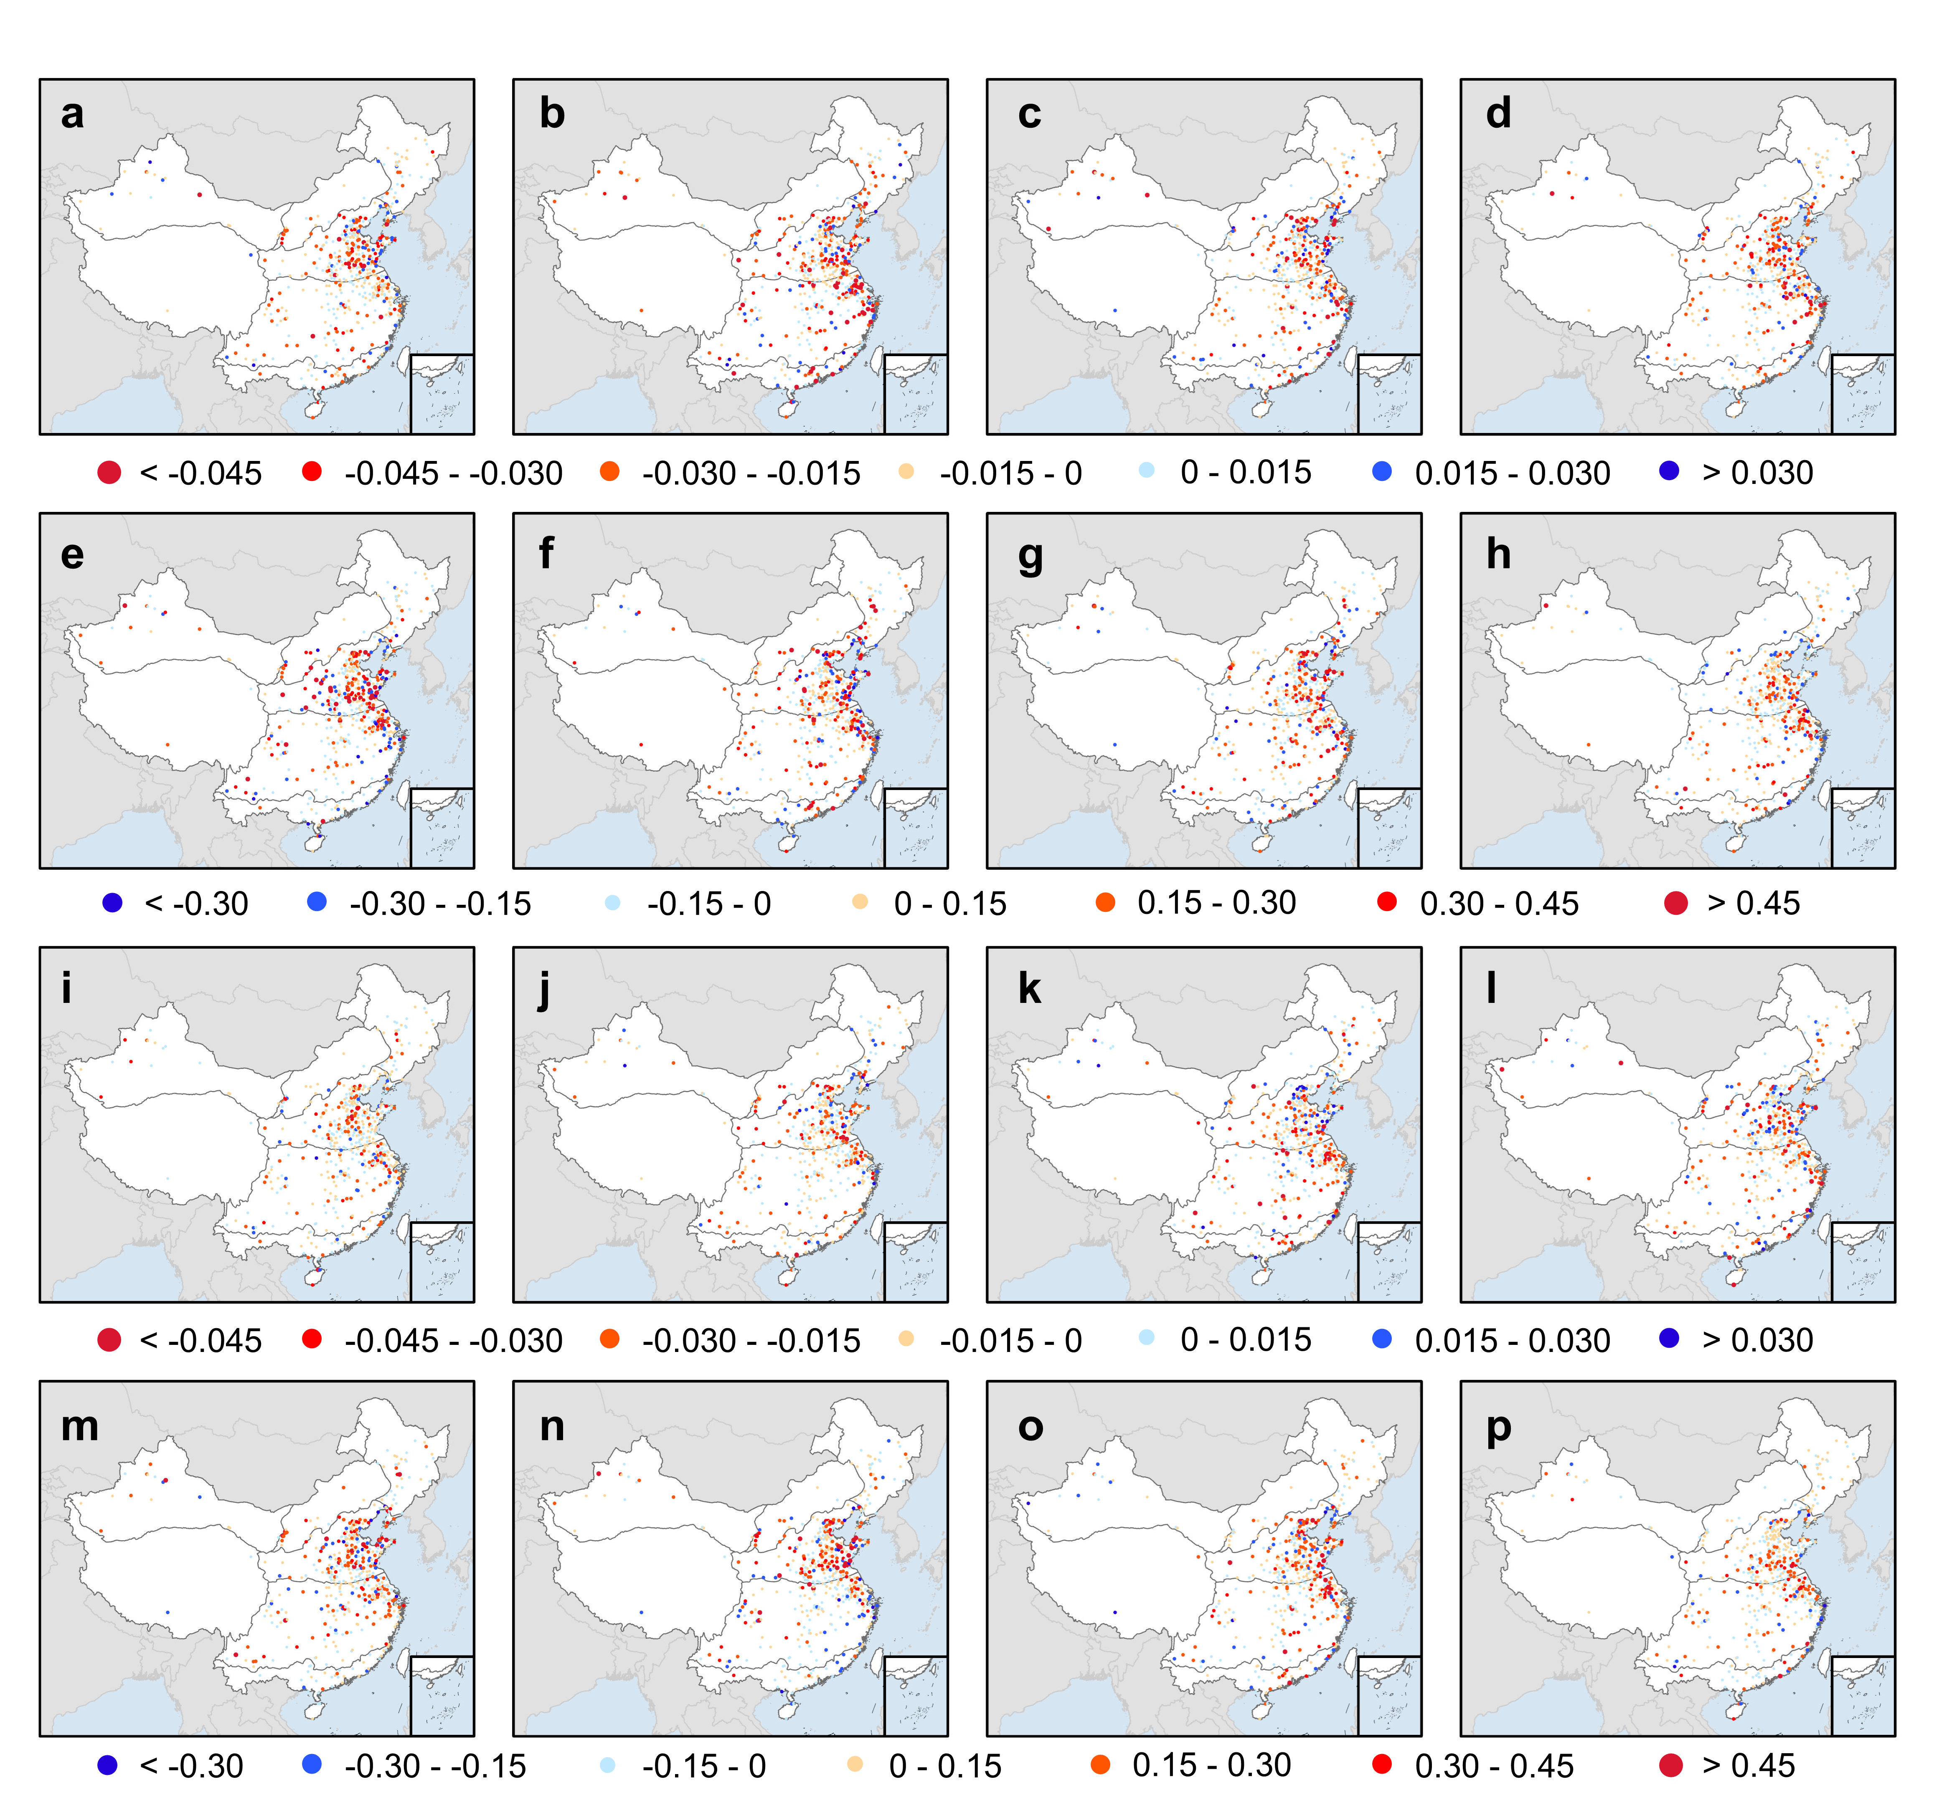

Fig. S6. Spatial distributions of the effects of urbanization on DWAA characteristics in different seasons. The first row to the fourth row exhibits the distributions for D-W transition duration, D-W severity, W-D transition duration, and W-D severity, respectively. The first column to the fourth column indicates the urbanization effects in spring, summer, autumn, and winter, respectively.

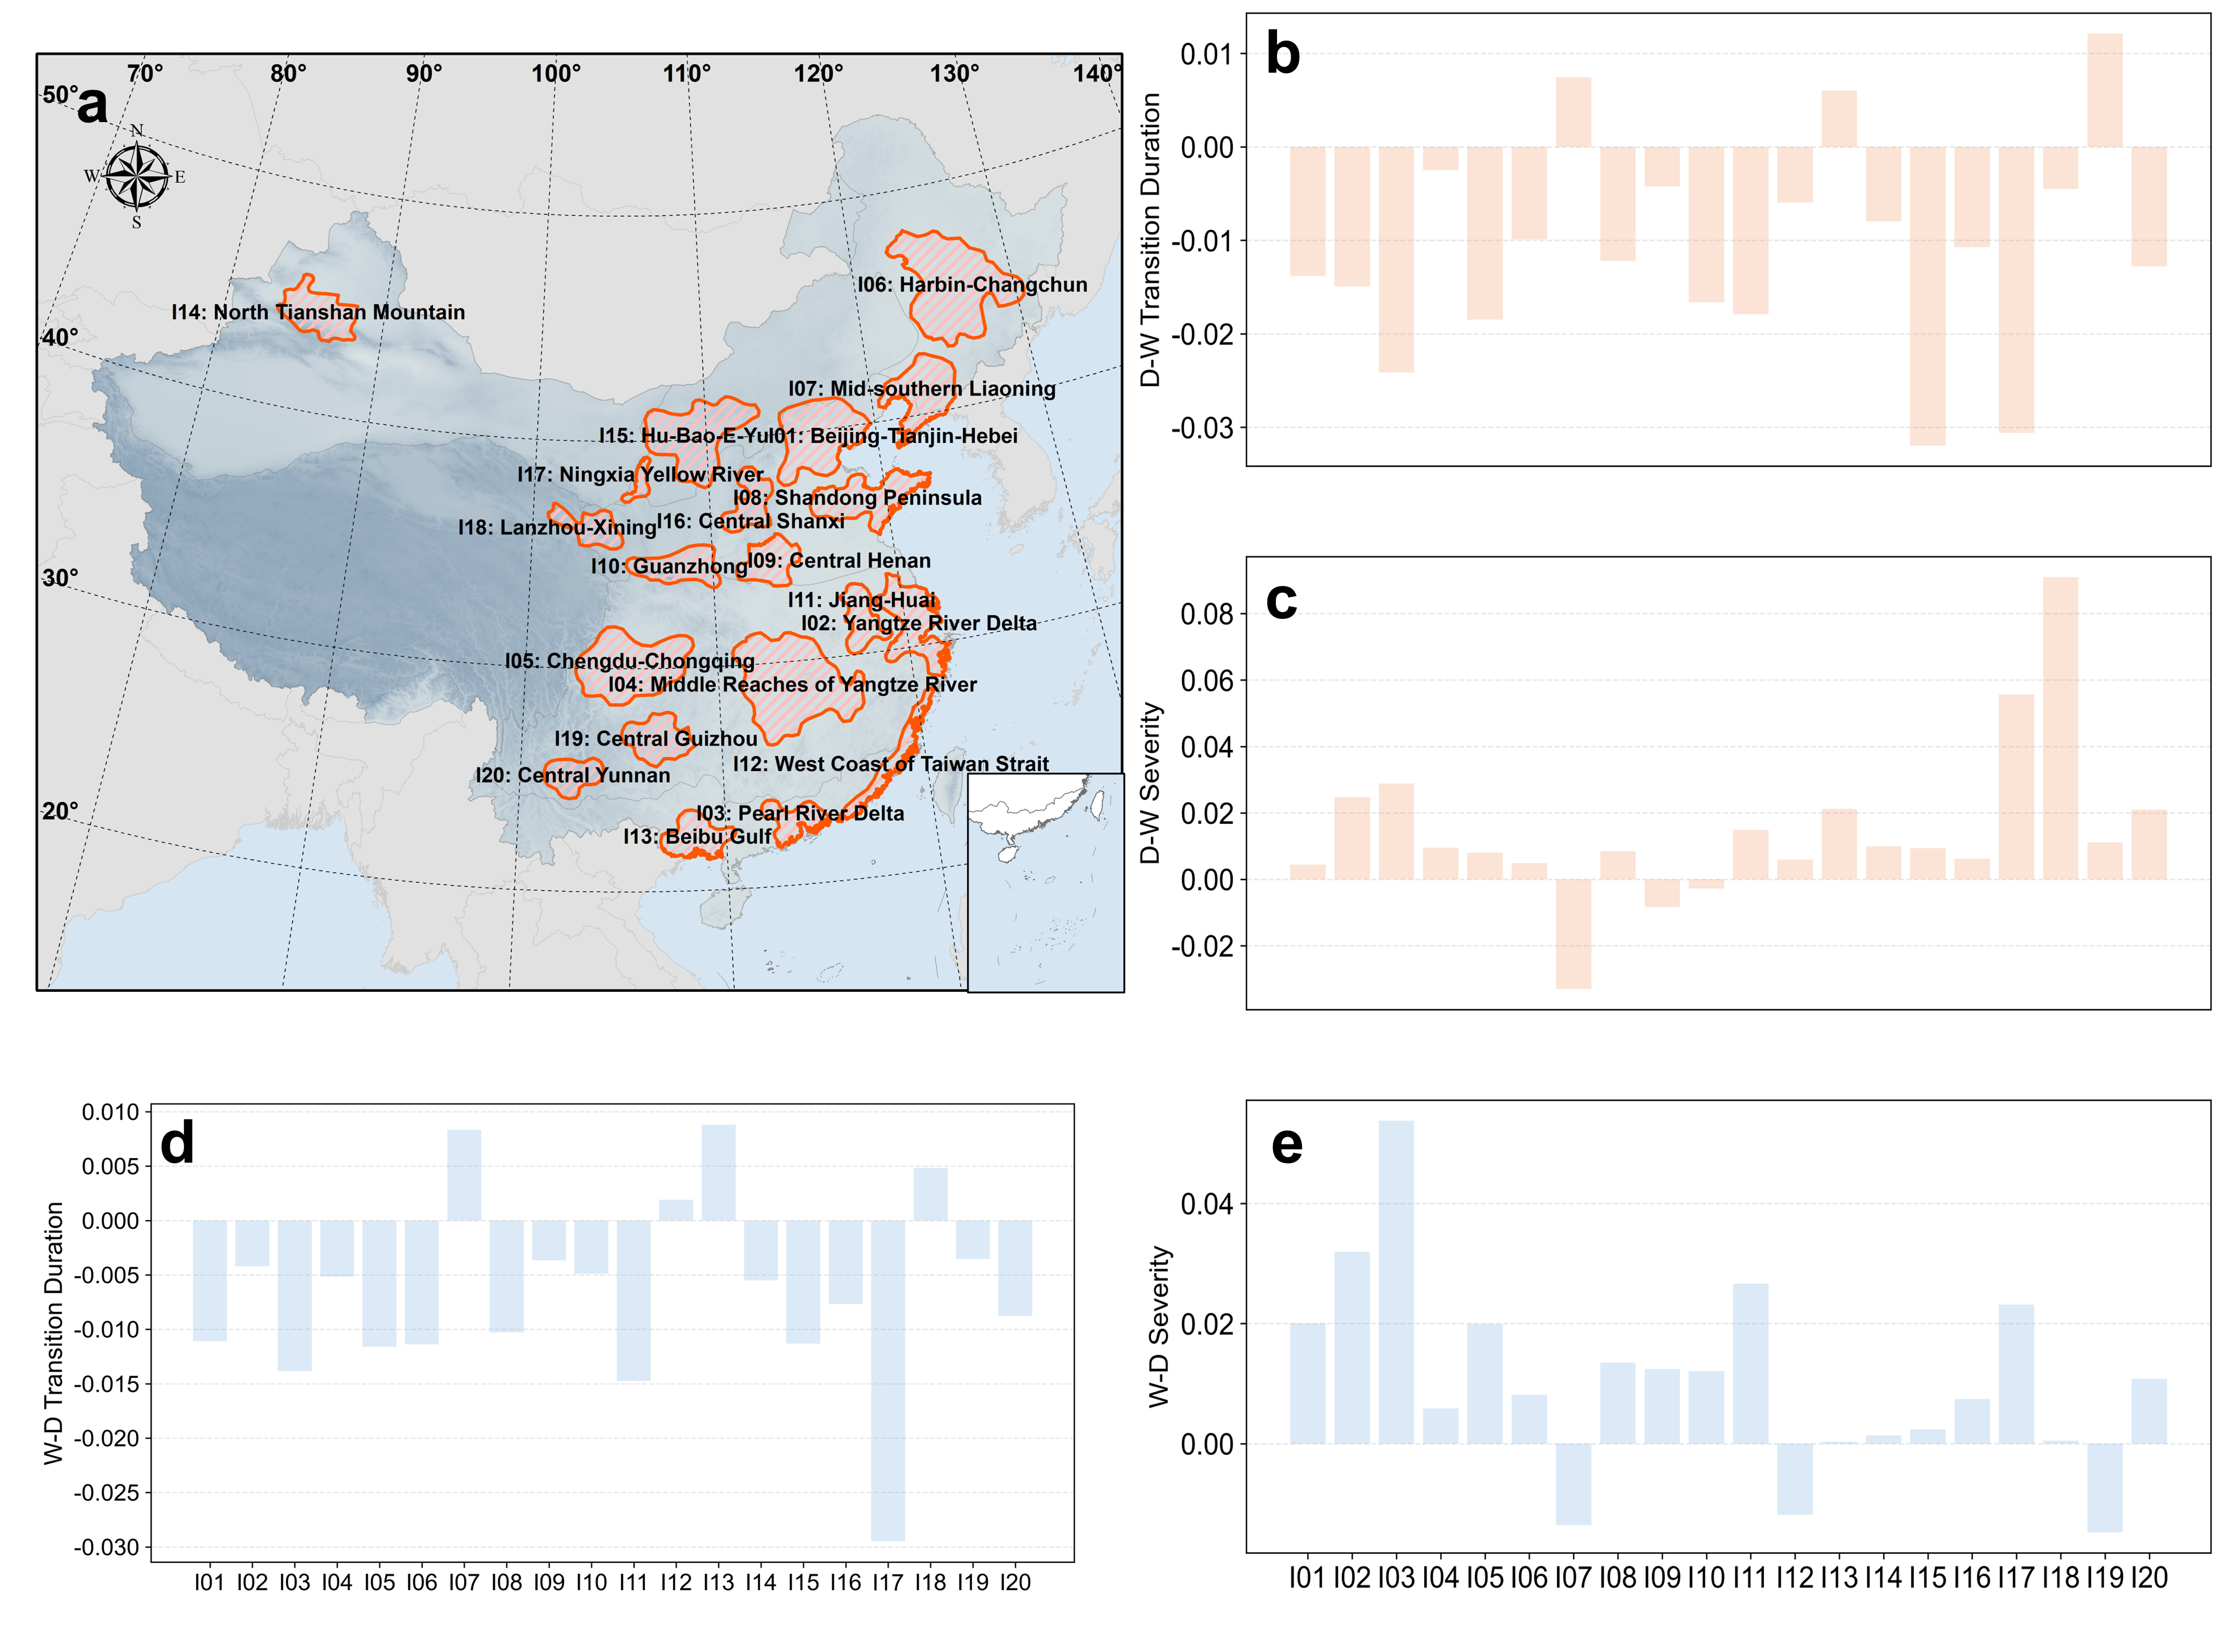

Fig. S7. The effects of urbanization on DWAA characteristics over Chinese urban agglomerations. a shows the map of 20 major urban agglomerations (I01-I20) in China.
b-e represent the effects of urbanization on D-W transition duration, D-W severity, W-D transition duration, and W-D severity in different urban agglomerations, respectively.

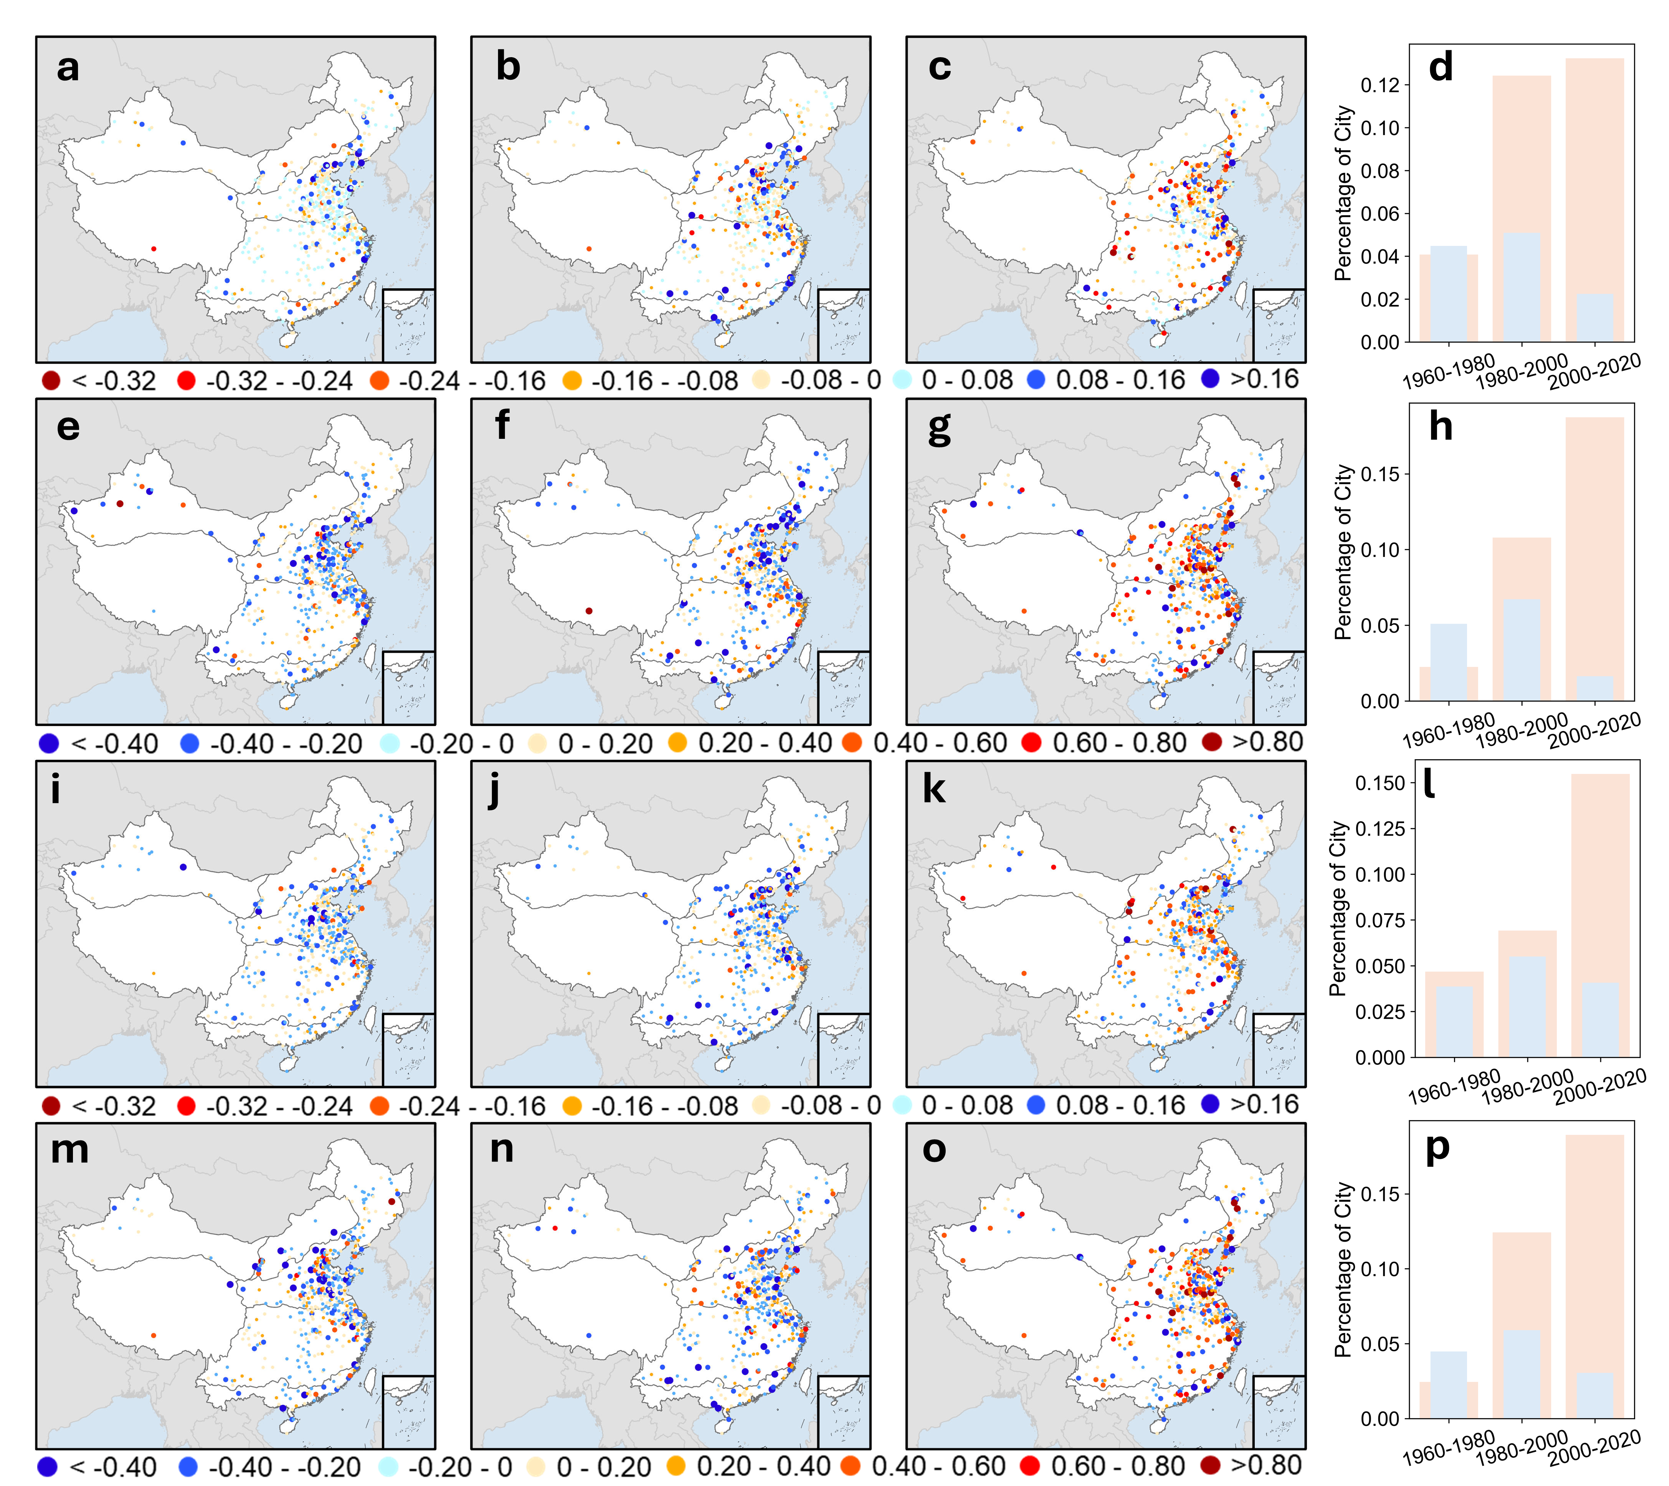

Fig. S8. Spatial distributions of urbanization effects on DWAA in different urbanization periods. The first row to fourth row indicates the distributions of urbanization effects on D-W transition duration, D-W severity, W-D transition duration, and W-D severity, respectively. The first, second, and third columns represent the urbanization effects during the periods of 1961-1980, 1981-2000, and 2001-2020, respectively. The bar charts show the percentages of cities with significantly negative (orange) urbanization effects and positive (blue) urbanization effects in different urbanization periods.

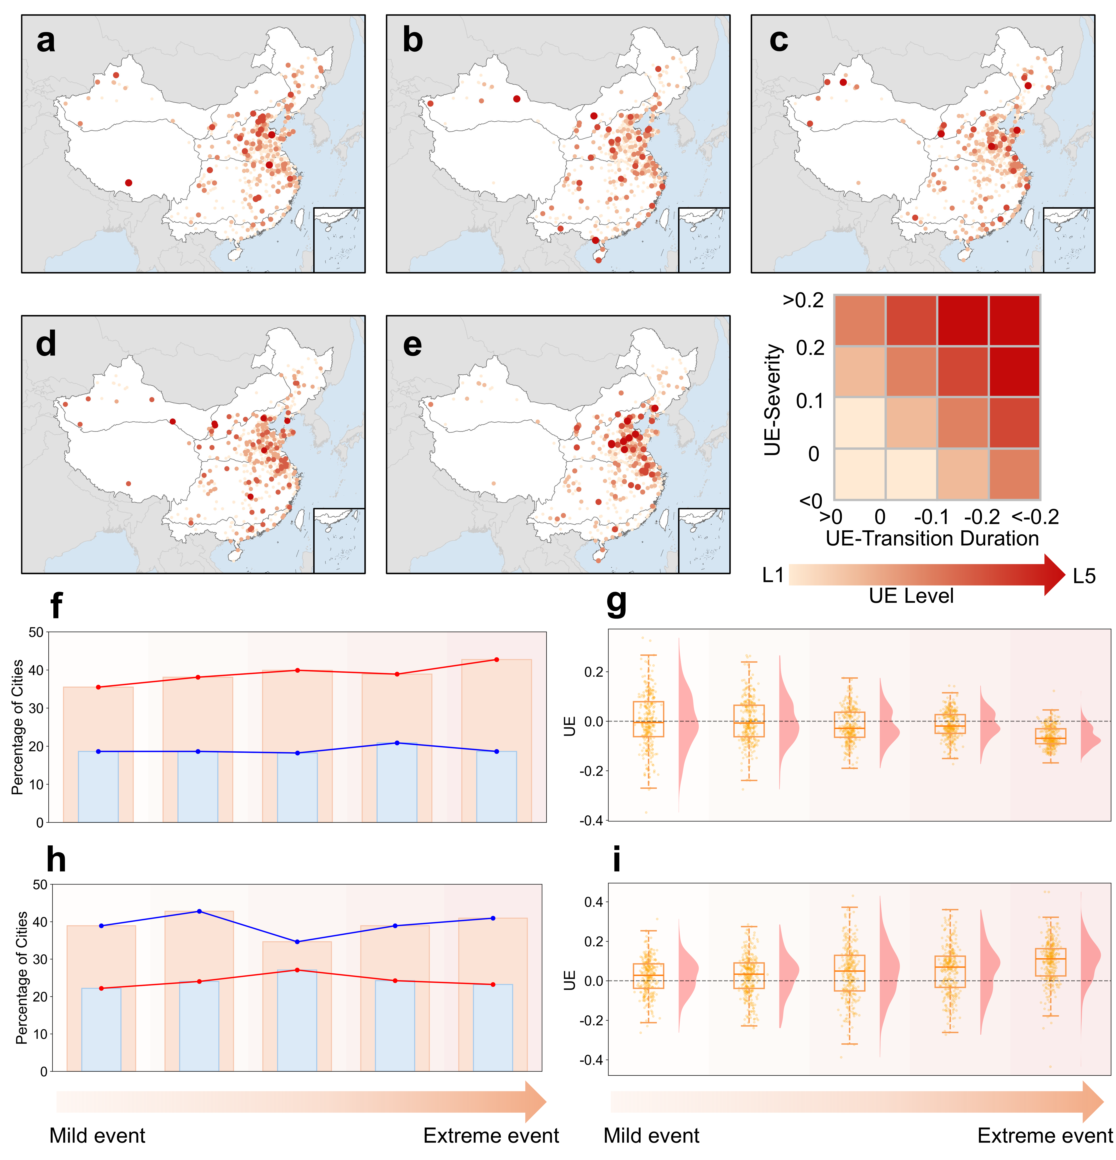

Fig. S9. Distributions of urbanization effects (UE) on D-W events with different extremity levels. a-e exhibit the effects of urbanization on D-W events from mild level to extreme level based on the extremity of dry period and wet period. Here we categorize the UE into five levels (L1-L5) considering both transition duration and severity. The specific classification is shown as the color table in the figure. f and h represent the percentages of cities with significantly negative/positive UE on transition duration and severity, respectively. g and i indicate the box plots of UE values on transition duration and severity, respectively.

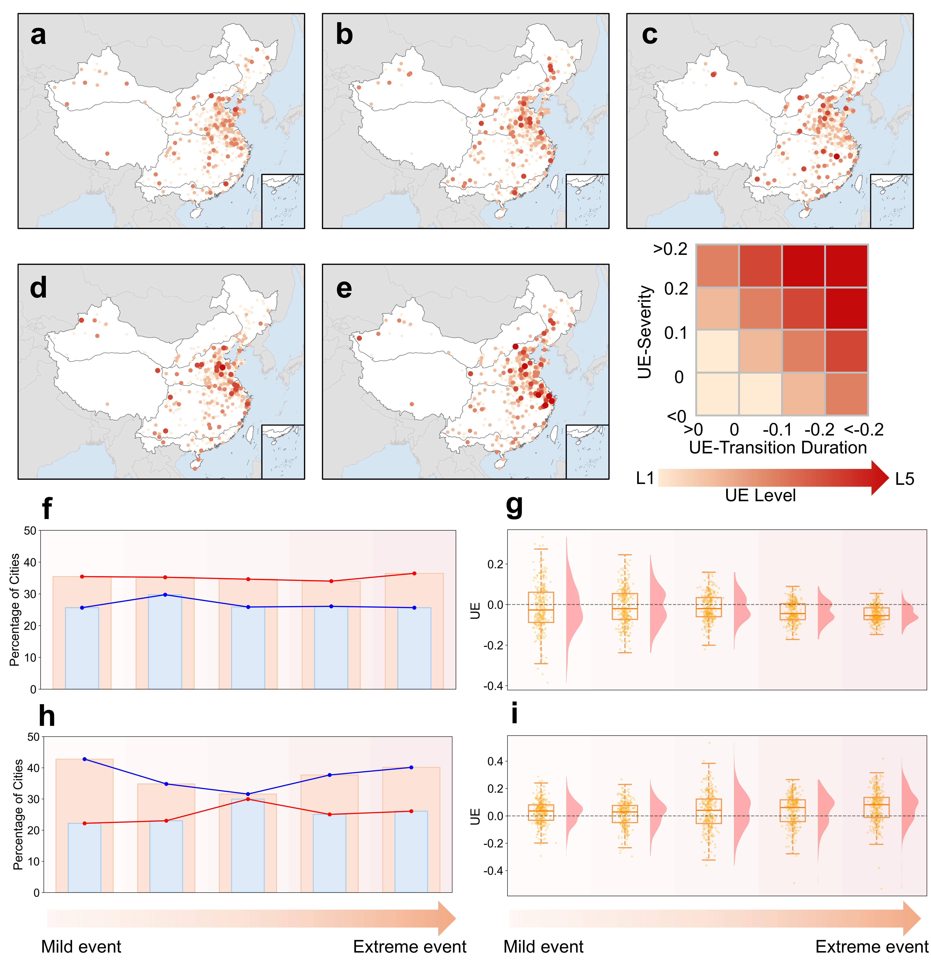

Fig. S10. Distributions of urbanization effects (UE) on W-D events with different extremity levels. a-e exhibit the effects of urbanization on W-D events from mild level to extreme level based on the extremity of dry period and wet period. Here we categorize the UE into five levels (L1-L5) considering both transition duration and severity. The specific classification is shown as the color table in the figure. f and h represent the percentages of cities with significantly negative/positive UE on transition duration and severity, respectively. g and i indicate the box plots of UE values on transition duration and severity, respectively.

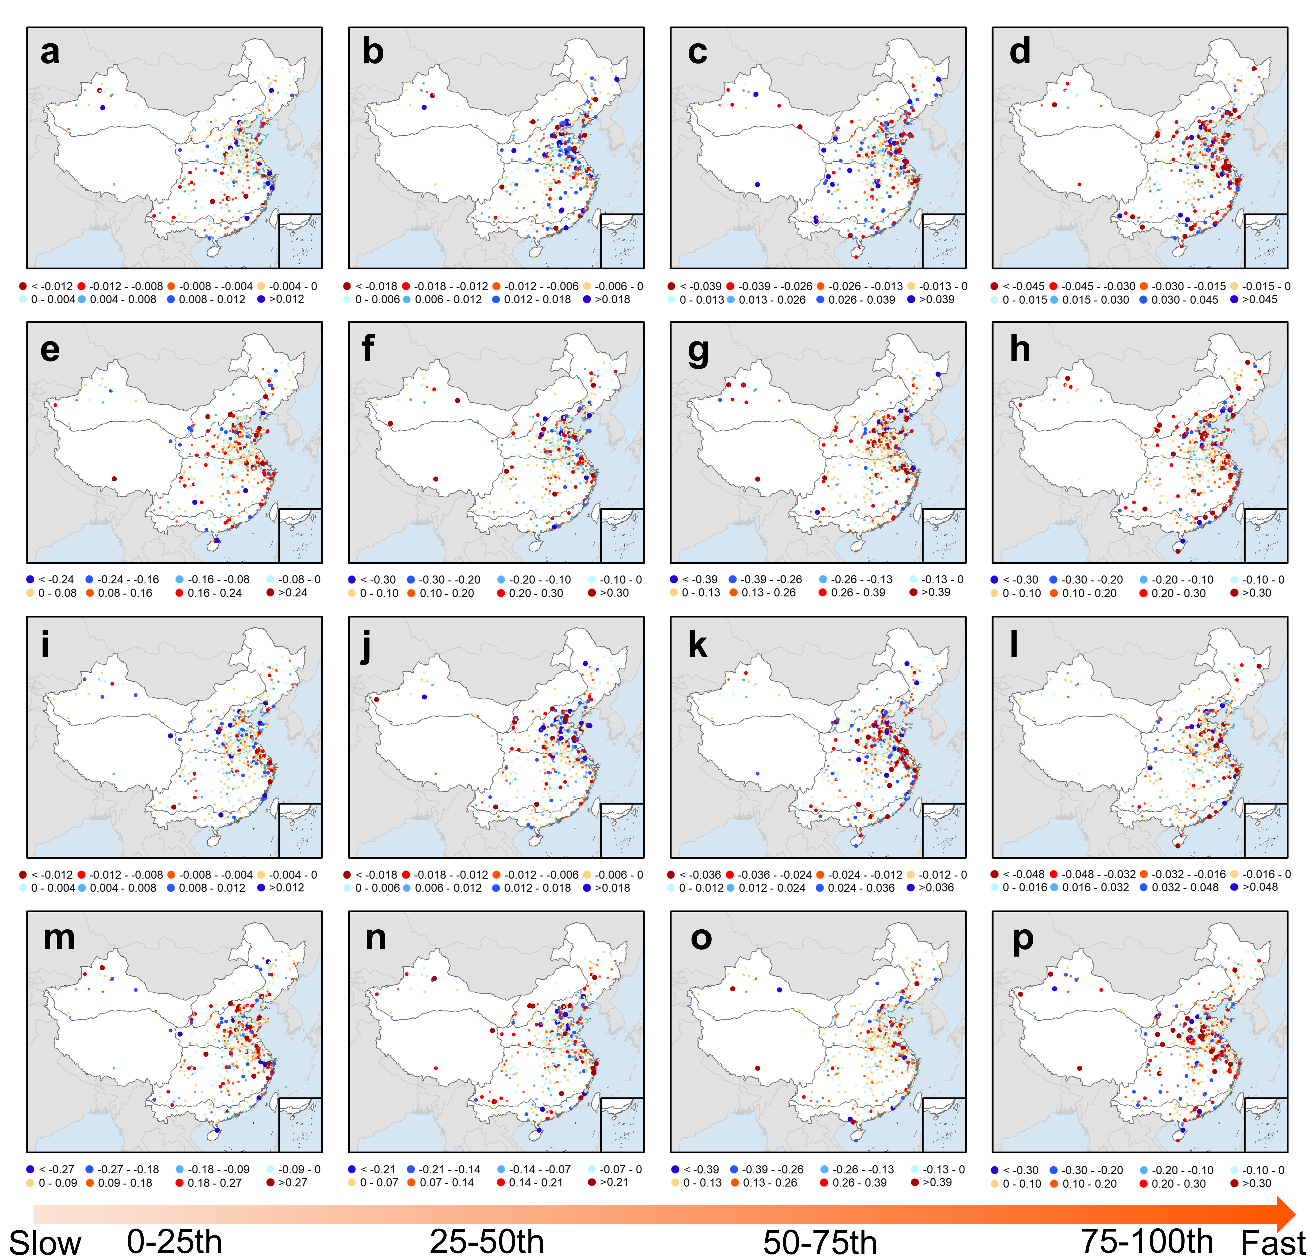

Fig. S11. Spatial distribution of urbanization effects on DWAA with different transition speed. The first row to the fourth row indicates the distributions of urbanization effects on D-W transition duration, D-W severity, W-D transition duration, and W-D severity, respectively. The first column to the fourth column shows the DWAA events with transition duration in the intervals of 0-25th (slow), 25-50th, 50-75th, and 75-100th (fast), respectively.

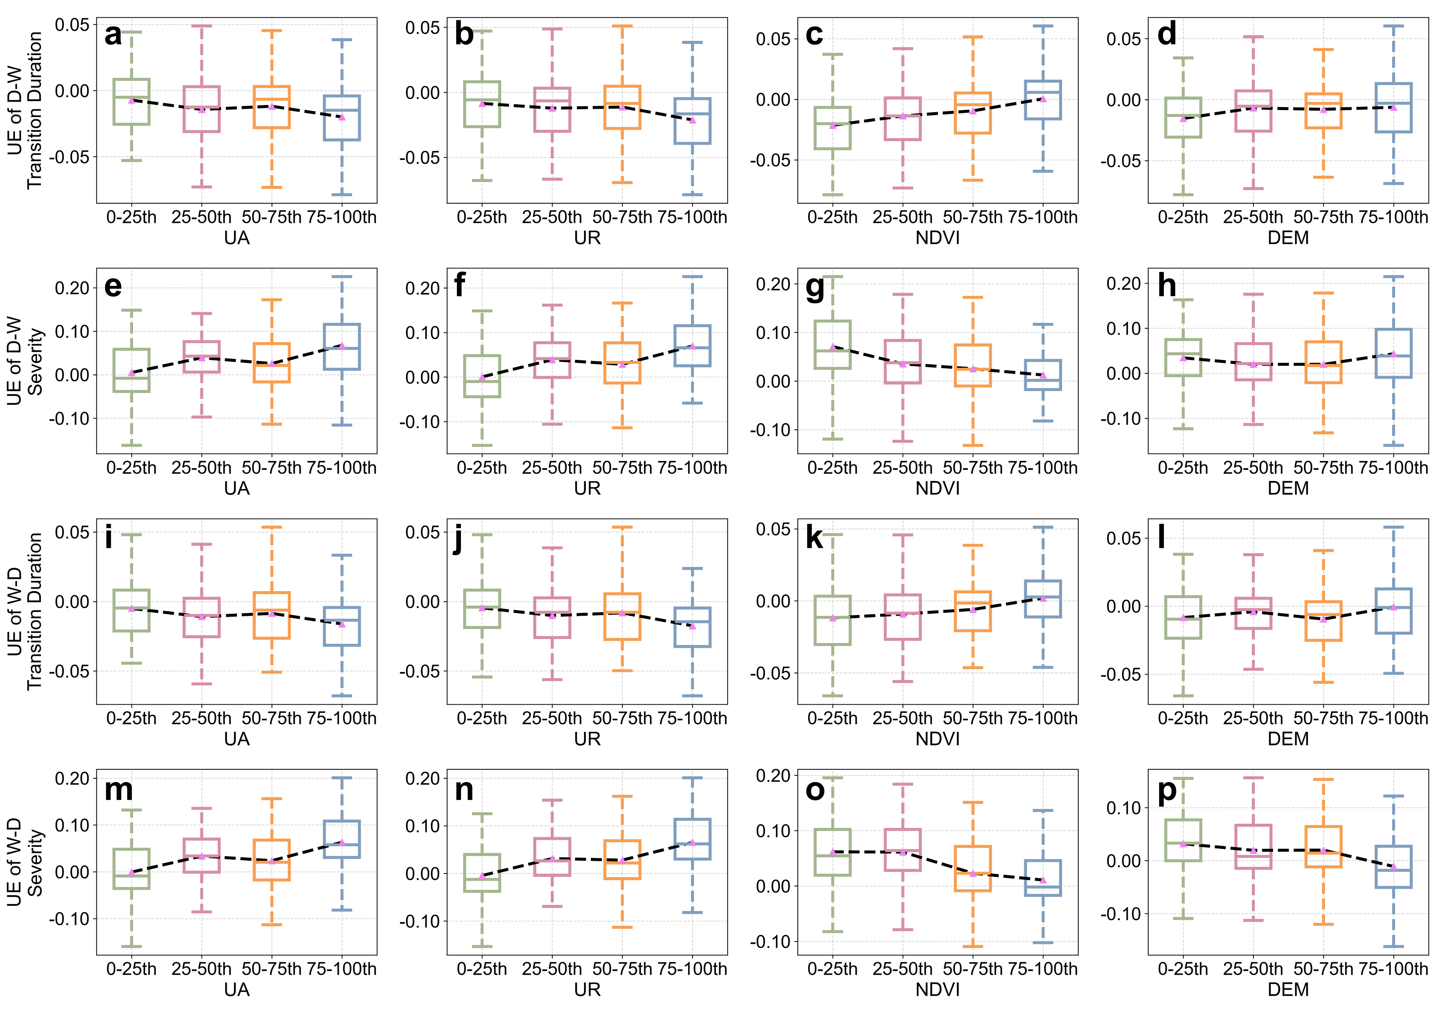

Fig. S12. Box plots of urbanization effects in cities with different categories of urban area (UA), urban expansion rate (UR), NDVI, and DEM. The first row to fourth row indicates the urbanization effects on D-W transition duration, D-W severity, W-D transition duration, and W-D severity, respectively. The black dashed lines represent the mean values of urbanization effects.

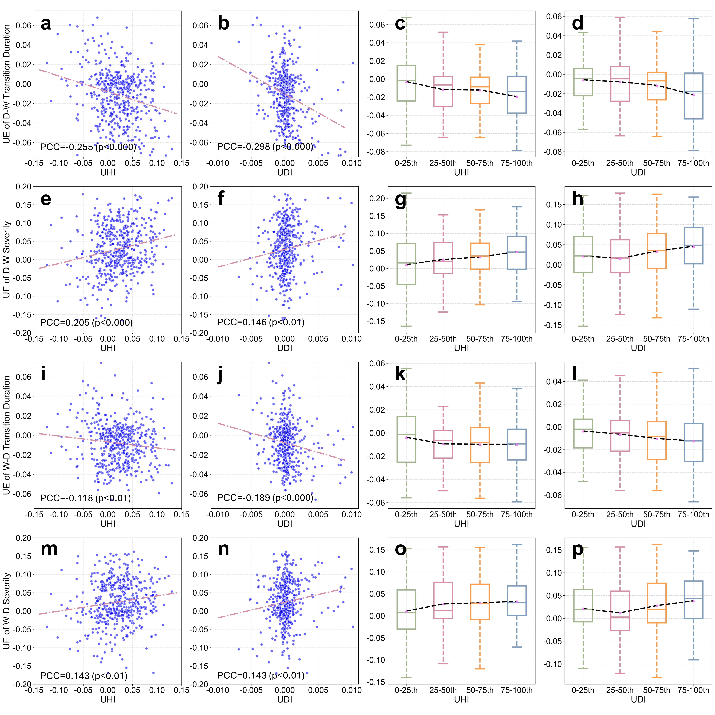

Fig. S13. Relationship between urbanization effects on DWAA characteristics and urban heat island effect (UHI)/urban dry island effect (UDI). The first row to fourth row indicates the urbanization effects on D-W transition duration, D-W severity, W-D transition duration, and W-D severity, respectively. The first column and the second column exhibit the scatter plot between urbanization effects and UHI/UDI. The violet dashed lines are the linear regression lines. The third column and the fourth column show the urbanization effects in cities with different categories of UHI and UDI, respectively. The black dashed lines represent the mean values of urbanization effects.

Fig. S14. Pixel-scale distributions of urbanization effects (UE) on D-W events over the 25th to the 100th largest Chinese cities (C25-C100). We combine and reclassify the effects of urbanization on DWAA into four types based on the UE values, which can be seen in Fig. 2 in the main text. Specifically, the red-toned pixels mean that urbanization accelerates DWAA transition and exacerbates DWAA intensity, while the blue-toned pixels represent that urbanization slows down DWAA transition and mitigates DWAA intensity. The orange-toned and green-toned pixels mean that urbanization only exacerbates DWAA intensity or accelerates DWAA transition, respectively. Based on the classification, the maps show the distributions of urbanization effects on D-W characteristics. The specific locations and percentages of red-, orange-, green-, and blue-toned pixels within cities can refer to Supplementary Table S3.

Fig. S15. Pixel-scale distributions of urbanization effects (UE) on W-D events over the 25th to the 100th largest Chinese cities (C25-C100). We combine and reclassify the effects of urbanization on DWAA into four types based on the UE values, which can be seen in Fig. 2 in the main text. Specifically, the red-toned pixels mean that urbanization accelerates DWAA transition and exacerbates DWAA intensity, while the blue-toned pixels represent that urbanization slows down DWAA transition and mitigates DWAA intensity. The orange-toned and green-toned pixels mean that urbanization only exacerbates DWAA intensity or accelerates DWAA transition, respectively. Based on the classification, the maps show the distributions of urbanization effects on D-W characteristics. The specific locations and percentages of red-, orange-, green-, and blue-toned pixels within cities can refer to Supplementary Table S4.

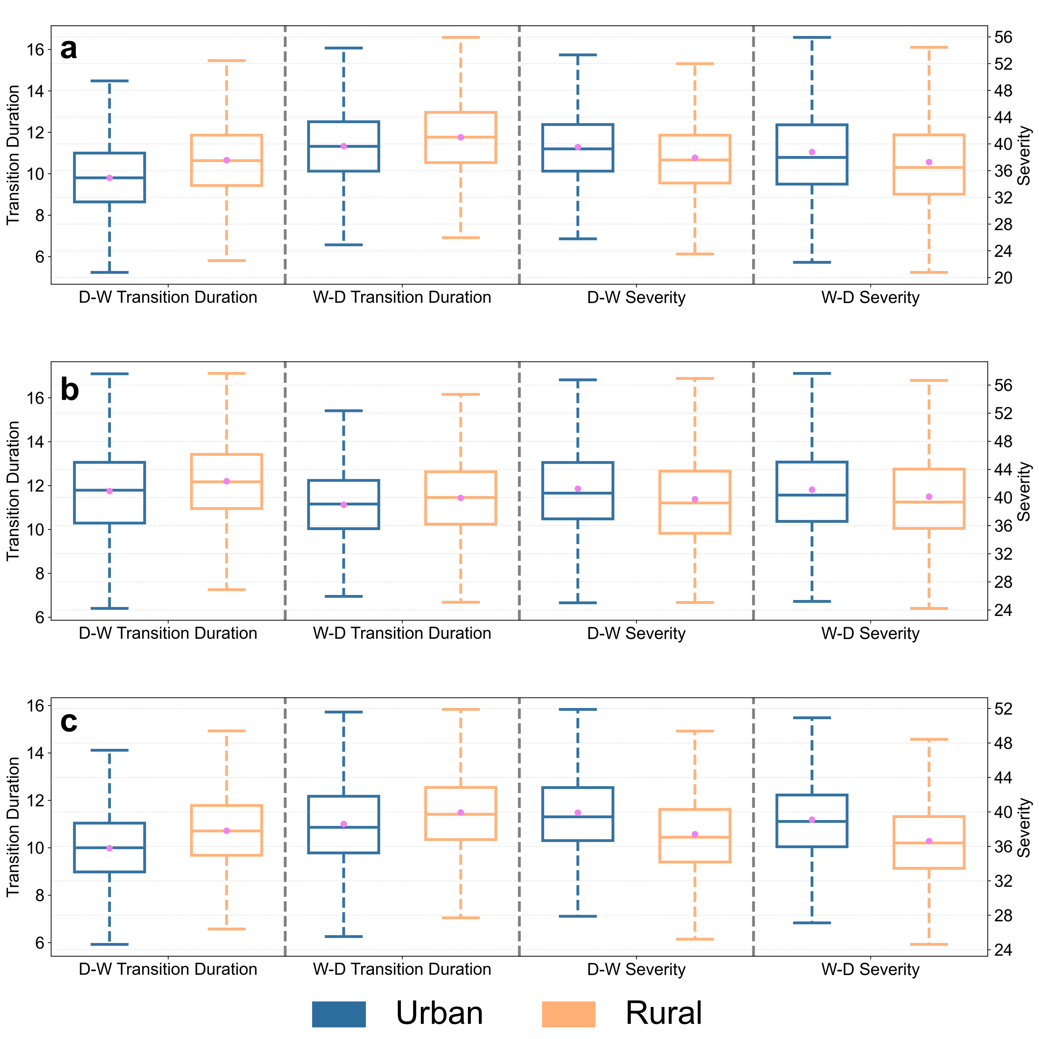

Fig. S16. Box plots of urbanization effects on WRF-simulated DWAA characteristics in urban and rural regions under urbanized scenario. a-c exhibit the box plots for BTH, PRB, and YRD urban agglomerations, respectively. The blue and orange boxes represent urban and rural regions, respectively.

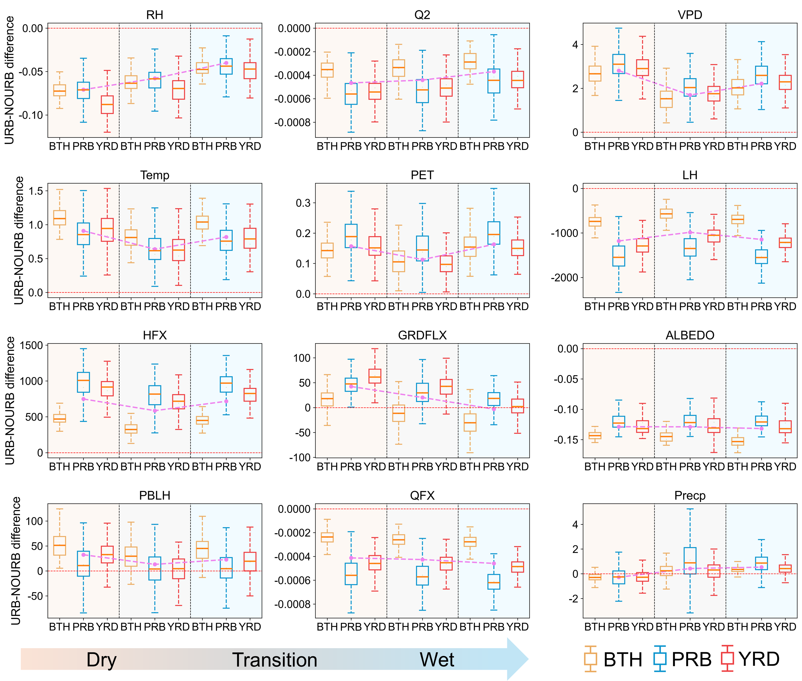

Fig. S17. Changes of surface D-W associated factors between urbanized and non-urbanized scenarios during different periods of D-W events in three urban agglomerations. RH = Relative humidity (unit: unitless); Q2 = Specific humidity at 2 m (unit: kg/kg); VPD = Vapor pressure deficit (unit: kPa); Temp = Air temperature at 2 m (unit: ℃); PET = Potential evapotranspiration (unit: mm); LH = Latent heat flux (unit: W/m²); HFX = Sensible heat flux (unit: W/m²); GRDFLX = Ground heat flux (unit: W/m²); ALBEDO = Surface albedo (unit: unitless); PHLH = Planetary boundary layer height (unit: m); QFX = Upward moisture flux (unit: kg/m/s); Precp = Light precipitation amount (unit: mm). In each panel, the areas with orange, grey, and blue background color indicate dry period, transition period, and wet period, respectively.

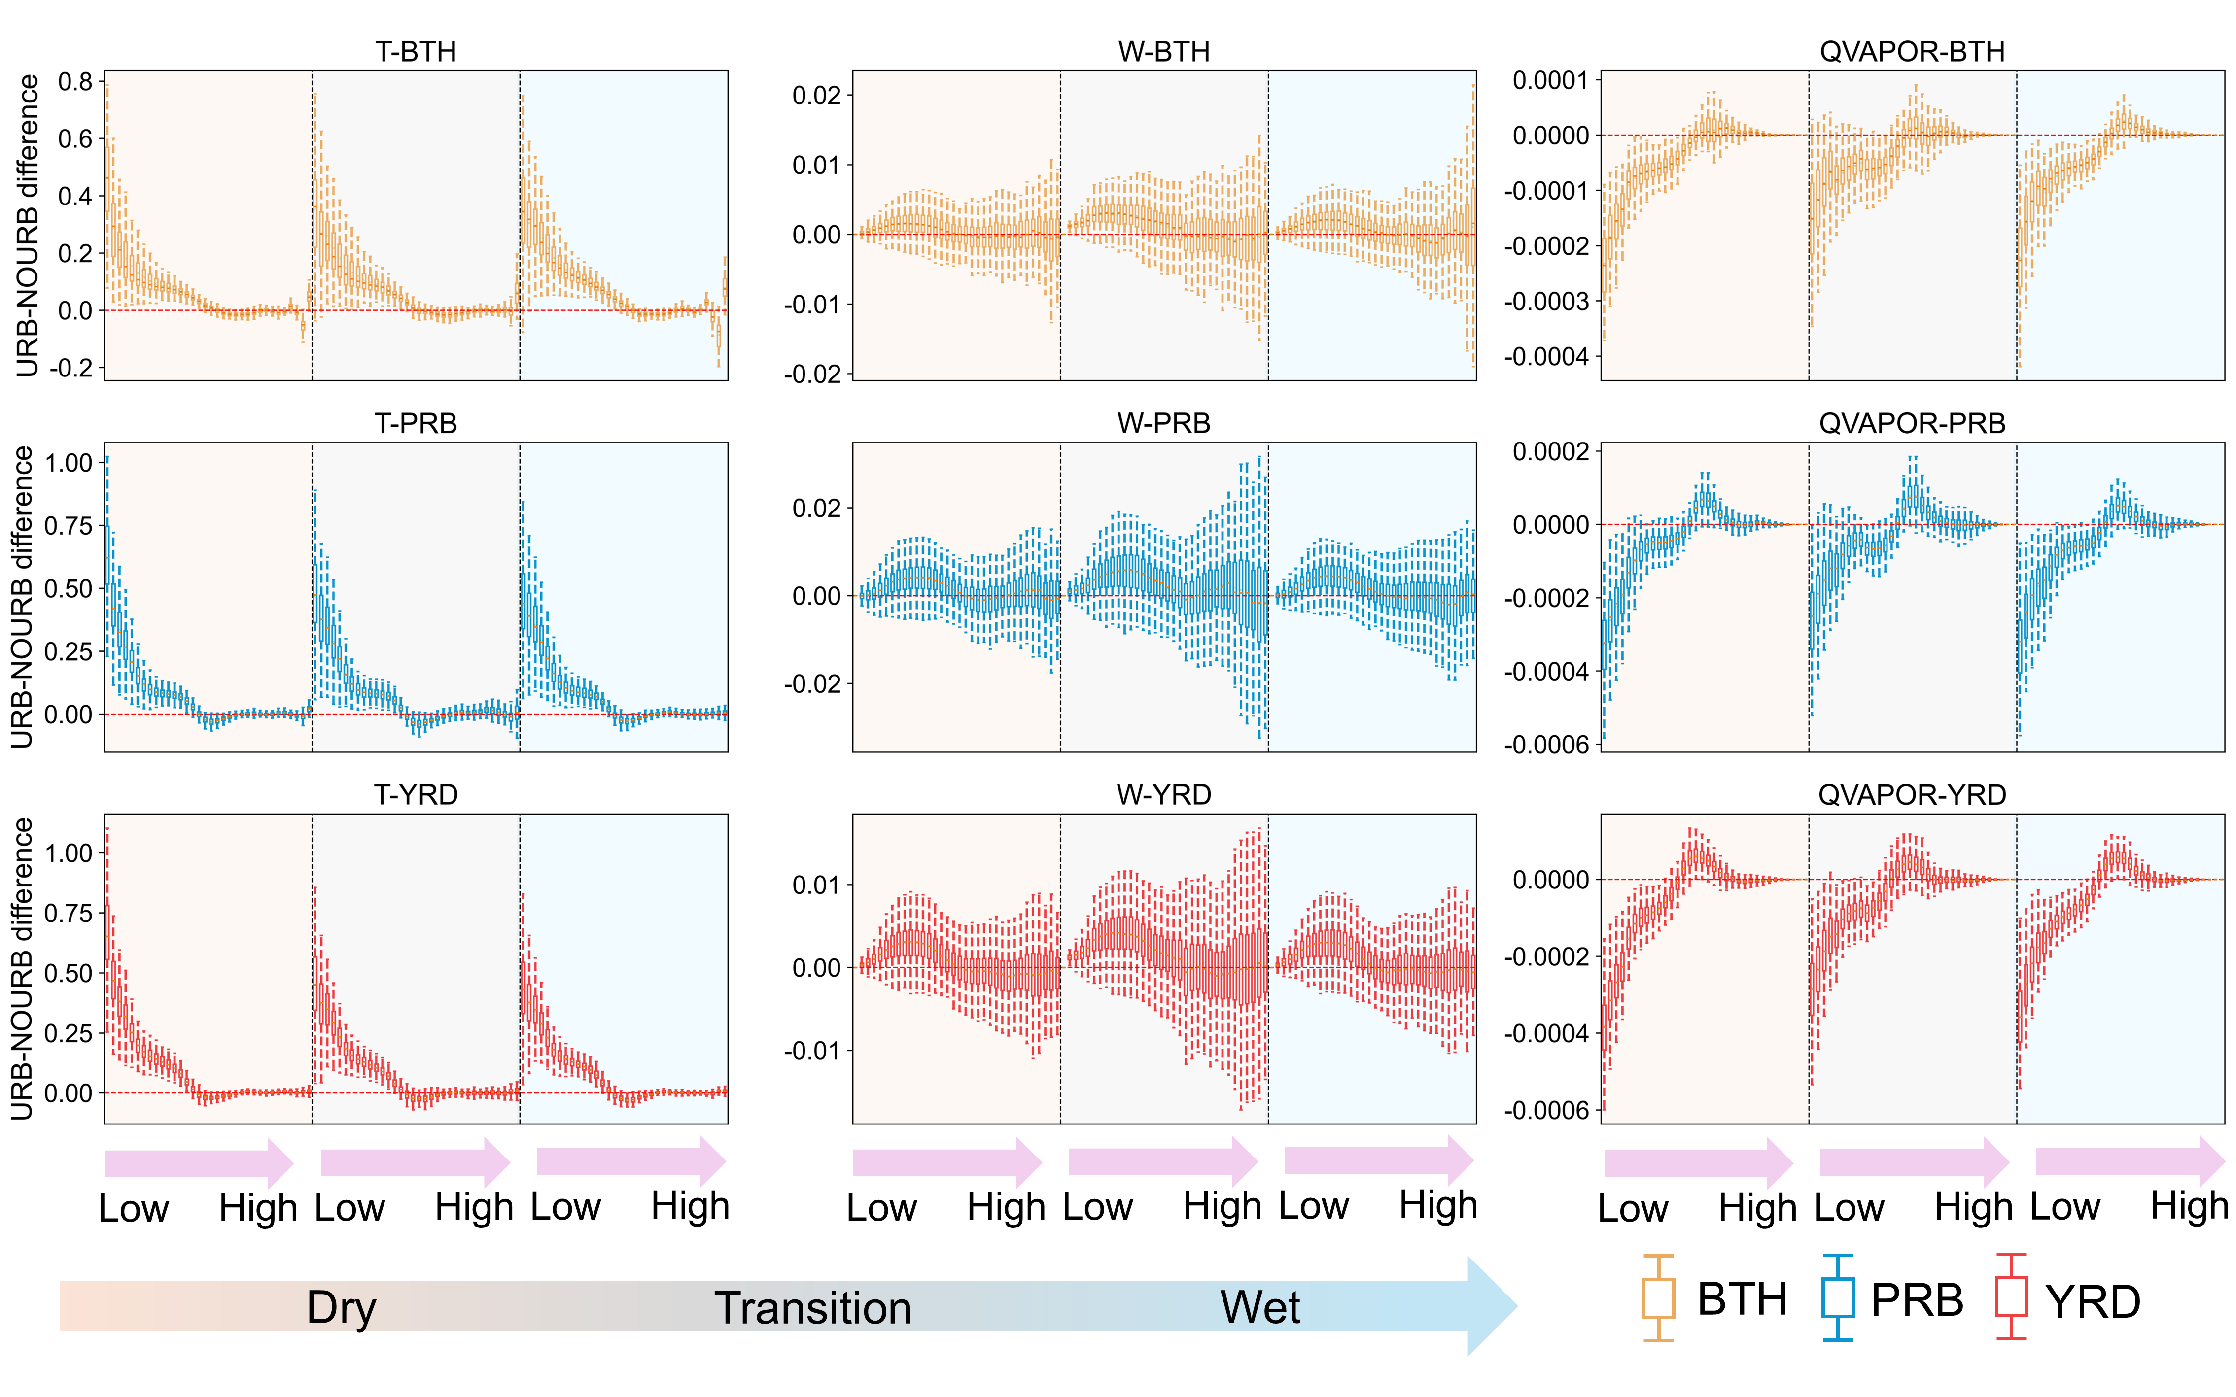

Fig. S18. Changes of D-W associated factors in various pressure levels between urbanized and non-urbanized scenarios during different periods of D-W events in three urban agglomerations. T = Perturbation potential temperature (unit: ℃); W = Z-wind component (unit: m/s); QVAPOR = Water vapor mixing ratio (unit: kg/kg). In each panel, the areas with orange, grey, and blue background color indicate the changes from low pressure levels to high pressure levels during dry period, transition period, and wet period, respectively.

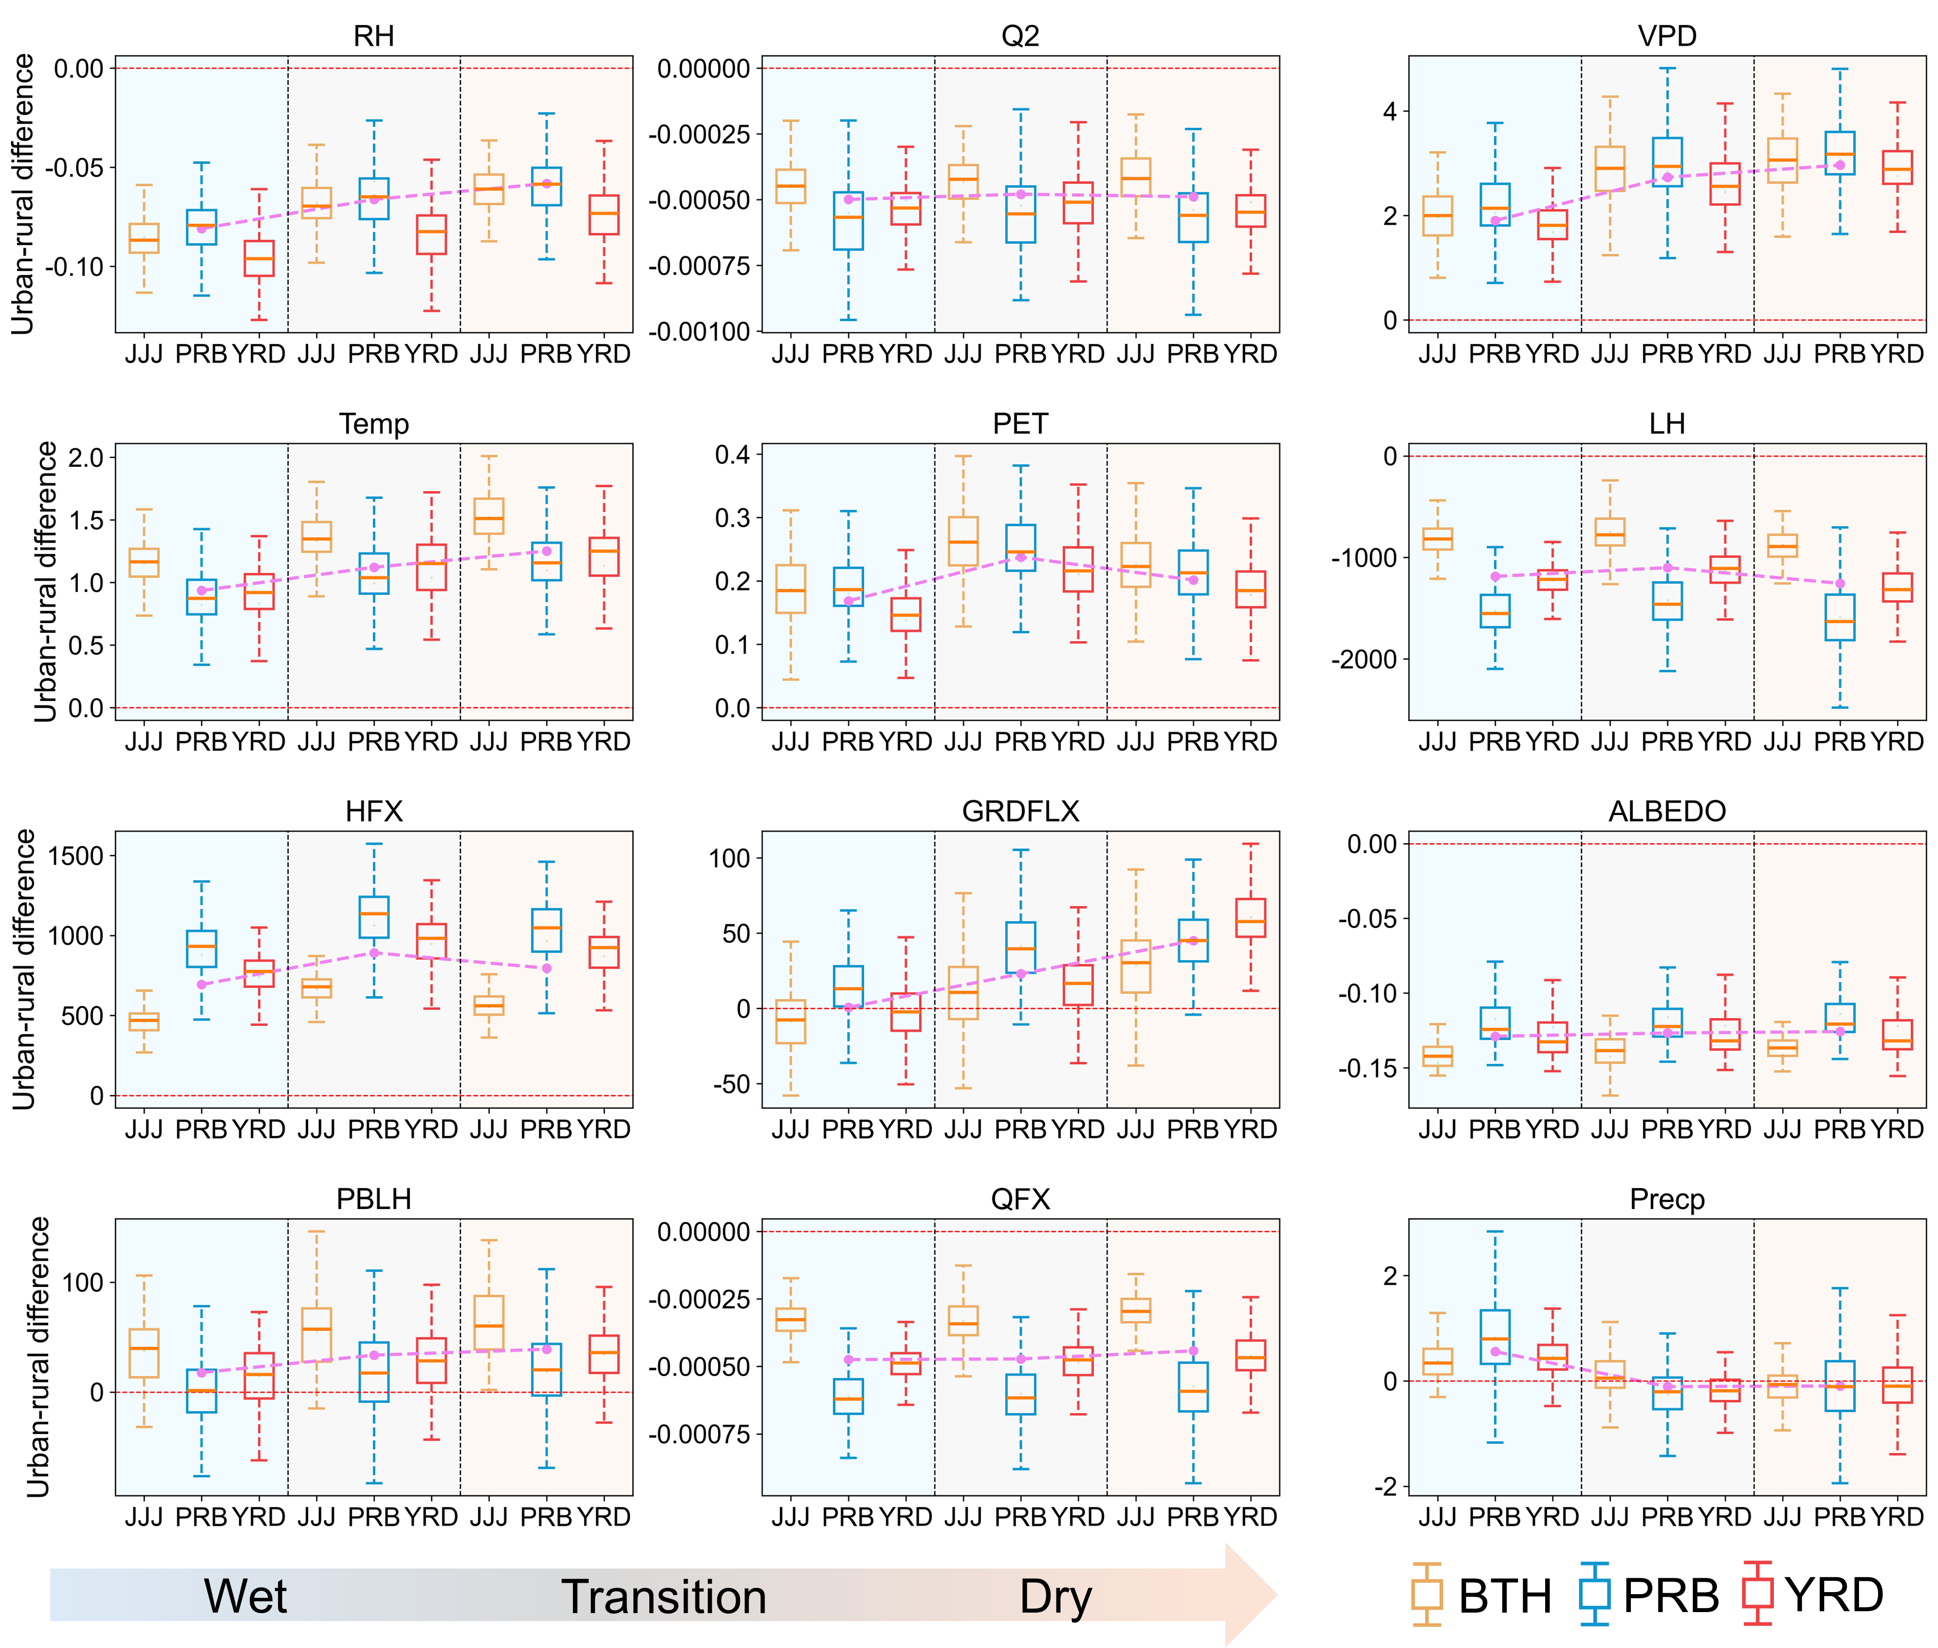

Fig. S19. Changes of W-D associated factors between urbanized and non-urbanized scenarios during different periods of W-D events in three urban agglomerations. RH = Relative humidity (unit: unitless); Q2 = Specific humidity at 2 m (unit: kg/kg); VPD = Vapor pressure deficit (unit: kPa); Temp = Air temperature at 2 m (unit: ℃); PET = Potential evapotranspiration (unit: mm); LH = Latent heat flux (unit: W/m²); HFX = Sensible heat flux (unit: W/m²); GRDFLX = Ground heat flux (unit: W/m²); ALBEDO = Surface albedo (unit: unitless); PHLH = Planetary boundary layer height (unit: m); QFX = Upward moisture flux (unit: kg/m/s); Precp = Light precipitation amount (unit: mm). In each panel, the areas with orange, grey, and blue background color indicate dry period, transition period, and wet period, respectively.

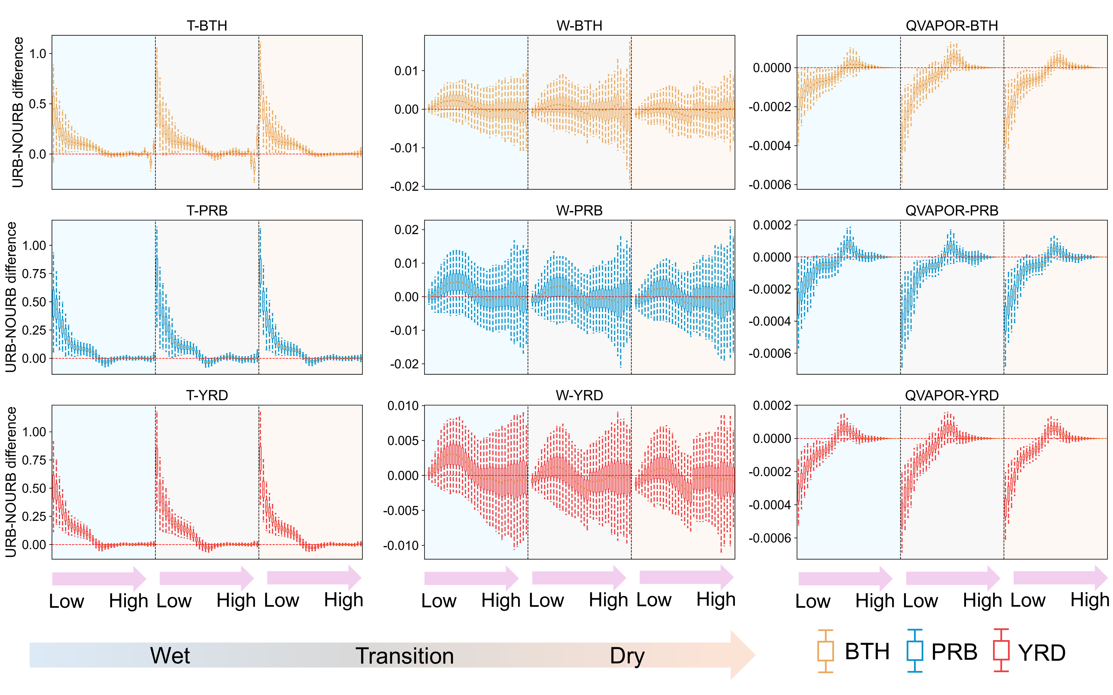

Fig. S20. Changes of W-D associated factors in various pressure levels between urbanized and non-urbanized scenarios during different periods of W-D events in three urban agglomerations. T = Perturbation potential temperature (unit: ℃); W = Z-wind component (unit: m/s); QVAPOR = Water vapor mixing ratio (unit: kg/kg). In each panel, the areas with orange, grey, and blue background color indicate the changes from low pressure levels to high pressure levels during dry period, transition period, and wet period, respectively.

Table S1. The domain information of selected urban agglomerations in WRF simulation.
Region | Domain | Resolution | Extent
BTH | D01 | 9 km × 9 km | 169 × 157
BTH | D02 | 3 km × 3 km | 180 × 165
PRB | D01 | 9 km × 9 km | 151 × 145
PRB | D02 | 3 km × 3 km | 153 × 135
YRD | D01 | 9 km × 9 km | 161 × 151
YRD | D02 | 3 km × 3 km | 147 × 138

Table S2. The configuration of WRF simulation in this study.
Physical Process | Parameterization Scheme
Microphysics | Lin et al. scheme
Cumulus | Kain-Fritsch
Longwave Radiation | RRTM
Shortwave Radiation | Dudhia
Planetary Boundary Layer | Yonsei University scheme
Surface Layer | Revised MM5 Monin-Obukhov scheme
Land Surface Model | Unified Noah
Urban Physical Process | Single-Layer Urban Canopy Model
SST_update | Enabled
Feedback | Enabled

Table S3. The percentages of red-, orange-, green-, and blue-toned pixels within the 25th-75th largest cities for D-W events. Specifically, the red-toned pixels mean that urbanization accelerates DWAA transition and exacerbates DWAA intensity, while the blue-toned pixels represent that urbanization slows down DWAA transition and mitigates DWAA intensity. The orange-toned and green-toned pixels mean that urbanization only exacerbates DWAA intensity or accelerates DWAA transition, respectively.
No. | City | Lon | Lat | Red | Orange | Green | Blue
C26 | Taizhou | 121.40 | 28.53 | 0.54 | 0.18 | 0.14 | 0.14
C27 | Daqing | 124.97 | 46.58 | 0.47 | 0.21 | 0.17 | 0.15
C28 | Shijiazhuang | 114.50 | 38.06 | 0.67 | 0.05 | 0.24 | 0.04
C29 | Changchun | 125.32 | 43.89 | 0.67 | 0.12 | 0.15 | 0.06
C30 | Shanghai | 120.97 | 31.99 | 0.46 | 0.24 | 0.20 | 0.10
C31 | Wenzhou | 120.63 | 27.78 | 0.25 | 0.55 | 0.06 | 0.14
C32 | Changsha | 112.99 | 28.20 | 0.49 | 0.14 | 0.23 | 0.14
C33 | Kunming | 102.78 | 24.96 | 0.32 | 0.20 | 0.26 | 0.22
C34 | Weifang | 118.08 | 36.78 | 0.31 | 0.06 | 0.42 | 0.21
C35 | Xianning | 114.42 | 30.50 | 0.38 | 0.31 | 0.20 | 0.11
C36 | Shantou | 116.39 | 23.27 | 0.62 | 0.12 | 0.20 | 0.06
C37 | Chongqing | 106.53 | 29.58 | 0.63 | 0.15 | 0.13 | 0.09
C38 | Dalian | 121.67 | 39.01 | 0.46 | 0.15 | 0.26 | 0.13
C39 | Hangzhou | 120.04 | 30.92 | 0.53 | 0.16 | 0.16 | 0.15
C40 | Hohhot | 109.88 | 40.63 | 0.80 | 0.13 | 0.04 | 0.03
C41 | Shenyang | 123.05 | 41.16 | 0.62 | 0.19 | 0.12 | 0.07
C42 | Wuhan | 114.16 | 30.57 | 0.52 | 0.20 | 0.13 | 0.15
C43 | Weihai | 121.35 | 37.50 | 0.47 | 0.09 | 0.26 | 0.18
C44 | Nanning | 108.35 | 22.80 | 0.62 | 0.16 | 0.16 | 0.06
C45 | Dongying | 118.58 | 37.48 | 0.49 | 0.20 | 0.16 | 0.15
C46 | Harbin | 126.65 | 45.70 | 0.60 | 0.26 | 0.07 | 0.07
C47 | Guiyang | 106.65 | 26.57 | 0.67 | 0.14 | 0.14 | 0.05
C48 | Baoding | 115.47 | 38.88 | 0.62 | 0.12 | 0.19 | 0.07
C49 | Xuzhou | 117.21 | 34.27 | 0.58 | 0.18 | 0.15 | 0.09
C50 | Bengbu | 117.36 | 32.94 | 0.73 | 0.09 | 0.16 | 0.02
C51 | Zhenjiang | 119.57 | 32.14 | 0.64 | 0.27 | 0.04 | 0.05
C52 | Xuchang | 113.76 | 34.14 | 0.74 | 0.06 | 0.18 | 0.02
C53 | Yinchuan | 106.23 | 38.46 | 0.54 | 0.07 | 0.31 | 0.08
C54 | Shaoxing | 120.08 | 29.29 | 0.65 | 0.18 | 0.07 | 0.10
C55 | Putian | 119.08 | 25.37 | 0.23 | 0.16 | 0.22 | 0.39
C56 | Luoyang | 112.46 | 34.65 | 0.64 | 0.30 | 0.04 | 0.02
C57 | Dezhou | 117.33 | 38.41 | 0.46 | 0.15 | 0.31 | 0.08
C58 | Baotou | 111.66 | 40.80 | 0.60 | 0.08 | 0.24 | 0.08
C59 | Anyang | 113.89 | 35.36 | 0.66 | 0.17 | 0.14 | 0.03
C60 | Suzhou | 116.80 | 33.97 | 0.54 | 0.10 | 0.25 | 0.11
C61 | Xinxiang | 113.16 | 35.22 | 0.63 | 0.17 | 0.15 | 0.05
C62 | Hebi | 114.28 | 36.11 | 0.53 | 0.11 | 0.29 | 0.07
C63 | Qinhuangdao | 119.58 | 39.94 | 0.38 | 0.11 | 0.23 | 0.28
C64 | Zhangjiakou | 114.92 | 40.71 | 0.45 | 0.16 | 0.15 | 0.24
C65 | Nanchang | 115.94 | 28.62 | 0.51 | 0.43 | 0.05 | 0.01
C66 | Liaocheng | 115.95 | 36.44 | 0.80 | 0.07 | 0.08 | 0.05
C67 | Yancheng | 119.07 | 33.58 | 0.75 | 0.09 | 0.13 | 0.03
C68 | Nanjing | 118.72 | 32.19 | 0.47 | 0.30 | 0.17 | 0.06
C69 | Nanyang | 112.55 | 33.02 | 0.60 | 0.15 | 0.23 | 0.02
C70 | Quanzhou | 119.55 | 25.92 | 0.74 | 0.14 | 0.08 | 0.04
C71 | Lanzhou | 103.76 | 36.08 | 0.62 | 0.16 | 0.18 | 0.04
C72 | Fuyang | 115.82 | 32.89 | 0.71 | 0.12 | 0.13 | 0.04
C73 | Fuzhou | 119.30 | 26.07 | 0.43 | 0.06 | 0.40 | 0.11
C74 | Taizhou | 119.42 | 32.38 | 0.48 | 0.20 | 0.19 | 0.13
C75 | Cangzhou | 116.12 | 38.58 | 0.37 | 0.07 | 0.41 | 0.15
C76 | Hengshui | 116.89 | 38.31 | 0.40 | 0.20 | 0.25 | 0.15
C77 | Haikou | 110.24 | 19.99 | 0.66 | 0.12 | 0.17 | 0.05
C78 | Pingdingshan | 113.33 | 33.78 | 0.61 | 0.23 | 0.07 | 0.09
C79 | Tai'an | 117.09 | 36.15 | 0.45 | 0.36 | 0.09 | 0.10
C80 | Dandong | 121.18 | 41.12 | 0.54 | 0.09 | 0.32 | 0.05
C81 | Huainan | 116.97 | 32.64 | 0.56 | 0.17 | 0.18 | 0.09
C82 | Rizhao | 120.08 | 35.94 | 0.50 | 0.10 | 0.30 | 0.10
C83 | Xiangyang | 112.16 | 32.10 | 0.60 | 0.10 | 0.15 | 0.15
C84 | Jilin | 126.54 | 43.87 | 0.54 | 0.10 | 0.24 | 0.12
C85 | Zhuzhou | 112.94 | 27.88 | 0.70 | 0.12 | 0.14 | 0.04
C86 | Huangshi | 115.01 | 30.17 | 0.67 | 0.12 | 0.17 | 0.04
C87 | Weihai | 122.11 | 37.45 | 0.37 | 0.22 | 0.18 | 0.23
C88 | Jinzhou | 120.83 | 40.71 | 0.57 | 0.07 | 0.29 | 0.07
C89 | Liuzhou | 109.40 | 24.32 | 0.55 | 0.25 | 0.12 | 0.08
C90 | Lianyungang | 119.25 | 34.63 | 0.71 | 0.15 | 0.11 | 0.03
C91 | Laiwu | 117.65 | 36.22 | 0.33 | 0.07 | 0.38 | 0.22
C92 | Harbin | 126.56 | 45.87 | 0.55 | 0.27 | 0.12 | 0.06
C93 | Nanchang | 115.80 | 28.69 | 0.41 | 0.19 | 0.24 | 0.16
C94 | Kaifeng | 114.29 | 34.79 | 0.52 | 0.14 | 0.15 | 0.19
C95 | Datong | 113.24 | 40.05 | 0.10 | 0.24 | 0.24 | 0.42
C96 | Yangquan | 113.58 | 37.87 | 0.46 | 0.19 | 0.23 | 0.12
C97 | Zibo | 117.78 | 36.85 | 0.68 | 0.13 | 0.12 | 0.07
C98 | Xiangtan | 113.11 | 27.85 | 0.70 | 0.22 | 0.06 | 0.02
C99 | Nantong | 120.34 | 32.03 | 0.09 | 0.75 | 0.07 | 0.09
C100 | Wuhan | 114.27 | 30.75 | 0.56 | 0.22 | 0.18 | 0.04

Table S4. The percentages of red-, orange-, green-, and blue-toned pixels within the 25th-75th largest cities for W-D events. Specifically, the red-toned pixels mean that urbanization accelerates DWAA transition and exacerbates DWAA intensity, while the blue-toned pixels represent that urbanization slows down DWAA transition and mitigates DWAA intensity. The orange-toned and green-toned pixels mean that urbanization only exacerbates DWAA intensity or accelerates DWAA transition, respectively.
No. | City | Lon | Lat | Red | Orange | Green | Blue
C26 | Taizhou | 121.40 | 28.53 | 0.49 | 0.25 | 0.16 | 0.10
C27 | Daqing | 124.97 | 46.58 | 0.41 | 0.22 | 0.23 | 0.14
C28 | Shijiazhuang | 114.50 | 38.06 | 0.39 | 0.11 | 0.35 | 0.15
C29 | Changchun | 125.32 | 43.89 | 0.78 | 0.13 | 0.06 | 0.03
C30 | Shanghai | 120.97 | 31.99 | 0.44 | 0.15 | 0.31 | 0.10
C31 | Wenzhou | 120.63 | 27.78 | 0.53 | 0.36 | 0.06 | 0.05
C32 | Changsha | 112.99 | 28.20 | 0.64 | 0.23 | 0.09 | 0.04
C33 | Kunming | 102.78 | 24.96 | 0.31 | 0.12 | 0.35 | 0.22
C34 | Weifang | 118.08 | 36.78 | 0.60 | 0.06 | 0.28 | 0.06
C35 | Xianning | 114.42 | 30.50 | 0.70 | 0.12 | 0.10 | 0.08
C36 | Shantou | 116.39 | 23.27 | 0.34 | 0.23 | 0.27 | 0.16
C37 | Chongqing | 106.53 | 29.58 | 0.61 | 0.18 | 0.13 | 0.08
C38 | Dalian | 121.67 | 39.01 | 0.59 | 0.14 | 0.18 | 0.09
C39 | Hangzhou | 120.04 | 30.92 | 0.58 | 0.16 | 0.15 | 0.11
C40 | Hohhot | 109.88 | 40.63 | 0.34 | 0.17 | 0.35 | 0.14
C41 | Shenyang | 123.05 | 41.16 | 0.63 | 0.15 | 0.16 | 0.06
C42 | Wuhan | 114.16 | 30.57 | 0.74 | 0.14 | 0.07 | 0.05
C43 | Weihai | 121.35 | 37.50 | 0.34 | 0.16 | 0.26 | 0.24
C44 | Nanning | 108.35 | 22.80 | 0.64 | 0.15 | 0.16 | 0.05
C45 | Dongying | 118.58 | 37.48 | 0.64 | 0.13 | 0.12 | 0.11
C46 | Harbin | 126.65 | 45.70 | 0.51 | 0.21 | 0.20 | 0.08
C47 | Guiyang | 106.65 | 26.57 | 0.48 | 0.28 | 0.14 | 0.10
C48 | Baoding | 115.47 | 38.88 | 0.39 | 0.08 | 0.48 | 0.05
C49 | Xuzhou | 117.21 | 34.27 | 0.51 | 0.14 | 0.26 | 0.09
C50 | Bengbu | 117.36 | 32.94 | 0.50 | 0.31 | 0.09 | 0.10
C51 | Zhenjiang | 119.57 | 32.14 | 0.55 | 0.20 | 0.12 | 0.13
C52 | Xuchang | 113.76 | 34.14 | 0.53 | 0.11 | 0.28 | 0.08
C53 | Yinchuan | 106.23 | 38.46 | 0.45 | 0.28 | 0.20 | 0.07
C54 | Shaoxing | 120.08 | 29.29 | 0.69 | 0.12 | 0.13 | 0.06
C55 | Putian | 119.08 | 25.37 | 0.26 | 0.36 | 0.16 | 0.22
C56 | Luoyang | 112.46 | 34.65 | 0.42 | 0.20 | 0.17 | 0.21
C57 | Dezhou | 117.33 | 38.41 | 0.58 | 0.08 | 0.21 | 0.13
C58 | Baotou | 111.66 | 40.80 | 0.50 | 0.23 | 0.18 | 0.09
C59 | Anyang | 113.89 | 35.36 | 0.51 | 0.23 | 0.23 | 0.03
C60 | Suzhou | 116.80 | 33.97 | 0.67 | 0.12 | 0.19 | 0.02
C61 | Xinxiang | 113.16 | 35.22 | 0.53 | 0.05 | 0.38 | 0.04
C62 | Hebi | 114.28 | 36.11 | 0.43 | 0.32 | 0.18 | 0.07
C63 | Qinhuangdao | 119.58 | 39.94 | 0.45 | 0.36 | 0.10 | 0.09
C64 | Zhangjiakou | 114.92 | 40.71 | 0.41 | 0.16 | 0.25 | 0.18
C65 | Nanchang | 115.94 | 28.62 | 0.48 | 0.10 | 0.26 | 0.16
C66 | Liaocheng | 115.95 | 36.44 | 0.48 | 0.11 | 0.36 | 0.05
C67 | Yancheng | 119.07 | 33.58 | 0.73 | 0.14 | 0.13 | 0.00
C68 | Nanjing | 118.72 | 32.19 | 0.53 | 0.2 | 0.14 | 0.13
C69 | Nanyang | 112.55 | 33.02 | 0.72 | 0.15 | 0.1 | 0.03
C70 | Quanzhou | 119.55 | 25.92 | 0.78 | 0.14 | 0.06 | 0.02
C71 | Lanzhou | 103.76 | 36.08 | 0.49 | 0.16 | 0.15 | 0.2
C72 | Fuyang | 115.82 | 32.89 | 0.52 | 0.22 | 0.17 | 0.09
C73 | Fuzhou | 119.30 | 26.07 | 0.47 | 0.16 | 0.31 | 0.06
C74 | Taizhou | 119.42 | 32.38 | 0.63 | 0.14 | 0.17 | 0.06
C75 | Cangzhou | 116.12 | 38.58 | 0.44 | 0.09 | 0.38 | 0.09
C76 | Hengshui | 116.89 | 38.31 | 0.48 | 0.15 | 0.23 | 0.14
C77 | Haikou | 110.24 | 19.99 | 0.62 | 0.15 | 0.2 | 0.03
C78 | Pingdingshan | 113.33 | 33.78 | 0.62 | 0.21 | 0.14 | 0.03
C79 | Tai'an | 117.09 | 36.15 | 0.57 | 0.17 | 0.14 | 0.12
C80 | Dandong | 121.18 | 41.12 | 0.47 | 0.33 | 0.08 | 0.12
C81 | Huainan | 116.97 | 32.64 | 0.42 | 0.38 | 0.07 | 0.13
C82 | Rizhao | 120.08 | 35.94 | 0.46 | 0.11 | 0.26 | 0.17
C83 | Xiangyang | 112.16 | 32.10 | 0.76 | 0.15 | 0.06 | 0.03
C84 | Jilin | 126.54 | 43.87 | 0.53 | 0.14 | 0.26 | 0.07
C85 | Zhuzhou | 112.94 | 27.88 | 0.58 | 0.28 | 0.07 | 0.07
C86 | Huangshi | 115.01 | 30.17 | 0.58 | 0.21 | 0.15 | 0.06
C87 | Weihai | 122.11 | 37.45 | 0.51 | 0.14 | 0.21 | 0.14
C88 | Jinzhou | 120.83 | 40.71 | 0.56 | 0.09 | 0.29 | 0.06
C89 | Liuzhou | 109.40 | 24.32 | 0.72 | 0.12 | 0.1 | 0.06
C90 | Lianyungang | 119.25 | 34.63 | 0.58 | 0.17 | 0.16 | 0.09
C91 | Laiwu | 117.65 | 36.22 | 0.67 | 0.22 | 0.1 | 0.01
C92 | Harbin | 126.56 | 45.87 | 0.61 | 0.14 | 0.21 | 0.04
C93 | Nanchang | 115.80 | 28.69 | 0.69 | 0.24 | 0.02 | 0.05
C94 | Kaifeng | 114.29 | 34.79 | 0.54 | 0.22 | 0.16 | 0.08
C95 | Datong | 113.24 | 40.05 | 0.19 | 0.04 | 0.31 | 0.46
C96 | Yangquan | 113.58 | 37.87 | 0.28 | 0.39 | 0.16 | 0.17
C97 | Zibo | 117.78 | 36.85 | 0.69 | 0.1 | 0.13 | 0.08
C98 | Xiangtan | 113.11 | 27.85 | 0.66 | 0.28 | 0.02 | 0.04
C99 | Nantong | 120.34 | 32.03 | 0.52 | 0.36 | 0.09 | 0.03
C100 | Wuhan | 114.27 | 30.75 | 0.48 | 0.31 | 0.12 | 0.09

