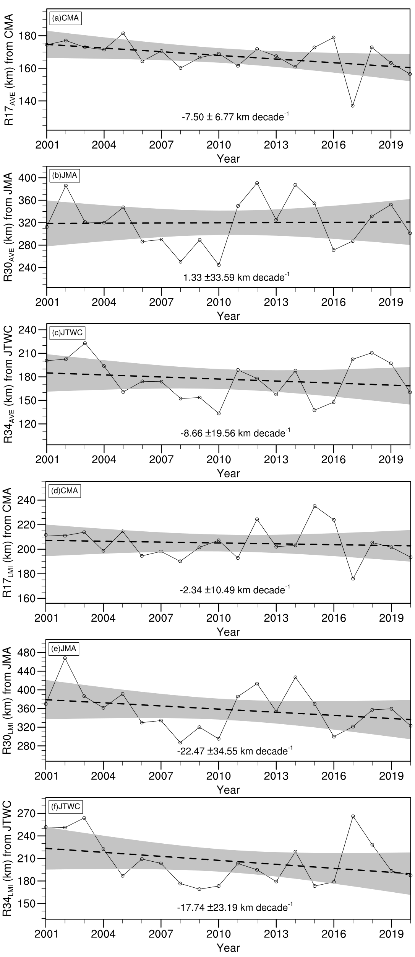
Fig. S1. Time series of TC size in the northwestern Pacific from 2001 to 2020 based on different observational datasets: (a) Time series of average R34 from CMA during lifetime; (b) Time series of average R30 from JMA during lifetime; (c) Time series of average R34 from JTWC during the TC lifetime; (d) Time series of R34 at the lifetime maximum intensity moment from CMA; (e) Time series of R30 at the lifetime maximum intensity moment from JMA; (f) Time series of R34 at the lifetime maximum intensity moment from JTWC. The black circles represent TC size for each year, the black dashed line represents the linear regression curve of the TC size trend, and the gray shading indicates the 95% two-sided confidence interval of the regression curve (km).

Table S1 Pearson correlation coefficients between the time series of annual average TC size in the Northwestern Pacific from 2001 to 2020 based on different observational datasets.
（a）average TC size during lifetime
r_{AVE} | CMA | JMA | JTWC
CMA | 1 | 0.23 | 0.11
JMA | 0.23 | 1 | 0.41
JTWC | 0.11 | 0.41 | 1
（b）TC size at the moment of lifetime maximum intensity
r_{LMI} | CMA | JMA | JTWC
CMA | 1 | 0.35 | 0.43
JMA | 0.35 | 1 | 0.59
JTWC | 0.43 | 0.59 | 1

