Supplementary Information for: Geochemical proxy records to reconstruct terrestrial input, redox conditions, and biological production in a tropical paleo-lagoon during the mid-Holocene

Chris Carl Agustin V. Toyado1 and Caroline Marie B. Jaraula1,*
1Marine Science Institute, University of the Philippines, Diliman, Quezon City, 1101 Philippines
*Corresponding author e-mail: carolinejaraula@gmail.com

Sediment core chronology
The ages of the uppermost 131.8 cm of the sediment core were determined using 210Pb and 137Cs dating. Assuming a Constant Initial Concentration (CIC) model for the excess 210Pb (210Pbxs) profile, 210Pb concentrations were converted to sediment ages using equation S1 (Appleby and Oldfield 1983),

(Eq. S1)

where t is the age of the sediment at depth x, C(0) is the 210Pbxs concentration at the sediment-water interface of 47 Bq/kg, C(x) is the concentration of 210Pb at depth x, k is the 210Pb decay constant of 0.03114 yr-1. The natural logarithms of the 210Pbxs concentrations are plotted on the left panel of Figure S1, with the numbers indicating the sampling depth. The dotted line is the weighted moving average model of these 210Pbxs concentrations. Depths in black font are used in the final 210Pb age model composed of two linear models intersecting at 91.8 cm. Depths in gray font shallower than 131.8 cm were discarded due to either the influx of old deep soils or young surface soils. Depths in gray font deeper than 131.8 cm, on the other hand, were discarded because the change in the 210Pbxs moving average model (center panel) became constant and near-zero beginning at 131.8 until 277.5 cm. The left panel shows the change in the change of the 210Pbxs moving average model with depth.

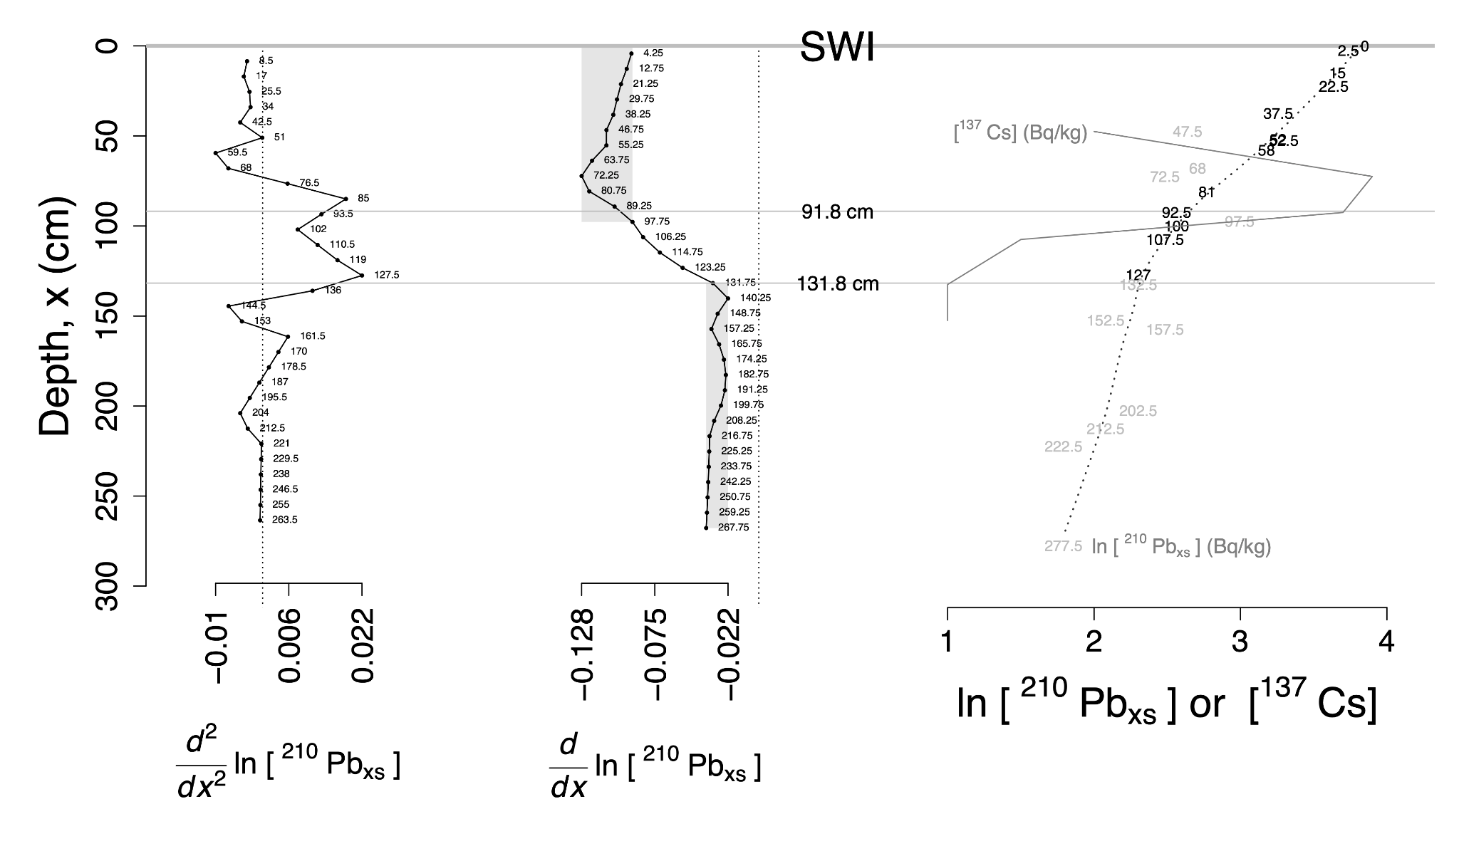
Figure S1. Derivation of the 210Pb age model used in this study.

Sediments ages at 328 cm and deeper, on the other hand, were derived from radiocarbon dates, whereas sediment ages between 328 cm, the topmost extent of the 14C age model, and 131.8 cm, the deepest extent of the 210Pb age model were interpolated. The radiocarbon ages for the 14C age model used in this study were adopted from Jaraula et al. (2014), but were recalibrated using Calib 8.2 (calib.org; Stuiver and Reimer, 1993). The 14C ages of the two Thiara riqueti freshwater shells at 326 and 638 cm depths were recalibrated using the IntCal20 database (Reimer et al. 2020), whereas the 14C ages of the rest of the materials come from marine organisms (i.e. Anomalocardia scabra, Tellina sp., and two other gastropods) and were recalibrated using the Marine20 database (Heaton et al. 2020). The reservoir age used for the marine samples was ΔR= –173 ± 75.0, calculated from the weighted mean of the three nearest sampled gastropods from Janao Bay, Mindoro Strait, and Mona Island in the western Philippines (Southon et al. 2002). The 14C age model has two segments: (i) the 6640 to 5990 cal BP segment was modeled using the calendar ages of shells at depths of 768, 832, and 998 cm, yielding an average sedimentation rate of 0.36 cm yr-1; whereas (ii) the 5990 to 2580 cal BP segment was modeled using shells at depths of 328, 638, 690, 694, 768, and 832 cm, yielding an average sedimentation rate of 0.14 cm yr-1.

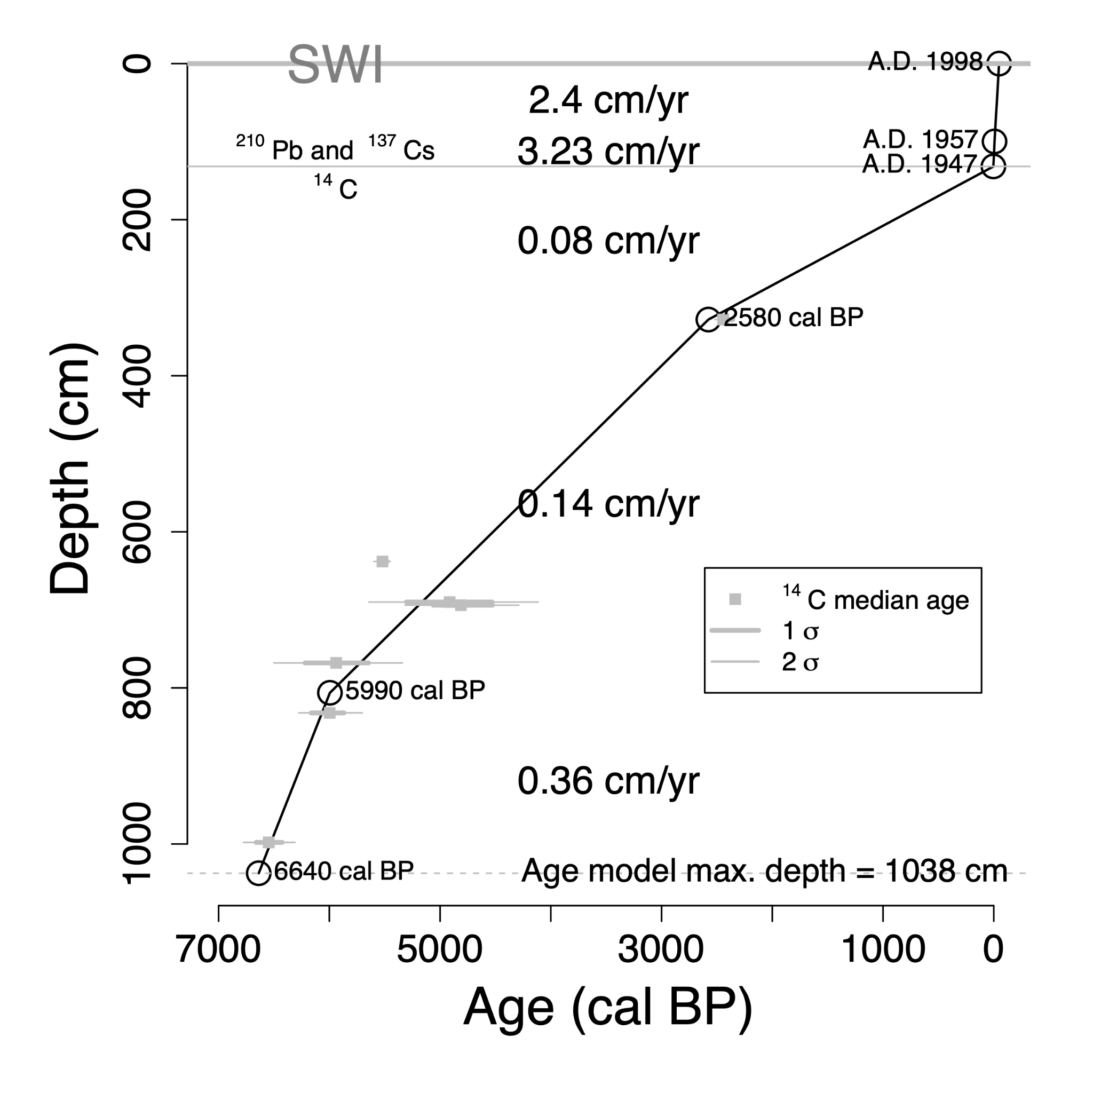
Figure S2. 210Pb-137Cs-14C age model for the entire 10.5-meter length of the sediment core collected from Laguna Lake's Western Lobe in 1998.
Proxy relationships
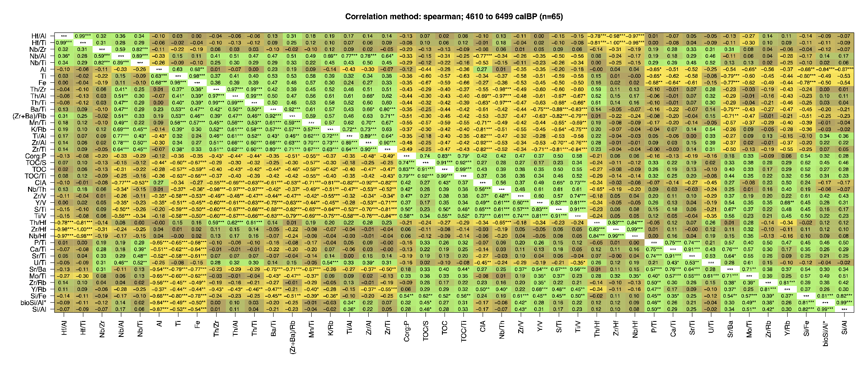
Figure S3. Spearman correlation matrix of terrestrial input, rainfall/weathering, salinity, redox, biological production, and grain size proxies (Dinelli et al. 2007) for the marine phase of Laguna de Bai's Western Lobe (6,510 to 4,590 cal BP). Correlation coefficients with asterisks *, **, and *** denote statistical significance at levels p < 5%, 1%, and 0.1%, respectively; whereas correlation coefficients without asterisks denote non-significant correlation (i.e. p > 5%). The pairwise number of cases during the correlation are presented in Figure S4.

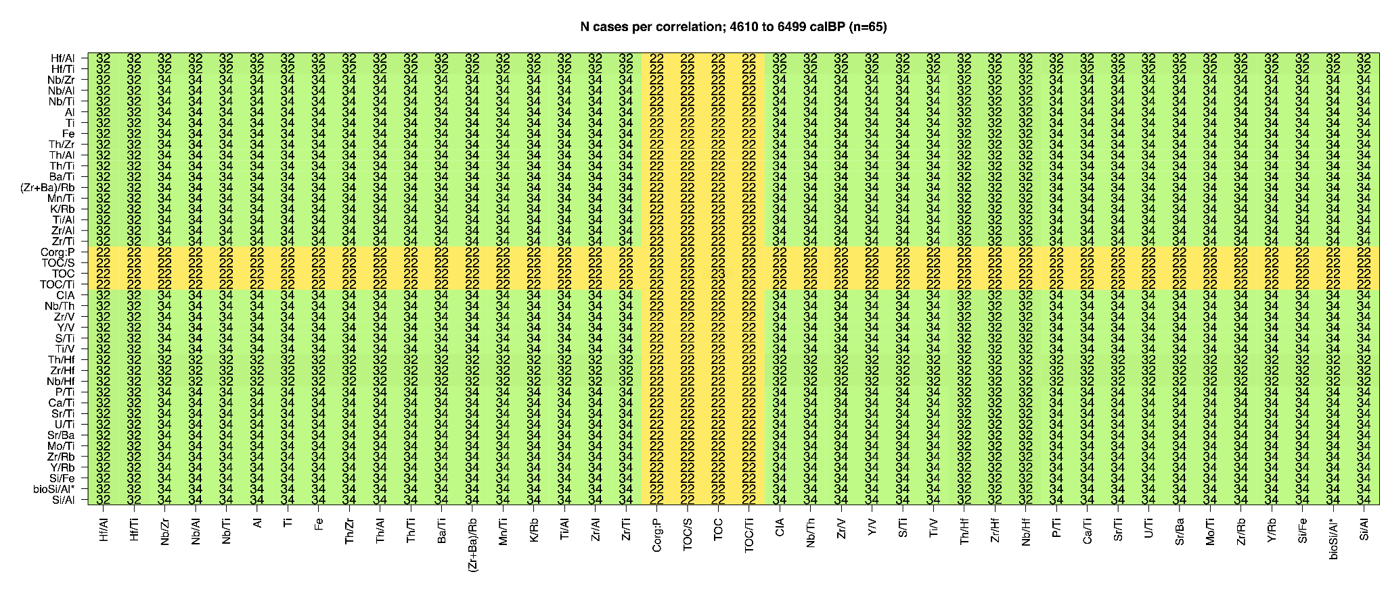
Figure S4. Pairwise number of cases in the correlation in Figure S3.

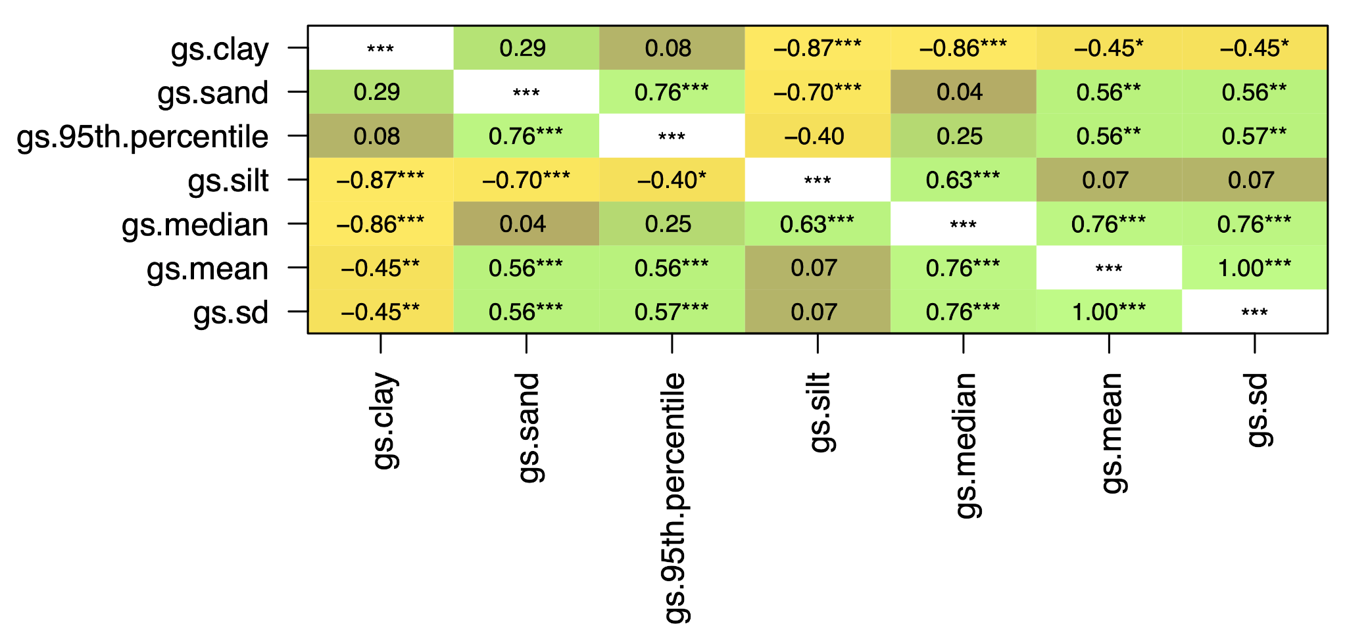
Figure S5. Spearman correlation matrix (n=42) of the grain size parameters for the marine phase of Laguna de Bai's Western Lobe (6,510 to 4,590 cal BP). Correlation coefficients with asterisks *, **, and *** denote statistical significance at levels p < 5%, 1%, and 0.1%, respectively; whereas correlation coefficients without asterisks denote non-significant correlation (i.e. p > 5%).

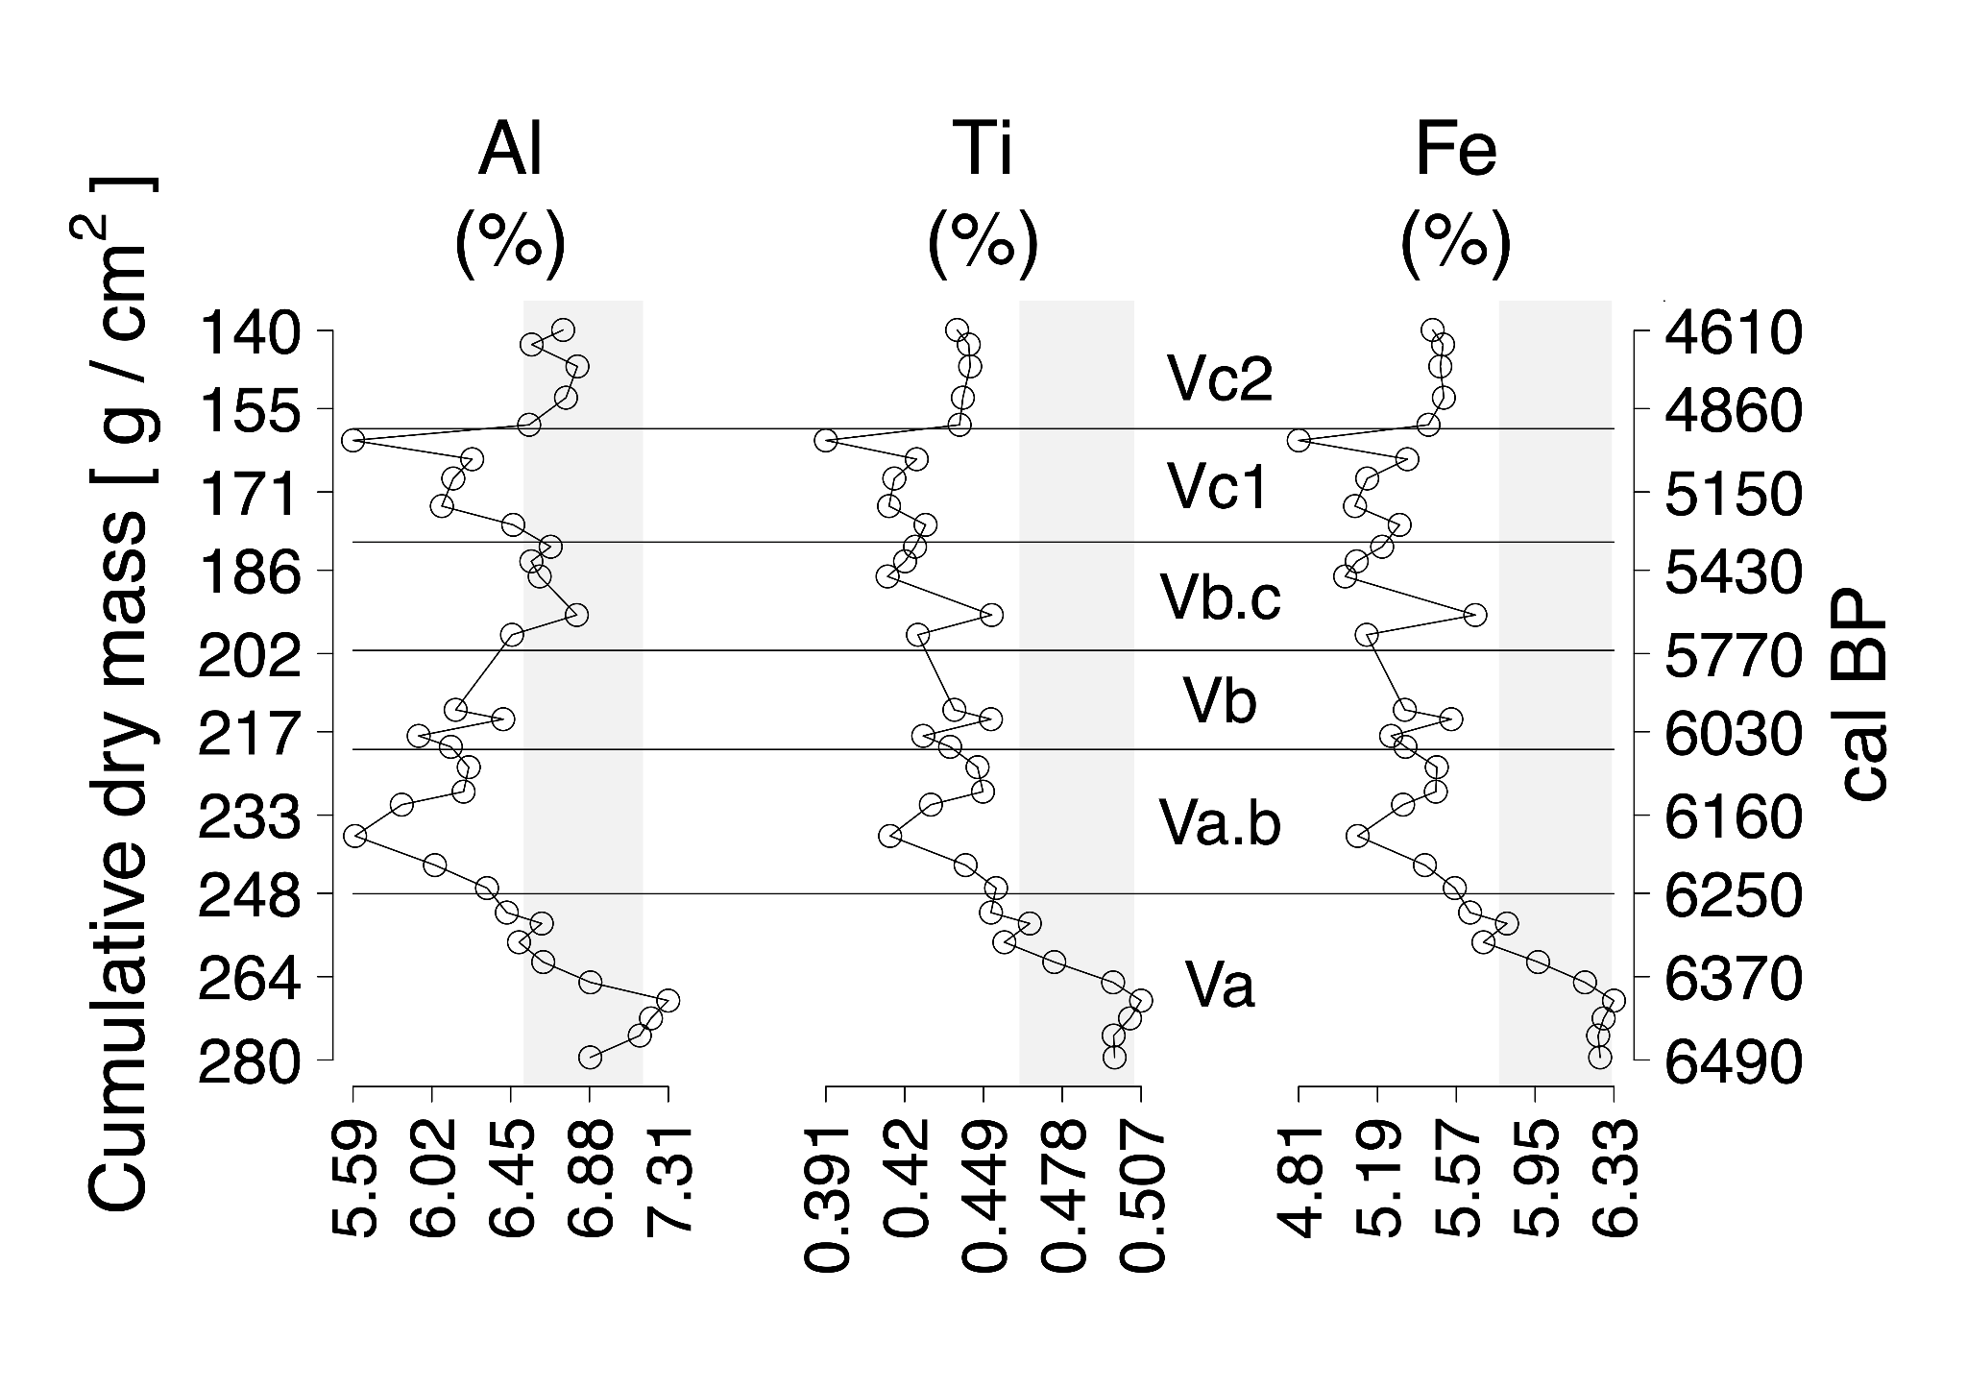
Figure S6. Major terrigenous element records of Laguna de Bai's Western Lobe during its marine phase (6,510 to 4,590 cal BP). Gray vertical bars represent the mean ± 1σ of Laguna de Bai's Western Lobe sub-tidal marine period values (Period Va; 6,510 to 6,260 cal BP), whereas the horizontal lines represent chemolithostratigraphic unit boundaries (Figure 2).

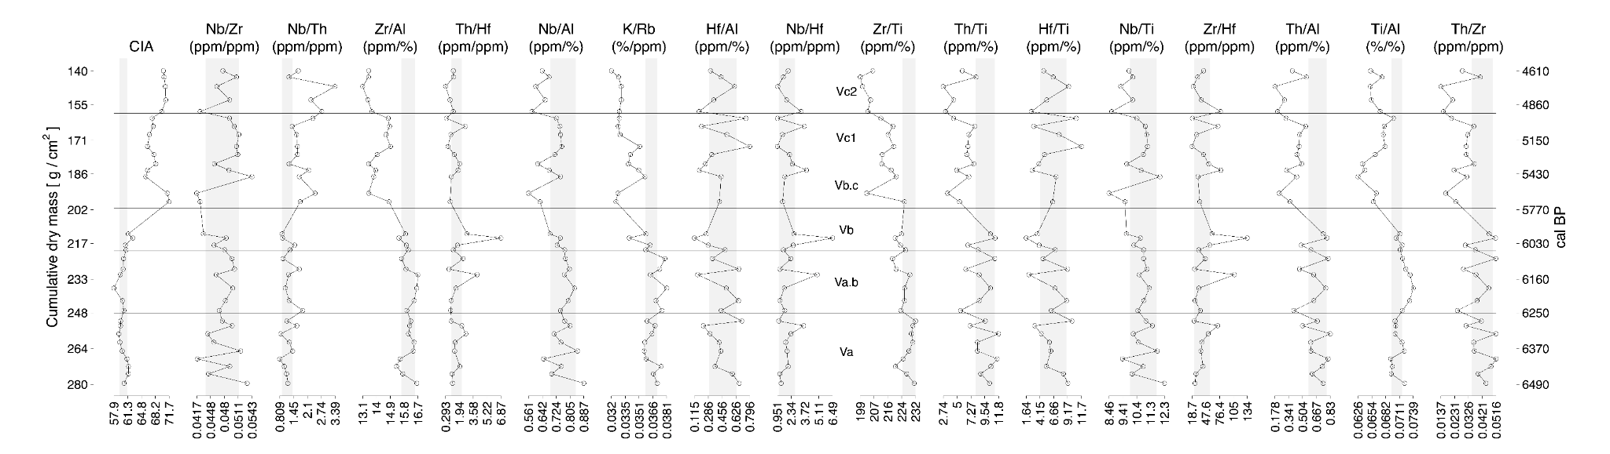
Figure S7. Weathering and rainfall proxy records of Laguna de Bai's Western Lobe during its marine phase (6,510 to 4,590 cal BP). Gray vertical bars represent the mean ± 1σ of Laguna de Bai's Western Lobe sub-tidal marine period values (Period Va; 6,510 to 6,260 cal BP), whereas the horizontal lines represent chemolithostratigraphic unit boundaries (Figure 2).

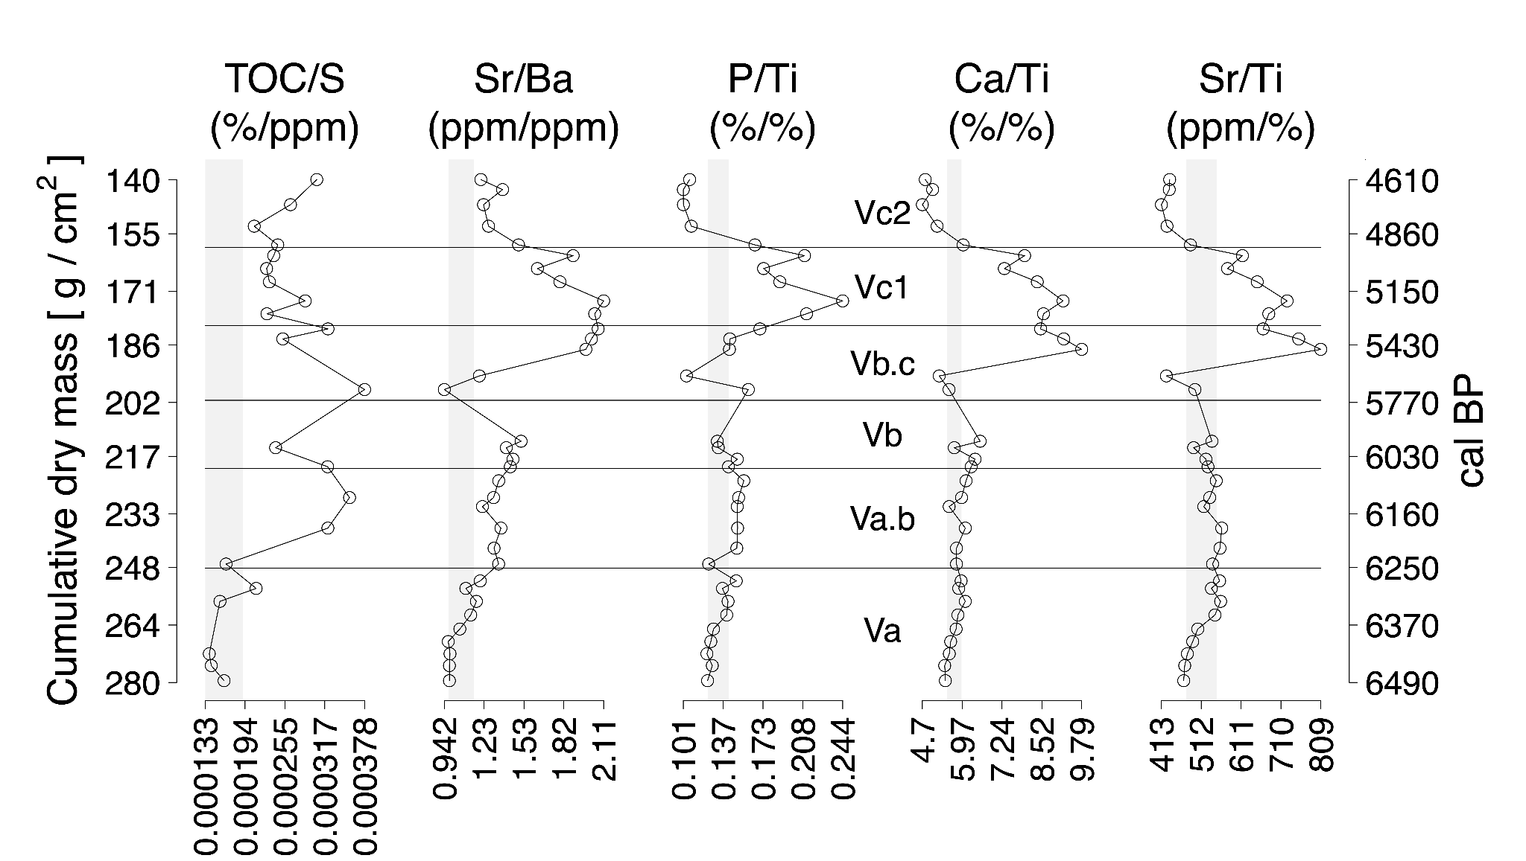
Figure S8. Salinity proxy records of Laguna de Bai's Western Lobe during its marine phase (6,510 to 4,590 cal BP). Gray vertical bars represent the mean ± 1σ of Laguna de Bai's Western Lobe sub-tidal marine period values (Period Va; 6,510 to 6,260 cal BP), whereas the horizontal lines represent chemolithostratigraphic unit boundaries (Figure 2).

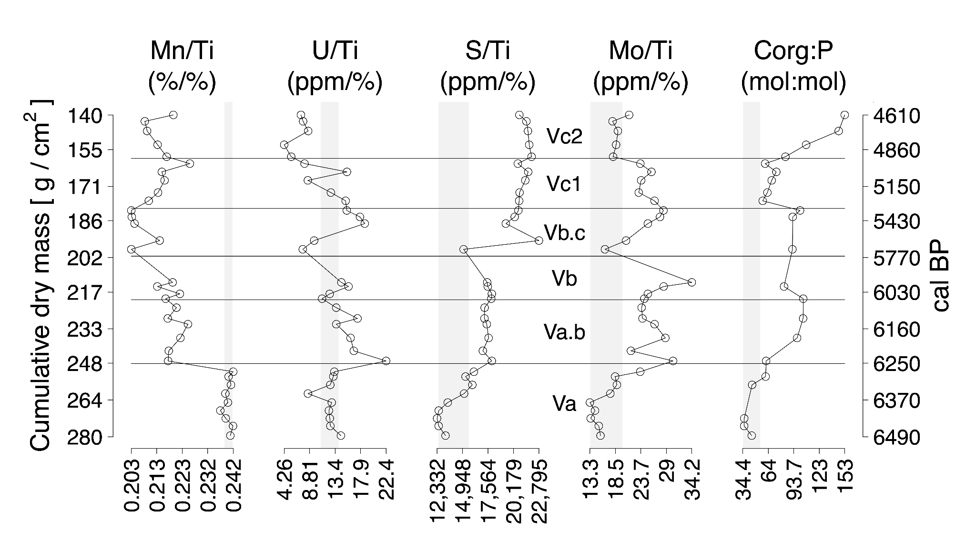
Figure S9. Redox proxy records of Laguna de Bai's Western Lobe during its marine phase (6,510 to 4,590 cal BP). Gray vertical bars represent the mean ± 1σ of Laguna de Bai's Western Lobe sub-tidal marine period values (Period Va; 6,510 to 6,260 cal BP), whereas the horizontal lines represent chemolithostratigraphic unit boundaries (Figure 2).

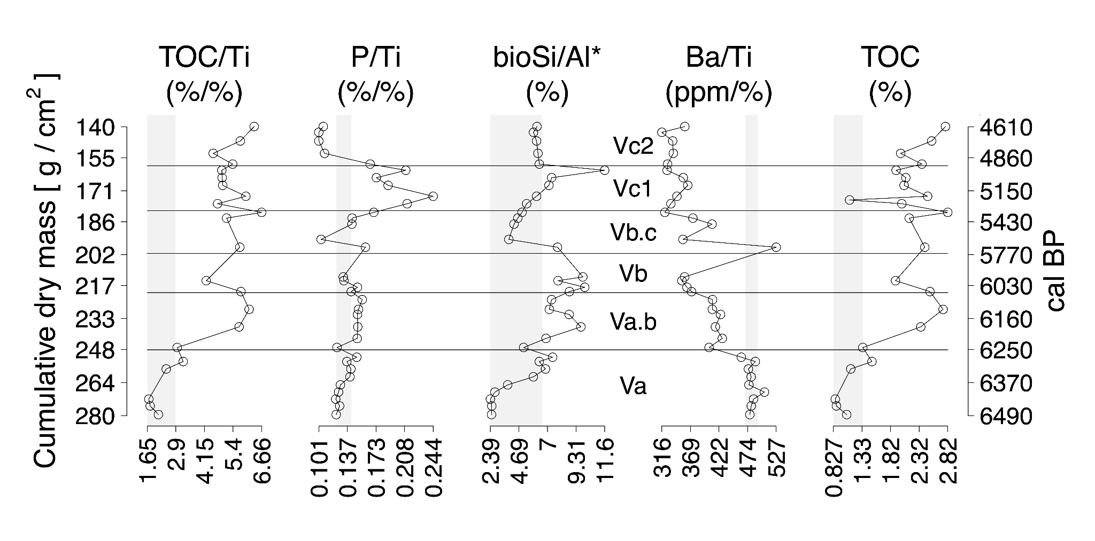
Figure S10. Biological production records of Laguna de Bai's Western Lobe during its marine phase (6,510 to 4,590 cal BP). Gray vertical bars represent the mean ± 1σ of Laguna de Bai's Western Lobe sub-tidal marine period values (Period Va; 6,510 to 6,260 cal BP), whereas the horizontal lines represent chemolithostratigraphic unit boundaries (Figure 2). bioSi/Al* was calculated using equation 1 with a baseline watershed value of 2.96 % Si per % Al.

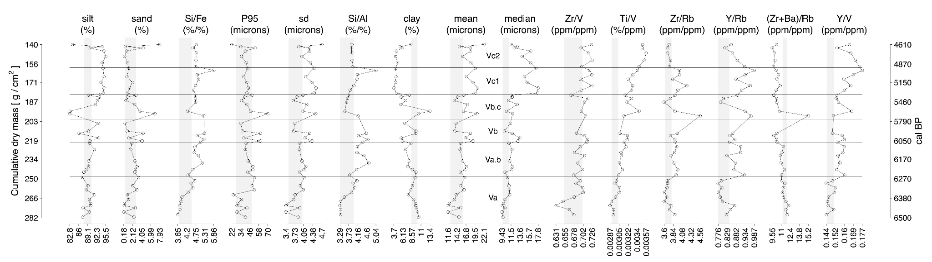
Figure S11. Grain size parameter and proxy records of Laguna de Bai's Western Lobe during its marine phase (6,510 to 4,590 cal BP). Gray vertical bars represent the mean ± 1σ of Laguna de Bai's Western Lobe sub-tidal marine period values (Period Va; 6,510 to 6,260 cal BP), whereas the horizontal lines represent chemolithostratigraphic unit boundaries (Figure 2).

