Table 1: Primer sequence and reaction conditions for P. falciparum confirmation PCR.
Species | Primer | Sequence | Expected size | Cycling  Conditions
Primary Reaction  Plasmodium Spp | rPLU1  rPLU5 | 5-TCAAAGATTAAGCCATGCAAGTGA-3  5- CCTGTTGTTGCCTTAAACTCC-3 | 1132 bp | 95°C/180 secs  95°C / 30 secs  60°C/ 30 secs  72°C/ 90 secs  30 Cycles  72°C/15mins
Secondary Reaction  Plasmodium falciparum | rFAL1  rFAL2 | 5TTAAACTGGTTTGGGAAAACCAAATATATT-3  5ACACAATGAACTCAATCATGACTACCCGTC-3 | 206 bp | 95°C/180secs.  95°C/ 30 secs  60°C/30secs  72°C/30 secs  30 Cycles  72°C/15 mins

Table 2: Primer sequences and reaction conditions for msp1, msp2 genes and poly alpha loci.
Primer name | Primer sequence | Cycling Conditions
Primary Reaction  msp-1Out-F:  msp-1Out-R: | 5'-CAC ATG AAA GTT ATC AAG AAC TTG TC-3'  5'-GTA CGT CTA ATT CAT TTG CAC G-3' | 95°C/5 Mins  94°C/30 secs  50°C/35 secs  68 °C /150 secs  45 Cycles  72°C/ 15 Mins
Secondary Reaction  msp-1 Nest-F:  msp-1 Nest -R: | 5'-GCA GTA TTG ACA GGT TAT GG-3'  5'-GAT TGA AAG GTA TTT GAC-3' | 95°C/5 Mins.  95°C/ 30 secs  50°C/ 35 secs  68°C /150 secs  30 Cycles  72°C/15 Mins
Primary Reaction  msp-2-S3F-Out :  msp-2-S2R-Out: | 5'-GAA GGT AAT TAA AAC ATT GTC-3'  5'-GAG GGA TGT TGC TCC ACA-3' | 95°C /5 Mins;  94°C / 30 secs  42°C / 60 secs  65 °C / 120 secs  45 Cycles  72°C/ 3 Mins
Secondary Reaction  msp-2-S1F-Nest:  msp-2-S4R-Nest: | 5'-GAG TAT AAG GAG AAG TAT G-3'  5'-CTA GAA CCA TGC ATA TGT CC-3' | 95°C/5 Mins.  95°C/30 secs  50°C / 60 secs  70°C / 120 secs  30 Cycles  72°C /3 Mins
Poly alpha Forward  Poly alpha Reverse-FAM | 5’-AAAATATAGACGAACAGA-3’  5’-GAAATTATAACTCTACCA-3’ | 94°C/2 mins.  94°C / 20 secs.  45°C /20 secs.  65°C/ 30 secs  40 Cycles  65°C/ 2mins

Table 3: Primer sequences and Reaction Conditions for Pfk13 gene.
Primer name | Primer Sequence | Cycling Conditions
Primary Reaction  Kelch-outer Forward  Kelch -outer Reverse | 5′CGGAGTGACCAAATCTGGGA-3′  5′GGGAATCTGGTGGTAACAGC-3′ | 95°C/1 Min  95°C/20 secs  58°C/ 20 secs  60 °C/60 secs  30 Cycles  60°C/ 3 Mins
Secondary Reaction  Kelch-Inner-Forward  Kelch-Inner-Reverse | 5′GCCTTGTTGAAAGAAGCAGA-3′  5′-GCCAAGCTGCCATTCATTTG-3′ | 95°C/1 Mins.  95°C for 20 secs  61°C for 20 secs  68°C for 60 secs  25 Cycles  68°C/ 3 Mins

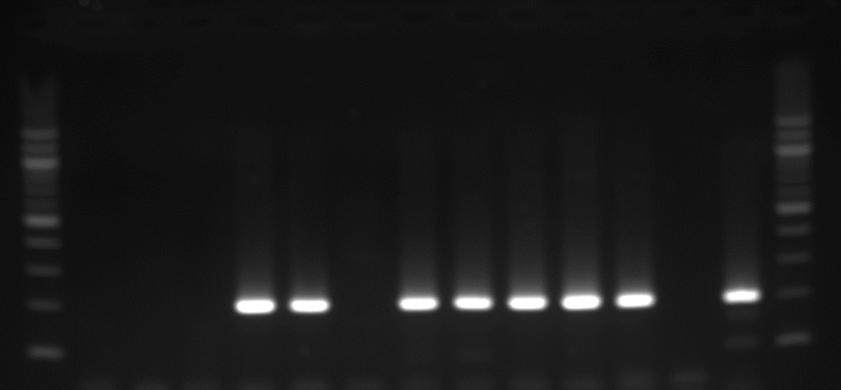
L 1 2 3 4 5 6 7 8 9 10 11 -VE 3D7 L L
100 bp
200 bp

Figure 1: Agarose gel electrogram of P. falciparum speciation PCR
L = 100 bp DNA ladder. Samples 4,5,7,8,9,11 = samples positive for Plasmodium falciparum. Samples 1,2,3,6 = samples negative for Plasmodium falciparum. -VE = Negative control. 3D7 = positive control

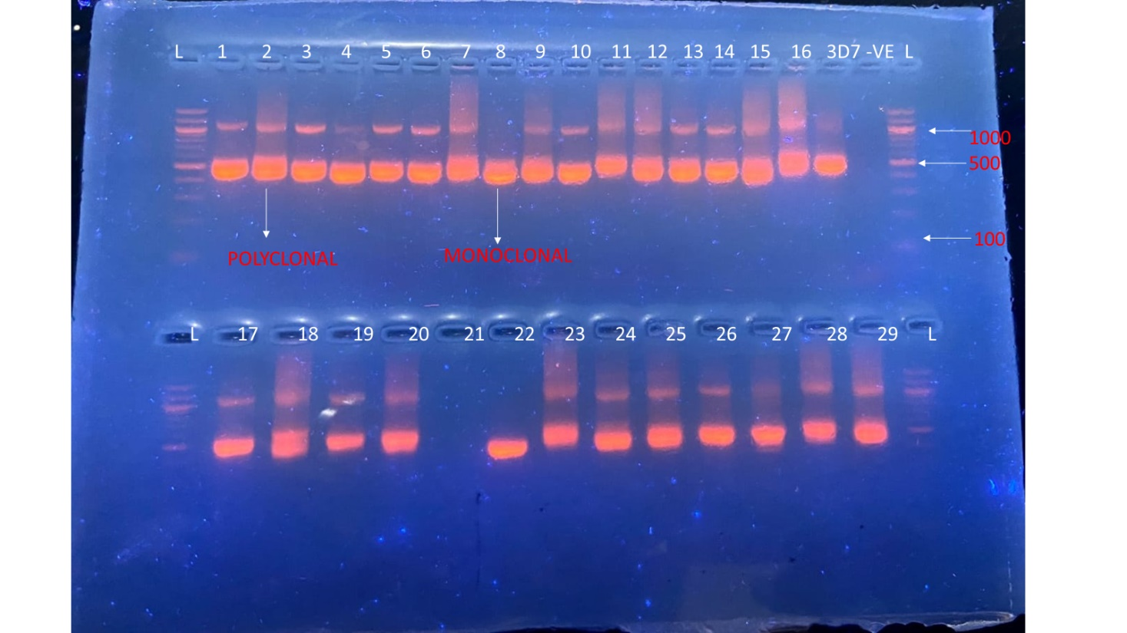
Figure 2: Agarose gel electrogram of Merozoite surface protein 1 gene amplification
L= DNA Ladder. Samples 1,2,3,5,6,7,9,10,11,12,13,14,15,16,
17,18,29,20,23,24,25,26,18,29=Polyclonal infections. Samples 4,8, 21,27= Monoclonal infection. 3D7=positive control. -VE= negative control.

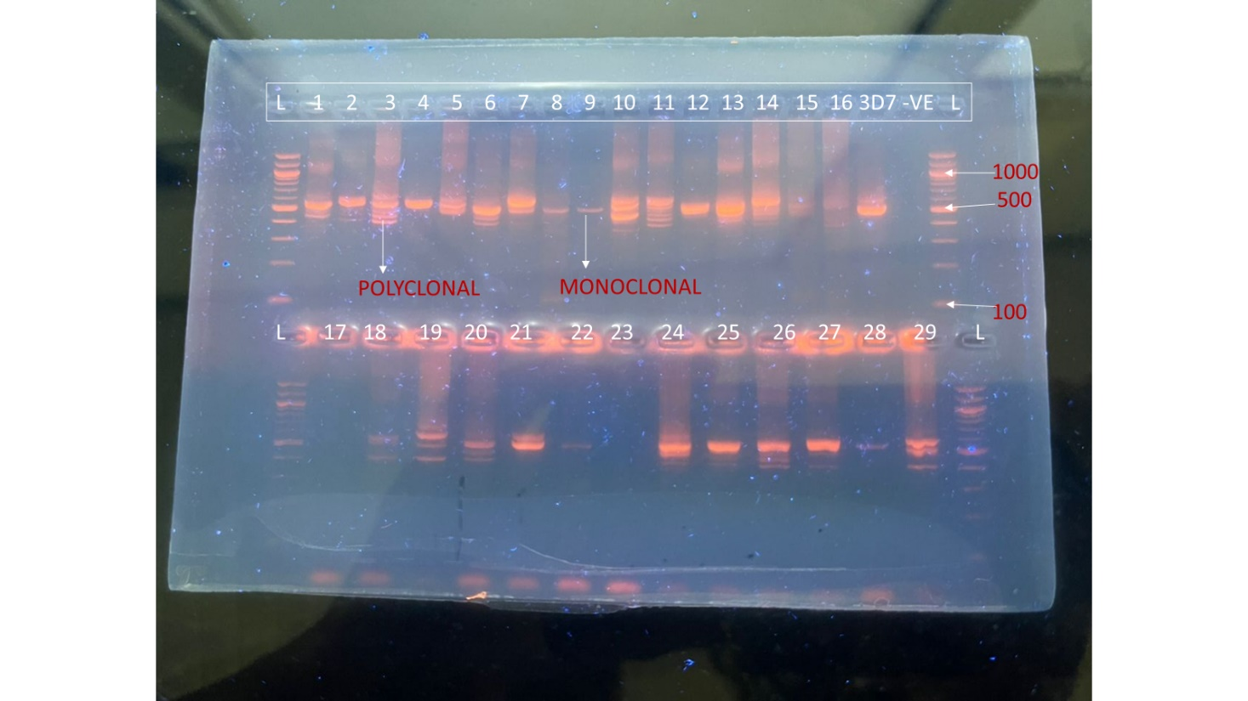
Figure 3: Agarose gel electrogram of Merozoite surface protein 1 gene amplification
L=DNA Ladder. Samples,1,3,6,10,11,18,19,20,21,29 =Polyclonal infection. Samples 2,4,5,7,8,9,12,13,14,15,16,22,24,25,26,27,28= Monoclonal infection. 3D7=Positive Control, -VE=Negative Control
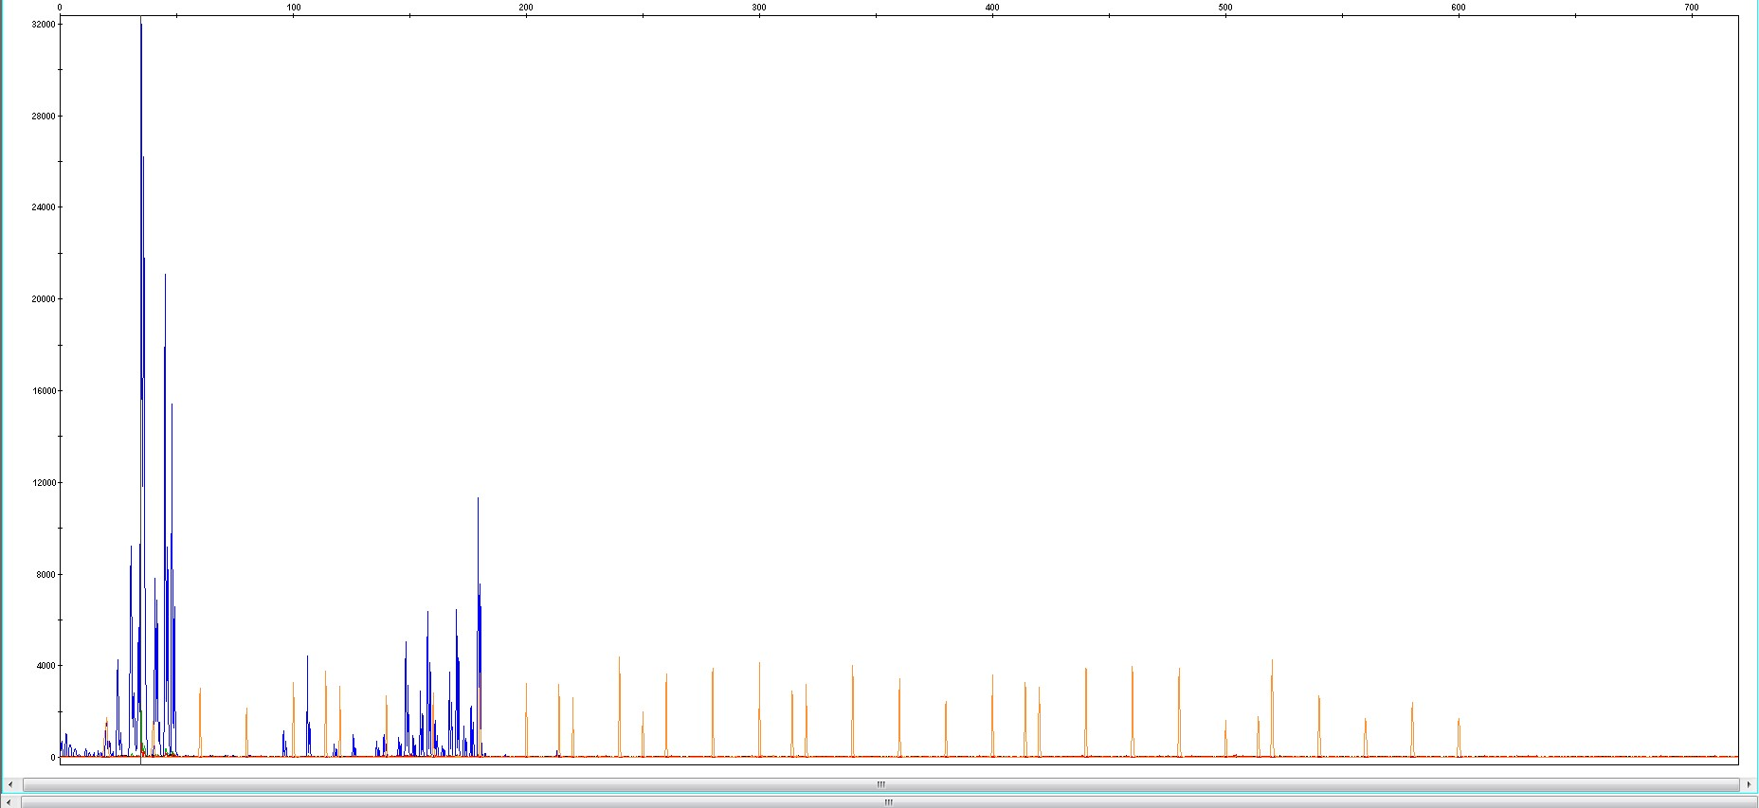
Figure 4:An illustration of GeneScan600Liz v2.0 standard peaks on sample HBCTR005 for poly alpha microsatellite analysis on Gene Mapper version 6 software.
Different alleles for poly alpha loci.
GeneScan600Liz v2.0 Standard.

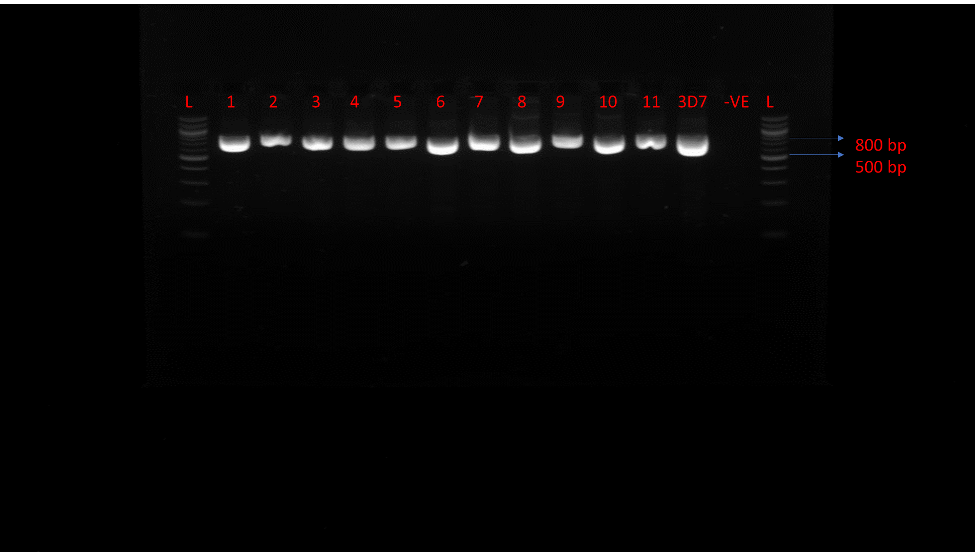
Figure 5:Agarose gel electrogram of P. falciparum Kelch 13 Amplification
L = 100 bp DNA ladder. Samples 1,2,3,4,5, 6,7,8,9,10,11 = samples positive for kelch 13 PCR -VE = Negative control. 3D7 = positive control.

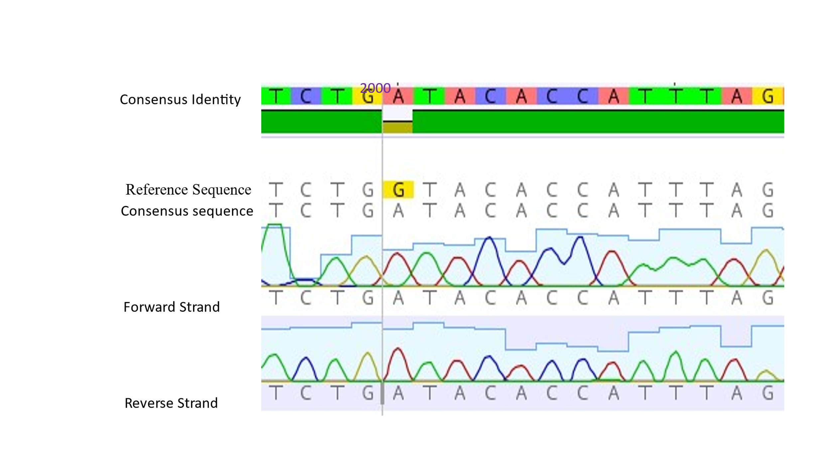Figure 6: Snapshot of a section of the chromatogram and alignment of Pfkelch13 with the reference sequence (PF3D7_1343700) from the PlasmoDB database using Geneious Prime v2022.2.1, showing single-nucleotide polymorphism at position 2000

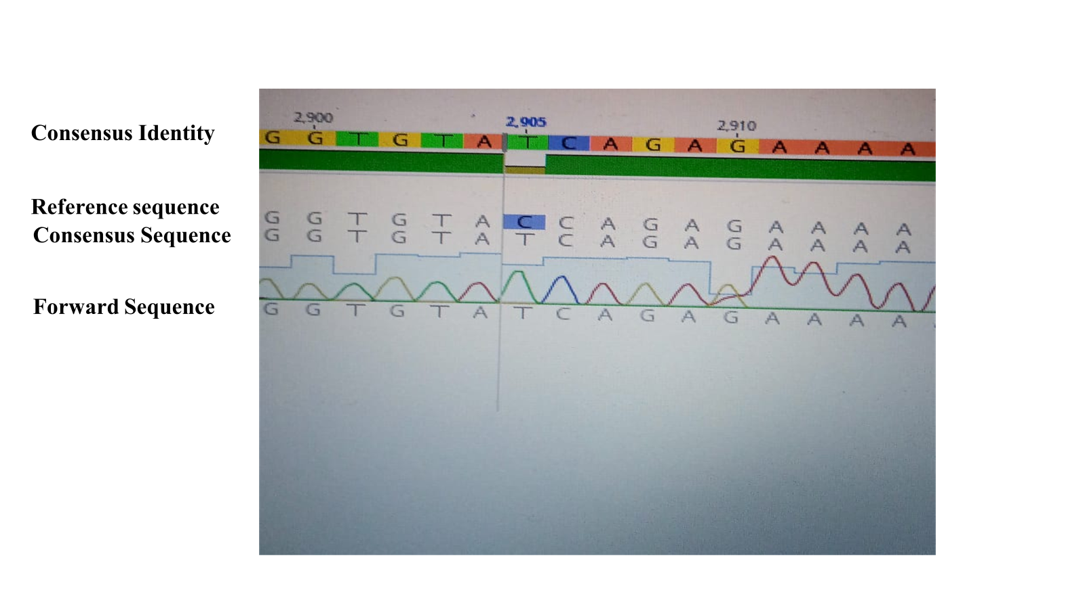Figure 7: Snapshot of a section of the chromatogram and alignment of Pfkelch13 with the reference sequence (PF3D7_1343700) from the PlasmoDB database using Geneious Prime v2022.2.1, showing single-nucleotide polymorphism at position 2905

