Supplementary Material for Review

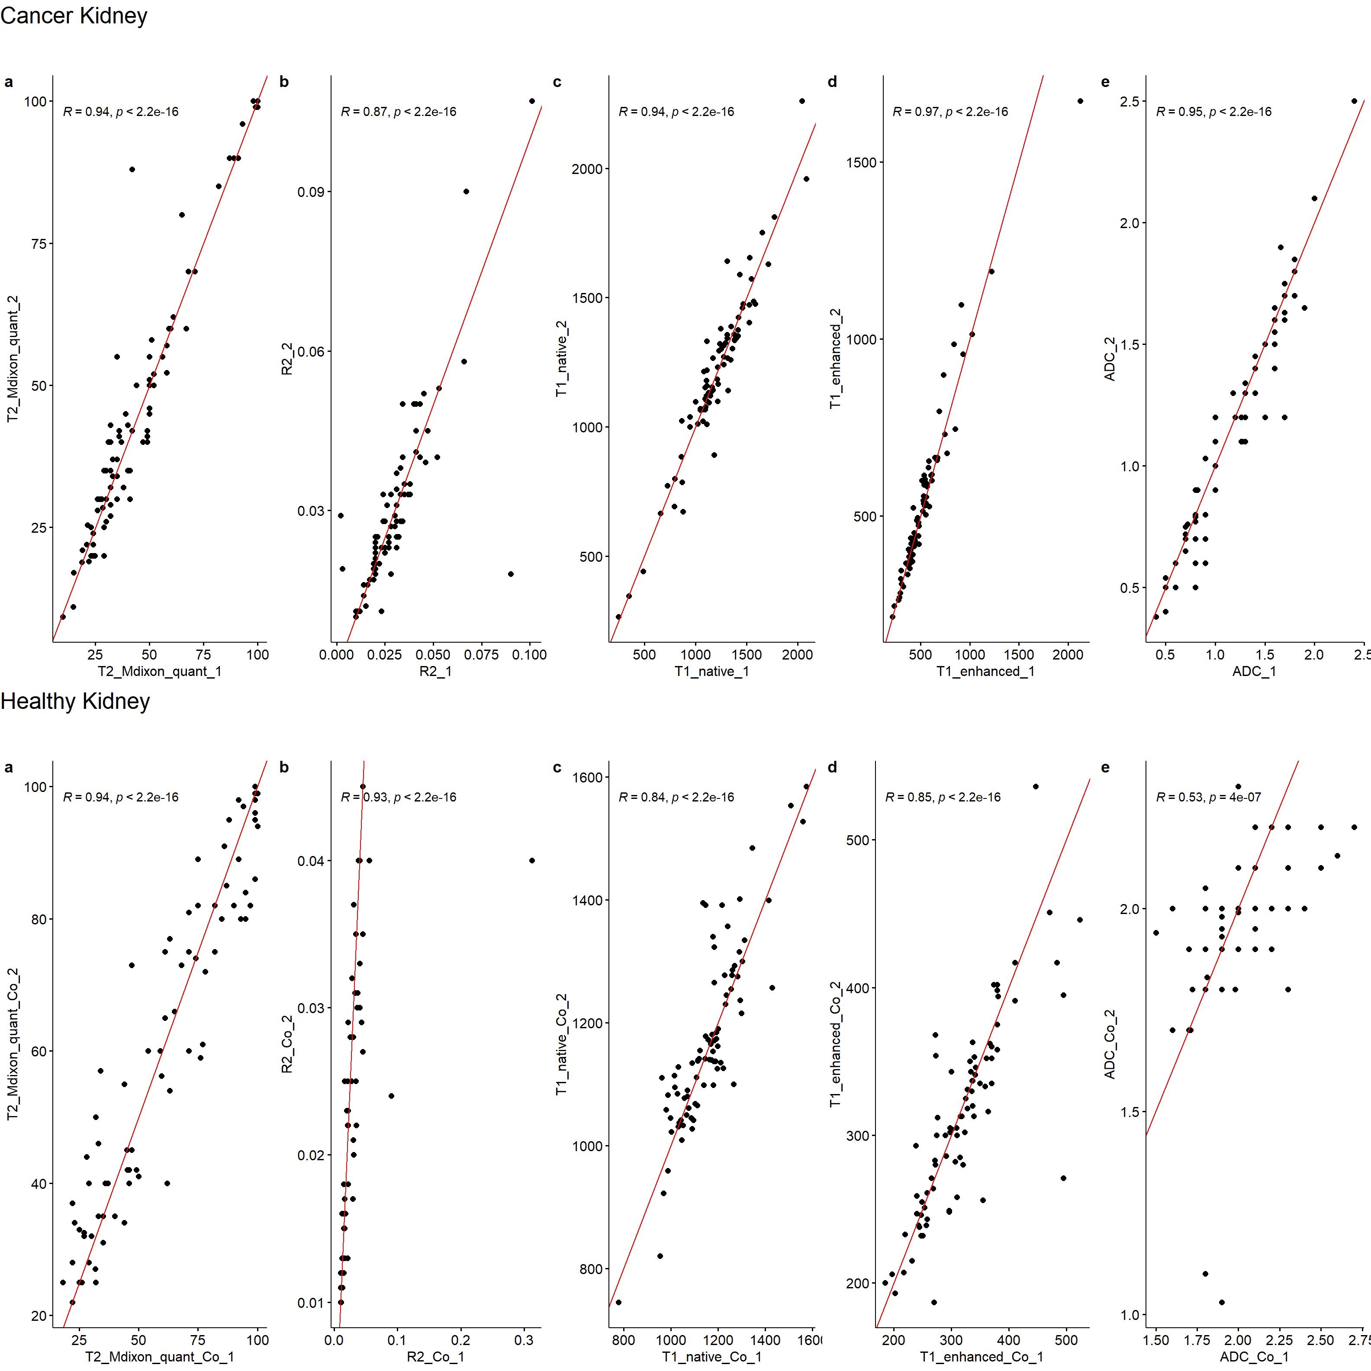
Figure S1 -Interobserver agreement of kidney tumor measurements: 1st observer's measurements are shown on the x-axis, 2nd observer's measurements are shown on the y-axis. T2 mDixon(a), R2*(b), T1 native(c), T1 enhanced(d) and ADC(e) values for kidney tumors were compared to assess the agreement between the 1st and 2nd observer.
Figure S2 - Interobserver agreement of opposite kidney renal cortex measurements: 1st observer's measurements are shown on the x-axis, 2nd observer's measurements are shown on the y-axis. T2 mDixon(a), R2*(b), T1 native(c), T1 enhanced(d) and ADC(e) values of the opposite kidney healthy cortex measurements were compared to evaluate the agreement between the 1st and 2nd observer.

 | Health Condition | Cancer | Healthy | Error Rate | Overall Accuracy
Test Data | Cancer | 74 | 8 | 0.098 | 0.932
Test Data | Healthy | 3 | 79 | 0.037 | 0.932

Table S1: Error rates of the data with test data which contains all of the samples from observer 2.

