Table S1 Basic Soil nutrient contents in the 0-20 cm depth before starting experiment
Test year | Test site | Organic matter content  (g kg⁻¹) | Total nitrogen content  (g kg⁻¹) | Available nitrogen content  (mg kg⁻¹) | Available phosphorus content  (mg kg⁻¹) | Available potassium content  (mg kg⁻¹) | Available boron content  (mg kg⁻¹)
2020 | Yancheng | 15.2 | 0.9 | 13.2 | 16.1 | 135.8 | 0.36
2020 | Xinghua | 10.7 | 0.5 | 10.9 | 13.1 | 106.6 | 0.31
2021 | Nanjing | 17.6 | 0.8 | 11.2 | 17.8 | 102.2 | 0.24

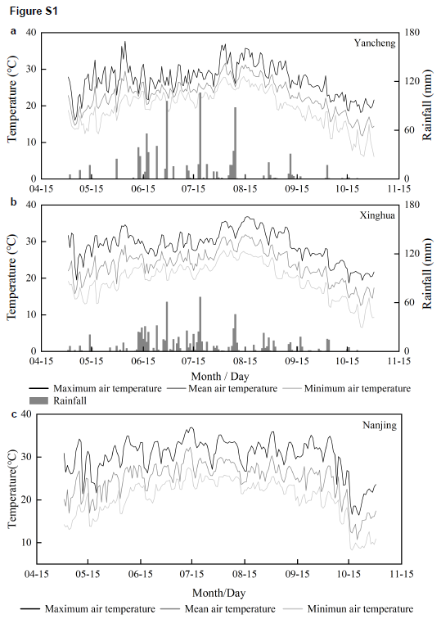
Figure S1 Meteorological data of the experimental sites. Daily maximum air temperature, minimum air temperature and mean air temperature as well as precipitation during cotton growth period in 2020 in Yancheng (a), Xinghua (b) and in 2021 in Nanjing (c).

