Supporting Information for
Original article

Total Synthesis and Bioactivity Investigation of a Chiral Diacylglycerol
Xuemei Liao^{1.2.4}, Xin Cheng², Ruirong Zhuang³, Beidou Zhou^{1.2.4*}
1. School of pharmacy and medical technology, Putian university, Putian 351100, China
2. School of Pharmacy, Fujian Medical University, Fuzhou 350108, China
3. Putian Lanhai Nuclear Medical Research Center, Putian 351100, China
4. Key laboratory of pharmaceutical analysis and laboratory medicine (Putian university), Fujian province university, Putian 351100, China
*Corresponding author. Tel: +8613205940072 E-mail: 491986737@qq.com or beidouzhou@ptu.edu.cn

Content
The nuclear magnetic resonance spectrum and infrared spectrum data of each step product...........2
The high resolution mass spectrum of compound 1.........................................................................13

1. The ¹H NMR spectrum of (S)-4-((benzyloxy)methyl)-2,2-dimethyl-1,3-dioxolane (acetone-d₆, 500 MHz) (3)
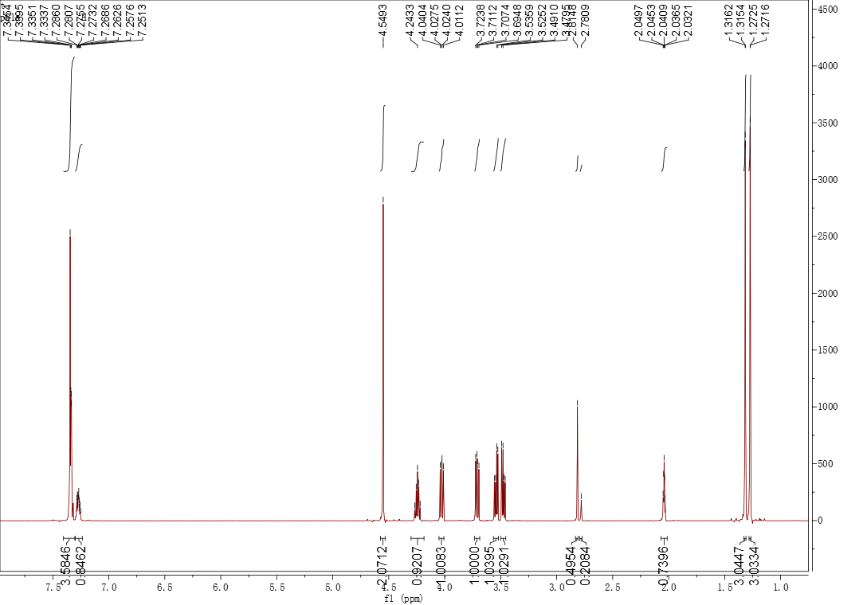
The ¹³C NMR spectrum of (S)-4-((benzyloxy)methyl)-2,2-dimethyl-1,3-dioxolane (3) (acetone-d₆, 125 MHz) (3)
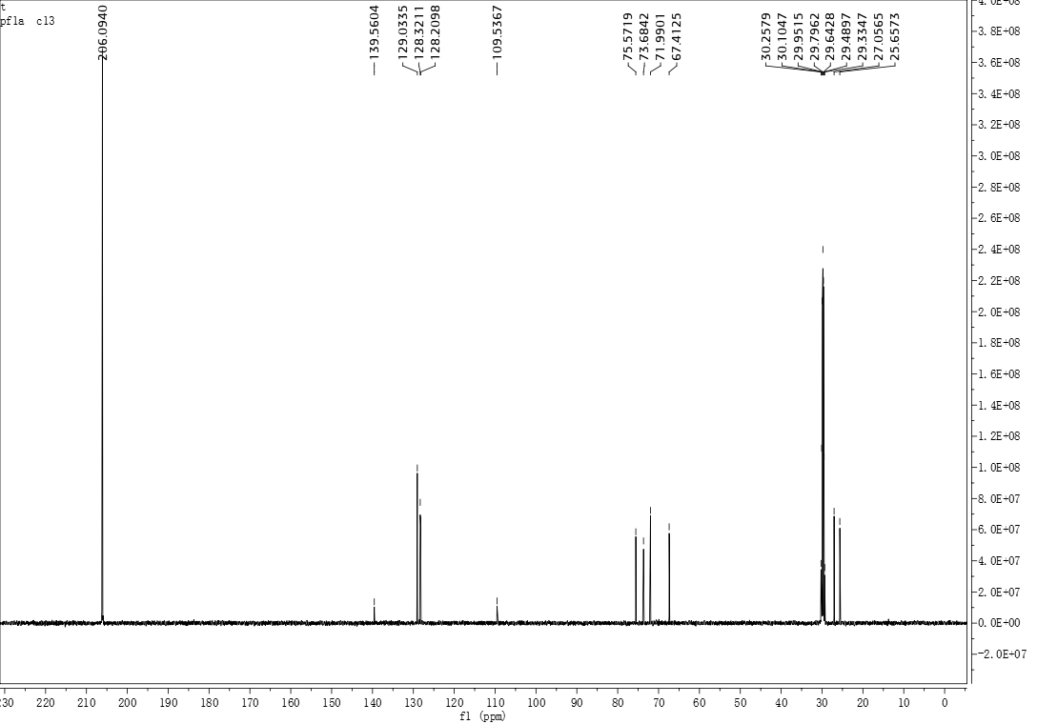

The IR spectrum of (S)-4-((benzyloxy)methyl)-2,2-dimethyl-1,3-dioxolane (KBr) (3)

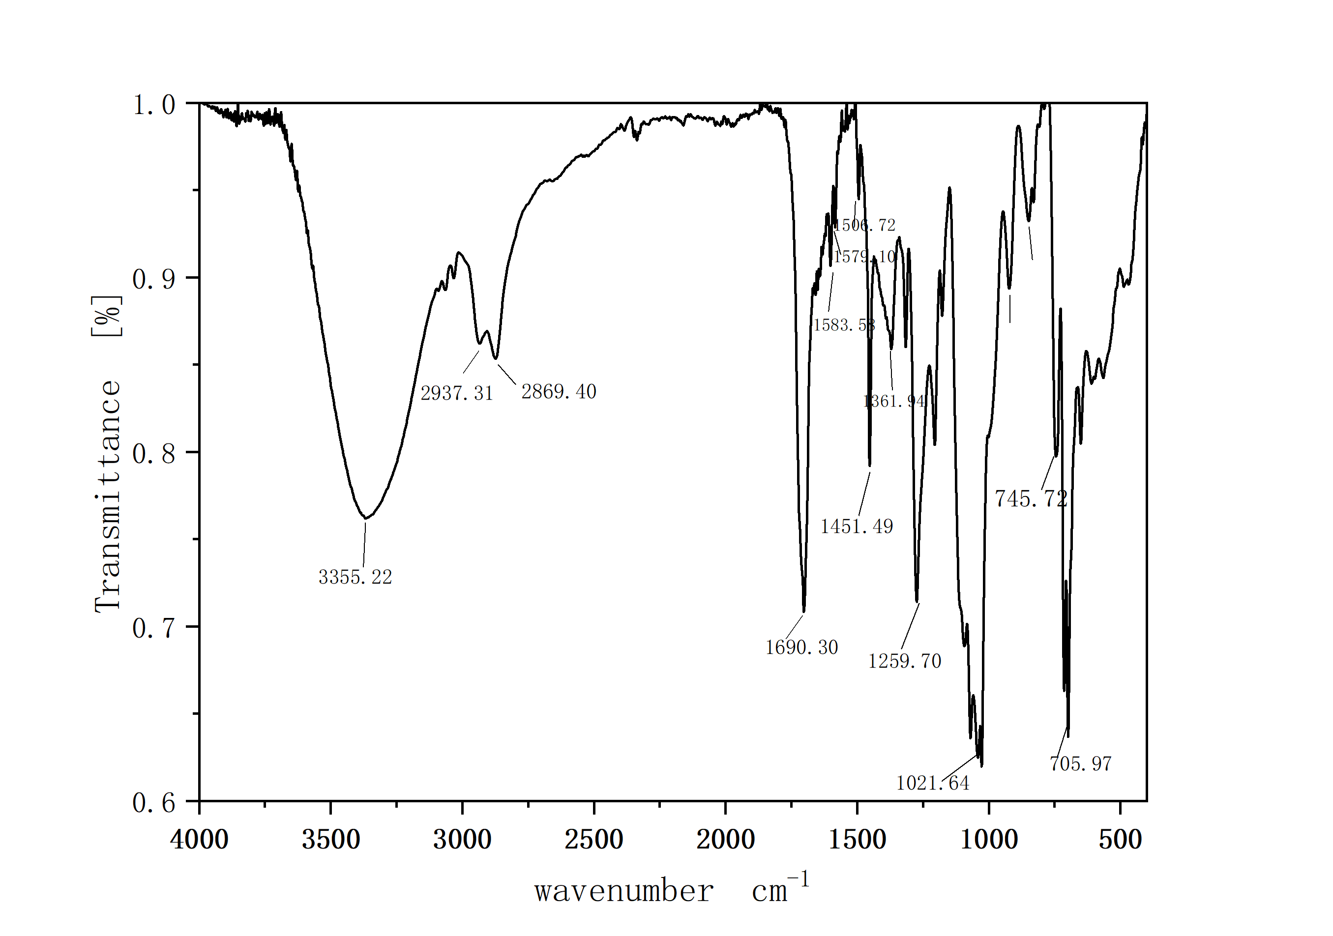
2.The ¹H NMR spectrum of (R)-3-(benzyloxy)propane-1,2-diol (acetone-d₆, 500 MHz) (4)
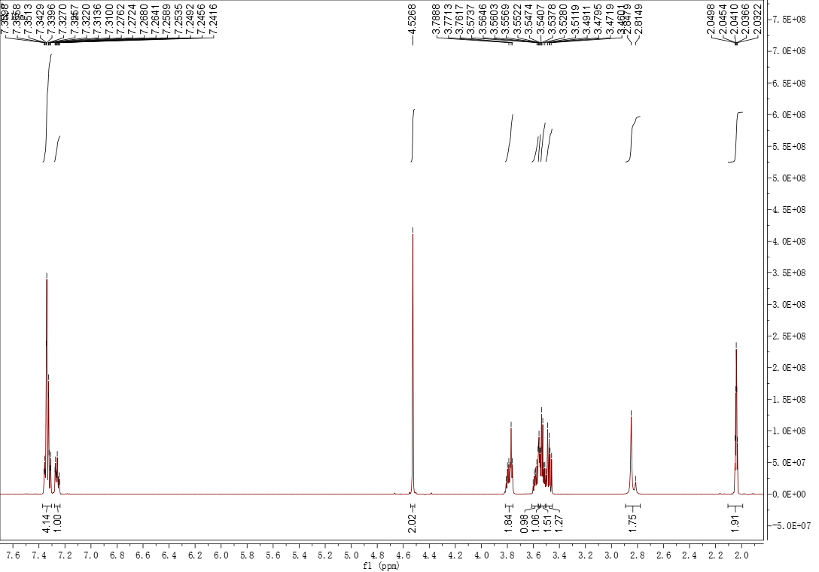

The ¹³C NMR spectrum of (R)-3-(benzyloxy)propane-1,2-diol (acetone-d₆, 125 MHz) (4)
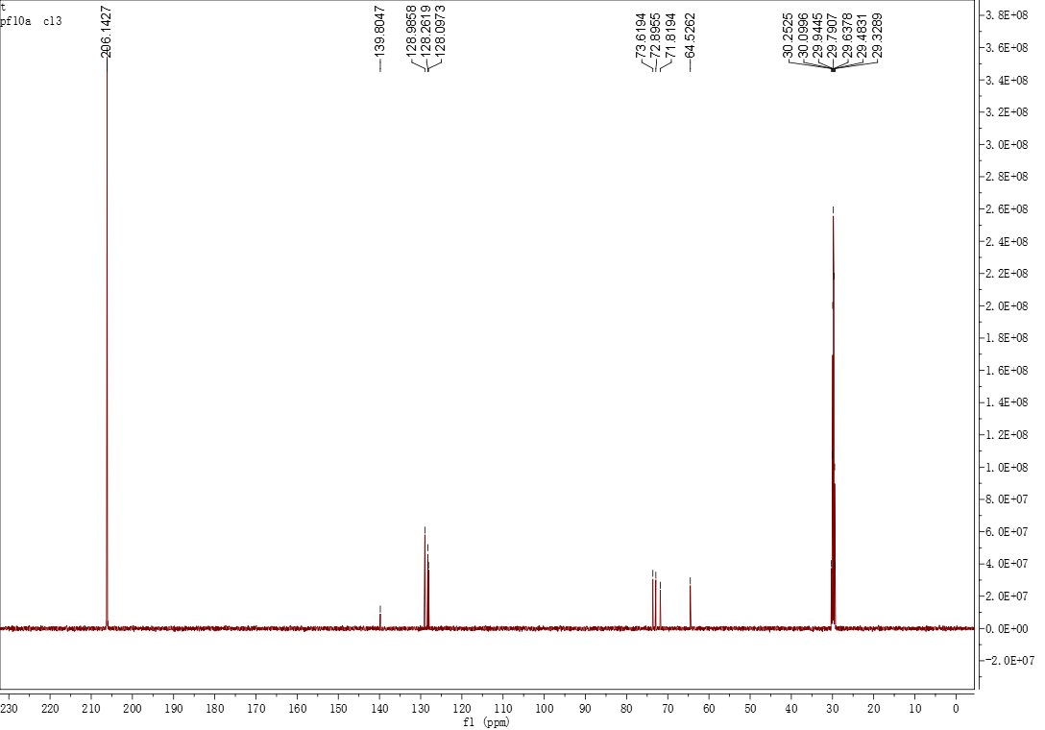

The IR spectrum of (R)-3-(benzyloxy)propane-1,2-diol (KBr) (4)

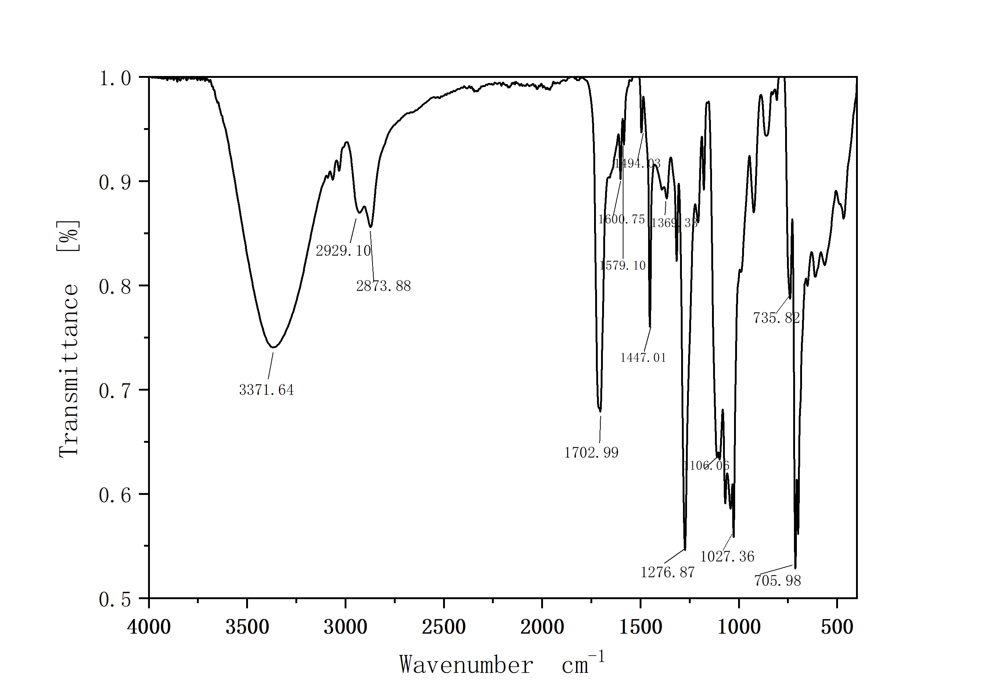

3. The ¹H NMR spectrum of (S)-1-(benzyloxy)-3-((tert-butyldimethylsilyl)oxy)propan-2-ol (acetone-d₆, 500MHz) (5)
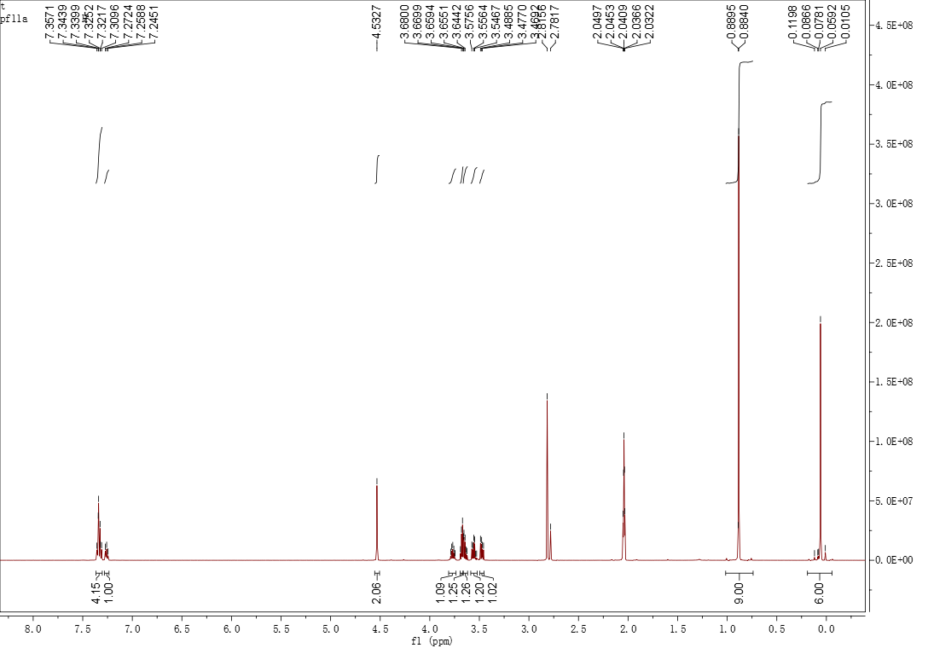
The ¹³C NMR spectrum of (S)-1-(benzyloxy)-3-((tert-butyldimethylsilyl)oxy)propan-2-ol (acetone-d₆, 125 MHz) (5)
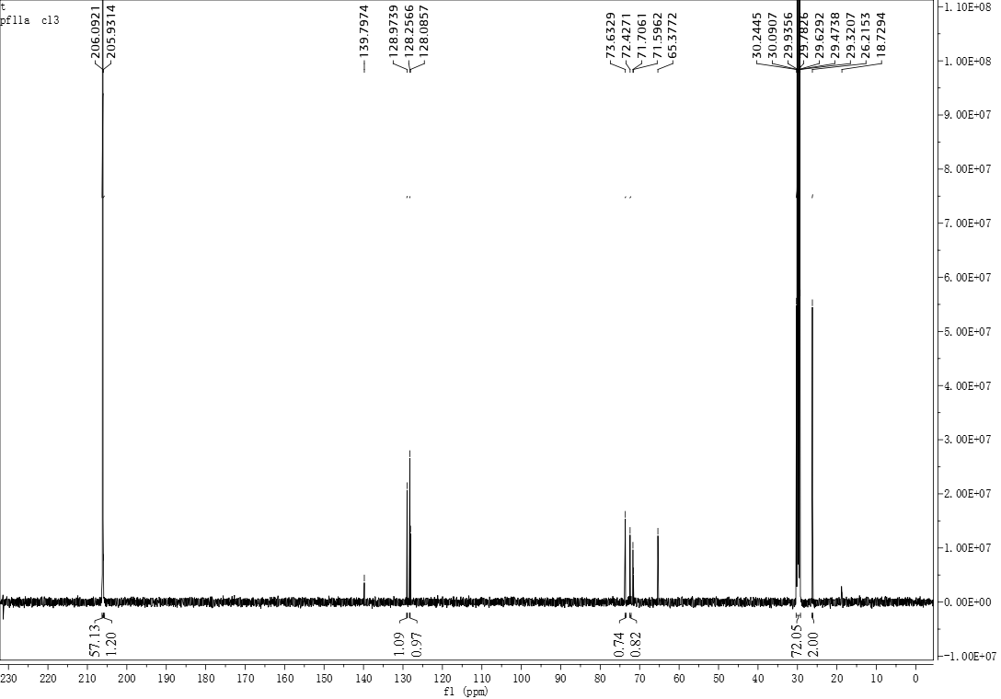

The IR spectrum of (S)-1-(benzyloxy)-3-((tert-butyldimethylsilyl)oxy)propan-2-ol (KBr) (5)

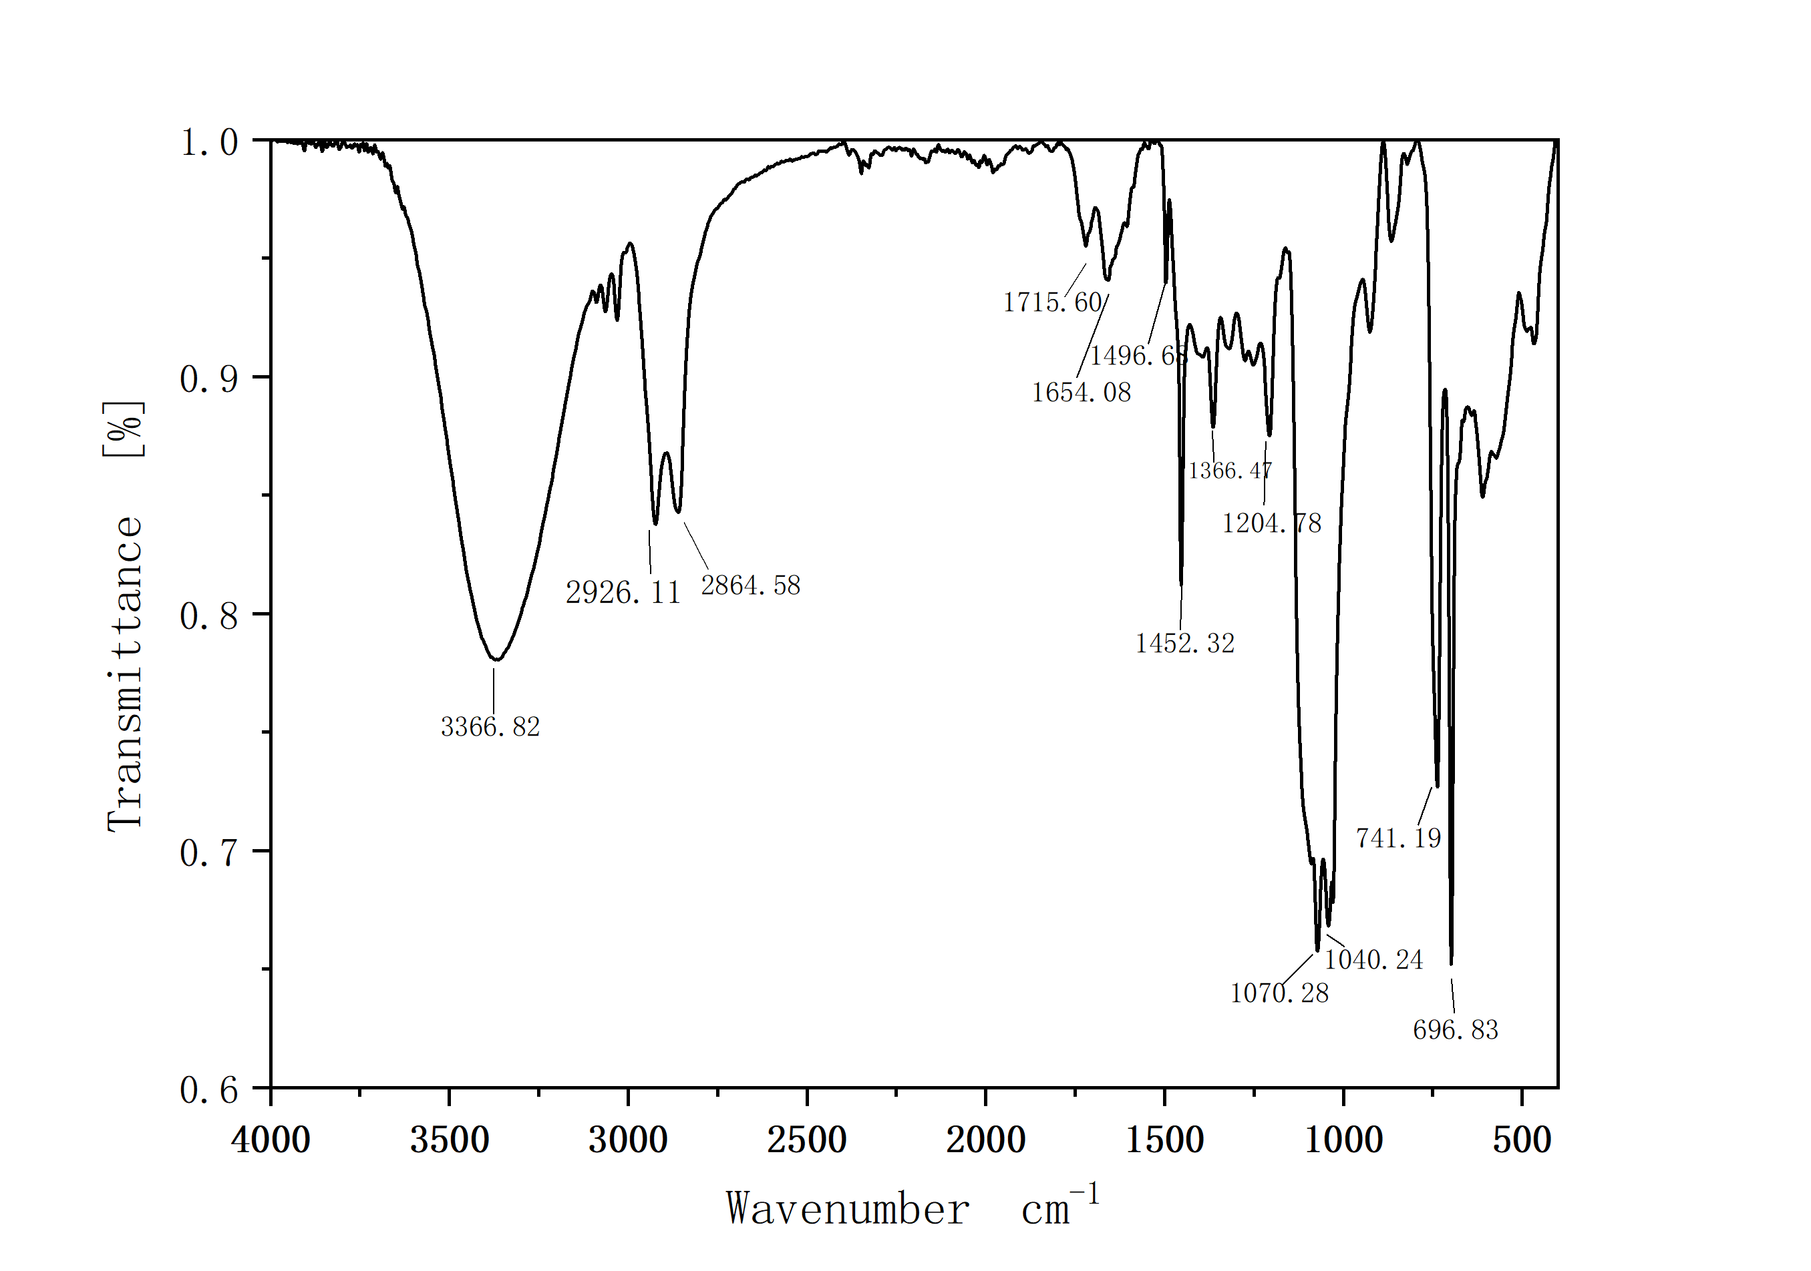
4. The ¹H NMR spectrum of (S)-1-(benzyloxy)-3-((tert-butyldimethylsilyl)oxy)propan-2-yl(Z)- docos-13-enoate (acetone-d₆, 500MHz) (6)
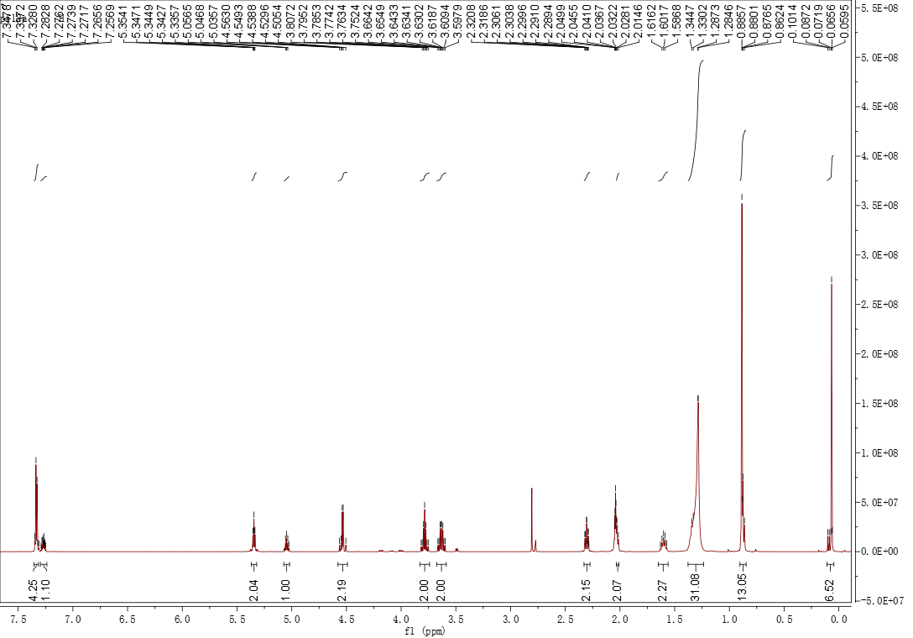

The ¹³C NMR spectrum of (S)-1-(benzyloxy)-3-((tert-butyldimethylsilyl)oxy)propan-2-yl(Z)- docos-13-enoate (acetone-d₆, 125 MHz) (6)
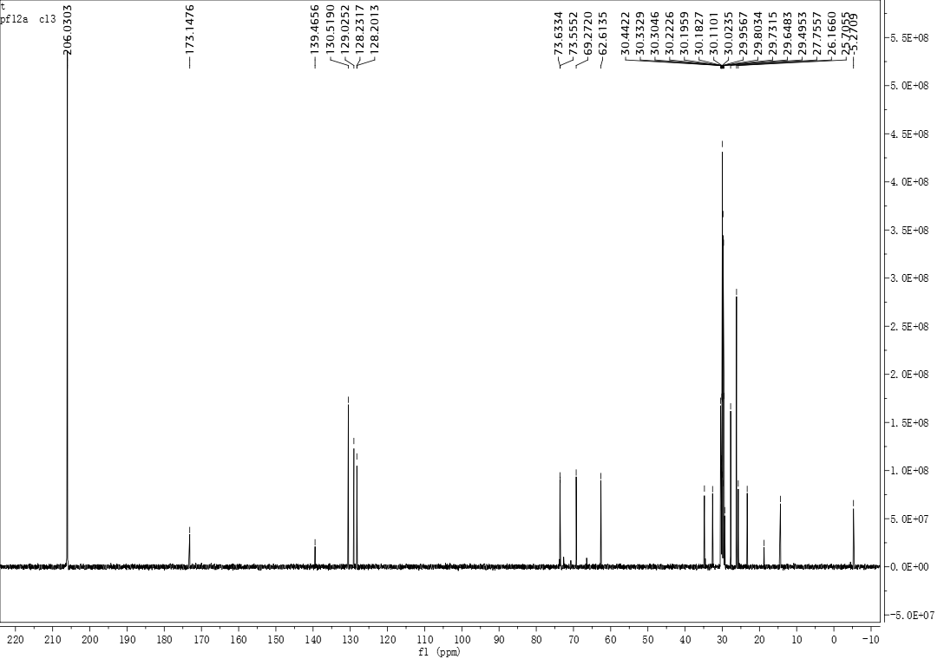
The IR spectrum of (S)-1-(benzyloxy)-3-((tert-butyldimethylsilyl)oxy)propan-2-yl (Z)-docos-13- enoate (KBr) (6)

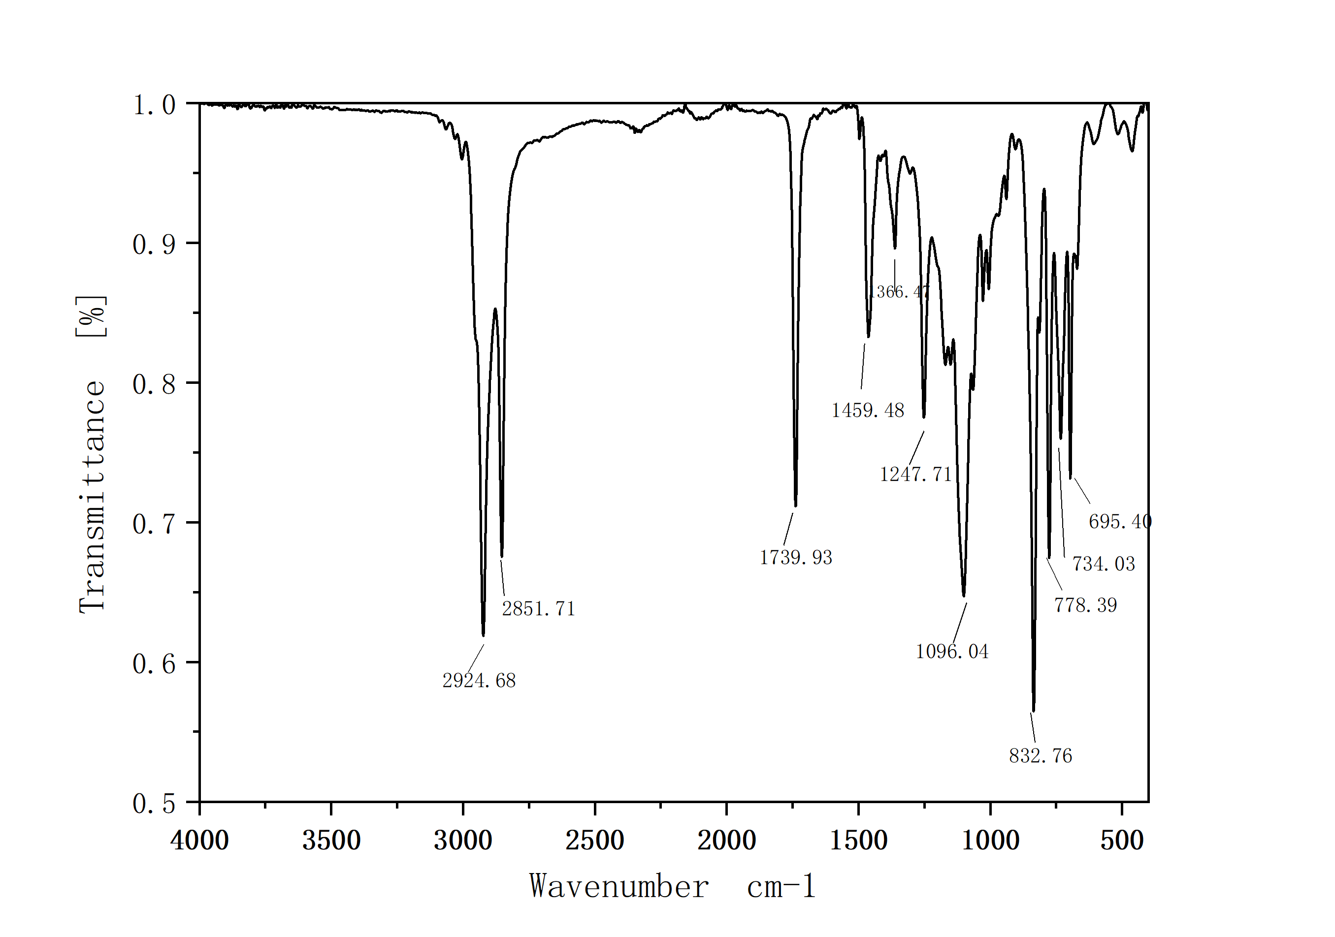

5. The ¹H NMR spectrum of (R)-1-(benzyloxy)-3-hydroxypropan-2-yl (Z)-docos-13-enoate (acetone-d₆, 500 MHz) (7)
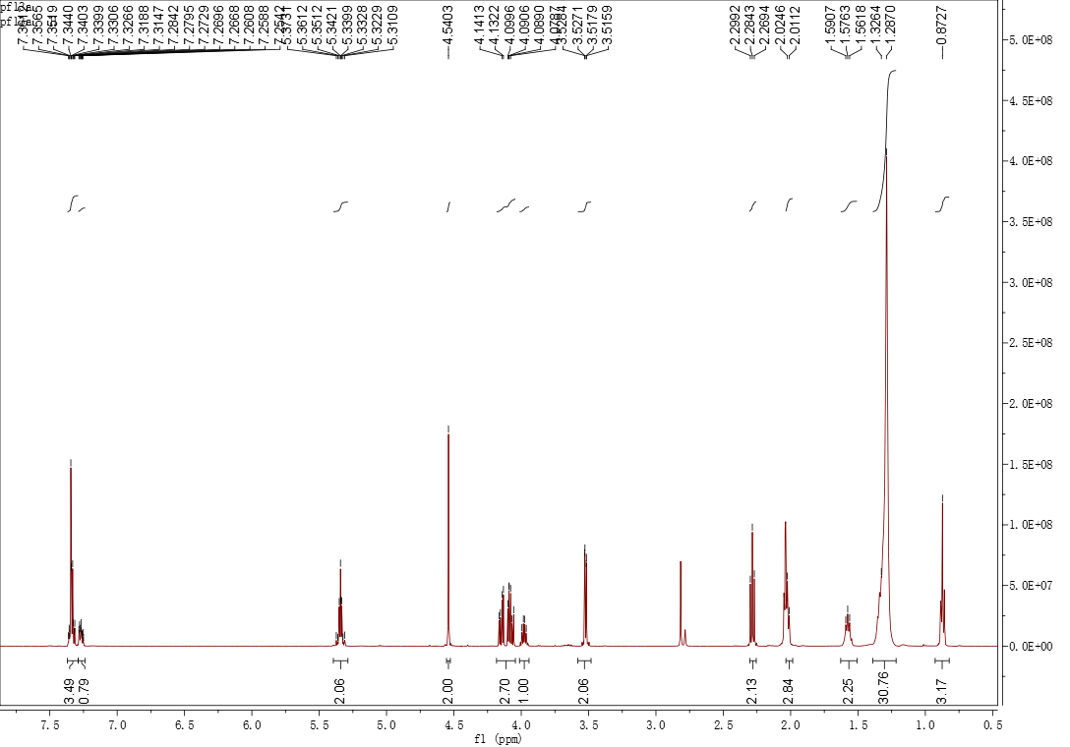
The ¹³C NMR spectrum of (R)-1-(benzyloxy)-3-hydroxypropan-2-yl (Z)-docos-13-enoate (acetone-d₆, 125 MHz) (7)
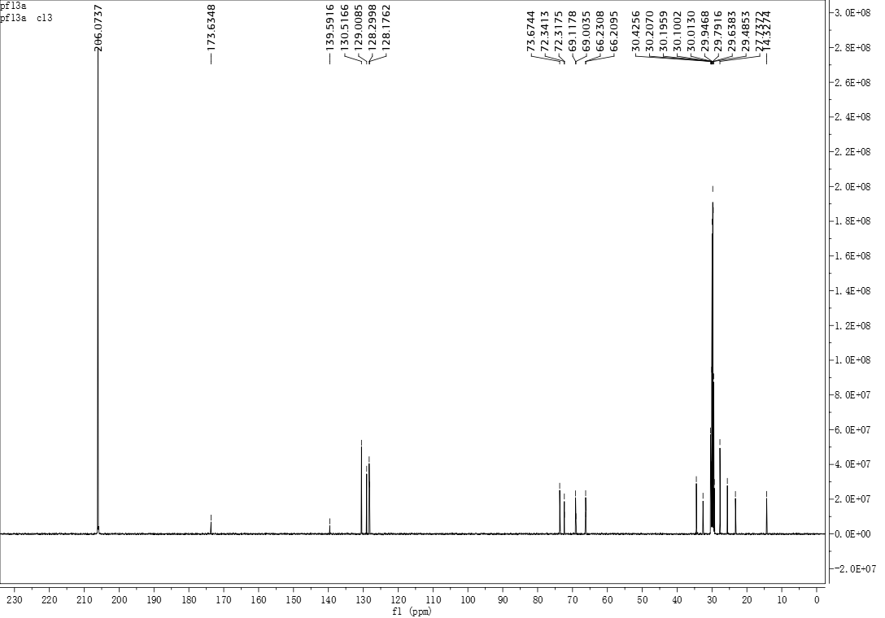

The IR spectrum of (R)-1-(benzyloxy)-3-hydroxypropan-2-yl (Z)-docos-13-enoate (KBr) (7)

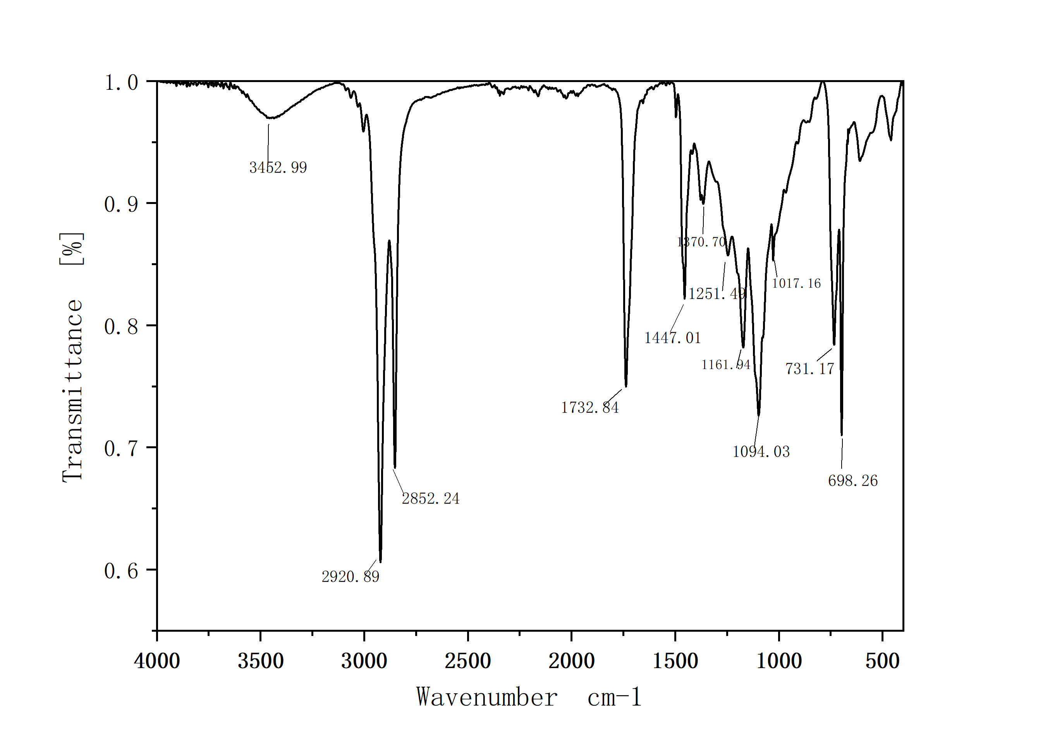
6. The ¹H NMR spectrum of (S)-1-(benzyloxy)-3-(pentadecanoyloxy)propan-2-yl(Z)-docos-13 -enoate (acetone-d₆, 500 MHz) (8)
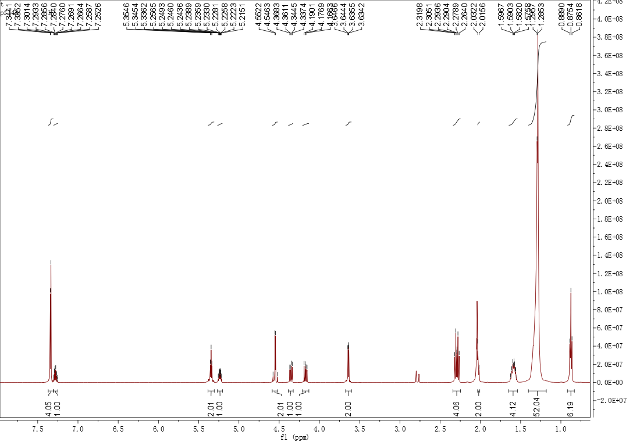

The ¹³C NMR spectrum of (S)-1-(benzyloxy)-3-(pentadecanoyloxy)propan-2-yl (Z)-docos-13- enoate (acetone-d₆, 125 MHz) (8)
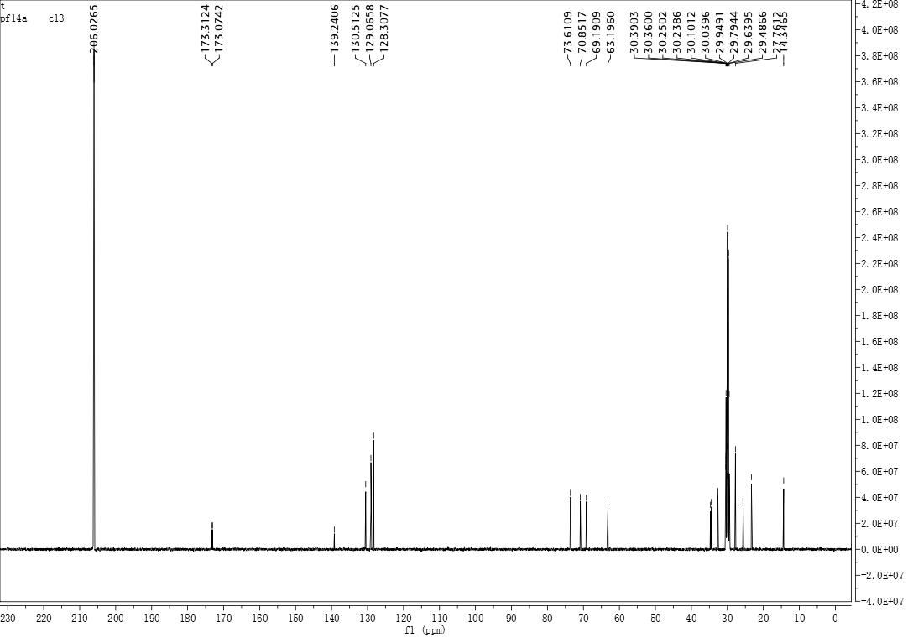
The IR spectrum of (S)-1-(benzyloxy)-3-(pentadecanoyloxy)propan-2-yl (Z)-docos-13-enoate (KBr) (8)

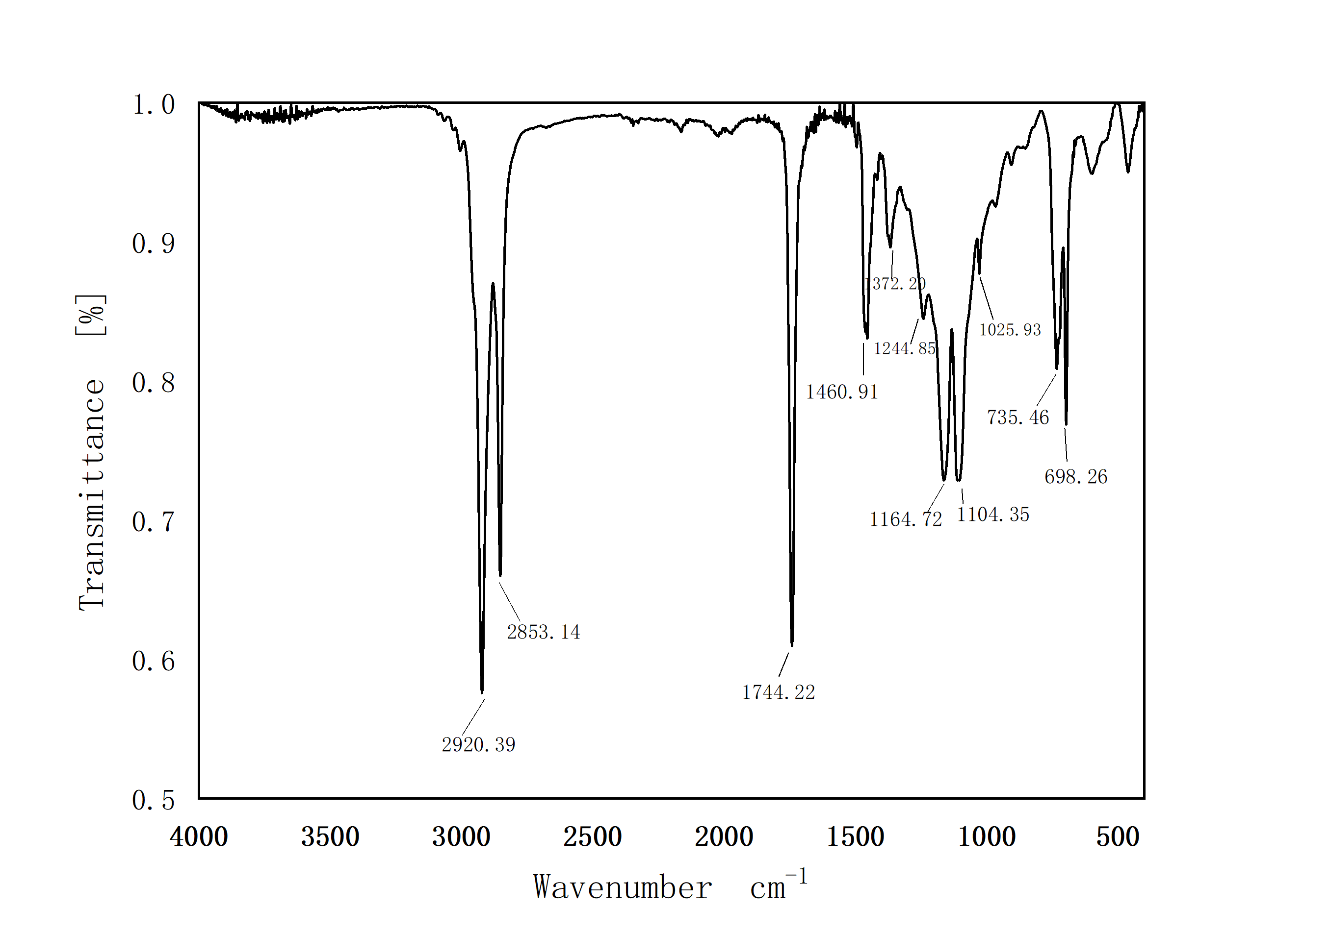

7. The ¹H NMR spectrum of (S)-1-hydroxy-3-(pentadecanoyloxy)propan-2-yl (Z)-docos-13-enoate (acetone-d₆, 500 MHz) (1)
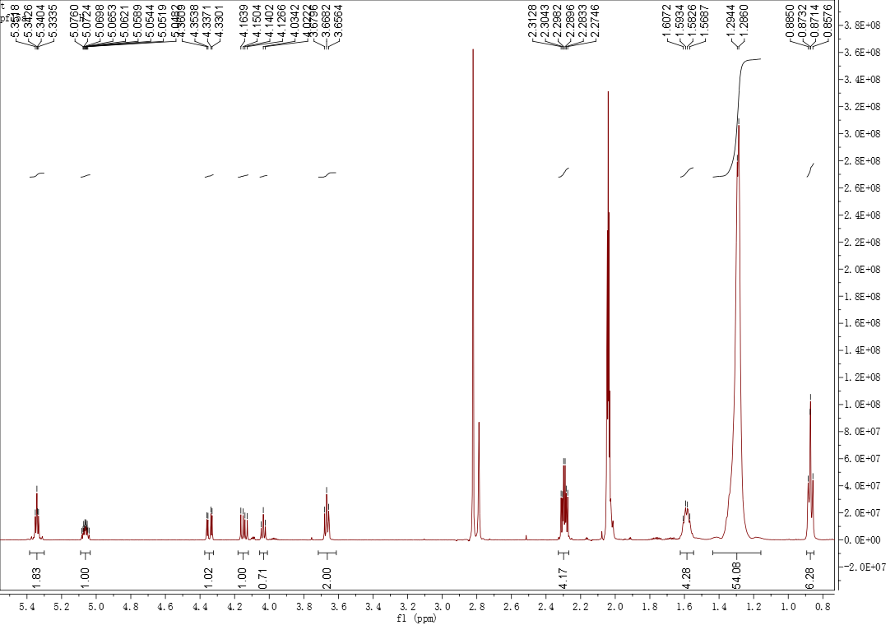
The ¹³C NMR spectrum of (S)-1-hydroxy-3-(pentadecanoyloxy)propan-2-yl (Z)-docos-13-enoate (acetone-d₆, 125 MHz) (1)
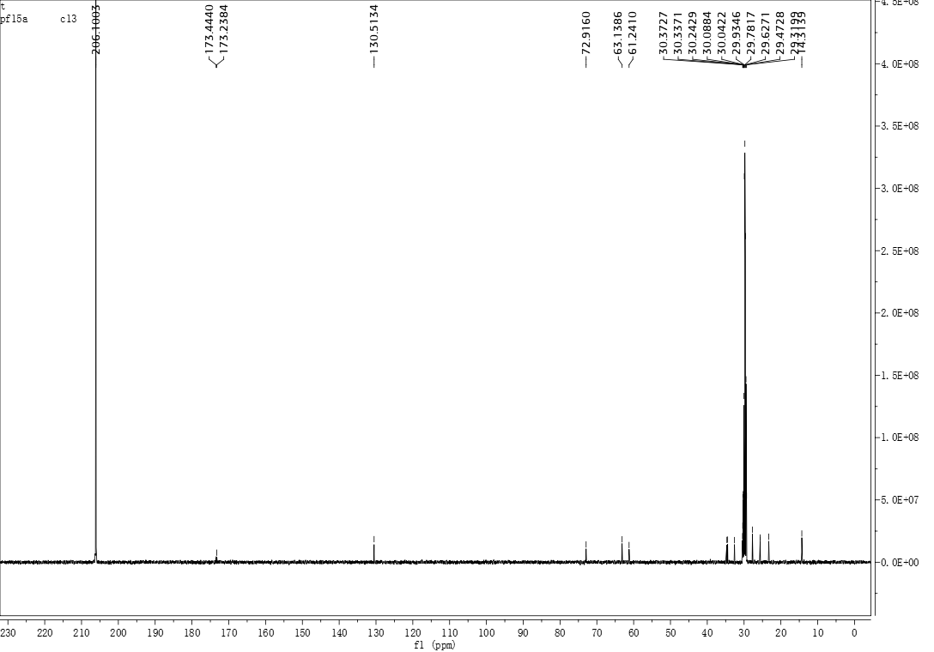

The IR spectrum of (S)-1-hydroxy-3-(pentadecanoyloxy)propan-2-yl (Z)-docos-13-enoate (KBr) (1)
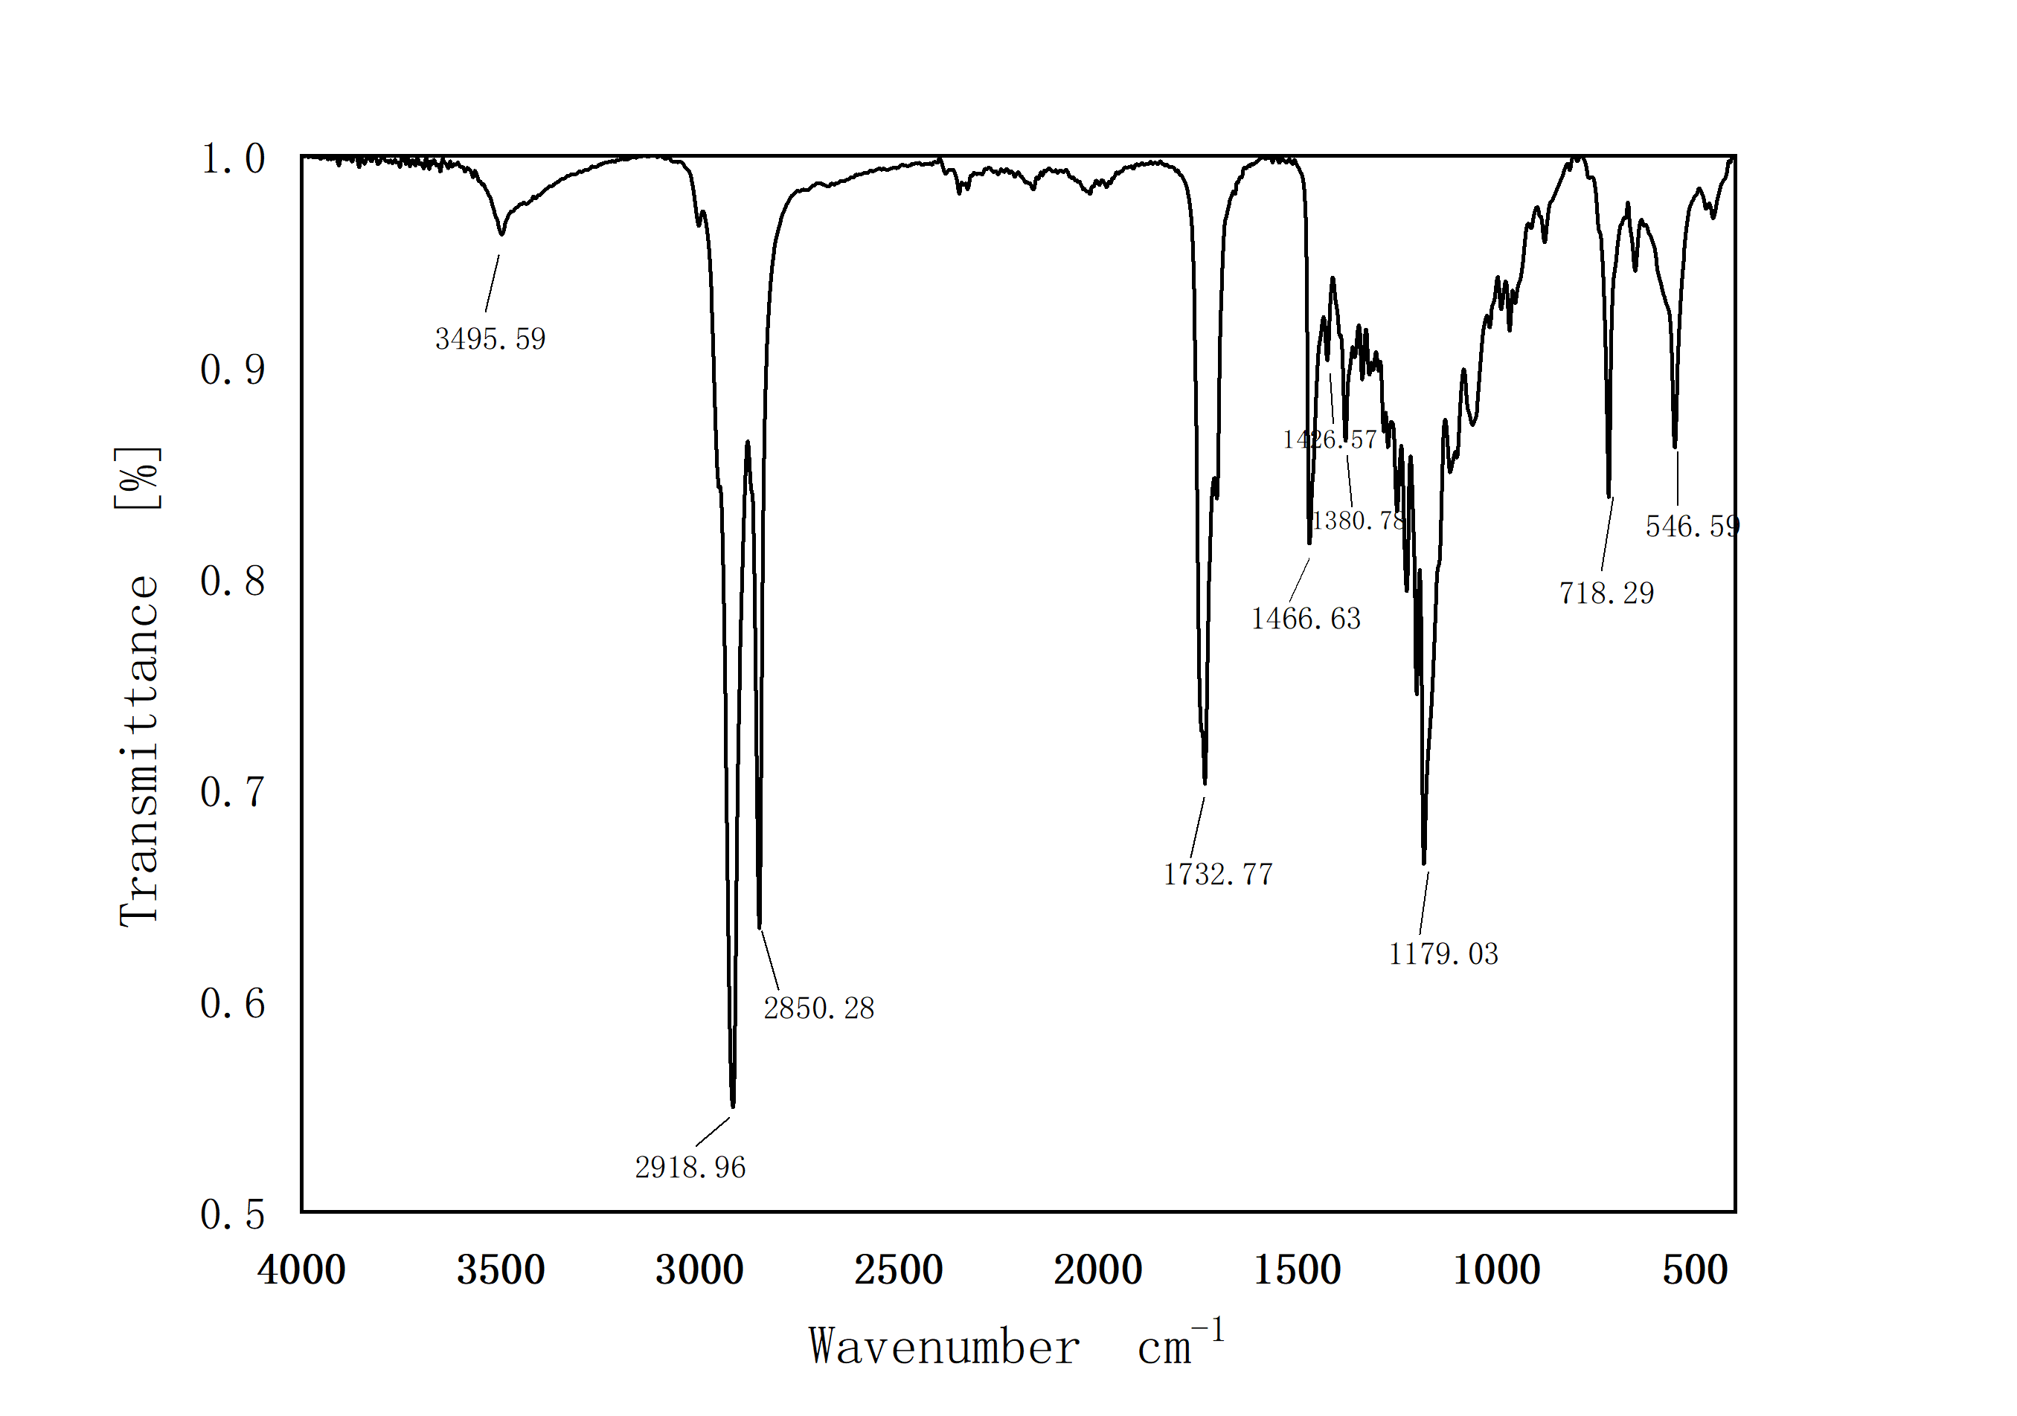

The high resolution mass spectrum of (S)-1-hydroxy-3-(pentadecanoyloxy)propan-2-yl(Z)-docos- 13-enoate (1)

