Supplementary materials
Table S1. Spearman’s correlations between the studied variables (N = 468).
 | IC | Multimorbidity | Frailty
IC | --
Multimorbidity | 0.223** | --
Frailty | 0.299** | 0.194** | --
Abbreviations: IC: intrinsic capacity
Note: **P＜0.01
Table S2. Mediated effects of of frailty in the association of multimorbidity with IC.
Outcome variable | Predictor | R | R² | F | β | t
Frailty |  | 0.248 | 0.061 | 30.412***
 | Multimorbidity |  |  |  | 0.247 | 5.515***
IC |  | 0.310 | 0.096 | 24.720***
 | Multimorbidity |  |  |  | 0.154 | 3.377***
 | Frailty |  |  |  | 0.235 | 5.140***
Abbreviations: IC: intrinsic capacity
Note: ***P＜0.001
Table S3. The mediation analyses between multimorbidity and IC.
Effect Type | Path | Estimate | 95%CI Lower | 95%CI Upper | P-value
Direct effect | Multimorbidity→IC | 0.154 | 0.064 | 0.243 | ＜0.001
Indirect effect | Multimorbidity→Frailty→IC | 0.058 | 0.029 | 0.092 | ＜0.001
Total Effect |  | 0.211 | 0.123 | 0.3 | ＜0.001
Abbreviations: IC: intrinsic capacity

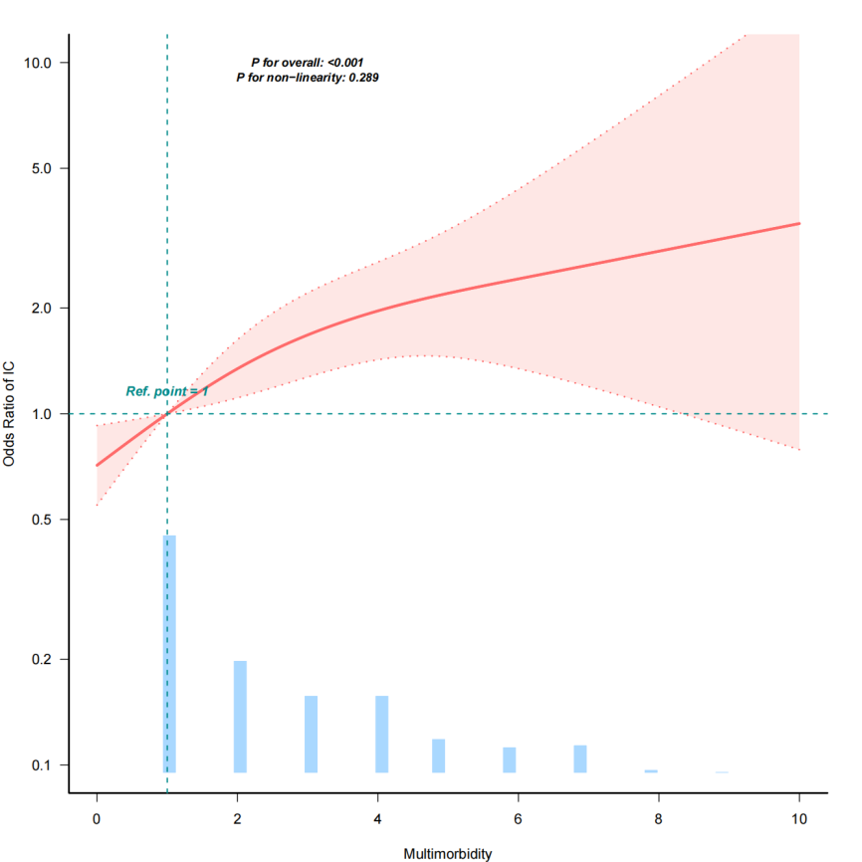
Fig. S1. Weighted restricted cubic spline curve describing the relationship between multimorbidity and IC.
Abbreviations: IC: intrinsic capacity

