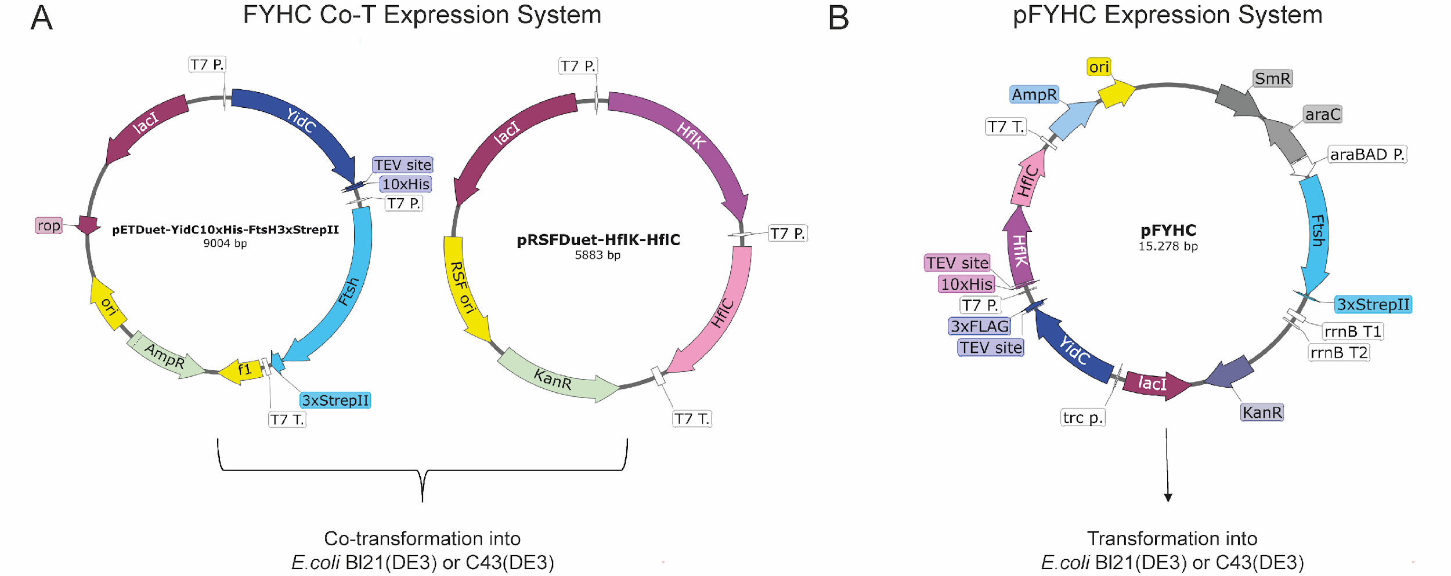
Sup. Fig. 1. FYHC Co-T and pFYHC expression system. A. In FYHC Co-T expression system, pETDuet plasmid has C-terminal 10xHis tagged YidC and C-terminal 3x StepTag II Tagged FtsH. B. pRSFDuet plasmid has HflK and HflC without tag. pETDuet has ampicillin and pRSFDuet has kanamycin resistance genes. Both plasmids were co-transfermed into E. coli Bl21 (DE3) or C43 (DE3) cells. B. In pFYHC expression system, a single plasmid, pFYHC, encodes 4 genes; FtsH-3xStreTagII under the arabinose promoter, 10xHis-HflK and HflC under the T7 promoter, YidC-3xFlagTag under the trc promoter. pFYHC plasmid was transformed into E. coli Bl21 (DE3) or C43 (DE3) cells and maintained with ampicilin, kanamycin and spectinomycin.
Primer Name | Sequence 5’-3’ | Aim
 | pRSFDuet-YidC10xHis-FtsH3xStrepTagII Design
1.FwpETDuet1 | AGCCATCACCATCATCACCAC | To linearize pETDuet-1 in the MCS-1 region
1.RwpETDuet1 | CATGGTATATCTCCTTCTTAAAGTTAAAC | To linearize pETDuet-1 in the MCS-1 region
2. FwYidC | CTTTAAGAAGGAGATATACCATGGATTCGCAACGCAATCTTTTAG | To amplify YidC-6xHis using the pFYHC plasmid as a template
2. RwYidC | GTGGTGATGATGGTGATGGCTCTGAAAGTACAGATCCTCGG | To amplify YidC-6xHis using the pFYHC plasmid as a template
FmutpETD3 | CACCACCACCATTAAAGCCAGGATCCGAATTCGAG | To convert YidC-6xHis to YidC-10xHis
RmutpETD3 | TTAATGGTGGTGGTGGTGGTGATGATGGTGATGGC | To convert YidC-6xHis to YidC-10xHis
1.2 FwpETDuetRev | ACCTAGGCTGCTGC | To linearize pETDuet-1-YidC-6xHis in the MCS-2 region
1.2 RwpETDuet1 | CATATGTATATCTCCTTCTTATACTTAACTAATATAC | To linearize pETDuet-1-YidC-6xHis in the MCS-2 region
2.FwFtsH | AGTATAAGAAGGAGATATACATATGGCGAAAAACCTAATACTCTGG | To amplify FtsH-3xStrepTagII using the pFYHC plasmid as a template
2.RwFtsHRev | GTGGCAGCAGCCTAGGTCATTTCTCGAATTGTGGATGACTCCAGGACCCGGC
 | pRSFDuet-HflK-HflC Design
3.FwpRSFDuet1 | GCGGCCGCATAATGCTTAAG | To linearize pRSFDuet-1 in the MCS-1 region
3.RwpRSFDuet1 | CATGGTATATCTCCTTATTAAAGTTAAACAAAATTATTTC | To linearize pRSFDuet-1 in the MCS-1 region
3.FwHflK | CTTTAATAAGGAGATATACCATGGCGTGGAATCAGCC | To amplify HflK using the pFYHC plasmid as a template
3.RwHflK | CATTATGCGGCCGCTTATTCCCCCTGACGCTGGTAG | To amplify HflK using the pFYHC plasmid as a template
3.2.FwpRSFDuet2 | ACCTAGGCTGCTGCCAC | To linearize pRSFDuet-HflK in the MCS-2 region
3.2.RwpRSFDuet2 | CATATGTATATCTCCTTCTTATACTTAACTAATATAC | To linearize pRSFDuet-HflK in the MCS-2 region
3.FwHflC | AGTATAAGAAGGAGATATACATATGCGTAAGTCAGTTATCGCG | To amplify HflC using the pFYHC plasmid as a template
3.RwHflC | GGCAGCAGCCTAGGTTAACGCGTTGCGGAAGTC | To amplify HflC using the pFYHC plasmid as a template
Sup. Table 1. Primers used in the design of the Co-T expression system. NEB HiFi DNA Builder was used for cloning, and the prepared plasmids were transformed into E. coli NEB10B cells. The underlined sequences in the primers represent the overlapping regions used for cloning.

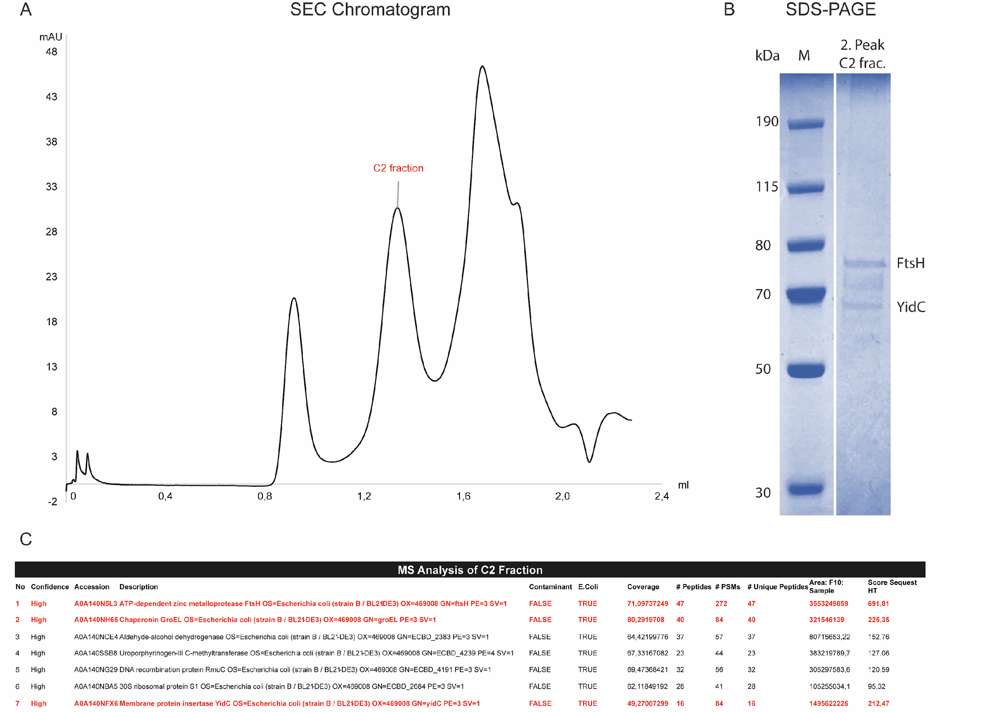
Sup. Fig. 2. SEC Purification and MS Analysis of FtsH, HflKC, and YidC Produced via the FYHC Co-T Expression System. FtsH, HflKC, and YidC proteins, expressed using the FYHC Co-T expression system and purified via Ni-NTA affinity chromatography, were further purified by size-exclusion chromatography (SEC) and analyzed by mass spectrometry (MS). Prior to Ni-NTA purification, the solubilized membrane fraction was treated with 0.25 mM DSP crosslinker. Ni-NTA fractions were concentrated using an Amicon® Ultra Centrifugal Filter (100 kDa MWCO). 3 mg/ml concentrated Ni-NTA purified fractions were then loaded onto a Superose 6 Increase 3.2/300 column for SEC purification. The chromatography was performed using an AKTAmicro device with a flow rate of 0.05 ml/min. SEC Buffer: 20 mM HEPES, 150 mM NaCl, 0.01% DDM, pH 8. The C2 fraction was collected in liquid form and sent for MS analysis. A. SEC chromatogram. B. SDS-PAGE gel. M: Marker. C. MS analysis of C2 fraction.

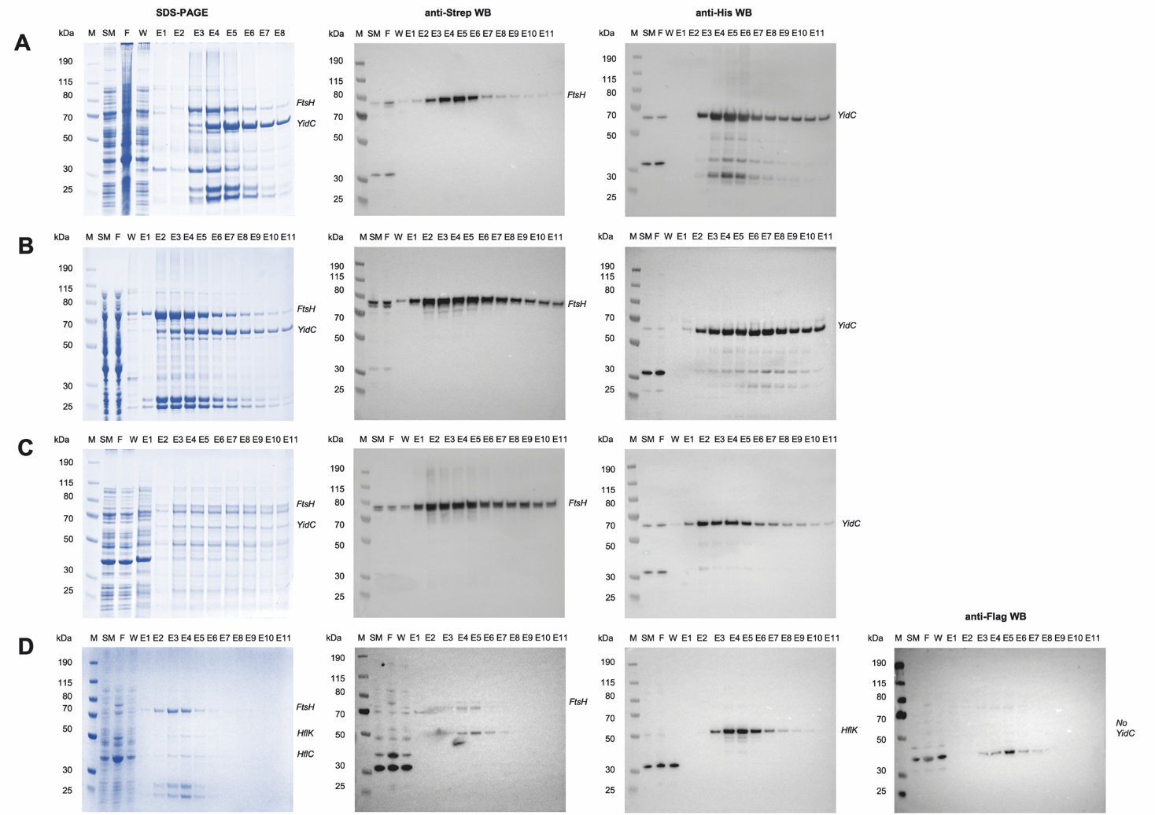
Sup. Fig. 3. SDS-PAGE Western Blot Analysis of YidC Co-purification with FtsH and HflKC. Expressions of FtsH, YidC, and HflKC proteins were carried out using FYHC co-T (panels A-C) and pFYHC (panel D) expression systems. Membrane proteins were purified using either Ni-NTA (panels A, B) or Strep-Tactin (C,D) affinity purification. In the crosslinker (+) condition (panel B), membranes were treated with 0.25 mM DSP, followed by Ni-NTA purification. For others, no crosslinker was used. Appropriate HRP-conjugated antibodies for the protein tags (e.g., anti-His, anti-Strep, anti-Flag) were used for Western Blot analysis. Samples; M: Marker, SM: Solubilized Membrane, F: Flow, W: Wash, E(Number): Elution.

Sup. Fig. 4. SEC Purification of FtsH, HflKC, and YidC Produced via the FYHC Co-T Expression System. Ni-NTA fractions (Supp. Fig.3D) were concentrated using an Amicon® Ultra Centrifugal Filter (100 kDa MWCO). 6 mg/ml concentrated Ni-NTA purified fractions were then loaded onto a Superose 6 Increase 3.2/300 column for SEC purification. The chromatography was performed using an AKTAmicro device with a flow rate of 0.05 ml/min. SEC Buffer: 20 mM HEPES, 150 mM NaCl, 0.01% DDM, pH 8. SEC fractions from the peak loaded to gel. A. SEC chromatogram. B. SDS-PAGE gel. M: Marker. B1-C8 are SEC fractions.

