Supplemental material

Toward food-grade production of the Bacteroides helcogenes
protein-glutamine glutaminase with an optimized Bacillus subtilis strain

Jana Senger, Mario Keutgen, Nicole Roth, Ines Seitl, Lutz Fischer*

University of Hohenheim, Institute of Food Science and Biotechnology,
Department of Biotechnology and Enzyme Science, Garbenstr. 25, 70599 Stuttgart, Germany

*Corresponding author
E-mail address: lutz.fischer@uni-hohenheim.de
Tel.: +49 711 459 22311

Supplemental Table 1: Plasmids used in this study.
Plasmid | Description
pLF_P_{aprE}_ PhoD_pro-PGB | Plasmid with PGB expression cassette (=pA-PGB) with expression controlled by P_{aprE} and pro-PGB gene (EMBL-EMI: ADV44662.1) fused to the PhoD signal peptide.
pJOE8999 | CRISPR/Cas9 plasmid for B. subtilis (Altenbuchner 2016)
pJOE8999_sgSigF | CRISPR/Cas9 plasmid with integrated sgRNA for sigF
pJOE8999_sgSigF_pA-PGB | CRISPR/Cas9 plasmid with integrated sgRNA for sigF and PGB expression cassette
pJOE8999_sgSfp | CRISPR/Cas9 plasmid with integrated sgRNA for sfp
pJOE8999_sgSfp_pA-PGB | CRISPR/Cas9 plasmid with integrated sgRNA for sfp and PGB expression cassette
pJOE8999_sgFlgE | CRISPR/Cas9 plasmid with integrated sgRNA for flgE
pJOE8999_sgFlgE_pA-PGB | CRISPR/Cas9 plasmid with integrated sgRNA for flgE and PGB expression cassette
pJOE8999_sgAmyE | CRISPR/Cas9 plasmid with integrated sgRNA for amyE
pJOE8999_sgAmyE_pA-PGB | CRISPR/Cas9 plasmid with integrated sgRNA for amyE and PGB expression cassette

Supplemental Table 2: Oligonucleotides used in this study.
 | Oligonucleotide | Sequence 5’3’ | Application
1 | SigF_O1 | TACGACAGCCCGATGCAGCCGATC | sgRNA for sigF locus, BsaI overhang
2 | SigF_O2 | AAACGATCGGCTGCATCGGGCTGT | sgRNA for sigF locus, BsaI overhang
3 | Sfp_O1 | TACGGCACATCTCCCAGCAGGGTG | sgRNA for sfp locus, BsaI overhang
4 | Sfp_O2 | AAACCACCCTGCTGGGAGATGTGC | sgRNA for sfp locus, BsaI overhang
5 | Flg_O1 | TACGCACAAGACGGGGGACAAATC | sgRNA for flgE locus, BsaI overhang
6 | Flg_O2 | AAACGATTTGTCCCCCGTCTTGTG | sgRNA for flgE locus, BsaI overhang
7 | AmyE_O1 | TACGTGAAGATCAGGCTATCACTG | sgRNA for amyE locus, BsaI overhang
8 | AmyE_O2 | AAACCAGTGATAGCCTGATCTTCA | sgRNA for amyE locus, BsaI overhang
9 | RepairPG_Fw_SfI | AAGGCCATCGTGGCCGAA | Amplification of PGB expression cassette
10 | RepairPG_Rev_SfI | AAGGCCTTCAGGGCCCGATTACGAATGCCGTCTC | Amplification of PGB expression cassette
11 | Up_flank_sigF_for: | AAGGCCAACGAGGCCGCATGAGCCTTGGAATTGAC | Amplification sigF upstream flank
12 | Up_flank_sigF_rev | AAGGCCACGATGGCCTCTCCTTAATTACAAAGCGC | Amplification sigF upstream flank
13 | Down_flank_sigF_for | AAGGCCCTGAAGGCCCTAGTCTGCAGTGCAGGCTAG | Amplification sigF downstream flank

Continuation Supplemental Table 2
 | Oligonucleotide | Sequence 5’3’ | Application
14 | Down_flank_sigF_rev | AAGGCCTTATTGGCCCACCGTTATGCCTCCGCCG | Amplification sigF downstream flank
15 | Up_flank_sfp_for | AAGGCCAACGAGGCCCTGTCAGATGTGCTACAATGAC | Amplification sfp upstream flank
16 | Up_flank_sfp_rev | AAGGCCACGATGGCCCATTCTAGATCCTCCGTCTGC | Amplification sfp upstream flank
17 | Down_flank_sfp_for | AAGGCCCTGAAGGCCGCTCATCAACAGCTTGACAC | Amplification sfp downstream flank
18 | Down_flank_sfp_rev | AAGGCCTTATTGGCCGAAGATCGCCATTGAACAGC | Amplification sfp downstream flank
19 | Up_flank_Flg_for | AAGGCCAACGAGGCCGCAGATGTCATCTGATATAC | Amplification flgE upstream flank
20 | Up_flank_Flg_rev | AAGGCCACGATGGCCCCAGAATAAAGTGAACGTAAC | Amplification flgE upstream flank
21 | Down_flank_Flg_for | AAGGCCCTGAAGGCCCATCTGATGAAATCCTTCAAG | Amplification flgE downstream flank
22 | Down_flank_FlgF_rev | AAGGCCTTATTGGCCGAGTGGTAAGAAGTCTTGC | Amplification flgE downstream flank
23 | Up_flank_AmyE_for | AAGGCCAACGAGGCCGGGCTTGTCTTTATCGTG | Amplification amyE upstream flank
24 | Up_flank_AmyE_rev | AAGGCCACGATGGCCCCTGATGTGAAGACTGGA | Amplification amyE upstream flank
25 | Down_flank_AmyE_for | AAGGCCCTGAAGGCC CAATGTGATGGCTGGACAG | Amplification amyE downstream flank
26 | Down_flank_AmyE_rev | AAGGCCTTATTGGCC CTCAATGAGGAAGAGAACCG | Amplification amyE downstream flank
27 | CC_AmyE | CTGTCCTTGCCGGTTTAATAG | Colony PCR
28 | PG-seq 16/60 | GCTGAAGATACATCCAG | Colony PCR
29 | CC_FlgE | CTGACAGATATGTGAATATAGG | Colony PCR
30 | CC_sigF | GCCTGAACAAATCTCATTG | Colony PCR
31 | CC_sfp | GAACGGCATATTTTCATTAC | Colony PCR
32 | Seq_sgRNA_pJOE8999 | GACCTCAAAAAGGTCTTTA | Sequencing sgRNA in pJOE8999

Supplemental Table 3: B. subtilis strains used in this study.
Strain designation | Genotype | Reference
B. subtilis 007 | Wild-type isolate | DSM118688
B. subtilis FS1 | B. subtilis 007 ΔsigF::pA_PGB | This study
B. subtilis FS2 | B. subtilis 007 ΔsigF::pA_PGB Δsfp::pA_PGB | This study
B. subtilis FS3 | B. subtilis 007 ΔsigF::pA_PGB Δsfp::pA_PGB ΔflgE::pA_PGB | This study
B. subtilis FS4 | B. subtilis 007 ΔsigF::pA_PGB Δsfp::pA_PGB ΔamyE::pA_PGB | This study

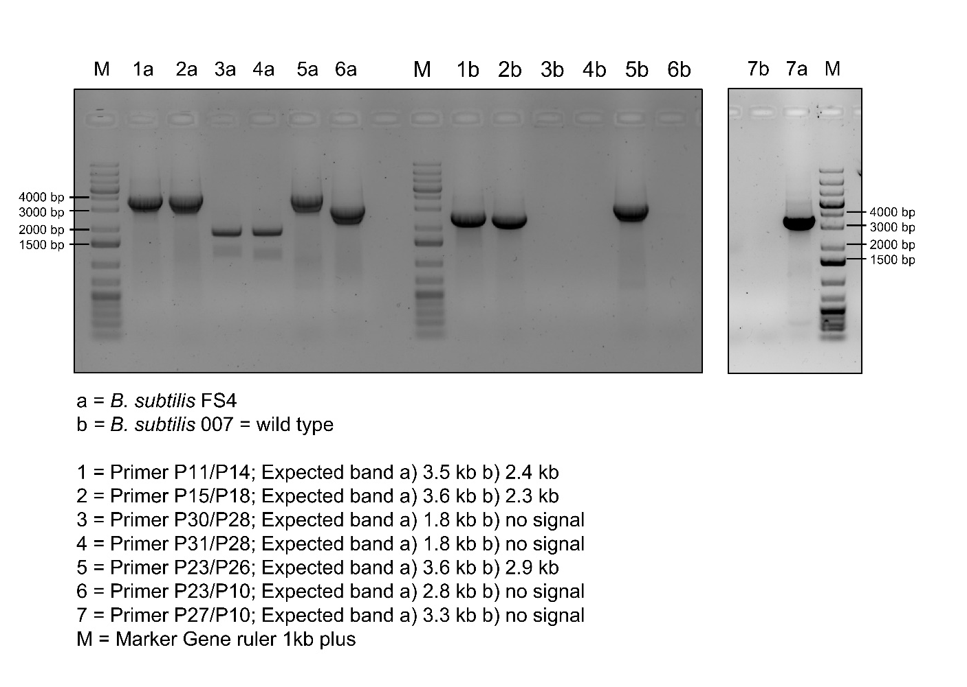
Supplemental Figure 1: Agarose gel of colony PCR for verification of B. subtilis FS4. Primer pairs bind in upstream and downstream flank of sigF (1), sfp (2), amyE (5); outside of flank and inside PGB expression cassette of sigF (3), sfp (4), amyE (7); in upstream flank and PGB expression cassette of amyE (6).

A
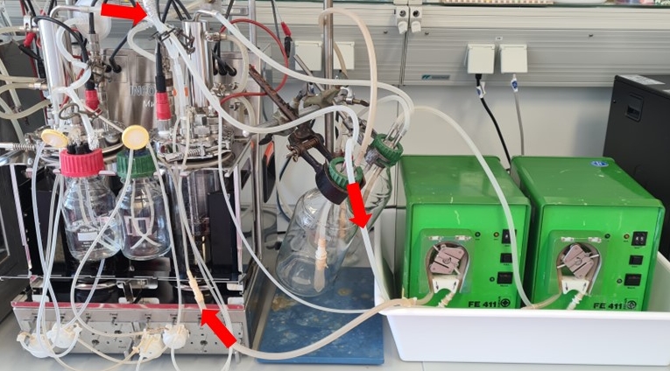
B
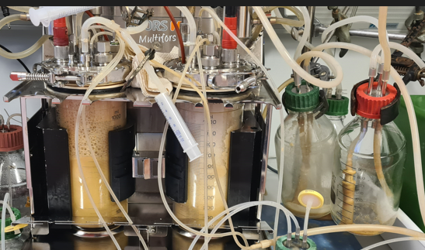

Supplemental Figure 2: Foam trap (A) and excessive foaming during bioreactor cultivation of B. subtilis FS1 (B). The red arrows indicate the direction of the foam pumped back into the reactors.

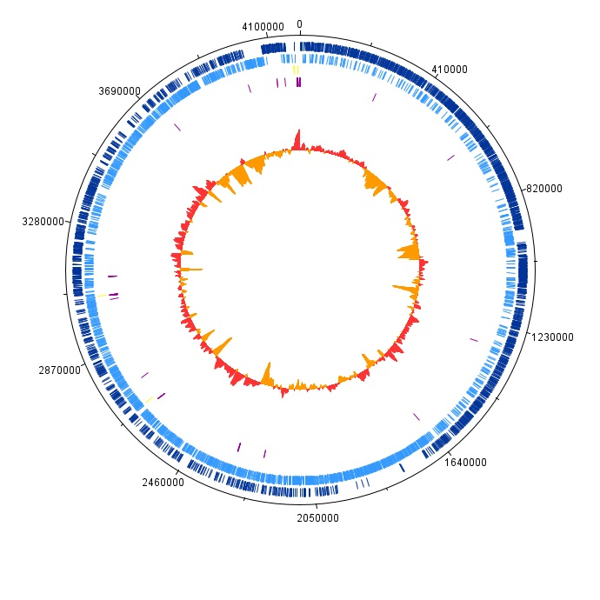
Supplemental Figure 3: Genome map of B. subtilis 007. CDS forward strand (dark blue); CDS reverse strand (blue); rRNA (yellow); tRNA (purple); GC plot below average (red) and above average (orange).

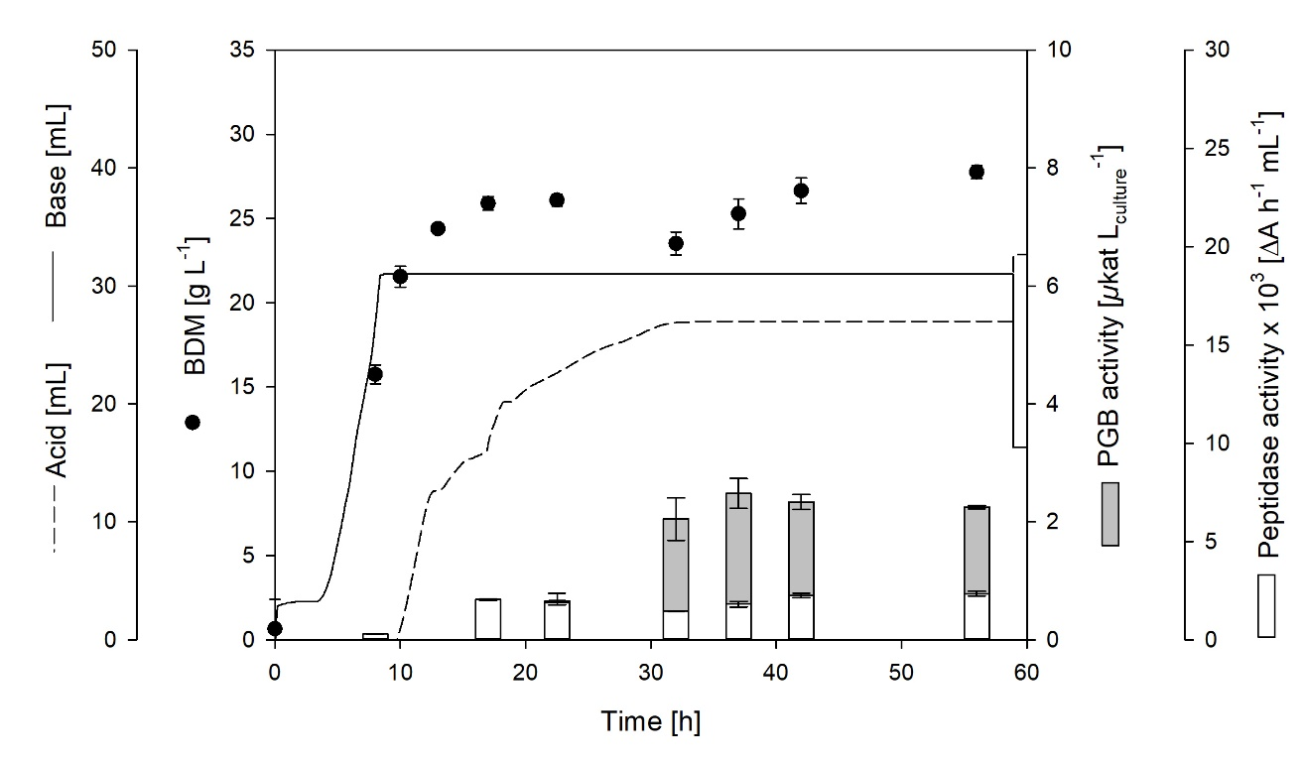
Supplemental Figure 4: Bioreactor cultivations of B. subtilis FS3.

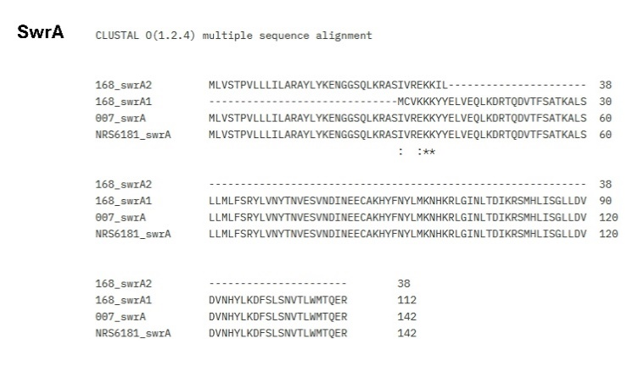
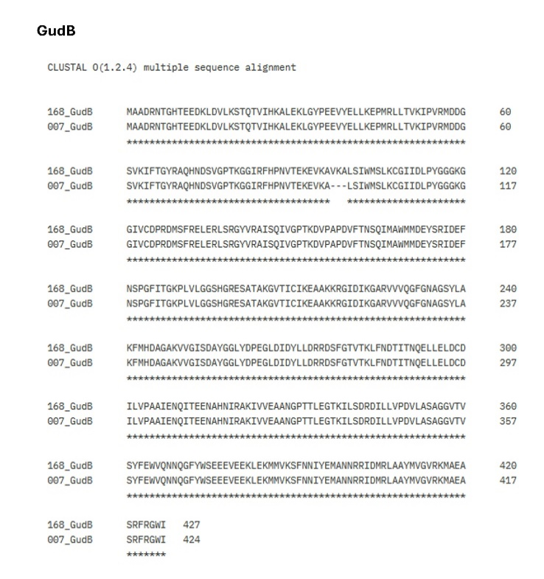
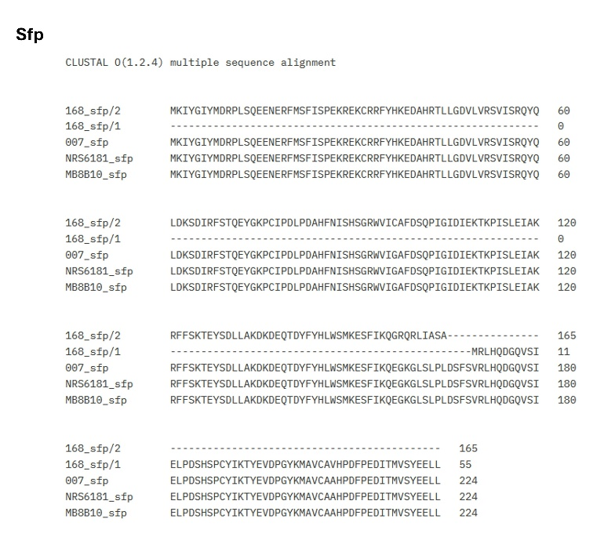
Supplemental Figure 5: Sequence alignment of SwrA, Sfp and GudB of B. subtilis 007 and B. subtilis 168, NRS6181 or MB8_B10.

