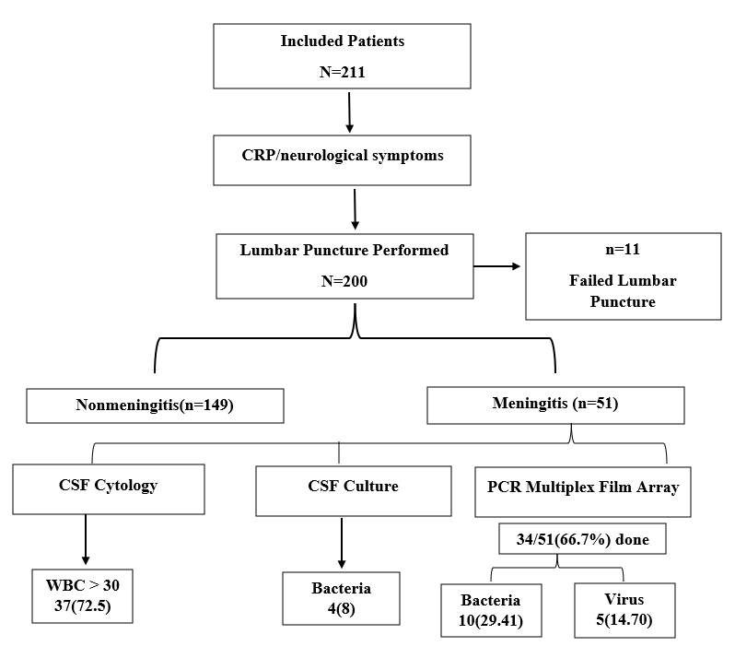
Supplementary Figure: Flow chart of study
Note: Positive WBC (>30 cells/µL) + positive culture: 1 patient; Positive WBC + bacterial PCR: 2 patients; Positive WBC + viral PCR: 2 patients; Positive WBC alone: 36 patients; Positive culture alone: 3 patients; Positive bacterial PCR alone: 8 patients; Positive viral PCR alone: 3 patients.

Supplementary Table. Maternal and obstetrical characteristics
Characteristics |  | Population N=200
Characteristics | All population | Meningitis n=51 | Nonmeningitis n=149 | ƿ
Maternal Age (years) | 28.86±6.60 | 28.82±6.90 | 28.87±6.50 | 0.53
Gravidity |  |  |  | 0.46
Primigravida | 70(35.00) | 20(39.20) | 50(33.60) | 0.46
Multigravida | 130(65.00) | 31(60.80) | 99(66.40) | 0.46
Parity |  |  |  | 0.43
Primipara | 80(40.00) | 18(35.30) | 62(41.60) | 0.43
Multipara | 120(60.00) | 33(64.70) | 87(58.40) | 0.43
Previous Cesarean Section | 22(11.00) | 8(15.70) | 14(9.40) | 0.43
Previous Preterm Births | 24(12.00) | 5(9.80) | 19(12.80) | 0.79
Maternal Fever During Pregnancy | 11(5.50) | 5(9.80) | 6(4.00) | 0.20
Other Obstetric Data |  | 17(31.40) | 43(23.50) | 0.26
Eclampsia/Preeclampsia | 3(5.00) | 1(2.00) | 2(1.30) | 0.26
Threatened Abortion | 2(3.34) | - | 2(1.30) | 0.26
Gestational Diabetes | 17(28.33) | 5(9.80) | 12(8.10) | 0.26
Threatened Preterm Labor | 1(1.66) | - | 1(0.70) | 0.26
Other | 37(54.5) | 11(21.60) | 26(17.40) | 0.26
Syphilis Screening During Pregnancy |  |  |  | 0.36
Positive | 2(1.00) | 1(2.00) | 1(0.70) | 0.36
Negative | 117(58.50) | 27(53.00) | 90(60.40) | 0.36
Not Monitored/No Abnormalities | 81(40.50) | 23(45.10) | 58(38.90) | 0.36
Toxoplasmosis Screening During Pregnancy |  |  |  | 1
Positive | 4(2.00) | 1(2.00) | 3(2.00) | 1
Negative | 123(61.50) | 31(60.80) | 92(61.70) | 1
Not Monitored/No Abnormalities | 73(36.50) | 19(37.30) | 54(36.20) | 1
Rubella Screening During Pregnancy |  |  |  | 0.67
Negative | 102(51.00) | 24(47.10) | 78(52.30) | 0.67
Positive | 9(4.50) | 3(6.00) | 6(4.00) | 0.67
Not Monitored/No Abnormalities | 89(44.50) | 23(47.10) | 65(43.60) | 0.67
Note: Variables presented missing data/not reported; previous cesarean section 28(14%) previous preterm births 30(15), maternal fever during pregnancy 55(27.5)
The values are expressed as the means ± standard deviations for continuous variables and as medians with interquartile ranges for distributions. Categorical variables are presented as frequencies and percentages. Statistical analyses were conducted via Student's t test, the chi-square test of independence, Fisher's exact test, and the Mann‒Whitney U test.

